Growth responses, nutrient utilization and digestibility in Tilapia niloticus fed cottonseed and palmkernel cakes based diets.

Paul Chuks Onuoha

Department of Fisheries and Marine Biology, Federal College of Fisheries and Marine Technology, Bar-beach Victoria Island, Lagos Nigeria
E-mail: hydro_vision@yahoo.com

Abstract: Growth responses, nutrient utilization and digestibility were investigated in fingerlings of Oreochromis niloticus using iso-nitrogeneous (32%) and iso-calaroric (425 kcal/100g diet) cottonseed and palm kernel cakes based diets for 70 days. The diets were formulated with cottonseed and palm kernel cakes at inclusion levels of 39(D1), 31(D2), 28(D3), 22.98(D4) and 0% (control-D5) respectively, and fed to the fish twice daily at 5% body weight. Percentage weight gain, feed utilization efficiencies and survival of O. niloticus increases as inclusion levels of cottonseed cake decreases from 39% (D1)to 0% (D5) – control diet (fish meal) and vice versa for palm kernel cake. Fish fed on diet D₃ (28.80% cottonseed and 28.80% palmkernel cakes) had highest growth responses, nutrient utilization and digestibility, followed by D₂ (31.62% cottonseed and 21.68% palmkernel) cakes, while the least occurred in diets with only cottonseed (D1) or palmkernel (D4) cakes respectively. The higher weight gain and feed utilization observed in diet D₃ could be as a result of higher diet palatability due to optimum presence of dietary fibre, amino acid composition and reduction in gossypol content of the diet. The result of this study indicated that diet of O. niloticus could be substituted with cottonseed and palmkernel cakes at inclusion levels of 28.80% respectively to give optimum growth.
[Paul Chuks Onuoha. Growth responses, nutrient utilization and digestibility in Tilapia niloticus fed cottonseed and palmkernel cakes based diets. Nat Sci 2014;12(8):95-109]. (ISSN: 1545-0740). http://www.sciencepub.net/nature. 14

Key words: growth, nutrient, utilization, digestibility, cottonseed, palmkernel

1.0 Introduction
Fish occupies an enviable position in the economy of any nation, by the provision of the cheapest source of animal protein (Orta and Sado, 1985). The popular artisanal fishing which formerly provides the bulk of fish protein needs of the teaming population is now giving to intensive aquaculture where faster growth is obtained with intensive feeding (Cantom et al 1974; Heinisah 1979; and Oyetayo 1985). This new trend in fish production is as a result of over exploitation of most of the valuable stocks in the wild, leaving relatively few new species for fishing (Oyetayo, 1985).
In Nigeria the recent dwindling economy has made the Federal government to ban the importation of frozen, dried fish together with the commercial feeds for fish feeds and other livestock. This motivated the Federal and state government, individuals and bodies to make concerted alternative efforts toward increasing fish production.
This took the form of integration of fish development project into water irrigation project spread all over the hinterland for freshwater fish cultivation. Marine and brackish waters fish cultivation were also carried out along the coastal areas of the country. Fish culture management practices involving the techniques of feeding and fertilization began in Nigeria in 1954 at Panyam fish farm.
The total annual production of fish since the proliferation of these farms has not met the ever increasing protein needs of the population. The cost of feed has been the largest component in recurrent cost of fish production. Cost of these items often becomes prohibitive and unaffordable to producers in many parts of the country. The establishment of economically viable fish culture production enterprises therefore requires the incorporation of cheap, locally available feedstuffs and agricultural farm waste products as components or supplemental constituents of locally manufactured feeds. Hence many researchers investigated other alternative sources of fish feed ingredients to supplement fish meal in order to reduce cost without necessarily reducing the biological quality of the feed.
Fish require protein, lipid, carbohydrates, vitamins and minerals in their diet to meet the physiological needs of growth and reproduction. The requirements vary from species to species and with fish age, sex, reproductive state and environmental factors.
Protein is a major constituent of any animal body and is essential in the diet of all fishes as a source of essential amino acids which are the building blocks for eggs, milt, antibodies and hormones.
The range of protein requirement for optimal growth and feed efficiency of juvenile fishes has been established as 35-59% depending on temperature, age and species (Mlilikan, 1982). Jauncy and Ross (1982) noted that Tilapia are able to utilize protein levels below the optimum and still produce good growth.
Ofojekwu (1989) obtained optimum growth response and feed utilization with 35% crude protein on O. nilotiotis fed on 5 – 10% dietary blood meal. Ufodike and Ekokotu (1986) showed that the best growth response was obtained with 32% algae and 52% blood meal diet using Clarias lazera at 50% crude protein.
The amount of protein that should be provided in practical diets depends largely upon the protein requirements, digestibility and amino acid composition. Protein with lower digestibility has to be included at higher dietary level to achieve the same level of protein uptake by fish.
The utilization of dietary protein by fish is mainly affected by its amino acid composition. Helver (1957) identified the following ten essential amino acids indispensible for the culture of fishes- arginine, instidine, isoleucine, leucine, lysine, methnonine, phenyladanine, threonine, tryptophan and Xaline. Jauncy and Ross (1982) observed that deficiency of these essential amino acids results in loss of appetite, reduced growth and poor feed conversion.
The most ranking fish protein sources include fishmeal, soybean meal, shrimp waste, bloodmeal, cottonseed cake and palmkernel cake. Jobiling (1981) working with plaice (pleur-a nectes platesses) noted that animal protein was better digested than those from plant sources. This is because almost all animal protein containing all the essential amino acids.
Cottoned seed cake is locally available and relatively cheaper than other vegetable oil cakes in Northern and South-West part of Nigeria, but does not satisfy quantitative dietary requirement of cultured fish species. Gohl (1981) determined the nutrient composition of soxhlet oil cottonseed to be, protein 47.3%, carbohydrate 28.5%; fat 7.4% fibre – 9.6% and mineral elements like nitrogen, phosphorous, potassium, and calcium.
Cottonseed meal has been reported to be very palatable to fish and contain relatively low content of lysine, methonine, and cysteine (Gohl, 1981).
The actual protein level and lysine content depends on the type of processing used and may vary between strains of cotton. The carbohydrate content and calcium contents are low, but it is a good variable source of thiamine (Gohl, 1981).
Cottonseed contain 0.03-0.2% yellow pigment known as gossypal (phenolic compound which has inhibitory effect on digestive enzymes of monogastric animals and contains a biological antioxidant which diminishes appetite and causes constipation in a wide range of animal (Jauncy and Ross 1982). This does not have any effect on growth rates of Tilapia, but has some long term effect on trout, particularly on the kidney (Herman, 1970).
Wilson et al (1981) indicated that the digestibility of lysine in cottonseed meal by channel catfish was low supplementing cottonseed meal with crystalline lysine may be cost effective means of substituting cottonseed meal for soyabean in fish feeds (Lovell, 1981).
Kolawole (1982) reported great success with addition of cottonseed cake to a poly-culture of clarius, gariopinus, Hertarotis, Hebarchranchus and Tilapia species. Fagbonro, (1988) in his evaluation of the dual role of cottonseed meal as fish feed and fertilizers recorded a mean net fish yield equivalent to 4508,20g/ha/yr in pond fed with cottonseed meal, while only 3375.70g/ha/yr was recorded in the control pond.
Palm kernel cake is obtained after the extractions of oil from palmkernel nut. It is a cheap to obtain particularly in the tropical regions, swampy areas, found mainly in the southern part of Nigeria.
Gohl (1981) noted that plamkernel is made up of the following nutrient components: protein – 20.4% carbohydrate – 56.6%, fat 8.3% and fibre 15%. He noted that despite the low protein content, palmkernel cake is of high quality with methrone as the only limiting amino acid. The ratio of calcium to phrosphorus is more favourable than in many other oil seeds residues (Gohl 1981). Despite that palm kernel is not a promising protein source for fish feeds, partly due to its high fibre content (Jauncy and Ross, 1982). However, Kamara (1982) found the growth performance of S. nitoticus fingerlings fed on a 59% protein diet in which half of the fish meal components was replaced by palm kernel was only 50% of those fed fish meal control diet.
Low protein digestibility has been reported for fish fed high fiber containing diet (Kitamikado et al 1964; Takeuclri et al 1979). Ufodike and Ekokotu (1986) observe a high protein digestibilities of 86% and 80.20% respectively on diets containing the least crude fiber content, while the least of 70% was obtained on the diet containing the highest crude fibre.
Ufodike and Matty (1983), recorded a very high protein digestibility, of 88% in carp when its diet contained 45% dietary carbohydrate. Edwards and Horn (1982) noted that relatively few fishes have the ability to digest cellulose containing material. This was as a result of lack of endogenous cellulotlytic enzymes (Stickney and Shunway, 1974). And lack of consistent intestinal microflora to degrade complex algal polycaccharide (Prejs and Blass –zyk 1977).
However, Lagler et al (1979) suggested that titration could play a major role in the utilization of algal nutrients by herbivorous fishes.
Oreochromis niloticus belong to the Tilapia group of fishes which serve as a major source of protein in many parts of the world. It is one of the most widely cultured species in the tropics (Berdach et al 1972; win free and Stickney, 1981). This is as a result of their great adaptability, high fecundity and rapid growth rate. They occur in variety of habitats- freshwater, brackish and marine waters and exhibit predatory, herbivorous and omnivorous mode of feeding. They tolerate a wide range of temperature, ammonia and dissolved oxygen concentrations (Mirens, 1983). They are resistant to many diseases and parasites (Huat, 1972). To add to their success, is their ability to convert food efficiently accepting artificially formulated diets, coupled with rapid growth rate.
This study was designed to test the suitability of cottonseed and palm kernel cakes as possible supplementary sources of protein for the culture of Oreochromis niloticus. The experiment was designed to investigate;
- The differences in growth response of Oreochromis niloticus fed different levels of cottonseed and palm kernel cakes based diets.
- The level of utilization of test diets at different inclusion levels.
- The digestibility of the nutrients in the different experimental diets.

2.0 Materials And Methods
2.1 Source And Maintenance Of Experinmental Fish
Oreochromis niloticus fingerling weighting 2.0-2.4g was collected from rock water fish farms in plateau state. The fish were transported in oxygen bags to the University of Jos hydrobiology and fisheries research laboratory. They were then guarantied for 14 days in rectangular glass aquaria which have been treated with 1ppm malachite green solution. This was to ensure that any parasite that might be present was killed. The water was aerated with 50Hz Charles Austum pump. Fish were fed twice daily at 2% of their body weight with commercial feed from NIOMR (Nigeria institute of oceanography and marine research).
The protein content of the commercial feed fed to the experimental fish was 30%. The fish were treated with 1ppm of malachite green solution during the first 3 days of acclimation period. Thereafter, treatment was done once every week.
The fish were transferred to the experimental tanks and allowed to acclimate for one week at a water temperature of 23-25 ºC.
2.2 Experimenal Facilities And Methodology
The experimental tanks consisted of 12 green plastic circular tanks with a water recirculation system. Each tank had a capacity of 15.6 liters and was continuously fed with water from the header tank. The flow of water into the tanks was maintained at the rate of 0.98 to 1.10 liters per, minute.
The over flown water from the experimental tanks flowed into the biological filter through two faecal traps. The biological filter measures 60 x 50 x 91 L and was three-quarter filled with gravel clips. The faecal traps were cleaned every week. The filtered water was pumped from the bottom of the filter into head tank with a force which helps to aerate the water.
The metallic head tanks with capacity of 273 litres were supplied with make up water from a tap connected to a higher reservoir. From the head tank, water flowed to a carbon filter which eventually supplied the green experimental tanks. Excess water from the head tank overflowed into the biological filter. The presence of a stand pipe at the middle of each tank and the angle at which water spurted into the fish tanks from the inflow taps, helped to recirculate the water.
Throughout the experimental period, constant effective recirculation was maintained by connecting the water pumps to electrothermal regulators. The recirculation was put off every night to allow the pumps to cool and also during feeding.
At the beginning of the experiment, 8 fish were randomly selected from the total of 96 fish used for the experimental tank. The 12 experimental tanks were made up of two replicates for each of the six experimental diets (Table I).
2.3 Diet Component And Treatment
The experimental diets were composed of cottonseed cake, palmkernel cake, fish meal, groundnut cake, maize flour, cassava flour, cellulose, corn oil vitayte and chronic oxide (Table I). All these ingredients except cottonseed were obtained from the local market. The cottonseed was obtained from the Nigerian Cottonseed Board Kuru, as ordinary seed. This was then boiled, dried ground and sieved. The oil contained in the sieved materials was soxhlet extracted after the method of AOAC (1980). The resulting residue (cottonseed cake) was dried and preserved for the formulation of the experimental diets. The boiling, drying and extraction of oil helped to reduce the toxic gossypol to a very low level (Watts, 1970).
The palmkernel bought from the local market were cracked to obtain the nuts. These were ground and the oil content removed by soxhlet extraction using AOAC (1980) method. The palmkernel cake resulting after the extraction was dried and sieved, ready for inclusion with the exception of chronic oxide, vitalyte and cellulose were ground and sieved to enhance their palatability and digestibility.
2.4 Feed Formulation And Storage
Six experimental diets were prepared to contain 33% crude protein with varying proportion of cottonseed cake and palmkernel cake (Table 1). The sixth diet containing only fish meal as essentially the protein source, serve as the control diet. The inclusion levels of cottonseed cake and palmkernel cake in each experimental diet required to make iso-nitrogenous diets were calculated. Groundnut cake, maize flour, fish meal and cassava were included in equal proportions respectively. The diets were made isocaloric using corn, oil and the cellulose.
All the calculated proportions were weighed out correctly. They were placed in a good mixer and thoroughly blessed for 10 minutes. Boiling water was added carefully and mixing continued by switching the mixer into a high speed until complete homogenization was ensured. The semi-moist paste diet obtained was extruded through a mincer using 3mm die. They were dried in a cabinet for 24 hours with an electric oven fan set at 40ºC. Long pellet were broken into shorter ones and put into polythene bags, sealed and stored at 6ºC for the experimental period. Samples of each dried experimental diets were collected for proximate analysis.
2.5 Feeding, Anaesthsia And Weighing
The fish were fed 3% of their body weight daily. The feed was divided into two equal parts and fed twice daily at about 9.00am and 4.00pm respectively. Big pallets were broken down into smaller sizes and scattered into the experimental tanks. The fish were not fed every weighing day to avoid further stress resulting from the anaesthesia after weighing.
Prior to each weekly weighing of fish on a top load balance, through the 10 weeks experimental period, they were anaesthesized with benzocaine solution. The benzocaine solution was made by dissolving 0.1g of benzocaine powder (Ethyl-p-aminobenzoate) in 1ml of ethanol and then diluted into 4 litres of water in a plastic container. The fish were anaestesized in the resulting solution until they become calm but still breathing.
They were then blotted dry on a damp towel and individual weights were noted to the nearest 0.1g using the top loading balance, Mettler P. 1210. The weighed fish were then transferred to a well aerated water to revive before being returned to their respective experimental tanks.

Table 1: Composition of Experimental Diets (% by Weight) Fed to Oreochronis Niloticus For 70 Days
Diets Designations
Compositions | D1 | D2 | D3 | D4 | D5 | D6 (CONTROL)
Cottonseed cake | 39.00 | 31.62 | 28.80 | 22.98 | ---- | ------
Palm kernel cake | --- | 21.98 | 28.80 | 31.62 | 39.00 | --------
Fish meal | 16.62 | 16.62 | 16.62 | 16.62 | 16.62 | 45.01
Groundnut cake | 5.54 | 5.54 | 5.54 | 5.54 | 26.47 | 5.54
Maize flour | 8.20 | 8.20 | 8.20 | 8.20 | 8.20 | 8.20
Cassava flour | 4.04 | 4.04 | 4.04 | 4.04 | 4.04 | 4.04
X-cellulose | --- | ---- | 1.50 | 0.50 | 1.17 | 15.71
Vitalyte | 3.50 | 3.50 | 3.50 | 3.50 | 3.50 | 3.50
Corn oil | 19.00 | 8.00 | 7.00 | 6.00 | 0.50 | 18.00
Chromic oxide | 0.50 | 0.50 | 0.50 | 0.50 | 0.50 | 0.50
Totals | 100.20 | 100.00 | 100.00 | 100.00 | 100.00 | 100.00

2.6 Faecal Sampling
Feces were collected every week by gently stripping the rectal regions by the fish anterior-poetariorly (Windel et al, 1978). Feces of all fish on each diet were pooled together weekly, dried at 105ºC for 24 hours and stored in air tight bottle for subsequent chemical analysis after the method of Farukawa and Tsukahara (1966).
2.7 Determination Of Proximate Composition
Prior to the experiment, the carcass of the fish and samples of the dried experimental diets were assayed for proximate composition. At the end of the experiment, carcass of the experimental fish on each diet was subjected to the analysis using the AOAC (1980) methods. The composition analyzed were mixture content, fat, crude protein, ash and nitrogen free extract (carbohydrate).
2.7.1 Moisture Content
Each of the samples was accurately weighed initially before even drying them to a constant weight at 105ºC for 24 hours. They were then removed cooled and weighed again for final weight. The amount of moisture was estimated as the difference between the final and initial weights, expressed as a percentage of the initial weight of the sample.
2.7.2 Crude Protein
Microkjeldahi distillation techniques which involved the determination of the nitrogen content of the sample and multiplied by a factor 6.25. The factor was based on the fact that average pure protein contains approximately 16% N.
A known weight or 0.3500g of a sample was digested by boiling with 10ml of concentrated sulphuric acid for 24 hours. This converts the nitrogen ammonia. Excess of the acid fixed the ammonia as ammonium sulphate. The resulting solution was cooled and diluted with distilled water to 100ml. 10ml of the aliquot solution was neutralized with 10ml of sodium hydroxide solution in the distillation chamber. The fixed ammonia was determined by liberating it by addition of excess of sodium hydroxide and distilling it into excess boric acid solution containing bromoerimol blue indicator. 50mls of the distillate collected was titrated with standard hydrochloric acid solution (0.01 N HCl percentage of the crude was determined by:
(a – b) x 0.01 x 14.01 x c x100 x 6.22
d x e
a = sample titre value (ml)
b = blank titre value (ml)
c = volume of which the digest was
made up (ml)
d = volume of aliquot taken for
distillation (ml)
e = weight of the test sample (g)
i = litre of NHCL = 14.01gm nitrogen
2.7.3 Crude Fat
A slight modification of the soxhlet petroleum other extraction as adopted by Ufodike and Matty (1983) was employed for proximate fat estimation of fish and diets. Dried samples weighing between 2 and 3 grams wrapped in filter paper were used. Extraction with petroleum ether of 60 – 80ºC boiling point range, instead for 8 hours.
The means of the loss in weight of the filter paper and contents, and the gain in weight of extraction flask was regarded as the fat content of the sample.
2.7.4 Ash Content
This was obtained by incinerating weights of samples between 3 and 4 grams, in a muffle furnace at 600ºC for 24 hours. All the ashed samples were allowed to coil in a desiccators, weighed and the difference in weight was expressed as percentage of the weight of original sample.
2.7.5 Carbohydrate
This was carried out after the anthrone reggeni method. A sample weight of 1 to 2 grams was suspended in 10 ml anthrone (0.2g of anthrone in 8ml absolute alcohol, 30ml distilled water and 100ml concentrated sulphuric acid. The content of the test was mixed and heated for 7 minutes in a boiling water bath. The test tube was immediately cooled, configured and the absorbence of the supernatant read in a spectrophotometer at 620m. A caliberation curve was prepared using glucose standard solution.
Carbohydrate, also known as Nitrogen free by the difference of the sum total of the ash, crude protein, lipid, fibre and moisture.
2.7.6 Crude Fibre
This was carried out using modified AOAC, (1980) method. A known weight (1-2grams) of defatted materials (ether extracted) was taken and boiled with 200mls of hot 1.25% sulphuric acid, for 30 minutes. This was refluxed for 30 minutes and filtered through a Whatman No. 4 filter paper. The residue on paper was washed several times with hot distilled water and few mls of HCl. The residue was then treated with 200ml boiling sodium hydroxide (1.25%) and refluxed again for 30 minutes and filtered through a weighed filter paper No. 4. The filter paper and the residue was carefully folded and put into a crucible and dried at 80 – 100ºC in hot air oven for 12 hours to remove any traces of water. This was then cooled to a constant weight in a desiccators. The sample weight was then determined. The difference between the weight of crucibles plus samples and crucible plus ash represent the crude fibre content which is the portion of total carbohydrate of a sample that is resistant to acid and alkali treatment.
2.7.7 Chronic Oxide Content
Chronic oxide content of the diet and feces was determined after the method of Furukawa (1966).
2.8 Water Quality Parameters
2.8.1 Water Temperature
This was determined by the use of dry bulb thermometer at 1cm depth, below the water surface in the tanks.
2.8.2 pH
The pH of the water was determined by dipping the electrodes of the pH meter in the water sample contained in a container.
2.8.3 Dissolved Oxygen
This was determined by Winkler technique against 0.01 N Na₂ S₂ O₃
2.8.4 Free Carbondioxide
This was determined by titrating 100ml of water sample against a standard solution of Sodium hydroxide (N/44 NaOH). The titre value was multiplied by a factor 10 to give the free carbondioxide in the water.
2.9 Determination Of Growth Indices And Feed Utilization
Formulae of various growth, feed utilization parameters and digestibility were as in Ufodike and Matty (1983).

2.9.1 Indices Of Growth
2.9.1.1 Percentage Weight Gain (%)
This was calculated as follow:
Weight gain (gm) x 100
Initial weight (gm)
2.9.1.2 Mean Growth Rate (Mgr)
The mean growth rate was expressed as average relative growth and was calculated as follows:
Mean growth rate (mg/g/day) = W₂ – W₁ x 100
0.5(W₂ + W₁)t

Where W₁ = initial weight of fish (gm)
W₂ = final weight of fish (gm)
t = experimental period in days
2.9.1.3 Specific Growth Rate (Sgr)
This is average percentage increase in body weight per day over a given time interval and was calculated as follows:

Log W2 - Log W1 x 100
T - t

Where log = base of nature/logarithm
W₂ = final weight of fish (gm)
W₁ = initial weight of fish (gm)
T = final time in days
t = initial time (o)
2.9.2 Indices Of Food Utilization
2.9.2.1 Food Conversion Efficiency (Fce)
This is the average weight of fish produced per unit weight of fish and was calculated as follows:
Weight gain (gm)
Food consumed (gm)
2.9.2.2 Protein Efficiency Ratio (Per)
This gives the weight of the fish produced per unit weight or dietary protein and was calculated as follows:
Weight gain (gm)
Crude protein fed (gm)
Where crude protein fed is = Total feed fed (gm) x % crude protein in diet.
2.9.2.3 Apparent Net Protein Utilization (Anpu)
This is a better indication of how well the protein in the diet was utilized by the experimental fish. It was computed as follows:

ANPU (%) = carcass protein at end x carcass protein at beginning x 100
Protein fed (gm)
2.9.3 Nutrient Digestibility
This was computed as follows:
Apparent digestibility = 100 = (100 x CD x NF)
CF ND
Where CD = % chronic oxide in diet
CF = % chronic oxide in feces
ND = % nutrient in diet
NF = % nutrient in feces
Chronic oxide content in a sample was computed as follows:
Chronic oxide content = spectrophometer absorbance - 0.0032
0.2089
2.9.4 Statistical Analysis
Analysis of variance (ANOVA) for completely randomized design was used at 5% level of significance to determine significant difference between variables.
Least significant difference (LSD) was used to test which pair of the treatment mean differed significantly from each other.
Standard error of means (SEM) was calculated using the relationship below:
SEM = s
√ n
Where s = standard deviation of sample
n = sample size

3.0 Results And Analysis Of Experimental Data
3.1 Mortality
Experimental fish showed good appetite and appeared in healthy condition. However, out of the total of 96 fish used in the experiment, only 8 died representing a mortality of 8.3%. Post-mortem examination of the dead fish could not reveal any pathological cause. The death however, suspected to have been caused by the stress from the weekly anaesthesiation and weighings
3.2 Water Quality Records
The mean weekly water quality record during the experimental period is shown in table 2.

Table 2: Mean weekly Water Quality Parameters
Weeks
Parameters | 0 | 1 | 2 | 3 | 4 | 5 | 6 | 7 | 8 | 9 | 10
Temperature (ºC) | 25.0 | 24.7 | 25.3 | 25.3 | 25.4 | 25.1 | 24.8 | 24.8 | 24.5 | 24.4 | 24.0
pH | 6.7 | 6.9 | 6.5 | 6.7 | 6.7 | 6.9 | 7.3 | 7.4 | 7.0 | 7.1 | 7.2
Dissolved Oxygen (mg/l) | 6.6 | 7.0 | 6.8 | 6.8 | 6.8 | 7.0 | 7.3 | 7.8 | 7.0 | 7.3 | 7.5
Carbonhydrate (mg/l) | 4.3 | 3.9 | 4.0 | 4.0 | 4.1 | 4.2 | 3.8 | 3.9 | 4.0 | 4.3 | 4.0

The water temperature and pH varied from 24 to 25.4ºC and 6.5 to 7.3 respectively throughout the experimental period. Dissolved oxygen and free carbondioxide of the water of the water varied from 6.6 to 7.8 and 3.8 to 4.3 respectively
3.3 Proximate Composition Of Experimental Diets

Table 3: Proximate Composition Of Experimental Diets (% By Weight) Fed To Oreochromis Niloticus For 70 Days
Diets Designations
Compositions | D₁ | D₂ | D₃ | D₄ | D₅ | D₆ (Control)
Moisture | 10.00 | 9.67 | 9.45 | 8.95 | 9.10 | 9.51
Crude Protein | 32.57 | 33.63 | 34.75 | 32.59 | 32.70 | 33.32
Lipid | 13.15 | 13.14 | 13.23 | 12.91 | 13.31 | 13.59
Ash | 11.05 | 10.30 | 8.93 | 9.72 | 9.32 | 9.98
Crude Fibre | 8.80 | 11.17 | 14.33 | 20.14 | 24.56 | 5.12
Chromic oxide | 0.46 | 0.37 | 0.37 | 0.37 | 0.42 | 0.46
Subtotals | 75.66 | 77.91 | 80.69 | 84.31 | 89.02 | 71.42
1 NFE | 23.88 | 21.72 | 18.94 | 15.32 | 10.56 | 28.12
TOTAL | 100.00 | 100.00 | 100.00 | 100.00 | 100.00 | 100.00
Total Energy Content (kcal/100g diet) | 420.5111 | 430.208 | 441.226 | 427.0040 | 435.3333 | 410.0787
1 NFE = Nitrogen Free Extract obtained by subtraction of subtotals from 100%.

The result of proximate composition of experimental diets containing different levels of cottonseed and palmkernel cakes as supplementary basal protein sources are shown in table 3. The crude protein and lipid contents ranged from 32.57 – 34.75% and 12.91 – 13.59% respectively, while the moisture and ash content ranged from 8.95 – 10% and 8.93 – 11.05% respectively. The crude fibre contents varied greatly from 5.12% in the control diet D₆ to 24.50% in the palmkernel diet D₅.
Nitrogen free extract (carbonhydrate) had the highest value of 28.12% in the control diet while the lowest value of 10.56% in diet D = Diets D₁ D₂ D₃ and D₄ had dietary carbonhydrate values of 23.88%, 21.72%, 18.94% and 15.32% respectively. Chronic oxide contents ranged from 0.37% in diets D₂, D₃ and D₄ to 0.46% in diets D₁ and D₆. The energy content of the different experimental diets varied from 382.9460 kcal/100g diet in diet D₁ to 453.9340 kcal/100g diet in diet D₅ respectively.
3.4 Proximate Carcass Composition
The means of extract and final proximate carcass composition of experimental fish are shown in table 4. The result indicated that there were general increase in protein, lipid and carbohydrate content of fish fed the various experimental diets as weight increased (Table 4). Moisture and ash contents showed a general decrease in compositions as weight increased.
Fish fed diets D₁ and D₅ did not show any significant difference (P 0.05) between their initial carcass protein and final carcass protein contents. Those fed diets D₂, D₃, D₄ and D₆ showed significant difference (P < 0.05) between their initial and final carcass protein content. There was no significant difference (P 70.05) between the final carcass protein of fish fed diets D₂ and D₃, although these were significantly different from those fed fishmeal control diet. The same trend was observed in their lipid content, except for the slight fall in those fed diet D₅.
No trend was observed in the carbohydrate carcass composition of the experimental fish (Table 4).

Table 4: Initial And Final Carcass Composition Of O. Niloticus Fed Cottonseed And Palm Kernel Based Diets For 70 Days
Final
Compositions | Initial | D₁ | D₂ | D₃ | D₄ | D₅ | D₆
Moisture | 70.80 0.04a | 70.49 0.04c | 69.45 0.05c | 69.01 0.02d | 70.11 0.14b | 70.74 0.02a | 67.51 0.02e
Crude protein | 16.87 0.01d | 17.17 0.01d | 18.26 0.02b | 18.66 0.35b | 17.88 0.06c | 16.98 0.05e | 19.64a
Lipid | 5.02 0.03d | 5.08 0.03d | 6.13 0.01b | 6.20 0.01b | 6.01 0.01c | 4.14 0.03e | 6.47 0.04
Ash | 3.26 0.05a | 4.37 0.02b | 2.76 0.24d | 2.63 0.29d | 3.20 0.01c | 5.77 0.23a | 2.21 0.01a
Carbohydrate | 3.95 0.30a | 2.89 0.20b | 3.40 0b | 2.50 0.06bc | 2.80 0.20bc | 2.47 0.06c | 4.17 0.01
Total | 100.00 | 100.00 | 100.00 | 100.00 | 100.00 | 100.00 | 100.00

Significance differences exist in the final carcass ash and moisture contents of experimental fish fed the different diets.

3.5 Growth Performance
The results of the mean weekly growth rate of O. niloticus fed the different experimental diets are shown in fig. 1. Fish fed on the control diet D₆ showed a consistent greater increase in weekly growth rate than the cost of the fish fed diets containing palm-kernel and cottonseed cakes. This was followed by fish diet D₃, while the least occurred in fish fed diet D₅ statistical analysis using the analysis of variance and (LSD) showed that there was significant difference in the mean weekly growth rates of the fish.
There was no significant difference (P 0.05) among the initial weights of the experimental fish, while significant differences (P 0.05) occurred among their final weights. The best growth performance in terms of percentage weight gain, mean growth rate and specific growth rate was recorded in fish fed diet D₆ which was the control (figures 2, 3 and 4).

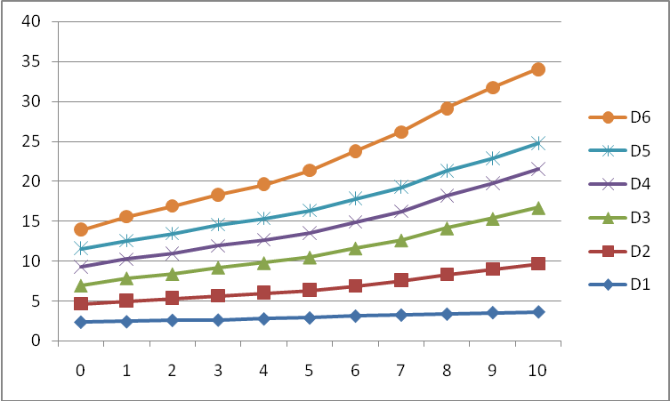
Weeks
Figure 1: Mean weekly growth responses of O. niloticus fed diets containing different levels of cottonseed and palmkernel cakes for 70days.
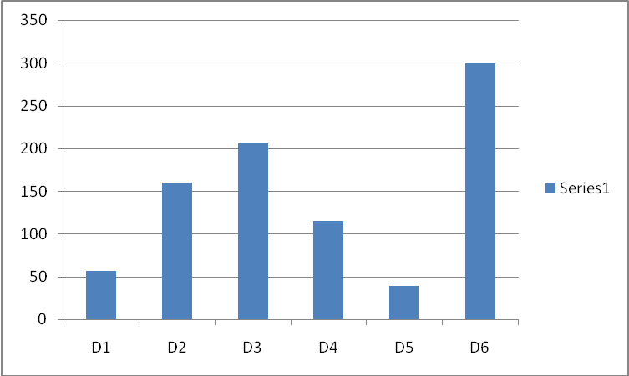
Diets
Figure 2: Percentage weight gain of O. niloticus fed diets containing different levels of cottonseed and palmkernel cakes for 70days.

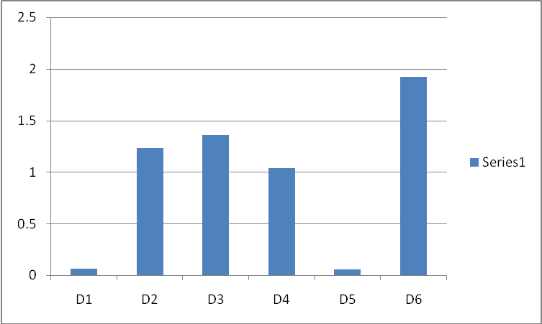
Diets
Figure 3: Mean growth rate of O. niloticus fed diets containing different levels of cottonseed and palmkernel cakes for 70days.

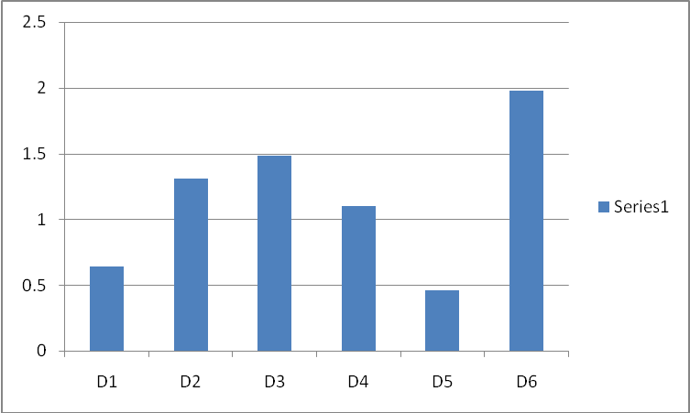
Diets
Figure 4: Specific growth rate of O. niloticus fed diets containing different levels of cottonseed and palmkernel cakes for 70days.

This fish fed on diet D₆ ranked next to those on the control diet, while the least growth performance occurred in diet D₅.
Statistical analysis using the analysis of variance (ANOVA) and least significant difference (LED) showed that there were gains in the differences (P < 0.05) among the percentage weight gains in the different groups of fish fed the different test diets. The fish on control diet D₆ had the highest percentage weight gain followed by those on D₃, while the least occurred in fish fed diet D₅.
There were significant difference (P<0.05) between the mean growth rates of fish fed the control and those fed on the test diets. The best mean growth rate among the fish fed the diets containing supplementary protein sources occurred in diet D₃, although this was not significant (P 0.05) from those fed D₂. There were no significant difference (P > 0.05) in those fed diets D₁ and D₅.
Significant differences (P< 0.05) exist in the specific growth rate of fish fed different experiment diets.
3.6 Feed Utilization Parameters
3.6.1 Food Conversion Efficiency (Fce)
The highest food conversion efficiency was recorded in fish fed control diet D₆, followed by those in diet D₃. The least food conversion efficiency occurred in fish fed diets D₅ (Fig. 5).
The food conversion efficiency values were found to be significantly different (P < 0.05) among the fish fed different diets. Increasing palmkernel cake and reducing cottonseed up to diet D₃, increased the food conversion efficiency. Thereafter, it started to decrease in the fish fed cottonseed and palmkrnel based diets.

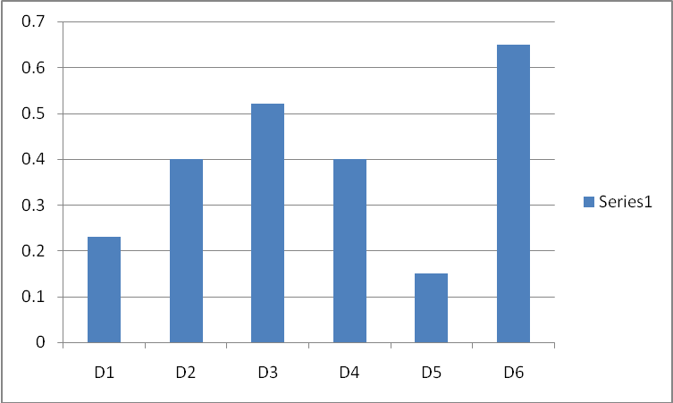
Diets
Figure 5: Food Conversion Efficiency in O. niloticus fed cottonseed and palmkernel based diets for 70days.

3.6.2 Protein Efficiency Ratio (Per)
The control diet D₆ gave the highest protein efficiency ratio, followed by the fish fed diet D₃’ with the least occurring in those on diet D₅ (Fig. 6). The protein efficiency ratio values for fish fed on diets containing cottonseed and palmkernel cakes were significantly different (P < 0. 05) from that of the fish fed the control diet D₆. Those fed on diets D₂ and D₃ were not significantly different (P > 0.05). These were however, found to be significantly different from those of diets D₁ and D₃. Protein efficiency values increased with increased palmkernel and decrease palmkernel up to diet D₃.
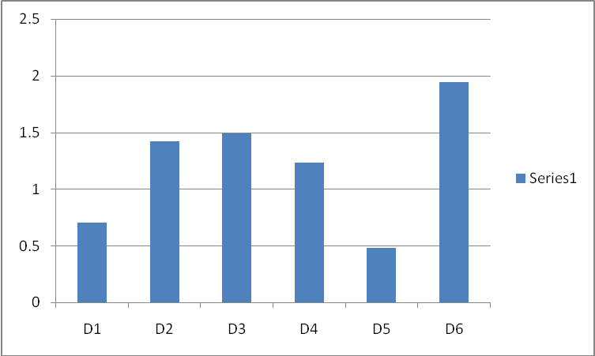
Diets
Figure 6: Protein Efficiency Ratio in O. niloticus fed cottonseed and palmkernel based diets for 70days.

3.6.3 Appendix Net Protein Utilization (Anpu)

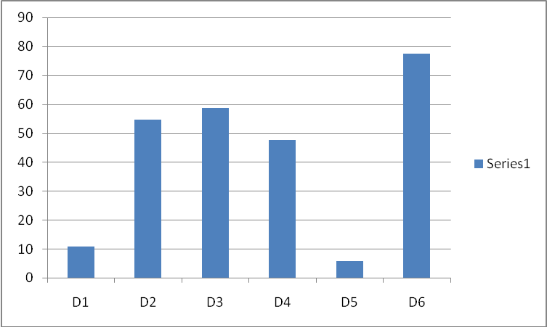
Diets
Figure 7: Apparent net Protein Utilization in O. niloticus fed cottonseed and palmkernel based diets for 70days.

The values of apparent net protein utilization indicates that protein was better utilized in fish fed diet D₆ (control), followed by those fed diet D₃. The least protein utilization occurred in those fed diet D₅ (Fig. 7).
Significant differences (P 0. 05) were found among the ANPU values of fish fed the different experimental diets.

3.7 Nutrient Digestibilty
The best apparent percentage protein digestibility of 85.79% was obtained in fish fed the fish meal control diet (D₆) (Fig. 8), while the poorest was recorded in palmkernel diet (D₅), with percentage digestibility of 31. 27%. An inverse relationship existed between the percentage apparent protein digestibility and percentage crude fibre content of the experimental diets (Table 3). Fish fed diet D₃ (28.80%cottonseed and 28.80% palmkernel) cakes ranked next to those on the control diets with digestibility values of 74.52%.
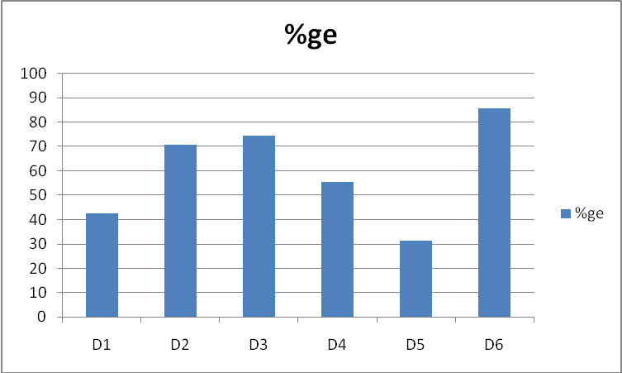
Diets
Figure 8: Apparent protein digestibility in O. niloticus fed diets containing different levels of cottonseed and palmkernel cakes for 70days.

Those fed on diets D₂ (31.62% cottonseed and 21.90% palmkernel) cakes and D₄ (22.98% cottonseed and 31.62% palmkernel) cakes had digestibility value of 70.79% and 55.43% respectively.
Statistical analysis of apparent protein digestibility showed significant difference (P < 0.05) between the fish on the control diet and the fish fed on the other diets. However, there was no significant difference (P 0.05) between the fish on diet D₃ and D₄.
The best apparent percentage carbohydrate digestibility of 86.42% was also observed in fish fed the control diet (D₆) while those fed on diet (D₂) ranked next with digestibility value of 75.54%. The least was observed in those fed palmkernel diet (D₅) with digestibility value of 47.12%. Those fed on diets D₂ and D₄ had apparent carbohydrate digestibility of 71.84% and 62.42% respectively (Fig. 9).
The carbohydrate digestibility seems to have a linear relationship with the level of digestible carbohydrate present in the experimental diets (Table 3). Statistical analysis of apparent carbohydrate digestibility showed that the fish fed on the control diet (D₆) differed significantly (P 0.05) from the fish fed on the other diets. Significant differences were also found among the other fish fed diets D₁, D₂, D₃, D₄ and D₅.
In comparative terms, dietary digestible carbohydrate was found to be relatively more digested then the dietary protein.
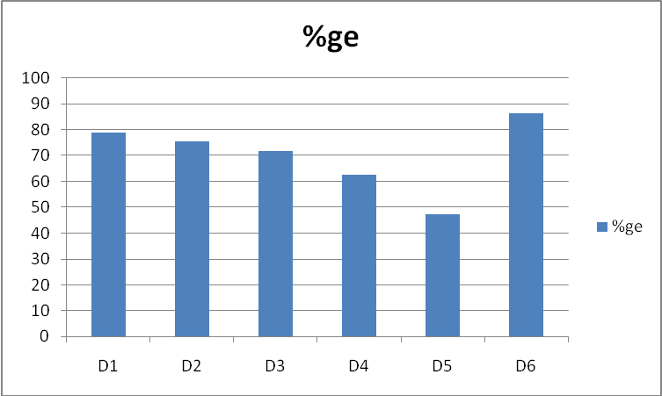
Diets
Figure 9: Apparent Carbohydrate digestibility in O. niloticus fed diets containing different levels of cottonseed and palmkernel cakes for 70days.

Discussion And Conclusions
Generally, the research involving the use of cottonseed and palmkernel cakes as supplementary source of protein to Oreochromis niloticus, showed some clear trends.
The seen weekly water temperature of 24.65ºC and dissolved oxygen of 6.91mg/l are within the optimal tolerance range for tilapia species (Dekimpe and Micha, 1974; Shireman et al, 1977).
The growth responses observed in Oreochromis niloticus were found to have a direct relationship with the proximate compositions of the experimental diets. The averaged protein level of 35.74% in the experimental diets was the optimal protein level for the growth of tilapia species ranging from 0.5-35 (Jauncoy and Rose, 1982), while the energy levels of 382.9460 kcal/100g diet to 453. 9340 kcal/100g diet were within the optimum energy level for the culture of carp and similar species (Takeuchi et al, 1979). The quality of protein in the different experimental diets might have played a major role in the differential growth observed in O. niloticus, since the diets were isonitrogenous and isocaloric.
The percentage weight gain of the fish fed fishmeal control diet was significantly higher (p< 0.05) than those of other fish. The agreed with the work of wee et al (1986) and Ofojekwu (1989) who observed a better growth response on fish fed fishmeal diet, than those containing plant protein sources.
As the level of cottonseed and palmkernel cakes increased, up to diet D₃, the growth rate increased, This trend might have to do with the individual nutrient quality in these two ingredients. From the proximate compositions of the experimental diets (Table 2), it could be observed that the level of dietary fibre increased with increase in the level of palmkernel. The optimum growth recorded in diet D₃ must have resulted from the optimum dietary fibre of 14.33% in this diets which enhances the digestibility of nutrients in fish fed this diet. This was within the recommended dietary fibre level of 15-20% in herbivorous fish diets (Edwards et al (1985). Furuichi and yone (1989) observed that low levels of dietary fibre helped to increase digestibility of nutrients through increased gut transit time and enzymatic activity. Jauncey and Ross (1982) observed that despite the high quality protein of palmkernel cake, it could be a promising source of protein for fish diets at low inclusion levels with adequate supplementation with fishmeal. This was as a result of impalatability and high fibre content of palmkernel
Cottonseed cake on the other hand has a lower fibre content and more limiting amino acids than palmkernel (Cohi,1981). Despite the more limiting amino acids in cottonseed, it has been found to be more palatable than palmkernel cake (Gohi 1981). But O. niloticus being a herbivore, would have been expected to thrive best in the diet containing the highest level of dietary fibre. This was explained by Stickney and Shuway 1974; Buddington 1980; David et al, 1985; and Furuichi and Yone 1989, when they noted that high level of cellulose in herbivorous fishes impaired digestibility and assimilation of nutrients due to limited ability of the fish to maintain balance symbiotic bacteria capable of hydrolyzing cellulose.
The toxic gossypol content and limiting amino acids of cottonseed, had no adverse growth effect on O. niloticus, probably due to the treatment it was given and its supplementation with lysine and methwonine content of the vitalyte. This was in consonance with the work of Herman (1980) Jauncey and Ross (1982), who noted that the gossypol content of cottonseed had no depressive effect on the growth of tilapia.
The growth responses of fish fed only cottonseed diet D₁ and palmkernel diet D₅ were significantly different (>0.05), from those fed combination of cottonseed, palmkernel and fish diets. This was in consonance with Jauncey and Ross (1982) who observed that no single oilseed can completely supply the protein requirements of tilapia. Igbinosun 1976; Bryant et al, 1980, and Jauncey and Ross 1982, suggested combination of various sources of protein to compensate for the individual differences.
The percentage weight gain of 38.62% obtained with palmkernel diet D_{5,} differed from the 50% obtain by kamara (1982) on S. niloticus. The difference could be attributed to the 50% level of protein he used, against the 33.73% used in this experiment. Differences could also arose from the initial size of the fish, and experimental period.
The best food conversion efficiency of 0.65 obtained in fishmeal diet D₆’ could be attributed to the high quality of protein of fishmeal, low level of fibre and appropriate level of carbohydrate in the fishmeal diet. The low food conversion efficiency values obtained in diets containing cottonseed and palmkernel cakes at high inclusion levels could be attributed to the findings of Bromley and Adkins (1984); Appler 1986; Alexis et al 1986; and Wee and Wang 1987 who reported reduced growth and feed conversion efficiency in diet with high level of plant protein incorporation. Poston (1986), also noted suppressed growth and feed conversion efficiency in lake trout, salvelinus namacycysh fed high levels of plant protein sources.
The best protein efficiency ratio of 1.94 was recorded in the fishmeal control diet. This was found to be significantly different (P < 0.05) from other fish, fed the supplementary protein sources. Protein efficiency ratio of 1.94 in the control diet compared favourably with that of Mazid et al (1979) and Jauncey and Ross (1982). For T. Zilli and S. Mossambicus respectively. Increasing the palmkernel component of the diets resulted in increased protein efficiency ratio up to diet D₃ where it started decreasing. The utilization of a diet depends on the degree of digestion. Low digestibility and hence feed utilization obtained at higher levels of palmkernel substitution might be attributed the complex structural carbohydrate present in palmkernel (kamara 1982).
The highest apparent net protein utilization of 77.38% recorded in fishmeal control diet indicated that protein was better utilized by fish fed on this diet, that those fed on diet containing supplementary protein sources. Ufodike and Matty (1983) obtain the highest apparent net protein utilization of 46.10% on fish fed fishmeal diet than those fed on cassava and rice based diets. This is due to the higher quality of amino acids in fishmeal than in the plant substitutes.
The increase in the final carcass protein, with increased percentage weight gain, recorded in the experiment, has been reported by nose and Aral 1972 and Takeda et al 1975/. Also the decrease in by Ufodike and Watty (1983). The inverse relationship between moisture content and lipid content recorded in the final carcass of experimental fish has been reported by other worker like Jauncey (1981), Winfree and Stickney 1982 and Appler, 1985.
The protein digestibility value of 85.75% recorded in fishmeal control diet compared favourably with 87% for Tilapia aurea (poman, 1982), while 74.52% recorded in diet D₃ compared with the protein digestibility of Nenhaded fishmeal which was 74% for channel catfish (Ictalurus punctatus (NRC1977).The non-significant difference (p>0.05)observed between the protein digestibilities of fish fed diet D₂ and D₃ could attributed to the work of Davis (1985), who observed that inclusion of 15-20 dietary fibre improves digestibility. The highest value of protein digestibility obtained in the fishmeal control diet might have resulted from the low fibre content and high quality amino acids in the diet. (Kita Mikado et al 1964).
The best carbohydrate digestibility of86.42%obtained with the fish meal control diet could be attributed to the level of digestible carbohydrate of 28.12% present in the diet.
Ufodike and Matty 1983; Anderson et al 1984; wee and Wang 1986 have reported inclusion of high level of carbohydrate of 45% in diet for herbivorous fish species to increase carbohydrate digestibility. The 86.46% carbohydrate digestibility obtained in the fishmeal control compared favourably with the 80.7% carbohydrate digestibility obtained in a diet containing 17% digestible carbohydrate (Ufodike and Ekokotu, 1988). The least carbohydrate digestibility of47.12% recorded in diet D₅ containing the least digestible carbohydrate agreed with the work of Onwuka (1980); who noted least carbohydrate digestibility of 17% in diet containing the least hydrolysable carbohydrate of 3%.the influence of crude fibre on carbohydrate digestibility was not noticed as in Takeuchi et al (1979).
Of all the six diets fed to O. niloticus, diet D₅ appeared to be the most inferior based on the least percentage weight gain, mean growth rate, specific growth rate, food conversion and protein efficiency ratio, when compared with those if the other diets. The inadequacy of the diet could be attributed to its low palatability resulting from high fibre content. Diet D₃ and D₂ gave fairly good results when compared to the control diet D₆. In view of the relative cheapness of cottonseed and palmkernel cakes, the growth performances recorded in D₃ andD₂ are recommendable when compared to the high cost of fish meal.
Based on these findings diet D₃ could be conveniently recommended as suitable diet for the rearing of Oreochromis niloticus weighing 2.0 - 2.4g. from the study, the following general conclusion could be drawn. Significant growth in O. niloticus could only be obtained with palmkernel diet at low inclusion with adequate supplementation with fishmeal.
The relatively poor growth performance of fish fed cottonseed cake diet, did not suggest it, to be very good diet for the experimental, except if adequately supplemented with fishmeal.
The appreciable growth recorded in diets D₃ andD₂ when compared with the control fishmeal diet D₆’ suggested that these two diets were possible combinations of cottonseed and palmkernel for the culture of fingerling of O. niloticus.

References
- Alexis, M. N., Theochari.V. and Papaparasckova-papou-Esoglou, E. (1986): Effect of diet composition and protein level on growth, body composition, haematological characteristics and cost of production of rainbow trout salmo qairdneri. Aquaculture, 58: 75 - 86.
- Anderson, N.H.H.J. Jackson, A.J. Matty, B.S. Capper (1984): Effects of dietary carbohydrate and fibre on the Tilapia Oreochromis nitoticus L. Aquaculture. 37: 303 – 314.
- Annon (1965). Carp farming on the Jos Plateau, Bull, de V FIFA an txxu ser. 1: 285 – 298.
- AOAC (Association of Official Analytical Chemist), (1980): Official methods of analysis of the AOAC (W. Horwits Ed.) Washington, D.C. 125 – 291, 858pp.
- Appler, H.N. (1985): Evaluation of Hydrodiction reticulatium as protein source in feeds of oreochromis (Tilapia) nitoticus and Tilapia zilli journal of fish Biology 27: 327 – 334.
- Barash, H. (1984). Growth rates of young tilapia fingerlings fed on commercial ed and trout diets. Bamidgeh 36: 70 – 79.
- Bard, J. Dekimps, P. Lazard, J., Lemasson, J. and Lessent P. (1976): Handbook of tropical fish culture. C.T. P. T., France, 165p.
- Bardach, J.E., Ryther, J.H. and Malarney, W.O. (1972): Aquaculture: the farming and husbandary of freshwater and marine organisms.
- Dabrowaki K. (1977): Protein requirements of grasscarp (ctanopharyngodon idella val). Aquaculture. 10. 63 – 73.
- Davis S. J. (1985): The role of dietary fibre in fish nutrition p. 219 – 249. In: Roberts R.J. and J. F. Muir (Eds) Recent advances in aquaculture west view press London. 282p.
- Delampe, P. and Micha, J.C, (1974): 1st guidelines for the of C. Lasera in central Africa. Aquaculture 4: 227 – 348.
- Del-Silva, S.S. (1985): Body composition and nutritional ecology of O. Massambicus population of manmade lake in Sri-Lanka. J.Fish Biol. 27: 621 – 633.
- Dorsal, W.J. Robinnette, H.R. Robinsson, E. H. and P.D.E, W.E. (1982): Effects of dietary cottonseed meal and gossypol on growth of young channalcatfish. Trans. Am. Fish. Soc. 111: 651 – 655.
- Edwards, P.M.M. Kamal and K.L. Wee (1985): Incorporation of compost and dried water hyacinth in pelleted feed for the tilapia Oreochromis nitoticus. Aqua. And Fish. Mang. 1: 233 – 248.
- Edwards, P.M. and Horn, M.H. (1982): Assimilation efficiency of a temperate zone, intertidal fish (cobiclicthyes violacaus) fed diets of marcoalgae. Mar. Biol. 67: 247 – 253.
- Edwin N. Robinson and Poe, W.E. (1982): Effects of dietary cottonseed meal and gossypol on the growth of channel catfish. Trans. Am. Fish, soc. 111: 651 – 655.
- Ejike, C. and Ofojekwu, P.C. (1982): Growth responses of Cyprinus Carpio fed on locally formulated artificial diets. Paper presented at 2nd Ann. Conf. Fish. Soc. Nig.
- Ejike, C. and Ofojekwu, P.C. (1984): Growth response and feed utilization in the tropical cichlid Oreochromis niloticus (Linn) fed cottonseed based diets. Aqua. 82: 27 – 36.
- Esin, J.O. (1980): Fish culture at the Bandel Tiferny Farm, Aviara fish farm. Nat. Sem. On Fish Res. and Dev in the eighties at the University of Ibadan Nigeria. Pp.15.
- Fagbenro, O.A. (1988): Evaluation of cottonseed cake as fish feed and pond fertilizer in the production of non-cichlid fishes. Nig. J. Appl. Fish and Hydrobiol. 3, 9-14.
- Fateroti, E.O. and Akinbode, R.E. (1986): Growth responses and nutrient utilization in Oreochromis niloticus fed varying levels of dietary cassava peel. Nig. J. of APpl. Hydrobiol.. and Fish. 1: 47 – 50.
- Fateroti, E.O and Balogun, A.M and Ugwu, L.L.C. (1986): Nutrient utilization and growth responses of Clarias (Clarias lazera) fed different dietary protein levels. Nig. J. APpl. Hydrobiol. And Fish. 1: 45 – 50.
- Fowler, L.G. (1980): Substitution of soyabean and cottonseed products for fish meal in diets fed to chinhook and coho salmon. The Prog. Fish. Cult. 42: 92 – 97.
- Furukawa, A. and Tsukahara, R. (1966): Acid digestion method for the determination of chromic oxide as an index substance in the study of digestibility. Bull. Jap. SC. Scient. Fish. 32: 502 – 506.
- Furulehi, H.O. and Yone, Y. (1982): Bull. Jap. Soc. Scient. Fish. 48: 945.
- Furulehi, H.O. and Yone, Y. (1982): Change of blood sugar and plasma insulin level in fish in glucose tolerance test Bull. Jap. Sec. scient. Fish. 47: 761 – 764.
- Jackson, A.J. Capper, B.S. and Matty, A.J. (1982): Evaluation of some plant proteins in complete diets for the Tilapia (Sarothelodon mossambicus). Aquaculture. 27: 97-109.
- Janucey, K. (1981): The effect of varying dietary protein level on the growth, food conversion, protein utilization and body composition of juvenile Tilapia (Sarotherodon mossambicus). Aquaculture 27: 43 – 54.
- Janucey, K. and Ross, B. (1982): A guide to Tilapia feeds and feeding. Institute of aquaculture, University of Stirling, Scotland, U.K.
- Jobling, M. (1981): Dietary digestibility and the influence of food components on gastric evacuation on place. Pleuronectes platessa L. J. Fish. Biol. 19: 29 – 36.
- Kamara, B.K.A. (1982): Evaluation of some oil seed meal protein in complete diets for Tilapia (Oreochromis nitoticus) M.Sc. Thesis, University of Stirling.
- Kitamikado, M. Morishita, T. and Techino, S. (1964): Digestibility of diatary protein in rainbow trout. (Bull.Jap.Soc.Scienc.Fish. 29: 242 – 244.
- Kolawole, C.O. (1982): Preliminary studies on the dual role of cottonseed cake as fish food and fish pond fertilizer. In: Proceedings of 2nd Ann. Confr. Of Fisson (Fisheries Society of Nigeria) Calabar, (1982). Pp 128 – 134.
- Lagler, K.F. Bardach, J.E. Miller, R. R. and Passino, C. R.M. (1977): Ichthyology. Willey and sons New York 365pp.
- Lovell, R.T. (1961): Cottonseed meal in fish feeds. Reprinted from feedstuffs 63 (52): 28 – 29.
- L.J Loosil, H. hints and warner R.G. (1979): Animal nutrition. 7th Edition, McGraw – Hill Inc. 13 – 14: 89-90. Inc. 13---14; 89-90opp.
- Matty, A. J. (1985): Nutrition and Aquaculture. Outlook on Agriculture, vol. 14 No. 1: 14 - 20.
- Mazid, M. A Tanaka, V., Katayama, T., Asadr-Rahman, M., Simpson, K. l., and chickester, c.o. (1989): Growth response of I, Zilli fingerlings fed isolaloric diets with variable protein levels. Aquaculture 18: 115 – 122.
- Mesk, C. (1985):Fish Aquaculture Technology and Experiments. Pergramon press Ltd. England.
- Milikan, M. R. (1982): Effects of dietary protein concentration on growth, feed efficiency and body composition of age -0 stripped bass. Trans. Am. Fish. Soc. 111: 373 - 378.
- Miler, J. W. (1975): Fertilization and feeding practices in warm- water pond fish culture in Africa. FAO/CIFA Symposium on Aquaculture in Africa, Accra Ghana, CIFA/T 4, PP 512-541.
- MIRES, D. (1983): Current techniques for the mass practiced at EIN HAMIFRATZ FISH HATCHERY Bamidgeh. 35: 3 - 8.
- Nose, T. and Arai, S. (1972): Optimum level of protein in purified diet for ed Anguilla japonica. Bull. Freshwater Res. Lab Tokyo. 22: 145 - 154.
- NRC (1983): (Nutrient Requirement of warm-water fishes and shell fishes). National Academy of sciences, wash. D.C. 94PP.
- Ofojekwu, P. C. (1989): Feed utilization in a Tilapia species Oreochromis niloticus (Trew). Phd Thesis, university of Jos. 237pp.
- Ogusie, F. (1982): Aspects of fed behavior end chymotrypsin activity in the cichlid sarotherodon niloticus (Trewavas) University of Jos, Nigeria.
- Onwuka. E. B.C. (1980): The utilization of dietary carbohydrate by trout and carp. Ph.D Thesis, Aston University, Birmingham.
- Oyetayo, A. S. (1985): The use of locally available materials in fish feed production In: Proceedings of the 4th Ann. Confr. Of the Fisheries Society of Nigeria (FISSON) – Port Harcourt, 26th – 29th November, 1985.
- Page, J. W. and Andrews, J. W. (1973): Interaction of dietary levels of protein and energy on channel catfish letaturus punetatus. J. Nutr. 103: 1339 – 1346.
- Partastico, J. B., Baldia, J. P. and Reves, D. M. (1986): Feed preference of milkfish (Chapps chands) fry gives different algal species as natural feed. Aquaculture. 56: 169 – 178.
- Philips, A. M. (1972): Calorie and energy requirements In: Fish Nutrition. (Halver, J. E. ed) pp 2 – 29. Academic Press – N. Y.
- Prather, E. E. and Lovell, R. T. (1978): Response of intensively fed channel catfish to diets containing various protein – energy ratio. Proc. Am. Confr. S.E. Assoc. Game Fish Comm 27: 455 – 459.
- Popman, T. J. (1982): Digestibility of selected feedstuff and naturally occurring algae by Tilapia. Ph.D Diss. Aubum University Alabama. 78pp
- Poston, M. R. (1986): The impact of planktivorous fish on the structure of plankton community. Freshwater Biol. 17: 79 – 89.
- Prejs, A. and Blasczczyks, (1977): Relation between food and cellulose activity in freshwater fishes, J. Fish. Biol. 11: 447 – 452.
- Reinitz, T. R. (1980):Freshwater fish in: Tuinms, D. W. G (ed): The stirling region, striling university for the British Association -283pp.
- Robinson, E. H.,R. P. wilson and K. E. poe (1980):re-eveluation of lysime requirement and utilization by channel catfish fingerlings. J. nutr. 110.: 2313-2316.
- Robinette, H, R. (1981): Use of cottonseed meal in catfish feeds. Proc. Catfish farmers of Am. Res. workshop 3: 26.
- Ringrose, R. C. (1971): Calorie to protein ratio for brook trout salvelinmus fontinalis, j. fish. Res.Bd. can. 28:1113-1117.
- Roehm J. N., D. J. Lee, and R. O. sinnhuber (1967): Accumulation and eliminating of dietary gossypol in the organs of rainbow trout. J. Nutr. 92: 425- 428.
- Rumsy, G. L. and H. G. Ketola (1975): Amino acids supplementation of casein in diets of Atlantic salmon (salmo salar) fry and of soy abeam meal for rainbow trout (salmo gaidner i) fingerlings. J. fish, Res.Ed. can. 32(3): 422-426.
- Sagua, V. O. (1976): Aquaculture and fishery development in Nigeria- A review paper, proceedings of 12th Ann. Conf. of Agric. Soc. Of Nig. Iie- lfe, 1976.
- Shireman J. V. Cole and Rottman R. W. (1977): intensive culture of grasscarp (ctenophanyngodon idelis) in circuler btanks. J. Fish. Boil. 11:267-273).
- Snood, K. E., Hastings, W. A., and K. H. Dupres (1972): Accomplishment and future priorities in warmwater fish nutrition Prog. In fisheries and food science University of Washington Publ. fish. New series 5:151 – 157.
- Spalaru, P. (1976): Natural feed of Tilapia aurea steindachner in polyculture with supplementation feed and intensive manuring. Bamidgeh, 25: 57 – 63.
- Stickyney, R. R. and Shumoray, S. E. (1974): Occurrence of cellulose activity in the stomach of fishes. J. Fish. Bio. 11: 447 – 452.
- Smith, R. R. (1977): A recent research involving sorabean meal in salmonid diets. Salmonid. 1 (4): 8 – 18.
- Takeuchir. T. Wantanabe, T. and Ogino, C. (1979): Availability of carbohydrate and lipid as dietary energy sources for carp. Bull. Jap. Soc. Scient. Fish. 45: 977 – 982.
- Takedo, M. Shimeno, S, Hosokana,. H., Hedetoshi, K. and Kaisyo, T. (1975): The effect of dietary calorie to protein ration on the growth, feed conversion, and body composition of young yellowtail. Bull. Jap. Soc. Sci. fish. 11: 141 – 147.
- Tanskley, T. D. (19710): Use of cottonseed meal in sivine rations. Feedstuffs. 42: 22- 23.
- Trewavas, E. (1972): The cichid fishes of the genus- pelmatochromis, the relationship between pelmatochromis and the recognition of sarotherodon as a district genus. Bull. British musieum natural history (zool). 25: 1-26.
- Tunison, A. V and Mecay c. M. (1940): Nutritional requirement of trout – Trans. Am. Soc. Fish. 65: 359-373.
- Ufodike, E. B. C. and Akombo, p. m. (1987): Effects of food and photoperiod of nutrient digestibility, protease activity and growth of the African catfish (clarias lazera). Nig. J. appl. Fish. Hydrobid. 2: 73-79.
- Ufodike, E. B. C and Ekokotu, p. a (1986): Protsin digestibility and growth of African catfish (clarias lazera) fed blood meal and algal diets. Act. Hydrobiol. 28: 237-243.
- Ufodike, E. B. C. and Matty, A. J. (1983): Growth responses and nutrient digestibility in mirror carp (cyprinus crapio) fed different leves of cassava and rice. Aquaculture, 31: 41-50.
- Ugwuzor, G. N. and Ufodike, E. B. C. (1983): Effects of cowblood meal, fish meal and sorglum diets on growth and tissue composition. Paper presented at the 3rd annual conference of fisheries society of Nigeria (FISSON).
- Viola, S. and Arieli, V. (1983): nutrition studies with Tilapia (sarotherodon): Replacement of fish meal by soyabean meal in feeds for intensive tilapia culture. Bamidgeh, 35: 9-17.
- Watts, A. B. (1970): Use of cottonseed meal in young chicken rations. Feedstuffs, 42: 23-24.
- Warren, C. E. J. H. Wales, G. E. Davis and p. Doudroff (1982): laboratory studies on the feeding, biogenetics and growth of fish. Pp 175-214. In: Gerking, S. D. (ed) / The Biological basis of freshwater fish fish production. Blackwel Scientific Publication, Oxford.
- WEE, K. L., Kerdchuen, N. and Edwards, p. (1986): Use of waste growth tilapia silage as feed for clarias batrachus L. J. Aquacult. Trop. 38: 40-49.
- Wee, K. and L. T. NG (1986): Use of cassava as an energy source in a pelleted feed for the Tilapia Oreochromis niloticus. Aqua. Fish. mgt. 17: 129-138.
- Wee, K. L. and Wang, S. (1987): Nutritive values of Leucaena leatmeal in pelleted feed for nile Tilapia. Aquaculture 62: 97-108.
- Wilson R. P., W. E. Poe and E. H. Robinson (1981): Amino acids requirements and utilization of feed grade lysine in practical diets by channel catfish. proc. Catfish farmers of America Research workshop. 3: 27.
- Winifred, R. W. and Stickney, R. R. (1981): effects of dietary protein and energy on growth, feed conversion efficiency and body composition of Tilapia aurea. J. Nutri. 111: 1001 – 1012.
- Windel, J. T. Foltz, J. W. and Sarokon, J. A. (1978): Method of fecel collection and nutrient leaching in digestibility studies. Prog. Fish. Cult. 40: 51 – 55.
- Wolf, L. F. (1952): Some pathological symptoms in brown trout on an all-seal diet. Progressive fish culturist. 14: 110 – 112.
- Wu, J. and Jan. L. (1977): Comparison of the nutritive value of dietary proteins in Tilapia aurea. J. Fish. Soc. Of Taiwan. 5: 55 – 60.

8/3/2014

