Effect Of Two Plant Extracts and Four Aromatic Oils on Tuta Absoluta Population and Productivity of Tomato Cultivar Gold Stone

Hussein, Nehal, M. ¹, M.I. Hussein², S.H. Gadel Hak³and M.A. Hammad²

¹ Plant Protection Institute, ARC, Dokki, Giza, Egypt.
² Department of Pant Protection Dep., Fac. of Agric., Ain Shams Univ., Shoubra El-Kheima, Cairo, Egypt.
³ Horticulture Dep., Fac. of Agric. Minia Univ., Minia, Egypt.
nehalmostafa2010@yahoo.com

Abstract: Plants extracts and essential oils were used in pest management in different crops against various pests. Under field conditions, we examined the effect of two plants extracts and four essential aromatic oils on the response of tomato hybrid cultivar Gold Stone to Tuta absoluta infestation. Also, their effects on some growth characteristics of tomato plants as well as their total phenolic compounds and total flavonoids contents were explored in the two successive summer seasons of 2011 and 2012. The treatments were Lemon grass extract (Cymbopogon citratus) at 25 gm /L., Garlic extract (Allium sativum) at 5ml / L., Eucalyptus oil (Eucalyptus spp.) at 0.5%, Rue oil (Ruta graveolens) at 0.5%, Anise oil (Ocimum basilicum) at 0.5%, Basil oil (Pimpinella anisum) at 0.5%. Ethyl acetate (Solvent) and tap water (Control). The plants were sprayed three times at two week intervals starting after 40 days from transplanting. All treatments reduced population density of Tuta absoluta significantly. The highest reduction was recorded by garlic extract followed by lemon grass extract and basil oil. Lemon grass extract significantly increased L-ascorbic acid (Vitamin C) contents in tomato fruits followed by basil oil. Also, garlic extract increased the yield of tomato significantly followed by eucalyptus oil in the first season while in the second season, anise oil followed by garlic extract were insignificantly increased the fruit yield than the other tested treatments. On the other hand, garlic extract recorded the highest values of total phenolic compounds (TPCs) and total flavonoids (TFs) in unifested and infested – treated tomato leaves.
[Hussein, Nehal, M., M.I. Hussein, S.H. Gadel Hak and M.A. Hammad. Effect Of Two Plant Extracts and Four Aromatic Oils on Tuta Absoluta Population and Productivity of Tomato Cultivar Gold Stone. Nat Sci 2014;12(8):56-66]. (ISSN: 1545-0740). http://www.sciencepub.net/nature. 9

Key words: Lemon grass extract (Cymbopogon citratus), Garlic extract (Allium sativum), Eucalyptus oil (Eucalyptus spp.), Rue oil (Ruta graveolens), Anise oil (Ocimum basilicum), Basil oil (Pimpinella anisum), Tuta absoluta, Tomato.

1.Introduction
Tomato leafminer, Tuta absoluta Meyrick (Lepidoptera: Gelechiidae) is an important pest of tomato (Clarke, 1962; Garcia and Espul, 1982; Notz, 1992 and Hussein et al., 2014). After its initial detection in eastern Spain in 2006, it rapidly invaded various other European countries and spread throughout the Mediterranean basin (Desneux et al., 2010). Currently, Egyptian tomato fields were infested with Tuta absoluta since 2009 and it became one of the economic pest of tomato and other Solanaceous plants (NAPPO, 2012). T. absoluta larvae can cause yield losses of up to 80 - 100% by attacking tomato leaves, flowers, stems, and especially fruits of tomato crops in both greenhouse and open field tomato (Picanco et al., 2007 and Desneux et al., 2010). Synthetic pesticides are currently the most effective means of pest control. However, the unceasing and indiscriminate uses of these substances have not only caused adverse effects on mammals' health, but have also affected many other non-target organisms (Bughio and Wilkins, 2004). They are also responsible for the development of insecticide-resistance phenomenon (Suinaga et al., 1999; Lietti et al., 2005). However, extracts and pure compounds isolated from different plants could be used for controlling insect pests. Natural product-based pesticides can sometimes be specific to the target species and have unique modes of action (Duke et al., 2003). Plant products have several uses in insect control (Trindade et al., 2000; Moreira et al., 2004; Farghaly et al., 2009; Moreno et al., 2011; Salari et al., 2012). These products have also been studied for acute toxicity, antifeedant, or repellent, and fumigant effects, as well as inhibiting reproduction of many pest species (Cox, 2004; Kubo, 2006 and Ben et al., 2010). Some of tropical plants extracts were used for pest control as Acmella oleracea extract which showed high insecticidal activity and could be used to control Tuta absoluta (Moreno et al., 2011). However, plant extract can be increased capability for activating defense responses of plants. Aqueous leaf extract of neem might be stimulate the plant natural defence response and provided the control of pathogen that its extract led to the changes in plant metabolism and exhibited high level of enzymes and content of phenolic compounds (Guleria and Kumar, 2006). Therefore, neem, pepper and garlic bulb extracts have been reported to be effective against some crop pests species (Jackai and Oyediran, 1991; Oparaeke et al., 2000 and Ahmed et al., 2009). Also, garlic and ginger extracts were much effective against some pests of cowpea (Panhwar, 2002; Ahmed et al., 2009 and Ben et al. 2010). Garlic showed the highest effects on T. absoluta second instar larvae while, basil leaves extract exhibited the least effect (Ghanim and Abdel Ghani, 2014). On the other hand, essential aromatic oils were used for control many pests on various crops. Further, while resistance development continues to be an issue for many synthetic pesticides, it is likely that resistance will develop more slowly to essential-oil-based pesticides owing to the complex mixtures of constituents that characterize many of these oils (Koul et al., 2008). Whereas, Gorski and Tomczak (2010) used basil oil, citronella oil, eucalyptus oil, juniper oil and patchouli oil, in the control of foxglove aphid. The strong adverse effects of J. excelsea, J. oxycedrus, F. vulgare, P. anisum, R. officinalis, J. regia and L. nobilis essential oils were showed on the reproductive performance of cabbage aphids (Işık and Görür, 2009). Other essential oils from various plants such as lemon grass (Cimbopogon winteriana), Eulcalyptus globulus, rosemary (Rosemarinus officinalis), vetiver (Vetiveria zizanoides), clove (Eugenia caryophyllus) and thyme (Thymus vulgaris) are known for their pest control properties. While peppermint (Mentha piperita) repels ants, flies, lice and moths; pennyroyal (Mentha pulegium) wards off fleas, ants, lice, mosquitoes, ticks and moths. Spearmint (Mentha spicata) and basil (Ocimum basilicum) are also effective in warding off flies (Koul et al. 2008 and Koul and Walia, 2009). Thrips can be significantly reduced when plants sprayed with the combination of essential oils and kaolin especially tea tree oil (Reitz et al.,2008) or with leaf extract mixtures of Neem + Eucalyptus, Neem + lemon grass, Neem + bitter leaf, Neem + tomato, and Eucalyptus + African curry (in that order) than on unsprayed plants (Oparaeke et al.,2005). Eventhough both essential oils of Eupatorium buniifolium and Artemisia absinthium chemically differed, they exhibited insecticidal and antifungal activity not only by direct contact but also by contact with their vapors against the tested organisms,Trialeurodes vaporariorum and Tuta absoluta, and the fungi Alternaria spp. and Botrytis cinerea (Umpiérrez, 2012). In this experiment, two plants extracts and four essential aromatic oils were evaluated to identify their impact on the population densities of Tuta absoluta tomato pest as well as their effects on the growth and yield of tomato cv. Gold stone.

2. Material and Methods
Two farm trials of this experiment were grown in two successive summer seasons, in 2011 at the Experimental Farm, Faculty of Agriculture, Minia University, and in 2012 at private farm, Talla village, Minia governorate. In both seasons, Seeds of cultivar Gold stone were planted on 26th April in the nursery trays. The plants were transplanted into the experimental field after 40 days. The experimental plots were 3.5x4 m and contained 24 plots. The distances between the plants were 40 cm and 100 cm between the rows. The plants were sprayed three times at two week intervals. The first spray was after 40 days from transplanting. The studied treatments were:
- Eucalyptus oil (Eucalyptus spp.) at 0.5%.
- Rue oil (Ruta graveolens) at 0.5%.
- Anise oil (Ocimum basilicum) at 0.5%.
- Basil oil (Pimpinella anisum) at 0.5%.
- Lemon grass extract (Cymbopogon citratus) at 25 gm /L.
- Garlic extract (Allium sativum) at 5ml / L.
- Ethyl acetate which was used as solvent of the essential oil at 0.5cm³/L.
- Control plants which were sprayed with the tap water.
Aqueous extract preparation:
- Garlic extraction: (Allium sativum): Garlic extraction was prepared according to the method described by (Brooklyn Botanic Garden, 2000) using the following items: 250 gm. of garlic fresh bulbs were shoped and strained in ginder, then the shoped bulbs were soaked in one liter of distilled water for one hour. The mixture was filtered through Whatman’s filter paper NO.1. and was considered as stock solution. Stock solution was stored in brown bottle container and was kept in refrigerator (5C°).A control set was also run in parallel with distilled water.
- Lemongrass extraction: (Cymbopogon citratus). The extraction was prepared according to Stoll (2000) as follow:
Dried leaves of lemongrass were powdered and strained. Fifty grams of powdered dried leaves were soaked in two liters of distilled water for six hours. The mixture was strained and filtered through Whatman’s filter paper NO.1. A control set was also run in parallel with distilled water.
In all treatments, Misrol at 0.14 was used as wetting agent. The plants received ammonium nitrate (33%), calcium superphosphate (15.5%) and potassium sulphate (48%) at the rate of 150, 300 and 100 Kg per feddan. These amount of fertilizers were added at three batches during the growing season. The experiment was arranged as Randomized Complete Block Design with three replications. Neither fungicides nor insecticides were applied. The other cultural practices were followed as recommended for commercial production of tomato (Mohamad and Desouky, 2005).
T. absoluta pest population attacking tomato plants during the period of study was recorded as indicator to the effectiveness of the used treatment. After 7 and 14 days of treatments, three replicates were tested.
- Field data
T. absoluta infestation: The percentage of reduction was calculated according to Henderson and Tilton formula (1955) with some modification as follows:
% of reduction = [1-Number of insect in specific treatment /number of insect population in control]*100.
Plant growth, fruit and yield characteristics:
- Dry weight of 250 g. of above ground growth as well as from mature fruits were determined in the second season. The samples were dried for 5 to 6 hours at 70^{O}C until constant weight and the fresh/dry ratio of the sample were calculated as follows:
- % of dry weight = (sample dry weight/250)*100
B. Chemical constituents of fruits:
- Total soluble solids TSS was determined by a hand refractometer (Carlizeiss Jena 1 DDR 783255) in a fruit juice obtained by squeezing the flesh after cutting the fruit crosswise.
- L-Ascorbic acid content was determined using 2, 4- Dichlorophenolindophenol blue dye (Cox and Person, 1962) and expressed as mg/100g fruit fresh weight.
- pH of tomato fruit juice was measured using pH digital instrument model Hi 98127-HANNA- as described by Dilmacunal et al.(2011).
- Number of locules/Friut. (Number of locules of ten fruits in each plot were used).
- Average fruit weigh: (The fruits/ treatment after each picking were used and their average was estimated).
- Shape index: (The shape index = 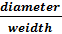 of fruit).
- Thickness of pericarp: (Thickness of flesh was determined by dermis tool).
-Percentage of Insect-infested fruit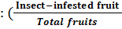 *100)
C. Yield (tones/Feddan). (Total weight of fruits per plot were determined and converted to tons/feddan).
- Extraction and determination of total phenolic compounds (TPCs) & total flavonoids (TFs):
TPCs were extracted from tomato leaves by MeOH-HCl and determined by method of Taga et al. (1984). The TFs content was determined by methods of Zhuang et al. (1992).
Statistical analysis:
Data were analyzed using the MSTAT statistical software (MSTAT Inc., USA), with comparison of means using Duncan’s separation test.

3. Results
Efficacy of two plant extract and four aromatic oils against Tuta absoluta in the first season is shown in Table (1). All treatments reduced the total numbers of mines of Tuta absoluta per plant. At 48 DAC (days after cultivation), mean mines per plant was not significantly differed on plant treated with various treatments whereas, garlic extract recorded the highest reduction percentage of mines per plant followed by lemon grass and basil oil. The reduction percentages of mines per plant were 66.59%, 63.94% and 63.27% for garlic extract, lemon grass extract and basil oil, respectively. At 55 DAC, mean mines counts per plant was not significantly differed on plant sprayed with lemon grass extract, rue oil and anise oil than counts on plant treatment with basil oil. The lowest mean number of mines per plant was recorded by garlic extract treatment, it was 16.33 compared to 44.73 mines/plant in control. At 64 DAC, lemon grass treatment was on par with all aromatic oils except for eucalyptus oil that recorded the higher mean mines per plant (27.53) than other treatments. Plants treated with garlic extract were recorded the lowest mean mines counts/plant (19.47) compared to water-treated plants (63.67). The effect of all treatments in reducing the population density of Tuta absoluta on plant were not significantly differed among them except for plants treated with eucalyptus oil at other monitoring days after cultivation. However, garlic extract was the best treatment which recorded the lowest percentage of T. absoluta infested plants. The reduction percentage of total number of mines per plant were 68.37, 68.60 and 69.32% by garlic extract at 71, 79 and 89 DAC, respectively. Similar results were observed in the second season, although the populations of pest were much lower (Table 2). Although, all treatments were significantly reduced the total number of mines per plant, there were insignificant differences among them. In the second season, at 48 DAC, lemon grass extract recorded the highest reduction percentage followed by garlic extract, rue oil and basil oil, respectively. The reduction percentages were (68.29%), (67.07%), (62.20%) and (60.98%), respectively. However, garlic extract recorded the highest reduction percentage of mines/plant followed by lemon grass and basil oil, respectively, at 55 and 64 DAC. These percentages of reductions were 70.00%, 68.33% and 65.00%, respectively, at 55 DAC and 76.47%, 74.51% and 68.63%, respectively, at 64 DAC in this season. Foliar damage by T. absoluta in infested treated-plants remained constant at 71, 79 and 86 DAC compared to control whereas, garlic extract and lemon grass extract recorded the lowest values followed by basil oil treatment. Means of mines/plant were 2.60, 2.60 and 3.27 at 71, 79, and 86 DAC, respectively compared to untreated control plants which recorded 10.87, 11.67 and 12.00 mines/plant at the same dates, respectively.
Data recorded on percentage of infested fruits are presented in Table (3) & (4). In the first season, all treatments were significantly reduced T. absoluta-damaged fruits compared to control. Plants treated with lemon grass extract were recorded the lowest percentage of T. absoluta–infested fruits (about 5%) followed by basil oil (about 7%) compared to water - treated plant (about 27%). However, the effect of garlic extract on infested fruits percentage was not significantly differed than other aromatic oils treatments. In the second season, all treatments reduced infested–fruits insignificantly compared to control (Table 4). T. absoluta population was low and about 15% of the fruit in the control plots being damage. Basil oil recorded the lowest percentage of infested fruits (4%) followed by ethylacetate (solvent) (about 6%) and lemon grass extract (about 9%). Fruits in the tested treatments did not differ statistically in the fruit weight, fruit shape index, TSS, number of locules in both seasons and in pericarp wall thickness in season 2012 and pH in season 2011( Table 5). In season 2012, pericarp wall thickness of fruits in plants treated with basil oil were higher (0.67cm) compared to 0.65cm in untreated plants. However, eucalyptus oil recorded the lowest value (0.60 cm). The effect of two plant extracts and other remaining aromatic oils on pericarp wall thickness did not significant differ than control. In season 2011, all treatments were significantly reduced pH compared to control. The effect of all plant extracts and aromatic oils treatments except rue oil on pH character did not significantly differ from ethylacetate–control treatment. On the other hand, the treated plants produced fruits with higher contents of ascorbic acid. The increment in ascorbic acid in tomato fruits was significantly more pronounced in lemon grass extract and basil oil treatments in the first season and in basil oil and lemon grass extract treatments in the second season.
Data recorded on yield are presented in Table (6) and Fig (1). In the first season, all treatments were affected significantly the total yield compared to the control. Garlic extract was the best treatment in increasing tomato yield followed by eucalyptus oil and lemon grass. Basil oil application was decreased the total yield (16.53 Ton/Fed.) compared to control (19.01 Ton/Fed.). In the second season, the application of various aromatic oils and plant extracts were affected insignificantly fruits yield. However, anise oil recorded the highest total yield followed by garlic extract, basil oil and eucalypts oil. Total fruits yield of plants treated with lemon grass extract in the second season nearly was on par with control. On the other hand, all treatments affected significantly the percentage of dry weight of fruits and vegetative growth in the second season (Table 6). Although all treatments significantly reduced the percentage of dry weight of fruits, the percentage of dry weight of vegetative growth were significantly increased by these treatments compared to control. The percentage of dry weight of vegetative growth of plants treated with eucalypts oil equaled to value which obtained from ethylacetate-treated control. Whereas, the significantly highest percentage of dry weight of vegetative growth occurred in basil oil followed by garlic extract and anise oil treatments compared to control.

Table (1) Efficacy of two plant extract and four aromatic oils against Tuta absoluta on tomato cv. Gold stone hybrid in season 2011.
Treatment | 1 st spray |  |  |  |  |  |  |  | 2 nd spray |  |  |  |  |  |  |  | 3 rd spray
 | 48 DAC |  | % Red. |  | 55 DAC |  | % Red. |  | 64 DAC |  | % Red. |  | 71 DAC |  | % Red. |  | 79 DAC |  | % Red. |  |  | 86 DAC |  | % Red.
Lemon grass ex. | 10.87 C |  | 63.94 |  | 18.47 CD |  | 58.72 |  | 22.00 CD |  | 65.45 |  | 23.40 D |  | 65.62 |  | 24.00 D |  | 66.35 |  |  | 25.47 D |  | 65.43
Garlic ex. | 10.07 C |  | 66.59 |  | 16.33 D |  | 63.49 |  | 19.47 D |  | 69.43 |  | 21.53 D |  | 68.37 |  | 22.40 D |  | 68.60 |  |  | 22.60 D |  | 69.32
Eucalptus oil | 14.67 C |  | 51.33 |  | 23.53 C |  | 47.39 |  | 27.53 C |  | 56.76 |  | 29.80 C |  | 56.22 |  | 30.67 C |  | 57.01 |  |  | 31.60 C |  | 57.11
Rue oil | 12.47 C |  | 58.63 |  | 19.20 CD |  | 57.08 |  | 22.47 CD |  | 64.71 |  | 23.85 D |  | 64.96 |  | 24.58 D |  | 65.54 |  |  | 25.52 D |  | 65.36
Anise oil | 12.33 C |  | 59.07 |  | 19.27 CD |  | 56.93 |  | 22.20 CD |  | 65.13 |  | 23.53 D |  | 65.43 |  | 24.00 D |  | 66.35 |  |  | 24.20 D |  | 67.15
Basil oil | 11.07 C |  | 63.27 |  | 18.87 CD |  | 57.82 |  | 21.87 CD |  | 65.66 |  | 23.07 D |  | 66.11 |  | 23.53 D |  | 67.01 |  |  | 23.60 D |  | 67.97
Ethylacetate | 25.40 B |  | 15.71 |  | 34.40 B |  | 23.10 |  | 47.67 B |  | 25.13 |  | 54.00 B |  | 20.67 |  | 54.59 B |  | 23.47 |  |  | 45.00 B |  | 38.92
Control | 30.13 A |  | - |  | 44.73 A |  | - |  | 63.67 A |  | - |  | 68.07 A |  | - |  | 71.33 A |  | - |  |  | 73.67 A |  | -
Significance at 0.05 level | * |  |  |  | * |  |  |  | * |  |  |  | * |  |  |  | * |  |  |  |  | *
Table (2) Efficacy of two plant extract and four aromatic oils against Tuta absoluta on tomato cv. Gold stone hybrid in season 2012.
Treatment |  | 1 st spray |  |  |  |  |  |  |  | 2 nd spray |  |  |  |  |  |  |  | 3 rd spray
 |  | 48 DAC |  | % Red. |  | 55 DAC |  | % Red. |  | 64 DAC |  | % Red. |  | 71 DAC |  | % Red. |  | 79 DAC |  | % Red. | 86 DAC |  | % Red.
Lemon grass ex. |  | 1.73 B |  | 68.29 |  | 2.53 B |  | 68.33 |  | 2.60 C |  | 74.51 |  | 2.60 C |  | 76.07 |  | 2.60 C |  | 77.71 | 2.60 C |  | 78.33
Garlic ex. |  | 1.80 B |  | 67.07 |  | 2.40 B |  | 70.00 |  | 2.40 C |  | 76.47 |  | 2.60 C |  | 76.07 |  | 2.60 C |  | 77.71 | 2.60 C |  | 78.33
Eucalptus oil |  | 2.63 B |  | 51.83 |  | 4.23 B |  | 47.08 |  | 4.50 C |  | 55.88 |  | 4.63 C |  | 57.36 |  | 4.63 C |  | 60.29 | 4.63 C |  | 61.39
Rue oil |  | 2.07 B |  | 62.20 |  | 3.13 B |  | 60.83 |  | 3.47 C |  | 66.01 |  | 3.53 C |  | 67.48 |  | 3.53 C |  | 69.71 | 3.53 C |  | 70.56
Anise oil |  | 2.53 B |  | 53.66 |  | 3.20 B |  | 60.00 |  | 3.53 C |  | 65.36 |  | 3.60 C |  | 66.87 |  | 3.60 C |  | 69.14 | 3.60 C |  | 70.00
Basil oil |  | 2.13 B |  | 60.98 |  | 2.80 B |  | 65.00 |  | 3.20 C |  | 68.63 |  | 3.27 C |  | 69.94 |  | 3.27 C |  | 72.00 | 3.27 C |  | 72.78
Ethylacetate |  | 4.27 A |  | 21.95 |  | 7.00 A |  | 12.50 |  | 7.53 B |  | 26.14 |  | 7.93 B |  | 26.99 |  | 8.27 B |  | 29.14 | 8.27 B |  | 31.11
Control |  | 5.47 A |  | - |  | 8.00 A |  | - |  | 10.20 A |  | - |  | 10.87 A |  | - |  | 11.67 A |  | - | 12.00 A |  | -
Significance at 0.05 level |  | * |  |  |  | * |  |  |  | * |  |  |  | * |  |  |  | * |  |  | *
Means followed by a common letter are not significantly different at 5% level. DAC= Day after cultivation.

Table (3) Effect of two plant extracts and four aromatic oils on percentage of infested fruits, 2011.
Treatment | Uninfested | %Uninfested | Infested
 |  |  | Tuta | No. of mines/fruit | Bollworm | No. of mines/fruit
Lemon grass ex. | 23.67 | 94.67 A | 0.66 | 0.66 | 0.66 | 0.66
Garlic ex. | 21.67 | 86.67 ABC | 2.33 | 2.33 | 1.00 | 1.00
Eucalyptus oil | 21.00 | 84.00 ABC | 1.33 | 1.33 | 2.67 | 2.67
Rue oil | 20.67 | 82.67 ABC | 2.67 | 2.67 | 1.67 | 1.67
Anise oil | 20.23 | 81.33 ABC | 3.00 | 3.00 | 1.67 | 1.67
Basil oil | 23.33 | 93.33 AB | 1.00 | 1.00 | 0.66 | 0.66
Ethylacetate (Solvent) | 20.00 | 80.00 BC | 2.00 | 2.00 | 3.00 | 3.00
Control | 18.33 | 73.32 C | 3.67 | 3.67 | 3.00 | 3.00
Significance at 0.05 level |  | *

Table (4) Effect of two plant extracts and four aromatic oils on percentage of infested fruits, 2012.
Treatment | Uninfested | %Uninfested | Infested
 |  |  | Tuta | No. of mines/fruit | Bollworm | No. of mines/fruit
Lemon grass ex. | 22.67 | 90.67 | 2.33 | 1.27 | 0.00 | 0.00
Garlic ex. | 21.00 | 86.67 | 2.33 | 1.50 | 1.00 | 0.67
Eucalyptus oil | 22.00 | 88.00 | 3.00 | 1.00 | 0.00 | 0.00
Rue oil | 23.00 | 92.00 | 2.00 | 1.00 | 0.00 | 0.00
Anise oil | 20.00 | 85.33 | 3.33 | 1.61 | 0.33 | 0.33
Basil oil | 23.50 | 96.00 | 1.00 | 0.67 | 0.00 | 0.00
Ethylacetate (Solvent) | 23.00 | 93.33 | 1.67 | 1.67 | 0.00 | 0.00
Control | 21.00 | 85.33 | 2.67 | 2.67 | 1.00 | 0.33
Significance at 0.05 level |  | ns
Means followed by a common letter are not significantly different at 5% level. DAC= Day after cultivation.

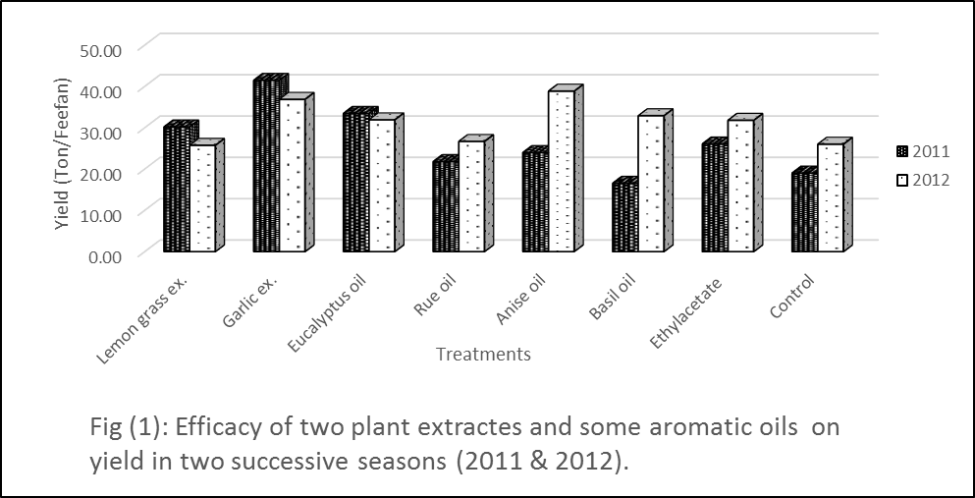

Table (5) Effect of two plant extracts and four aromatic oils on tomato fruit characteristics of hybrid cultivar Gold stone in two successive seasons, 2011 & 2012.
Treatment / Season | Fresh weight (gm) |  | Shape index |  | TSS (º Brix ) |  | No. of locules |  | Thickness of pericarp |  | L- Ascorbic acid mg/100g |  | pH
 | 2011 | 2012 | 2011 | 2012 | 2011 | 2012 | 2011 | 2012 | 2011 | 2012 | 2011 | 2012 | 2011 | 2012
Lemon grass ex. | 101.80 | 92.67 | 1.05 | 1.03 | 3.33 | 2.57 | 5.11 | 5.00 | 0.67 | 0.64 AB | 16.35 A | 16.04 AB | 4.27 B | 4.93
Garlic ex. | 109.07 | 92.93 | 1.07 | 1.01 | 3.22 | 2.67 | 4.89 | 5.00 | 0.63 | 0.62 AB | 14.11 BC | 11.93 BCD | 4.20 B | 4.63
Eucalyptus oil | 102.28 | 94.13 | 1.06 | 1.00 | 3.67 | 2.89 | 5.11 | 5.00 | 0.61 | 0.60 B | 13.36 BC | 14.20 ABC | 4.40 B | 4.60
Rue oil | 110.53 | 96.53 | 1.06 | 1.05 | 3.39 | 2.67 | 5.06 | 5.44 | 0.61 | 0.61 AB | 14.91 AB | 9.34 D | 4.50 AB | 4.63
Anise oil | 98.13 | 89.73 | 1.07 | 1.04 | 3.37 | 2.45 | 4.89 | 5.00 | 0.56 | 0.61 AB | 14.11 BC | 12.68 ABCD | 4.27 B | 4.67
Basil oil | 98.77 | 88.53 | 1.05 | 1.05 | 3.37 | 2.56 | 5.00 | 5.22 | 0.66 | 0.67 A | 15.23 AB | 16.79 A | 4.40 B | 4.77
Ethylacetate (Solvent) | 103.53 | 85.07 | 1.10 | 1.03 | 3.44 | 3.11 | 4.99 | 5.00 | 0.59 | 0.60 B | 12.99 BC | 8.96 D | 4.33 B | 4.63
Control | 102.07 | 80.80 | 1.13 | 0.99 | 3.00 | 2.89 | 4.89 | 5.11 | 0.63 | 0.65 AB | 12.24 C | 9.71 CD | 4.80 A | 4.53
Significance at0.05 level | ns | ns | ns | ns | ns | ns | Ns | ns | ns | ** | ** | ** | * | Ns
Means followed by a common letter are not significantly different at 5% level. DAC= Day after cultivation.

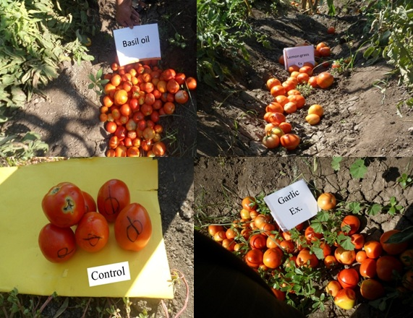
Plate (1): Efficacy of garlic extract, lemon grass extract and basil oil on quality of tomato fruits compared to control.

Data presented in Table (7) and Fig (2) and Fig (3) show that total phenolic compounds (TPCs) and total flavonoids (TFs) were affected in uninfested and infested tomato leaves after 24 hours of plant extracts and essential oils foliar treatments. TPCs values were ranged from 10.00 to 23.00 mg/100g and 14.00 to 36.00 mg/100g in uninfested and infested plants, respectively. The highest values were 23.00 mg/100g and recorded in uninfested plants treated with garlic extract followed by 19.00 mg/100g and 18.00 with eucalyptus oil, rue oil and lemon grass, respectively. In infested plants, the highest values of TPCs were 36.00 mg/100g and recoded in garlic extract-treated plants followed by 26.00 and 24.00 mg/100g with rue oil and eucalypts oil, respectively. The spraying of uninfested and infested tomato leaves with garlic extract increased TPCs concentration with 367.35% compared to unsprayed plants (Fig 2). On the other hand, the highest values of TFs were 57.50 and 87.65 mg/100g which recorded in uninfested and infested plants treated with garlic extract, respectively, followed by lemon grass extract. The values of TFs were 44.56 and 56.79 mg/100g recorded in lemon grass uninfested and infested –treated plants, respectively. As shown in Fig (3) the spraying of both uninfested and infested tomato plants with garlic extract led to sharp increase in TFs concentration with about 6 fold than unsprayed leaves.

Table (6) Efficacy of two plant extracts and four aromatic oils on yield in two successive seasons (2011 & 2012).
Treatment / Season | Dry weight/250 gm. Of fruits | % of dry weight of fruits | Dry weight /250 gm. Of vegetative growth | % of dry weight of vegetative growth | Yield ( Ton/Feedan )
 | 2012 |  | 2012 |  | 2011 | 2012
Lemon grass ex. | 11.34 | 4.53 B | 89.64 | 35.86 B | 30.19 BC | 25.72
Garlic ex. | 12.02 | 4.81 B | 92.51 | 37.00 B | 41.46 A | 36.85
Eucalyptus oil | 11.75 | 4.70 B | 78.86 | 31.54 C | 33.45 B | 31.89
Rue oil | 11.99 | 4.80 B | 87.13 | 34.85 BC | 21.79 DE | 26.66
Anise oil | 13.81 | 5.53 AB | 91.85 | 36.74 B | 23.96 CDE | 38.84
Basil oil | 14.09 | 5.64 AB | 102.32 | 40.93 A | 16.53 E | 32.88
Ethylacetate (Solvent) | 15.33 | 6.13 A | 79.36 | 31.74 C | 26.06 BCD | 31.78
Control | 15.03 | 6.12 A | 85.89 | 34.35 BC | 19.01 DE | 25.99
Significance at 0.05 level |  | * |  | * | * | ns
Means followed by a common letter are not significantly different at 5% level. DAC= Day after cultivation.

Table (7) Total phenolic compounds and total flavonoids in uninfested and infested tomato leaves after 24 hours of plant extracts and essential oils treatments.
Treatment | TPCs mg / 100 g |  | TFs mg / 100 g
 | Uninfested | Infested | Uninfested | Infested
Lemon grass ex. | 18.00 | 22.00 | 44.56 | 56.79
Garlic ex. | 23.00 | 36.00 | 57.50 | 87.65
Eucalyptus oil | 19.00 | 24.00 | 18.97 | 23.97
Rue oil | 18.00 | 26.00 | 17.87 | 22.66
Anise oil | 10.00 | 14.00 | 8.90 | 13.98
Basil oil | 12.00 | 15.00 | 12.09 | 15.08
Without spray | 8.60 |  | 12.90
Ethylacetate | 12.70 |  | 31.75
Control | 9.80 |  | 14.70

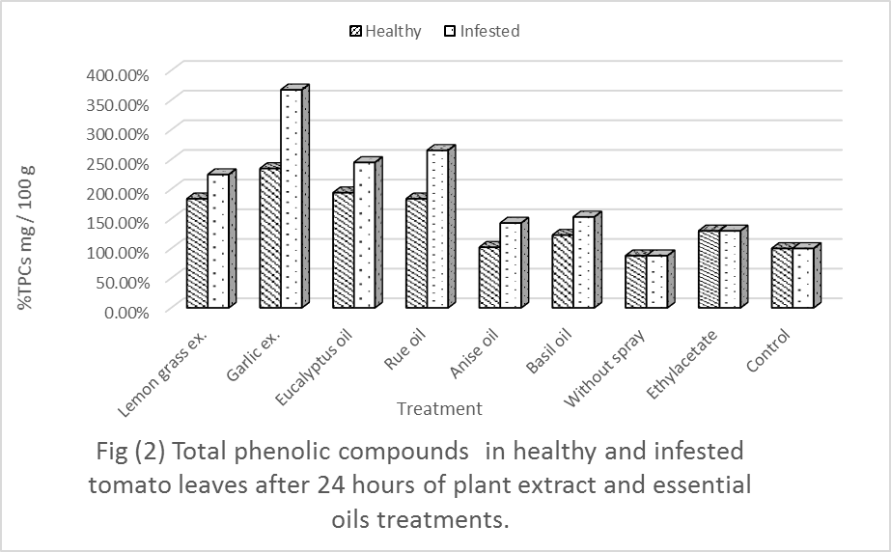

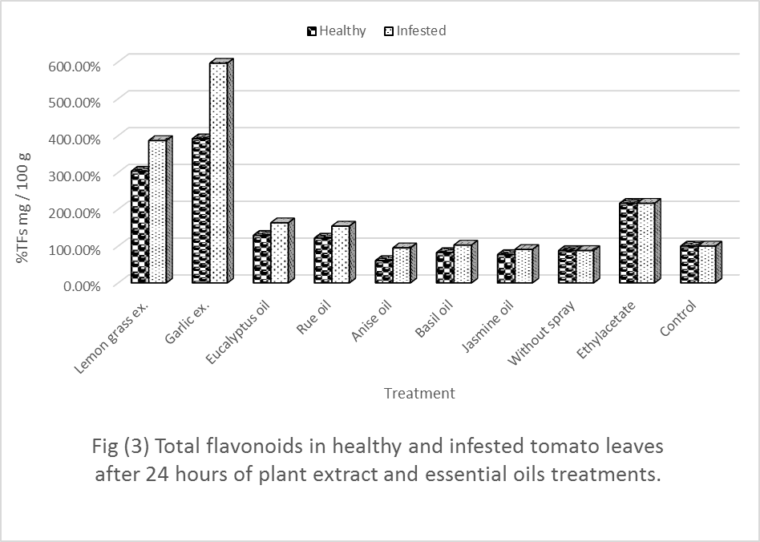

4. Discussion
Plant extracts are known to possess toxic organic poison that is effective in reducing insect pest population (Fuglie, 1998 and Gaby, 2000). Literature has been documented several studies where extracts, isolated compounds or mixture products have been evaluated for their efficacy against a variety of pests. These studies have been comprehensively reviewed (Arnason et al., 2004 and Rosell et al. 2008). Also, the essential oils were renewed with emerging demonstration of their fumigant and contact insecticidal activities to a wide range of pests (Shaaya et al., 1991 and Koul et al., 2008). The aim of this work to study the response of tomato plants to some plant extracts and essential oils against Tuta absoluta. All treatments recorded a significant reduction in T. absoluta population. The highest reduction of T. absoluta population was obtained after tomato plants treated with garlic extract. These results were in agreement with those reported by Ghanim and Abdel Ghani (2014), who showed that highest effects of garlic on T. absoluta second instar larvae under laboratory conditions but it had a moderate effects on T. absoluta under greenhouse conditions. Also, garlic leaf lectin (ASAL) has been found to have detrimental effect on growth and survival of two important homopteran insect pests, Lypaphis erysimi, commonly known as aphids and Dysdercus cingulatus (red cotton bug) (Bandyopadhyay et al., 2001). Neem, garlic and ginger extracts contain insecticidal properties that are lethal to a wide range of insects (Oparaeke, 2007). A mechanism of garlic extract effects based on the presence of an olerisine substance, a volatile oil and the antifeedant characters of garlic due to the presence of an essential oil (allyl propyl disulphide and daily disulphide) (Ben et al., 2010 and Ghanim and Abdel Ghani, 2014) ). Lemon grass extract and essential aromatic oil reduced the population of T. absoluta on plant significantly. The results obtained were in agreement with Moreno et al. (2011) who found that the crude hexane extract of Acmella oleracea produced high insecticidal activity and can be used to control T. absoluta in organic or conventional crops. However, antifeedant and larvicidal activity of ethyl acetate, leaf and flower extracts of Ocimum canum and Ocimum sanctum against lepidopterans suggested their capability as an ideal ecofriendly approach for the control of the agricultural pests (Kamaraj et al.,2008). ALSO, The essential oils such as those of lemongrass (Cymbopogon winterianus) and Eucalyptus globulus that were known for their pest control properties and basil (Ocimum basilicum) are also effective in warding off flies (Koul and Walia,2009). Plant essential oil, like this from O. sanctum was either toxic or growth inhibitory against Spodoptera litura larvae (Sharma et al., 2001). 1,8-cineole from Eucalyptus globules and citronellal from lemon grass were among the most active constituents against insects (Koul et al.,2008). On the other hand, 1,8-cineole exhibited both contact and fumigant toxicity when tested against T. castaneum (Tripathi et al., 2001 and Koul et al.,2008 ). Moreover, essential oil constituents such as thymol, citronellal and α-terpineol were effective as feeding deterrent against tobacco cutworm, S. litura. Synergism or additive effects of combination of monoterpenoids from essential oils had been reported against S. litura larvae (Hummelbrunner and Isman, 2001). The effect of two plant extracts and the essential aromatic oils on fruit damage resulted in less T. absoluta – damaged fruits. Similar results with other pests were obtained by Panhwar (2002) who reported that good aqueous solution of garlic would effectively control worms, beetles and thrips in cowpea. Also, Ghanim and Abdel Ghani (2014) showed that Basil leaves exhibited the lowest initial kill on T. absoluta. After 3 days, the concentration 6% of this tested plant exhibited significantly higher effects than that of 2%. Similalrly, essential oils of Ocimum sanctum caused 20% mortality to 3rd instar S. litura larvae (Sharma et al., 2001). On the other hand, the obtained results indicated that all treatments insignificantly affected fresh weight, shap index, TSS, no. of locules and thickness of pericarp in season 2011 and pH in season 2012. Different results were showed by Tyiagi et al. (1990) who found that plant growth improved and plant weights also increased with increasing concentration of leaf lemon grass extract and with longer dip duration. All treatments affected thickness of pericarp in season 2012 and pH in season 2011. Also, most treatments were significantly increased L-ascorbic acid in both seasons. Interestingly, the tested plant extracts and essential oils were affected the percentage of dry weight of fruits and vegetative growth of tomato plants significantly. Also, the two plant extracts and most of the used essential aromatic oils increased the total yield of tomato in the first season whereas, in the second season all treatments had no significant effects on tomato yield. Garlic extract was the best treatment and gave the highest yield of tomato fruits in the first season while it was the second in the second season. Similar results were showed by Ahmed et al. (2009) on cowpea. Also, the obtained results correspond positively with the earlier work conducted by researchers which they showed that plant extracts increase the yield of vegetables by protecting them from insect pests (Stoll, 1988; Panhwar, 2002 and William and Ambridge, 1996). However, plant extracts application at flowering and pod formation stages reduced the level of infestation of insect pests and increased yield of pea plants (Panhwar, 2002). However, the chemical of analysis total phenolic compounds and total flavonoids showed that garlic extract had a sharp increase in TPCs and TFs leaves contents in both uninfested and infested leaves of tomato. These results were in agreement with those obtained by Miean and Mohamed (2001), Lanzotti (2006) and Bozin et al. (2008). They reported that garlic extract was characterized by more polar compounds of phenolic, steroidal origin (glycosylated and flavonoids) which showing interesting pharmacological properties. According to the obtained results, it can be concluded that foliar application of garlic extract, lemon grass extract and basil oil on tomato plants reduced T. absoluta population and improved the quality and quantity of tomato fruit yield.

Reference
- Ahmed B.I., Onu, I. and Mudi, L. (2009). Field bioefficacy of plant extracts for the control of post flowering insect pests of cowpea (Vigna unguiculata (L.) Walp.) in Nigeria Journal of Biopesticides, 2(1): 37-43.
- Arnason JT, Guillet G and Durst T. (2004). Phytochemical diversity of insect defenses in tropical and temperate plant families. In: Carde RT, Miller GJ, editors. Advances in Insect Chemical Ecology. Cambridge University Press, Cambridge. p. 1–20.
- Bandyopadhyay S., Roy A. and Das S. (2001). Binding of garlic (Allium sativum) leaf lectin to the gut receptors of homopteran pests is correlated to its insecticidal activity. Plant science.161,5, 1025-1033.
- Ben I. C., Nudubuisi U.and Maxwell N.B. (2010). Comparative studies on effects of garlic (Allium sativum) and ginger (Zingiber officinale) extracts on cowpea insects pest attack. World Rural Observations. 2 (2).
- Bozin B., Mimica-Dukic N., Samojlik I., Goran A. and Igic R.(2008). Phenolics as antioxidants in garlic (Allium sativum L., Alliaceae). Volume 111, Issue 4, 15 December, Pages 925–929.
- Brooklyn Botanic Garden. (2000): Natural disease control: A common-sense approach to plant first aid. Handbook 164. Brooklyn Botanic Garden, Inc. 1000 Washington Avenue, Brooklyn, NY.
- Bughio FM and Wilkins RM (2004). Influence of malathion resistance status on survival and growth of Tribolium castaneum (Coleoptera: Tenebrionidae), when fed on flour from insect-resistant and susceptible grain ricecultivars. J Stored Products Research 40: 65-75.
- Clarke JF (1962). New species of microlepidoptera from Japan. Entomological News 73: 102.
- Cox PD (2004). Potential for using semiochemicals to protect stored products from insect infestation. J Stored Products Research 40: 1-25.
- Cox, H.E. and Pearson D. (1962). The chemical Analysis of Food Chemical Publishing. Co. Ink. New York; pp: 420.
- Desneux N., Wajnberg E., Wyckhuys K.A.G., Burgio G., Arpaia S., Narva/ez-Vasquez C.A., Gonzalez-Carera J., Ruescas D.C., Tabone E., Fradon J., Pizzol J., Poncet C., Cabello T., and Urbaneja A. (2010). Biological invasion of European tomato crops by Tuta absoluta : ecology, geographic expansion and prospects for biological control. J. Pest. Sci. 83: 197-215.
- Dilmacunal T., Koyuncu M.A., Aktas H. and Bayindir D. (2011). The effect of several postharvest treatments on shelf life quality of bunch tomatoes. Not. Bot. Horti. Agrobo, 39 (2):209-213.
- Duke SO, Baerson SR, Dayan FE, Rimando AM, Scheffler BE, Tellez MR, Wedge DE, Schrader KK, Akey DH, Arthur FH, De Lucca AJ, Gibson DM, Harrison HF Jr, Peterson JK, Gealy DR, Tworkoski T, Wilson CL, Morris JB. (2003). United States Department of Agriculture- Agricultural Research Service research on natural products for pest management. Pest Manag Sci 59: 708–717.
- Farghaly SF, Torkey HM and Abou-Yousef HM (2009). Natural extracts and their chemical constituents in relation to toxicity against whitefly (Bemisia tabaci) and aphid (Aphis craccivora). Aust J Basic & Appl Sci 3: 3217-3223.
- Fuglie S.L. (1998). Producing Food without Pesticides: Local Solution to Crops Pest Control in West Africa. Church – World Service, Dakar, Senegal, 140 PP.
- Gaby S. (2000). Natural Crop Protection in the Tropics. 2nd Enlarged and Revised edition. Margraf Verlag Press 502 PP.
- Garcia MF and Espul JC (1982). Bioecology of the tomato moth (Scrobipalpula absoluta) in Mendoza, Argentine Republic. Revista de Investigaciones Agropecuarias 17: 135-146.
- Ghanim, N. M. and Abdel Ghani S. B. (2014). Controlling Tuta absoluta (Lepidoptera: Gelechiidae) and Aphis gossypii (Hemiptera: Aphididae) by aqueous plant extracts. Life Scence Journal.11, (3).
- Gorski R. and Tomczak M. (2010). Usefulness Of Natural Essential Oils In The Control Of Foxglove Aphid (Aulacorthum solani Kalt.) Occurring On Eggplant (Solanum melongena L.) Ecological Chemistry And Engineerings. Vol. 17, No.3.
- Guleria S. and Kumar A. (2006). Azadirachta indica leaf extract induces resistance in sesame against Alternaria leaf spot disease Journal of Cell and Molecular Biology 5: 81-86.
- Henderson C.F. and Tilton W. (1955).Tests with acaricides against the brown wheat mite. J. Econ. Entomol. 48:157-161.
- Hummelbrunner, A. L. and Isman M.B. (2001) Acute, sublethal, antifeedant and synergistic effects of monoterpenoid essential oil compounds on the tobacco cut worm (Lepidoptera: Noctuidae). J. Agric. Food Chem., 49, 715–720.

Hussein, Nehal, M., Hussein M.I., Gadel Hak S.H., Hammad M.A.and Shaalan H.S. (2014). Efficacy of Exogenous Elicitors against Tuta Absoluta on Tomato. Nature and Science. 12 (5): 68-77.
- Işık M. and Görür G. (2009). Aphidicidial activity of seven essential oils against the cabbage aphid, Brevicoryne brassicae L. (Hemiptera: Aphididae). Munis Entomology & Zoology, 4 (2): 424-431].
- Jackai L.E.N. and Oyediran I.O. (1991). The potential of neem Azadirachta indica Juss. for controlling post flowering pests of cowpea Vigna unguiculata (L.) Walp. The pod borer, Maruca vitratas. Insect Science and its Application, 9: 267-276.
- Kamaraj C, Rahuman A and Bagavan A. (2008). Antifeedant and larvicidal effects of plant extracts against Spodoptera litura (F.), Aedes aegypti L. and Culex quinquefasciatus Say. Parasitology Research; 103:325–31.
- Koul O. and Walia S. (2009).Comparing impacts of plant extracts and pure allelochemicals and implications for pest control. CAB Reviews: Perspectives in Agriculture, Veterinary Science, Nutrition and Natural Resources. 4, No. 049.
- Koul O, Walia S. and Dhaliwal GS. (2008) Essential oils as green pesticides: potential and constraints. Biopesticides International;4:63–84.
- Kubo I. (2006). New concept to search for alternate insect control agents from plants. In: Rai and Carpinella, editors. Naturally Occurring Bioactive Compounds. Amsterdam, The Netherlands: Elsevier, pp 61-80.
- Lanzotti V. (2006). The analysis of onion and garlic Journal of Chromatography A, 1112 3–22.
- Lietti MM, Botto E and Alzogaray RA (2005). Insecticide resistance in Argentine populations of Tuta absoluta (Lepidoptera: Gelechiidae). Neotropical Entomology34:113-119.
- Miean K. H. and Mohamed, Sohayla (2001). Flavonoid (Myricetin, Quercetin, Kaempferol, Luteolin, and Apigenin) Content of Edible Tropical Plants. J. Agric. Food Chem.,49 (6), pp 3106–3112.
- Mohamad M.A. and Desouky S.M. (2005). Producing and trading tomatoes.Technical Bulletin No.14. Issued by the General Administration of Agriculture Culture.
- Moreno S. C., Carvalho G. A., Picanco M. C, Morais E. GF and R. M Pereira. (2011). Bioactivity of compounds from Acmella oleracea against Tuta absoluta (Meyrick) (Lepidoptera: Gelechiidae) and selectivity to two non – target species. Society of Chemical Industry. Pest Manag Sci 2012; 68:389 - 393.
- Moreira MD, Picanco MC, Barbosa LC, Guedes RNC and Da Silva EM (2004). Toxicity of leaf extracts of Ageratum conyzoides to Lepidoptera pests of horticultural crops. Biological Agriculture and Horticulture 22: 251-260.
- NAPPO: North American Plant Protiction Orgnization (2012). Surveillance Protocol for the Tomato Leaf Miner, Tuta absoluta, for NAPPO Member Countries.
- Notz A.P. (1992). Distribution of eggs and larvae of Scrobipalpula absoluta in potato plants. Revista de la Facultad de Agronomia (Maracay) 18: 425-432.
- Oparaeke A.M. (2007). Toxicity and spraying schedules of a biopesticide prepared from Piper guineense against two cowpea pests. Plant Protection Sciences, 43: 103-108.
- Oparaeke A.M., Dike M.C. and Amatobi C.I. (2000). Field trial of botanical extract for insect pests control on cowpea, Vigna unguiculata (L.) Walp. Poster presentation, World Cowpea Research Conference III. 2000 September 4-7, IITA. Ibadan, Nigeria.
- Oparaeke A. M., Dike M. C. and Amatobi C. I. (2005). Botanical Pesticide Mixtures for Insect Pest Management on Cowpea, Vigna unguiculata (L.) Walp Plants–The Legume Flower Bud Thrips, Megalurothrips sjostedti Trybom. Journal of Sustainable Agriculture 29, 1, 5-13.
- Panhwar S.B. (2002). Farmers adoption of plant materials for insects control. International Service for National Agricultural Research. Haque, Netherland. 4:61-68.
- Picanco MC, Bacci L, Crespo AL, Miranda MM and Martins JC (2007). Effect of integrated pest management practices on tomato production and conservation of natural enemies. Agricultural and Forest Entomology 9: 327-335.
- Reitz S. R., Maiorino G., Olson S., Sprenkel R., Crescenzi A., and Momol M. T. (2008). Integrating plant essential oils and kaolin for the sustainable management of thrips and tomato spotted wilt on tomato. Plant Dis. 92:878-886.
- Rosell G., Quero C., Coll J. and Guerrero A. (2008) Biorational insecticides in pest management. Journal of Pesticide Science; 33:103–21.
- Salari E, Ahmadi K, Dehyaghobi RZ, Purhematy A and Takalloozadeh HM (2012). Toxic and repellent effect of harmal (Peganum harmala L.) acetonic extract on several aphids and Tribolium castameum (Herbst). Chilean J Agricultural Research 72: 147-151.
- Shaaya E, Ravid U, Paster N, Juven B, Zisman U and Pissarev V. (1991) Fumigant toxicity of essential oils against four major stored-product insects. Journal of Chemical Ecology;17:499–504.
- Sharma SS, Gill K, Maliok MS and Malik OP. (2001). Insecticidal, antifeedant and growth inhibitory activities of essential oils ofsome medicinal plants. In: Sushil K, Hasan SA, Samresh D, Kukreja AK, Ashok S, Sharma AK, et al., editors. Proceedings of the National Seminar on the Frontiers of Research and Development in Medicinal Plants. CIMAP, Lucknow; p. 288–98.
- Stoll G. (1988). Natural crop protection; Based on local Farm Resources in the Tropics and Sub–Tropics. Weker-shem Germany. Margraf publisher, Scientific Books. 188 PP.
- Stoll G. (2000) Natural Crop Protection in the Tropics and sub tropics. Letting information come to life. 2nd edition, Margraf Veriag, pp: 171.
- Suinaga FA, Picanco M, Jham GN and Brommonschenkel SH (1999). Chemical resistance of Lycopersicon peruvianum (L.) to Tuta absoluta (Meyrick) (Lepidoptera: Gelechiidae). An Soc Entomol Brazil 28: 313-321. (in Portuguese with abstract in English).
- Taga M. S., Miller E. E. and Pratt D. E. (1984). Chia seeds as a source of natural lipids antioxidants. J. Am. Oil Chem. Soc. 61:928-993.
- Tiyagi S. A., Ahmad, A. and Alam M. M. (1990). Control of root-knot, reniform and stunt nematodes by root dip in leaf extract of lemongrass. International Pest Control Vol. 32 No. 3 pp. 70-71.
- Trindade RCP, Marques IMR, Xavier HS and de Oliveira JV (2000). Neem seed kernel extract and the tomato leafminer egg and larvae mortality. Scientia Agricola 57:407-413. (in Portuguese with abstract in English).
- Tripathi A.K., Prajanpati V., Aggarwal K.K. and Kumar S. (2001) Toxicity, feeding deterrence, and effect of activity of 1, 8-cineole from Artemisia annua on progeny production of Tribolium castanaeum (Coleoptera: Tenebrionidae). J. Econ. Entomol., 94, 979–983.
- Umpiérrez M. L. , Lagreca M. E., Cabrera R., Grille G. and Rossini C. (2012). Essential oils from Asteraceae as potential biocontrol tools for tomato pests and diseases. Phytochemistry Reviews. 11, 4, pp 339-350.
- William, A. and Ambridge, L. (1996). Guide to insect pests of Nigerian crops. Identification: Biology and Control. Natural Resource Institute/Overseas Development Administration. 253 PP.
- Zhuang X.P., Lu Y.Y. and Yang G.F. (1992). Extraction and determination of Flavonoid in ginkgo Chinese Herbal Medicine, 2: 122-124.

7/27/2014

