Monitoring Agricultural Land Degradation in Egypt Using MODIS NDVI Satellite Images

Khalil A.A.; Y.H. Essa and M. K. Hassanein

Central Laboratory for Agricultural Climate (CLAC), Agricultural Research Center (ARC), Ministry of Agriculture and Land Reclamation (MALR), Egypt
alaa_amka@yahoo.com

Abstract: Land degradation is one of the root causes of declining agricultural productivity globally. The aim of this study is mainly directed to monitoring and assessment the agricultural land degradation in Egypt using the Moderate Resolution Imaging Spectrometer (MODIS) Normalized Difference Vegetation Index (NDVI) with spatial resolution 250 m during the period from December 2010 to May 2012. The results indicated that the agricultural land degradation during 2011 was about 95269 feddan, changed to about 27000 feddan in May 2012. The highest land degradation was found in New Valley Governorate and the highest impact was found in South Sinai Governorate where it lost more than 10% from their total agricultural area.
[Khalil A.A.; Y.H. Essa; M. K. Hassanein. Monitoring Agricultural Land Degradation in Egypt Using MODIS NDVI Satellite Images. Nat Sci 2014;12(8):15-21]. (ISSN: 1545-0740). http://www.sciencepub.net/nature. 2

Keywords: Monitoring Agricultural Land degradation, NDVI, Remote Sensing, MODIS GIS

Introduction
Land degradation is one of the most severe problems of our times. And also is one of the root causes of declining agricultural productivity globally; if left uncontrolled, it will exacerbate the problems of food security within the region. The land degradation is defined as the long-term loss of ecosystem function and productivity caused by disturbances from which the land cannot recover unaided (Bai et al., 2008). Egypt has the lowest area of agricultural land per individual in Africa (Rabia, 2012). The agricultural land stands for a total of approximately 3.5 million ha which characterized about 3.5% of the total area of Egypt in 2007. Moreover, high population growth stresses on agricultural production, in one of their most recent reports, the United Nations Population Division projects the population of Egypt is expected to reach 100,909 million for the year 2025 and 123,452 million for 2050 (United Nations, 2011). According to the population clock device, the number of Egypt's population at home arrived 84 million people at the first of March 2013 (Al-Ahram Gate, 2013). Actually, there is no periodic census for agricultural lands in Egypt. The last formal agricultural census was carried out in early 1960s; however, inventory of cultivated area is carried out by traditional methods of surveying. In addition, urban encroachment upon cultivated land makes it difficult to make an accurate inventory by traditional surveying. Hereher (2012) reported that no less than 136 km² of agricultural lands have been changed to urban area between 1973 and 2006 in Cairo area. The urban encroachment over arable productive agricultural land in Egypt is common and is called urban desertification. Urban expansion has become a major form of land degradation; the annual loss of arable land to urbanization is 1.2 % (Rabia, 2012). Urban sprawl on the agricultural lands is one of the negative outcomes that happened due to lack of the security regime during and after the Egyptian revolution that began on the 25th of January 2011. During the 18 days of the revolution thousands of feddans of highly fertile and cultivated lands were illegally converted to built-up areas (Salwa et al., 2013). One of the most successful applications of remote sensing is in the agriculture field. The availability of at least two decades of digital data in multiple wavebands of the spectrum (visible, near infrared and thermal bands) and their large ground coverage makes remote sensing superior to field based study. The premise in using digital data in monitoring agricultural lands is based upon the unique interaction of vegetation biomass with solar electromagnetic radiation which differs from other land cover components, e.g. water and bare deserts. The chlorophyll of the green leaf strongly absorbs the red radiation (630–690 nm), whereas the leaf’s cellular structure strongly reflects the near infrared radiation (760–900 nm) (Tucker, 1979). The objective of this study is to monitoring the agricultural land degradation after 25 Jan Egyptian revolution (From December 2010 up to May 2012)
Dataset and Tools
The main dataset used in this study is Normalized Difference Vegetation Index NDVI, which has been derived from Moderate Resolution Imaging Spectroradiometer (MODIS) instrument on the Terra satellite which is launched by NASA as a part of its Earth Observing System (EOS), in December 1999 and has been activated in February 2000. MODIS is 36-band sensors are derived at 250-m, 500-m, and 1-km spatial resolution, it available globally at no cost to the public. The MODIS repeat cycle for is sixteen days, during which each point on the earth will be viewed with a range of view angles between ~55° in the forward and backscatter direction. The MODIS Normalized Difference Vegetation Index (NDVI) 16 - day product (MOD13Q1; 250 m; Version 5), used in this study. Data for version 4 and above have been validated and approved for scientific research. The data are provided in the HDF-EOS format and is 16 bit signed integer; these data must then be stored with a float data type.
Arc GIS version 10.0, ERDAS Imagine version 9.2 which designed to handle remote sensing visualization, manipulation and analysis of aerial and satellite images as well as geographic data records, and Microsoft excel are used in data processing, analysis and calculating the required area.
Methodology
Routine downloads of MODIS Terra 250-m NDVI every 16 days from December 2010 up to end of May 2012 has been from http://reverb.echo.nasa.gov website. The data are downloaded covering all Egypt.
- Pre- processing satellite data
Pre-processing steps have been done by using the most powerful commercially available ERDAS Imagine software package.
All downloaded data are imported using “IMPORT” package to convert it from hdf format to img format, and then combined into one file covering the entire study area for each date using “MOSAIC” package, and monitoring the changes on the land which appear in the satellite data during the study period as shown in Figure (1), then re-projected it into geographic latitude and longitude (WGS 84) coordinates.

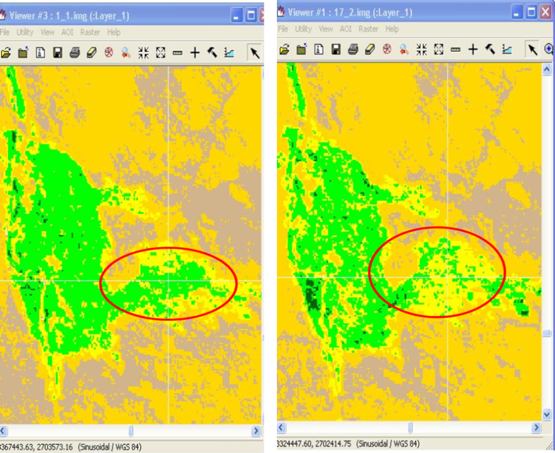
NDVI at 1 Jan. 2011
NDVI at 17 Feb. 2011

Figure (1): Monitoring the change in agricultural land at different period.

- Processing and analysis satellite data
Arc GIS software program was used to processing and analysis satellite data as the following:
Firstly the re-projected NDVI images had classified to “Water”, “No vegetation”, “Moderate vegetation”, and “High vegetation” according to the value of NDVI as show in Figure (2). Secondly combine all re-classified NDVI data in to one map using “UNION” package to compare what happen for NDVI during different periods, where we can monitoring the vegetation cover every 16 day. Then justify the areas that converted suddenly from “High vegetation” or “Moderate vegetation” to “No vegetation “and still to end of study period May 2012.

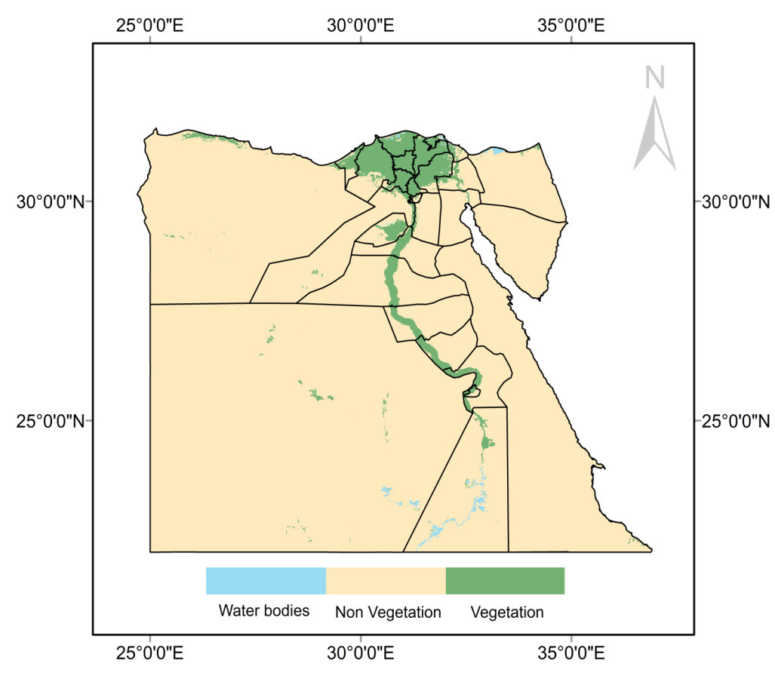
Figure (2): NDVI Classification.

Results and Discussion
This study monitors the vegetation regions and assesses its degradation during the study period from December 2010 to May 2012 by using MODIS NDVI data.
Monitoring process has been done into two stages; the first one was from a start study period December 2010 up to December 2011 and the second one was continued up to May 2012.

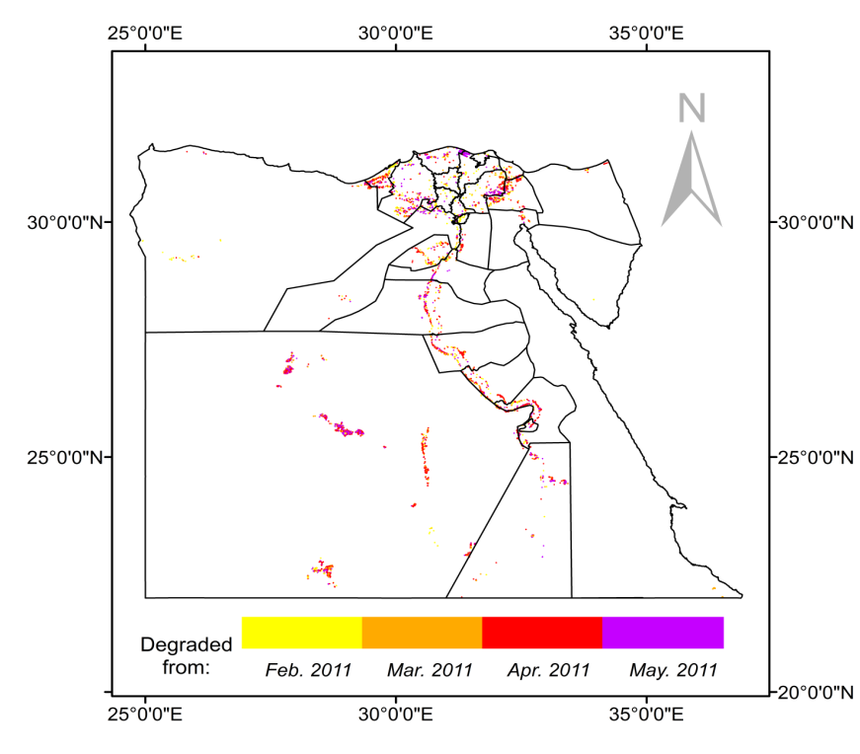
Figure (3): The degraded agricultural area from December 2010 up to December 2011.

Figure (3) shows the degraded areas from December 2010 up to December 2011, classified according to the degradation date, and as it observes the month of April has the highest degraded area in 2011, also the neighboring of four classifications (colors) at most areas which may indicate to expansion of the degraded area with time. The total degraded area was about 95269 feddan (1 feddan is approximately 1 acre or 0.4 ha), and the degraded agricultural area according to degradation date are shown in table (1). By completing the monitoring to May 2012, it has been observed confirmation for the degradation at some areas and enhance other but the dominant phenomenon which is observed was the instability in the land status and this consider not bad indication because the land is still arable.

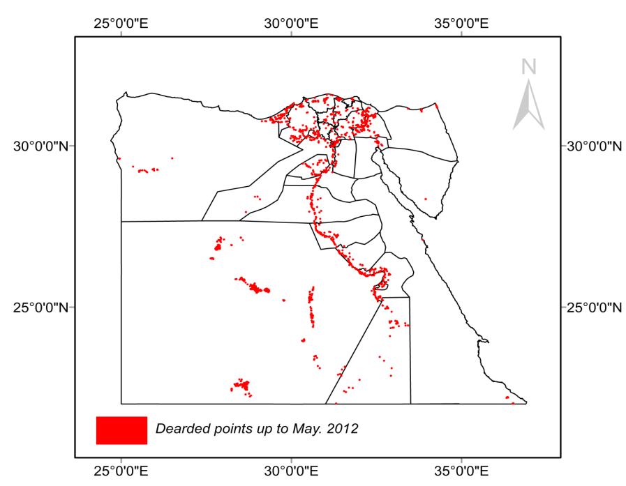
Figure (4): The degraded agricultural area from December 2010 up to May 2012.

Figure (4) shows the areas that still degraded from December 2010 to May 2012 and it estimated by 26928.5 feddan distributed in different agricultural zones and it observed their increases in New Valley, Upper Egypt Governorates, Alexandria and Ismailia in costal Governorates.

Figure (5): The total degraded area in Egypt's Governorates from December 2010 to May 2012.

Figures (5) show the degraded area in a Egypt's Governorates, it observe that the highest degraded area in 2011 was found in New Valley where it estimated about more than 8000 feddan followed by Behera and Alexandria Governorates, also it found that the degraded area in all of Upper Egypt’s near or more than 1000 feddan but all of Middle Egypt’s Governorates less than 1000 feddan.
Although New-Valley Governorate has the highest degraded area, South Sinai has the highest impact where it has more than 10% from their agricultural area exposed to degradation as shown in table (2) which shows the total agricultural areas for the Egypt Governorates estimated from NDVI data 250-m and the area degraded percentage. Also it observed that Damietta Governorate has the least agricultural degraded area and also no impact on their agricultural land.
The enhanced degraded areas from Dec.2011 to May.2012 were estimated by about 800 feddan and the unstable areas by about 67541 feddan distributed in New Valley and Upper Egypt, and in edges of Nile Delta as show in Figure (6).
(Youm7 gate, 2012) published that the total urban sprawl over agricultural land from 25 Jan. 2011 up to 19 Dec. 2012 was about 27000 feddan and increased in 2013 to 38000 feddan (Youm7 gate, 2013) represented 813000 agricultural infringement cases, security services succeeded in removing 90000 cases from them during removal campaigns which have been implemented on an area of 5164 feddan. The usage of the agricultural lands in Egypt is characterized by being among most intensive agricultural systems in the world, It may reach three crop cultivations a year, this practice will not only decrease the areas of the fertile lands but will also decrease Egypt’s exports from vegetables and fruits and hence add a lot of burden on the Egyptian economy. In addition, building on some agricultural lands will hinder the fair water distribution to the rest of the agricultural lands due to the presence of a concrete obstacle in the path of the water way to the neighboring lands. One of the negative outcomes of building on cultivated lands is that the area negatively influenced by this built-up area is 4 to 6 times the area of the actual area of the building (Salwa et al., 2013). That is because the building forms a shadow around it which is reflected on the productivity of the cultivated plants. Also this unofficial building represents a stealing to the government properties in part of the road and land and hence influences the safety of the inhabitants.

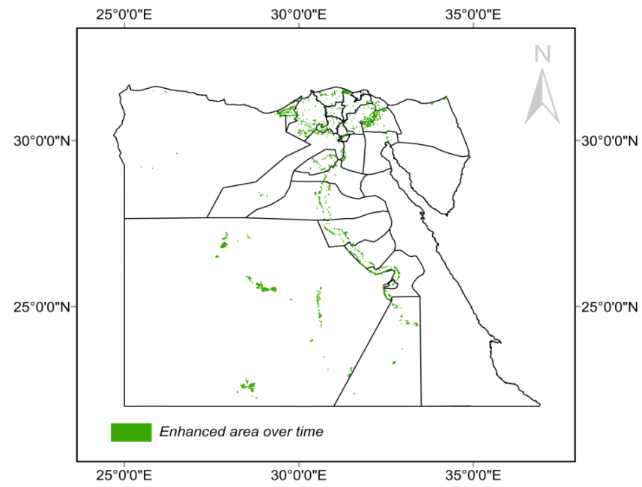
Figure (6): The excluded area from degradation area during assessment process

Table (1): The degraded agricultural area according to degradation date.
Classification | Degraded to Dec. 2011.  Area (fed.) | Still Degraded to May 2012  Area (fed.) | Enhanced in 2012  Area (fed.)
Degraded from Feb. 2011 | 15650.99 | 8221.3 | 156.9
Degraded from Mar. 2011 | 12072.44 | 4420.6 | 120.9
Degraded from Apr. 2011 | 47079.33 | 10258.2 | 332.1
Degraded from May. 2011 | 20465.97 | 4028.4 | 189.7
Total | 95268.73 | 26928.5 | 799.6

Table (2): The total agricultural area of Egypt's governorates and its degraded area percentage.
Governorate | Agricultural Area (Fed.) | Degraded Percentage
Behera | 1512148 | 0.1
Damiate | 151522 | 0.0
Daqahlia | 890408 | 0.1
Gharbia | 481885 | 0.1
Kafer- Elshikh | 804993 | 0.1
Mnofia | 456247 | 0.1
Qaluibia | 234430 | 0.0
Sharkia | 1048465 | 0.2
Alexandria | 363816 | 0.5
Ismailia | 273375 | 0.5
Matrouh | 397995 | 0.1
Port-said | 125660 | 0.3
Suzie | 30449 | 1.0
Bani Seiwf | 370958 | 0.1
Cairo | 114014 | 0.4
Fayoum | 455904 | 0.1
Giza | 334278 | 0.3
Aswan | 354259 | 0.2
Asyuot | 436212 | 0.3
Manya | 649969 | 0.1
Qana | 491918 | 0.3
Souhag | 453345 | 0.2
New Valley | 307039 | 2.7
North Sinai | 56773 | 0.3
South Sinai | 805 | 10.6
Total |  | 18.7

Despite the availability of clear policies to address the problem and strict laws to legalize, this did not resolve the problem or even reduce the size of the damage by a reasonable degree, it is possible to have an excellent policy but the final results of this policy are not good enough because the methodology of applying the policy was incorrect or unsuitable. To get good policy results and attempt to solve the problem, a good policy is needed along with a suitable method of applying this policy.

Conclusion
For the overall results, it could be concluded that.
- Satellite data is a good and quick technique to monitoring the changes in agricultural land with low cost.
- The highest area governorates exposed to land degradation were New Valley, El-Beheira, Kafr El-sheikh, Sharkia, Alexandria, Ismailia, Giza, and Qena while Damietta was the lowest area governorates exposed to land degradation.
- The highest impact was in South Sinai Governorate where it lost more than 10% from their vegetated area followed by New Valley governorate which lost about 2.7 from their vegetated area.
- The land degradation in Egypt in 2012 alter than 2011 and decreased by about 70% where about 0.8% (800 feddan) from them enhanced and returned to agriculture and about 69.2% (67541 feddan) not completely stabled but those still arable land.
- More than 18% from total vegetated area in Egypt exposed to degradation during year of 2011.
- Good policy is needed along with a suitable method of applying this policy.
- Enhance awareness of population and environment linkages and related issues qua relevant elements in development policies.

Acknowledgements
The present work would not have been possible without the help of The Arab Center for the Studies of Arid Zones and Dry Land (ACSAD).

References
- Al-Ahram Gate, 2013: Egypt's Population of 92 Million People with Early March 8 Million of them abroad and Males Superior to Females, 27 February, http://gate.ahram.org.eg/News/31432
- Bai, Z.G., Dent, D.L., Olsson, L., and Schaepman, M.E. (2008). “Global Assessment of Land Degradation and Improvement 1: Identification by Remote Sensing”. Report 2008/01, FAO/ISRIC – Rome/Wageningen
- Hereher, M., 2012. Analysis of urban growth at Cairo, Egypt using remote sensing and GIS. Natural Science 4, 355–361.
- Rabia. A. H, 2012. Do we really need new policies? A study on soil sealing in Egypt. IIASA 40th Anniversary Conference Hofburg Congress Center, Vienna and IIASA, Laxenburg, Austria 24-26 October 2010 Available at: http://works.bepress.com/ahmed_rabia/9
- Salwa F. Elbeih, Adel A. Shalaby, Ahmed M. Bahy El Deen., 2013. Water Management Problems Associated with Urban Sprawl in Gharbia Governorate, Egypt Using Remote Sensing and GIS. International Journal of Advanced Remote Sensing and GIS 2013, Volume 2, Issue 1, pp. 243-259, Article ID Tech-128 ISSN 2320 - 0243
- Tucker, C., 1979. Red and photographic infrared linear combination for monitoring green vegetation. Remote Sensing of Environmen8, 127–150.
- United Nations, Department of Economic and Social Affairs, Population Division, 2011: World Population Prospects: The 2010 Revision, Highlights and Advance Tables. ESA/P/WP220.
- Youm7 gate, 2012: Rising encroachment on agricultural land of 27 thousand faddens, 19 December, http://youm7.com/News.asp?NewsID=881466#.Uodaw-Kn7h1
- Youm7 gate, 2013: Agriculture: High encroachment on agricultural land of 38 thousand faddens, 10 November, http://youm7.com/News.asp?NewsID=1336664#.UodZ1-Kn7h1

7/11/2014

