Influence of Maternal Anemia on Placental Volume with Study of Uterine Artery Doppler

Fatma M. El-Sokkary, Madiha M. Hanafy and Hanan Abd Elmonem Mohamed

Obstetrics & Gynecology Faculty of Medicine for Girls Al-Azhar university

Abstract: Objectives: To study the influence of maternal hematocrit (Ht) and hemoglobin (Hb) level on placental volume with study of uterine artery Doppler. Subjects and Methods: In this prospective study 40 pregnant( singleton pregnancy) cases were selected from the outpatient clinic of Alzahra university Hospital. They were divided into two groups the study group (20 cases)were anemic( iron deficiency) and the control group( 20cases) were healthy. For each case two scans for the placenta and fetal growth were performed, the first at recruitment and the second 5 weeks later. Placenta volume was measured at each visit using three dimensional ultrasound. The maternal Hb and (Ht) were measured in each visit. Results: It revealed a non statistical significance between maternal hemoglobin, hematocrit and placental volume during the 1st visit and 2nd visit in anemic group compared to the control group. As regards Doppler study of the uterine artery in the present study it was noted that the pulsatility index and resistance index showed a non significant increase in the anemic group compared to the control group. Conclusion: Maternal iron deficiency anemia can affect placental growth and development. Placental volume increased with mild anemia during the first trimester but has no significant effect of fetal growth.The use of 3D ultrasound is more accurate and efficient safe technique of great value in evaluating placental growth and volume. Also, the study of uterine artery blood flow during the mid second trimester showed a non significant increase of RI and PI with maternal anemia. Further study are needed for the effect of anemia on fetal growth during preconceptional, first, second, third trimester and the outcome of pregnancy.
[Fatma M. El-Sokkary, Madiha M. Hanafy and Hanan Abd Elmonem Mohamed. Influence of Maternal Anemia on Placental Volume with Study of Uterine Artery Doppler. Nat Sci 2014;12(7):146-152]. (ISSN: 1545-0740). http://www.sciencepub.net/nature. 21

Keywords: Influence; Maternal Anemia; Placental Volume; Uterine Artery Doppler

Introduction
Anemia is an important prevalent and preventable disease which may have considerable complications for mothers and fetuses. More than half of the women in the world experience anemia during pregnancy ^{1.} Anemia in pregnant may contribute to an increased nutritional insult to the fetus, by further contributing to fetal growth retardation ². Iron deficiency is the cause of more than 90-95% of anemia during pregnancy ³. According to The World Health Organization ⁴ Iron deficiency anemia (IDA) is the most common cause of nutritional anemia.
Fetal growth and well-being depends on the functional and structural component of the placenta⁵. Anemia has a tremendous effect on the placenta. Maternal anemia increases the volume of the placenta. Fetal hypoxemia usually develops as a consequence of maternal anemia, due
Humberto Azpurua et al., 2009⁶ studied the use of two-dimensional ultrasound (2DUS) for evaluation of placental volume, Placental location and shape. Three-dimensional ultrasonography is shown to be an appropriate, safe, non-invasive and accurate technique for evaluating the placental volume (PV) at the first trimester ⁷.
Uterine artery Doppler ultrasound found to be a useful, non invasive method with which to assess indirectly from the earliest stages of pregnancy changes in the uteroplacental circulation. ⁸. When abnormal uterine artery Doppler velocimetry was accompanied with maternal anemia the risk of adverse pregnancy outcome was increased ⁹
This work aimed to assess the influence of maternal hematocrit and hemoglobin percent on placental volume, crown rump length and uterine artery Doppler.

2. Patients and Methods
This was a prospective study including forty pregnant women attending Al- zahraa university hospital outpatient clinic for routine hospital antenatal visit at 11- 14 weeks, during the period from June 2012 to June 2013.
Twenty cases were anemic (hemoglobin level less than 11 gm/dl) The other 20 cases were healthy control (hemoglobin level more than 11 gm/dl), all cases were singleton pregnancy with living fetus at a gestational age between 11 and 14 weeks, of low risk pregnancy. Women with threatened miscarriage, Multiple pregnancy, Fetal anomalies or fetal death, Insulin-dependent diabetes, hypertension or heart disease were excluded. All cases signed an informed consent. All the pregnant women were subjected to detailed history taking, complete clinical examination, Routine investigations including complete blood count (CBC), complete urine analysis, random blood sugar (RBS) renal and liver function tests. Blood samples were taken at first visit at gestational age (11-14 weeks) to estimate hemoglobin and hematocrit levels using the sysmex apparatus and assess their correlation with placental volume and crown rump length. Ultrasonographic examination: was performed using voluson 730 pro ultrasound machine (General Electric Medical System). Two dimensional ultrasonography was performed for all women included in the study during the first visit (11-14 weeks) to confirm viable singleton pregnancy and to confirm gestational age by measuring the fetal crown–rump length (CRL). All the participants were scheduled to have 3D scan of the placenta for measurement of placental volume, using the same ultrasound machine which was equipped with transabdominal volumetric probe its frequency ranged from 3.5 – 5 MHZ. Calculation of placental volume was made using the nomogram of Carla et al, ( 2008)¹⁰ and Nowak et al, ( 2010)¹¹. Women were requested to return for a second visit at 19 - 22 weeks for follow up. During this 2nd visit, color uterine artery Doppler velocimetry including S/D ratio(systolic/diastolic ratio),pulsatility index(PI) and the resistance index (RI) were calculated by the same examiner and by using the same machine. Another blood sample was taken to estimate hemoglobin and hematocrit levels to assess their correlation with placental volume and EFW.

Statistical analysical
Data was statistically analyzed using SPSS (statistical package for social science) program version 13 for windows for all the analysis. p value < 0.05 was considered statistically significant:
Student t- test was done for normally distributed quantitative variables to measure mean and standard deviation and p-value < 0.05 was considered significant.
Paired sample t- test was done for distributed quantitative variables to measure mean, standard deviation, correlation and p-value < 0.05 was considered significant.

3. Results
In the present study, there was no statistical significant difference between the anemic and control groups as regards age, gravidity, parity, number of abortion, body mass index during first visit and second visit. The anemic group has a higher mean maternal age than the control group. The anemic group also had a lower BMI during 1st visit than the control group (Table 1 ).
Tables (2 & 3) showed that mean maternal hemoglobin and hematocrit during 1st visit in anemic group (10.34 mg/dl and 31.97 respectively) and were associated with non significant higher mean placental volume (79.29cmᶟ ) compared with that of the control group the mean maternal hemoglobin and hematocrit were (12.42 mg/dl and 37.5 respectively) and the placental volume was (69.11cmᶟ).
Tables (4 & 5) showed that the low mean maternal hemoglobin and hematocrit in the anemic group were associated with non significant increased mean crown rump length in anemic group than in the control group which was (6.05 and 5.59 respectively)..
Tables (6 &7) showed that The anemic group had lower hemoglobin and hematocrit during the 2nd visit than in control groups (10.01, 31.3 and 11.51 and 35.34 respectively) and were associated with non significant higher placental volume than the control group was (141.78 and 134.43).
Tables ( 8 & 9 ) showed that the anemic group has a lower mean maternal hemoglobin,and a non significant higher EFW (333.6Kg ) during the 2nd visit compared with the control group EFW(326Kg).
Tables (10 & 11) revealed that the mean maternal hemoglobin and hematocrit were (10.01 mg/dl, 31.3) and( 11.51 mg/dl,35.34 ) in anemic and control group respectively and systolic diastolic ratio of uterine artery during the 2nd visit showed no difference between anemic and control groups. A non-significant statistical difference were found between maternal hemoglobin (Hb), hematocrit (HCT) and systolic diastolic ratio (SD ratio) of uterine artery during the 2nd visit in both anemic and control groups
Tables (12 & 13) revealed that the resistance index (RI) of uterine artery was higher in anemic group (0.77) than that of the control group (0.56). A non-significant statistical difference were found between maternal hemoglobin (Hb), hematocrit (HCT) and resistance index (RI) of uterine artery during the 2nd visit in both anemic and control groups.
Tables (14 & 15) revealed that the pulsatility index (PI) of uterine artery was higher in the anemic group (1.63) than that of the control group(1.27). non-significant statistical difference were found between maternal hemoglobin (Hb), hematocrit and pulsatility index (PI) of uterine artery during the 2nd visit in both anemic and control groups. P value>0.05
Figures (1) showed that ultrasonogrphic measurements in an anemic case.
Figures (2) showed that ultrasonogrphic measurements in a control case.

Table (1): The demographic data of both anemic and control groups.
 | Group I (Anemic) N=20  mean± SD | Group II (Control ) N= 20  Mean± SD | t. test | P. value
Age | 28.3±4.5 | 26.7±5.2 | 1.072 | 0.289
Gravidity | 3.4±1.6 | 2.8±1.6 | 1.218 | 0.230
Parity | 1.9±0.9 | 1.8±1.1 | 0.268 | 0.790
Abortion | 0.7±1.0 | 0.3±0.6 | 1.437 | 0.159
Height | 160.75±6.03 | 160.8±6.57 | -0.06 | 0.95
Weight 1st | 71.67±13.06 | 73.2±14.4 | -0.36 | 0.7
Weight 2nd | 72.6±13.8 | 74.8±14.2 | -0.52 | 0.6
M BMI 1st | 27.90±5.7 | 28.34±5.34 | -0.25 | 0.8
BMI 2nd | 28.42±5.98 | 28.96±5.25 | -0.3 | 0.76
P. value > 0.05 is non significant P. value < 0.05 is significant P. value < 0.01 is highly significant

Table (2): The correlation between maternal hemoglobin (Hb ), and placental volume (pv) during the 1st visit in both anemic and control groups.
 | Hb first visit | Pv first visit | Correlation* | P
Anemic | 10.34±0.56 | 79.29±17.44 | -0.31 | 0.19
Control | 12.42±1.03 | 69.11±18.45 | 0.00 | 1.00
*Paired sample test
Table (3 : The correlation between maternal hematocrit (HCT) and (pv)during the 1st visit in both anemic and control groups.
 | HCT first visit | Pv first visit | Correlation* | P
Anemic | 31. 97±1.63 | 79. 29±17. 44 | -.186 | .432
Control | 37.50±3.43 | 69. 11±18.45 | 0.11 | 0. 65
*Paired sample test

Table (4): The correlation between maternal (Hb) and crown rump length (CRL)during the 1st visit in both anemic and control groups.
 | Hb first visit | CRL first visit | Correlation* | P
Anemic | 10. 34±0. 56 | 6. 05±1.38 | -.305 | .191
Control | 12.42±1. 03 | 5.59±1. 41 | 0. 13 | 0.59

Table (5): The correlation between (HCT) and (CRL) during the 1st visit in both anemic and control groups.
 | HCT first visit | CRL first visit | Correlation* | P
Anemic | 31. 97±1 63 | 6.05±1.38 | -.426 | .061
Control | 37. 50±3 43 | 5. 59±1.41 | 0.03 | 0.90

Table (6): The correlation between (HCT) and (pv)during the 2nd visit in both anemic and control groups.
 | HCT second visit | Pv second visit | C Correlation* | P
Anemic | 31. 30±2.61 | 141.78±35.25 | -.316 | .175
Control | 35.34±2.79 | 134.43±25.56 | - 0. 09 | 0.70

Table (7): The correlation between maternal (Hb) and (pv)during the 2nd visit in both anemic and control groups.
 | Hb second visit | Pv second visit | Correlation* | P
Anemic | 10. 01±0.89 | 141. 78±35.25 | -.250 | .288
Control | 11.51±1.10 | 134.43±25.56 | -0.14 | 0.56

Table (8): The correlation between maternal (Hb) and estimated fetal weight (EFW)during the 2nd visit in both anemic and control groups.
 | Hb second visit | EFW second visit | Correlation* | P
Anemic | 10.01±0.89 | 333.60±104.08 | -.333 | .152
Control | 11.51±1.10 | 326±85.71 | - 0. 09 | 0.70

Table (9): the correlation between maternal hematocrit and estimated fetal weight (EFW)during the 2nd visit in both anemic and control groups.
 | EFW second visit | H HCT second visit | Correlation* | P
Anemic | 333.60±104.08 | 31.3±2.6 | -12.88 | 0.00
Control | 326±85.71 | 35.34±2.79 | -15.1 | 0.00

Table (10): The correlation between maternal (Hb) and systolic diastolic ratio (SD ratio) of uterine artery during the 2nd visit in both anemic and control groups.
 | Hb second visit | SD second visit | Correlation* | P
Anemic | 10.01±0.89 | 5.34±7.24 | -.091 | .704
Control | 11.51±1.10 | 5.34±7.24 | -0.14 | 0.55
Table (11): The correlation between maternal (HCT) and (SD ratio) of uterine artery during the 2nd visit in both anemic and control groups.
 | HCT second visit | SD second visit | Correlation* | P
Anemic | 31.30±2.61 | 5.34±7.24 | -.110 | .644
Control | 35.34±2.79 | 4.10±4.25 | -0. 21 | 0. 38

Table (12): The correlation between maternal (Hb) and resistance index (RI) of uterine artery during the 2nd visit in both anemic and control groups.
 | Hb second visit | RI second visit | Correlation* | P
Anemic | 10.01±0.89 | 0.77±0.49 | -.034 | .887
Control | 11.51±1.10 | 0.56±0.27 | -0.22 | 0.36

Table (13): The correlation between maternal (HCT) and (RI) of uterine artery during the 2nd visit in both anemic and control groups.
 | HCT second visit | RI second visit | Correlation* | p
Anemic | 31.30±2.61 | 0.77±0.49 | -.176 | .458
Control | 35.34±2.79 | 0.56±0.27 | -0. 09 | 0. 71

Table (14): The correlation between maternal (Hb) and pulsatility index (PI) of uterine artery during the 2nd visit in both anemic and control groups.
 | Hb second visit | PI second visit | Correlation* | P
Anemic | 10.01±0.89 | 1.63±1.02 | -.125 | .600
Control | 11.51±1.10 | 1.27±0.81 | -0.23 | 0.32
Table (15): The correlation between maternal (HCT) and (PI) of uterine artery during the 2nd visit in both anemic and control groups.
 | HCT second visit | PI second visit | Correlation* | P
Anemic | 31.30±2.61 | 1.63±1.02 | -.234 | .321
Control | 35.34±2.79 | 1.27±0.81 | -0.21 | 0.38

Fig. (1) : (Anemic case )
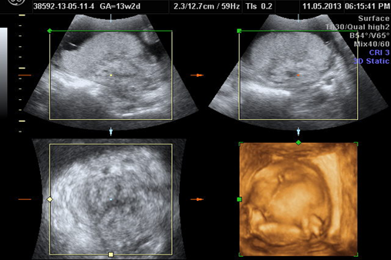
Fig. (1-a): Measurement of placental volume at 13 week gestation (First visit)
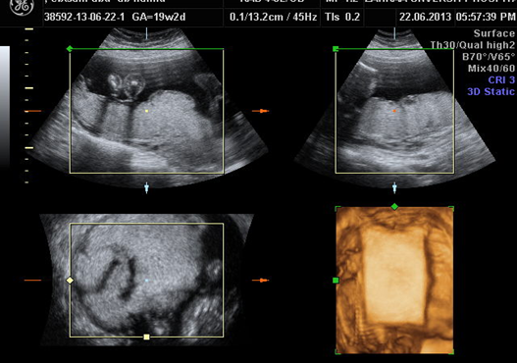
Fig. (1-b): Measurement of placental volume at 19 week gestation (Second visit)

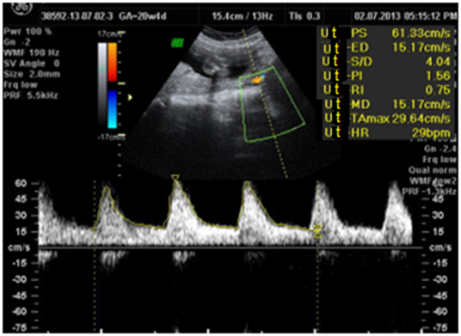
Fig. (1-c ): Uterine artery Doppler indices at 19 week gestation (second visit)
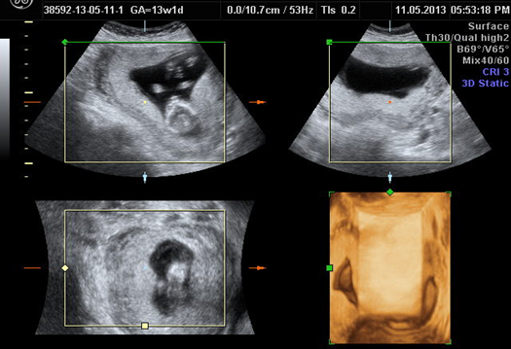
Fig. (2) : control case
Fig. (2-a ): Measurement of placental volume at 13 week gestation (First visit)
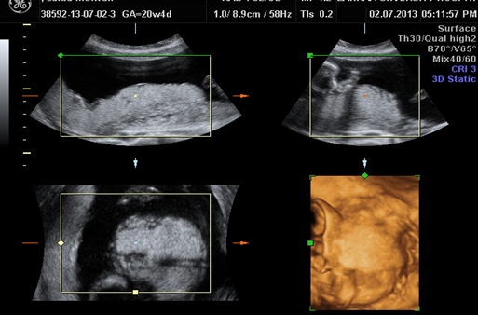
Fig. (2-b): Measurement of placental volume at 20 week gestation (Second visit)
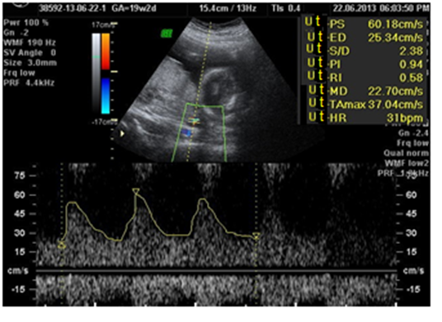
Fig. (2-c): Uterine artery Doppler indices at 20 week gestation (second visit)

4. Discussion
In the present study the anemic group had a higher mean maternal age (28.3 years) than group II (control group) which was (26.6), this was in agreement with Tippawan¹² who stated that body mass index, maternal age and parity were independently associated with maternal anemia.
The anemic group also had a non significant lower BMI during 1st and 2nd visits than the control group, this was in agreement with Bently and Griffith(2003) ¹³ and Adam et al.,(2008) ¹⁴ and Lama et al.,(2011) ¹⁵ they noted that low maternal body mass index has a strong relationship with maternal anemia.
Baig-Ansari et al. (2008) ¹⁶, stated that anemia in pregnancy is associated with malnourishment and low socioeconomic conditions. This supports the concept that pregnant women with low BMI need special attention for prevention and treatment of anemia.
The present study showed that the anemic group was characterized by higher gravidity and parity. The abortion rate was higher in the anemic group than the control group, however this difference was not significant this agree with Uche-Nwachi et al (2010)¹⁷ who found that parity, gravidity, and previous spontaneous abortions were directly related to the prevalence of anemia.
In the present study non significant statistical difference was found between maternal hemoglobin, hematocrit and placental volume during the 1st visit in anemic group. These findings were in agreement with Huang et al.,(2001)¹⁸ who found that enlargement of placenta was associated with mild and moderate degree of maternal iron deficiency anemia and appeared to be a uniform (proportional) physiological compensatory growth. Also, Michailidies et al ¹⁹ demonstrated that maternal hemoglobin and hematocrit levels appear to be inversely related to the placental growth rate.
In the present study there were non significant correlations between maternal hemoglobin, hematocrit and crown rump length in the anemic group, while these correlations were non significant positive correlations in the control group. These were in agreement with (Dennis et al., 2010)²⁰ who found that higher hematocrit levels and higher diastolic blood pressure were associated with a shorter crown rump length.
Hassan et al (2011)²¹ in study of the relationship between maternal characteristics and neonatal birth size in Egypt showed that overall maternal hemoglobin level had a negative correlation with all neonatal anthropometric measurements, which were significant for neonatal weight, length and head circumference.
During the 2nd visit in the present study there was a non statstical significance between maternal hemoglobin (Hb), hematocrit (HCT) and placental volume (pv).
The present study shows that maternal hemoglobin during the second visit has a non statistical significance with estimated fetal weight in the anemic group and in the control group.
Effect of maternal anemia on intrauterine growth is attributed to chronic deprivation of oxygen to the developing fetus. Severe maternal anemia if present from early gestation may be associated with reduced placental weight and structural abnormalities of the placenta²², which in turn affect nutrient transport from the mother to the fetus, this explains how maternal anemia adversely affects fetal growth²³
Malhotra et al.,(2002) ²⁴ found that the biggest newborn birth weight was denoted among women with hemoglobin concentration ranging between 9.6 and 10.5 gm/dl.
Nadia Mudher Al-Hilli, 2010 classified anemia as mild if haemoglobin was 10-10.9(gldL), moderate (7.0-9.9), severe (<7.0) and very severe( decompansated)( <4.0).
This might explain why in the present study there was no significant difference between the study and the control group as regards fetal crown rump length and EFW.
As regards Doppler study of the uterine artery in the present study it was noted that the pulsatility index and S/D ratio and resistance index showed a non statistical significance with maternal hemoglobin and hematocrit during the second visit in both anemic and control groups although there was an increase in the RI,and PI index and S/D ratio in the anemic group.
This could be explanined by the persistence of low Hg and HCT( mild anemia) during the second trimester might lead to changes in placental vasculature to adapt for the decrease in oxygen supply
Several potential biological mechanisms have been proposed by Rodriguez-Bernal et al, to explain the pathways through which iron deficiency, including its more severe form, anemia, could impair fetal growth.
Anemia (by causing hypoxia) and iron deficiency (by increasing serum norepinephrine concentrations) can induce maternal and fetal stress, which stimulates the synthesis of corticotropin-releasing hormone (CRH). CRH also increases fetal cortisol production, and cortisol may inhibit longitudinal growth of the fetus. An alternative mechanism could be that iron deficiency increases oxidative damage to erythrocytes and the fetoplacental unit.
Women with severe anemia at all stages of pregnancy doubled the risk of delivering LBW infants; when stratifying according to trimester of pregnancy, the association was found to be stronger for severe anemia in the first trimester with a 15-fold increase in the risk.30 Results from a study in India also suggested a negative effect of anemia during pregnancy on different anthropometric measurements at birth.28 Contrary to these results, two studies in different populations (United States and United Kingdom) did not find a relationship between iron status markers (hemoglobin or mean corpuscular volume [MCV]) at different stages of pregnancy and fetal growth outcomes. 29,31 It is important to consider that in the British study only 3% of the sample had hemoglobin levels under 11 g/dL at 12 weeks.
Milan Stefanović et al., (2005)²⁵ found that only severe anemia (maternal hemoglobin < 60 g/l) triggered fetal cerebral vasodilatation, however the uterine index was normal in this group and also in the group whose heamoglobin was > 60g/l.
Absence of fetal blood flow redistribution for maternal heamoglobin level of >60 g/l suggests that the oxygenation of the fetus was still satisfactory this may be due to the huge placental reservoir of maternal blood; therefore, even if the maternal blood oxygen content is lower than normal,there is enough oxygen passing through the placenta.²⁶
We can conclude that anemia can affect placental growth and development. Placental volume may be increased with maternal anemia.The use of 3D ultrasound is a safe technique of great value in evaluating placental growth and volume. It is more accurate and efficient than 2D ultrasound in measurement of placental volume. The use of Doppler ultrasound is an efficient method for evaluation of uteroplacental circulation. Uterine artery blood flow increase with maternal anemia.
We may recommend to prevent and treat anemia, as it can affect both mother and fetus, also it can affect placental growth and development.
Use of 3DUS is of great value than 2DUS in measurement of placental volume as it is safe and more accurate technique. Also Doppler ultrasound is recommended for uterine artery blood flow measurement for evaluation of uteroplacental circulation.

References
- Cunningham Leveno KJ, Bloom FL, Hauth.,JC, Gilstrap III L and Wenstrom KD (2010): Williams Obstetrics, translated by Ghazi Jahani B.,23rd edition, volume 1, Golban Publications, Tehran, Iran, pp. 1365-1367.
- Mahajan, S. Aalinkeel, R. Shah, P. Singh S. and Kochupillai N. (2008): British Journal of Nutrition 100, 408–417 Nutritional anaemia dysregulates endocrine control of fetal growth.
- Cunningham FG, Leveno KJ, Bloom FL, Hauth.,JC, Gilstrap III L and Wenstrom KD (2008): Williams Obstetrics, translated by Ghazi Jahani B., 22nd edition, volume 1, Golban Publications, Tehran, Iran, pp. 154-155.
- WHO, Centers for Disease Control and Prevention Atlanta (2008): Worldwide prevalence of anaemia 1993–2005. www.who.int. http://whqlibdoc. who.int/publications/2008/ 9789241596657_eng.pdf.
- Mahamuda Begum, Shamim Ara, Segupta Kishwara, Abu Sadat Mohammad Nurunnabi and Khandaker Abu Rayhan (2010): Microscopic Changes of the Placental Components in Maternal Anaemia: Bangladesh Journal of Anatomy Vol. 8 No. 2 pp. 59-63.
- Humberto Azpurua, M.D., Edmund F. Funai, M.D., Luisa M. Coraluzzi, Leo F. Doherty, M.D., Isaac E. Sasson, M.D., Merwin Kliman, M.S.E.E., and Harvey J. Kliman, M.D., Ph.D. (2009): Determination of Placental Weight Using Two-dimensional Sonography and Volumetric Mathematic Modeling. Am J Perinatol 0735-1631.
- Nardozza LM, Nowak PM and Araujo Júnior E (2009): Evaluation of placental volume at 7–10+6 weeks of pregnancy by 3D-sonography. Placenta. 30:585– 9.
- Jurkovic D, Jauniaux E, Kurjak A, Hustin J, Campbell S and Nicolaides KH (1991): Transvaginal color Doppler assessment of the uteroplacental circulation in early pregnancy. Obstet Gynecol 77:356-369.
- Han Sung Hwang, Young Han Kim, Young Kwon Ja and Young Han Park (2010): uterine and umbilical artery Doppler velocimetry as a predictor for adverse pregnancy outcomes in pregnant women with anemia. J. perinat. med. 38: 467-471.
- Carla Fagundes Silva de Paula, MD, Rodrigo Ruano, MD, PhD, Juliana Alvares Duarte Bonini Campos, DDS, PhD and Marcelo Zugaib, MD, PhD (2008): Placental volumes measured by 3-Dimensional ultrasonography in normal pregnancies from 12 to 40 weeks gestation. J Ultrasound Med 27:1583-1590.
- Nowak PM, Nardozza LMM, Araujo Jْnior E, Rolo LC, Guimares Filho HA and Moron AF (2010): Estimation of placental volume by three-dimensional ultrasonography with the XI VOCAL method in the first gestational trimester. Radiol Bras. 43 (2):81– 84.
- Tippawan Liabsuetrakul (2011): Is International or Asian Criteria-based Body Mass Index Associated with Maternal Anaemia, Low Birthweight, and Preterm Births among Thai Population?—An Observational Study. J HEALTH POPUL NUTR; 29(3):218-228.
- Bentley ME and Griffiths PL (2003): The burden of anemia among women in India. Eur J Clin Nutr 57:52-60.
- Adam I, Babiker S, Mohmmed AA, Salih MM, Prins MH and Zaki ZM (2008): Low body mass index, anaemia and poor perinatal outcome in a rural hospital in eastern Sudan. J Trop Pediatr 54:202-4.
- Lama Al-Mehaisen, Yousef Khader, Oqba Al-Kuran, Fayrouz Abu Issa, and Zouhair Amarin (2011): Maternal Anemia in Rural Jordan: Room for Improvement: Hindawi Publishing Corporation Anemia Volume 2011, Article ID 381812, 7 pages doi:10.1155/2011/381812.
- Baig-Ansari N, Badruddin SH, Karmaliani R, Harris H, Jehan I, Pasha O, et al., (2008): Anemia prevalence and risk factors in pregnant women in an urban area of Pakistan. Food Nutr Bull; 29:132–9.
- Uche-Nwachi EO, Odekunle A, Jacinto S, Burnett M, Clapperton M, David Y, Durga S, Greene K, Jarvis J, Nixon C, Seereeram R, Poon-King C and Singh R (2010): Anaemia in pregnancy: associations with parity, abortions and child spacing in primary healthcare clinic attendees in Trinidad and Tobago. Afr Health Sci; 10(1): 66–70.
- Huang A, Zhang R and Yang Z. (2001): Quantitative (stereological) study of placental structures in women with pregnancy iron-deficiency anemia. Eur J Obstet Gynecol Reprod Biol 97 (1): 59-64.
- Michailidis GD,Morris RD,Mamopoulos A, Papageorgiou P and Economides DL (2002): The influence of maternal hematocrite on placental development from the first to the second trimesters of pregnancy. Ultrasound Obestet Gynecol 20:351-355.
- Dennis O, Mook-Kanamori, Eric A. P. Steegers and Paul H. Eilers. (2010): Risk factors and outcomes associated with first trimester fetal growth restriction, JAMA. 303(6):527-534.
- Hassan, N.E. Shalaan A.H. and El-Masry S.A. (2011): Relationship between maternal characteristics and neonatal birth size in Egypt. Eastern Mediterranean Health Journal (EMHJ), Vol. 17 No. 4.
- Pollack RN and Divon MY (1992): Intrauterine growth retardation: definition, classification and etiology. Clin Obstet Gynecol;35:99-107.
- Singla PN, Tyagi M, Kumar A, Dash D and Shankar R. (1997): Fetal growth in maternal anemia. J Trop Pediatr. 43:89-92.
- Malhotra M, Sharma JB, Batra S, Sharma S, Murthy NS, Arora R., (2002): Maternal and perinatal outcome in varying degrees of anemia, Int J Gynaecol Obstet, Vol.79, No.2, pp.93-100.
- Milan Stefanović, Mileva Milosavljević, Dragana Radović-Janošević, Ranko Kutlešić and Predrag Vukomanović (2005): maternal anemia and fetal cerebral hemodynamic response – Doppler assessment. Medicine and Biology Vol.12, No 2, pp. 93 – 96.
- Carles G, Tobal N, Raynal P, Herault S, Beucher G, Marret H and Arbeille P (2003): Doppler assessment of the fetal cerebral hemodynamic response to moderate or severe maternal anemia. Am J Obstet Gynecol 188:794-9.

7/22/2014

