**Morphological characteristics and incidence of diseases on white yam (*Dioscorea rotundata* L. Poir) tubers in Abuja, Nigeria**

Anjorin Toba Samuel1, Nwokocha Onyetugo Violet2, Sanni Abdulmumin Dee3

1Department of Crop Science, Faculty of Agriculture, University of Abuja, Abuja- Nigeria

2Department of Policy and implementation, FCT, Ministry of Education, Abuja Nigeria

3Department of Biological Sciences, Faculty of Science, University of Abuja, Abuja-Nigeria

[oyindamola35@yahoo.com](mailto:oyindamola35@yahoo.com)

**Abstract:** This study was carried out to identify the white yam varieties in the Federal Capital Territory (FCT), Abuja, Nigeria and investigate their morphological characteristics and diseases. The survey research showed that out of the ten commonly cultivated white yam cultivars in the FCT, Abuja, *Gwari* and *Makakusa* were the commonest (43.60 and 41.70% respectively) while *Dalunga* was the least cultivated (24.10%). Morphologically, *Makakusa* has the highest weight and length while Akuki had the least weight and length among the surveyed cultivars. Dry tuber rot disease caused by fungi or nematode had the highest incidence (25.68%) on yam tubers in the territory while *Meloidogyne* tuber gall disease had the least incidence (8.40%) but often more severe. Detailed histological, biochemical, pathological and nutritional studies is necessary on the identified tubers of white yam cultivars in Nigeria. Measures should be taken to prevent damages, pest and disease attack on yam tubers.

**[**Anjorin Toba Samuel, Nwokocha Onyetugo Violet, Sanni Abdulmumin Dee. **Morphological characteristics and incidence of diseases on white yam (*Dioscorea rotundata* L. Poir) tubers in Abuja, Nigeria.** *Nat Sci* 2014;12(7):58-65]. (ISSN: 1545-0740). <http://www.sciencepub.net/nature>. 10

**Key words:** Morphology, incidence, severity, diseases, white yam tuber, Abuja-Nigeria

1. **Introduction**

White yam *(Dioscorea rotundata* L. Poir*)* Family Dioscoreaceae is native to West Africa, but it does not occur in the wild, and is probably developed in cultivation from the wild species - *D. praechensilis* Benth. *D. rotundata* Poir is grown on a greater acreage than any other cultivars in West Africa.Other popular cultivated yam species in Nigeria are *D. cayenensis* Lam. (yellow yam) and *D. alata* L. (water yam) **(Amusa, 1999)**. The white yam tuber is more or less cylindrical in shape. The skin of the tuber is smooth and brown, while the flesh is usually white and firm. Starch grains in the tuber are large and ovoid **(Degrass, 1993)**. The traditional yam famer is an expert at identifying and distinguishing different cultivars of *D. rotundata*, and of yams generally.

The yam tuber grows from a massive, corm-like structure located at the base of the vine. Indeed, this corm is present very early in the life of the plant, being formed shortly after sprouting occurs. The main feeder roots and later tuber arise from it. After harvesting, the corm may remain attached to the tuber but can be separated from it by breaking the narrow junction between them **(Orkwor *et al.*,1998)**. Roots attached to the corm, as well as to the body of the tuber, may also be present on ware yams brought to market.

The various cultivars can be identified by the tuber characteristics after harvest or by their shoot characteristics while they are growing in the field. Underground tubers vary in size and shape averaging 1.3 - 3.6 kg, sometimes reaching 27.2 kg or more **(IITA, 2007)**. Nutritionally, the content of white yam is mainly carbohydrate, but also contain about 1-2% dietary protein, which is high compared with other tropical root crops (Ekefan et al., 1999). In Nigeria, it is eaten as boiled or pounded yam and as *amala* among the Yorubas of southwest, Nigeria (Phillips *et al*., 2004).

Identification of yam tubers may be based on distinctive features such as tuber shape, tuber skin colour and structure, tuber flesh colour and tuber flesh texture; or on the colour of sprout and shoot tips, quantity and distribution of spines and bloom on the stem, and leaf shape, size, and colour (**Hamon, and Toure, 1990; Collins, 1997)**. Within each species, there are wide differences in each of these characteristics.

There is a very large number of cultivars of *D. rotundata* that are grown, especially in Nigeria where it originated and is most widely cultivated **(Osunde, 2006)**. Though a yam tuber naturally has periderm, which microorganisms usually cannot breach, it is easily wounded by rodents, nematodes and humans during weeding, harvesting and post-harvest handling. Such would facilitate the penetration and development of rot microorganisms (**Noon, 1999**).

Currently, the identification and common diseases of most of these cultivars of yam are not known partly because detailed descriptions of the distinguishing features of each cultivar are lacking and incidence of white yam diseases in this region had not been reported. The objective of this study were therefore to identify various white yam cultivars in the FCT Abuja, determine their morphological characteristics and investigate the incidence and severity of common diseases on white yam tubers in the farmers stores in the FCT, Abuja – Nigeria.

**2. Materials and method**

**2.1 Study Area**

This study was carried out in the FCT Abuja, the capital city of Nigeria. Abuja is situated between Lat. 9o401 N and Long. 7o291 E and has a total land area of 713 km2. The surveyed area is shown in Fig.1.

Abuja is made up of six area councils from which data were collected. The primary occupations of the traditional inhabitants of the FCT are farming and the settlers, civil servants and traders. The area council are Abaji, AMAC, Gwagwalada, Kuje, Bwari and Kwali.

**2.2 Sampling method and data collection**

Three villages were selected randomly from each area council namely Kuje, Kwali, Gwagwalada and AMAC for the study. In each village, three yam stores or barn were visited. In the store, morphological characteristics of the 100 yam tubers from each of the cultivars were observed and identified. With the aid of a pictorial handbook of yam and their diseases, prevalence, incidence and severity estimations were calculated by the following formulae(**Yusuf and Okusanya, 2008** and **Taylor and Sasser, 1978**):

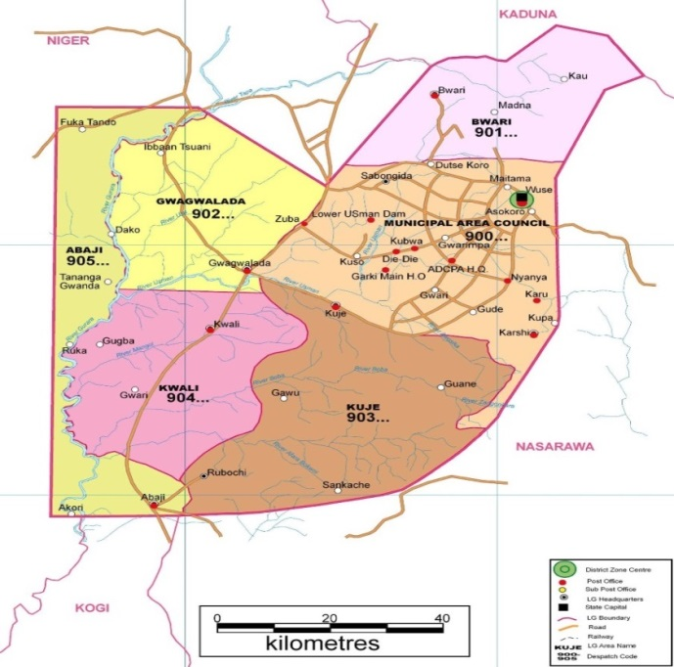

**Fig: 1: Map of the surveyed area in the FCT Abuja, Nigeria.**

*Prevalence of a yam* *cultivar $=\left(\frac{no of cultivars in the store}{Total no of yam cultivars stored }\right)100$*

$$100$$

*Disease incidence $=\left(\frac{no of diseased yam tubers}{Total no of yam examined }\right)100$*

*Disease severity $=\left(\frac{Area of yam tuber affected }{Total area of yam tuber}\right)$*

**Data Analysis**

The data collected from the survey were analyzed and result presented using frequency counts and percentages.

**3.0 Results**

**3.1 Distribution of white yam cultivars produced by farmers**

Gwagwalada and Kwali Area councils had the highest prevalence of white yam cultivars (Table 1). This research survey has indicated that a wide range of white yam cultivars are produced by farmers of the FCT Abuja. Those identified include *Akuki, Asuba, Arme, Dalunga, Danitcha, Gwari, Lagos, Makakusa, Pepa* and *Yengbedi.* This was based on certain distinguishing morphological characteristics. *Gwari* and *Makakusa* cultivars were most cultivated white yam cultivars with *Dalunga* was the least cultivated cultivar among the ten cultivated white yam cultivars by FCT Abuja farmers.

**Table 1: Distribution of white yam cultivars produced by farmers in Abuja**

|  |  |  |  |  |  |  |  |  |  |  |  |
| --- | --- | --- | --- | --- | --- | --- | --- | --- | --- | --- | --- |
| **Area council** | *Akuki* | *Asuba* | *Arme* | *Dalunga* | *Danitcha* | *Gwari* | *Lagos* | *Pepa* | *Meka Cusa* | *Yan gbedi* | *Mean Prevalence* |
| AMAC | - | - | - | - | + | + | + | + | + | + | 60 |
| Gwagwalada | + | + | + | - | + | + | + | - | + | + | 80 |
| Kuje | + | + | + | - | - | + | + | - | + | - | 60 |
| Kwali | - | + | + | + | + | + | - | + | + | + | 80 |
| Total | 2 | 3 | 3 | 1 | 3 | 4 | 3 | 2 | 4 | 3 |  |

**Key: - absent + present**

**3.2 Prevalence of white yam cultivars produced by each Area Council in the FCT, Abuja**

In AMAC, *Danitcha* was the most prevalent white yam cultivar and *Akuki* was the least prevalent. For Gwagwalada, it was Mekakusa that was the most prevalent white yam cultivar and *Danitcha* was indicated to be the least prevalent. *Gwari* was the most prevalent and *Dalunga* was the least prevalent cultivar in Kuje. In Kwali are council *pepa* was the most prevalent and Lagos was the least prevalent white yam cultivar respectively (Table 2).

**Table 2: Prevalence of white yam cultivars produced by each Area Council in the FCT, Abuja**

|  |  |  |  |  |  |
| --- | --- | --- | --- | --- | --- |
| **White yam cultivars** | **AMAC (%)** | **Gwagwalada (%)** | **Kuje (%)** | **Kwali (%)** | **Mean FCT** |
| *Akuki* | 20.8 | 25.6 | 28.8 | 26.0 | 25.30 |
| *Asuba* | 27.5 | 65.5 | 31.0 | 31.0 | 38.75 |
| *Arme* | 31.6 | 35.5 | 24.1 | 29.5 | 30.18 |
| *Dalunga* | 25.3 | 23.4 | 22.1 | 25.6 | 24.10 |
| *Danitcha* | 63.7 | 20.7 | 28.2 | 37.6 | 37.55 |
| *Gwari* | 61.8 | 23.4 | 58.2 | 31.0 | 43.60 |
| *Lagos* | *54.1* | *53.8* | *25.2* | *22.5* | *38.90* |
| *Makakusa* | 36.5 | 68.6 | 26.2 | 35.5 | 41.70 |
| *Pepa* | 27.3 | 23.9 | 27.2 | 60.5 | 34.73 |
| *Yangbedi* | 34.0 | 48.8 | 26.5 | 28.5 | 34.45 |

* 1. **Morphological characteristics of white yam tubers in Abuja, Nigeria**

The morphological characteristics of the white yam cultivars, four cultivars of the yam tubers possessed relatively small corms, four cultivars with moderate corms and two cultivars with large corms respectively. *Akuki* had the smallest weight and *Mekucusa* had the highest weight among the cultivars and thus specifically known for their giant size compared to others.

Four of the cultivars had an oval shape, four cylindrical, and two with an oblong shape. *Makakusa* has the highest length and *Akuki* has the shortest length among the cultivars. *Akuki* had the highest mean number of sub-tuber let and *Yangbedi* with the lowest mean number of tuberlets (Table 3). Tubers of some cultivars such as Arme and Asuba have distinctive characteristics such as rough bark texture (Table 3). There were five cultivars of yam that mostly have tuber branch and also five cultivars of yam with branches respectively. As indicated in Fig. 3, akuki cultivars had corky periderm (Plate 2.5), *Asuba* had a cracked corky periderm (plate 2.7) while *Gwari*, Lagos and *Danitcha* all had a characteristic rough corky periderm while *Dalunga* (Plate 2.8), Pepa (Plate 2.3), *Makakusa* (Plate 2.2), and *Yangbedi* (Plate 2.4) had a smooth corky periderm respectively.

**3.4. Incidence of Disease of the white yam tubers in the barn**

There were four major categories of tuber diseases of white yam tubers in the FCT, Abuja namely bacteria soft tuber rot, tuber canker by bacteria, dry rot by fungi/nematode and *Meloidogyne* yam rots by nematode. Dry tuber rot disease caused by fungi or nematode had the highest incidence (25.68%) on yam tubers in the territory while *Meloidogyne* tuber gall disease had the least incidence (8.40%). In AMAC, the highest white yam disease incidence was dry rot by fungi/nematode (26.1%) while the least was tuber canker by bacteria (Table 4). In Gwagwalada, Kuje and Kwali tuber rot by fungi and bacteria had the relatively high incidence.

White yam from Kuje had the highest incidence of bacterial tuber rot disease while tuber canker and dry rot disease was the least incidence of disease attack in Gwagwalada area council (Table 4). In Kuje, tuber rot (wet rot) disease by bacteria the most incidence disease on yam tuber followed by tuber canker disease by bacteria with the least incidence. Generally, *Meloidogyne* yam gall disease by nematode had the least incidence.

**Table 3: Morphological characteristics of white yam tubers in Abuja**

|  |  |  |  |  |  |  |  |  |  |  |
| --- | --- | --- | --- | --- | --- | --- | --- | --- | --- | --- |
| Morphological characteristic | *Akuki* | *Asuba* | *Arme* | *Dalunga* | *Danitcha* | *Gwari* | *Lagos* | *Makacusa* | *Pepa* | *Yanbedi* |
| Size of yam corm | small | small | moderate | large | moderate | small | Mode rate | large | moderate | small |
| Shape | oval | oval | cylindrical | cylindrical | cylindrical | oval | oblong | cylindrical | oval | oblong |
| Average weight (kg) | 1.13 | 1.15 | 1.25 | 1.45 | 1.35 | 1.30 | 1.21 | 3.1 | 1.92 | 1.42 |
| Mean tuber length (m) | 1.0 | 1.2 | 1.8 | 2.1 | 2.2 | 2.4 | 2.2 | 3.3 | 2.3 | 2.1 |
| Mean no. of sub-tuberlet | 4 | 3 | 2 | 3 | 2 | 1.5 | 2 | 5 | 1 | 1 |
| Tuber branch | absent | absent | Absent | present | present | present | present | present | absent | present |

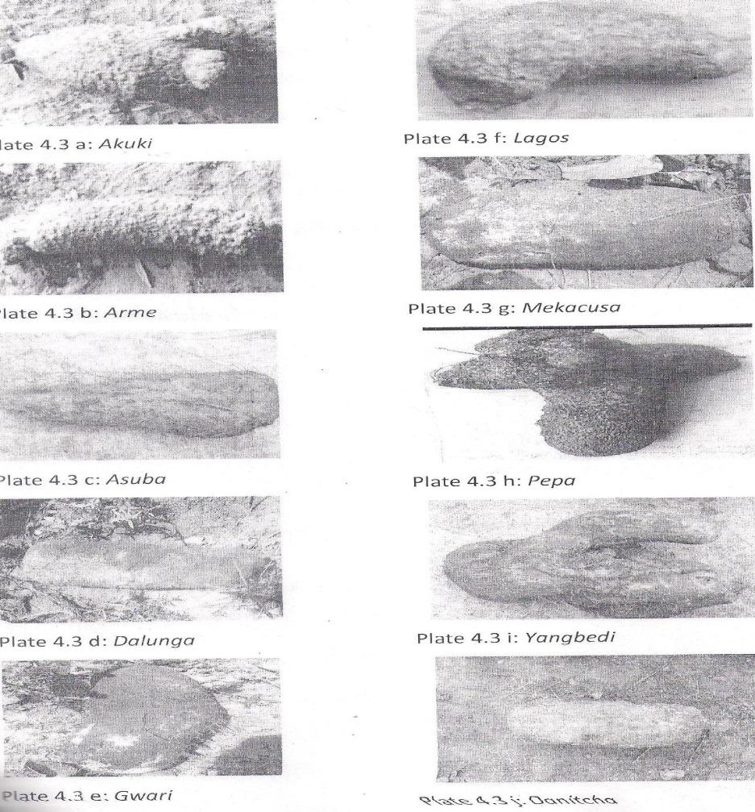

Plate 1.10: Danitcha Onitshae 10

Plate 1.4: Makakusa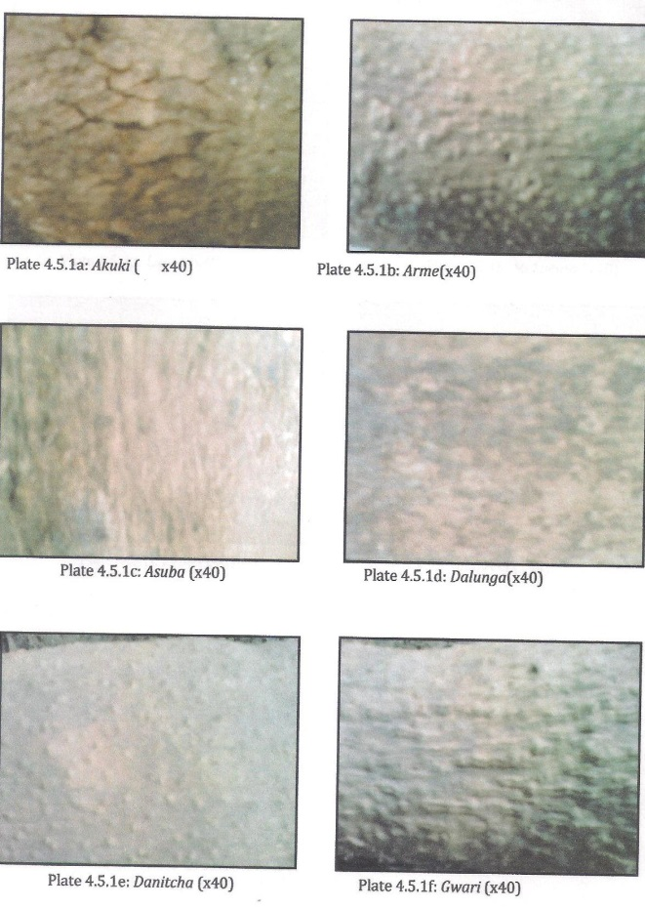e 10

Plate 1.2: Lagose 10

Plate 1.1: Akukie 10

Plate 1.3: Armee 10

Plate 1.9: Gwarie 10

Plate 1.7: Dalungae 10

Plate1. 8: Yangbedie 10

Plate 1.6: Pepae 10

Plate 1.5: Asubae 10

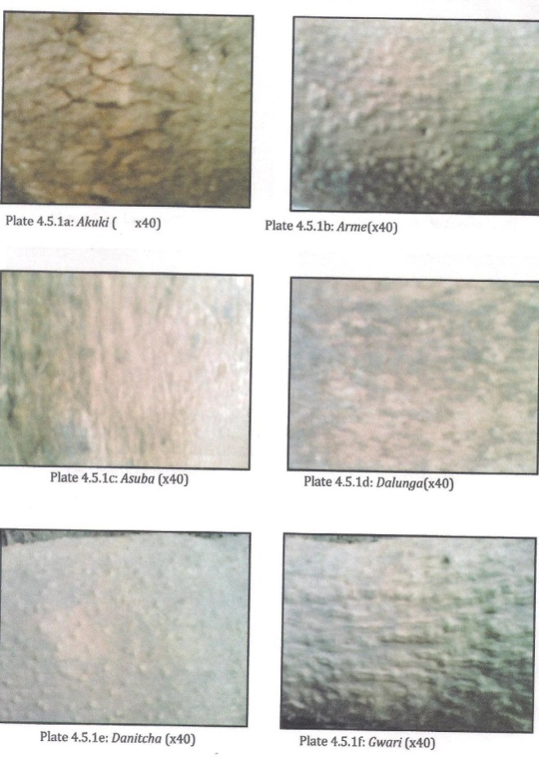

Plate 1: Shape of different types of white yam in the FCT Abuja, Nigeria

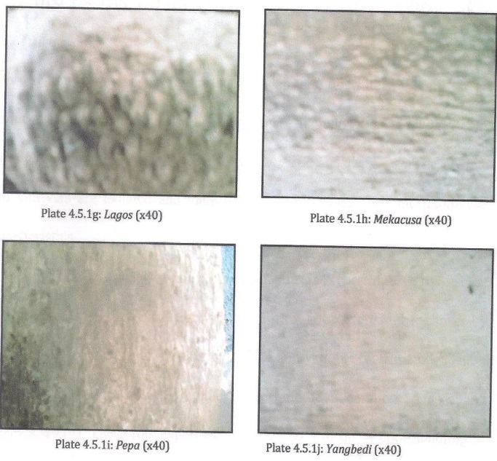

Plate 2.2: Makakusa (x40)

Plate 2.4: Yangbedi (x40)

Plate 2.3: Pepa (x40)

Plate 2.1: Lagos (x40)

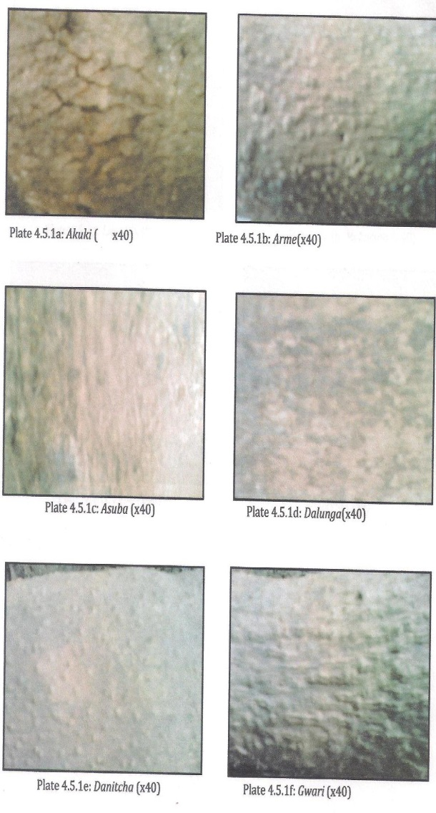

Plate 2.10: Gwari (x40)

Plate 2.9: Danitcha (x40)

Plate 2.8: Dalunga(x40)

Plate 2.7: Asuba(x40)

Plate 2.6: Arme (x40)

Plate 2.5: Akuki (x40)

**Plate 2: Micrographic texture of skin (periderm) of healthy white yam tubers in the FCT, Abuja**

**Table 4: Incidence of disease of white yam tubers in the barn**

|  |  |  |  |  |  |
| --- | --- | --- | --- | --- | --- |
| **Diseases** | **AMAC (%)** | **Gwagwalada (%)** | **Kuje (%)** | **Kwali (%)** | **Mean FCT** |
| 1. Bacteria soft tuber rot | 17.8 | 22.4 | 23.5 | 25.0 | 22.18 |
| 2. Tuber canker by bacteria | 16.1 | 13.1 | 19.6 | 18.0 | 16.70 |
| 3. Dry rot by fungi/nematode | 26.1 | 25.0 | 23.6 | 28.0 | 25.68 |
| *4. Meloidogyne* yam tuber gall disease by nematode | 7.0 | 6.5 | 10.6 | 9.5 | 8.40 |

* 1. **Severity of Tuber Rot Diseases of White Yam in Yam Barn**

In the yam tuber stores in all the Area councils, dry rot by fungi/nematode and *Meloidogyne* yam rots by nematode were more severe than other diseases but they were location specific depending on how endemic a particular soil is. Yam tubers from Kuje had the highest severity of bacteria soft rot while Gwagwalada had the highest tuber canker. Kwali had the highest severity of dry rot by fungi/nematode while *Meloidogyne* yam rots disease was most severe in AMAC and Gwagwalada.

**Table 5: Severity of tuber rot diseases of white yam in yam barn**

|  |  |  |  |  |  |
| --- | --- | --- | --- | --- | --- |
| **Diseases** | **AMAC (%)** | **Gwagwalada (%)** | **Kuje (%)** | **Kwali (%)** | **Mean FCT** |
| Bacteria soft tuber rot | 19 | 10 | 20 | 21 | 17.50 |
| Tuber canker by bacteria | 10 | 12 | 14 | 13 | 12.25 |
| Dry rot by fungi/nematode | 21 | 20 | 20 | 23 | 21.0 |
| *Meloidogyne* yam rots by nematode | 20 | 20 | 10 | 21 | 17.75 |

**4.0 Discussion**

The structure of the white yam tuber is highly variable, depending on the cultivar. These characteristics are the main features by which white yam are differentiated and identified. Both genetics and environment play significant roles in determining tuber shape and size. Some yam tubers were cylindrical, oval and some were irregular in shape **(Dansi *et al.*, 1999).**

Tuber rots of various kinds are the most significant diseases caused by fungi in yams, whether in storage, the planted sett or the growing tuber in the field, indeed fungal rots account for a greater loss of stored tubers than any other single cause. **Okigbo and Ajalie (2005)** reported that fungi cause both dry and soft rots in the yam tuber. The soft rots were due mainly to *Penicillium* spp., *Fusarium* spp., and *Botrydiploidia* spp. and less frequently, soft rots may be caused by *Rhizopus* or *Lasiodiplodia* spp. Fungi which have been identified as causing the dry rot are *Rosellinia* and *Sphaerostilb*e. These mycoflora which cause rots in the stored tuber are also responsible for the rotting of setts after planting and in cases where the rotting organism is present in the yam sett, it may persist in the soil until the new tuber is formed. Infection of the new tuber may thus occur, resulting in a rotted tuber at harvesting. The symptoms of dry rot though vary with varying coloration depending on the invading pathogen. The infected tissues become hard and dry. When tubers are infected with *Penicillium oxalicum* and *O. cyclopclum*, the tuber turn brown, become hard and dry maintaining their integrity except when the tissue were invaded by *S. marcesens* (IITA, 2007). Such invaded tissues become covered with greenish mycelia of the fungus. When tubers were infected with *Aspergillus niger* and *A. lamar*; such tissues subsequently turn brown with yellowish margin. *Rosellinia bunades* and *Botrydioplodia thobrome*, has been reported to cause dry black rot. The infected yam tubers become pulvelulent, breaking into small dry particles. *Fusarium* species were also reportedly associated with dry rot in yam tubers in Nigeria (**Morse *et al.,* 2000)**

including pinkish with yellowish border on the infected tissue **(IITA, 2007).**

Chupp and Sherf, 1992 reported that bacteria contribute to the rotting of yam tuber and *Serraria* has been implicated, but other genera are probably involved as well. The tuber rots caused by the bacteria are usually more fetid than those caused by fungi. Wet rot is characterized by the oozing of whitish fluid of the yam tissue when pressed and this symptom is usually associated with a bacterium, *Erwinia carotovora pv carotovora* **(IITA, 2007)**.

The same sanitary precautions outlined for fungi apply in the case of bacterial rots. **Scott *et al*., (2000)** observed that nematodes, when present, often aggravate fungal rots by helping their spread. He further suggested that control measures for checking fungal tuber rots involve treating the sett with fungicide or alkaline material such as wood ash, lime-wash before planting, harvesting carefully so as not to wound the tubers, and constant inspection of the stored tubers so as to isolate rotting tubers early. In addition, good soil aeration will keep the incidence of rotted tubers at harvesting to a minimum.

Symptoms of bacteria tuber rot (wet rot) included oozing of whitish fluid from the tuber; dead yam tissues, tuber coloration and shrinking of yam tuber are symptoms of tuber canker disease caused by bacteria. Infected yam tissues with soft rot fungus become soft as it is ramified by the fungal mycelium. The causal fungus quickly ramified the tissue which turn brown and become soft and at time wet due to a rapid collapse of the cell walls. Fungi associated with this type of rot were *Rhizopus* spp., *Mucor circinelloides*, *S. vollsii* and *Rhizoctonia solani* and *Armillariella mellea* ***(*Green *et al.*, 1995)**

Yam rot diseases by nematode can create point of entry for other pest and pathogens. Dry tissue on yam tuber significantly causes necrotic tissue on the tuber. These tuber diseases have been reported in other regions in Nigeria (**Amusa and Baiyewa, 1999)**. **Booth (1995)** reported that during storage, the tubers are subjected to losses of up to 50% of the fresh material. Here, the losses due to bacterial and fungal attack play a predominant role. These rots experienced may be as a result of infection on the field and or due to poor handling of yam tubers after harvest **(Collins, 1997)**. **Morse *et al*. (2000)** reported that pathogens penetrate through wounds in the tubers and infect the inner tubers after harvest.

The yam nematode (*Scutellonema bradys*) is the most common nematode which attacks yam. It inhabits the area just below the skin of the yam tuber. The eggs laid by the females produce larvae which are capable of infecting other subterranean plant tissues such as roots or tubers. The activities of the yam nematode result in extensive browning of the subsurface layer of the yam tuber, and the resultant destruction of the meristematic zone there. As such, tubers that have been infested with this nematode will usually be unable to geminate **(FAO, 1998)**.

The root-knot nematode (*Meloidogyne* spp.) also attacks growing yam tubers, producing a characteristic warty appearance on the surface of tuber. The larvae occur freely in the soil, but can penetrate through the softer portions of the growing tuber and become parasitic within the tuber. The larvae soon enter into adult life, during which time only the female is parasitic – discharging eggs through the tuber surface into the soil. These eggs will hatch to produce larvae which will again seek to infest another tuber or root material, if the tuber has been harvested and is in storage. The egg masses, as well as the larvae that they produce on hatching, remain within the tuber. The root-lesion nematode (*Pratylenchus* spp.) also attacks yam tubers and other underground plan parts. They invade the tuber in the larval or adult stages, and cause a dark-brown dry rot that extends irregularly into the tuber flesh. This may be accompanied by slitting of the tuber skin.

All the foregoing nematodes that attack yam also produce secondary effects on the tubers in addition to their own direct effects **(Booth, 1995)**. The wounds created by these nematodes on the tuber surface act as weak spots through which bacterial and fungal infection can occur. Secondly, since these nematodes attack and reside in the tuber, they are present in the tuber, and continue their activities within it, during storage. Thus, for example, yams infested with root-knot nematode may be observed to become progressively more warty during their storage life. Similarly the brown subsurface discolouration caused by the yam nematode will continue to spread during storage.

The major mode of control of nematode diseases in yam is to try to avoid them. To begin with, setts which show symptoms of nematode infestation should not planted. Judicious crop rotation may also be useful, so that yam is not grown immediately after a crop that is known to cause a build-up of these nematodes. Attempts at control through killing of the nematodes have also been tried. Soil fumigation with nematicides such as nemagon has been partially successful. Also the dipping of infested setts in hot water at 50oC for ten minutes before planting may reduce nematode infestation, but it may sometimes result in damage to the sett **(Arene, 1987).**

**Conclusion**

Based on the result of this survey, it is conclusive that among the cultivars of white yam tubers produced in the FCT, *Makakusa* and *Gwari* were the most prevalent cultivars. *Dalunga* cultivar was the least prevalent. Morphologically, *Makakusa* has the highest weight and length while Akuki had the least weight and length among the surveyed cultivars. It was noted that there were variation in corm size among the cultivars of white yam tubers and they had distinctive corky periderm among the tubers. The highest white yam disease incidence in the FCT, Abuja was dry rot caused by fungi/nematode while the least was *Meloidogyne* tuber gall disease though its infection was often severe on any tuber infected. Studies on morphological and anatomical differences between all the parts of white yam cultivars including the shoot and root are necessary. Also disease tolerance and nutritional profile of yam tubers from various identified cultivars are imperative.

**Corresponding Author:**

Dr. Anjorin, Toba Samuel

Department of Crop Science

Faculty of Agriculture

University of Abuja

PMB 117

Abuja, Nigeria

E-mail: [oyindamola35@yahoo.com](mailto:oyindamola35@yahoo.com)

**References**

1. Amusa, N.A. (1997). Fungi associated with anthracnose symptoms of yam (*Dioscorea* spp) in South western Nigeria and their role in crop resistance, 13:177- 183
2. Amusa, N. A. (1999). Concentric leaf spot of yam (*Dioscorea* spp.) in south western Nigeria. Mycopathologia, 148:113-120
3. Amusa, N. A. and Baiyewa, R. A. (1999). Storage and market disease of yam tubers in south western Nigeria. Ogun journal of Agriculture Research (Nigeria), 11:211- 255.
4. Amusa, N. A. (2000). Screening cassava and yam cultivars for resistance to anthracnose using toxic metabolite of *Colletotricum* species. Mycopathologia, 150:137 – 142.
5. Arene, O. B. (1987). Advances integrated control of economic diseases of cassava in Nigeria. In: Halin. S. K. And Canenes, F. E. (eds). Integrated pest management for tropical root and tuber crops. pp 167 – 175.
6. Booth, R. H. (1995). Post – harvest deterioration of tropical crops: losses and their control. Trop. Sci., 16:46 – 63.
7. Chupp, C and Sheft, A. F. (1992). Yam diseases and their control. The Ronald press Co. New York. Pp 200 – 210.
8. Collins, W. W. (1997). Root Vegetables: New uses for old crops. In: Janick, J. And Simon J. E. (eds). New crops. Wiley Publishers. New York. Pp. 106 – 537.
9. Dansi, A. Mignowa, H. D., Zoundjihekpson, J., Sangore, A., Adiedu, and Quinn, F. M. (1999). Morphological diversity, cultivar groups and possible descent in the cultivated yams (*Dioscorea cayenensis*/ *D. rotundata*) complex in Benin Republic. Genetic Research and Crop Evolution 46:371 – 388.
10. Degrass, L. (1993). The yam: A tropical Toot Crop. The Macmillan press Ltd., London England.
11. Ekefan, E. J., Simon, S.A., Nwankiti, A. O. And Peter, J. C. (1999). Effect of intercropping on the incidence of foliar anthracnose and tube yield of susceptible *Dioscorea alata* yam in Nigeria. Journal of Plant Protection in the Tropics, 12(2):80 – 90.
12. FAO (2005). Food and Agricultural Organisation Production year book for 2004. FAO, Rome, Italy.
13. FAO (Food and Agricultural Organisation) (1998). Precautionary approach to yam management. FAO technical guideline for disease of yam. No. 2.
14. Green, K. R., Sangoyomi, A. T., Amusa, N. A. (1995). The importance of Rhizoctoria solari as a pathogen of yam (*Dioscorea* spp.) in Nigeria. Proceedings of the 6th symposium of the internal society for root and tuber crops African branch, pp. 412 – 418.
15. Hamon, P. and Toure, B. (1990). The classification of the cultivated yams (*Dioscorea cayenensis – rotundata complex*) of West Africa. Euphytica 47:179 – 187.
16. International Institute of Tropical Agriculture (IITA, 2007). Yam research for development. IITA publication 1. Pp1 – 10.
17. Morse, S., Archolo, M., McNamara, P. And Oliver, R. (2000). Control of storage insects as a means of limiting yam tuber fungal rots. J. Stored products Res., 36:37 – 45.
18. Noon, O. (1999). Fungus diseases of plants and their treatment. Agricultural Research, 11:50 – 55
19. Okigbo, R. N. and Ajalie, A. N. (2005). Biological control of post-harvest rot of yams (*Dioscorea* spp.) with *Bacillus subtilis*. Mycopathologia, 159:307 – 314.
20. Orkwor, G. C., Asiedu, R. and Ekannayake, I. J. (1998). Food yams: Advances in Research. International Institute for Tropical Agriculture (IITA). Ibadan and national Root Crops Research Institute (NRCRI) Umudike. Pp187 – 215.
21. Osunde, Z. D. (2006). Prediction of sprouting and weight loss of yam in local storage structures in Niger State of Nigeria. Unpublished Ph. D Thesis. Federal University Technology, Minna, Nigeria.
22. Phillips, T. P., Taylor, D. S., Sanni, L and Akoroda, M. O. (2004). A yam industrial revolution in Nigeria: the potential for a new industrial crop. IFAD/FAO/UN Rome. Pp 49.
23. Scott, G. J., Rosegrant, M. And Ringer, C. (2000). Roots and Tubers for the 21st Century: Trends, Projections and policy options. Food Agriculture and the environment. Discussion Paper 31. Washington D. C. International Food Policy Research Institute (IFRI) and International Potato Centre (IP)
24. Taylor, A.L. and J.N. Sasser 1978. Biology identification and control of root-knot nematodes. *(Meloidogyne* spp.) Cooperative publishing. Department of Plant Pathology, North Carolina State University, Agency of International Development: Raleigh, North Carolina State University and USAID. 111pp
25. Yusuf, C and B.A.O. Okusanya (2008). Fungi associated with the storage of yam (*Dioscorea rotundata* L. Poir) in Yola, Adamawa State. Journal of Sustainable development in Agriculture and Environment, (3):2 99-103.

6/13/2014