Diagnosis of Stroke by Magnetic Resonance Imaging (MRI)

Hanan.Y.Abbas¹, Ikhlas O. Saeed² and, Mariam S. AL-Juaidi³

^{1,2 and 3}Diagnostic Radiology Department, Faculty of Applied Medical Sciences, King Abdulaziz University P.O.Box 80328, Jeddah, 21589
habbas1@kau.edu.sa

Abstract: Stroke, occurs when the blood supply is disrupted in any part of the brain, causing brain cells to die, which is considered as a medical emergency. So, anyone is having a stroke should be taken to a medical check immediately for evaluation and treatment. Magnetic resonance imaging (MRI) is one of the most important diagnostic tools to produce very accurate images of the brain and its arteries. It provides good contrast between the different tissues of the body, which makes it especially useful in imaging the brain, compared with other techniques. The aim of this work was to find out the role of Magnetic Resonance Imaging in diagnosing of stroke at KAUH. This retrospective study was done in the department of diagnostic radiology at KAUH, where the data was collected from 50 patients who had symptoms of stroke over the years (2010, 2011). MRI was performed using 1.5 T Siemens machine and stroke protocol. The results indicated that, Most of patient (68%) have acute stroke that occurred suddenly, while 32% of the cases have MRI with chronic stroke (after 24 hours from symptoms onset). Out of the two types of stroke; 77% of cases have ischemic stroke, while 23% of patients have hemorrhagic stroke when a blood vessel that spills blood into the brain. Most patients who are found to have ischemic stroke detected by MRI, they have normal result when diagnosed by CT scan, except 6% of cases. The study concluded that, MRI is more accurate for detecting ischemic stroke and hemorrhagic stroke. As well as, helping to identify the stage and site of stroke and diagnose other medical conditions with similar symptoms.
[Hanan. Y. Abbas, Ikhlas O. Saeed and Mariam S. AL-Juaidi Diagnosis of Stroke by Magnetic Resonance Imaging (MRI). Nat Sci 2014;12(7):13-16]. (ISSN: 1545-0740). http://www.sciencepub.net/nature. 2

Key words: Stroke, MRI, Diffusion-Weighted Imaging (DW), apparent diffusion coefficient (ADC

1. Introduction:
Stroke is considered as the second most common cause of death and a major cause of disability worldwide. Because of the ageing population, the burden of stroke is likely to increase, especially in developing countries, during the next 20 years.(Donnan et al. 2008)
Brain cell function requires a constant delivery of oxygen and glucose amount from the bloodstream. A Stroke, or cerebrovascular accident (CVA), occurs when blood supply to part of the brain is disrupted, causing brain cells to die. (Del Zoppo, et al. 2009). Whereas, is leading a cause of death, responsible for 4.4 million (9 %) of the total 50.5 million deaths each year.
Strokes are classified into two major categories: ischemic and hemorrhagic. Ischemic strokes are caused by blockages of the blood supply, while hemorrhagic strokes result from an abnormal vascular configuration or break of a blood vessel. Strokes caused by ischemia represent 87%, while the rest caused by hemorrhage. Some hemorrhages develop inside areas of ischemia ("hemorrhagic transformation"). It is unidentified how many hemorrhages really start as ischemic stroke (Donnanetal., 2008).

Computed tomography scan is a valuable to identify whether the stroke is due to bleeding or clotting. It's quicker than the MRI scan and improves the chances of rapidly delivering treatments such as clot-busting drugs (thrombolysis). That is might be used in appropriate cases, but the computed tomography scan usually cannot produce images showing signs of ischemic stroke until 48 hours after onset, so a repeat scan may be performed.

MRI is an examine test which produces very accurate pictures of the brain and its arteries without x-rays or dyes. This test is useful for detecting a wide variety of brain and blood vessel abnormalities. The MRI machine creates a magnetic field which briefly changes the water molecules in brain cells. The response to this magnetic field is then detected and used to create an image of the brain (http://www.strokecenter.org/patients/stroke-diagnosis/imaging-tests/mri/)
Stroke symptoms are typically start suddenly and do not developed further in most cases. Usually The symptoms depend on the affected area of the brain. The more the brain is affected, the more brain functioning is possible to be lost. Intracranial hemorrhage can cause additional signs by compressing other structures close to affected area Headache is not one of the symptoms in most types of stroke, except for subarachnoid hemorrhage and cerebral venous thrombosis and occasionally intracerebral hemorrhage (Goldstein andSimel, 2005).
Different systems have been expected to increase discovery of stroke. Detection of stroke is delineated to different degrees in different results. Arm drift and abnormal speech, sudden-onset face weakness, are the most results that lead to the accurate detection of stroke increasing the probability by 5.5 when at least one of these is at hand). In the same way, when all of these three results are absent, the probability of stroke is considerably diminished (probability ratio of 0.39) (Goldstein and Simel, 2005). However, these results are not ideal for diagnosing stroke, In the acute setting these results can be assessed relatively quickly and simply (Harbison, 1999). The symptoms may include reduction in sensory or vibratory sensation and initial flaccidity (hypotonicity),hemiplegia and muscle weakness of the face, numbness, replaced by spasticity (hypertonicity), hyperreflexia, and obligatory synergies, when the affected area of brain contains one of the three prominent central nervous system pathways, corticospinal tract, the spinothalamic tract, or dorsal column (medial lemniscus).. (O'Sullivan and Susan, 2007).
The symptoms only affect one side of the body (unilateral) in most cases, depending on the area of the brain affected, where, the brain defect is usually on the opposite side of the body.
In addition to the abovementioned symptoms there is related symptoms headache, loss of consciousness, and vomiting usually take place more frequently in hemorrhagic stroke than in thrombosis because of the increased intracranial pressure from the leaking blood compressing the brain. The cause is more likely to be a subarachnoid hemorrhage or an embolic stroke. If symptoms are maximal at onset,
The aim of this work was to find out the role of Magnetic Resonance Imaging in diagnosing of stroke at KAUH-Saudi Arabia.
Magnetic Resonance Imaging of Stroke
A number of different MRI techniques are used in the diagnosis of stroke. The imaging regimen in acute stroke includes diffusion weighted imaging (DWI), T2 and fluid attenuated inversion recovery (FLAIR) weighted imaging, gradient recalled echo imaging (GRE) or susceptibility-weighted imaging (SWI) and magnetic resonance angiography (MRA), followed by physiological assessment with perfusion weighted imaging (PWI) Wintermark et al. (2008). Stroke evaluation protocols should include a combination of DWI and PWI, because together they define the location and extent of ischaemia and infarction within minutes of onset. In addition, when performed in series, they can provide information about the pattern of evolution of the ischaemic lesion and treatment monitoring (Duong and Fisher, 2004).

2. Materials and Methods
Study population
This study was done in the department of diagnostic radiology at King Abdul-Aziz University Hospital. After obtaining research ethical approval, a retrospective study was performed where the data were collected from 50 patients with symptoms of stroke over two years (2010 and 2011).
The participants included 14 females and 36 males, ranging in an age from 27 to 78 years with the mean age is about 51 year.
The age had been categorized following: 15 patients were under 49 years, 28 patients their age were between 50-69 years and 7 patients were more than 70 years old and considered as old age with age range(27 to 78 years) and mean age (51 year).
Methods:
MRI scan was performed using 1.5 T (Siemens-Symphony).with head coil. Images of the brain covered the area from base of skull to vertx with glabella as reference point. The data was collected from patients with the following inclusion criteria:weakness or Paralysis in the left or right side from the body, Hemisensory loss, numbness or/and tingling in the extremities, hemiplegia of the lower half of the right or left face, severe headache, Loss of consciousness and loss of balance.
Protocol used for stroke:
Imaging protocols include; Scout imaging – axial, coronal, Sagittal T1 Spine echo (TR/TE: 220 /8; flip angle,150º; field of view, 240 mm; Base rasolution, 256; slice thickness, 5 mm; averagy, 2),coronal T1 Spine echo (TR/TE: 220 /8; flip angle,150º; field of view, 240 mm; Base rasolution, 256; slice thickness, 5 mm; averagy, 2), axial T2-weighted images- Fluid Attenuated Inversion Recovery(FLAIR) (TR/TE:5500 /94; flip angle,150º; field of view, 230 mm; Base rasolution, 256; slice thickness, 5 mm; averagy, 2; the inversion time, 1918), axial dual scan (PD+T2) spine echo echo (TR/TE: 3080 /18; flip angle,150º; field of view, 230 mm; Base rasolution, 320; slice thickness, 5 mm; averagy, 2), axial T1 spine echo echo (TR/TE: 550 /8; flip angle,190º; field of view, 220 mm; Base rasolution, 256; slice thickness, 5 mm; average, 1) then axial diffusion weighted images (DWI) gradient echo (TR/TE: 4700 /110; field of view, 240 mm; Base resolution, 204; slice thickness, 5 mm; average, 3) and axial 3D time of flight (TOF) gradient echo (TR/TE: 20 /3.6; flip angle,18º; field of view, 210 mm; Base resolution, 320; slice thickness, 0,60 mm; average, 1) were obtained during a total acquisition time over 20 minutes. (Fig. 1).

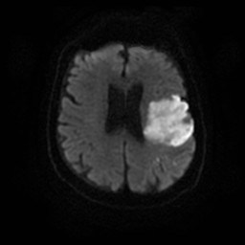
Fig. (1): The axial Diffusion Weighted MR image of the brain showing increased signal (stroke) involving portions of the left frontal, parietal, and temporal lobes

Image interpretation:
The images produced were independently evaluated using PACS workstations by qualified radiologist with long experience in the field.
Commented on points included: soft tissue of the brain if there were any abnormal signal intensity noted, midline shift, intra or extra focal lesion, mid brain, brain stem, pons, medulla, size and configuration ventricular system and intracranial vessels.
Arterial stenosis and occlusion appeared as luminal narrowing and luminal filling defect in the 3D TOF sequence.

3. Results:
The distribution of the whole sample according to acute or chronic stroke is seen in Fig (2) where 68% of the cases had MRI with acute stroke, within 24 hours after symptoms onset. Symptoms include numbness, weakness or paralysis, slurred speech, blurred vision, confusion and severe headache. While, 32% of the cases had MRI with chronic stroke that is mean that after 24 hours from symptoms onset.

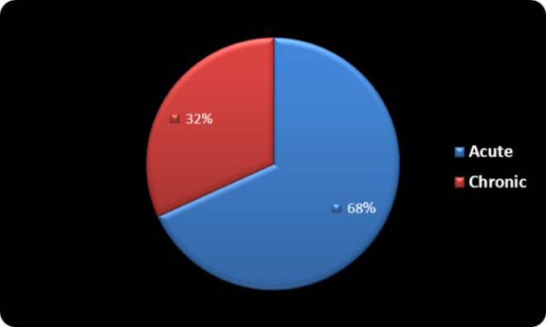
Fig. (2) Shows distribution of the sample according to the condition of stroke.

Fig. (3) Reflects that 77% of cases had ischemic stroke, while 23% of patients have hemorrhagic stroke. The two types of stroke were diagnosed correctly by MRI for the whole sample

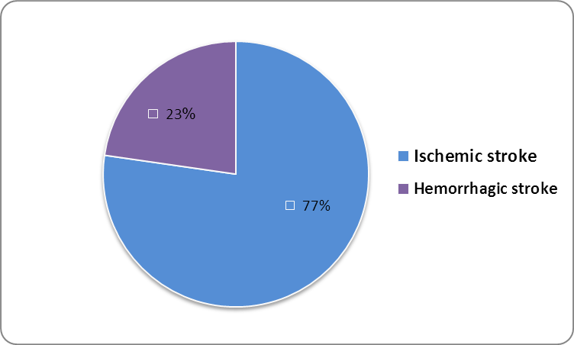
Fig.(3): Distribution of the whole sample according to the types of stroke.

Out of 50 patients; (97%) had stroke while (3%) had other diseases. As shown in Fig (4). Age had been categorized as the following:
- patients under 49 years;21% of them have stroke, (13%) male and only (8%) were female
- Sixty-percent of cases their age were between 50-69, most of them (44%) were males while (16%) were females.
- Sixteen percent of patients were more than 70 years old and considered as old adults.
According to this study we found that stroke is more affecting to ages between 50-69 years and it is more affecting in male more than female.

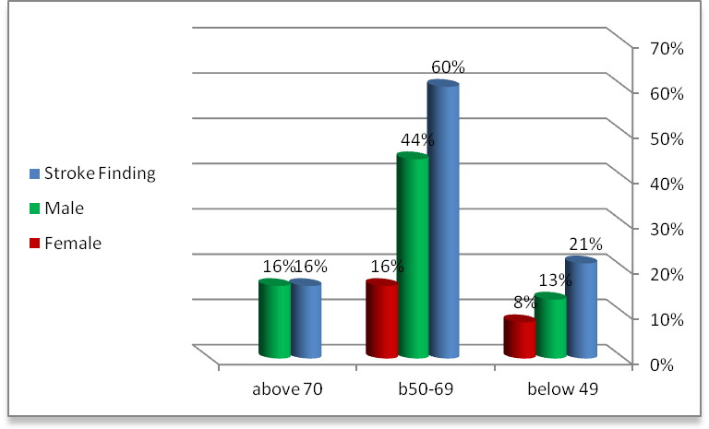
Fig. (4) the Relationship between stoke finding \ with age and sex

As illustrated in Fig. (5) the most common site of stroke was the middle cerebral artery (MCA) which represents (60%), while 40% were other intracranial vessels.

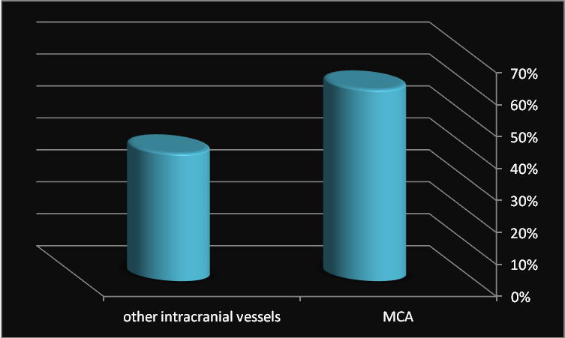
Fig.(5) shows : the most common site of stroke

4. Discussion:
As illustrated in the results that the most of the patients who had stroke were between (50-69 years) most of them were male. Small number of patients had stroke was below 49 year and above 70 year. The study also found that, MRI is more sensitive in the diagnosis of stroke wheather hemorrhagic or ischemic stroke.
DWI was accurate for diagnosing stroke weather was acute or chronic stroke, this result was in the agreement with R. Gilberto González, et al (1999) who stated that; (Diffusion-weighted MR imaging is highly accurate for diagnosing stroke within 6 hours of symptom onset and is superior to CT).
In addition the study found that DWI and ADC used to detect the stroke in acute or chronic cases, this was coincide with Mina Petkova, et al. (2010), who reported that (MR imaging might be used as a “clock” for determining stroke age in patients with an unknown onset time.
From Fig.(5) stroke is more affecting to ages between 50-69 years more than young, this was in agreement with Annette Fromm, et al. (2010), who found that; (in total, 1217 patients were included one hundred (8.2%) were < 50 years (range : 18- 49 years) and 1117 (91 %) were ≥ 50 years (range 50-98 years).

Conclusion:
MRI is more accurate for detecting ischemic and hemorrhagic stroke, as well as helps to identify the stage and site of stroke and diagnose other medical conditions with similar symptoms
References:
- Annette Fromm, Ulrike Waje-Andreassen,Lars Thomassen, and Halvor Naess (2010) Comparison between Ischemic Stroke Patients <50 Years and ≥50 Years Admitted to a Single Centre: The Bergen Stroke Study.
- Del Zoppo G.J, et al. Expansion of the Time Window for Treatment of Acute Ischemic Stroke with Intravenous Tisse Plasminogen Activator: A Science Advisory from the AMerican Heart Association/American Stroke Association. Stroke 2009;40;2945-2948.
- Donnan GA, Fisher M, Macleod M, Davis SM (2008). "Stroke". Lancet 371 (9624): 1612–23.
- Donnan GA, Fisher M, Macleod M, et al., Stroke, Lancet, 2008;371:1612–23.
- Duong TQ, Fisher M, Applications of diffusion/perfusion magnetic resonance imaging in experimental and clinical aspects of stroke, Curr Atheroscler Rep, 2004; 6:267–73.
- Goldstein LB, Simel DL (2005). "Is this patient having a stroke?". JAMA 293(19): 2391–402.
- Harbison J, Massey A, Barnett L, Hodge D, Ford GA (1999). "Rapid ambulance protocol for acute stroke". Lancet 353 (9168): 1935.
- The internet stroke center, How a Stroke is Diagnosed. http://www.strokecenter.org/patients/stroke- diagnosis/imaging-tests/mri/
- Mina Petkova, et al 2010. MR Imaging Helps Predict Time from Symptom Onset in Patients with Acute Stroke: Implications for Patients with Unknown Onset Time.
- O'Sullivan, Susan.B (2007). "Stroke". In O'Sullivan, S.B., and Schmitz, T.J.. Physical Rehabilitation. 5. Philadelphia: F.A. Davis Company. p. 719.
- R. Gilberto González, et al. (1999) Diffusion-weighted MR Imaging: Diagnostic Accuracy in Patients Imaged within 6 Hours of Stroke Symptom Onset.
- Wintermark M, Albers GW, Alexandrov AV, et al., Acute stroke imaging research roadmap, AJNR Am J Neuroradiol, 2008;29:e23–30.

5/23/2014

