Seven Days Levofloxacin, Tinidazole, Based Triple Therapy versus Standard Triple Therapy for Helicobacter Pylori, Eradication

Hesham Al Shabrawy, Hany Kamal and Ayman Rabie Abdelkader

Liver Unit, Ahmad Maher Teaching Hospital. Cairo, Egypt.
Heshamshabrawy64@yahoo.com

Abstract: Background: the standard first-line therapies for helicobacter pylori (H. Pylori) eradication are based on clarithromycin and amoxicillin or metronidazole plus ppi. Recent studies suggested levofloxacin as an alternative option for both first-and second-line H. Pylori eradication treatment. Levofloxacin based helicobacter pylori eradication, regimen have shown good efficacy and very few side effects. Failure of first line anti helicobacter pylori therapies is primarily the result of antibiotic resistance and poor compliance with medications. Shorter treatment regimen and absence of significant side effects should improve compliance to therapy and increase the helicobacter pylori rate of eradication. The aim of this work: is to compare the effectiveness of seven days levofloxacin, tinidazole based triple therapy versus standard clarithromycin, amoxicillin based triple therapy for helicobacter pylori., age and sex variability effect. Material and methods: 100 patient with the H. pylori +ve histo-pathological biopsies by endoscopy divided into two groups, group (I) 50 patients will take levofloxacin, tinidazole, PPI and group (2) 50 patients will take clarithromycin, amoxicillin, PPI. Results: 7 days levofloxacin, tinidazole based triple therapy is significantly effective and better tolerated than the generally traditional treatment of 14 days clarithromycin, amoxicillin based triple therapy. No significance concerning age, and sex factors.
[Hesham Al Shabrawy. Hany Kamal and Ayman Rabie Abdelkader. Seven Days Levofloxacin, Tinidazole, Based Triple Therapy versus Standard Triple Therapy for Helicobacter Pylori, Eradication. Nat Sci 2014;12(6):126-132]. (ISSN: 1545-0740). http://www.sciencepub.net/nature. 18

Keywords: therapy; helicobacter pylori (H. Pylori); clarithromycin; amoxicillin; metronidazole

1. Introduction
Helicobacter pylori infection is the main cause of gastritis, gastro duodenal ulcer disease, and gastric cancer. After more than 20 years of experience in H. pylori treatment, however, the ideal regimen to treat this infection has still to be found. Thus, even with the current most effective treatment regimens, including proton pump inhibitors (PPIs) plus two antibiotics, approximately 20% of patients will fail to eradicate the infection and remain H. pylori positive⁽³⁾.
After failure of a combination of a PPI-based triple regimen, the use of the so called quadruple therapy (that is, PPI, bismuth, tetracycline and metronidazole) has been generally used as the optimal second-line therapy based on the relatively good results reported by Marco et al.,(2011)⁽¹¹⁾.
However, this regimen requires the administration of four drugs with a complex scheme (bismuth and tetracycline usually prescribed every 6h, and metronidazole every 8h) and is associated with a relatively high incidence of adverse effects. Furthermore, this quadruple regimen still fails to eradicate H. Pylori in approximately 20-30% of the patients, and these cases constitute a therapeutic dilemma, as patients who are not cured with two consecutive treatment including clarithromycin and metronidazole will have at least single, and usually double resistance for helicobacter pylori treatment⁽¹³⁾.
Levoﬂoxacin is a ﬂuoroquinolone antibacterial agent with a broad spectrum of activity against Gram-positive and Gram-negative bacteria and atypical respiratory pathogens.⁽¹²⁾ Several randomized-comparative trials have demonstrated the efﬁcacy of levoﬂoxacin in the treatment of infections of the respiratory tract, genitourinary tract, skin and skin structures⁽¹²⁾.
Recently, some studies have evaluated the efficacy of new ﬂuoroquinolones, such as levoﬂoxacin, that could prove to be a valid alternative to standard antibiotics not only as ﬁrst-line therapies but, more interesting, as rescue-regimens⁽¹³⁾.
Aim of the work
The aim of this work is to compare the effectiveness of seven days levofloxacin, tinidazole based triple therapy versus 14 days standard clarithromycin, amoxicillin based triple therapy for treatment of helicobacter pylori. any effect concerning age and sex variability on results .

2. Material and methods
100 dyspeptic patients with helicobacter pylori infection not treated before will be enrolled in this study, will be divided into two groups:
Group A: 50 patients will be given:
- Levofloxacin, 500mg BID for 7 days.
- Tinidazole 500 mg Bid for 7 days.
- Omerazole 20 mg BID for 7 days.
Group B: 50 patients will be given:
- Clarithromycin 500mg BID for 14 days.
- Amoxacillin 1000 mg BID for 14 days.
- Omeprazole 20 mg BID for 14 days.
Before treatment; all patients will be subjected to, upper GIT endoscopy and H pylori infection will be diagnosed by biopsy and histopathology obtained from antrm and corpus during endoscopy. After treatment; H. pylori eradication will be assessed after 6 weeks of treatment by re-endoscopy and histopathology for helicobacter pylori.
All individuals will agree on a written informed consent include description of benefits and risks to the subjects and if any patients wants to withdraw from the study. The study was approved by ethics committee of our hospital. Exclusion criteria were (i) age under 18 years. (ii) presence of severe comorbidities. (iii) prior H. pylori eradication. (iv) gastric surgery. (v) allergy of any of the antibiotics in the study and (vi) intake of antibiotics, PPIs or non steroidal ant-inflammatory drugs within the last month.

Statistical analysis
The results will be analyzed statistically to clarify the significance and effectiveness of introduction of levofloxacin and tinidazole for seven days as an alternative for the traditional therapy of clarithromycin, amoxicillin of helicobacter pylori infection for 14 days.
Data were statistically described in terms of means, standard deviation. Chi-square test of significance was used in order to compare proportions between two categorical variables and continuous variables are described with mean and slandered deviation or median and range as appropriate. P-values lower than 0.05 were considered statistically significant. All statistical calculations were done using computer programs, SPSS statistical programs.

3. Results (Tables 1-6 and Figures 1-7)
Majority of patients were between age group 19-60 years and 58% were males and the main clinical presentation was dyspepsia
H. pylori eradication with 7 days levofloxacin 500mg/12h + tinidazole 500/12h and PPI 20mg/12h (omeprazole) results was 40 patients became –ve for H. pylori by histo-pathology with percentage of 80% and 10 patients still +ve, versus the traditional treatment of 14 days clarithromycin 500mg/12h and amoxicillin 1000mg/12 plus PPI omeprazole 20mg/12, which was 26 patients becomes –ve for H. pylori by histo-pathologiy and 24 patients still +ve, with a percentage of 52% i.e. significant.
Non-significant relation between age and result of treatment of helicobacter pylori by histo-pathology either levofloxacin, tinidazole based therapy versus standerd therapy either –ve or +ve.
Non significant relation between sex of the patients and result of treatment of H. pylori by levofloxacin, tinidazole based therapy versus standard therapy, by histopathology either –ve or +ve.

Table (1): Percentage % of male and female in total N. and total N. of +ve and -ve H. Pylori after treatment.
 | N. | %
Sex
Female | 42 | 42.0
Male | 58 | 58.0
Result of helicobacter pylori histopath. after tt.
Negative | 66 | 66.0
Positive | 34 | 34.0
Histo path. for helicobacter pylori before tt.
Positive | 100 | 100.0

Table (2): Relation between group I and group II as regard sex
Sex |  | Groups
 |  | Levo flaxacin + tinidazole + PPI (new tt.) |  | Clarithromycin + amoxacillin + PPI  (classic tt.) |  | Total
 |  | N. | % | N. | % | N | %
Female |  | 24 | 48.00 | 18 | 36.00 | 42 | 42.00
Male |  | 26 | 52.00 | 32 | 64.00 | 58 | 58.00
Total |  | 50 | 100.00 | 50 | 100.00 | 100 | 100.00
Chi-square | X² | 0.739
 | P-value | 0.390 (NS)
Non sig. >0.05 Sig. <0.05* High sig. <0.001*

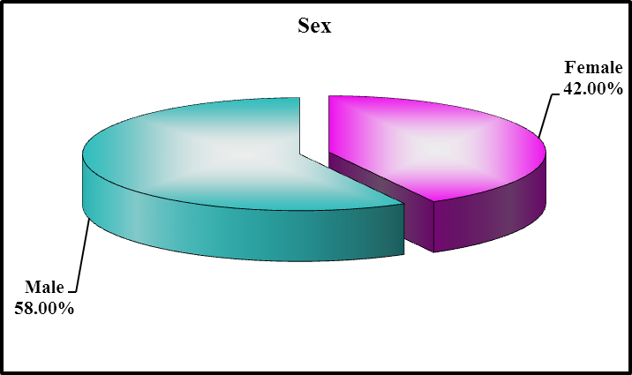
Fig.1: Percentage of male and female in total patients.

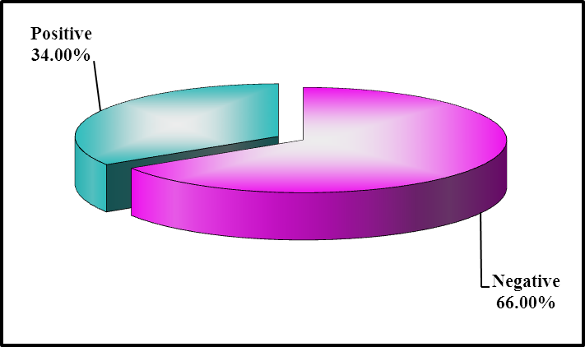
Fig.2 Result of helicobacter pylori by histo- path. after treatment in all patients

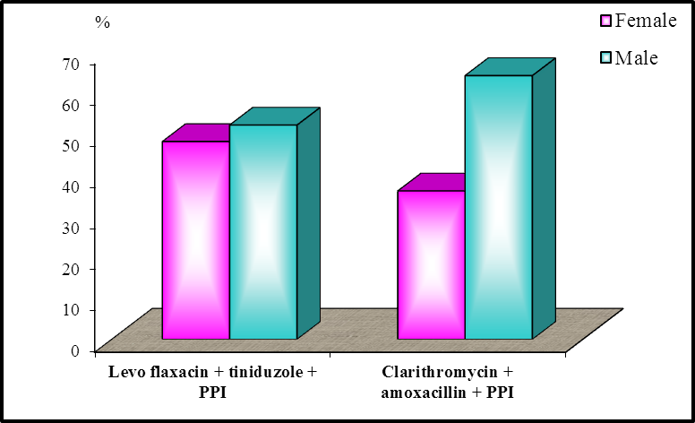
Fig.3: Non significant relation between sex either male or female in the two groups and type of treatment.

Table (3): Comparison between group I and group II as regard age.
Groups | Age |  |  |  |  |  | T-test
 | Range |  |  | Mean | ± | SD | t | P-value
Levo flaxacin + tinidazole + PPI (new tt.) | 19 | - | 52 | 38.760 | ± | 10.925 | -0.928 | 0.358  (Non Sig.)
Clarithromycin + amoxacillin + PPI  (classic tt.) | 28 | - | 60 | 41.320 | ± | 8.425
Non sig. >0.05 Sig. <0.05* High sig. <0.001*
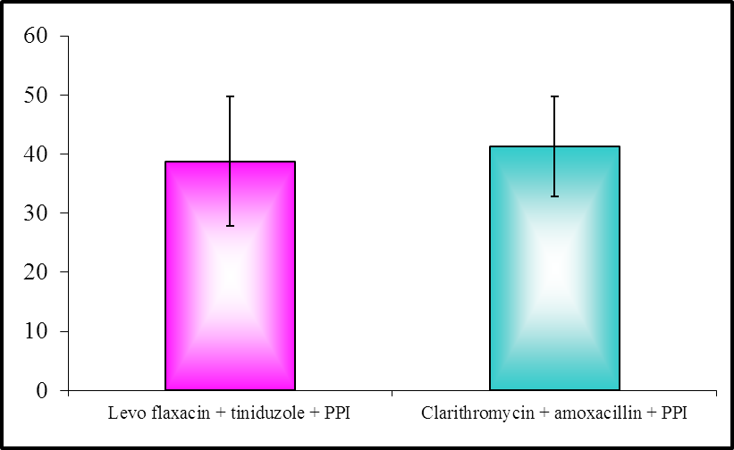
Fig.4 Non-significant relation between age and result of treatment in the two groups.

Table (4): Relation between group I and group II as regard results of H. pylori histopathology after treatment.
Result |  | Groups
 |  | Levo flaxacin + tinidazole + PPI (new ttt) |  | Clarithromycin + amoxacillin + PPI  (classic ttt) |  | Total
 |  | N. | % | N. | % | N | %
Negative |  | 40 | 80.00 | 26 | 52.00 | 66 | 66.00
Positive |  | 10 | 20.00 | 24 | 48.00 | 34 | 34.00
Total |  | 50 | 100.00 | 50 | 100.00 | 100 | 100.00
Chi-square | X2 | 4.367
 | P-value | 0.037* (Sig.)
Non sig. >0.05 Sig. <0.05* High sig. <0.001*
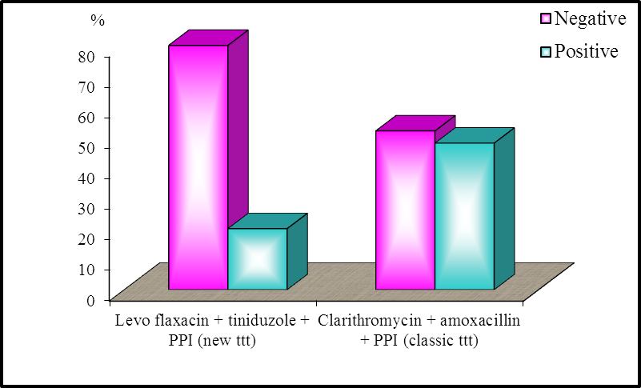
Fig5:Significant relation between type of treatment (levo + Tinid. + PPI) or (Clarith. + Amox + PPI) and the result of H. pylori in the two group

Table (5):Non-significant relation between sex and result of treat in both group.
Sex |  | Result of helicobacter pylori histo path. after ttt
 |  | Negative |  | Positive |  | Total
 |  | N. | % | N. | % | N. | %
Female |  | 30 | 45.45 | 12 | 35.29 | 42 | 42.00
Male |  | 36 | 54.55 | 22 | 64.71 | 58 | 58.00
Total |  | 66 | 100.00 | 34 | 100.00 | 100 | 100.00
Chi-square | X² | 0.475
 | P-value | 0.490 (Non sig.)
Non sig. >0.05 Sig. <0.05* High sig. <0.001*
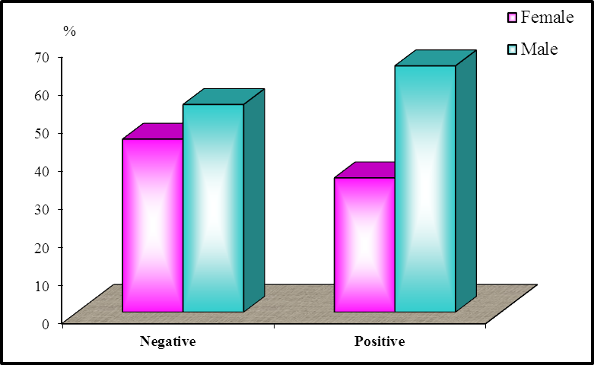
Fig.6:Non-significant relation between sex and result of treat in both group.

Table (6): Comparison between result of helicobacter pylori histo path. after ttt as regard age.
Result | Age |  |  |  |  |  | T-test
 | Range |  |  | Mean | ± | SD | t | P-value
Negative | 19 | - | 60 | 40.939 | ± | 10.099 | 0.908 | 0.368  (Non sig.)
Positive | 20 | - | 51 | 38.294 | ± | 9.040

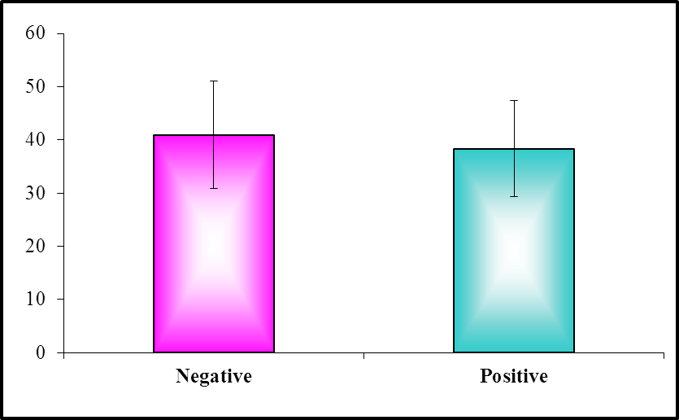
Fig.7:Non-significant relation between age and result of treatment in both groups.

4. Discussion:
Antimicrobial drug resistance is major cause of the failure of Helicobacter pylori eradication and is largely responsible for the decline in eradication rate.
In study done by Gisbert and Morena (2006)⁽⁵⁾ about systematic review and meta-analysis; levofloxacin-based rescue regimens after helicobacter pylori treatment failure, it's found that mean eradication rate with levofloxacin-based regimens was 80%. Ten-day regimens were more effective than 7-day combinations (levofloxacin based therapy) (81% vs. 73%, P<0.01). The meta-analysis showed better results with levofloxacin than with the quadruple combination (tetracycline, bismuth, metronidazole, PPI) (81% vs. 70%; OR= 1.80; 95% CI= 0.94-3.46)^{(6.7)}.
Helicobacter pylori eradication rate (weighted mean) with levoﬂoxacin-based regimens was, overall, 80% (95% CI, 77–82%).
In a study done by Shah et al. About safety and efficacy of 1-week levofloxacin-based triple therapy in first-line treatment for Helicobacter pylori-related peptic ulcer disease in Kashmir, India, H. Pylori-positive were treated with levofloxacin 500 mg once day, rebeprazole 20 mg twice a day, and tinidazole 500 mg twice daily for 7 days followed by rabeprazole 20 mg OD for 8 weeks, and the results were one hundred and thirty-one patients with gastro duodenal ulcers (duodenal 118, and gastric 13) were included. Drug compliance was 97.7%. the eradication rate of H. Pylori by intention-to-treat analysis was 85.5%.
And concluded that levofloxacin -tinidazole-based triple therapy was highly effective and safe as a first-line regimen in indian patients with gastro duodenal ulcer disease associated with H. pylori infection.⁽¹⁰⁾
In another study done by Nista et al. (2003)⁽¹³⁾ using two hundred and eighty consecutive patients who failed to respond to standard triple therapy (clarithromycin, amoxicillin, rabeprazole) were randomly assigned to four groups: (1) levoﬂoxacin 500 mg o.d., amoxicillin 1 g b.d., rabeprazole 20 mg b.d. for 10 days (LAR, n ¼ 70); (2) levoﬂoxacin 500 mg o.d., tinidazole 500 mg b.d., rabeprazole 20 mg b.d. for 10 days (LTR, n ¼ 70); (3) tetracycline 500 mg q.d.s., metronidazole 500 mg t.d.s., bismuth salt 120 mg q.d.s., rabeprazole 20 mg b.d. for 7 days (7TMBR, n ¼ 70); and (4) for 14 days (14TMBR, n ¼ 70). Helicobacter pylori status and side-effects were assessed 6 weeks after treatment, the results was the eradication rate was 94% in the LAR group and 90% in the LTR group in both intention-to-treat and per protocol analyses. Helicobacter pylori eradication was achieved in 63 and 69% of the 7TMBR group and in 69 and 80% of the 14TMBR group in intention-to treat and per protocol analysis, respectively. Side-effects were signiﬁcantly lower in the LAR and LTR groups than in the 14TMBR group and concluded that ten-day levoﬂoxacin-based therapies are better than standard quadruple regimens as second-line option for H. pylori eradication⁽¹²⁾.
Another study done Nista et al. (2006) to compare efficacy and tolerability of two different 7-day standard triple therapies versus 7-day levofloxacin-based triple therapy in first-line treatment for H. pylori infection. Using Three hundred consecutive H. pylori positive patients were randomized to receive: clarithromycin, amoxicillin, esomeprazole (Group A: N = 100); clarithromycin, metronidazole, esomeprazole (Group B: N = 100); or clarithromycin, levo-floxacin, esomeprazole (Group C: N = 100). H. pylori status was rechecked by (13)C urea breath test 6 wk after the end of therapy. The eradication rate achieved with levofloxacin-based triple therapy was significantly higher than that with standard therapies in either ITT (87%vs 75%, p <0.05; 87%vs 72%, p <0.01) or PP analysis (90.6%vs 79%, p <0.05; 90.6 vs 77.4, p <0.05). No difference was found between standard triple therapies. The incidence of side effects was similar among groups and concluded that a 7-day levofloxacin-based triple therapy can achieve higher H. pylori eradication rates than standard regimens. These data suggest levofloxacin-based regimens can be the most effective in first-line anti-H. pylori therapy, at least in the Italian population⁽¹³⁾.
In another study done by Romano et al. about in empirical levofloxacin-containing versus clarithromycin-containing sequential therapy for Helicobacter pylori eradication, the results eradication rates in the intention-to-treat analyses were 80.8% (95% CI, 72.8% to 87.3%) with clarithromycin sequential therapy, 96.0% (95% CI, 90.9%to 98.7%) with levofloxacin-250 sequential therapy, and 96.8% (95% CI, 92.0% to 99.1%) with levofloxacin-500 sequential therapy. No differences in prevalence of antimicrobial resistance or incidence of adverse events were observed between groups. Levofloxacin-250 therapy was cost-saving compared with clarithromycin sequential therapy and concluded that in an area with >15% prevalence of clarithromycin resistant H pylori strains, a levofloxacin containing sequential therapy is more effective, equally safe and cost-saving compared to a clarithromycin containing sequential therapy.⁽¹⁶⁾
Also Molina et al. (2013)⁽¹²⁾ mentioned that levofloxacin – based triple and sequential therapy are superior to clarithromycin triple and sequential therapy as first–line regimen in a setting with high-clarithromycin resistance-However, all of these therapies still have 20% failure rate⁽¹²⁾, Molina et al. (2013)studied a total of 460 patients were randomized into four 10-day therapeutic schemes (115 patients per group): (i) standard OCA, omeprazole, clarithromycin and amoxicillin; (ii) triple OLA, omeprazole, levofloxacin and amoxicillin; (iii) sequential OACM, omeprazole plus amoxicillin for 5 days, followed by omeprazole plus clarithromycin plus metronidazole for 5 days; and (iv) modified sequential OALM, using levofloxacin instead of clarithromycin. Eradication was confirmed by 13C-urea breath test. Adverse effects and compliance were assessed by a questionnaire, and the result was per protocol cure rates were: OCA (66%; 95% CI: 57–74%), OLA (82.6%; 75–89%), OACM (80.8%; 73–88%) and OALM (85.2%; 78–91%). Intention-to-treat cure rates were: OCA (64%; 55–73%), OLA (80.8%; 73–88%), OACM (76.5%; 69–85%) and OALM (82.5%; 75–89%). Eradication rates were lower with OCA than with all the other regimens (P < 0.05). No differences in compliance or adverse effects were demonstrated among treatments⁽¹²⁾.
In the present study eradication rate using the levoflocacin, tnidazole, based-triple therapy for 7 days confirmed by endescopy and histo-pathology 6 weeds after treatment is 80% in comparison to eradication rate by the traditional clarithromycin, and amoxicillin based triple therapy for 14 days confirmed also by endoscopy and histo-pathology 6 weeks after treatment wich is 52% i.e. a significant ratio.

Conclusion:
A quinolone based triple therapy is a safe and well-tolerated option in anti H. pylori therapy – the combination of PPI, levofloxacin and tinidazole is a valid option. Especially in countries where bismuth salts are unavailable in first line therapy, a quinolone – based triple therapy can generally be recommended at the moment. However, under specific circumstances this combination might be considered as an individual first line treatment option. Thus in a population with low primary quinolone resistance and high primary clarithromycin resistance, a PPI triple therapy with levofloxacin or moxifloxacin, and amoxicillin for 7-10 days could be a valuable alternative especially in quinolone - naïve patients.

References:
- Croom KF and Goa KL (2003): Levoﬂoxacin: a review of its use in the treatment of bacterial infections in the United States. Drugs; 63: 2769–802.
- Frinizio R, Nista EC, Candelli M, Metal (2006): Three and seven days levofloxacin/ azithromycin based triple therapy as first line treatment for H. pylori infection eradication. Gastroenterology, 2006; 130-94.
- Gatta L, Zullo A, Perna F, et al. (2005): A 10-day levoﬂoxacin-based triple therapy in patients who have failed two eradication courses. Aliment Pharmacol Ther; 22: 45–9.
- Giannini EG, Bilardi C, Dulbeco P et al. (2006): Can H. pylori eradication regimen be shortened in clinical practice?? An open label randomized pilot study of 4 and 7 days triple therapy with reperazole, High dose levofloxacin, and tinidazole. J Clin Gastroenterology, 40 (6): 515-520.
- Gisbert JP and Morena DeLa F. (2006): Systematic review and meta-analysis: levoﬂoxacin-based rescue regimens after Helicobacter pylori treatment failure. Aliment Pharmacol Ther 23, 35–44
- Gisbert JP and Pajares JM (2005): Helicobacter pylori ‘rescue’ therapy after failure of two eradication treatments. Helicobacter; 10: 363–72.
- Gisbert JP, Boixeda D, Bermejo F, et al. (1999): Re-treatment after Helicobacter pylori eradication failure. Euro J Gastroenterol Hepatol; 11: 1049–54
- Gisbert JP, Calvet X, Gomollon F, Mones J (2005): Eradication treatment of Helicobacter pylori. Recommendations of the II Spanish Consensus Conference. Med Clin (Barc); 125: 301–16.
- Gisbert JP, Pajares JM. (2002): Review article: Helicobacter pylori ‘rescue’ regimen when proton pump inhibitor-based triple therapies fail. Aliment Pharmacol Ther; 16: 1047–57.
- Shah A, Javid G, Zargar SA, Teli F, Khan BA, Yattoo GN, Gulzar GM, Sodhi JS, Khan MA, Shoukat A, Saif R. (2013):About safety and efficacy of 1-week levofloxacin-based triple therapy in first-line treatment for Helicobacter pylori-related peptic ulcer disease in Kashmir, India. Indian J Gastroenterol, 32 (1): 32-6.
- Marco B, Sausane K, Stephan M (2011): Should quinolones comes first in helicobacter pylori therapy? Ther Adv. Gartrentrology; 4 (2): 103-114.
- Molina-Infants J, Perez-Gallurdo B, Fernande M, Berme JO, Hernandez M, Alonso G, Vinagre, C Duenas, J, Mateos-Rodriguez M, Gonzalez-Garcia EG et al. (2013): Clinical trial clarithromycin vs. levofloxacin in first line triple and sequential regimen for helicobacter pylori eradication. Aliment PHarmacol Ther. 31 (10) 1077-1084.
- Nista E, Candelli M, Cremonini F, Cazzato I, Di Caro S, Gabrielli S, Santarelli L, Zocco M, Ojetti V, Carloni E, Cammarota G, Gasbarrini G& Gasbarrini A (2003): Levoﬂoxacin-based triple therapy vs. quadruple therapy in second-line Helicobacter pylori treatment: a randomized trial, Aliment Pharmacol Ther 2003; 18: 627–633.
- Nista EC, Candelli M, Zocco MA, Cremonini F, Ojetti V, Finizio R, Spada C, Cammarota G, Gasbarrini G, Gasbarrini A. (2006): Levofloxacin-based triple therapy in first-line treatment for Helicobacter pylori eradication. Am J Gastroenterol. 2006 Sep; 101(9):1985-90.
- Oksanen AM and Rautelin H (2003): Levoﬂoxacin combination therapy for clamithromycin and metronidazole resistant Helicobacter pylori strains. Helicobacter; 8: 476.
- Romano M, Cuomo A, Gravina AG, Miranda A, Iovene MR, Tiso A, Sica M, Rocco A, Salerno R, Marmo R, Federico A, Nardone G. (2010): Empirical levofloxacin-containing versus clarithromycin -containing sequential therapy for Helicobacter pylori eradication: a randomised trial. Gut. 2010; 59(11):1465-70.

4/27/2014

