Improve the drainage water using In-stream Wetland (Case study)- Egypt

Salwa M. AbouElElla

Associated professor, Channel Maintenance Research Institute, National Water Research Center, Delta Barrage, P.O. Box 13621, Egypt. salwaabouelella@yahoo.com

Abstract: Agriculture waste water in open drains makes their waters suitable for reuse in irrigation in many cases. However, it is uneconomic to construct waste water treatment plants at villages because of the low discharges that are insufficient for economic operation of the treatment plants. This raises the need to use the In- Stream Wetland (IW) waste water treatment system technology that treats the waste water in the open drain itself.IW treatment system technology uses the natural processes such as plant absorption of pollutants which results significant improvement in the downstream water quality. The objective of this work is to investigate the potentiality of the In-Stream wetland treatment system as the most appropriate natural treatment systems that can be used on existing drains inEgypt.The potential of application of the proposed methodology is applied on Emtdad El Umum drain. To achieve the objectives of the research, the field work divided into two phases, the first phase was to evaluate water quality conditions for Emtdad El Umum drain monthly during the period from March 2011 to February 2012. The second phase was to study the effect of water hyacinth on the agricultural drainage water seasons. The water hyacinth is stocked with natural water hyacinth, across its width for about 1 kilometer along the drain. Temporal analysis of physical and chemical parameters for the inlet and the outlet along the entire system is provided. From the result, water samples of outlet water showed lower in most parameters than inlet in spring and summer seasons because the growth rate of water hyacinth and its capability for removing pollutants depends on temperature.The findings of the In-stream drain water treatment pilot testing program brings to light several important aspects of existing drain water quality conditions, and presents a simple, low-cost technology to provide effective treatment for drain water.
[Salwa M. AbouElElla. Improve the drainage water using In-stream Wetland (Case study)- Egypt. Nat Sci 2014;12(6):5-13]. (ISSN: 1545-0740).http://www.sciencepub.net/nature. 2

Keywords: In stream wetland- water quality – water hyacinth

Abbreviations: IW, In-stream wetland; BCM, billion cubic meter; TDS, Total dissolved solids; TSS, Total suspended solids; DO, Dissolved oxygen; NH₄, Ammonia; NO₃, Nitrate; PO₄, Soluble phosphate; BOD, Biological Oxygen Demand; COD, Chemical Oxygen Demand; Cu, Copper; Zn, Zinc; Mn, Manganese; Fe, Iron; Cd, Cadmium.

- Introduction
Drainage reuse was practiced since 1970 in the Lower Egypt. With the expansion of drainage reuse activities, the government developed, in 1975, a national policy for drainage reuse in an attempt to raise the Nile water use efficiency and hence to expand the cultivated area. At present, drainage reuse is widely practiced in Delta region through 23 locations defined as central drainage reuse system. This system provides about 4.0 BCM/year of drainage water to be mixed with the fresh water of main canals. The government has an ambitious plan to expand drainage reuse to reach 8.0 BCM/year leaving a quantity not less than 8.0 BCM/year to be discharged to the sea which, is thought to be the minimum amount to keep the salt balance for Delta region. As water resources became scarcer in recent years, due to expanding the cultivated area and then spreading water out of Delta and the expansion of rice cultivation, water deficit at canal tails was recorded. Therefore, farmers found that the only way to compensate their irrigation is the nearby drains. They started to lift drainage water to their fields violating the irrigation and the drainage laws and regulations, and neglecting the side effects of the polluted drainage water (Abdel-Azim and Allam, 2005).
There are many technologies for wastewater treatment that can help in re-establishing and preserving physical, chemical and biological integrity of water (Nevena and Ljubinko, 2007). All of these technologies can be classified in two basic groups:
1. Conventional methods for purification of wastewater (wastewater treatment is carried out by physical, chemical and biological processes) and
2. Alternative methods for purification of wastewater (wastewater treatment is carried out by imitating self-purification process present in natural wetlands).
Today these conventional wastewater treatment facilities fail in satisfying all demands of ecologically aware societies. This is because they: do not harmonize with basic principles of water conservation, do not enable reclamation and reuse of water and nutrients, generate toxic sludge as by product and use chemicals, harmful to environment and people, in the treatment process. So scientist sought for other solutions that will go beyond all problems mentioned above. All of the answers were found in natural wetlands which then served as model for construction of systems for wastewater purification by aquatic plants (Hammer (ed.), 1989).
Number of aquatic plant species successfully used for wastewater treatment in decades, was of particular importance. Many studies by various researchers had been conducted to improve the water quality through natural means to overcome this problem. (Scheffield (1967); Boyd (1970a); Stewart (1970); Wooten and Dodd (1976); Conwell et al. (1977); Qitaoet. al.(2009); David and Kola (2013)) were among the pioneers to demonstrate the nutrient removal potential of aquatic plants. (Wolverton and McDonald (1975, 1976); Seidal (1976); Wolverton and Mckown (1976)) experimentally proved the importance of aquaticplants in removing organic contaminants from aquatic environments. Since then extensive research is being conducted globally by various scientist to study theworking and efficiency of different macrophyte species in nutrient removal in various aquatic water bodies.
Abdel Naby (2009) and Shahat (2011) use in-stream wetland system, the results significant improvement in the downstream water quality.
It is important to emphasize that water hyacinth has a huge potential for removal of the vast range of pollutants from wastewater (de Casabianca and Laugier, 1995; Chua, 1998; Maine et al., 2001; Sim, 2003; Mangabeira et al., 2004) and that a great number of aquatic systems with water hyacinth as basic component were construct (U.S. EPA, 1988; Aoi and Hayashi, 1996).
The objective of this research is to investigate the potentiality of the in-stream wetland treatment system as the most appropriate natural treatment systems that can be used on existing drains in Egypt.

- Materials and Methods
2-1 Description of Study Region
Emtdad El Umum drain is located on latitude 33º N and longitude of 33º E. its length is 6.9 km, and its end discharge at El Umum drain (figure 1). The drain bed width is about 20m and average depth of 3.4m. There are 2 side roads of 3-4 meter width along the drain sides.
The selected drain contains mainly agricultural drainage water from the outlets of subsurface drainage collectors, some municipal wastewater from private pipes of individual houses, and illegal sanitation car.
Drainage depth in the selected drain is greater than 3.4 meter, which allows for using the drain an In- stream water body.Industrial wastewater and /or solid wastes were not observed along the drain, since no industrial activities are in the vicinity. Water hyacinth exist at the nearby the drain.

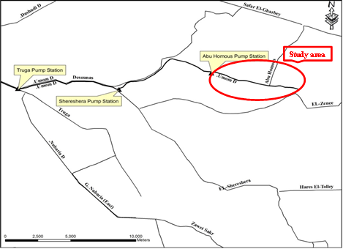

Figure (1): A schematic diagram representing the pilot scale location

2-2 Constructed wetland system
An appropriate means to improved drain water quality is desperately needed to support the national drain water reuse program and to protect environmental and human health. Drain water treatment technologies are further limited by the fact that Egyptian Law discourages use of existing agricultural land for other purposes. Given these constraints, the resulting challenge is to develop a low-cost treatment technology that effectively treats contaminated drain water.
So constructed wetland treatment systems are engineered systems that utilize the natural processes involving wetland vegetation and their associated microbial assemblages to assist in treating wastewater.
The barrier units had been designed and constructed in a specified shape as shown in plate (1) to suite its purpose, Preventing weeds from passing to the out of pilot area.
The study site consists of an 1000 meter section of the drain. The drain section was approximately 75% covered with water hyacinth (Eichorniacrassipes) during the 12 months field testing period. Contaminated drainage water flowed into the IW study site.
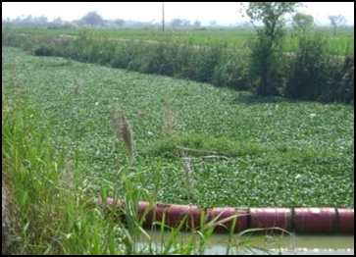
Plate (1): A free water surface wetland treatment system
2-3 Analytical Methods
Water quality data were collected from the wetland cell and its major inflowsand outflows over an 12-month period between March 2011 and February 2012. During this period of time, water samples were collected in plastic bottles that hadbeen previously soaked in 10% nitric acid for 48 hours and thoroughly rinsed with deionized-distilled water. All samples were ﬁltered using 0.45 µm cellulose acetate ﬁlters, and acidiﬁedto pH 2 with nitric acid in the laboratory.
Water samples were preserved to the laboratory for analysis. Physicaland chemical water parameters including turbidity,total dissolved solids (TDS),total suspended solids (TSS), dissolved oxygen (DO), Ammonia NH₄-N, Nitrate NO₃-N, soluble phosphate PO₄ (filterable) Biological Oxygen Demand (BOD), chemical Oxygen Demand (COD) and heavy metal (Cu,Zn, Mn, Fe and Cd)were analyzed using standard methods (APHA, (2005). The wastewater quality was compared with water quality standards.
2-4 Statistics
Data were analyzed using appropriate statistical procedures. Analysis of variance was used to determine the effects of wetland variables. All analysis was computed using SPSS software with one way variance analysis (ANOVA) and are reported at the 0.05 significance level.

- Results and Discussion
3-1 Temporal effect of water quality
Changes in inlet and outlet concentrations of nearly all pollutants monitored were observed (Figures 2a, 2b) however, statistically significant differences between inlet and outlet water quality measurements could not be detected in some cases.
The removal rates observed in the pilot systems was found to correlate closely with other similar studies (Kristopher (2000); Abdel Bary et. al. (2003); Hann- chyuan et. al. (2010); Ebrahem et. al. (2012) and David and Kola (2013)).
There was a significant reduction in turbidity level with a performance of reduction range from 16.7 % to 50%, the maximum reduction in May month. Higher turbidity levels are often associated with higher levels of disease causing microorganisms such as viruses, parasites and some bacteria. There was an increase in the pH value which range from 6.7 to 7.73 with a temperature range from 15.5 °c in February to 28.1 °c in August.
Through optimum pH for bacteria to function up to 7.83 but most treatment plants are able to effectively nitrify with a pH of 6.9 to 7.3.
The total suspended solids (TSS) was reduced by 46.67% at the outlet in March 2011. This means that the TSS includes silt, clay, plankton, organic wastes, and inorganic precipitates.
The treatment plant had little effect on the total dissolved solids (TDS). Though the TDS concentration is way below the standard limit given by (Egyptian environmental law 48/1982), 2000 mg/l, its composition in the outlet can still be reduced.
The dissolved oxygen (DO) values show a significant improvement in all months, the maximum improvement reach values of 142 % and 135% in Jun and July 2011. However, it is still less than the water quality standards. Maximum 36 % reduction in ammonia (NH₄) concentration was achieved by treatment system in June 2011. In general the ammonia concentrations reduction ranged between 0.69 % in April to 36% in June 2011.
Water that contained mostly organic and ammonia nitrogen were considered to have been recently polluted and therefore of great potential danger. On the other hand, water in which most of the nitrogen was in the form of nitrate were considered to have been polluted long time before. Figure (2b) show the inlet and outlet concentrations of ammonia (NH₄) and Nitrate (NO₃) and the percentage of reduction, which are about 36% and 75% respectively. The result shows that water hyacinth has more effect on removing NH₄ than NO₃.
The phosphate concentration increase in all months except March and May but it is under 4 mg/l. Removal of phosphate was relatively high at May, which reaches to 40.9 % as shown in figure (2b). The increase in phosphate concentration could be as a result of excessive using fertilizers.
Biological oxygen Demand (BOD) is a measure of oxygen consumption of microorganisms in the oxidation of organic matter. The value of BOD for inlet water is relatively higher than the limit recommended by law 48/1982, which should not be more than 10 mg/l. Water samples of outlet water showed lower BOD values than the inlet except in October, November, January and December.
The COD was reduced with a maximum removal rate of 30.7% in April and July, that there was a sharp drop of the COD during the months from April to September due to the comparatively high temperature, (Abdel Bary,2003).
The BOD and COD ratio reveals the treatability of waste water, so if the ratio is above 0.5 the waste water is considered to be highly biodegradable and if lower than 0.3 the waste water is deemed to undergo a chemical treatment before the routine biological treatment. For the present constructed wetland, the BOD to COD ratio is 0.53 except in March, the ratio 0.4. Therefore, it is concluded that the waste water generated in the constructed wetland is highly biodegradable. The results of BOD and COD are agree with the author David and Kola (2013).
The common trace elements such as; (Cu, Zn, Mn, Fe and Cd) in mg/l, were analyses for constructed wetland (monthly) were done of water samples during the monitoring measurements for two sites, to be sure that the efficiency of aquatic weed to remove the trace elements.
Data of the laboratory analysis of trace elements concentrations are shown in the figures (2b). The data clear that the permissible limits of the water quality standards ( law 48/1982) at the two sites, it is due to three reasons (Adel Naby, 2009).
- The pH values are above 7 in the sites.
- The using of water hyacinth (Eichorniacrassipes) in the water treatment design.
- There is no source of industrial waste that can lead to drain pollution with trace elements.
The results indicate that the removal efficiency by water hyacinth recorded from March to September as shown in figure (2b). The highest removal recorded is about 54.5 %, 91.76 %, 63.4 %, 74.58%, 66.7% for Cu, Zn, Mn, Fe and Cd in May, June, September, July and March respectively.
3-2 Seasonal Fluctuations
Further testing was done to determine if concentrations were subject to seasonal fluctuations. The inlet and outlet concentrations for four seasons (March – February) were averaged and evaluated (Table 1).
As shown in table 1, water samples of outlet water showed lower in most parameters than inlet in spring and summer seasons because the growth rate of water hyacinth and its capability for removing pollutants depends on temperature.
The seasonal trends in nutrients (an increase followed by a decrease) are likely due to the changing processes of water hyacinth uptake and decomposition.
Generally, factors affecting nutrient and metal accumulation by aquatic plants could be of biological ( e.g., species, plant age, generation time) or non-biological nature (e.g., temperature season, salinity, pH- (Sharma et. al.,(2006) and Bonanno and Lo- Giudice, (2010).
Growing season (Spring and Summer) outlet concentrations of pH, TSS, Turbidity, BOD, COD, NH₄-N, PO₄, SO₄, Cu, Zn, Mn, and Cd were lower than the mean inlet concentration. Dormant season (winter) levels declined significantly with a maximum6 % for turbidity drop from 24.5 mg/l at the inlet to 23 mg/l at the outlet.
Although Zinc removal seems greater in the growing season, the differences between seasons were not statistically significant. Zinc concentrations during growing periods were 0.76mg/l at the inlet and 0.17 mg/l at the outlet for a 77.12% decrease. However, inlet and outlet dormant season levels were unchanged at 0.56 mg/l and 0.55 mg/l,respectively.
Significant differences were found for pH, TSS, TDS, DO, turbidity, BOD,NO₃,PO₄ between the four seasons at p<0.01 except DO the level of significant at p<0.05.

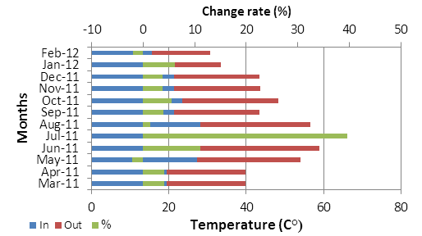 | 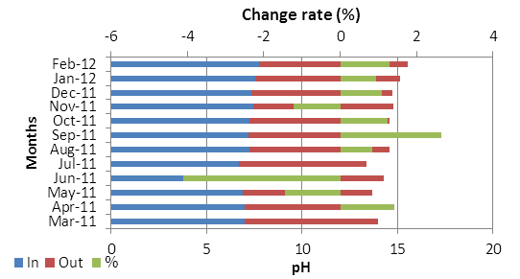
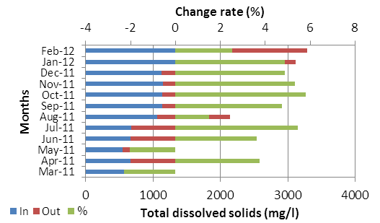 | 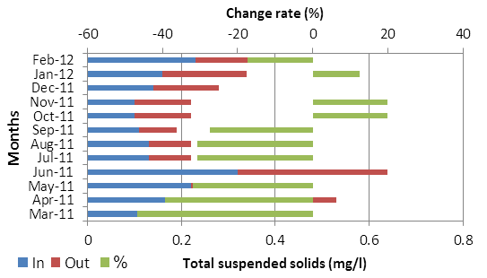
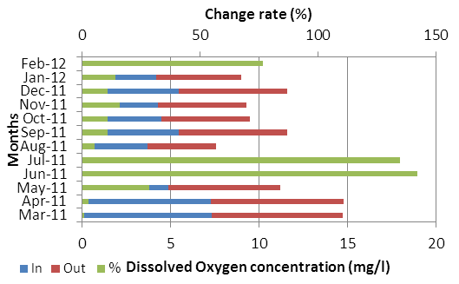 | 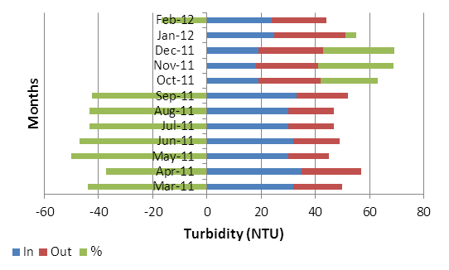
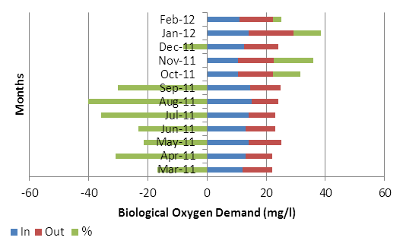 | 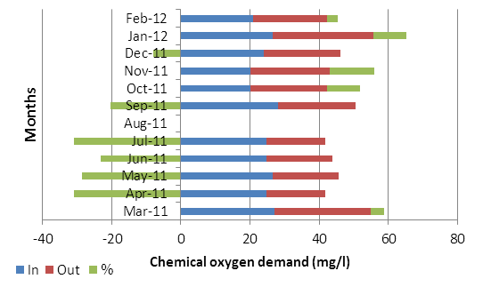
Figure (2a): Monthly variation (increase or decrease) in the water characteristics inlet and outlet of wetland area supporting by water hyacinth. Water characteristics were measured monthly from March 2011 to February 2012.

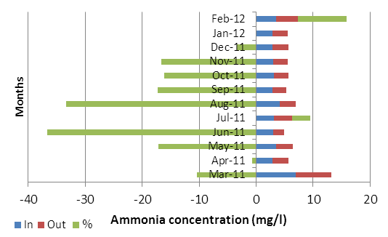 | 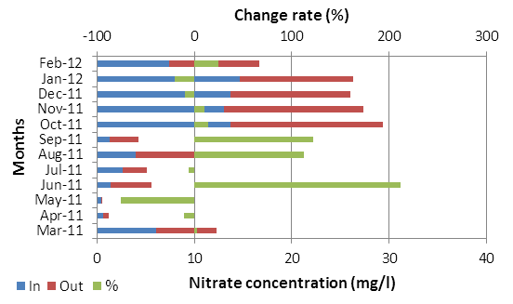
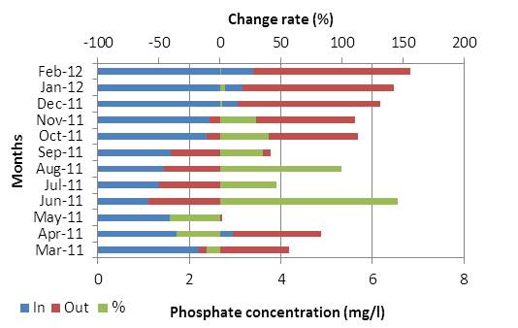 | 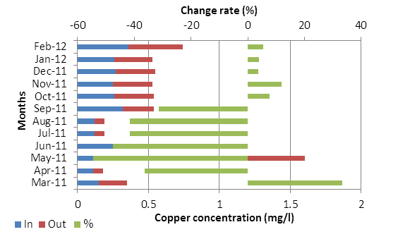
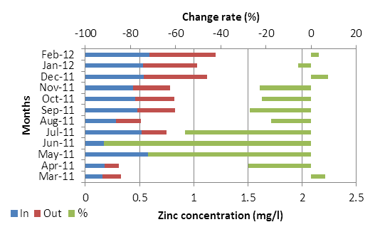 | 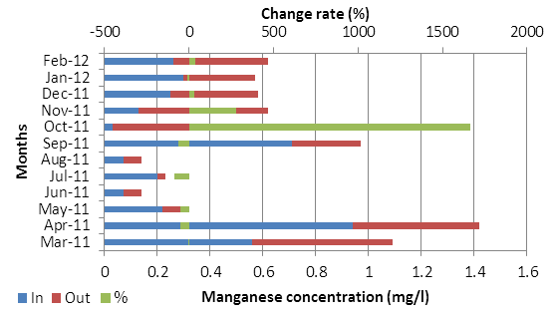
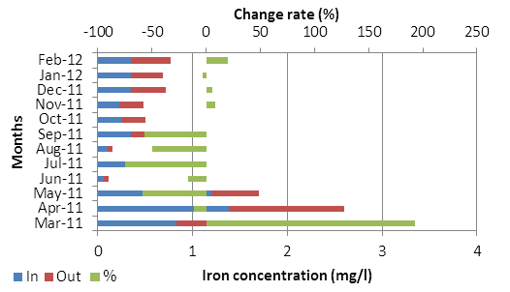 | 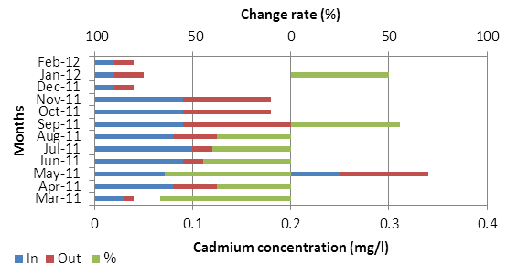
Figure (2b): Monthly variation (increase or decrease) in the water characteristics inlet and outlet of wetland area supporting by water hyacinth. Water characteristics were measured monthly from March 2011 to February 2012.

Table (1): Overall performance of treatment between inlet and outlet on the parameters tested in the four seasons
Parameter/ Season | Spring |  | Change percentage (%) | Summer |  | Change percentage (%) | Autumn |  | Change percentage (%) | Winter |  | Change percentage (%) | Probability
 | Inlet | Outlet |  | Inlet | Outlet |  | Inlet | Outlet |  | In | Outlet
Temperature (Cº) | 23.55±  2.341 | 24.575±  2.619 | 4.352 | 23.457±  2.322 | 26.633±  2.278 | 13.539 | 22.066±  0.717 | 23.033±  0.884 | 4.382 | 15.85±  0.350 | 16.20±  1.000 | 2.208 | Not significant at  P< 0.05
pH | 7.05± 0.0866 | 6.975± 0.0629 | -1.063 | 7.053± 0.177 | 7.136± 0.219 | 1.176 | 7.337± 0.0521 | 7.363± 0.0233 | 0.354 | 7.63± 0.0999 | 7.715± 0.163 | 1.114 | P <0.01
Total Dissolved Solid (mg/l) TDS | 630.25±  29.615 | 636.00±  37.244 | 0.912 | 958.333±  141.829 | 994.00±  143.263 | 3.721 | 1139.33±  5.487 | 1200.00±  7.637 | 5.325 | 1572.5±  52.500 | 1630±  36.00 | 3.656 | P <0.01
Dissolved Oxygen (mg/l) ( O₂) | 5.303± 1.342 | 6.080± 1.030 | 14.652 | 3.733± 1.011 | 4.9±  0.643 | 31.261 | 4.766± 0.371 | 5.366± 0.3666 | 12.589 | 2.75± 1.45 | 3.55±  1.25 | 29.090 | P< 0.05
Total suspended solids (mg/l) | - 0.293± 0.025 | 0.208±  0.0390 | -29.010 | 0.123±  0.0066 | 0.0866±  0.0033 | -29.593 | 0.113±  0.013 | 0.126±  0.0066 | 11.504 | 0.195±  0.0350 | 0.185±  0.0049 | -5.128 | P < 0.01
Turbidity (NTU) | 32.25± 1.031 | 18.00±  1.472 | -44.186 | 31.00±  1.0 | 17.666± 0.666 | -43.012 | 18.666± 0.333 | 23.333± 0.333 | 25.002 | 24.5± 0.5 | 23±  3.0 | -6.122 | P < 0.01
Biological Oxygen Demand (mg/l) BOD | 13.00±  0.408 | 10.00±  0.408 | -23.076 | 14.533±  0.291 | 9.400±  0.399 | -35.319 | 11.266±  0.666 | 11.733±  0.133 | 4.145 | 12.5±  1.5 | 13.3±  2.0 | 6.4 | P < 0.01
Chemical Oxygen Demand (mg/l) COD | 25.75±  0.611 | 20.775±  2.449 | -19.320 | 17.6±  8.855 | 19.75±  2.65 | 12.215 | 21.466±  1.266 | 22.333±  0.404 | 4.038 | 23.75±  2.850 | 25.3±  3.8 | 6.526 | Not significant at  P< 0.05
Ammonia (mg/l) NH₄ | 4.08±  0.966 | 3.47±  0.948 | -14.950 | 3.4±  0.404 | 2.8±  0.231 | -17.647 | 3.0±  0.0577 | 2.633±  0.088 | -12.233 | 3.15±  0.35 | 3.3±  0.5 | 4.761 | Not significant at  P< 0.05
Nitrate (mg/l) NO₃ | 2.13±  1.318 | 2.8±  1.473 | 31.455 | 2.653±  0.771 | 4.643±  1.933 | 75.009 | 13.446±  0.223 | 14.11±  0.970 | 4.938 | 11.05±  3.62 | 10.45±  1.22 | -5.429 | P < 0.01
Phosphate (mg/l) PO₄ | 1.993±  0.393 | 1.897±  0.346 | -4.816 | 1.466±  0.073 | 2.35±  0.280 | 60.300 | 2.627±  0.217 | 3.203±  0.062 | 21.926 | 3.275±  0.115 | 3.365±  0.065 | 2.748 | P <0.01
Copper (mg/l) Cu | 0.445±  0.229 | 0.248±  0.090 | -44.269 | 0.186±  0.066 | 0.12±  0.05 | -35.483 | 0.26±  0.0057 | 0.28±  0.000 | 7.692 | 0.31±  0.0500 | 0.325±  0.055 | 4.833 | Not significant at  P< 0.05
Zinc (mg/l) Zn | 0.765±  0.392 | 0.175±  0.026 | -77.124 | 0.427±  0.074 | 0.27±  0.04 | -36.768 | 0.48±  0.031 | 0.426±  0.0768 | -11.25 | 0.56±  0.03 | 0.555±  0.055 | -0.892 | Not significant at  P< 0.05
Manganese (mg/l) Mn | 0.447±  0.194 | 0.295±  0.122 | -34.004 | 0.327±  0.195 | 0.12±  0.071 | -63.302 | 0.136±  0.064 | 0.45±  0.061 | 230.882 | 0.28±  0.020 | 0.315±  0.0450 | 12.5 | Not significant at  P< 0.05
Iron (mg/l) Fe | 0.867±  0.293 | 1.05±  0.519 | 21.107 | 0.346±  0.141 | 0.116±  0.033 | -66.473 | 0.276±  0.037 | 0.29±  0.04 | 5.072 | 0.35±  0.00 | 0.38±  0.04 | 8.571 | Not significant at  P< 0.05
Cadmium (mg/l) Cd | 0.113±  0.047 | 0.05±  0.016 | -55.752 | 0.090±  0.057 | 0.083±  0.0284 | -7.777 | 0.066±  0.023 | 0.066±  0.0233 | 0 | 0.02±  0.00 | 0.025±  0.005 | 2.5 | Not significant at  P< 0.05

- Conclusion and Recommendation
The constructed wetland with water hyacinth is capable of removing pollutants and the water hyacinths have shown its ability to survive in high concentration of nutrients with significant nutrient removal.
The treatment performance of water hyacinth for agricultural drainage water resulted from these measurements is concluded as follow:
- The field observation shows that water hyacinth achieve high reduction of total suspended solid (TSS), of about 46.67 %.
- The reduction percentages of the concentrations of Ammonia (NH₄) and Nitrate (NO₃) are about 36.67 % and 75 % respectively. This shows that water hyacinth has more effect on removing NH₄ than on NO₃.
- The BOD and COD are considered organic pollution indicator. The percentage of reduction according to water hyacinth is about 40 % and 30.7 % respectively, which illustrates that water hyacinth, can achieve high removal efficiency.
- The percentage of the reduction of the concentration of PO₄ is about 40.9 %.
- The water hyacinth has a great effect on reducing the concentration of heavy metals especially in copper (Cu), Manganese (Mn), zinc (Zn) and Iron (Fe). The maximum percentages of reduction for the concentrations of Cu, Zn, Mn and Fe about 54.5 %, 91.76 %, 63.4 %, 74.58 % and 66.7% respectively.
- Monthly nutrient and heavy metals reductions were generally associated with temperature changes. Higher temperatures resulted in greater reduction of NH₄-N and heavy metals concentrations.
- Growing season (Spring and Summer) outlet concentrations of pH, TSS, Turbidity, BOD, COD, NH₄-N, PO₄, Cu, Zn, Mn, and Cd were lower than the mean inlet concentration.
A general approach to selecting sites for possible inclusion in a demonstration wetland project would be based on the below items as mentioned in Harza Environmental Services et. al. (2000):
- All information in the pilot in-situ study,
- Drainage configuration,
- Information gathered about drainage operation, etc.
- Regions with low permeability soils
- Sites that have aminimum of 1km of branch drain before a secondary drain or main drain.
- Negative effects on hydraulic character of the overall drain reach must be minimized,
- Required retention time and channel area for proper treatment must be available or feasibly created,
- The system must have adequate access for maintenance vehicles and equipment,
- Vegetation management facilities must be accessible.
- Location of aquatic habitat.
- Cross section profile (width, depth, …).
Most of the above criteria agree with Candidate criteria for use in prioritizing and selecting sites for the demonstration project.

- References
- Abdel Bary M. R.; Khalifa A.; Nour. Eldin M.; Refaat A. M.; Ali M. M.; El-Barbary Z. M. (2003). Wetland As Pollution Control Treatment System For Agricultural Drains. Seventh International Water Technology Conference Egypt 1-3 April 2003.
- Abdel Naby M. M. (2009). Improvement of Water Quality in Tertiary Drains Using Wetland Plants. Ph D. Thesis, Institute Of Environmental Studies & Research, Ain Shams University.
- Abdel-Azim R., and Allam M.N. (2005): Agricultural drainage water reuse in Egypt: strategic issues and mitigation measures. In: Hamdy A. (ed.), El Gamal F. (ed.), Lamaddalena N. (ed.), Bogliotti C. (ed.), Guelloubi R. (ed.). Non-conventional water use: WASAMED project. Bari: CIHEAM / EU DG Research, 2005. p. 105-117 (Options Méditerranéennes: Série B. Etudes et Recherches; n. 53).
- Aoi, T., Hayashi, T., (1996): Nutrient removal by water lettuce (Pistiastratiotes). Water Sci. Tech. 34, 407-412.
- APHA, American Public Health Association Standard Methods for the Examination of Water and Wastewater, (2005), 21th ed., American Public Health Association Inc., New, York, N.Y.
- Bonanno, G., Lo Giudice, R., (2010). Heavy metal bioaccumulation by the organs of phragmitesaustralis ( common reed) and their potential use as contamination indicators. Ecol. Indicat. 10, 639-645.
- Boyd, C. E. (1970a). Vascular aquatic plants for mineral nutrient removal from polluted waters. Economic Botany, 24, 95–103.
- Chua, H., (1998): Bio-accumulation of environmental residues of rare earth elements in aquatic flora Eichhorniacrassipes (Mart.) Solms. in Guangdong Province of China. The Science of Total Environment214, 79-85.
- Cornwell, D. A., Zoltek Jr., J., Patrinely, C. D., Furman, T. S.,& Kim, J. I. (1977). Nutrient removal by water hyacinths. Journal of the Water Pollution Control Federation, 49,57–65.
- D.A., Hammer (ed.), (1989): Constructed Wetlands For Wastewater Treatment: Municipal, Industrial, and Agricultural. Lewis Publishers Inc., MI, 831.
- David O. Olukani and Kola O. Kokumo (2013). Efficiency Assessment Of A Constructed Wetland Using EichhorniaCrassipes For Wastewater Treatment. American Journal Of Engineering Research (AJER), volume 2, Issue 12, pp: 450-454.
- De Casabianca, M.-L., Laugier, T., (1995): Eichhorniacrassipes production on petroliferous waste waters: effects of salinity. Bio resource Technology 54, 39-43.
- Harza Environmental Services, Inc.; Camp Dresser & McKee International, Inc.; Environmental Quality International, Inc.; ECG Engineering Consultants Group S.A (2000). Utilizing Passive In-StreamWetland Systemsfor Treatment ofDrain Water aPilot Study. Project Number:263-270. Middle Egypt Utilities Master Planning Project.
- Kristopher Lucas Bass (2000) Evaluation of a Small In-Stream Constructed Wetland in North Carolina’s Coastal Plain. Master thesis, Biological and Agricultural Engineering, North Carolina State University. Raleigh, North Carolina.
- Maine, M.A., Duarte, M.V., Sune, N.L., (2001): Cadmium uptake by floating macrophytes. Water Research35, 11, 2629-2634.
- Mangabeira P.A.O., Labejof, L., Lamperti, A., de Almeida, A-A.F., Oliveira, A.H., Escaig, F., Severo, M.I.G., da C. Silva, D., Saloes, M., Mielke., M.S., Lucena, E.R., Martinis, M.C., Santana, K.B., Gavrilov, K.L., Galle, P., Levi-Setti, R., (2004): Accumulation of chromium in root tissues of Eichhorniacrassipes (Mart.) Solms. in Cachoeira river – Brazil. Applied Surface Science 231-232, 497-501.
- Nevena N., Ljubinko J. (2007). Potential Use of Water Hyacinth (E. Crassipens) for Wastewater Treatment in Serbia 1Institute of Forestry, 2 Center for multidisciplinary studies, University of Belgrade Belgrade, Serbia and Montenegro. Nkuranga, E., 2007.
- Qitao Yi, Youngchul Kim, Masafumi Tateda (2009). Evaluation Of Nitrogen Reduction In Water Hyacinth Ponds Integrated With Waste Stabilization Ponds. Desalination Journal 249 (2009): 528- 534.
- Scheffield, C. W. (1967). Water hyacinth for nutrient removal. Hyacinth Control Journal, 6, 27–30.
- Seidal, K. (1976). Macrophytes and water purification. In J. Tourbier, & R. W. Pierson (Eds.), Biological control for water pollution (pp. 109–121). Pennsylvania, PA: Pennsylvania University Press.
- Sharma, P., Asaeda, T., Manatunge., J., Fujino, T., (2006). Nutrient cycling in a natural stand of Typhaangustifalia, J. Freshw. Ecol. 21, 431-438.
- Shehata S. Y. (2011). Low Cost Wastewater Treatment Technologies Case Study For Wetland Application. Master Thesis. Faculty of Engineering, Cairo University.
- Sim, C.H., (2003): The use of constructed wetlands for wastewater treatment. Water International –Malaysia Office, 24.
- Stewart, K. K. (1970). Nutrient removal potential of various aquatic plants. Hyacinth Control Journal, 8, 34–35.
- U.S. EPA, (1988): Design Manual – Constructed Wetlands and Aquatic Systems for Municipal Waste water Treatment. U.S. Environmental Protection Agency. Report no. EPA/625/1-88/022. Office of Research and Development, Cincinnati, OH, 83.
- Wolverton,, & McDonald, (1976). Don’t waste water weeds. New Scientist, 71, 318–320.
- Wolverton, B. C., & McDonald, R. C. (1975). Water Hyacinth for upgrading sewage lagoon to meet advanced waste water treatment standards: Part I. NASA TM-X-72729, Oct 1975.
- Wolverton, B. C., & Mckown, M. M. (1976). Water hyacinth for removal of phenols from polluted waters. Aquatic Botany, 30, 29–37.
- Wooten, J. W., & Dodd, J. D. (1976). Growth of water hyacinth in treated sewage effluent. Economic Botany, 30, 29–37.

5/2/2014

