Optical and Electrical Properties of Undoped GaN Films on Sapphire substrate Grown By Metalorganic Chemical Vapor Deposition

Hanan Abbas¹ and Michael Player²

¹Department Daignostic Radiology, Faculty of Applied Medical Sciences, KAU, ³Department of Engineering, University of Aberdeen (UK).
P.O Box 4266, Jeddah 21491, Saudi Arabia. E-mail: Habbas1@kau.edu.sa

Abstract: Photoluminescence (PL) properties of GaN undoped epitaxial layers grown by (MOCVD) metal organic chemical vapor deposition method on sapphire substrate have been studied in the temperature range of 100-300K. At 10K the spectra obtained are dominated by the well resolved interband free excitons A and B as well as the bound excitons. There was a strong influence of the residual strain in determining the energies of exciton transitions.The replica of neutral donor bound exciton of each sample was observed and was separated from the neutral donor bound exciton by about 0.022eV. A ~29 meV donor depth was deduced for each sample (i.e. ~29 meV below the bandgap). A-band free exciton first excited state was observed, consequently, the free A-exciton binding energy was calculated. XRD analysis corresponding to the (004), (002), (104) and (204) diffraction was performed. By using standard methods the electron concentration and carrier mobility in the films were calculated. Cody’s coefficients for the temperature variation of bandgap were obtained through a study of the temperature dependence of free exciton.
[Hanan Abbas and Michael Player. Optical and Electrical Properties of Undoped GaN Films on Sapphire substrate Grown By Metalorganic Chemical Vapor Deposition. Nat Sci 2014;12(5):80-86]. (ISSN: 1545-0740). http://www.sciencepub.net/nature. 11

Keywords: MOCVD, Undoped, GaN ,Films, Free excitons, bound excitons, XRD analysis, Cody’s coefficients, temperature dependence, residual strain, exciton energies.

1. Introduction
GaN-based wide-band -gap III-V nitride semiconductors have currently attracted extensive attention for their potential optoelectronic and electronic device applications such as UV blue light- emitting diodes (LEDs), laser diodes, High temperature electronics, and detectors operating in the blue and UV wave length range. A detailed knowledge of GaN fundamental optical properties is required for its optoelectronic devices application. Extrinsic and intrinsic optical properties must be obtained to optimize the laser devices efficiency [8,10].
Extrinsic and intrinsic optical properties Information was taken using Photoluminescence (PL) [1,8,9,10,14,19,26,32]. Photoluminesce (PL) gives in particular information about extrinsic optical properties such as yellow band and Donor Acceptor Pair (DAP) emission [26], while photoluminescence excitation spectroscopy, absorption and reflectivity give the ability to draw information abut the structure of the intrinsic exciton of GaN [10]. It is very important to identify the various emissions in GaN to understand and improve device performance through better dopants and more efficient luminescence [9]. Fast progress in nitride epitaxial growth technology, high quality nitride single-crystal epifilm can be grown on such substrates as sapphire and SiC [8]. Although assessment of the properties and potential applications of nitrides is actively pursued to accelerate the device fabrication, some vital issues directly related to optoelectronic device application such as carrier dynamics, have not been widely addressed, and detailed studies on some important parameters associated with the electronic structures have not been fully explored [8]. Initial attempts were centered around the II-VI compounds ZnSe and ZnS with direct bandgap structure. However long device operating time could not be achieved based on these materials because of the crystallographic defects even at lower density level of the order of 10⁵-10⁶ cm⁻² [20].
In this work, we have carried out Photoluminescence (PL) measurements on six samples of undoped GaN on substrate of sapphire using metal organic chemical vapor deposition (MOCVD) in order to get A and B free exciton transition energies that indicate the degree of strain reflected in the various samples, as well as their full width at half muxima (FWHM), that indicate the optical quality of the samples. There was a strong influence of strain to determine the exciton transition energies. Moreover, the half width of XRD rocking curve are used to examine the samples quality. In addition, the Hall measurements were used to define the currier mobility and concentration of the samples. From PL at 10K, about 29 meV donor depth was deduced for each sample and free A-exciton binding energy was calculated for all samples. The temperature dependence of free exciton transitions was investigated. Cody coefficients for bandgap variation for sample 5 only were determined, because this sample exhibited best optical and electrical properties.

2. Experimental Methods
The samples examined in this study are non-intentionally doped GaN films grown on sapphire (0001) substrate in a commercial reactor of MOCVD. The growth parameter varied was the deposition temperature (1100-1150 ºC) in a 4-µm constant thickness series (deposition temperature of sample 1 is 1100C, of sample 2 is 1110C, of sample 3 is 1120 ºC, of sample 4 is 1130 ºC, of sample 5 is 1140 ºC and of sample 6 is 1150 ºC). GaN buffer layer thickness of ~20 nm was grown at 540 ºC. The film surface was colorless, transparent and mirror-like. A Fluorolog-3 Model FL3-21 (from Jobin Yvon Horiba company) was used for performing Photoluminescence PL experiments. A closed cycle Helium cryostat was used to perform temperature dependence at any required value between 10 and 300K.

3. Results and Discussion
The Photoluminescence spectra obtained at 10 K for the six samples are shown in Fig. 1. This set of sample has identical excitation conditions, for the purpose of comparison [19]. According to our results illustrated in Fig. 1 the energy positions of neutral donor bound exciton (I₂) are 3.488064, 3.494113, 3.49026, 3,488475, 3.492795 and 3.493338 eV, and the energy positions of A-free exciton (FX^{A}) are 3.494353, 3.500355, 3.496707, 3.494485, 3.499036, 3.49971eV, while those of B-free exciton (FX^{B}) are 3.5025, 3.508654, 3.50508, 3.5029, 3.5074 and 3.50806 eV for Sample 1 to sample 6 respectively. These various peak positions of I₂, FX^{A} and FX^{B} were obtained using mix Maxwellian and Lorentzian line shape function to give the best fit of the spectrum for each sample. The interpretation of these transitions was carried out on the basis of the values of the peak positions, halfwidthes, temperature dependence and the peak separations. Here only the exciton transitions are going to be discussed.
GaN has Wurtzite symmetry when grown on sapphire substrate. Triply degenerate valence band is found in the absence of any perturbations. The degeneracy is lifted into a doubly degenerate state and a lower lying singlet state due to the hexagonal symmetry of Wurtzite crystal field. Because of the spin-orbit interaction, the degeneracy is further removed then as final result there will be three valance bands A, B and C or referred to as
Γ₉^{v} , Γ₇^{v} and Γ₇^{v} in the order of decreasing energy [20]. The deviation of the free exciton
values from the strain free values is an indication of the magnitude of the strain. The free exciton transitions A and B observed in our samples are higher than those obtained from the strain free bulk GaN reported by Monemar (who used photoluminescence excitation spectroscopy) [4] and Dingle (who used reflectance experiments)[11]. Monemar et al determined the energy positions of free excitons A, and B to be 3.4751 and 3.4815 eV respectively while Dingle et al. obtained A and B excitons at 3.474, 3.481 eV respectively. As mentioned in the theory, the epitaxial layers grown on sapphire substrate have large lattice mismatch of 13%, in addition to mismatch of thermal expansion coefficient, which develop a large amount of strain in the lattice. This is manifested as the deviation of the free exciton transition [20].
We could list some values of excitons energy positions reported in the literature with our exciton values to make a very brief studies. Visconti et al [26] observed 3.486 eV and 3.493 eV attributed to the free A and B excitons. while Chichibu et. al.[1] , resolved A at 3.488 eV from B at 3.496 eV. Smith et al. [20] obtained FXA and FXB at 3.4857 and 3.4921 eV. These mentioned values of the transition energies obtained are a bit lower than our results (it is a good indication of the increased a mount of strain in our case) while Volm et al [23] have got the corresponding values of FXA and FXB at 3.4962 and 3.5050 eV respectively, that are similar to our result (nearly the same as those of sample 3). A lot of discrepancy can be occurred when comparing the observed exciton transition energies in GaN epilayers deposited on sapphire with that observed in GaN epilayers deposited on SiC which can be attributed to the effects of residual strain in the epilayers due to the mismatch of lattice parameters and coefficients of thermal expansion between GaN and the substrate materials. Because of the inevitable occurrence of strain relaxation by the formation of a large density of dislocations, the separation of the strain effects caused by lattice parameter mismatch from the ones involving thermal expansion mismatch is generally difficult so as to exactly determine their influence on the optical properties of GaN epitaxial layers. For example, comparing the results of Shan et al [7] who used SiC as substrate and obtained 3.470, 3.474 values of A and B free excitons and our results of free excitons on sapphire to the results of 3.4815, and 3.4935 eV that reported by Monemar et al [4] who used virtually strain free bulk GaN, we can clearly conclude that the overall effects of the generation of residual strain in GaN on sapphire is compressive (our results), which results in an increased exciton transition energies (i.e, an increased bandgap), while the stress induced in GaN on SiC is tensile (Shan’s results), which leads to a decrease in the measured energies of exciton transition. Therefore, one can conclude that residual strain induced by thermal-expansion mismatch in GaN based epilayers has the prevailing influence on the energy variations of exciton transitions. The lattice mismatch induced strain has a completely opposite effect on the variation of GaN band gap [7]. From our results of photoluminescence, we have found that, FX^{A} shows a FWHM 4.124, 3.581, 3.547, 3.98, 3.508 and 3.805 meV, while that of FX^{B} 5.483, 1.297, 1.903, 4.006, 2.075 and 7.816 meV for Sample 1, Sample 2, Sample 3, Sample 4, sample 5 and Sample 6 respectively, which are narrow and signify the quality of our samples. These values of FWHM are comparable with some of the literature [20],[26]. To make this comparison realistic, Viswanath et al [20] used GaN grown on sapphire substrate using low- pressure metal organic chemical vapor deposition technique. The buffer layer was 27nm while epilayer was 3.5 micron and growth temperature was 1080 ºC. The film surface mirror-like, colorless and transparent (relatively similar to the growth conditions of our samples). FWHM of FX^{A} was 5.6 meV while that of FX^{B} was 2.8 meV (with FXA, FXB energy positions of 3.481 and 3.489 eV respectively), and they mentioned in their paper these values are quite narrow and signify the quality of their sample. In the current work it was found that, the energy separation between A and B exciton resonances is ~ 8 meV which is similar to that of Viswanath et al [20] and Chichibu et al [1]. They obtained separation between FXA and FXB as small as 8 meV. Broadenings of the peaks occur with increasing of the temperature [1]. The energy separation between A and B excitons is also an indication of the strain [20]. In the low energy side of the I₂ peak is structured by shoulder at about 22mev lower in energy (occurred at about 3.46 ev), which can sometimes be resolved as defined peak by increasing the resolution of the equipment using 1800 line/mm grating for the emission photon. From this replica, labeled I₂ (n=2), the donor depth (donor binding energy) can be deduced for each sample. Skromme et al. [17] attributes this feature I₂ (n=2) to a two electrons replica of the neutral donor bound exciton peak in which the donor is left in its n=2 excited state after recombination of the exciton. This assignment implies a 1s-2s splitting of 22 meV, for a donor binding energy of 29meV if we assume a simple hydrogenic model for donor. This is in agreement with magnetoluminescence experiments [17], [13]. Using Haynes rule the donor ionization energy (activation energy) can be obtained. It is found that, E_{D} ~146meV for all samples.
According to figure 1. at 10k, the (n=2) excited state of A-exciton (the first excited state of A-band free exciton) can be observed, consequently, the binding energy of free A-exciton can be calculated [5,6,9] as well as the A band gap of GaN [5] of each sample of our set. According to our results the binding energies of FXA are 26.7386 meV, 25.3933 meV, 25.337333 meV, 25.8066 meV, 24.752 meV, N/A, while the corresponding A band gaps are 3.514196, 3.5194, 3.51571, 3.51384, 3.5176 eV, N/A for sample 1 to sample 6 respectively.
It is well known that in high quality samples with low impurity concentrations, free exciton can exhibit excited states in addition to their ground state transitions [2]. So that this excited state of A-exciton is an evidence of the quality of the layer of GaN. As a result, the calculated values of the A band gap of GaN of each sample of our set are for samples 1, 2, 3, 4, 5 and 6.
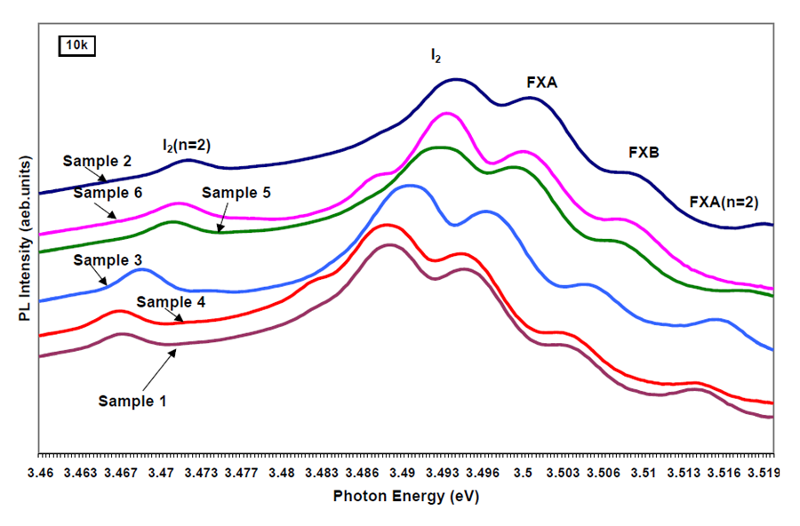
Figure 1: Near-band-edge exciton PL spectra at 10K from GaN epilayer of the whole set of samples grown on sapphire by MOCVD

XRD rocking curve was another evidence of crystallinity [12,14,18,21,22,25,28,29]. XRD analysis corresponding to the (004), (002), (104) and (204) diffraction of the six samples of GaN were carried out. The effect of growth temperature on the crystalline quality is depicted in Fig. 2. This Figure gives the relation of growth temperature on X-ray rocking curve line width. As can be seen this relationship is nearly constant which means that, when the growth temperature of the samples is ranging from 1100C to 1150C at fixed thickness (4microns) the samples have nearly the same quality of crystal of FWHM about 0.08, 0.09, 0.067, 0.05 degree for the (004), (002), (104) and (204) diffractions respectively (these are my own conclusions). Our results are compatible with literature. Visconti et al [26] have used XRD rocking curve to demonstrate the high crystal quality of a set of (MOCVD) unintentionally doped GaN films grown on sapphire substrate. The GaN epilayers were grown at temperature 1150C while the thickness of these films varied between 1.5 and 4 microns. They obtained full width at half maximum (FWHM) of the (0 0 2) symmetric peak in the range of 4.6-5.0 arcmin (0.077-0.08 degree), and the FWHM of (104) asymmetric peak in the range of 3.6-4.0 arcmin (0.06 -0.067 degree nearly like ours) [26]. Van der Stricht et al [16] obtained high quality GaN films by MOCVD. The epilayer growth temperature was 1050C. The FWHM of the DC X- ray curve is typically between 100 and 300 arcsec. Xu et al [22] performed high crystal quality of the low defect material supported by double crystal rocking curves. The FWHM was as low as 38.1 arcsec, demonstrating an extremely high crystal quality of the material. They mentioned that the FWHM of 38.1 arcsec is the lowest reported for the HVPE material. Amano et al [28] have used high quality GaN film on sapphire by MOVPE. The epilayer growth temperature was 1040C. The FWHM obtained by double crystal XRC was of about 1.9 min (~0.03167 degree), which is narrower than our results. Concerning the electrical properties of this set of samples, a decrease of carrier concentration versus growth temperature was observed as can bee seen in Figure (3). An increase of the electron mobility versus growth temperature was also observed in this set of samples as shown in Figures (4), which rules out compensation to explain the observed decrease of the carrier concentration. These results are in good agreement with literature [15,16]. Sample 4 (1130C) and Sample 6 (1150C) gave lower values of mobility than expected. Figure (4) shows that Sample 5 (1140C) has the highest value of electron mobility of 466.88 cm²/Vs. with lowest carrier concentration of 2.98x10¹⁵/cm³ with respect to the other samples in this set. We can infer that high carrier concentration is associated with native defects (such as nitrogen vacancies) in the films and the impurities (such as oxygen) incorporation. Since this high carrier concentration occurs when lowering the growth temperature of the main layer which creating crystal defects and allowing an increased incorporation efficiency of impurities [15]. Van der Striche et al [16] showed that most of the 1 micron thick undoped GaN films gave an n-type background carrier concentration of approximately 510¹⁷ /cm³ and a Hall mobility of 150 cm²/Vs [16]. While for 2.5 microns thick films the mobility increased to 245 cm²/Vs. As it was shown by Pakula et al [27], who used high quality undoped GaN films on sapphire by MOVPE, for films in the range of 3 to 6 microns the mobility range would be from 720 to 890 cm²/Vs at room temperature. They mentioned in their paper that, increasing the thickness of the films improves their quality. This improvement is usually explained as a reduction of the concentration of extended defects. Amano et al.[28] used high quality MOVPE GaN films on sapphire substrate. The mobility was 350-430 cm²/Vs at room temperature with carrier concentration of (2-5)x10¹⁷ cm⁻³. According to the above discussion Sample 5 showed the best optical and electrical properties, we thus chose this sample by varying its temperature from 10K to 300K. Figure 5 shows the temperature dependence of sample 5 in the excitonic region (3.46 to 3.52 ev) from 10K to100K, using a logarithmic scale for the intensity, this is, for clarity. Two sharp luminescence lines dominate the emission spectra, the intensity of the strongest emission line I₂ peak was found to decrease with increasing temperature much faster than that FX^{A} (ie, an efficient quenching of I₂ intensity). It became hardly resolvable when the temperature was raised to above 120K, but still a very small indication of this emission [1,8] as illustrated in Figure (6). Since as-grown GaN is always n-type, neutral donors are expected to be the most common extrinsic centers in the crystals. Such variations of the luminescence intensity as a function of temperature indicate the emission line can be attributed to the radiative recombination of excitons bound to neutral donors [7,8]. The second strongest luminescence line FX^{A}, together with the weak emission feature marked by FX^{B} on the higher -energy side of I₂ can be assigned to intrinsic free-excitons associated with various interband transitions in GaN. Figure (6) shows the temperature dependence of this sample at 100K, 130K, 150K, 200K, 250K and 300K. There is a strong shift of energy position of the excitons in addition there is an efficient decrease of there intensities in this range of temperature. Because of the thermal broadening at 300k (this broadening due to exciton-phonon interaction occurring when temperature is further increased), the A and B excitons are not clearly resolved and appeared as a broad peak. With the aid of curve fit programmes (Auxum and DataMax) the peak energies of FXA and FXB at 300K are obtained as 3.43123 eV and 3.43923 eV respectively. These energy positions are a bit higher than those detected by Chichibu et al [1] who obtained 3.421 and 3.429 eV, for FXA and FXB respectively. The peak energies are un changed by changing the excitation intensity [1]. Figure (5) and (6) showed that if the band edge photoluminescence (PL) can be dominated by either localized or free excitons at 10 K, it is always of intrinsic nature at room temperature [30]. Figure (7) plots the energies of free excitons as function of temperature of the two observed interband excitonic transitions A and B of our GaN sample. The temperature dependence for the inter band transitions was deduced by using the empirical equation proposed by Cody [24]:
E _{g} (T ) = E_{g} (0) − a[exp(b / T ) −1]. The solid lines in Figures (7) represents the theoretical fit to the experimental data using the Cody equation. The parameters obtained from the best fit to the experimental data for A and B excitons by using Axum 6 and Curve Expert Programs. According to the fitting, using Cody’s equation E_{g}(T)= 3.49833-0.146265 / (Exp(349.111/T)-1 and E_{g}(T)= 3.50626-0.154038/ (Exp(359.614/T)-1 for FX^{A} and FX^{B} respectively [31]. As can be seen from this discussion, the temperature dependence of the excitonic resonances is dependent on the particular sample as well as the local strain. Figure (7) exhibits the dependence for sample 5, presumably relaxed, under compressive strain. The reduced deviation with increasing temperature has been attributed to partial relaxation. The fact that the bound-exciton transitions decrease rapidly while the free-exciton transitions are observable even at room temperature is indicative of small localization energies associated with the bound excitons. The peak energies are in good agreement with the exciton energies up to RT. From these considerations, we say that, the PL spectra of GaN are dominated by exciton emissions up to RT [1].

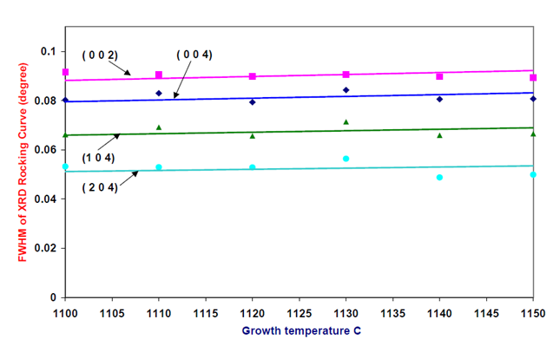
Figure 2: FWHM of XRD Rocking Curve of different orientation vs. Growth Temperature

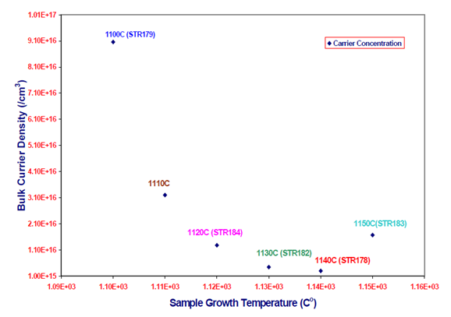
Figure 3: Variation of Bulk Carrier Concentration Vs Growth Temperature
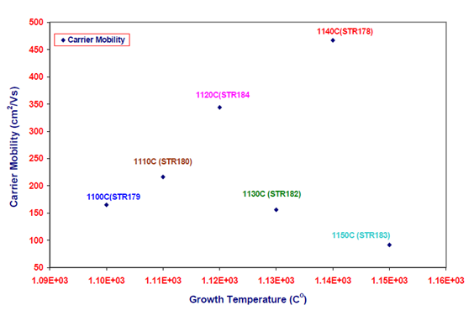
Figure 4: Variation of Carrier Mobility Vs Sample Growth TemperatureFigure 4: Variation of Carrier Mobility Vs Sample Growth Temperature

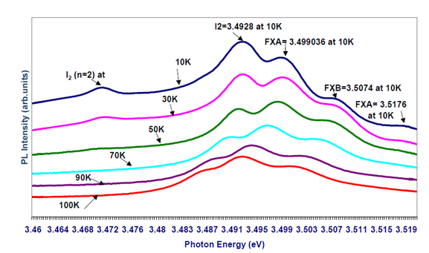
Figure 5: Near-band-edge exciton PL spectra at 10K from GaN epilayer grown on sapphire by MOCVD.

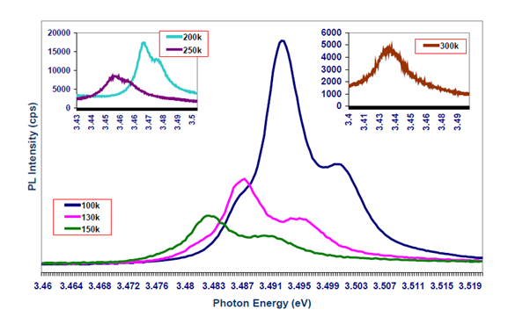
Figure 6: PL Temperature Dependence of a MOCVD un doped GaN Sample (sample 5) at 100k, 130k, 150k, 200k, 250k and 300k
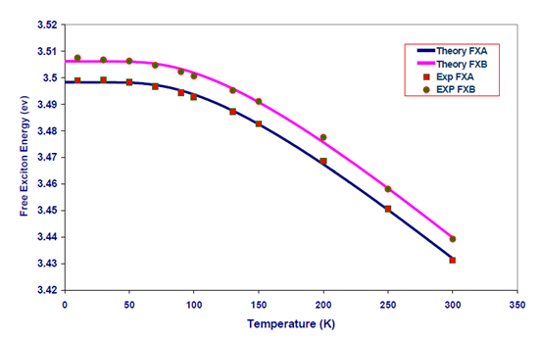
Figure 7: Temperature dependence of Free A, B- Excitons ( Sample 5). The solid curves represent the theoretical fit to the experimental data using the empirical equation proposed by Cody (Ref.(24).

Conclusions
Six samples of undoped GaN grown by MOCVD on sapphire substrate showed good quality of epilayers.
Using photoluminescence experiments A and B excitons were seen clearly. An indication of the magnitude of the strain can be seen as a result of the deviation of the values of free exciton from that of strain free, which is sample dependence as can be seen clearly from our results of the excitonic energy positions. Our observation of exciton transitions with higher energies in the epitaxial GaN based materials grown on sapphire substrates compared to that on SiC substrates suggests that the GaN based epilayers on sapphire substrate are under compressive strain, while those on SiC are subject to tensile strain. On the other hand, the quality of epilayers were judged by measuring the FWHM of (FX^{A}) and (FX^{B}) from PL experiments at 10K. The FWHMs were narrow and signify the quality of our samples. XRD rocking curve was another evidence of crystallinity of our samples. The relation of growth temperature on X-ray rocking curve line width was obtained. This relationship is nearly constant which means that, the samples have nearly the same quality of crystal of FWHM about 0.08, 0.09, 0.067, 0.05 degree for all samples for the (004), (002), (104) and (204) diffractions respectively, when the growth temperature of the samples is changing from 1100 ºC to 1150 ºC at fixed thickness (4microns). Hall measurement was used as a third evidence of quality of the samples as can be seen from the results. Sample 5 (1140C) was chosen to illustrate the temperature dependence of free exciton transitions, once it has the narrowest FWHM of FX^{A} and has the highest value of electron mobility of 466.88 cm²/Vs with respect to the other samples in this set. The variation of the fundamental band gap of the undoped GaN (sample 5) was maped out as function of temperature. The temperature dependence of free excitons was obtained using the empirical equation proposed by Cody. Cody’s coefficients were calculated for the bandgap temperature variation. The PL peak energies are in good agreement with the exciton energies up to RT. Thus, exciton emissions dominate the PL spectra of our GaN sample up to RT.

References
- S. Chichibu, T. Azuhata, T. sota and S. Nakamura, (1996). Recombination dynamics of excitons and biexcitons in a hexagonal GaN epitaxial layer. J. Appl. Phys. 79 (5), 2784-2786.
- S. Chichibu, T. Mizutani, T. Shioda, H. Nakanishi, T. Deguchi, T. Azuhata, T. Sota, and S. Nakamura; Appl. Phys. Lett. 70 (25), 23 (1997).
- M. Smith, G. D. Chen, J. Y. Lin, H. X. Jiang, M. Asif Khan, C. J. Sun, C. J. Chen and J. W. Yang; J. Appl. Phys., 79, 1996, 7001.
- B. Monemare, Phys. Rev. B 10, 676 (1974).
- C. Reynolds and D. C. Look, W. Kim, O. Aktas, A. Botchkarev, A. Salvador, H. Morkoc, D.N. Talwar. J.Appl.Phys. 80 (1), 594-596, (1996).
- Hadis Morkoc “Nitride semiconductors and Devices”, Series in material science, (1999).
- W. Shan, A. L. Fischer, and J. J. Song Appl. Phys. Lett. 69 (6), 1996).
- W. Shan, T. Schmidt, X. H. Yang, and J.J. Song. J. Appl. Phys. 79 (7), 1996.
- D. G. Chtchekine, G. D. Gilliand, Z. C. Feng, S. J. Chua, D. J. Wolford, S. E. Ralph, M. J. Schurman, and I. Ferguson [MRS Internet J. Nitride Semicond. Res. 4S1, G6.47 (1999)].
- C. G Guenaud, E. Deleporte, M. Voos, C.Delalande [MRS Internet J. Nitride Semicond. Res.vol 2 (1997) 10]
- R. Dingle, D. D. Sell, S. E. Stokowski and M. Ilegems, Phys. Rev., B4, 1971, 1211.
- J. X. wang, D. Z. Sun, X. L. Wang, J. M. Li, Y. P. Zeng, X. Hou. And L.Y. Lin; Journal of Crystal Growth. Volume 227-228, P386-389, (2001).
- Leroux, B. Beaumont, N. Grandjean, P. Lorenzini, S. Haffouz, P. Vennegures, J. Massies, P. Materials Science and Engineering B50 (1997) 97-104.
- Zhizhong Chen, Jianming Zhu, Bo Shen, Rong Zhang, Yugang Zhou, Peng Chen, Weiping Li, Wenjun Liu, Zhenlin Wang, Youdou Zhenh and Shusheng JiangMaterials &Design. Volume 21, Issue 6, P579-582 (2000).
- Haoxiang Zhang, Zhizhen Ye, Binghui Zhao; Journal of Crystal Growth 210 (2000) P 511-515
- W. Van der Stricht, I. Moerman, P. Demeester. J.A. Crawley, E. J. Thrush; MRS internet Journal semiconductor Research, V.1, Article 3 (1996).
- B.J. Skromme, H. Zhao, B. Goldenberg, H. S. KKKZong, M.T. Leonard, G. E. Bulman, C. R. Abernathy, S. J. Pearton. ”Photoluminescence, Reflectance, and Magnetospectroscopy of shallow excitons in GaN”Mat. Res. Symp. Proc. Vol. 449 (1997).
- Grzegorz Kamler, Janusz Zachara, S-awomir Podsiad-o.”Bulk GaN single-crystals growth” Journal of Crystal Growth. Volume 212,Issues 1-2, P39-48, (2000).
- C. C. Shen, C. K. Shu, H. C. Lin, J. Ou, W. K. Chen, M. C. Lee and W. H. Chen; Chinese Journal of Physics. Vol.36, NO.1, P32-37 (1997)
- K. Viswanath, J. I. Lee, C. R. Lee, J. Y. Leem and Dongho Kim. Solid state communication, Vol. 108, No. 7, pp. 483-487, 1998 .
- Usikov, V.V. Ratnikov, R. Kyutt, W.V.Lundin, B. Pus hnyi, N.M.Shmidt, M.P. Scheglov; [MRS Internet J. Nitride Semicond, Volume 3, Articale 42 (1998)].
- Xueping Xu, R.P. Vaudo, C.Loria, A. Salant, G. R. Brandes and J. Chaudhuri”Growth and charactetization of low defect GaN by hydride vapor phase epitaxy”Journal of Crystal Growth, Volume 246,Issues 3-4, P 223-229(2002).
- Volm D., Oettinger, Streibl.,. Kovalev, D., Ben-Chorin., Diener, J., Meyer, B.K., Majewski, J., Eckey, L., Hoffman, A., Amano, H., Akasaki, I., Hiramatsu, K. and Detchprohm, D., Phys. Rev., B53, 1996, 16 543
- G. D. Cody: Hydrogenated Amorphous Silicon, ed. J. I. Pankove, Semiconductors and Semimetals Vol.21, Pt.b (Academic, New York, 1984), Chap.2, pp. 11-79.
- J. Bai, T. Wang, H. D. Li, N. Jiang, S. Sakai; Journal of Crystal Growth. Volume 231, P41-47, (2001).
- P. Visconti, M. A. Reshchikov, F.Yun, K. M. Jones and H. Morkoc. A. Passaseo, E. Piscopiello, A. Pomarico and R. Cingolani. M. Lomascolo, M. Catalano.”Structural, optical and electrical properties of GaN films grown by metalorganic chemical vapor deposition on sapphire”VCU school of Engineering Puplications June 2001.
- K. Pakula, Jacek M. Baranowski, M. Leszcznski, B. Suchanek, and M. Wojdak; [MRS Internet J. Nitride Semicond. Res. Volume 3, Article 23 (1998)].
- H. Amano, I. Akasaki, K. Hiramatsu, N. Koide and N. Sawaki; Thin Solid Films, 163 (1988) 415-420.
- H. Amano, N. Sawaki, and I. Akasaki; Appl. Phys. Lett. 48 (5), 353-355 (1986).
- M.Tchounkeu, O. Briot, B. Gil, J.P. Alexis and R-L. Aulombard, “Optical properties of GaN epilayers on sapphire” J. Appl. Phys. 80 (9), 5352-5360 (1996).
- S. Chichibu, T. Mizutani, T. Shioda, and H. Nakanishi, T. Deguchi, Azuhata, T. Sota, and S. Nakamura; Appl. Phys. Lett. 70 (25), 3440-3442(1997).
- Monemar, J.P. Bergman, I.A. Buyanova, W.Li, H.Amano, I. Akasaki [MRS Internet J.Nitride Semicond. Res. (USA) Vol.1 (1996) 2].

4/15/2014

