Loss Reduction in Electrical Distribution Systems Using Artificial Intelligence

A. Mabruok khafagei, A. Mahmuod Agwa and M. Ibrahim El-Sayed

Faculty of Engineering, Al-Azhar University, Cairo, Egypt
kh_ama@yahoo.com

Abstract: This paper using the artificial intelligence tools in identifying the optimal locations and sizes of shunt capacitors to be placed in radial distribution system to loss reduction have overall economy considering the saving due to energy loss minimization and cost of capacitors. Capacitor banks are added on Radial Distribution system for Power Factor Correction, Loss Reduction and Voltage profile improvement. For these purpose two stage methodologies is used in this paper. In first stage, the load flow of pre-compensated distribution system is carried out and performed the power loss reduction index (PLRI). Fuzzy controller identifies the candidate number of buses on the basis of load flow solution and (PLRI). In the second stage, genetic algorithms are used to identify the size of the capacitors for minimizing the energy loss cost and capacitor cost. The developed algorithm is tested for 33-BUS, IEEE 69 redial distribution system at 12.66 KV high voltage distribution system (HVDS).
[A. Mabruok khafagei, A. Mahmuod Agwa and M. Ibrahim El-Sayed. Loss Reduction in Electrical Distribution Systems Using Artificial Intelligence. Nat Sci 2014;12(5):27-35]. (ISSN: 1545-0740). http://www.sciencepub.net/nature. 4

Keywords: Shunt Capacitors Placement and Sizing, Fuzzy Controller, Genetic Algorithms.

1. Introduction
The power loss in a distribution system is significantly high because of lower voltage and hence high current, compared to that in a high voltage transmission system. The pressure of improving the overall efficiency of power delivery has forced the power utilities to reduce the loss, especially at the distribution level. In this paper a radial distribution system is taken because of its simplicity. The same technique can be applied to other types of feeders. The loss can be reduced by adding shunt capacitors to supply a part of the reactive power demands. Shunt capacitors not only reduce the loss but also improve the voltage profile, power factor and stability of the system [1]. The active power demands at all nodes and losses must be supplied by the source at the root node, as distribution system is mainly radial. However, addition of shunt capacitors can generate the reactive power and therefore it is not necessary to Supply all reactive power demands and losses by the source. Thus, there is a possibility to minimize the loss associated with the reactive power flow through the branches. Distribution system accounts for a major portion of power system losses. The pressure of improving the overall efficiency of power delivery has forced the power utilities to reduce the loss, especially at the distribution level. In addition, shunt capacitors could also accommodate voltage regulation and VAR supply. For capacitor placement, general considerations are:
- The number and location
- Type (fixed or switched)
- The size
2. Fuzzy Logic Theory
Fuzzy logic has been applied in various power system problems [2]. Fuzzy logic rests on the fact that all things admit to certain degree of truth. Fuzzy logic deal with ambiguities and the uncertainties of the system [3, 4].

Fuzzy logic consists of a group of elements. (Fuzzy Sets, Membership Functions, Fuzzy Inference Systems and Defuzzification.).

2.1. Fuzzy Sets

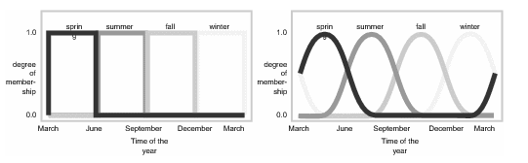
Figure(1): A classical set & A fuzzy set

Fuzzy logic starts with the concept of a fuzzy set. A fuzzy set is a set without a crisp, clearly defined boundary. It can contain elements with only a partial degree of membership. In figure (1) use the year seasons as example to illustrate the deference between the fuzzy sets and classical sets. A classical set is shown on the left in the figure (with sharp edge, wholly includes or wholly excludes) and the fuzzy set is shown on the right (with a partial degree of membership).

2.2. Membership Functions
A membership function (MF) is a curve that defines how each point in the input space is mapped to a membership value (or degree of membership) between 0 and 1[5].
2.2.1. The Shapes of Membership Functions
The only condition, a membership function must really satisfy is that it must vary between 0 and 1. The function itself can be an arbitrary curve whose shape we can define as a function that suits us from the point of view of simplicity, convenience, speed, and efficiency. Different shapes of the membership functions can be proposed such as Triangular, Trapezoidal, or Gaussian.

2.3. Fuzzy Inference Systems
Fuzzy inference is the process of formulating the mapping from a given input to an output using fuzzy logic. There are two types of fuzzy inference systems. Mamdani-type and Sugeno-type[6].
2.3.1. Mamdani-Type Inference
The Mamdani is based on the collection of if-then rules with both fuzzy-antecedent and consequent predicates. The advantage of this model is that the rule base is generally provided by an expert, and hence, to a certain degree. the Mamdani model is the most widely used technique for solving many real world problems.

2.3.2. Sugeno-Type Inference
The second category of the fuzzy model is based on Takagi-Sugeno-Kang (TSK) method of reasoning. These types of models are formed by if-then rules that have a fuzzy antecedent part and functional consequent. It is generally implemented in two forms, depending upon the type of consequent. If the consequent is a linear function, then it is called a first order TSK model, and if consequent is simply a constant, then it is termed as a zero order TSK model. The main advantage of this approach is its computational efficiency.
2.4. Defuzzification Process
Defuzzification, is a process of converting the output of the fuzzy rule from fuzzy to crisp values. This process depends on the output fuzzy set which is generated from the fired rules. The methods are commonly used is Centroid, Bisector and Middle, Smallest, and Largest of Maximum.
A typical fuzzy rule based system is depicted in Figure (2)

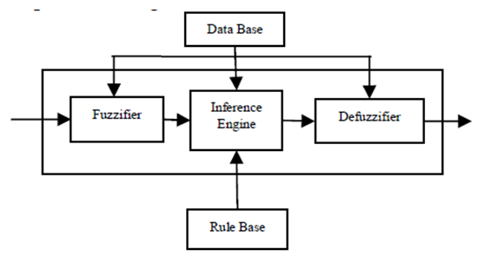
Figure (2) Main elements of a fuzzy rule-based system

The fuzzifier converts real numbers of inputs into fuzzy sets. (Number between zero and one indicating its actual degree of membership). The knowledge base includes a fuzzy rule-base and a database. Membership functions of the linguistic terms are contained in the database. The rule base consists of if-then rules, which represents the relationship between input and output variables.

3. Genetic Algorithm
Genetic Algorithms (GAs) has been applied in various power system problems [7, 8]. GAs is adaptive heuristic search algorithms based on the evolutionary ideas of natural selection and natural genetics [9, 10]. GAs operates on a number of potential solutions, called a population. Typically, a population is composed of between 30 and 100 individuals. GAs uses a “Chromosomal” representation which requires the solution to be coded as a finite length string.
A simple genetic algorithms that yields good results in many practical problems is composed of three operators: Reproduction (selection), Crossover and Mutation.
3.1. Reproduction (selection)
Select two parent chromosomes from a population according to their fitness (the better fitness, the bigger chance to be selected). According to Darwin's theory of evolution the best ones survive to create new offspring. The fitness function measure the quality of the represented solution and it is always problem dependent. There are many methods in selecting the best chromosomes such as Roulette Wheel Selection Method, Stochastic Universal Sampling,
3.2. Crossover (Recombination)
The basic operator for producing new chromosomes in the GAs is that of crossover. Like its counterpart in nature, crossover produces new individuals that have some parts of both parent’s genetic material. There are many methods to execute the crossover such as single-point crossover, Multi-point Crossover, Uniform Crossover.
3.3. Mutation
In natural evolution, mutation is a random process where often parts of chromosome are replaced by another to produce a new genetic structure. Mutation results in slight changes in the new solution structure and maintains diversity of solutions.
3.4. Parameters of GAs
There are two basic parameters of GAs, crossover probability and mutation probability.
3.4.1. Crossover Probability (P_{c})
If crossover probability is 100%, then all offspring are made by crossover. If it is 0%, whole new generation is made from exact copies of chromosomes from old population. Typical values for Pc lie within the range of (0.6, 0.95)
3.4.2. Mutation Probability (P_{m})
The typical values for Pm lie within the range of (0.01, 0.1). And high mutation rates promote diversity among the population.
Steps in Basic Genetic Algorithms
- [Start] Generate random population of n chromosomes (suitable solutions for them problem).
- [Fitness] Evaluate the fitness f(x) of each chromosome x in the population.
- [New population] Create a new population by repeating following steps until the new population is complete.
  - [Selection] Select two parents’ chromosomes from a population according to their fitness.
  - [Crossover] With a crossover probability cross over the parents to form new offspring (children).
  - [Mutation] With a mutation probability mutate new offspring at each locus (position in chromosome).
  - [Accepting] Place new offspring in the new population.
- [Replace] Use new generated population for a further run of the algorithm.
- [Test] If the end condition is satisfied, stop, and return the best solution in current population.
[Loop] Go to step 2.

4. Fuzzy Based Capacitors Locations
First, we set the power loss reduction index PLRI and the voltage index V to be the input variables of the fuzzy logic controller. The capacitors placement suitable index CPSI Is the output variable of the fuzzy logic controller. The structure of fuzzy controller is shown in Fig.2.

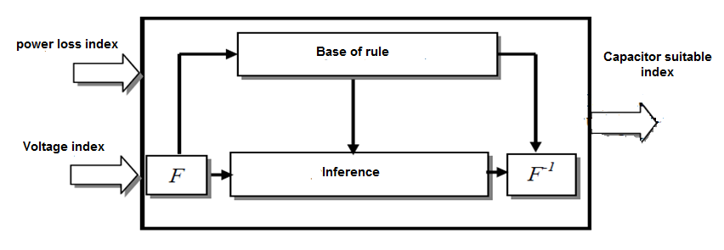
Figure( 3) structure of fuzzy controller (where: F = fuzziffication; F⁻¹ = defuzziffication)

To determine the critical busses the Voltage Magnitude (output from the base case load flow) and Power Loss Reduction Index (PLRI) at each node shall be calculated and are represented in fuzzy membership function. By using these voltages and PLRI, rules are framed and are summarized in the fuzzy decision matrix as given in Table 1. The linguistic variables are defined as {L, LM, M, HM, H}[11], where L means low, LM means low medium, HM means high medium, H means high, five membership function is used. The membership function of the fuzzy logic controller are shown in the following figures:
Mamdani-type fuzzy inference will be used.
According to the table (1) the rules is formulated as .(if PLRI is (L) and V is (H) then CPSI is (L)). And so on the rest of rules.

Table (1) fuzzy decision matrix
CPSI |  | V
 |  | H | HM | M | LM | L
PLRI | L | L | L | LM | LM | M
 | LM | L | LM | LM | M | HM
 | M | LM | LM | M | HM | HM
 | HM | LM | M | HM | HM | H
 | H | M | HM | HM | H | H

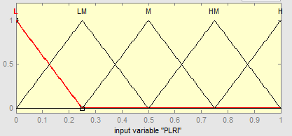
Figure (4) power loss reduction index membership function

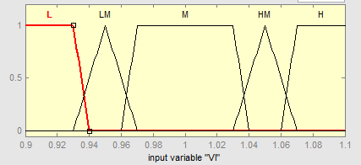
Figure (5) voltage index membership function

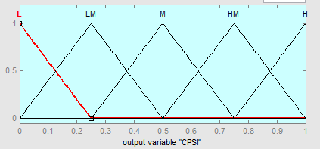
Figure (6) capacitor placement suitable index membership function

Algorithm for critical busses identification
Following algorithm explain the methodologies to identify critical busses, which are
More suitable for capacitor placement.
Step1: Read line and load data of power system.
Step2: Calculate power flow by Newton Raphson method.
Step3: Determine total active power loss and bus voltage magnitude.
Step4: By compensation the self –reactive power at each node and conduct the load
flow to determinate the total active power losses in each case.
Step5: Calculate the power loss reduction index (PLRI) as below:
PLRI (k) = Where,
Loss reduction at bus K = (base case loss – compensation loss)
Step6: The PLRI and the per-unit voltage magnitude (base case load flow) are the inputs to the fuzzy Controller.
Step7: The outputs of Fuzzy controller are deffuzzified (using Centroid method). This gives the ranking of CPSI. The nodes having the highest value of CPSI are the most suitable for capacitor placement.
Step8: Stop.

5. Genetic Algorithms Based Capacitors Sizing
The success of the GAs structure will lies on the coding scheme, the coding scheme and the brief discussion of various operators with reference to the problem of interest is summarized as:
Here we use an integer representation of the chromosome.
Having identified the potential buses, the sizing is attempted using GAs. Let the capacitor allowable range is from 300 KVAR to 3600 KVAR [12].
5.1 Initialization and Objective Function
Initialization is the generation of initial population. Here, the initial population is generated randomly which is the capacitors of different size (KVAR ratings) to be install at the potential buses. The string (individual) length is equal to the number of buses selected for the shunt capacitors.
After generating population of required size the corresponding load flow solution has run to evaluate the objective function 'S' and the fitness function 'F' for each chromosome string are calculated as given below:
S = Ce × +
F =
Where S is the cost function for minimization.
Ce is the energy rate.
EL_{i} is energy loss (kW) in section–i in time duration T.
Cci is the constant installation cost of capacitor (cost per location).
Ccv is the rate of capacitor per kVAR.
Qck is the rating of capacitor on bus-k in kVAR.
The load flow solution, evaluation of objective function is repeated for all the strings in the population. The procedure to determine the fitness function 'F' is very much application oriented. It is directly associated with the objective function value in the optimization problem. In the capacitor placement problem. The objective function is minimization of cost function.
The main constraint for capacitor placement is that all voltage magnitudes should be within the lower and upper limits. In this paper, the voltage limits is according to ANSI C84.1. It is gives limits for medium-voltage systems, The standard defines two ranges of voltage: Ranges A and B. Range A is ( – 2.5% ) to (+ 5% ), and Range B is( – 5% ) to ( + 5.8% ). In this paper we take the voltage limits close to Range B.
(Vmin ) 0.94 <= V <= 1.04 (Vmax)
The methodology of the capacitor design in distribution system is as follows:
Step 1: Read the distribution system branch impedance values and the bus real and reactive Power data.
Step 2: Run the Load Flow of Distribution System to find out voltage magnitudes at the buses and total power loss.
Step 3: Select the candidate buses by using fuzzy logic controller.
Step 4: Set GEN = 0
Step 5: Form initial population of integer numbers, which is randomly selected value of capacitors to be installed at the candidate buses for compensation.
Step 6: Update the reactive power at candidate buses.
Step 7: Run the Load Flow of Distribution System with updated reactive power at the candidate buses for each population. Also calculate total power loss for each population.
Step 8: Calculate the total Energy Loss Cost and Capacitor Cost for Population.
Step 9: For each population, evaluate the objective function and the fitness value. The objective function for each population is the total energy loss cost and the cost of capacitors.
Step 10: GEN = GEN + 1
Step 11: Select the solutions in pool from initial population.
Step 12: Perform Crossover on the solutions selected randomly and generate two off springs.
Step 13: Perform Mutation on the offspring generated by the crossover operation.
Step 14: Check offspring satisfying the voltage constraints and calculate Energy Loss Cost and Capacitors Cost. Also evaluate objective function and Fitness Function of each offspring's.
Step 15: Combine the solutions of the pool and the offspring's and refer them as new population.
Step 16: Replace new population with initial population for next generation.
Step 17: Go to step 10, till the maximum number of generation reached.
Step 18: STOP

6. Case Study and Results
Prior to capacitor installation, a load flow program is run to obtain the present system conditions. Systems conditions are shown in Tables (2,3). The tables specifies the minimum per-unit bus voltage, maximum per-unit bus voltage at full load and no load, real power losses in KW and the cost of energy losses . It is clear from the table that the minimum bus voltages during the simulation are less than the pre-specified minimum allowable bus voltage. Therefore, capacitors shall be installed to provide the required voltage correction and to reduce the overall power losses in the system.
The proposed solution methodologies have been implemented in MATLAB 7.7. The solution algorithms based on fuzzy controller and GAs, and tested on IEEE 69 Bus and 33bus redial systems. In this case, only fixed type capacitors are installed in the system and all the loads are assumed to be linear and constant. The parameters are defined as shown below:
Population Size = 50
Mutation rate = 0.01
Crossover rate = 0.7
No. of generations before algorithm is terminated = 50
The parameters are set empirically by trial and error procedure. Parameters that have resulted in the best solution were chosen.
The optimal solution for this work is obtained and the result as in the following tables and charts:
Where
(Ce=0.06$/kWh, Ccv=3$/kvar, Cci=1000$/location) [13]
From the upper tables and charts we can decided that
- The distribution network is operated under the safe condition. Where, the voltage magnitude is between its permissible limits at full load and no load operation.
- The power loss is reduced by sufficient amount to insure economical and high efficient operation.
From the upper tables and charts we can decided that
- The distribution network is operated under the safe condition. Where, the voltage magnitude is between its permissible limits at full load and no load operation.
- The power loss is reduced by sufficient amount to insure economical and high efficient operation.

Table (2) System conditions without and with capacitors placement for IEEE 69 Bus System
Case | Before capacitor | After capacitor
Minimum bus voltage at full-load (p u) | 0.909 | 0.94
Voltage regulation (%) | 9.1 | 6
Improvement of voltage regulation (%) | --- | 3.1
Maximum bus voltage at no-load (p u) | 1 | 1.025
Real power loss(kw) | 224 | 163
Optimal Location of Capacitor  & value Bus number KVAR | --------------  --------------  -------------- | At bus 59 ( 600) kvar  At bus 61 (750) kvar  At bus 64 (600) kvar
Total KVAR placed |  | 1950
KVAR required from source | 2667 | 717
Savings due to Reduction in Power loss ($/Year) |  | 32061.6
Total cost of the Capacitors ($/Year) |  | 9300
Net Savings ($/Year) |  | 22761.6
Loss Reduction % |  | 27.23 %

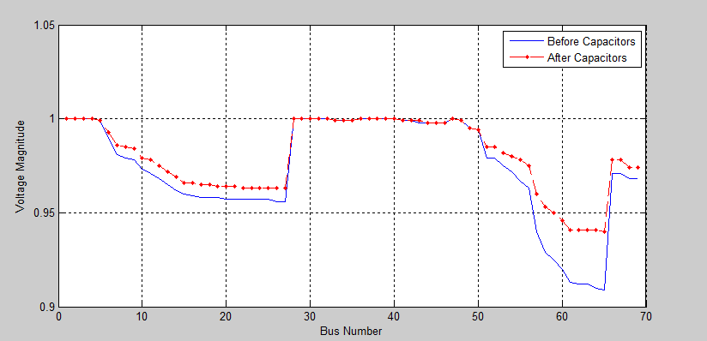
Figure ( 7 ): Comparison of Voltage profiles for IEEE 69 bus system

Table (3) System conditions without and with capacitors placement for 33 Bus System
Case | Before capacitor | After capacitor
Minimum bus voltage at full-load (p u) | 0.904 | 0.943
Voltage regulation (%) | 9.6 | 5.7
Improvement of voltage regulation (%) | --- | 3.9
Maximum bus voltage at no-load | 1 | 1.033
Real power loss (kw) | 210 | 146
Optimal Location of Capacitor  & value Bus number KVAR | ---------------  ---------------  --------------- | At bus 15 600 kvar  At bus 30 450 kvar  At bus 32 450 kvar
Total KVAR placed |  | 1500
KVAR required from source | 2289 | 789
Savings due to Reduction in Power loss ($/Year) |  | 33638.4
Total cost of the Capacitors ($/Year) |  | 7500
Net Savings ($/Year) |  | 26138.4
Loss Reduction % |  | 30.47 %

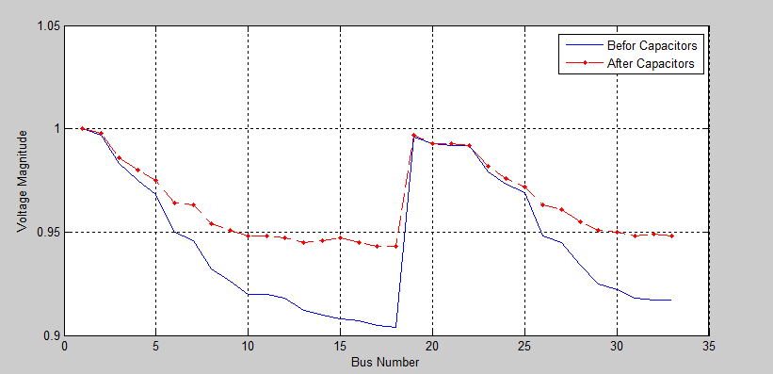
Figure (8): Comparison of Voltage profiles for 33 bus system

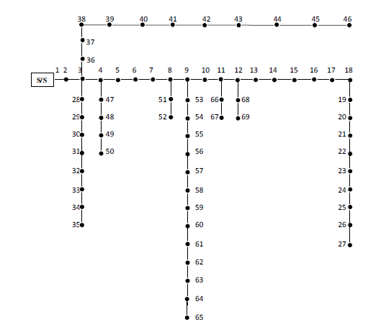
Figure (9): 69-Bus Redial Distribution System
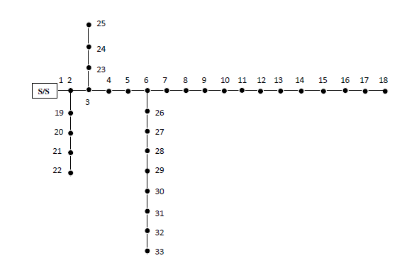
Figure (10): 33-Bus Redial Distribution System

6 Conclusions
The work has been carried out to find the optimal locations and sizes (kVAr) of capacitors to be placed in radial distribution system. The above problem has been solved by two step methodology, the candidate locations for compensation are found using fuzzy controller. The sizing has been attempted using Genetic Algorithms. From the study the following conclusions are drawn.
- The compensation is yielding into increase in voltage profile and reduction in losses.

- The method developed in this paper is simpler and more effective than some methods, where it dividing the complicated problem to two smaller sections (placement is a section and sizing other one). Each section has independent procedure and this lead to obtain fasted solutions with high accuracy by lesser computational burden. It is clear in the Genetic Algorithms operation where not use large population size and also not need to large generation number.

References
- Turan Gonen, "Electric Power Distribution system engineering," California State University, Sacramento, 1986.
- Mohamed E. El-Hawary "Electric Power Applications of Fuzzy Systems," Dalhousie university, 1998
- Leonid Reznik, "Fuzzy Controllers," Victoria University of Technology, Melbourne, Australia, 1997.
- Andries P. Engelbrecht, "Computational Intelligence" University of Pretoria, South Africa, 2002.
- www.mathworks.com/access/helpdesk/help/toolbox/fuzzy/fuzzyin3.html
- www.mathworks.com/access/helpdesk/help/toolbox/fuzzy/fuzzytn3.html
- Charette A., J.Xu, A.Ba-Razzouk, P.Pillay, V.Rajagopalan," The Use of the Genetic Algorithm for in-situ Efficiency Measurement of an Induction Motor," IEEE Power Engineering Society Winter Meeting, 1(1), 2000, 392-397.
- Dong Z.Y, D.J.HILLAND, V.Y.MAKAROV, "Power System VAR Planning with Genetic Algorithm,” Technical Report: EE-98015, Department Of Electrical Engineering, University of Sydney, Australia, 1998.
- Holland J.H., "Adoption in Natural and Artificial Systems,” (Massachusetts, Cambridge, MIT Press, 1975).
- Goldberg D.E.," Genetic Algorithm in Search Optimization and Machine Learning," (Massachusetts, Addison-Wesley, 1989).
- Damodar M. Reddy and N. V. Vijaya Kumar, "Optimal Capacitor Placement for Loss Reduction in Distribution System Using Fuzzy and Harmony Search Algorithm" ARPN Journal of Engineering and Applied Sciences, VOL. 7, NO. 1, JANUARY 2012
- Short T. A.," Electric Power Distribution Equibment And Systems" Montana State University, 2006
- Amritpal Singh, "Loss Minimization In High Voltage Distribution System By Capacitor Placement Using Genetic Algorithm," M.S.C. thesis, Thapar University, Patiala, 2010
- A. Mahmoud Agwa, "New Control Methods of The Nonlinear And Time-Varying Systems," M.S.C. thesis, Department of Electrical Engineering, Faculty of Engineering Al-Azhar University, 2008.

3/30/2014

