In vitro Study Evaluating the Micro-Tensile Bond Strength of Different Restorative Materials After Treatment by Chemo-Mechanical Agent

Mona Abdel Rehim Wahby¹; Eman Sayed ElMasry²; Manal Ahmed El Sheikh³ and Sherine Badr Youness⁴

Resident in Pediatric Dentistry Department, Faculty of Dentistry, Sinai University¹

Professor of Pediatric Dentistry and Dental Public Health, Faculty of Oral and Dental Medicine, Cairo University²

Lecturer of Pediatric Dentistry and Dental Public Health, Faculty of Oral and Dental Medicine, Cairo University³

Lecturer of Pediatric Dentistry and Dental Public Health, Faculty of Oral and Dental Medicine, Cairo University⁴

monawahby_82@hotmail.com

Abstract: Aim of study: This study was aimed to evaluate the effect of the application of a papain-based gel on the micro-tensile bond strength of different restorative material to carious dentin. Material and methods: Thirty two extracted human primary posterior teeth with moderate caries were assigned into two groups according to mechanism of caries removal, each containing sixteen (16) teeth [thirty two (32) halves].Group 1: Caries are mechanically removed with a round bur "control group" and restorative material was applied. Group 2: Caries are chemo-mechanically removed with a chemo –mechanical solvent (Papacarie) and restorative material was applied. Both groups were subdivided into two subgroups: Sub-group A: Glass iomomer restoration Sub-group B: Light curing composite resin restoration. The samples were sectioned longitudinally to the long axis of the tooth to obtain sticks of standardized cross sectional area. These sticks were stressed to failure under tensile force in a universal testing machine. The micro-tensile bond strength for each specimen was calculated in megapascal (MPa). Results: Papacarie may decrease the bond strength of restorative materials regardless the type of adhesive filling. Conclusion: Papacarie may affect negatively the bond strength and consequently the durability of restorative materials.
[Mona Abdel Rehim Wahby; Eman Sayed ElMasry; Manal Ahmed El Sheikh and Sherine Badr Youness. In vitro Study Evaluating the Micro-Tensile Bond Strength of Different Restorative Materials After Treatment by Chemo-Mechanical Agent. Nat Sci 2014;12(5):22-26]. (ISSN: 1545-0740). http://www.sciencepub.net/nature. 3

Keywords: Dental caries, chemo-mechanical caries removal, Papacarie, micro-tensile bond strength, adhesive restorative materials.

1. Introduction
Preservation of a healthy set of natural teeth for each patient should be the objective of every dentist. All work in the health field is aimed basically at conservation of the human body and its function (Rainey, 2002).
Dental caries was defined as a disease of the calcified tissues of the teeth. Two zones can usually be distinguished within a carious lesion. There is an inner layer which is partially demineralized and can be re-mineralized and in which the collagen fibrils are still intact, known as affected dentin, and there is an outer layer where the collagen fibrils are partially degraded and cannot be remineralized, known as infected dentin (Yoshiyama et al., 2003).
An efficient process of caries removal should identify the mineralized portion as well as the demineralized one, and remove only the latter. For these we require reagent, which must be able to cause further degradation of this partially degraded collagen (Ericsson, 1999).
Traditional means of cavity preparation is based on a philosophy of extension for prevention. However, drilling often removes parts of tooth, which are healthy, in addition to the decayed areas. This weakens the tooth and makes it less durable in the long run (Jawa et al., 2010).
Chemo-mechanical caries removal is a non invasive technique eliminating infected dentin via a chemical agent. This process not only removes infected tissues, it also preserves healthy dental structure (Chambers et al., 2007).
In 2003, a research project in Brazil led to the development of a new formula to universalize the use of chemo-mechanical method for caries removal and promote its use in public health. The new formula was commercially known as Papacarie. (Sandra et al., 2005).
Restoration of cavities prepared by this technique requires materials such as composite resins or glass ionomer which bond to the dentin surface rather than materials such as amalgams which involve cutting a cavity designed to mechanically retain the restoration (Chambers et al., 2007).
In cavity preparation for an adhesive restoration after removal of caries-infected dentin, large areas of the cavity floor are composed of caries-affected dentin. Therefore, in clinical settings, bonding substrate is commonly caries affected dentin, not normal dentin. Many studies on dentin bonding have used normal dentin as bonding substrate, which have contributed to the dramatic development of dentin adhesive systems during the past decades. On the other hand, there are a few studies about bonding to caries-affected dentin, in which the bond strengths to caries-affected dentin are lower than those of normal dentin (Wei et al., 2008; Scholtanus et al., 2010 and Xuan et al., 2010). Therefore, the current study was conducted to evaluate the effect of Papacarie on the micro-tensile bond strength of different restorative materials to caries-affected dentin.

2. Materials and Methods
I. Materials:
Materials used in this study were classified into:
- Thirty two (32) extracted human primary posterior teeth with moderate caries.
- Papain-based gel for chemo-mechanical caries removal (Papacarie, F&A Laboratório Farmacéutico Ltda, São Paulo, Brazil).
- Restorative materials:
(a) Glass Ionomer (Ketac™ Molar,3M ESPE).
(b) Resin based composite material (Herculite®, XRV™, Kerr corporation). It's a Two-step Etch-and-Rinse adhesive system.
II. Methods:
A. Selection of teeth:
Thirty two extracted human primary posterior teeth with moderate caries were collected from the out-patient clinic of the Pediatric and Community Dentistry Department, Faculty of Oral and Dental Medicine, Cairo University and were stored in physiologic solution (saline 0.9 % NaCl) for no longer than one month until the beginning of the experiment.
B. Preparation of teeth:
The teeth were longitudinally cut through the centre of carious lesion, mesio-distally, in two sections (halves) (Figure 1) using a double-sided abrasive disc attached to a low speed hand piece under copious water coolant.
C. Grouping the specimens:
The thirty two (32) carious teeth [sixty four (64) halves] were assigned into two groups according to mechanism of caries removal, each containing sixteen (16) teeth [thirty two (32) halves].
Group 1:
Caries are mechanically removed with a round bur "control group" and restorative material was applied.
Group 2:
Caries are chemo-mechanically removed with a chemo-mechanical solvent (Papacarie) (Figure 2) and restorative material was applied.
Both groups were subdivided into two subgroups according to the restorative material:
Sub-group A:
Glass iomomer restoration.
Sub-group B:
Light curing composite resin restoration.
Caries removal:
One half of each tooth was excavated using round and fissure burs on a high-speed dental handpiece with a copious water spray, the other half was excavated by Papacarié.
D. Bonding Procedures:
All materials were manipulated according to manufacturer’s instructions.
E. Measurement of bond strength:
Each specimen was sectioned lengthwise to obtain multiple sticks.
A precise digital caliper was used to check the cross sectional area and the length of the specimens, each with cross sectional surface area of approximately [1.0×1.0mm (1.0±0.1mm²)]. A total of sixteen (16) sticks for each subgroup were tested.
A specially designed attachment was constructed for micro-tensile bond strength testing. Each stick (square in its cross sectional shape) was fixed to the attachment with a cyanoacrylate and stressed in tension using universal Lloyd testing machine at Ain Shams University, Department of Biomaterials (Figure 3), travelling at a cross-head speed of 1 mm/minute until failure.
Specimens which showed premature debonding during testing were recorded but not included in statistics. A micro-tensile bond strength (MPa) value of each stick was determined by computing the ratio of maximum load in Newton recorded by the testing machine to the adhesion area in mm².
F. Statistical analysis:
Data were presented as means and standard deviation (SD) values. One Way-ANOVA was used to study the interaction between all study groups on mean micro-tensile strength. Two way-ANOVA was used to study the effect of different restorative used and different cavity preparation mechanism on mean Micro-tensile strength.

3.Results
Statistical analysis:
Data were presented as means and standard deviation (SD) values. One Way-ANOVA was used to study the interaction between all study groups on mean micro-tensile strength. Tukey's post-hoc test was used for pair-wise comparison between the means when ANOVA test is significant. Two way-ANOVA was used to study the effect of different restorative used and different cavity preparation mechanism on mean micro-tensile strength.

1. Effect of cavity preparation mechanism and restorative material on micro-tensile bond strength:
Mean and standard deviation (SD) of micro-tensile bond strength of different restorative materials with different cavity preparation mechanism were presented in table (1).
It has been found that Papacarie produced significant reduction on the mean micro-tensile bond strength (μTBS) for both the glass ionomer and resin composite with an insignificant difference (22.9±9.01 μTBS and 25.97±6.14 respectively).On the other hand; there is a significant difference between GI and composite resin for the mechanical preparation method with the higher mean produced for the composite resin (38.63±8.48 μTBS and 74.08±12.88 respectively).

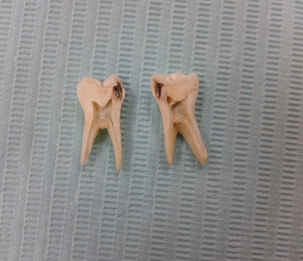
Figure (1): The teeth were longitudinally cut through the centre of carious lesion, mesio-distally, in two sections before caries removal.

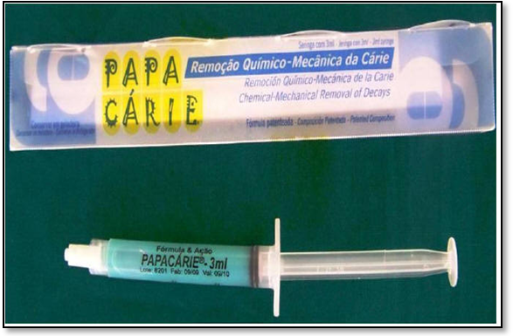
Figure (2): Papacarie (F&A Laboratório Farmacéutico Ltda, São Paulo, Brazil).

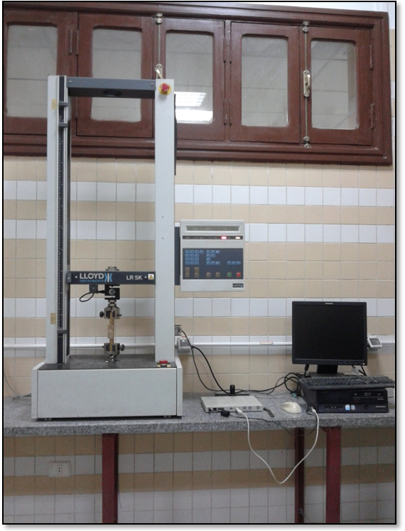
Figure (3): Universal Lloyd testing machine.

Table (1): Means, standard deviations and test of significance of micro-tensile bond strength of different restorative materials with different cavity preparation mechanisms.
 |  | Caries removal tool |  |  |  | p-value
 |  | Mechanical (bur) (MPa) |  | Chemo-mechanical (papacarie) (MPa)
 |  | Mean | ±SD | Mean | ±SD
Micro-tensile | GI | 38.63  MPa | ±8.48^{b}  MPa | 22.90  MPa | ±9.01^{c}  MPa | ≤0.001*
 | Composite | 74.08  MPa | ±12.88ª MPa | 25.97  MPa | ±6.14^{c}  MPa
Means with the same letter are not significantly different at p=0.05. *= significant level <0.05

- Discussion
The conventional method for caries removal is usually carried out with high speed hand piece to access the lesion and a low speed hand piece to remove caries. Although, this method is quick and efficient in caries removal, it may result in unnecessary removal of sound tooth structure. In addition, caries removal with the conventional method is usually associated with pain, annoying sound and possibility of producing thermal and mechanical injuries to dental pulp. Furthermore, in children and patients with anxiety the conventional technique is often associated with discomfort (Sarmadi et al., 2013).
These disadvantages potentiated the development of alternative minimally invasive techniques for caries removal; among them is the chemo-mechanical caries removal (Colgrave et al., 2012).
In 2003, a Brazilian formulation was introduced and commercially denominated Papacarié. Papacarié is a chemo-mechanical agent, basically composed of papain, chloramines, toluidine blue, salts, thickening vehicle and preservatives (Bussadori et al., 2005).
Papain is a proteolytic enzyme, similar to pepsin, it acts only on infected tissues. Chloramines present in the product have the potential to dissolve carious dentin through chlorination of partially degraded collagen (Maragakis et al., 2001).
Since the outcome of bond strength between the tooth surface and the restorative material is dependent on the characteristics of the remaining dentin surface, the question remains whether chemo-mechanical caries removal using Papacarié could influence the bond strength to restorative materials therefore, this study was done to throw light on the effect of papain based gel (Papacarié) on micro-tensile bond strength of two adhesive restorative materials; Glass Ionomer (Ketac™ Molar,3M ESPE) and light cured composite resin restorations (Herculite®, XRV™, Kerr corporation).
The result of the current in vitro study showed that the chemo-mechanical agent produced significant reduction on the micro-tensile bond strength (μTBS) for both the glass ionomer and resin composite with an insignificant difference (22.9±9.01 MPa and 25.97±6.14 MPa respectively) to caries affected dentin.
These results are supported by other studies (Burrow et al., 2003 and Sonoda et al., 2005) in which there is a decrease of micro-tensile bond strength of glass ionmer and composite resin (13.4 ± 3.9 MPa and 31.10 ± 9.21MPa respectively ) to caries affected dentin.
This is because, Papacarie acts only on infected tissues lacking a plasmatic anti-protease called α1-anti-trypisin that inhibit proteolysis in healthy tissues thus preserving the affected (non-infected) layer which produces lower bond strengths than normal dentin, regardless of the type of adhesive system, this is in agreement with (Nakajima et al., 2000 and Arrais et al., 2004).
Also, the hybrid layers created to caries-affected dentin are thicker than those of normal dentin, because caries affected dentin is more susceptible to the acid etching due to partially demineralization, resulting in the formation of a deeper demineralized zone which is more difficult for resin monomer to penetrate to the bottom of the exposed collagen matrix (Nakajima et al., 2000 Wang et al., 2007; and Erhardt et al., 2008).
On the other hand, Wei et al. demonstrated that when analyzing the effect of dentin type (normal and caries-affected dentin) on bond strength, it was found that the condition of dentin had a significant effect on bond strength as bond strength to caries-affected dentin would still be significantly lower than to normal dentin. The change in chemical and morphological characteristics of caries affected dentin would be also reasons for the lower bond strength (Wei et al., 2008).
However, Harada et al. reported that bond strengths to caries affected dentin of two bonding systems after chemo-mechanical caries removal were not significantly different from those of the conventional method. Also, the results disagree with (Harada et al., 2000) who reported higher bond strength values with the chemo-mechanically-prepared dentin than those exhibited with conventionally-prepared dentin.
According to the results obtained in this study, the chemo-mechanical caries removal method was concluded to have a significant role in reducing the bond strength of adhesive restorative materials.

Recommendation
Further studies are recommended on the improvement of bonding potential to caries-affected dentin and this should be considered in new development strategies of adhesive materials and carious treatment, which could lead to reinforcement of tooth - restoration complex, improving the clinical performance of restorative treatment.

References
- Arrais CAG., Giannini M., Nakajima M. and Tagami J.: Effect of additional and extended acid etching on bonding to caries-affected dentin. Eur. J. Oral Sci., 112: 458-464, 2004.
- Burrow MF., Bokas J., Tanumiharja M. and Tyas MJ.: Microtensile bond strengths to caries-affected dentine treated with Carisolv. Australian Dental Journal, 48(2):110-114, 2003.
- Bussadori SK., Castro LC. and Galvao AC.: Papain gel: a new chemomechanical caries removal agent. J. Clin. Pediatr. Dent., 30(2): 115-119, 2005.
- Chambers MS., Fleming TJ., Toth BB., Lemon JC., Craven TE., Bouwsma OJ., Garden AS., Espeland MA., Keene HJ., Martin JW. And Sipos T.: Erratum to "Clinical evaluation of the intraoral fluoride releasing system in radiation-induced xerostomic subjects. Part 2: Phase I study". Oral Oncol. , 43 (1): 98-105, 2007.
- Colgrave ML., Allingham PG., Tyrrell K. and Jones A.: Multiple reaction monitoring for the accurate quantification of amino acids: using hydroxyproline to estimate collagen content. Methods Mol. Biol., 828:291-303, 2012.
- Erhardt MC., Rodrigues JA., Valentino TA., Ritter AV. and Pimenta LA.: In vitro micro TBS of one-bottle adhesive systems: sound versus Artificially-created caries-affected dentin. J. Biomed. Mater. Res. B Appl. Biomater., 86: 181-187, 2008.
- Ericsson D., Simmerman M., Raber H., Götrick B. and Bornstein R.: Clinical evaluation of efficacy and safety of a new method for chemomechanical removal of caries. Caries. Res., 33: 171-177, 1999.
- Harada N., Nakajima M., Pereira PNR., Yamaguchi S., Ogata M. and Tagami J.: Tensile bond strengths of a newly developed one-bottle self-etching resin bonding system to various dental substrates. Dentistry in Japan 36: 47-53, 2000.
- Jawa D., Singh S., Somani R., Jaidka S., Sirkar K. and Jaidka R.:Comparative evaluation of the efficacy of chemomechanical caries removal agent (Papacarie) and conventional method of caries removal: An in vitro study. J. Indian Soc. Pedod. Prevent. Dent., Issue 2,Vol. 8., 2010.
- Maragakis GM., Hahn P. and Hellwig E.: Chemomechanical caries removal: a comprehensive review of the literature. Int. Dent. J., 51(4): 291-299, 2001.
- Nakajima M., Sano H., Urabe I., Tagami J. and Pashley DH.: Bond strengths of single-bottle dentin adhesives to caries-affected dentin. Oper. Dent., 25: 2-10, 2000.
- Rainey JT.: Air abrasion: an emerging standard of care in conservative operative dentistry. Dent. Clin. North Am., 46(2): 185-209, 2002.
- Sandra KB., Laura CC. and Ana CG.: Papain Gel: A New Chemo-Mechanical Caries Removal Agent. J. Clin. Pediatr. Dent. 30(20): 115–120, 2005.
- Sarmadi R., Hedman E. and Gabre P.: Laser in caries treatment - patients' experiences and opinions. Int. J. Dent. Hyg., 2013.
- Scholtanus H., Purwanta K., Dogan N., Kleverlaan CJ. and Feilzer AJ.: Microtensile bond strength of three simplified adhesive systems to caries-affected dentin. J. Adhes. Dent. 12: 273-278, 2010.
- Sonoda H., Banerjee A., Sherriff M., Tagami J.and Watson TF.: An in vitro investigation of microtensile bond strengths of two dentine adhesives to caries affected dentine. Journal of Dentistry, 33:335–342, 2005.
- Wang Y., Spencer P. and Walker MP.: Chemical profile of adhesive/caries-affected dentin interfaces using Raman microspectroscopy. J. Biomed. Mater. Res. A., 81(2): 279-286, 2007.
- Wei S., Sadr A., Shimada Y. and Tagami J.: Effect of caries-affected dentin hardness on the shear bond strength of current adhesives. J. Adhes. Dent. 10:431- 440, 2008.
- Xuan W., Hou BX. and Lü YL.: Bond strength of different adhesives to normal and caries-affected dentins. Chin. Med. J. (Engl),123(3): 332-336, 2010.
- Yoshiyama M., Tay FR., Torii Y., Nishitani Y., Doi J., Itou K., Ciucchi B. and Pashley DH.: Resin adhesion to carious dentin. Am. J. Dent., 16(1): 47-52, 2003.

3/30/2014

