**Corrosion inhibition by Tri Sodium Citrate-Ni2+ System for Carbon steel in Well Water**

N.Vijaya1, A. Peter Pascal Regis2, A. John Amal Raj3, C. Rajarathinam2 S. Rajendran4,5, and M.Pandiarajan4

1Department of chemistry, Vellalar College for Women, Thindal, Erode, India, E. mail: [chemvijaya68@gmail.com](mailto:chemvijaya68@gmail.com)

2Department of chemistry, St. Joseph’s College, Tiruchirappalli, Tamil Nadu, India, E. mail: [drpascalregis@gmail.com](mailto:drpascalregis@gmail.com) and [rajarathnamorg@gmail.com](mailto:rajarathnamorg@gmail.com)

3Department of chemistry, Periyar E.V.R College, Tiruchirappalli, Tamil Nadu, India, E. mail: [amalrajevr@gmail.com](mailto:amalrajevr@gmail.com)

4Corrosion Research Centre, Department of Chemistry, RVS School of Engineering and Technology, Dindigul- 624005.E-mail: [srmjoany@sify.com](mailto:srmjoany@sify.com).

5Corrosion Research Centre, PG and Research, Department of Chemistry, GTN Arts College, Dindigul- 624005. E-mail: [pandiarajan777@gmail.com](mailto:pandiarajan777@gmail.com)

**Abstract**: The inhibition efficiency (IE) of trisodium citrate (TSC) –Ni2+ system in controlling of Carbon steel in well water has been evaluated by weight loss study. The experimental procedures are carried out by varying immersion period and concentration of the inhibitor at room temperature. A synergistic effect exists between TSC and Ni2+.The formulation consisting of 50 ppm of TSC and 25 ppm of Ni2+ provides 81% of IE. FTIR spectra reveal that the protective film consists of Fe2+ - TSC complex and Ni(OH)2. Polarization of study confirms the formation of a protective film on the metal surface. The inhibitor system controls the cathodic reaction predominantly.

**[**N.Vijaya, A. Peter Pascal Regis, A. John Amal Raj, C. RajarathinamS. Rajendran, and M.Pandiarajan. **Corrosion inhibition by Tri Sodium Citrate-Ni2+ System for Carbon steel in Well Water.** *Nat Sci* 2014;12(5):15-21]. (ISSN: 1545-0740). <http://www.sciencepub.net/nature>. 2

**Key words:** corrosion; inhibition; carbon steel; trisodium citrate; synergistic effect.

**1. Introduction**

The principles and practices of corrosion inhibition have begun in recent years to take into account the health and safety considerations. The use of hazardous chemicals has been restricted to no contact with the environment. Hence, there is a search for non-toxic, eco-friendly corrosion inhibitors. The use of inhibitors is one of the most practical methods to protect metals from corrosion. Corrosion inhibitor is a chemical substances which, when added to the corrosive environment at an optimum concentration, significantly decreases the corrosion rate of metals (or) alloys.

Corrosion is a natural, spontaneous and thermodynamically stable process. The process of corrosion can be controlled but it cannot be prevented. There are many methods by which corrosion can be controlled one such method is the use of inhibitors. These inhibitors when added is small quantity, decrease the rate of corrosion. Corrosion inhibitors usually contain polar groups with atoms such as nitrogen, sulphur and oxygen. Correspondingly inhibitors include a wide list of organic and inorganic compounds1 containing the functional groups such as aldehydes2, amines3, amino acids4, nitro compounds5, amides6, ester7. Thio compounds8, phosphates9, phosphonates10. Ketones11, and carboxylic acids. Trisodium citrate has carboxyl group and hydroxyl groups. Such compounds are expected to have good inhibition efficiency.

The present work is undertaken

1. to evaluate the inhibition efficiency of trisodium citrate (TSC)- Ni2+system in controlling corrosion of mild steel in well water,
2. to analyse the protective film by FTIR spectroscopy and
3. to study the mechanistic aspects of corrosion inhibition by polarization study and AFM .

**2. Materials and Methods**

**Metal specimens**

Mild steel specimen was used in the present study. (Composition (wt %): 0.026 S, 0.06 P, 0.4 Mn, 0.1 C and balance iron. The dimension of the specimen was 1 x 4 x 0.2 cm. The molecular structure of trisodium citrate is shown in scheme 1.



**Scheme 1. Structure of trisodium citrate**

The inhibition efficiency of TSC-Ni2+ system in controlling corrosion of mild steel in well water. The parameter of well water is given in the table-1.

**Table 1: Parameters of well water**

|  |
| --- |
| Parameters Value |
| pH 8.38 |
| Conductivity 3110 **µΩ-1cm-1** |
| Chloride 665 ppm |
| Sulphate 14 ppm |
| TDS 2013 ppm |
| Total hardness 1100 ppm |

**Weight –Loss Method:**

Mild steel specimens in triplicate were immersed in 100 ml of well water containing various concentration of TSC in the presence and absence of Ni2+ for three days. The weight of the specimens before and after immersion was determined using a Shimadzu balance, model AY62.The corrosion products were cleansed with Clarke’s solution 12.

The inhibition efficiency (IE, %) was then calculated using the equation:

IE = 100 [1-(W2 / W1 ) ]%

Where W1 = corrosion rate in the absence of the inhibitor, and

W2 = corrosion rate in the presence of the inhibitor

**Potentiodynamic polarization:** Polarization studies were carried out in a CHI – Electrochemical workstation with impedance, Model 660A. A three-electrode cell assembly was used. The working electrode was mild steel. A saturated calomel electrode (SCE) was the reference electrode and platinum was the counter electrode. From the polarization study, corrosion parameters such as corrosion potential (Ecorr), corrosion current (Icorr) and Tafel slopes (anodic = ba and cathodic = bc) and Linear polarization resistance (LPR) were calculated.

**Surface examination study:** The carbon steel specimens were immersed in various test solutions for a period of one day. After one day, the specimens were taken out and dried. The nature of the film formed on the surface of the metal specimens was analysed for surface analysis technique by FTIR spectra and fluorescence spectra.

**FTIR Spectra:** FTIR spectra were recorded in a Perkin – Elmer1600 spectrophotometer. The film was carefully removed, mixed thoroughly with KBr made into pellets and FTIR spectra were recorded.

**Atomic Force Microscopy:** Atomic Force Microscopy (AFM) is an exciting new technique that allows surface to be imaged at higher resolutions and accuracies than ever before. The microscope used for the present study was Pico SPM I Molecular Imaging, USA. Polished specimens prior to the initiation of all corrosion experiments were examined through an optical microscope to find out any surface defects such as pits or noticeable irregularities like cracks, etc. Only those specimens which havea smooth pit-free surface were subjected for AFM examination. The protective films formed on the carbon steel specimens after immersion in the inhibitor systems for different time durations were examined for a scanned area of 30 x 30 µm2 and 15 x 15 µm2. The two-dimensional and three-dimensional topographies of surface films gave various roughness parameters of the film.

**3. Results and Discussion:**

**3.1 Analysis of Results of Weight loss method**

Corrosion inhibition efficiency of carbon steel in the absence and presence of various concentrations of inhibitor obtained by the weight loss method for three days are given in the table-2.

**Table-2: Inhibitor system : TSC - Ni 2+ (25 ppm) Immersion period: 3 days**

|  |  |  |  |
| --- | --- | --- | --- |
| **TSC ppm** | **Ni 2+ ppm** | **CR mdd** | **IE %** |
| 0 | 0 | 24.67 | - |
| 50 | 25 | 4.68 | 81 |
| 100 | 25 | 6.16 | 75 |
| 150 | 25 | 11.34 | 54 |
| 200 | 25 | 12.58 | 49 |
| 250 | 25 | 13.57 | 45 |

**Analysis of potentiodynamic polarization study**

Polarization study has been used to know if a protective film is found on the metal surface, the linear polarization resistance (LPR) increases and corrosion current decreases.

The potentiodynamic polarization curves of mild steel immersed in various test solutions are shown in figure.1.The corrosion parameters namely, corrosion potential (Ecorr), Tafel slopes (*b*c= cathodic *b*a =anodic), linear polarization resistance (LPR) and corrosion current (Icorr) are given in Table. 3. When mild steel is immersed in well water the corrosion potential is -630 mV vs SCE. The *LPR* value is 7799.9 ohmcm2. The corrosion current is 5.537x10-6 Acm-2.

When inhibitors (TSC50 ppm + Ni2+ 25 ppm) are introduced into the system, the *LPR* value increases tremendously from 7799.9 to 21999 ohm cm2. Increases in LPR value is an indication of formation of protective film formed on the metal surface13-22. This is also supported that by the fact that there is a sharp decrease in the corrosion current value, the corrosion current decreases from 5.537x10-6 to 1.960x10-6 A cm-2. It is observed that the corrosion potential has shifted to the cathodic side (-630 to -651mV vs SCE), in presence of inhibitors. This suggests that the cathodic reaction is controlled predominantly in presence of inhibitor system.

When 25 ppm of Ni is added to TSC solution 81% IE is obtained for 50 ppm of TSC. However as the concentration of TSC increases the inhibition efficiency decreases. This is due to the fact that, as the concentration of TSC, the Ni2+ -TSC complex becomes more stable and bond is not broken in presence of Fe2+. This accounts for the decreases in the IE in presence of higher concentration of TSC. Similar reason can be given for the decrease in IE of 50 ppm Ni2+ TSC system. It is observed that 25 ppm Ni2+ and 50 ppm TSC system has 81 %IE. However the IE decreases as the concentration of TSC increases.

The LPR value increases from 7799.9 ohm cm2 to 21999 ohm cm2; the corrosion current decreases from 5.537x10-6 A/cm2 to 1.960x 10-6 A/c cm2. Thus polarization study confirms the formation of a protective film on the metal surface.

**Table. 3. Corrosion parameters of carbon steel immersed in well water in the absence and presence of inhibitor system obtained from potentiodynamic polarization study.**

|  |  |  |  |  |  |
| --- | --- | --- | --- | --- | --- |
| **System** | **Ecorr**  **mv vs SCE** | **bc**  **mV /decade** | **ba**  **mV/decade** | **Icorr A/cm2** | **LPR ohm cm2** |
| Well water | -630 | 203 | 194 | 5.537X10-6 | 7799.9 |
| Well water TSC(50 ppm) + Ni2+25ppm) | -651 | 187 | 212 | 1.960x10-6 | 21999 |

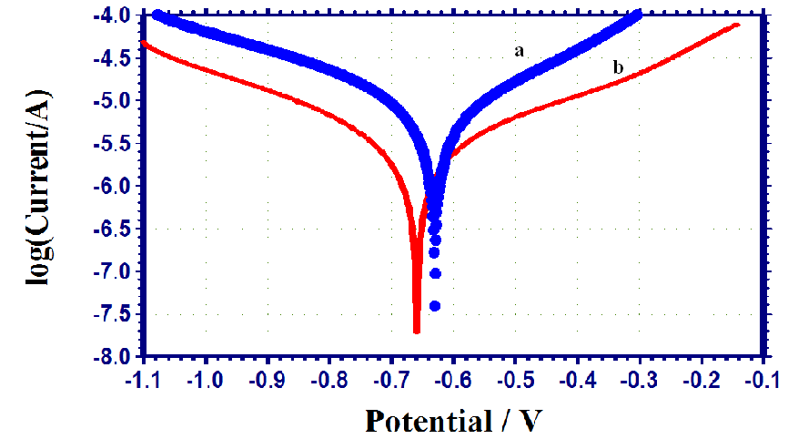

**Figure-1. Polarization curves of mild steel immersed in various test solutions**

**(a) well water (blank)**

**(b) well water + TSC (50ppm) + Ni2+(25ppm)**

**Analysis of FTIR spectra**

FTIR spectroscopy has been used to analyse the protective film formed on the metal surface 23. The FTIR spectrum of pure TSC is shown in Figure 2. The >C=O stretching frequency of the carboxyl group appears that 1647cm-1. The -OH stretching frequency appears that 3432 cm-1. The FTIR spectrum of the film formed on mild steel surface after immersion in the solution containing 50 ppm of TSC and 25 ppm of nickel is shown in Figure.2 It is observed that the >C=O stretching frequency has shifted from 1647cm-1 to 1627 cm-1. The - OH stretching frequency shifted from 3432 cm-1 to 3456 cm-1.This indicates that the oxygen atoms of the carboxyl group and -OH have coordinate with Fe2+ resulting in the formation of Fe2+-TSC complex formed on the anodic sites of the metal surface 24-27. The peaks at 1447 cm-1 and 538cm-1 are due to Ni-O bond. The –OH stretching frequency appears at 3417cm-1.These observation suggest that Ni(OH)2 is formed on the cathodic sites of the metal surface28 .



Wave number in cm-1

**Figure 2. FTIR spectra of Pure TSC**



Wave number in cm-1

**Figure 3. FTIR spectra of TSC + Ni2+**

**Atomic Force Microscopy Characterization**:

Atomic force microscopy is a powerful technique for the gathering of roughness statistics from a variety of surfaces. AFM is becoming an accepted method of roughness investigation 29-31.

All Atomic Force Microscopy images were obtained in VEECO Lab incorporation AFM instrument operating in contact mode in air. The scan size of all the AFM images are05mx05m are as at a scan rate of 6.68 m /second.

The two dimensional (2D) three dimensional (3D) AFM morphologies and the AFM cross-sectional profile for polished carbon steel (reference sample), carbon steel surface immersed in well water (blank sample) and carbon steel surface immersed in well water containing formulation of TSC 50ppm and 25ppm of Ni2+ are shown as Fig6 (a,d,g), (b,e,h), (e,f,i) respectively

**Root mean square roughness, average roughness, peak-to-valley value:**

AFM image analysis was performed to obtain the average roughness Ra (the average deviation of all points roughness profile form a mean line over the evaluation length), root-mean-square roughness, Rq (the average of the measured height deviations taken within the evaluation length and measured from the mean line) and the maximum peak-to-valley (p-v) height values (largest single peak-to-valley height in five adjoining sampling heights) Rq is much more sensitive than Ra to large and small height deviations from the mean . Table-4 is summary of the average roughness (Ra), rms roughness (Rq) maximum peak-to-valley height (p-v) value for carbon steel surface immersed in different environments.

The value of RRMS, Ra and p-v height for the polished carbon steel surface (reference sample) are 19.1nm,14.6nm and 21.91nm respectively, which shows a more homogeneous surface,with some places in where the height is lower than the average depth. Fig .4 (a,d,g) displays the un corroded metal surface. The slight roughness observed on the polished carbon steel surface is due to atmospheric corrosion. The rms roughness, average roughness and p-v height values for the carbon steel immersed in well water are 74.6 nm62 nm and 162.5 nm respectively. These data suggest that carbon steel surface immersed in well water has a greater surface roughness than the polished metal surface, which shows that the unprotected mild steel surface is rougher and is due to the corrosion of carbon steel in well water. Fig.4 (b,e,h) displays corroded metal surface with few pits

The presence of 50 ppm of TSC and 25 ppm of Ni2+ in well water reduces the Rq by a factor of 24.8nm from 74.6 nm and the average roughness is significantly reduced to 19.3nm when compared with 62nm of carbon steel surface immersed in well water. The maximum peak-to-valley height also was reduced to 31.56 nm from 162.5nm.These parameters confirm that the surface appear smoother. The smoothness of the surface is due to the formation of a compact protective film of Fe2+ TSC complex and Ni (OH)2 on the metal surface thereby inhibit in g the corrosion of carbon steel.

Also the above parameters observed are somewhat greater than the AFM data of polished metal surface which confirms the formation of the film on the metal surface. Which is protective in nature.

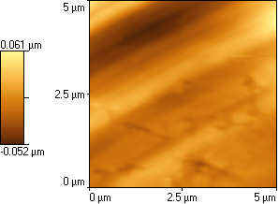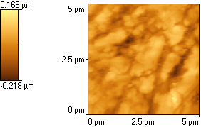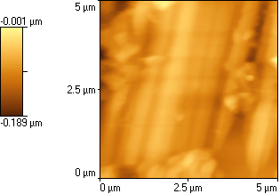

**(a) (b) (c)**

**Figure. 4: 2D AFM Images of the surface of**

a) Polished carbon steel (control)

b) Carbon steel immersed in well water (blank)

c).Carbon steel immersed in well water containing TSC (50ppm)+Ni2+ (25ppm)

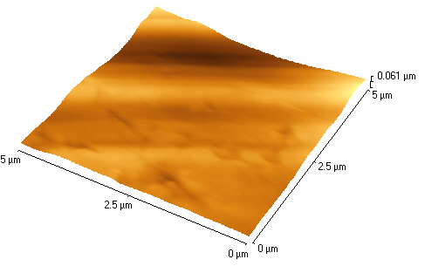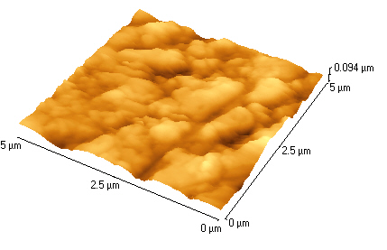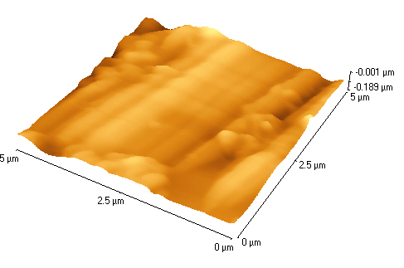

**(d) (e) (f)**

**Figure 4. 3D AFM Images of the surface of**

d) Polished carbon steel (control)

e) Carbon steel immersed in well water (blank)

f) Carbon steel immersed in well water containing TSC (50ppm)+Ni2+ (25ppm)

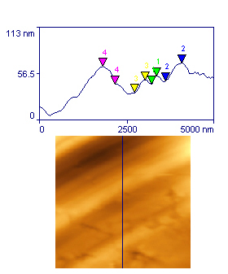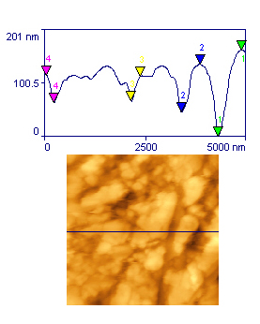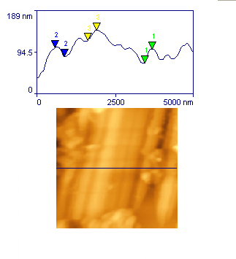

**(g) (h) (i)**

**Figure 4: The cross section profile which are corresponding to as Shown broken lines in AFM Images of the surface of**

(g) Polished carbon steel (control)

(h) Carbon steel immersed in well water (blank)

(i) Carbon steel immersed in well water containing TSC (25ppm)+Ni2+ (50ppm)

**Table 4. AFM data for carbon steel surface immersed in Inhibited and uninhibited environments**

|  |  |  |  |
| --- | --- | --- | --- |
| **Samples** | **RMS (Rq)**  **Roughness(nm)** | **Average (Rq)**  **Roughness(nm)** | **Maximum peak to valley height(nm)** |
| Polished carbon steel (control) | 19.1 | 14.6 | 21.91 |
| Carbon steel immersed in well water (blank) | 74.6 | 62 | 162.5 |
| Carbon steel immersed in well water containing TSC(50ppm) + Ni2+(25ppm) | 24.8 | 19.5 | 31.56 |

**4. Conclusions:**

The present study leads to the following conclusions:

1. The inhibition efficiency (IE) of trisodium citrate (TSC)- Ni2+ system is Controlling corrosion of Carbon steel in well water has been evaluated by weight loss method.
2. The formulation consisting of 50 ppmof TSC and 25 ppm of Ni2+ offers 81% IE to Carbon steel immersed in well water.
3. Polarization study reveals that TSC –Ni2+ system controls the cathodic reaction predominantly.
4. FTIR spectra reveal that the protective film consists of TSC-Fe2+ complex and Ni(OH)2.

**Acknowledgements:**

The authors are thankful to their respective managements for their help and constant encouragement

**Corresponding Author:**

Dr. Peter Pascal Regis A.

Department of chemistry

St. Joseph’s College

Tiruchirappalli, Tamil Nadu, India

E. mail: [drpascalregis@gmail.com](mailto:drpascalregis@gmail.com)

**References**

1. M. Pandiarajan, S. Rajendran, J. Sathiyabama, J. Lydia Christy, J. Jeyasundari, P. Prabhakar, P., Eur. Chem. Bull. 2013, 2(1), 1-8;
2. M. Abdallah, I. Zaafarany, A.S. Fouda, J. Mater. Eng. Perform., 2012, 21(6), 995;
3. R.V. Kashkovskiy, Y. Kuznetsov, L.P. Kazansky, Corros. Sci., 2012, 64, 126.
4. Gomma, G. K., Wahdan, M. H., Mater Chem Phys., 1994, 39(2), 142;
5. N.S. Jayateertha, N. Hayavadana, Res. J. Pharm. Biol. Chem. Sci., 2012, 3(2), 614.
6. A. Sliwa, G. Dive, J. Marchand-Brynaert, Chemistry - Asian J., 2012, 7(2), 425.
7. S.-Y. Baek, Y.-W. Kim, K.-W. Chung,. S.-H. Yoo, Appl. Chem. Engg., 2011, 22(4), 367.
8. A. Kalendová, D. Veselý, I. Sapurina, J. Stejskal, Progress Org. Coat., 2008, 63(2), 228.
9. M. Bouklah, A. Ouassini, B. Hammouti, A. El Idrissi, Appl. Surf. Sci., 2006, 252(6), 178.
10. J. Michael, Franklin, C. David, White, S.Hugh, S., Isaacs, Corros. Sci., 1992, 33(2), 251.
11. K. Kavipriya, S. Rajendran, J. Sathiyabama, and A. Suriya Prabha, Eur. Chem. Bull., 2012, 1(9), 366- 374.
12. G. Wranglen, Introduction to corrosion and protection of metals (Chapman and Hall, London), 1985. 236.
13. K.Kavipriya, J. Sathiyabama, S. Rajendran, A. Krishnaveni, Int. J. Adv. Eng. Sci. Technol. 2012, 2(2), 106.
14. N. Manimaran, S. Rajendran, M. Manivannan, R. Saranya, J. Chem. Biol. Phys. Sci., 2012, 2(2), 568.
15. A. Sahayaraja, S. Rajendran, J. Electrochem. Sci. Eng. 2012, 2, 91.
16. N. Manimaran, S. Rajendran, M. Manivannan, S. Johnmary, . Res. J. Chem. Sci., 2012, 2(3), 52.
17. Sribharathy, V., Rajendran, S. Int. J. Adv. Eng. Sci. Technol. 2011, 1(1), 77.
18. M.C. Anbarasi, S. Rajendran, N. Vijaya, M. Manivannan, T. Shanthi, The Open Corros. J., 2011, 4, 40.
19. V.Johnsirani, S. Rajendran, J. Sathiyabama, T.S. Muthumegala, A. Krishnaveni, N. Hajarabeevi, Bulg. Chem. Commun. 2012, 44(1), 41.
20. M. Sangeetha, S. Rajendran, J. Sathiyabama, A. Krishnaveni, P. Shanthy, P., N. Manimaran, B. Shyamaladevi, Portugaliae Electrochim. Acta, 2011, 29(6), 429.
21. M. Manivannan, Int. J. Adv. Eng. Sci. Technol., 2011, 3, 8048.
22. A. Noreen, S.H. Benita, S. Rajendran, Portugaliae Electrochim. Acta ., 2010, 28(1), 1.
23. G. Ruba Helen Florence, A. Noreen Anthony, J. Wilson Sahayaraja, A. John Amalraj, Susai Rajendran., Indian. J. Chem. Technol., 2005, 12, 472.
24. Umamathi, T., Arockia Selvi, J., Agnesia Kanimolizhi, S., Susai Rajendran., John Amalraj, A., Indian J. Chem. Technol., 2008, 15, 560.
25. Sathyabama, J., SusaiRajendran., Arockia Selvi, J., John Amalraj, A., Indian. J. Chem. Technol., 2008, 15, 462.
26. Mary Anbarasi, C., Susai Rajendran., Narayanasamy, B., Krishnaveni, A., Asian J. Chem., 2012, 24(11), 5029.
27. Sangeetha, M., Rajendran, S., Sathyabama, J., Prabhakar, P., J. Nat. Prod. Plant. Resour., 2012, 2(5), 601.
28. N.Vijaya, A. Peter Pasgal Regis, S. Rajendran, M. Pandiarajan, and R. Nagalakshmi, Eur. Chem. Bull., 2013, 2(5), 275.
29. Holness RJ, Williams G, Worsley DA et al. J Electrochem Soc. 2005;152:B73.
30. Telegdi J, Shaglouf MM, Shaban A, et al. Electrochim Acta. 2001;46:3791.
31. Selvi JA, Rajendran S, Jeyasundari J. Zastita Materijala. 2009;50:91.

3/30/2014