Histological Study on Pulmonary Changes Induced by Agarwood (Aoud) Inhalation in Albino Rats: Do Omega-3 Fatty Acids Have a Soothing Effect?

Fatimah A. Alhomaid¹ and Hoda A. Ali²

¹Dept. of Biology, Collage of Science and Arts, Qassim University, KSA. Email: abdo_1416@yahoo.com
²Dept. of Nutrition and Food Science, Collage of Designs and Home Economy, Qassim University, KSA. Email: drhodaali@hotmail.com

Abstract: Researches have been carried out on the trunk and resin of Agarwood (Aoud), but little is known about pulmonary detrimental effect induced by inhalation and how to overcome. This work was designed to study the histological and ultrastructure of pulmonary changes induced by Aoud inhalation at low and high levels for various duration. The study also clarifies a possible soothing effect of omega-3 fatty acids (n-3 PUFA) on lung tissue of exposed Albino rats. A total of 60 healthy male adult Albino rats were divided into equal 6 groups (G): G1 serves as control; G2 dosed orally with 5 ml/kg/day n-3 PUFA. Rats of groups G3 and G4 were exposed to low level of Aoud vapour (0.928 mm/m3 for 8 hrs per day); G4 was treated with 5 ml/kg/day n-3 PUFA as one dose orally. G5 and G6 were exposed to high level of Aoud vapour (9.28 mm/m3 for 8 hrs per day); G6 was treated with 5 ml/kg/day n-3 PUFA. Lungs were processed for both light and electron microscope. Computerized morphometric measurement was obtained by cell image analysis to monitor the fibrillar components (collagenous, elastic and reticular fibres) changes in each group. Aoud inhalation induces lung injury in exposed rats. The degree of lungs damage and soothing potency of n-3 PUFA are varied according to exposed Aoud dosage and duration. Further investigation is recommended to determine the suitable dose of n-3 PUFA treatment and/ or the potent dose of Aoud that cause no pulmonary change.
[Fatimah A. Alhomaid and Hoda A. Ali. Histological Study on Pulmonary Changes Induced by Agarwood (Aoud) Inhalation in Albino Rats: Do Omega-3 Fatty Acids Have a Soothing Effect? Nat Sci 2014;12(5):1-14]. (ISSN: 1545-0740). http://www.sciencepub.net/nature. 1

Keywords: Agarwood, omega-3, pulmonary, fibrillar, morphometric.

1.Introduction
The genera Aquilaria is large trees found mainly in Southeast Asia. The resinous portions of its branches and trunks are known as Agarwood and Aoud in Saudi Arabia. It have been used in natural medicine as a digestive (Kakino et al., 2010), sedative (Kumeta and Ito, 2010), antimicrobial and antitumor agents (Cui et al., 2011, and Kumphune et al., 2011).
The oriental incenses (Aoud) is commonly used as a foundation for perfume in Arabian area. Phytochemical and pharmacological researches have been carried out on the trunk and resin of Agarwood, but little is known about its detrimental effect caused by inhalation. Excessive dose of Agarwood inhalation may cause excited actions in mice (Takemoto et al., 2008). Alarifi et al. (2004a) concluded that exposure to Ma’amoul (Bakhour) was provoked ultrastructural pulmonary changes and the collagen fibrils were deposited in the alveolar walls and produced alveolar fibrosis which might indicate impaired respiratory efficiency. Saudi women usually suffering from respiratory disorders due to social custom, indoor exposure to Aoud vapour. (Dossing et al., 1994). On the same line, some children in Qatar who exposed to Arabian incense had respiratory asthma. (Dawod and Hussain, 1995). (Masubuchi et al., 1998) concluded that lung inflammation caused as a result of Bakhour Inhalation.
Gomez-Pinilla (2011) stated that certain dietary factors, such as Omega-3 poly-unsaturated fatty acids (n-3 PUFA), have been reported to improve functional status due to anti- inflammatory effect (Bento et al., 2011). Leon et al. (2011) reported that biosynthesis of resolvins and protectins from n-3 PUFA and releases anti-inflammatory cytokines lead to new treatments for inflammatory diseases. Pascoe et al. (2011) mentioned that n-3 PUFA was influenced both inflammatory and depressive disorders. Numerous experimental and observational studies in humans have found an inverse association between dietary consumption of n-3 PUFA and systemic markers of inflammation (Riediger et al., 2009 and Galland, 2010). Fish oil as a source of n-3 PUFA might improve the sings of chronic inflammatory disease and protect against the effects of endotoxin and similar inflammatory challenges in animal models. Fish oils have been shown to reduce inflammation and improved endothelial function of inflamed lung (Skulas-Ray et al., 2011 and Bilal et al., 2011).
This work was designed to study the histological pulmonary changes induced by Aoud inhalation in low level (0.928 mm/m³ for 8 h per day) and high level (9.28 mm/m³ for 8 hrs per day) for different durations (4 – 8 weeks). The study also includes a possible soothing effect of n-3 PUFA on lung tissue of exposed Albino rats. The examinations included percentage of fibrillar components (collagenous, elastic and reticular fibres) using Orcein, Masson's Trichrome and Gomori stains respectively and ultrastructure pulmonary changes using transmission electron microscopy.
2.Materials and Methods
Materials:
Aoud used in the current experiment obtained from Arabian Aoud Company, KSA, which present in the form of strips. Omega-3 fatty acids were purchased from Dallah Pharma, No 2100, Al Ryaid, KSA, in dark bottle. It is in the form of oil included eicosapentaenoic and docosahexaenoic acids.
Experimental house: Experimental animal house is designed to mimic reality, consists of three chambers. One chamber for control rats, the other two chambers used for Aoud vapour exposure. Chambers dimension were ×2×31 m³, well closed and isolated from each other. Each chamber supplied with special electric current, light source and cooling system.
Animal and experimental diet:
A total of 60 healthy male adult Albino rats obtained from Animal House, King Saud University, KSA were used in the current experiment with an average weight 90-100 g. Rats were housed at College of Science, Qassim University Laboratory, in certain wire cages with a temperature- and humidity-controlled conditions (22-24°C, 12-h light/dark cycles) before being used for experiments. All rats used in the study were received a commercial diet obtained from General Company of Feed Silo and Powder Mint (Qassim, KSA) one week before starting the experiment. The diet formulated to furnish all the nutrient requirements recommended by NRC (1985) for rats (18%soybean meal- 21.5% ground yellow corn –10% barley -14% wheat bran - 29.5% hay -7% protein, vitamins and minerals supplement). The commercial diet and water were offered ad libitum before and throughout the experiment, which lasted 8 weeks during April and May 2010.
The animals were randomly assigned to 6 equal groups 10 rat each. The first group (G1) was served as control fed commercial diet without any treatment. Group (G2) received n-3 PUFA at rate of 5 ml/kg/day as one dose orally. Rats of groups G3 and G4 were exposed to low level of Aoud vapour 0.928 mm/m³ for 8 hrs per day, one of them (G4) treated with n-3 PUFA at rate of 5 ml/kg/day as one dose orally. Last groups (G5&G6) were exposed to high level of Aoud vapour 9.28 mm/m³ for 8 hrs per day, one of them (G6) treated with n-3 PUFA at rate of 5 ml/kg/day as one dose orally. At 4 weeks of experimentation period, half-experimental rats from each group were anesthetized; remaining rats were dissected at 8 weeks. Lungs were removed for light and electron microscopical examinations. Light microscopical examination included percentage of fibrillar components (collagenous, elastic and reticular fibres) using Orcein, Masson's Trichrome and Gomori stains respectively. Computerized morphometric measurement obtained by cell image analysis. Ultrastructural pulmonary changes were recorded using transmission electron microscopy.
Light microscopy examination:
Pieces of the of lung tissues, 5 mm thick, were taken from Bouin's solution fixed lung, processed for paraffin embedding, and sections 6 /um thick cut and stained with by Masson's Trichrome, Orcein and Gomori stains and used for histological examination of fibrillar components (collagenous, elastic and reticular fibres) respectively. Area percentage of each fibre was determined using computerized morphometric measurement obtained by cell image analysis (Mcmanus and Mowry, 1965; Bancroft and Gamble, 2002).
Electronic microscopy examination:
Immediately after removal of lungs from the dissected animals, specimens were diced into proper sized pieces (1 mm³) and fixed by immersion in 3% buffered glutaraldehyde (cacodylate buffer, pH 7.2) for 4 h at 4°C. Tissue specimens were then post-fixed in 1% osmium tetroxide (OsO ), in cacodylate buffer pH 7.2, for 42 hrs at 4°C. Dehydration of the fixed tissues was performed using ascending grades of ethanol and then tissues were transferred to epoxy resin via propylene oxide. After impregnation with the pure resin (Epon/araldite mixture), tissue specimens were embedded in the same resin mixture. Semi-thin sections (1 μm thickness) were prepared for the purpose of tissue orientation and stained with toluidine blue. Accordingly, thin sections of silver-gold shades (70-80 nm) were cut on an ultramicrotome (Leica, UCT) with a diamond knife and double stained with uranyl acetate and lead citrate. Stained tissue sections were observed with a transmission electron microscope (JEOL, 100 CX) operating at 80 kv.(Reynold, 1963; Bozzola and Russell, 1992).
Statistical Analysis: The data were analyzed using SPSS program version 16. The analysis of covariance (one way ANOVA) was used to detect the differences in the means between the control and treated groups.
3.Results
Regarding the collagenous, elastic and reticular fibres analysis in experimental groups exposed to Aoud smoke in two levels (0.928 - 9.28 mm/m3) for 4 and 8 weeks (Table 1 and Figs. 1,2,3). Results showed significant increase of collagen fibres percentage in lung tissue of rats inhaled both levels of Aoud smoke for various durations (17.75&15.78 vs 9.58%) respectively. There was slight increase in elastic and reticular percentage in group exposed to low level of Aoud inhalation for 4 and 8 weeks as compared to control. Data in the same table indicated that high level of Aoud inhalation had no effect on lung tissue considering these kinds of fibres.
Group supplemented with n-3 PUFA and exposed to low Aoud level for 4 weeks showed significant decrease of collagen fibres comparable to group subjected to Aoud without supplementation (15.76 vs 17.75%). While rats inhaled high level of Aoud and received n-3 PUFA dosing showed slight improvement of lung tissue concerning collagen fibres at 4 and 8 weeks of experiment. Elastic and reticular fibres were decreased in group inhalation low level of Aoud for both duration with n-3 PUFA dosing and this decrease was significant at 8 weeks (8.99 and 9.91 % respectively). n-3 PUFA supplementation caused slight decrease in elastic and reticular fibres in animals inhaled high Aoud level for both duration comparable to group exposed to Aoud without n-3 PUFA.
The contribution of collagen fibre of lung parenchyma stained by Masson's Trichrome showed that fibres were stained blue and the nuclei stained black. Normal fibre content was observed in the control (G1) and n-3 PUFA treated group (G2). Fibre thickness was deposited in the thick interalveolar septa and around pulmonary bronchioles in both low (G3) and high (G5) inhaled Aoud groups. Focal hyperplasia of bronchiole- associated lymphoid tissue (BALT) was observed in high inhaled Aoud group that indicating mild infiltration of fume. Few collagen fibre content was noticed in interalveolar septa, around bronchioles in inhaled Aoud with n-3 PUFA both low (G4) and high (G5) groups comparable to control (Fig. 4).
Red-brown elastic fibre of lung parenchyma as stained by Orcein. Normal fibre content was observed around the bronchiole in the control (G1) n-3 PUFA (G2) and high inhaled Aoud with n-3 PUFA (G6) treated groups. Increasing of the elastic fibres content was observed in the lung sections (Fig 5). Marked increase of elastic fibres content was observed in high inhaled Aoud (G5) group.
Regarding the meshwork black reticular fibre of lung parenchyma as stained by Gomori. Normal reticular fibre content was observed in the control (G1) and n-3 PUFA treated group (G2). Thickness in the reticular fibre was observed from slight in (G3&G6) groups to marked in (G5) group. No significant change in the reticular fibre content in (G4) as showed in Fig. 6.
Concerning the ultrastructure of interalveolar septum with its components, the lungs of control (G1) and n-3 PUFA (G2) treated rats were showed normal architecture. The alveoli appeared patent with thin walls contain two types of cells. The flattened pneumocyte type I (PI) with dark dense heterochromatin oval nucleus, and pneumocyte type II (PII) that appeared round with large round nucleus with heterochromatin rich on its periphery. Large multi vesicular bodies with lamellae surrounded the nucleus. Also there were macrophages containing numerous lairised-sized lipid droplets (G2). The interalveolar septa appeared mostly thin (Fig.7).
Aoud-inhaled rats at low level (G3) were showed alteration in the alveolar architecture of the lung tissue. Large pneumocytes type II was detached from the interalveolar septum and showing sloughed microvilli, numerous multi vesicular bodies lost many lamella and mitochondria. Central spherical nucleus contained perinucleolar dark heterochromatin (Fig.8). The ultrastructure of interalveolar septum with its components in the lung of high Aoud treated rats showing detached large macrophage surrounded by numerous collagen fibrils. The nucleus appeared irregular, the cytoplasm contains many vesicles with deformed surfactant phagocytosed by macrophage with appeared electron dense. Desquamated and enlargement of pneumocyte II showing irregular microvilli at the free surface. Several stages of formation of multi vesicular bodies with less electron lucent materials and the large filled with electron dense material. Extravasated erythrocytes were appeared also with the alveolar lumen and many vesicles filled with surfactant, which is a sign of inflammation (Fig. 9).
Groups that dosed with n-3 PUFA and inhaled Aoud (G4&G6) showed a considerable degree of smoothing effect of alveolar architecture. The inter alveolar septum showed mild thickening and filled with hypertrophied PI, PII and macrophage. In addition, there were endothelial cells with enlarged oval nucleus in the periphery. PII was characterized by detachment lamellae in the superficial with pinocytotic vesicles, which swallow and filled with surfactant. There were enlarged PI characterized by large oval nucleus filled with dark dense heterochromatin (Fig.10).
4.Discussion
Previous researches have been carried out on Agarwood, but little is known about its detrimental effect caused by inhalation. The present work aimed to study the effect of Aoud inhalation and n-3 PUFA dosing on the lung architecture using light and transmission electron microscopy. Cell image analysis data revealed significant increase in area percentage of collagen fibres in both levels of Aoud inhaled groups and at two durations comparable to control. Also there are significant increases of elastic and reticular fibres in group exposed to high Aoud level at 4 weeks. These findings confirmed by the thick interalveolar septa and around pulmonary bronchioles stained by Masson's Trichrome.

Table (1): Morphometric measurement of lung fibrillar components (collagen, elastic and reticular) fibres of different experimental groups using cell image analysis (area %).
Groups | Collagen fibres % |  | Elastic fibres % |  | Reticular fibres %
 | 4W | 8W | 4W | 8W | 4W | 8W
Control (G1) | 9.58^{ab}  ±0.54 | 10.99^{ab}  ±1.17 | 6.78  ±0.82 | 11.9  ±1.24 | 5.99  ±0.76 | 10.22  ±1.25
n-3 PUFA (G2) | 10.94  ±2.47 | 10.94  ±o.56 | 7.01  ±0.94 | 10.8  ±1.35 | 6.98  ±1.37 | 10.92  ±1.11
L A* (G3) | 17.75^{ac}  ±1.44 | 20.89ª  ±1.76 | 8.15  ±2.84 | 12.51ª  ±1.87 | 7.91  ±3.13 | 11.55ª  ±2.06
L A & n-3 PUFA (G4) | 15.71^{c}  ±1.60 | 19.94  ±.67 | 7.75  ±1.30 | 8.99ª  ±2.29 | 6.99  ±1.73 | 9.91ª  ±2.06
HA** (G5) | 15.78^{b}  ±1.27 | 17.78^{b}  ±1.44 | 7.99  ±1.87 | 10.2  ±0.86 | 6.97  ±2.16 | 10.00  ±1.01
HA & n-3 PUFA (G6) | 14.89  ±2.90 | 16.92  ±2.13 | 7.5  ±1.49 | 9.82  ±0.86 | 5.92  ±2.12 | 9.30  ±1.73
The values are the Mean ± Standard Deviation.
Values in the same Column with same superscript are significantly different at P >0.05.
* Low Aoud level. **High Aoud level.
Fig.(1): Area % of collagen fibres of different experimental groups using cell image analysis. | Fig.(2): Area % of elastic fibres of different experimental groups using cell image analysis.
Fig. (3): Area % of reticular fibres of different experimental groups using cell image analysis.

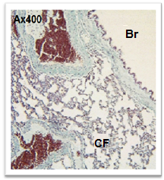 | 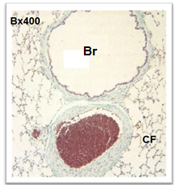
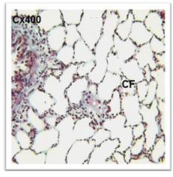 | 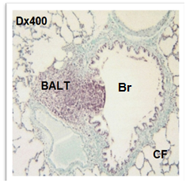
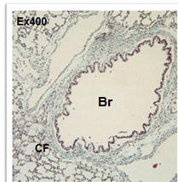 | 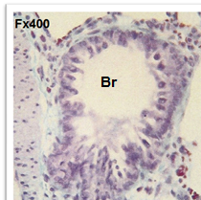

Fig. (4): Collagen fibres (CF) of lung parenchyma stained by Masson's Trichrome stain. Fibres stained blue and the nuclei stained black. Normal fibre content is observed in the control (A) and n-3 PUFA treated group (B) around pulmonary bronchioles (Br). Slight thickness in the fibre is observed in both low (C) and high (D) inhaled Aoud groups with focal hyperplasia of bronchiole- associated lymphoid tissue (BALT) is observed in high inhaled Aoud group. Normal fibre content of inhaled Aoud with n-3 PUFA both low (E) and high (F) groups comparable to control group.

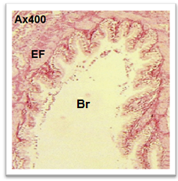 | 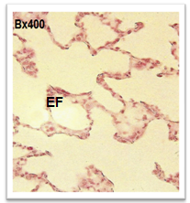
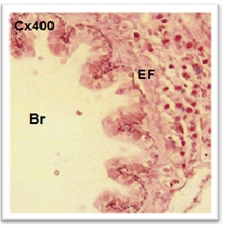 | 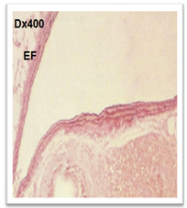
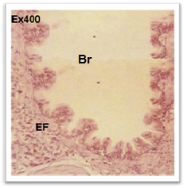 | 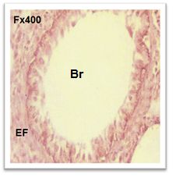

Fig. (5): Red-brown elastic fibres (EF) of lung parenchyma stained by Orcein stain. Normal elastic fibre content is observed around the bronchiole (Br) in the control (A), n-3 PUFA treated (B) and high inhaled Aoud with n-3 PUFA (E) groups. Thickness in the elastic fibre is observed from slight in low inhaled Aoud with or without n-3 PUFA (C& E) to marked in high inhaled Aoud (D) group.

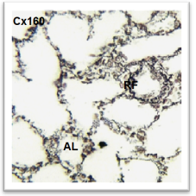 | 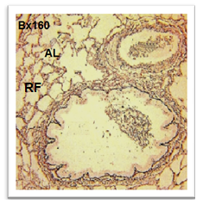
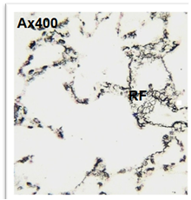 | 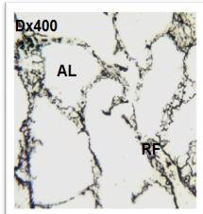
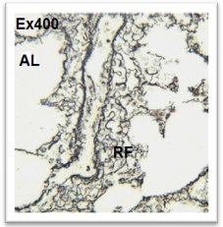 | 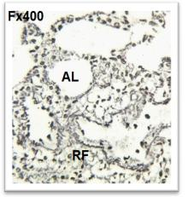

Fig. (6): The meshwork black reticular fibre (RF) of lung alveoli (AL) stained by Gomori stain. Normal fibre content is observed in the control (A), n-3 PUFA treated (B) and low inhaled Aoud with n-3 PUFA (E) groups. Thickness in the reticular fibre is observed from slight in low inhaled Aoud (C) and high inhaled Aoud with n-3 PUFA (F) group to marked in high inhaled Aoud group (D).

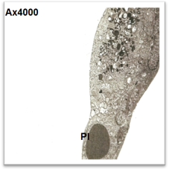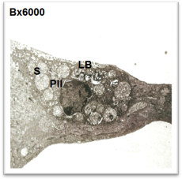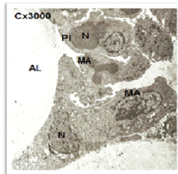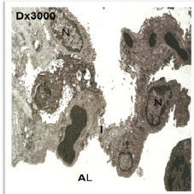

Fig. (7): The ultrastructure of interalveolar septum with its components in the lung of control (A, B) and n-3 PUFA (C, D) treated rats showing the pneuomocyte type I (PI) is elongated and flattened cell with dark dense heterochromatin oval nucleus. The second pneuomocyte (PII) appeared round with large round nucleus with heterochromatin rich on its periphery. The nucleus (N) is surrounded by large multi vesicular bodies with lamellae (LB). n-3 PUFA treated group (C, D) showing alveoli (AL) lined by (P1) separated by thin interalveolar septa (I). Also there is irregular in shape macrophage (MA) containing numerous lairised-sized lipid droplets and large electron lucent globules containing deformed surfactant material (S) phagocytosed by the macrophage.

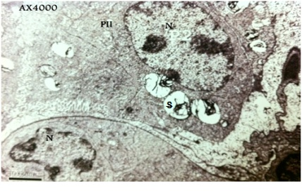
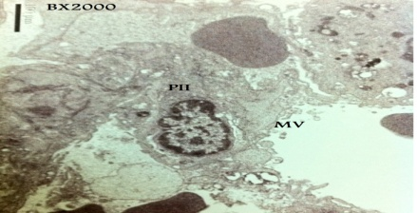
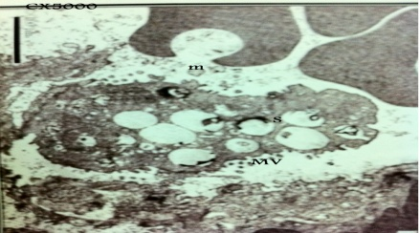

Fig. (8): The ultrastructure of interalveolar septum with its components in the lung of low Aoud treated rats showing large pneumocytes type II (PII) detached from the interalveolar septum, deformed surfactant material (S) and central spherical nucleus (N) contained perinucleolar dark hetero chromatin (A). Interalveolar septum showing sloughed microvilli (MV) (B) and numerous multi vesicular bodies lost many lamella and mitochondria (m) (C).

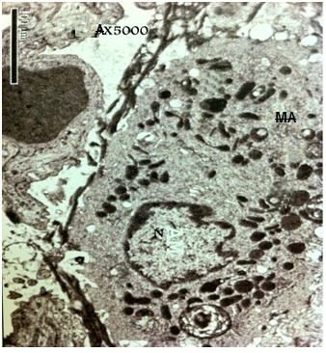
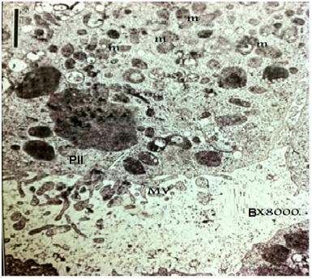
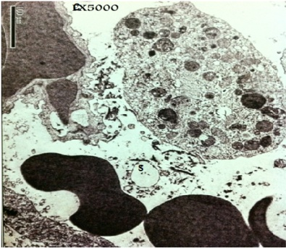
Fig. (9): The ultrastructure of interalveolar septum with its components in the lung of high Aoud treated rats showing detached large macrophage (MA) surrounded by numerous collagen fibrils, the nucleus (N) appeared irregular, the cytoplasm contains many vesicles with deformed surfactant phagocytosed by macrophage with appeared electron dense (A). Desquamated and enlargement of pneumocyte II (PII) showing irregular microvilli (MV) at the free surface, several stages of formation of multi vesicular bodies with less electron lucent materials and the large filled with electron dense material (B). Extravasated erythrocytes was appeared also with the alveolar lumen and many vesicles filled with surfactant(S) (C).

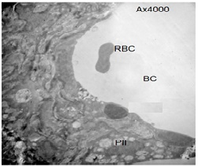 | 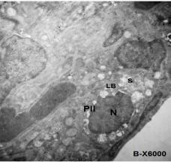
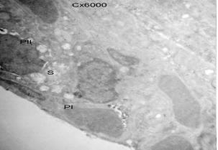 | 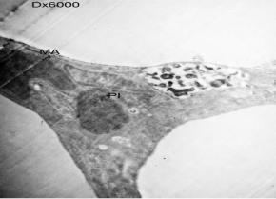

Fig. (10): The ultrastructure of interalveolar septum with its components in the lung of low (A,B) and high (C,D) Aoud and n-3 PUFA treated rats. Alveolar blood capillary (BC) congestion and infiltration of erythrocytes (RBCs) in to the lumen of alveoli, which is a sign of inflammation, are observed (A). Enlarged surfaced lamellar bodies (LB) have electron lucent areas unlatch dissolved during preparation and also contain surfactant (S) around the nucleus (N) (B). Pneuomocyte type I (PI) appeared hypertrophied on the periphery of inter alveolar septum (C&D).

There was increasing of the elastic and reticular fibres content in the lung sections, which ranged from slight in low inhaled Aoud to marked in high inhaled Aoud groups. Focal hyperplasia of bronchiole- associated lymphoid tissue (BALT) was observed in high inhaled Aoud group that indicating mild infiltration of fume. Pulmonary fibrosis was previously discussed as abnormal lung physiology and characterised by excessive production of extracellular matrix molecules such as collagen, elastin, and proteoglycans (Faffe and Zin, 2009). Parra et al. (2008) reported that collagenous fibre density were significantly higher in late pulmonary injury, whereas elastic fibre content was lower than in control group. Pierce et al. (1995) reported that, in emphysema and fibrosis, elastin is present in abnormal-appearing, probably non-functional, elastic fibres, and mesenchymal cell of the alveolar wall increases tropoelastin expression during fibrotic disorders. Ancia˜es et al. (2011) stated that destruction of alveolar walls in emphysema, with consequent alterations in the elastic and collagen fibre networks, alters lung viscoelastic properties. Shifren et al. (2006) and Vlahovic et al. (1999) were considered the increase in elastin and collagen gave the possibility of a remodelling and repairing process in the connective matrix in alveolar walls.
Electronic microscopical examination of the lung tissue of Aoud-inhaled rats at both levels showed an alteration in their alveolar architecture. Surfaced lamellar bodies were decreased and deformed surfactant around the nucleus that phagocytosed by macrophage were observed. Alveolar blood capillary congestion and infiltration of RBCs in to the lumen of alveoli, which might considered as a sign of inflammation. Masubuchi et al. (1998) found that exuded inflammatory cells that might contribute in damaging of the alveolar and interstitial pulmonary structures through elaboration of lytic enzymes. Alarifi et al. (2004 a,b) and Alokail and Alarifi (2004) concluded that exposure to Bakhour provoked ultrastructural pulmonary changes which might indicated impaired respiratory efficiency. These fine changes involved also the cell organelles and surfactant material of type II cells. Alveolar septal hypercellularity was due to hyperplasia of the alveolar cells in the affected lung tissue. Neutrophil cell infiltration in the alveolar lumena was accompanied with degenerative and necrotic changes of the alveolar lining cells. Many erythrocytes were extravasated from the distended alveolar capillaries. Kaczynska et al. (2011) reported that lamellar bodies of P II contained phospolipid lamellae, which stratified into an irregular arrangement and the extracellular lining layer of lung alveoli was partially destroyed. Ancia˜es et al. (2011) were reported the increased number of alveolar macrophages in emphysematous lungs. The present study provided evidence that Aoud inhalation affects the whole lung parenchyma and by impairing production of the surfactant might disturb the regular respiratory function.
The lung tissue of n-3 PUFA supplementation showed a considerable degree of preservation of alveolar architecture. Morphometric measurement of low level Aoud exposed animals for 4 weeks with n-3 PUFA supplementation showed significant decrease of collagen fibres in lung tissue comparable to group subjected to Aoud without n-3 PUFA treatment that confirmed by Masson's Trichrome stain . Unfortunately, rats inhaled high level of Aoud and received n-3 PUFA dosing showed slight improvement of lung tissue collagen fibres at 4 and 8 weeks.
The present findings revealed that n-3 PUFA supplementation success to improve deleterious effect caused by low level of Aoud inhalation for 8weeks by decrease elastic and reticular fibres. The obtained findings indicate that the degree of the effects of n-3 PUFA on lungs are thought to depend on the dosage and duration. The dose of n-3 PUFA used in the current experiment had soothing effect to low level of Aoud inhalation although it was not enough to face the detrimental effect caused by high level of Aoud inhalation especially for long run. Studies using higher doses of eicosapentaenoic acid (EPA) and docosahexaenoic acid (DHA) have shown evidence of reduced inflammation and improved endothelial function (Skulas-Ray et al., 2011).
Electronic microscopical examination showed a considerable degree of smoothing effect of alveolar architecture in groups which dosed with n-3 PUFA and inhaled Aoud. The inter alveolar septum showed mild thickening and filled with hypertrophied PI and PII and macrophage. PII was characterized by detachment lamellae in the superficial with pinocytotic vesicles which swallow and filled with surfactant. There were enlarged PI characterized by large oval nucleus filled with dark dense heterochromatin. Recent studies by Bilal et al. (2011) have demonstrated that the n-3 PUFA derived lipid mediators, protectin D1 and resolvin E1, may act as potent resolution agonists in airway inflammation and have a direct protective role for lung n-3 PUFA in allergic airway responses. Uddin and Levy ( 2011) reported that resolvins had provided a window to explore the pathobiology of inflammatory disease and structural templates for the design of novel pro-resolving therapeutics. Leon et al., (2011) reported biosynthesis of resolvins and protectins from n-3 PUFA and releases anti-inflammatory and reparative cytokines lead to new treatments for inflammatory diseases. Numerous experimental and observational studies in humans have found an inverse association between dietary consumption of n-3 PUFA and systemic markers of inflammation (Galland, 2010).
The soothing effect of n-3 PUFA in lung tissue of rats exposed to Aoud smokes may be attributed to proportions of n-3 PUFA and n-6 PUFA in the inflammatory cells, since typically; inflammatory cells contain high proportions of the n-6 PUFA and low proportions of n-3 PUFA (Calder, 2003). After consumption, n-3 PUFAs might incorporated into cell membranes and reduce the amount of arachidonic acid available for the synthesis of proinflammatory eicosanoids (e.g., prostaglandins, leukotrienes). Likewise, n-3 PUFAs can also reduce the production of inflammatory cytokines, such as tumor necrosis factor α, interleukin-1, and interleukin-6 (James et al., 2009). Calder (2003) reported that the fatty acid composition of inflammatory and immune cells was sensitive to change according to the fatty acid composition of the diet. Also, feeding fish oil (n-3 PUFA eicosapentaenoic acid) was resulted in partial replacement of n-6 PUFA in cell membranes by n-3 PUFA. In addition, n-3 PUFA is a substrate for cyclooxygenase and lipoxygenase that gives rise to mediators that often have different biological actions or potencies.

Conclusion:
From the previous findings, it could be concluded that Aoud inhalation induces injury in rats lung. The degree of lung damage is varied according to the level of Aoud and time expose. The soothing potency of n-3 PUFA on lungs of exposed rats is thought to depend on its dosage. The dose of n-3 PUFA used in the current study had soothing effect to low level of Aoud inhalation, although it was not enough to face the detrimental effect caused by high level especially for long run. In this respect, it is need further investigation to detect the actual dose of n-3 PUFA to achieve maximal soothing effect to lung tissues.

References
- Alarifi,S.A., M. Mubarak and M.S. Alokail (2004a): Ultrastructure of the Pulmonary Alveolar Cells of Rats Exposed to Arabian Mix Incense (Ma'amoul). Journal of Biological Sciences 4 (6): 694-699.
- Alarifi,S.A., M. Mubarak and M.S. Alokail (2004b): Ultrastructural changes of pneumocytes of rat exposed to Arabian incense (Bakhour). Saudi Med J. Vol. 25 (11): 1689-1693
- Alokail, M.S. and S.A. Alarifi, (2004): Histological changes in lung of Wister albino rats (Rattus norvegicus) after exposure to the Arabian incense (Genus Boswellia). Ann. Saudi Med., 24: 217-219.
- Ancia˜ es A.M., Olivo C.R., Prado C.M., Keila H. Kagohara, Pinto T.S., et al. (2011): Respiratory mechanics do not always mirror pulmonary histological changes in emphysema. Clinics .66 (10) : 1797-1803
- Bancroft,J.D and Gamble, M.(2002):theory and practice of hisltologicaltechniques.5th ed,Churchill living stone,london.
- Bento A.F., Claudino R.F., Dutra R.C., Marcon R., Calixto J.B. (2011): Omega-3 fatty acid-derived mediators 17(R)-hydroxy docosahexaenoic acid, aspirin-triggered resolvin D1 and resolvin D2 prevent experimental colitis in mice. J Immunol. 15;187(4):1957-69.
- Bilal S., Haworth O., Wu L. (2011): Fat-1 transgenic mice with elevated omega-3 fatty acids are protected from allergic airway responses. Biochim Biophys Acta. 1812(9):1164-9.
- Bozzola,.J.J. and Russell, L.D. (1992): Electron , icroscopy. Boston,London,Singapore:Jones and Barlett Publishers.
- Calder P.C. (2003): N-3 polyunsaturated fatty acids and inflammation: from molecular biology to the clinic. Lipids. 38(4):343-52.
- Cui J.L., Guo S.X.and Xiao P.G.(2011): Antitumor and antimicrobial activities of endophytic fungi from medicinal parts of Aquilaria sinensis. J Zhejiang Univ-Sci B (Biomed & Biotechnol) 12(5):385-392
- Dawod S.T. and A.A. Hussain, (1995): Childhoodasthma in Qatar. Ann. Allergy Asthma Immunol., 75: 360-4.
- Dossing M., J. Khan and F. Al-Rabiah, (1994): Risk factors for chronic obstructive lung disease in Saudi Arabia. Respir. Med., 88: 519-22.
- Faffe D.S. and Zin W. A. (2009): Lung Parenchymal Mechanics in Health and Disease Physiol Rev 89: 759–775.
- Galland M.D. (20!0): Diet and Inflammation. Nutr Clin Pract Volume 25 Number 6, 634-640
- Gomez-Pinilla F. (2011): Collaborative effects of diet and exercise on cognitive enhancement. Nutr Health ;20(3-4):165-9.
- James W., Fetterman Jr. and Martin M. Zdanowicz (2009): Therapeutic potential of n-3 polyunsaturated fatty acids in disease. Am J Health Syst Pharm. 1;66(13):1169-79.
- Kaczynska K., Walski M., Szereda-Przestaszewska M. (2011): Ultrastructural changes in lung tissue after acute lead intoxication in the rat. J Electron Microsc (Tokyo) ;60(4):289-94.
- Kakino M., Tazawa S., Maruyama H. et al. (2010): Laxative effects of agarwood on low-fibre diet-induced constipation in rats. BMC Complementary and Alternative Medicine 2010, 10:68
- Kumeta Y. and M. Ito (2010): Characterization of d-Guaiene Synthases from Cultured Cells of Aquilaria, Responsible for the Formation of the Sesquiterpenes in Agarwood. Plant Physiology, Vol. 154, pp. 1998–2007.
- Kumphune S. E. Prompunt, K. Phaebuaw et al. (2011): Anti-inflammatory effects of the ethyl acetate extract of Aquilaria crassna inhibits LPS-induced tumour necrosis factor-alpha production by attenuating P38 MAPK activation. Int J Green Pharm 5:43-8.
- Leon M.M., Jaba I.M, Cozma C.D., Albu E., Bahnea R., Mungiu O.C. (2011): Resolution of inflammation--pharmacological aspects. Rev Med Chir Soc Med Nat IasiApr-Jun;115(2):470-6.
- Masubuchi T., S. Koyama, E. Sato, A. Takamizawa, K. et al. (1998):. Smoke extract stimulates lung epithelial cells to release neutrophil and monocyte chemotactic activity. Am. J. Pathol., 153: 1903-12.
- Mcmanus,J.F.A. and Mowry, R.W. (1965): histologic and histochemical. Third ed,Hobber medical division harper and row.U.S.A New York.
- NRC (1985): National Research Council guide for the care and use of laboratory animals. In Publication No.85-23 (rev.) National Institutes of Health, Bethesda, MD.
- Parra E. R., G. Boufelli, F. Bertanha et al. (2008): Temporal evolution of epithelial, vascular and interstitial lung injury in an experimental model of idiopathic pulmonary fibrosis induced by butyl-hydroxytoluene Int. J. Exp. Path., 89, 350–357.
- Pascoe MC, Crewther SG, Carey LM, Crewther DP (2011): What you eat is what you are -- a role for polyunsaturated fatty acids in neuroinflammation induced depression?. Clin Nutr. 2011 Aug;30(4):407-15. Epub May 31.
- Philip C. Calder (2002): Dietary modification of inflammation with lipids. Proceedings of the Nutrition Society , 61, 345–358
- Pierce R.A, Mariani T.J, Senior R.M. (1995): Elastin in lung development and disease. Ciba Found Symp.;192:199-212;
- Reynold, E.S (1963): The used of lead citrate at hish Ph as on electron opaque stain electron microscopy . J Cell.Biol.., 17:208.
- Riediger N.D, Othman R.A, Suh M., Moghadasian M.H. (2009):A systemic review of the roles of n-3 fatty acids in health and disease. J Am Diet Assoc;109:668-679.
- Shifren A., Mecham R.P. (2006): The stumbling block in lung repair of emphysema: elastic fibre assembly. Proc Am Thorac Soc 3: 428– 433.
- Skulas-Ray A.C., Kris-Etherton P.M., Harris W.S. et al. (2011): Dose-response effects of omega-3 fatty acids on triglycerides, inflammation, and endothelial function in healthy persons with moderate hypertriglyceridemia. Am J Clin Nutr. Feb;93(2):243-52.
- Takemoto H.M., Ito T., Shiraki T., Yagura G. et al. (2008): Sedative effects of vapor inhalation of agarwood oil and spikenard extract and identification of their active components. J Nat Med 62:41–46.
- Uddin M. and Levy B.D. (2011): Resolvins: natural agonists for resolution of pulmonary inflammation. Prog Lipid Res. Jan;50(1):75-88. Epub 2010 Sep 29.A.
- Vlahovic G., Russell M.L., Mercer R.R., Crapo J.D.(1999): Cellular and connective tissue changes in alveolar septal walls in emphysema. Am. J. Respir. Crit. Care Med. 160:2086–2092.

3/30/2014

