**Design And Production Of Fabrics Suitable For Patches And Valves Frames**

1Sabry,A.,M., 2 El-Bheiry, H., 3 Mostafa, S., A., 4 Mahmoud,I.,I. and 5 Ibrahim, G., E.

1,4&5 Spinning, Weaving & Knitting Dept. Faculty of Applied Arts, Helwan University

2 * Collage of Engineering & Science Clemson University – USA

3 * The National Heart Institute

[appliedarts71@gmail.com](mailto:appliedarts71@gmail.com)

## **Abstract:** This research is mainly concerned with designing fabrics used in heart prostheses (patches and valves frames). The woven technique was applied to produce samples under study, using polyester. Different parameters were studied including, the fabric structure (regular hopsack 2/2, satin 4 and twill 1/3), yarn count (50, 70 and 100 denier), warp set (80, 100 and 120 ends /cm) and weft set (75, 100 and 125 picks /cm) for patches, valves frames. The produced fabrics were treated with Chitosan.Their influence on the performance of the end-use fabric and the achieved properties were studied. On the other hand physical-chemical properties including; air permeability, water permeability, thickness and weight were evaluated according to the final product needs. Some more results were reached concerning structures and materials.

[Sabry,A.,M., El-Bheiry, H., Mostafa, S., A., Mahmoud,I., I. and Ibrahim, G., E. **Design And Production Of Fabrics Suitable For Patches And Valves Frames.** *Nat Sci* 2014;12(4):45-57]. (ISSN: 1545-0740). <http://www.sciencepub.net/nature>. 5

## **Keywords**: Heart prostheses, patches, valves frames, Chitosan and Sterilization.

## **1.Introduction**

# Textiles are the largest items of application next only to engineering goods, textiles have found wider acceptance in industry, household, aerospace and apparel field…. etc. (1)

# The range of industrial textiles was rapidly widened. It is only in the last few decades that industrial textiles have become a commonly considered special group of textiles products, (2) where when manmade fibers became available they have grown more rapidly than household textile and apparel approximately 10 percent a year and makes up about 20 percent of the market share of textile products, they are used in agriculture and forestry materials to protect natural resources and the living environment in transportation and storage, in civil and railway engineering and in the manufacture of sports leisure goods … etc.(3)

# Medical textiles in the industrial textile field gradually have taken an important role.Medical textiles refer to textile products often used in combination with non-textile materials, which are used for the medical care of humans and animals and act as protection for personnel and equipments in medical care situation. (4) Medical textiles differ from other textile products in that there is often little scope for diversification and design variation (5)

Heart prostheses are a well known example of the application of engineering technique to medical situations and must be considered a great success by any measure. Prostheses made by the weaving, nonwoven and knitting routes are available, but it is becoming accepted that those made in a velour type construction offer superior performance because of their characteristics. Woven fabrics in general prosthesis is a device that is used to overcome surgically some deficiency in the body. The most common prostheses are prosthetic heart valves and patches…etc (6)

## **-Classification of prostheses**

Each prosthesis can be classified(according to their structure) into:

**1-synthetic textile**

A-knitted B-woven

**2-synthetic non-textile**

A-extruded /expanded polymers

**3-Biological**

A-Allograft B- Homograft (7)

## **Patches**

Patches are used to close gaps in the septal wall of the heart and are used to repair the whole prior disorders, subsequently, it has become a widely accept technique for the repair of coarctation. Prosthetic patch has become a widely accept technique for the repair of coarctation.(8) Prosthetic patch are widely used in the surgical treatment of congenital heart disease.Patch material may be either autogenous or synthetic autogenous, grafts have been formed from arterial venous and peritoneal tissue. Many surgeons prefer veins for autogenous patches because they are more readily available and they expand like a vein patch whereas Synthetic patches may be made from polyester or (P TFE) teflon mesh or tightly woven polyester. Synthetic patches may be made from polyester or (PTFE) teflon mesh or tightly woven polyester patches may be flat pieces of fabric or cut from tube graft as the patch is cut to fit the arteriotomy and may be oval, rectangular or Y shaped (have a bifurcation like these used in transplantation or reimplantation).The size of the patch is determined by the length of the arteriotomy, and the patch is made large enough to ensure that sutures can be placed in an area of the heart that is free of disease. (9) patch has been laminated on to the surface of a cardiac pumping diaphragm to maintain a totally biolized surface.(10)

## **Prosthetic heart valve**

Prosthetic heart valves, whether mechanical or biological, are caged ball valves with metal struts, mounted on a frame called a stent that is, of necessity rigid. when fitted, the stent is surrounded by tissue that pulses with the beating o­­­­­­­­­f the heart (11) stents are therefore fitted with the beating with a sewing ring made from woven polyester to provide a means of suturing the valve to the surrounding tissues. The fabric is also used to develop tissue ingrowth into the struts.

Stents perform three functions: first it provides a secure anchorage for the valve in position, second,it seals the valve against leakage,and third, it acts as a cushion between the rigid stent and the flexible tissue, spreading the stresses caused by the sutures more evenly. (12)

## **The cardiac valve prostheses**

The first clinical use of a cardiac - valve prostheses took place in 1952, when Brcharles Hufngel implanted the first artificial caged ball valve for aortic insufficiency but the first successful implant of a replacement valve in the anatomic position took place in 1960, (13) since then many different types of heart valve prostheses have been developed and used in general during the past 10 years.

The surgical implantation of prosthetic heart valves has become successful. (14) Today there are many different way making prosthetic valves, because of the various complications, which occur with different valves. (15)

## **1.The ideal heart valve should**

1-Be fully sterile at the time of implantation and be non toxic.

2-Be surgically convenient to insert near the normal location of the heart.

3-Conform to the heart structure (the size and shape of prosthesis should not interfere with cardiac function.)

4-Show a minimum resistance to flow to prevent a significant pressure drop across the valve.

5-Have a minimal reverse flow necessary for valve closure, so as to keep the incompetence of the valve allow level.

6-Show long resistance to mechanical and structural wear belong – lasting (25 years,) and maintain its normal functional performance (most not deteriorate over time)

7-The valve should also allow probability for thromboembolic complications without the use of anticoagulants

8-Be sufficiently quiet so as not to disturb the patient

9-Minimize production of turbulence

10-Not induce regions of high shear stress

11-Contain no stagnation or separation regions in its flow field, especially adjacent to the valve super structure.(16)

## **The ideal graft**

The ideal graft should last a life time and permit blood passage without clotting or infection.(17) The rate should be as close 100% as possible and it should show more compliance. The vessel that is used in replacing.(18) The grafts should be easy to manufacture and store impervious to blood leakage to prevent excessive blood loss and the development of perigraft hematoma, which can interfere with healing and promote infection.(19) Porosity may be essential for fabrics and other biological grafts.The ideal graft should also be reasonably priced -readily available – variety of size – easy to store easy to manufacture – durable (survives repeated sterilization, long life in body) suitable for use in the body (bio compatible – non toxic – non allergic – non thrombogenic, infection resistant easy to handle (easy to pass suture needle – pliable elastic – does not kink).(20)

## **Requirements of fabrics used in heart prostheses**

Requirements specified for implants with regard to duration of contact with human body where the contact medium and the intended biostability of the material are stricter compatibility than those for operating. Theatre textiles and products which are used in direct contact with the central nervous system or in the immediate vicinity of the heart or those which are deliberately dissolved in the body.The most important general requirement of heart prosthesis is the compatibility of the material to the human body and the ease with it can be sterilized.(21)

## **Biocompatibility requirements**

Blood compatibility where blood compatibility is necessary in fabrics used in heart prostheses, blood compatibility implies that fabrics should not cause thrombosis,which is the clotting of blood formed within a blood vessel.In addition to must not change in blood composition and blood properties (blood clothing haemolysis),Should not cause alteration of the plasma proteins,destruction of the enzymes,depletion of electrolytes, damage to adjacent tissue or destruction of the cellular elements of the blood such as the red blood cells, white blood cells and platelets.(12) no triggering of immunological reactions and allergies, no causing of unusual foreign body reaction, no cytotoxic reaction, no mutagenic, teratogenic or earunogenic reaction, no undesirable biodegradation, Wide –lumen textile vascular replacement a cement thrombogenic for intraco - operative sealing, be- sterility, freedom from pyrogens, adequate stability of the structure (including under long term loading - tensile- pressure- bending), load- elongation characteristics compatible with the tissue being replaced, inter operative length matching of the prosthesis, availability in suitable dimensions (22), non-toxicity (non – pyrogenicity, non allergenic respond, non carcinogenesis), the ability to be sterilized, biocompatibility (bioinert, bioactive),good flexibility, tenacity and softness in vivo stability (chemistry, size,shape, absorbency), non antigenic, mutagenicity, tumorigenicity, antigenicity,blood compatibility (hemolysis, coagulation) (12)

Mechanical properties such as elasticity, durability, tensile strength, torsional strength, impact strength, ductility, brittleness, creep, and stress propagation, physiological properties such as formability, wetability, electrical nature (charge, zeta potential, critical surface tension, crystallinity, thermal history and surface structure. (23)

**2.Experimental Work**

##### There are no previous studies about fabrics used in heart prostheses, this research produced fabrics used in patches and valves frames. One textile material used in this research, that is textured polyester denier 50, 70 and 100 denier. Three different woven structures were used in this research to produce all samples, Regular hopsack 2/2, twill weave 1/3,and satin weave 4.Three warp set used in produced samples, theses, 80, 100 and 120 ends /cm and three weft set 75, 100 and 125 picks /cm.

## **Finishing treatment**

The produced fabrics were undergoing special treatments before being used. These treatments include coating with Chitosan, and then sterilization as following.

## **Coating**

Patches and valves frames are impregnated with Chitosan, which decrease the permeability, preclotting of coated prostheses have been advocated for many years for their non-porous surface which minimizes blood loss of the patients (24)

The fabric samples were padded in an aqueous solution containing 12% Chitosan, solution then squeezed to a wet pick up 100 %. The fabric samples were dried at 85 0C for 5 min, then thermo-fixed at 140 0C 90 sec. (25)

Table **(1) Specifications of produced woven patches and valves frames**

|  |  |  |
| --- | --- | --- |
| No | Property | Specification |
| 1 | Warp type | Textured Polyester |
| 2 | Weft type | Textured Polyester |
| 3 | Count of warp yarns | 50,70,100 denier |
| 4 | Count of weft yarns | 50,70,100 denier |
| 5 | Warp set (ends / cm) | 80,100 and 120 ends / cm |
| 6 | Weft set (picks / cm) | 75,100 and 125 picks / cm |
| 7 | Fabric structures | Regular hopsack 2/2, twill 1/3 and satin 4 |
| 8 | Reed used | 10 dents /cm |
| 9 | Denting | 8,10 and 12 ends /dent |
| 10 | Width of finished fabric | 13 cm |
| 11 | Finishing | Samples were treated with Chitosan and them sterilized |

## **Sterilization**

Patches and valves frames fabrics are sterilized by ethylene oxide gas, where sterilization is applied in special autoclaves under carefully controlled conditions of temperature a humidity.(34) The gas alters proteins, killing bacteria, fungal spores and viruses. A through cleaning cycle is required before sterilization and a gas removal cycle is needed before use.(26)

**Tests Applied to Sample under Study**

Several tests were carried out in order to evaluate the produced fabrics, these tests are follow:

1-Air permeability, this test was carried out according to the B.S. 2925: 88 (27)

2-Water permeability, this test was carried out according to the (ASTM.D 4491) (28)

3-Fabric thickness, this test was carried out according to the ISO 2094 & BS 4052 (29)

4-Fabrics weight, this test was carried out according to the ASTM-D 3776- 79 (30)

## **3. Results and Discussion**

Results of experimental examination on the produced samples are presented in the following table and graphs. Results were statically analyzed for data listed.

Table (2) the results of the tests applied to all samples.

|  |  |  |  |  |  |  |  |  |
| --- | --- | --- | --- | --- | --- | --- | --- | --- |
| **No.** | **Fabric structure** | **Yarn count (denier)** | **Warp set** | **Weft set** | **Air permeability (L3 /min.m 2)** | **Water permeability (sec)** | **Thickness (mm)** | **Weight (g/m2)** |
| 1 | Regular hopsack 2/2 | 50 | 80 | 75 | 27 | 30 | 0.46 | 210.1 |
| 2 | Regular hopsack 2/t2 | 50 | 80 | 100 | 23 | 36 | 0.47 | 247.7 |
| 3 | Regular hopsack 2/2 | 50 | 80 | 125 | 19 | 40 | 0.47 | 270.5 |
| 4 | Regular hopsack 2/2 | 50 | 100 | 75 | 18 | 34 | 0.47 | 260.5 |
| 5 | Regular hopsack 2/2 | 50 | 100 | 100 | 15 | 46 | 0.49 | 290.7 |
| 6 | Regular hopsack 2/2 | 50 | 100 | 125 | 14 | 49 | 0.51 | 314.9 |
| 7 | Regular hopsack 2/2 | 50 | 120 | 75 | 13 | 45 | 0.51 | 275.1 |
| 8 | Regular hopsack 2/2 | 50 | 120 | 100 | 11.5 | 49 | 0.49 | 308.8 |
| 9 | Regular hopsack 2/2 | 50 | 120 | 125 | 9.5 | 52 | 0.53 | 331.6 |
| 10 | Twill 1/3 | 50 | 80 | 75 | 26 | 35 | 0.45 | 211.7 |
| 11 | Twill 1/3 | 50 | 80 | 100 | 22 | 44 | 0.465 | 246.9 |
| 12 | Twill 1/3 | 50 | 80 | 125 | 15 | 50 | 0.47 | 271.9 |
| 13 | Twill 1/3 | 50 | 100 | 75 | 16 | 39 | 0.45 | 261.8 |
| 14 | Twill 1/3 | 50 | 100 | 100 | 13 | 48 | 0.47 | 292.6 |
| 15 | Twill 1/3 | 50 | 100 | 125 | 11 | 50 | 0.49 | 316.2 |
| 16 | Twill 1/3 | 50 | 120 | 75 | 10 | 47 | 0.47 | 274.9 |
| 17 | Twill 1/3 | 50 | 120 | 100 | 8 | 51 | 0.48 | 309 |
| 18 | Twill 1/3 | 50 | 120 | 125 | 6.5 | 60 | 0.50 | 330.4 |
| 19 | Satin 4 | 50 | 80 | 75 | 16.5 | 49 | 0.44 | 212.8 |
| 20 | Satin 4 | 50 | 80 | 100 | 9 | 54 | 0.45 | 245.8 |
| 21 | Satin 4 | 50 | 80 | 125 | 7 | 70 | 0.456 | 272.4 |
| 22 | Satin 4 | 50 | 100 | 75 | 12 | 55 | 0.45 | 261.6 |
| 23 | Satin 4 | 50 | 100 | 100 | 7 | 60 | 0.46 | 295.1 |
| 24 | Satin 4 | 50 | 100 | 125 | 5 | 80 | 0.47 | 316.9 |
| 25 | Satin 4 | 50 | 120 | 75 | 6.5 | 62 | 0.46 | 275.8 |
| 26 | Satin 4 | 50 | 120 | 100 | 4.5 | 78 | 0.47 | 293.4 |
| 27 | Satin 4 | 50 | 120 | 125 | 3.5 | 84 | 0.49 | 317.5 |
| 28 | Regular hopsack 2/2 | 70 | 80 | 75 | 25 | 39 | 0.45 | 210.1 |
| 29 | Regular hopsack 2/t2 | 70 | 80 | 100 | 18 | 40 | 0.46 | 247.7 |
| 30 | Regular hopsack 2/2 | 70 | 80 | 125 | 12 | 42 | 0.49 | 270.5 |
| 31 | Regular hopsack 2/2 | 70 | 100 | 75 | 11 | 38 | 0.48 | 260.5 |
| 32 | Regular hopsack 2/2 | 70 | 100 | 100 | 9 | 46 | 0.51 | 290.7 |
| 33 | Regular hopsack 2/2 | 70 | 100 | 125 | 7 | 54 | 0.54 | 314.9 |
| 34 | Regular hopsack 2/2 | 70 | 120 | 75 | 7 | 47 | 0.53 | 275.1 |
| 35 | Regular hopsack 2/2 | 70 | 120 | 100 | 5 | 50 | 0.53 | 308.8 |
| 36 | Regular hopsack 2/2 | 70 | 120 | 125 | 3.5 | 68 | 0.6 6 | 331.6 |
| 37 | Twill 1/3 | 70 | 80 | 75 | 23 | 43 | 0.42 | 211.7 |
| 38 | Twill 1/3 | 70 | 80 | 100 | 17 | 47 | 0.43 | 246.9 |
| 39 | Twill 1/3 | 70 | 80 | 125 | 10.5 | 51 | 0.48 | 271.9 |
| 40 | Twill 1/3 | 70 | 100 | 75 | 9.5 | 41 | 0.45 | 261.8 |
| 41 | Twill 1/3 | 70 | 100 | 100 | 8 | 48 | 0.48 | 292.6 |
| 42 | Twill 1/3 | 70 | 100 | 125 | 6 | 56 | 0.53 | 316.2 |
| 43 | Twill 1/3 | 70 | 120 | 75 | 5.5 | 59 | 0.50 | 274.9 |
| 44 | Twill 1/3 | 70 | 120 | 100 | 4.5 | 72 | 0.52 | 309 |
| 45 | Twill 1/3 | 70 | 120 | 125 | 2.5 | 80 | 0.56 | 330.4 |
| 46 | Satin 4 | 70 | 80 | 75 | 8.5 | 45 | 0.41 | 212.8 |
| 47 | Satin 4 | 70 | 80 | 100 | 6 | 50 | 0.43 | 245.8 |
| 48 | Satin 4 | 70 | 80 | 125 | 5 | 54 | 0.47 | 272.4 |
| 49 | Satin 4 | 70 | 100 | 75 | 6 | 60 | 0.47 | 261.6 |
| 50 | Satin 4 | 70 | 100 | 100 | 5 | 66 | 0.50 | 295.1 |
| 51 | Satin 4 | 70 | 100 | 125 | 2 | 88 | 0.49 | 316.9 |
| 52 | Satin 4 | 70 | 120 | 75 | 2.5 | 86 | 0.49 | 275.8 |
| 53 | Satin 4 | 70 | 120 | 100 | 1.5 | 90 | 0.51 | 293.4 |
| 54 | Satin 4 | 70 | 120 | 125 | 0.5 | 126 | 0.53 | 317.5 |
| 55 | Regular hopsack 2/2 | 100 | 80 | 75 | 13.5 | 42 | 0.59 | 278.9 |
| 56 | Regular hopsack 2/t2 | 100 | 80 | 100 | 10 | 48 | 0.67 | 321.4 |
| 57 | Regular hopsack 2/2 | 100 | 80 | 125 | 8 | 52 | 0.69 | 351.2 |
| 58 | Regular hopsack 2/2 | 100 | 100 | 75 | 5 | 50 | 0.64 | 330.2 |
| 59 | Regular hopsack 2/2 | 100 | 100 | 100 | 4.5 | 54 | 0.66 | 372.4 |
| 60 | Regular hopsack 2/2 | 100 | 100 | 125 | 2.5 | 59 | 0.67 | 410.5 |
| 61 | Regular hopsack 2/2 | 100 | 120 | 75 | 2.5 | 58 | 0.64 | 380.3 |
| 62 | Regular hopsack 2/2 | 100 | 120 | 100 | 1.5 | 62 | 0.66 | 411.4 |
| 63 | Regular hopsack 2/2 | 100 | 120 | 125 | 0.5 | 92 | 0.70 | 443.3 |
| 64 | Twill 1/3 | 100 | 80 | 75 | 12 | 57 | 0.58 | 279.7 |
| 65 | Twill 1/3 | 100 | 80 | 100 | 9 | 60 | 0.63 | 322.1 |
| 66 | Twill 1/3 | 100 | 80 | 125 | 6 | 65 | 0.65 | 350.9 |
| 67 | Twill 1/3 | 100 | 100 | 75 | 4 | 62 | 0.62 | 331.8 |
| 68 | Twill 1/3 | 100 | 100 | 100 | 3.5 | 68 | 0.63 | 373.5 |
| 69 | Twill 1/3 | 100 | 100 | 125 | 2 | 70 | 0.65 | 411.3 |
| 70 | Twill 1/3 | 100 | 120 | 75 | 2.5 | 80 | 0.63 | 381.6 |
| 71 | Twill 1/3 | 100 | 120 | 100 | 2 | 86 | 0.64 | 412.7 |
| 72 | Twill 1/3 | 100 | 120 | 125 | 1 | 90 | 0.68 | 444.9 |
| 73 | Satin 4 | 100 | 80 | 75 | 6 | 73 | 0.57 | 278.9 |
| 74 | Satin 4 | 100 | 80 | 100 | 4.5 | 82 | 0.60 | 323.3 |
| 75 | Satin 4 | 100 | 80 | 125 | 2 | 90 | 0.65 | 445.8 |
| 76 | Satin 4 | 100 | 100 | 75 | 3 | 80 | 0.59 | 332.8 |
| 77 | Satin 4 | 100 | 100 | 100 | 4 | 86 | 0.62 | 374.9 |
| 78 | Satin 4 | 100 | 100 | 125 | 1.5 | 95 | 0.65 | 412.6 |
| 79 | Satin 4 | 100 | 120 | 75 | 2 | 100 | 0.59 | 382.8 |
| 80 | Satin 4 | 100 | 120 | 100 | 1.5 | 130 | 0.66 | 413.6 |
| 81 | Satin 4 | 100 | 120 | 125 | 0.5 | 142 | 0.67 | 445.5 |

## **Air permeability the test**

-Before treatment

It is clear from the diagrams that regular hopsack 2/2 has obtained the highest rates of air permeability, whereas satin 4 has obtained the lowest rates, and this is for sake of the increase in the number of intersections per unit area for the hopsack 2/2 weave cause increasing of the air spaces in the fabric, so air spaces in the fabric will be increasing causing increasing in the air permeability.

It is also obvious from the statistical analysis of the air permeability results that there is an inverse relationship between number of ends and picks per cm and air permeability. We can report that the increasing in ends and picks cause an obstruction in air passage, causing decreasing in air permeability.

We can be also noticed from the diagrams that samples made of 100 denier have recorded the lowest rates of air permeability, whereas samples made of 50 denier have recorded the highest rates. I can report that yarns of denier 100 have thicker than diameter denier, 50 and 70, which decrease the air passage.

We can be also noticed from the diagrams that inverse relationship between thickness, weight and air permeability. I can state that increasing in thickness and weight are resulted from the increasing in yarn diameter, number of picks and ends per unit area, which cause an obstruction in air passage, causing decreasing in air permeability.

It can be also noticed from the Statistical analysis F test for all variables used in produced woven patches and valves frames.

-After treatment

All treated samples have prevented blood through them, we can state that the porosity of the samples has been occluded by the Chitosan, and so air was prevented from passing.

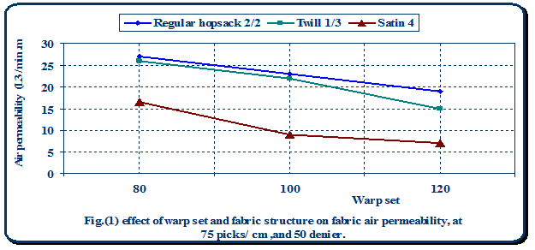

Table (3) regression equation and correlation coefficient for the effect of warp set and fabric structure onair permeability, at 75 and 50 denier

|  |  |  |
| --- | --- | --- |
| Correlation coefficient | Regression equation | **Fabric structure** |
| -1 | Y=-0.02 X +43 | **Regular hopsack 2/2** |
| -1 | Y=-0.275 X 48.5 | **Twill 1/3** |
| -1 | Y=-0.2375X +34.58333 | **Satin 4** |

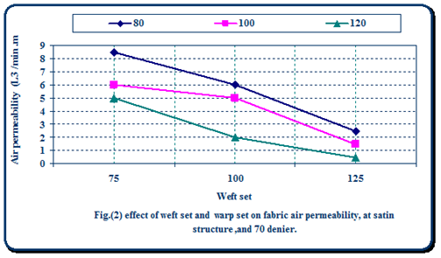

Table (4) regression equation and correlation coefficient for the effect of warp setand weft set on air

|  |  |  |
| --- | --- | --- |
| Correlation coefficient | Regression equation | **Weft set** |
| -1 | Y=-0.02 X +43 | **75** |
| -1 | Y=-0.275 X 48.5 | **100** |
| -1 | Y=-0.2375X +34.58333 | **125** |



Table (5) regression equation and correlation coefficient for the effect of weft set and fabric structure on fabric air permeability, at 80 ends/cm,and100 denier.

|  |  |  |
| --- | --- | --- |
| Correlation coefficient | Regression equation | Fabric structure |
| -1 | Y=-0.01 X +15 | Regular hopsack 2/2 |
| -1 | Y=-0.06 X 10 | Twill 1/3 |
| -1 | Y=-0.04X +7 | Satin 4 |

## **Water permeability test**

It is obvious from the diagrams, that regular hopsack 2/2 has recorded the highest rates of water permeability, whereas satin 4 has recorded the lowest rates. I can report that because hopsack 2/2 weave have more intersections than satin and twill weave which cause the produced fabric to be less compacted, so spaces in the fabric will be decreased causing decreasing in water permeability.

It is also clear from the diagrams that there is an inverse relationship between number of ends and picks per cm and water permeability. This is for sake of that because of the increased number of ends and picks, which prevent the passage of water.

We can also notice that samples made of 100 denier have obtained the lowest rates of water permeability, whereas samples made of 50 denier have obtained the highest rates.

This is probably due to that the more diameter the yarns get the less porosity the fabric become and this is for sake of the increasing of the cover factor

We can be also noticed from the diagrams that inverse relationship between thickness, weight and water permeability. We can state that increasing in thickness and weight means increasing in yarn diameter, number of picks and ends per unit area, which cause an obstruction in water passage, causing decreasing in water permeability.

We can be also noticed from the Statistical analysis F test that number of warp and weft set, yarn count, fiber type and fabric structure had a highly significant and significant effect on water permeability.

And also from F test for the effect of warp and weft set, yarn count fabric structure and yarn type on water permeability. Besides it is clear that, there is a highly significant effect of warp set and weft set, warp set and yarn count, warp set and yarn type, warp set and fabric structure on water permeability, and interaction between them,also there is a highly significant effect of weft set and yarn count, and interaction between them,also there is a highly significant effect of weft set and yarn type, weft set and fabric structure, whereas interaction between them is significant. Besides there is a highly significant effect of yarn count and yarn type, yarn count and fabric structure and interaction between them, also there is a highly significant effect of yarn type and fabric structure and interaction between them.

-After treatment

All treated samples didn’t let blood to pass. I can report that the porosity of the samples have been occluded by the Chitosan and so prevented the blood from passing.

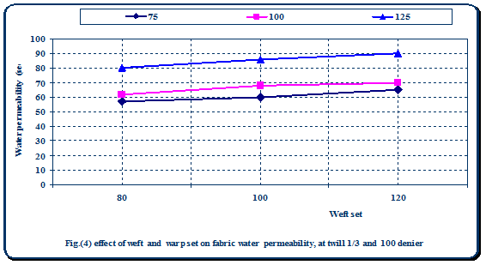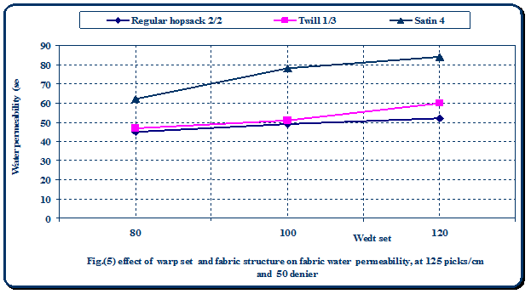

Table (6) regression equation and correlation coefficient for the effect of weft and warp set on fabric water permeability, at twill 1/3 and 100 denier.

|  |  |  |
| --- | --- | --- |
| Correlation coefficient | Regression equation | Fabric structure |
| 1 | Y=0.25 X +35 | Regular hopsack 2/2 |
| 1 | Y=0.01X 58 | Twill 1/3 |
| 1 | Y=0.02X +66 | Satin 4 |

Table (7) regression equation and correlation coefficient for the effect of warp set and fabric structure on fabric water permeability, at 125 picks/cm and 50 denier.

|  |  |  |
| --- | --- | --- |
| Correlation coefficient | Regression equation | Weft set |
| 1 | Y=-0.15 X +34 | 75 |
| 1 | Y=0.45X 6 | 100 |
| 1 | Y=0.3X +48 | 125 |

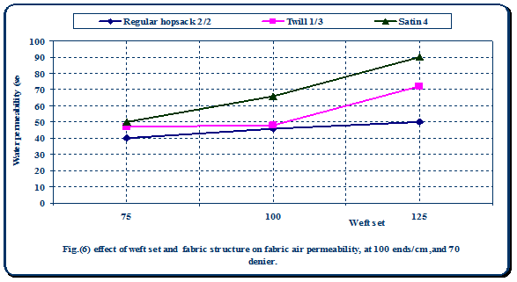

Table (8) regression equation and correlation coefficient for the effect of weft set and fabric structure on fabric air permeability, at 100 ends/cm,and 70 denier.

|  |  |  |
| --- | --- | --- |
| Correlation coefficient | Regression equation | Fabric structure |
| 1 | Y=0.2 X +26 | Regular hopsack 2/2 |
| 1 | Y=1. 2X 72 | Twill 1/3 |
| 1 | Y=1.2X +54 | Satin 4 |

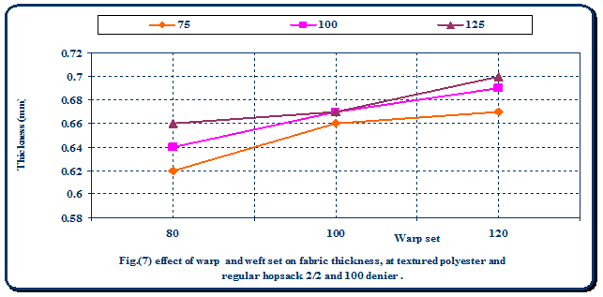

## **Thickness**

-Before treatment

It is clear from the diagrams and tables, that regular hopsack 2/2 has recorded the highest rates of thickness, followed by twill and then satin weave, which achieved the lowest rates, and it was found that the difference between both of them was insignificant.

This is mainly for sake of that hopsack 2/2 weave have more intersections than twill and satin weave, which gives it the advantage of having ridges on fabric surface giving hopsack 2/2 weave the ability of being thicker than the other structures.

Another reason for these difference in thickness is yarn count, as samples with denier 100 have recorded the highest thickness followed by samples with 70 denier, and then samples with 50 denier, This is due to that yarns of 100 denier are thicker than yarns of 70 and 50 denier, causing the produced samples to be thicker.

It was also found that the more yarns per unit area the more thicker the samples become, so samples with 150 ends per cm and 144 picks per cm have recorded the highest rates of thickness, whereas samples with 100 ends per cm and 72 picks per cm have recorded the lowest rates.

## **After treatment**

No changes occurred to the samples after treated with Chitosan, I can report that Chitosan has filled the spaces in the fabric, where the 12% Chitosan that added to the samples is an insignificant percentage to affect samples thickness.

Table (9) regression equation and correlation coefficient for the effect of warp and weft set on fabric thickness, at textured polyester and regular hopsack 2/2 and 100 denier.

|  |  |  |
| --- | --- | --- |
| Correlation coefficient | Regression equation | Weft set |
| 1 | Y=0.0005 X +0.61 | 75 |
| 1 | Y=0.001X 0.57 | 100 |
| 1 | Y=0.0015X +0.52 | 125 |

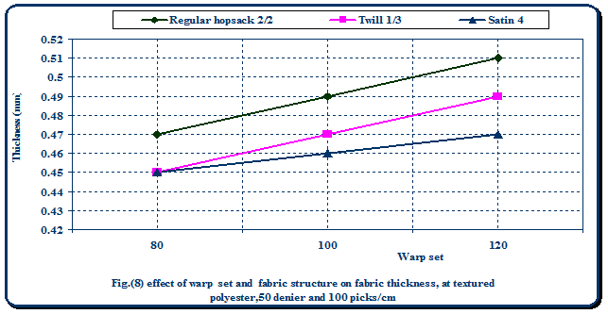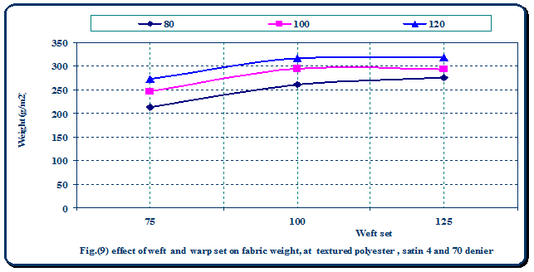

Table (10) regression equation and correlation coefficient for the effect of warp set and fabric structure on fabric thickness, at textured polyester,50 denier and 100 picks/cm.

|  |  |  |
| --- | --- | --- |
| Correlation coefficient | Regression equation | Fabric structure |
| 1 | Y=0.001 X +0.39 | Regular hopsack 2/2 |
| 1 | Y=0.001X 0.37 | Twill 1/3 |
| 1 | Y=0.0005X +0.41 | Satin 4 |

## **Weight**

-Before treatment

It is clear from the diagrams and tables that there was insignificant in weight between the three structures.

It is also clear that samples produced of 100 denier have recorded the highest weight followed by samples with 70 denier, and then samples with 50 denier, This is for sake of that yarns of 100 denier are thicker than yarns of 70 and 50 denier, causing the produced samples to be increased in weight.

It was also found that the more yarns per unit area the more thicker the samples become, so samples with 120 ends per cm and 125 picks per cm have recorded the highest weight, whereas samples with 80 ends per cm and 75 picks per cm have recorded the lowest weight.

It was also found that F test for all variables used in woven patches and valves frames. It is clear from this table that number of warp and weft set, yarn count, fiber type and fabric structure had a highly significant and significant effect on weight.

## **-After treatment**

The increasing in samples weight after treatment was about 12%.

Table (11) regression equation and correlation coefficient for the effect of weft and warp seton fabric weight, at textured polyester, satin 4 and 70 denier.

|  |  |  |
| --- | --- | --- |
| Correlation coefficient | Regression equation | Weft set |
| 1 | Y=1.33 X +112.8 | 75 |
| 1 | Y=1.09X 186.1 | 100 |
| 1 | Y=1.205X +172.9 | 125 |

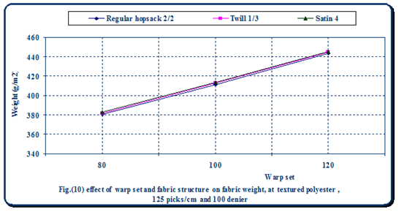

Table (12) regression equation and correlation coefficient for the effect of warp set and fabric structure on fabric weight, at textured polyester, 125 picks/cm and 100 denier.

|  |  |  |
| --- | --- | --- |
| Correlation coefficient | Regression equation | Fabric structure |
| 1 | Y=1.595 X +251.9 | Regular hopsack 2/2 |
| 1 | Y=1.61X 251.7 | Twill 1/3 |
| 1 | Y=1.595X +254.1 | Satin 4 |

Table (13) the area of all samples for determination of ideal samples by radar analysis.

|  |  |  |  |  |  |
| --- | --- | --- | --- | --- | --- |
| **The area** | **Sample no.** | **The area.** | **Sample no.** | **The area** | **Sample no.** |
| 2702.07087 | 55 | 2336.54879 | 28 | 2139.41358 | 1 |
| 4177.17866 | 56 | 3364.02421 | 29 | 2684.63521 | 2 |
| 4974.33962 | 57 | 3977.53897 | 30 | 3330.91262 | 3 |
| 4121.03073 | 58 | 3370.81328 | 31 | 2493.64596 | 4 |
| 25893.3339 | 59 | 4304.62369 | 32 | 3600.21216 | 5 |
| 6091.70163 | 60 | 4713.80489 | 33 | 3978.22202 | 6 |
| 4902.9913 | 61 | 4402.28486 | 34 | 4159.73517 | 7 |
| 5558.48207 | 62 | 4995.67582 | 35 | 4602.06731 | 8 |
| 7660.32176 | 63 | 5760.3357 | 36 | 5531.20369 | 9 |
| 4846.46411 | 64 | 4131.45073 | 37 | 4127.10564 | 10 |
| 10655.4907 | 65 | 4475.7615 | 38 | 4368.16931 | 11 |
| 6482.76151 | 66 | 5621.93612 | 39 | 5112.52845 | 12 |
| 6302.44689 | 67 | 4869.32265 | 40 | 4705.33421 | 13 |
| 7194.1935 | 68 | 6481.10945 | 41 | 3413.08832 | 14 |
| 10002.0437 | 69 | 7370.76941 | 42 | 7047.11479 | 15 |
| 45410.78 | 70 | 7216.99611 | 43 | 6796.73677 | 16 |
| 12361.4156 | 71 | 8330.76811 | 44 | 7288.79196 | 17 |
| 23753.5755 | 72 | 10700.9042 | 45 | 10561.7069 | 18 |
| 8389.30045 | 73 | 7424.21633 | 46 | 6717.19636 | 19 |
| 9836.79549 | 74 | 8813.88499 | 47 | 9205.25683 | 20 |
| 12624.4585 | 75 | 9895.91176 | 48 | 9957.08836 | 21 |
| 10870.7491 | 76 | 9624.9928 | 49 | 8286.89023 | 22 |
| 11922.8451 | 77 | 11148.0257 | 50 | 8893.81583 | 23 |
| 16113.509 | 78 | 13359.1115 | 51 | 11522.1642 | 24 |
| 11263.5672 | 79 | 11014.3457 | 52 | 10264.5277 | 25 |
| 15234.3638 | 80 | 12559.8415 | 53 | 11436.8241 | 26 |
| 19468.5161 | 81 | 16342.8963 | 54 | 14553.6798 | 27 |

## The previous results proved that:

## All samples have achieved the excepted results for end uses and the sample produced with 70 denier for warp and weft, 120 ends/cm,125 picks /cm and regular hopsack 2/2, has achieved the ideal results.



## **References**

1. Adams RD, Victor M: Principles of Neurology, 5th ed. New York: McGraw-Hill, 1993.
2. Al Rajeh S, Awada A, Niazi G, Larbi E: Stroke in a Saudi Arabian National Guard community. Analysis of 500 consecutive cases from a population-based hospital.Stroke. 1993;24:1635.
3. Benditt EP: Origin of human atherosclerotic plaques: The role of altered gene expression. Arch Pathol Lab Med. 1988; 112: 997-1001.
4. Bert C, Rob G, and Hans Hoeneveld: Benefit of carotid patching. A randomized study. J Vas Surg, 7: 240; 1988.
5. Bluth EI, Stavors AT, Marich KW, *et al.*: Carotid duplex sonography: A multicenter recommendation for standardized imaging and Doppler criteria. Radigraphics 1988; 8: 487
6. Svedova, J., “ Industrial Textiles “, Elsevier, New York, 1990. P,301,302.
7. Anderson,R., H., “Normal and abnormal development of the heart ”, Glenn thoracic and cardiac vascular surgery, Appleton & Lange, California, 1992,. p. 845.
8. King, H., Hasier, G, and King, R., “ Repair of coarctation of the aorta by patch grafting ” Cardiovasc, Surg, vol.94, March, 1987 p. 72.
9. Weldos, E., “ Surgical reconstruction of the out flow partions of right and left ventricles ”, Journal of Thoracic & Surgery, 1984 p.92
10. Williams,D., “Concise encyclopedia of medical & dental materials ”, 1st edition, Pergamon press, England, 1990,
11. Shamash, K “ A healthy prognosis”, Textile month, December,1980. p.15,16.
12. Adunur, S “ Wellington Sears handbook of Industrial Textiles ”, Wellington sear Company, Technomic Publishing Company, Inc.,Lancaster,Pennsylvania,1995, 346,345
13. Bronzino, D., J., “ Bio-medical engineering ”, CRC press, 1995. 654 – 655
14. Granmia, K.,R., and Wage, C.,R., “ Cardiac Ultra –sound ”, The C.V Mosby company, Saint Louis, 1975. p-543
15. Hopmeyer, J., “ Mechanics of heart valves ” Biomedical engineering, CRC press 1995. p. 440-441.
16. Rosenbery, N.,“ Private communication chief of vascular surgery ”, Middle sex university, New Jersey, 1988. p. 32.
17. kempczinsk, R.,F., “ Vascular grafts in R.B Rutherfordced ”, vascular surgery, 4th edition, W. B Saunders, Philadelphia,1995,p.470-474.
18. Wright, C.,W., “ The regulatory environment for vascular grafts, in P.N sawyer(ed) vascular grafts”, McGraw – Hill,New York, 1987, p. 105- 114.
19. Whit, R.,A., “ Evaluation of small diameter grafts parameters using replacement from vascular prostheses ”,B. Wright, Inc., Boston, 1983, p. 315-325.
20. Juniper., R., “ A new vascular prosthesis ” Biomedical polymers, vol. 1, No. 10, February, 1986 p. 304.
21. Timmis, D.,A., and Nathan, W.,A., “ Essentials of cardiology “, second edition, Oxford scientific publications, London, 1995, p. 205.
22. Artandic, C “ Fiber in medicine ”, Shrilly Institute, August 1981, p. 476-481.
23. Scott, S., M “ A collagen Coated Vascular Prosthesis ”, J. Cardiovasc, Surg, 1987, p. 128,498.
24. Majeti,N,V., Kumar, R “A review of Chitin and Chitosan Application ’’ Reactive &Functional polymers,No,46 2000 p-2-3
25. Fuerst,R., “ Microbiology in health and disease ”, 15th edition, W.B. Saunders company, Philadelphia, 1998, p 191 –216.
26. Murrary, R.,R “ Medical microbiology”, 2nd edition, Mosby- year book, 1994, p. 116.
27. B.S. 2925: 88 “ British Standard Method for Determining the Air permeability
28. ASTM-D 4491-92 “ British standard method for determining the water permeability”
29. ASTM-D 1777-84 “ Standard Test Method for Measuring Thickness of Textile Materials”
30. ASTM-D 3776, “ Standard Test Method for Weight of Woven Fabric”.

3/11/2014