Protective Role of Panax Gensing on Fluvoxamine Maleate Induced Structural Changes in the Submandibular Salivary Gland of Rats

Alaa A. El-Agamy¹, Omayma K. Afifi ² and Abdelrazek A. Sheta ³

^{1;} Dental Surgery Specialist, University Clinic; Taif University; KSA
^{2;} Department of Histology; Faculty of Medicine, Tanta University, Egypt & Faculty of Medicine, Tiaf University KSA
^{3;} Department of Anatomy & Embryology; Faculty of Medicine, Tanta University; Egypt & Faculty of Dentistry, Umm Alqura University, KSA
Omaymakamel@yahoo.com

Abstract: Background: Many dental patients receive Selective Serotonin Reuptake Inhibitors (SSRIs) antidepressant therapy; fluvoxamine maleate. The most common and significant major complication of this group is hyposalivation and its related complaints, particularly xerostomia. There are some herbal plants which are believed to be excellent therapy to alleviate the symptoms of many diseases as ginseng. Aim of the work: was to evaluate the histological changes in rat submandibular salivary gland that might result from fluvoxamine maleate treatment and the possible protective role of ginseng. Material and Methods: Nineteen adult male albino rats were used and were divided into group I (control);group II (experimental):each rat was daily and subcutaneously injected with fluvoxamine maleate in a dose of 2 mg/kg body weight, and group III (protective):each rat was given panax ginseng at a dose of 10 mg/kg body weight orally and daily concomitantly with fluvoxamine maleate by the same dose, route and method of administration used in group II. After 28 days, the submandibular glands were dissected and were processed for histological examination. Results: examination of the submandibular glands of fluvoxamine maleate- treated animals revealed degenerative changes especially in the secretory acinar cells. These changes were in the form of cytoplasmic vacuolation especially in serous acini, reduced secretory granules that became basal, dilated intralobular ducts, congested blood vessels and widening of the interlobular spaces. Ultrastructurally, dilated rough endoplasmic reticulum and cytoplasmic vacuolization were the prominent features. As regards the secretory granules, serous acini showed degranulation while the granules of mucous acini exhibited coalesce and heterogenous appearance of their materials. Conclusion: it could be concluded that a treatment with fluvoxamine maleate could induce structural changes in rat submandibular salivary gland, which could be partially minimized by concomitant treatment with ginseng.
[Alaa A. El-Agamy, Omayma K. Afifi and Abdelrazek A. Sheta. Protective Role of Panax Gensing on Fluvoxamine Maleate Induced Structural Changes in the Submandibular Salivary Gland of Rats. Nat Sci 2014;12(4):21-29]. (ISSN: 1545-0740). http://www.sciencepub.net/nature. 3

Key word: Xerostomia, fluvoxamine maleate, gensing, L/M, E/M.

1. Introduction
Xerostomia (dry mouth) is a very common condition in dental practice, and it is the most common longstanding problem for the majority of the patients who suffer from salivary gland dysfunction¹. It is a subjective complaint and usually caused by a decreased salivary flow or by changes in the biochemical composition of saliva. Patients suffering from xerostomia usually complain about difficulties when chewing, swallowing or even speaking, particularly those with dental prosthesis. The symptoms of dry mouth can also include a burning sensation in the mouth, taste disturbance, painful tongue, dry and cracked lips, bad breath and dry rough tongue. In addition, the xerostomic patients are susceptible to teeth decay, mouth infection and bad healing of sores in the tongue. Whereas xerostomia is a subjective concept, hyposalivation makes reference to a decreased salivary flow and it is, therefore, an objective and measurable variable ^{2, 3}.
The most important etiological factors related to xerostomia are head and neck radiotherapy, some systemic conditions like Sjögren syndrome, stress, diabetes, and also the intake of certain drugs^{4,5}. More than 500 drugs, including 42 different pharmacological groups can cause xerostomia as a side effect⁶. The drugs with the most intense xerostomizing effect are also the most widely and frequently used. The drugs which most commonly associated with xerostomia are antidepressants particularly tricyclic antidepressants and Selective Serotonin Reuptake Inhibitors (SSRIs) ^{7,8}.
Nowadays, owing to many stressors in our environment such as low socio-economic status, chronic family or work stress, social isolation, negative emotions and negative personality patterns, the incidence and prevalence of psychological disturbance like depression is a widespread⁹ and the antidepressants are one of the most commonly used pharmacological treatments¹⁰.
The most widely prescribed antidepressants come from a class of medications known as selective serotonin reuptake inhibitors (SSRIs). The SSRIs act on serotonin, which helps in mood regulation and also plays a role in digestion, pain, sleep, mental clarity, and other bodily functions, that is why SSRI antidepressants cause a wide range of side effects including a longstanding Xerostomia¹¹.
Fluvoxamine maleate (faverin) is a potent SSRI that is rapidly and completely absorbed after oral administration and has anxiolytic in addition to the antidepressant effect. So, it is widely prescribed to treat many disorders as; depression, anxiety disorders, obsessions and post-traumatic stress disorder¹².
There is a wide range of therapies in the treatment of xerostomia but their efficiency is controversial ². Several herbal drugs have been recently developed and used in clinical trials successfully to relieve xerostomia. There are some herbal plants in traditional system of medicine, which are believed to be excellent to alleviate and help with the symptoms of chronic salivary gland diseases particularly xerostomia^{1,13}.
Ginseng (the root of panax ginseng) is one of the most commonly used herbal medicines. Many studies have shown that ginseng roots contain multiple active constituents as ginsenosides, which belong to a family of steroidal saponins¹⁴. Approximately 30 different ginsenosides have been isolated and identified from panax ginseng that is responsible for the pharmacological effects of ginseng. They have different therapeutic effects as immunostimulat, antioxidant, and anti-inflammatory activities^{15,16}.
The lack of the detailed microscopic changes in salivary glands induced by faverin and also the protective role of herbs on these changes, makes it difficult to determine the validity of herbal effects or its mechanism of action. Using the submandibular gland of albino rat as an animal model, the present study was designed to evaluate the structural changes in the salivary glands after treatment with fluvoxamine maleate and to determine the protective role of ginseng on these glands using light and electron microscopy.

2.Material and methods
Nineteen adult male albino rats weighing 180-200 gm each, were used in this study. All animals were kept in clean properly ventilated cages under similar environmental conditions and fed the same laboratory diet. All experimental procedures were followed the Guide for the Care and Use of Laboratory Animals¹⁷. The animals were divided equally into four main groups:
Group I (control group) it was consisted of nine rats that was subdivided into 3 equal subgroups, 3 animals each. Subgroup Ia: Animals were left untreated. Subgroup Ib: the animals were injected subcutaneously with 2 ml/kg of saline (2 mg/kg body weight daily) for 4 weeks. Subgroup Ic: Each rat was given panax ginseng at a dose of 10 mg/kg body weight (dissolved in 1 ml of distilled water) orally by a gastric tube once daily for 4 weeks. This dose was similar to that used in previous studies ¹⁸. Ginseng was available in the form of capsules containing the dried roots of Panax ginseng. Each capsule contained 100 mg and was purchased from Pharco Pharmaceuticals, Alexandria, Egypt.
Group II (experimental group):
It was consisted of five crats, each rat was daily injected subcutaneously with fluvoxamine maleate dissolved in 0.9% NaCl in a dose of 2 mg/kg body weight. According to Belowski et al.,¹⁹ this dose was enough to produce salivary glands hypofunction. Fluvoxamine maleate is a product of Pharco pharmaceuticals-Alexandria under license of Solvay pharmaceuticals B.V. Wessp Holland and under trade name Faverin.
Group III (Protective groups):
It was consisted of five rats, each animal was concomitantly treated by both Panax ginseng and Fluvoxamine maleate at the same doses and duration as in groups I and II, respectively.
After 28 days, the animals were anaesthetized with diethyl ether, perfused through the heart with 2% paraformaldehyde and 1.25% glutaraldehyde solution, and both submandibular glands of each animal were removed and immersed in buffered glutraldhyde as a fixative at 4ºC. All specimens were processed for preparation of paraffin sections and stained with Haematoxylin & Eosin (H&E) ²⁰. For electron microscopic study, the samples of the glands were fixed in 5% phosphate buffered gluteraldehyde (pH 7.3) for two hours at 4ºC and postfixed in 1% phosphate buffered osmium tetraoxid for 30 minutes. Then, they were dehydrated and embedded in epoxy resin. Semithin sections were cut and stained with toluidine blue. Ultrathin sections were cut with LKB ultramicrotome and contrasted with uranyl acetate and lead citrate 12 for examination with transmission electron microscope ²¹.

3.Results
Light microscopic examination of the H & E and toluidine blue-stained sections of the group I revealed the well-known histological structure of the submandibular glands. Each gland consisted of many lobules that contained serous and mucous secretory acini, as well as intralobular ducts. Many blood vessels and large excretory ducts were present in the connective tissue septa between the lobules (Fig.1). The serous cells were easily distinguished by their apical darkly stained secretory granules and rounded basal nuclei. Mucous cells were identified by the pale mucous granules filling their cytoplasm giving vacuolated appearance. Most of the mucous acinus is capped by serous demilunes (Figs 2 & 3).
Examination of specimens from faverin-treated animals (group II) revealed marked structural changes especially in the secretory acini. The acini were widely separated by connective tissue containing congested dilated blood vessels and dilated ducts (Fig. 4). The cytoplasm of the serous acinar cells was faintly stained and showed variable-sized vacuoles that displaced the nuclei more peripherally. Fusion of many mucous acini was also observed (Fig.5). Many acinar cells either serous or mucous showed variable degrees of cytoplasmic vacuolation and an apparent reduction in the secretory granules especially the serous acini. Basal migration of the reduced secretory granules was also appeared (Figs. 6 & 7).
Specimens from animals of the protective group that concomitantly treated with both ginseng and faverin (group III) showed mild dilatation in the blood vessels and ducts of the interlobular spaces (Fig. 8). Most of the secretory acini are more or less as in the control group. The secretory granules were numerous and are present in the supranuclear region and in the acinus lumen (Figs. 9 & 10).
Electron microscopic examination of ultrathin sections of control animals (group I), showed the well-known histological structure. The serous cells showed basal regular euchromatic rounded nuclei and supranuclear homogenous electron-dense secretory granules. Well-developed rough endoplasmic reticulum was located in the basal part in the perinuclear region and some cisternae were also located inbetween the secretory granules (Fig. 11). The mucous cells showed regular basal ovoid nuclei and variable sizes electron-lucent secretory granules having flocculent contents and filling most of the cytoplasm. The rough endoplasmic reticulum and Golgi complex were present in the perinuclear region while mitochondria were randomly distributed (Fig. 12).
Regarding faverin-treated animals (group II), some ultrastructural changes were observed especially in the secretory cells. Basal migration of the secretory granules was a prominent feature in most of secretory cells. The granules of the serous cells were morphologically heterogenous and fused with each other. Some contents appeared dense while others were lucent. Most of serous cells showed marked dilatation of rough endoplasmic reticulum (Fig.13). Some granules in the mucous cells were fused with each other and form large pools of secretory materials. These materials vary in electron density and patterns: some were fibrellar while others appeared granular (Fig. 14).
Examination of specimens from the protective group that concomitantly treated with ginseng and faverin (group III) showed that the majority of acinar cells appeared more or less as in control group and having no apparent structural changes. The nuclei were regular rounded or oval and had normal chromatin distribution. The secretory granules cells were as in control group, dense in serous cells, and lucent in the mucous cells. Few granules in the mucous cells had a tendency to fuse with each other (Fig. 15).

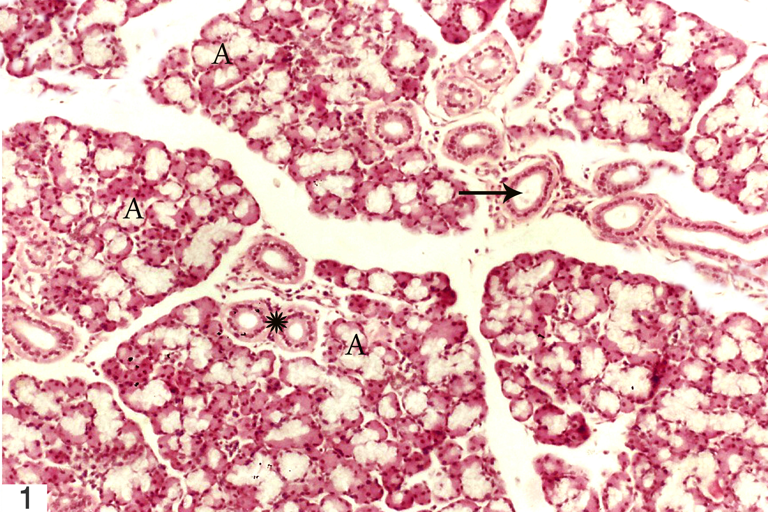 | 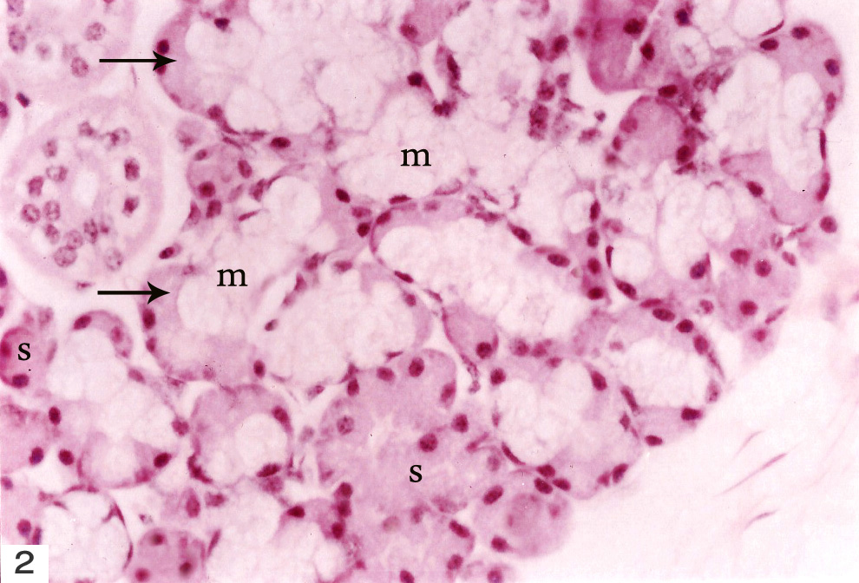
Fig. 1: A photomicrograph of a section of a submandibular gland of control rat showing many lobules containing secretory acini (A) and intralobular ducts (*) and are separated by connective tissue containing interlobular ducts (→). H & E X 100 | Fig. 2: A photomicrograph of a section of a submandibular gland of control rat showing serous cell (s) with rounded nuclei, and mucous cells (m) with flat basal nuclei and serous demilune ( → ). H & E X 400
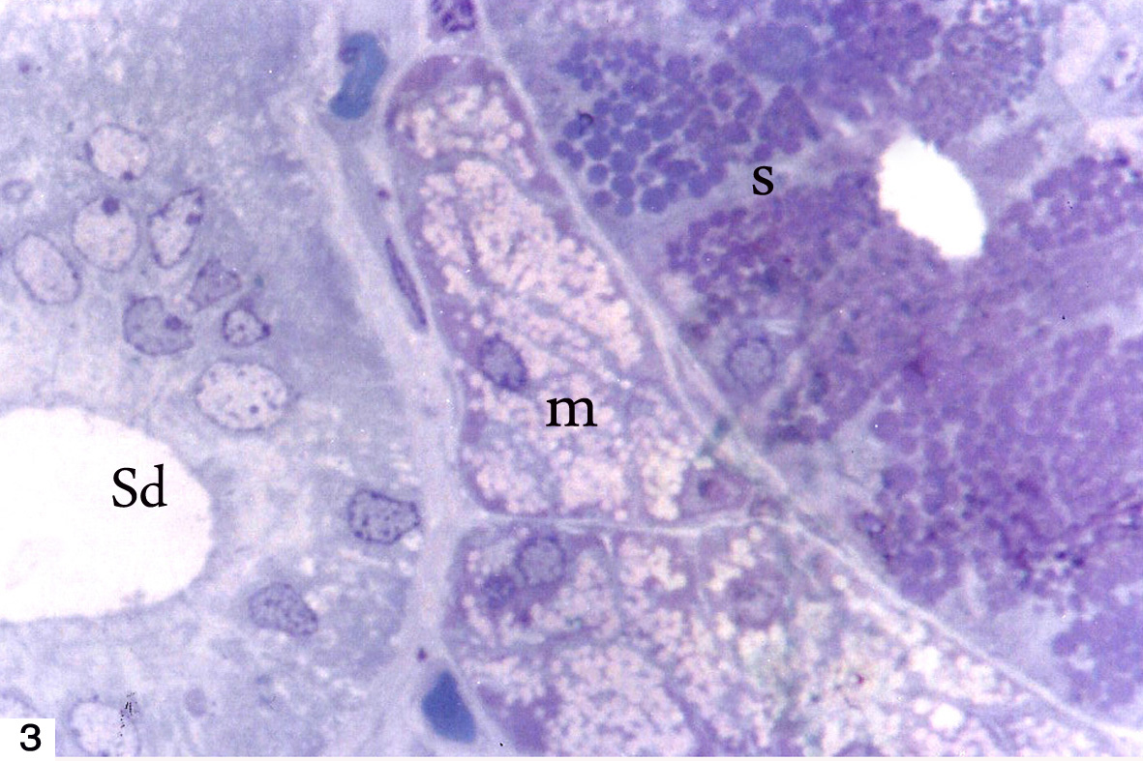 | 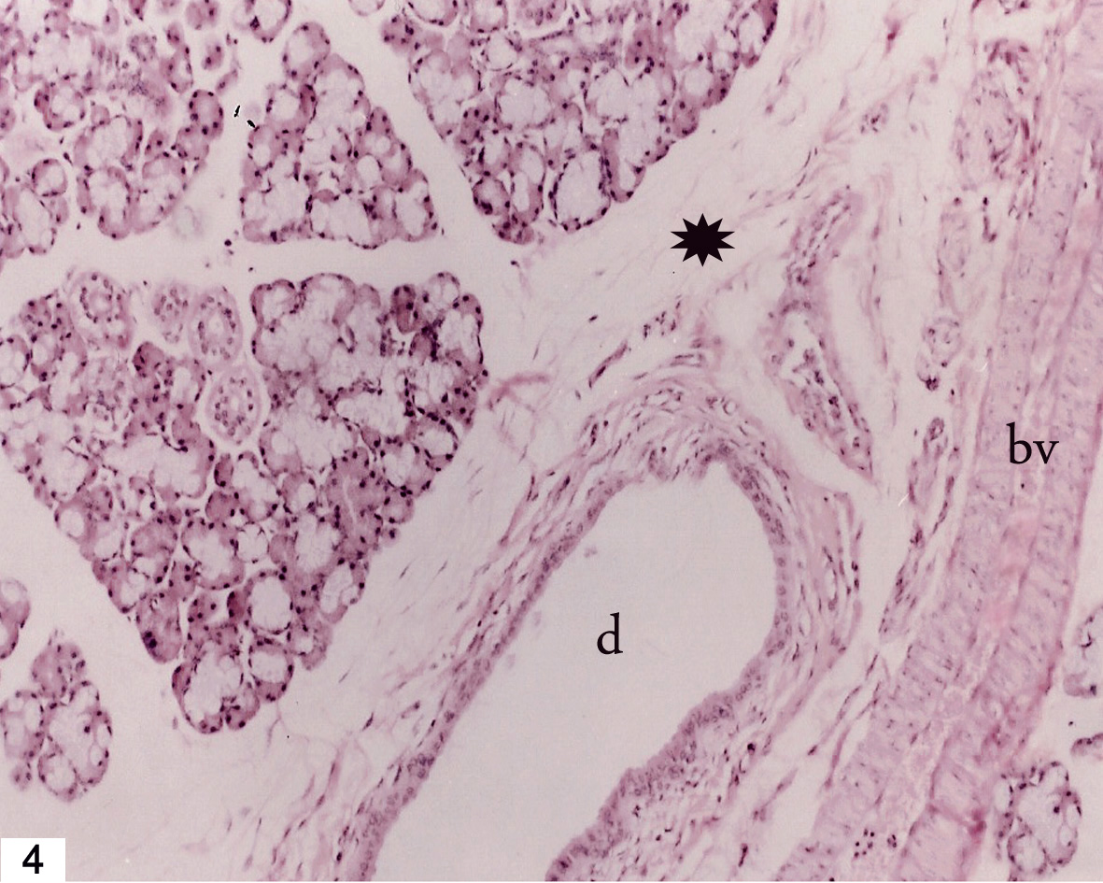
Fig. 3: A photomicrograph of a semithin section of a submandibular gland of control rat showing secretory acini containing dark serous cells filled with secretory granules (s) and pale vacuolated mucous cells (m). Notice the striated duct (Sd). Toluidine blue X 1000 | Fig. 4: A photomicrograph of a section of a submandibular gland of faverin treated rat showing widening of spaces between the acini (*). Notice dilated blood vessels (bv) and ducts (d). H & E X 100
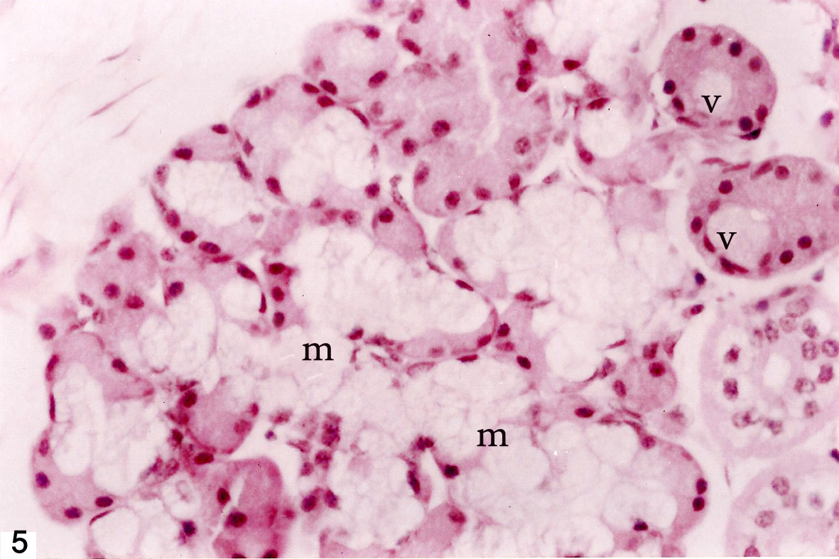 | 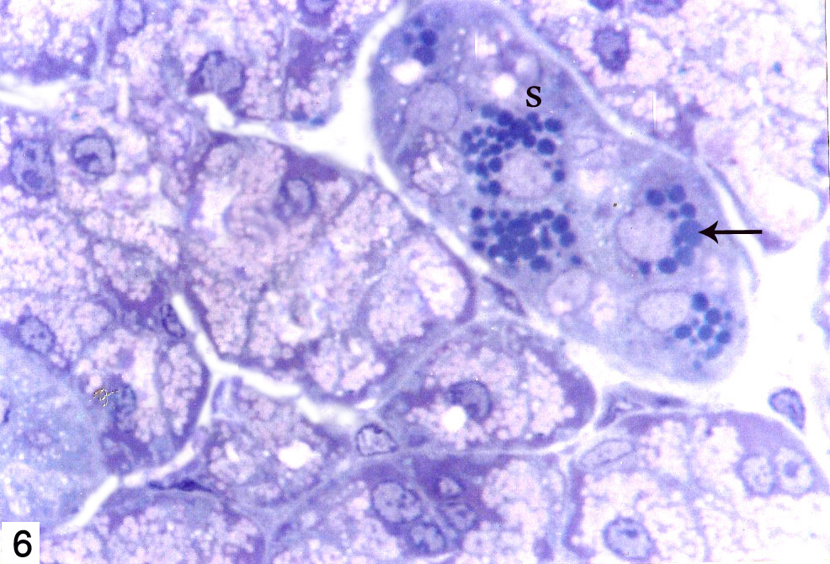
Fig. 5: A photomicrograph of a section of a submandibular gland of faverin treated rat showing cytoplasmic vacuolation of serous acinar cells (v) that displaced the nuclei more peripherally and fusion of many mucous acini (m). H & E X 400 | Fig. 6: A photomicrograph of a semithin section of a submandibular gland of faverin treated rat showing an apparent reduction in the secretory granules of serous acini (s) and most of them is basal in position (→). Toluidine blue X 1000
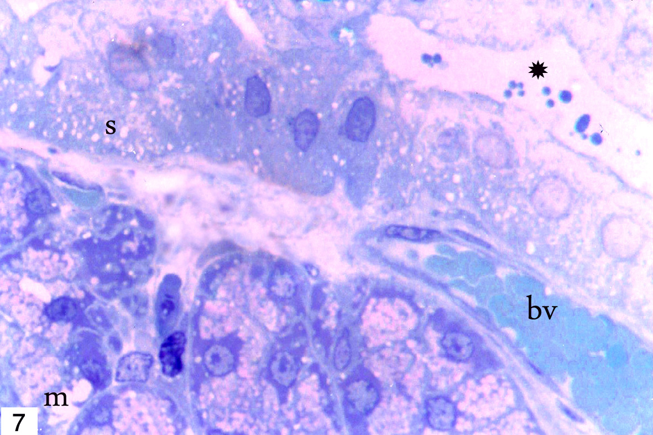 | 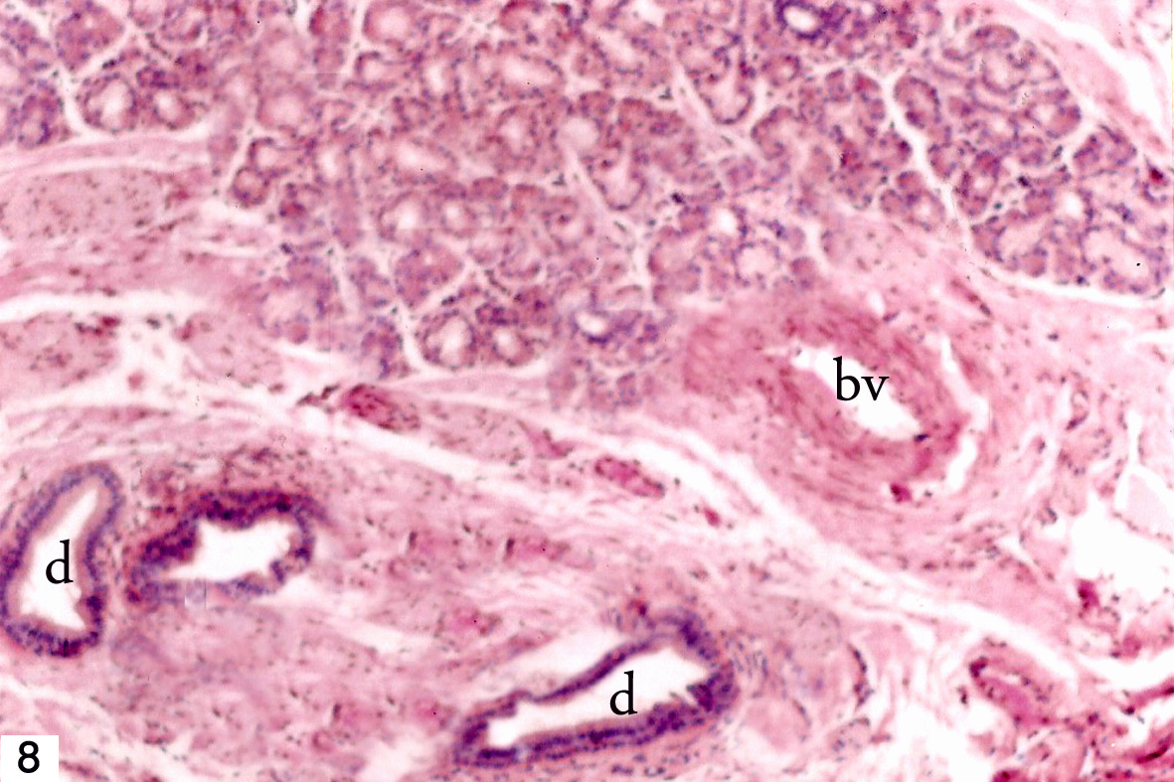
Fig. 7: A photomicrograph of a semithin section of a submandibular gland of faverin treated rat showing vacuolization of both serous (s) and mucous cells (m) and dilated blood vessel (bv). Notice, few secretory granules in the duct lumen (*). Toluidine blue X 1000 | Fig. 8: A photomicrograph of a section in the rat submandibular gland from group III (protective group) showing minimal dilatation of the ducts (d) and vessels (bv) and more or less normal architecture. H and E X 100
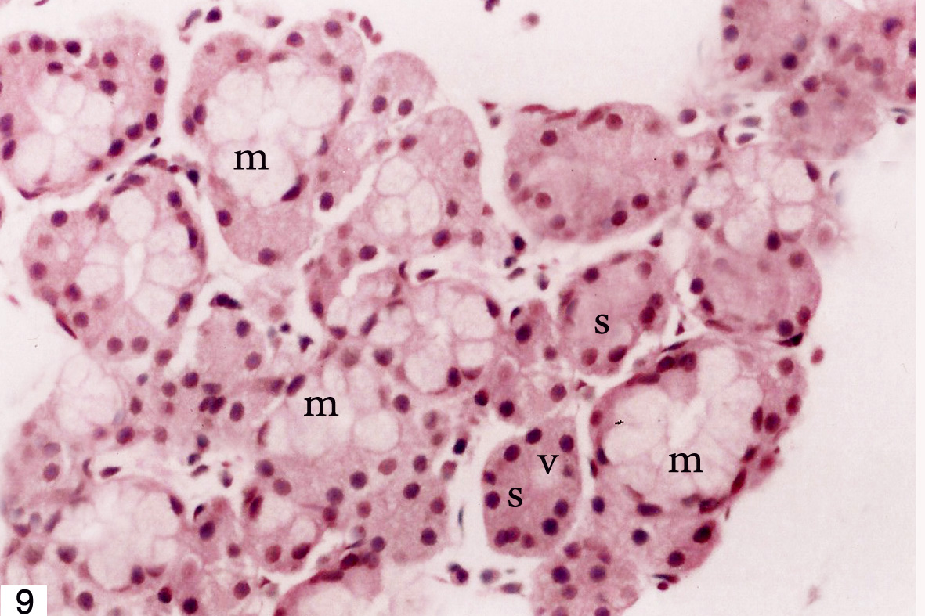 | 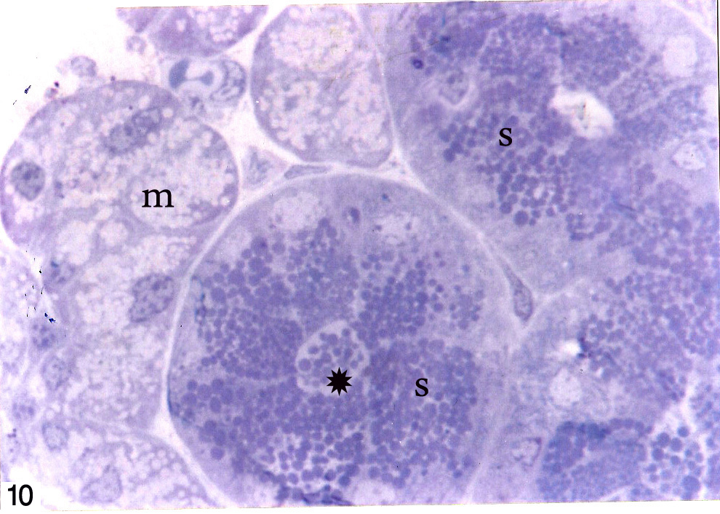
Fig. 9: A photomicrograph of a section in the rat submandibular gland from group III (protective group) showing few serous acini (s) still having few small vacuoles (v) while the mucous acini (m) are more or less as in control group. H & E X 400 | Fig. 10: A photomicrograph of a semithin section in the rat submandibular gland from group III (protective group) showing more secretory granules in the serous acini (s) and in the lumen of the duct (*). Notice that the mucous acini (m) are more or less as control group. Toluidine blue X 1000
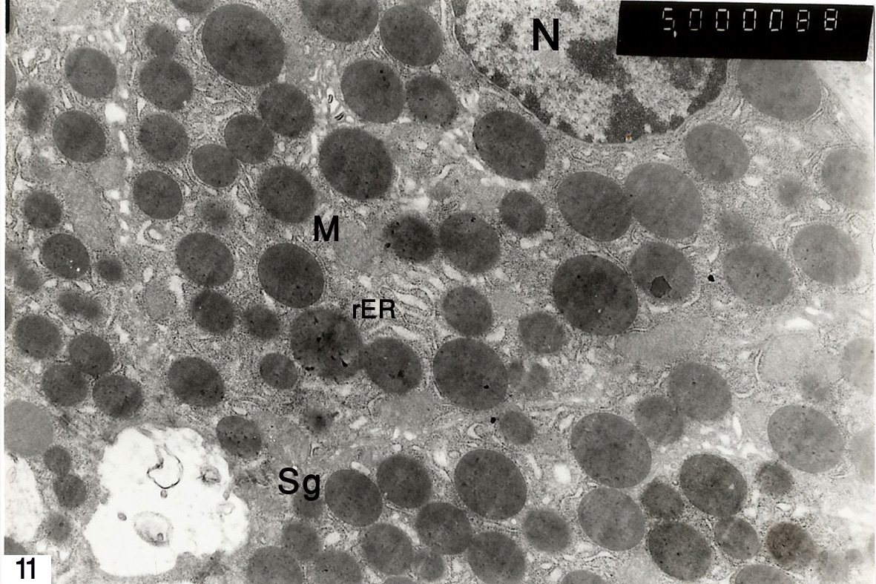 | 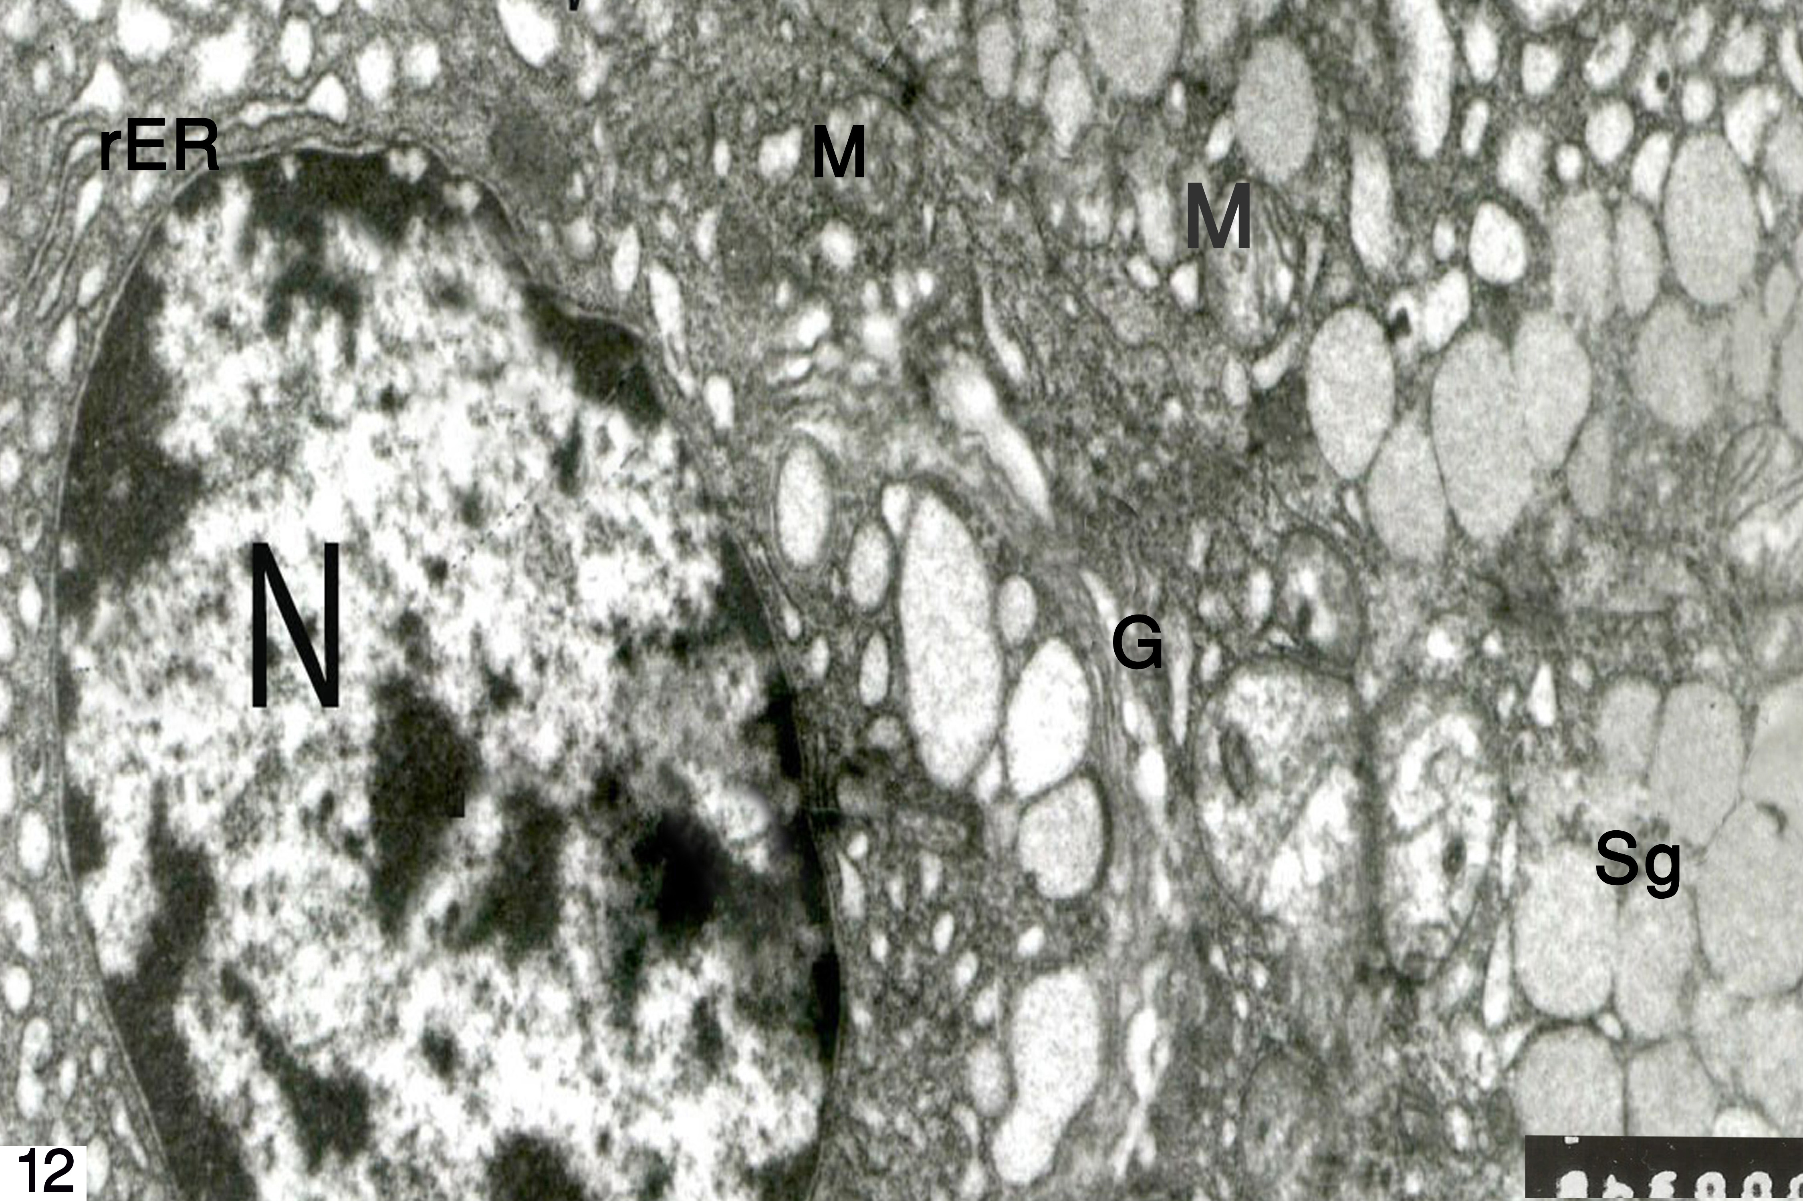
Fig 11: An electron micrograph of an ultrathin section of submandibular gland of a control animal showing serous cell with rounded euchromatic nucleus (N), mitochondria (M) and rER as well as apical electron dense secretory granules (Sg). X 5000 | Fig 12: An electron micrograph of an ultrathin section of submandibular gland of a control animal showing mucous cell with basal avoid nucleus (N), mitochondria (M), rER, Golgi complex (G) and electron lucent secretory granules (Sg) of variable size filling most of the cytoplasm. X 8000
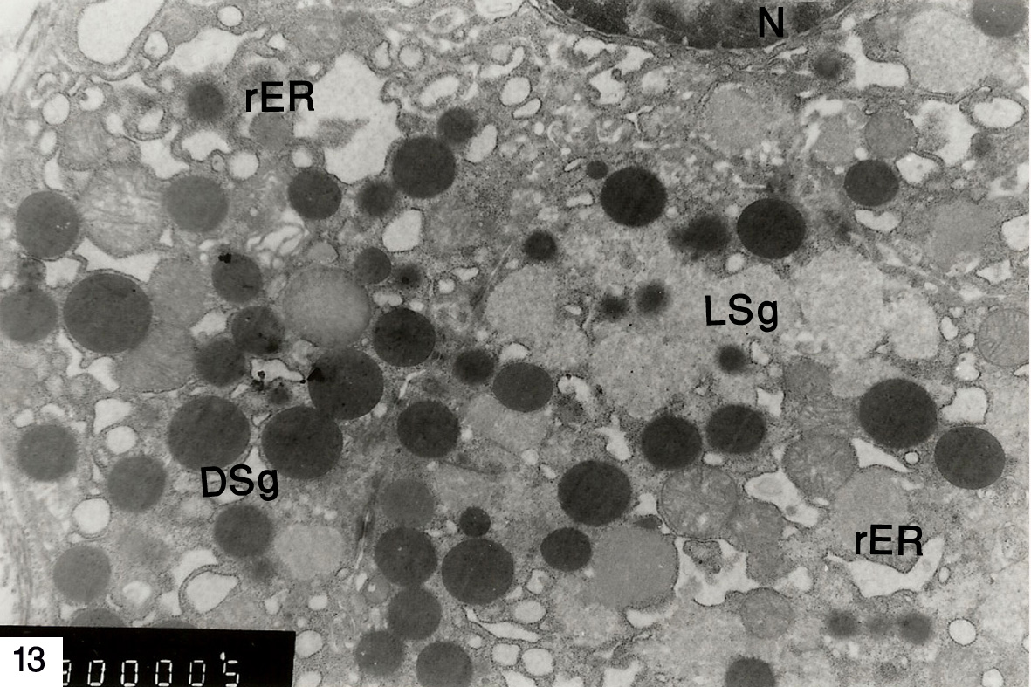 | 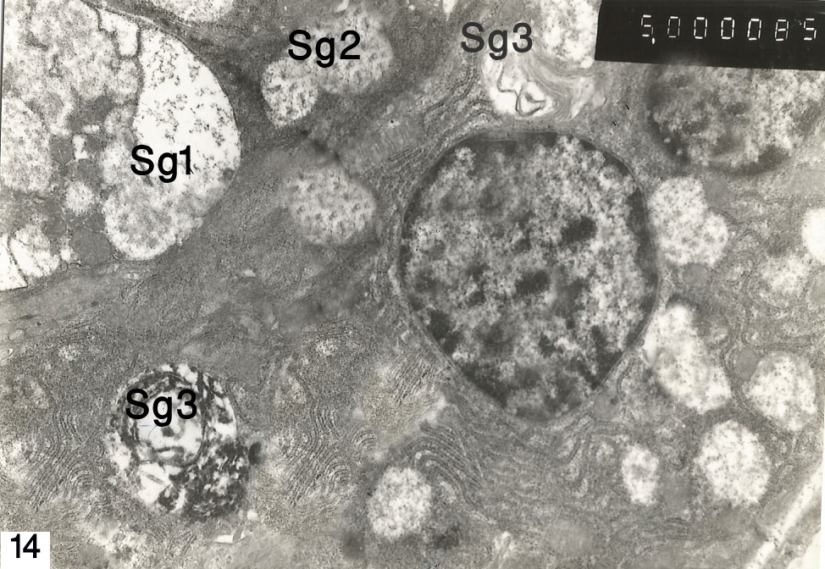
Fig 13: An electron micrograph of an ultrathin section of submandibular gland of faverin treated rat showing serous cell with dilated rER, basally located electron lucent (LSg) and electron dense (DSg) secretory granules. X 5000 | Fig 14: An electron micrograph of an ultrathin section of submandibular gland of faverin treated rat showing mucous cell with reduced secretory granules. Some secretory granules are fused (Sg1), some have granular pattern (Sg2) and some have fibrellar pattern (Sg3). X 5000
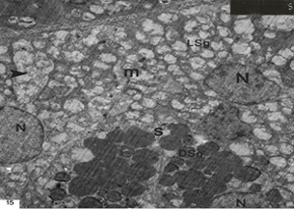
Fig. 15: An electron micrograph of an ultrathin section of submandibular gland of a rat from aprotective groupshowing mucous (m) and serous (s) cells more or less as in control group. Notice the nuclei (N) with extended chromatin, electron dense secretory granules in serous cells (DSg), and electron lucent granules in the mucous cells (LSg). Notice few fused granules (arrow head). X 5000

4.Discussion
This study showed that a long-term administration of faverin, induced marked structural changes in the rat submandibular gland. The most striking changes recorded by light microscope were variable degrees of cytoplasmic vacuolization of acinar cells, basal displacement of the secretory granules, widening of interlobular spaces and dilated ducts as well as vessels. With EM, the most obvious morphologic changes were distension of the rER cisternae, and reduced secretory granules in addition to their fusion and appearance of some heterogeneous granules. All these changes are suggestive of degenerative changes and low salivary secretion. This is in parallel with other studies which suggested that the CNS drugs have pharmacological actions on the salivary glands inducing hyposalivation that lead to bad oral hygiene. The attempts to clarify this xerostomic effect of such drugs have been of great scientific value in explaining the mechanism of action to bring a protective agent to patients using these drugs²².
The pathophysiologic mechanism that underlies the xerostomic effect of faverin is exactly undetermined. As it is one of the SSRIs, it causes greater serotonin availability in the synaptic gap, which alters the binding of acetylcholine to the muscarinic receptors (M3) present in the salivary glands. Thus, it may decrease the quantity of salivary secretion²³. Furthermore, it was reported that, SSRI medications increase serotonin availability, which may bind to 5-HT receptors in the peripheral microcirculation as in the salivary glands. This would alter the blood flow in the salivary glands and, consequently, the quantity and composition of the salivary flow²⁴.
On the other hand, other studies have shown that the prolonged use of psychotropics drugs cause alterations in the receptor sensitivity. They do not seem to block saliva production, but they interfere with the binding of acetylcholine to M3 receptors so, the saliva is produced, but it cannot be excreted. This could be reinforced by a decrease in the number of myoepithelial cells which have contractile functions and responsible for excretion²⁵.
In addition, it was found that a fluoxetine which is one of SSRIs group, downregulated the activity of superoxide dismutases and upregulated the activity of glutathione peroxidase, elevating glutathione reductase activity and total antioxidant status in rats. These results suggested that it interfered with stress-induced pathways of oxidative defense. In addition, it induced apoptotic alterations in the form of decrease in Bcl-2 expression and increased DNA fragmentation²⁶. The dilatation of the blood vessels that were seen in this work might be due to affection of the antioxidant system.
The cytoplasmic vacuolization which was found in this work in the submandibular gland is a degenerative change which may be due to disruption of plasma membrane and its transport activity. This may be a result of accumulation of lipid droplets from the unutilized fatty acids as a result of decreased cellular activity. In addition, the inhibited exocytosis may be through interference of ca⁺² mobilization via disturbing membrane associated pools or gating mechanism for calcium. This disruption of plasma membrane may also explain the expansion of the endoplasmic reticulum²⁷.
The widening of the interlobular spaces which was noticed in this work is most probably due to accumulation of tissue fluids (edema). This may be a result of increase the amount and composition of the extracellular matrix with subsequent increased tissue fluids in salivary glands²⁸.
In addition dilated rER may be a manifestation of cell injury due to disorganization of cytoskeleton and integral membrane protein or a result of deficiency of the protective enzymes, superoxide dimutase and glutathione peroxidase. The rER represent the main site of protein synthesis, so, any disruption of rER leads to an altered function style of protein fabricating mechanism with subsequent degranulation or depletion of secretory granules. Depletion of secretory granules was preceded by their basal migration due to arrest of exocytosis enhancing basolateral release of granules^{29, 30.}
The pathological changes observed in the second group (animals treated with faverin) were apparently decreased in the third group (animals treated with both ginseng and faverin at the same time) and the secretory granules became more or less as in the control group either in position or in their amount. Although most clinicians are unfamiliar with herbal medications, alternative medicines are gaining popularity and recognition within the professional community and ginseng; is one of the most commonly used herbal supplements that used in folk remedies for different medical conditions¹.
It is well known that, ginseng enhances the uptake of choline and facilitates the release of acetylcholine³¹. In addition it is rich in a large number of ginsenosides that belong to a family of steroidal saponins which responsible for their diverse biological effects. Some of the main pharmacological actions of these compounds include anti-inflammatory, antioxidant and immunomodulatory activities¹⁶. Ginseng acts through suppression of proinflammatory cytokines or mediators including tumor necrosis factor-α and interleukins^{32,33}, regulates cytokine production and phagocytic activities of macrophages and dendritic cells and so, it activate the T and B-lymphocytes^{16,34}. It also has been shown to be responsible for induction of cytoprotective heat-shock proteins that may contribute to prevention of tissue injury³⁵.
Although research studies have widely been performed about different pharmacological properties of ginseng, there is little evidence about its effect on salivary glands and their secretion. Salivary secretion is complex and occurs subsequent to neurotransmitter stimuli. The principal control of this secretion is derived from sympathetic and parasymphatetic innervations which regulate the secretory function on the acinar cell level. It has been determined that parasympathetic stimulation increases the volume and causes a copious flow of saliva with low outputs of protein and sympathetic nerve stimulation which per se mainly affects protein content and composition and causes less fluid secretion^{3,36}. The authors believe that gensing effect on salivation can be attributed to some kind of cholinergic action as it facilitates the release of acetylcholine³¹. However, the exact mechanism is not fully understood. Moreover, Mittal et al.,³ reported that treatment of xerostomia with drugs having anticholinesterasic or cholinergic action represents an efficient therapeutic option.
In summary, this study showed that treatment with faverin could induce marked structural changes in rat submandibular gland. These changes could be partially reduced by concomitant administration of ginseng. So, it is recommended that awareness should be focused on ginseng as an important protective herbal or drug from dry mouth during treatment with faverin. Further investigations on different constituents of gensing in different doses also seem to be essential to identify the responsible constituent and the optimum effective dose for saliva secretion.

References
- GoliChamani, Mohammad Reza Zarei, Mitra Mehrabani, and Yousef Taghiabadi: Evaluation of Effects of Zingiber officinale on Salivation in Rats. Acta Medica Iranica, 2011; 49 (6): 336-340

Cassolato SF, Turnbull RS. Xerostomia: clinical aspects and treatment. Gerodontology. 2003;20:64–77

Mittal S, Bansal V, Garg S, Atreja G, Bansal S. The diagnostic role of Saliva -areview. J Clin Exp Dent. 2011;3:e314–20.

Silvestre-Donat FJ, Miralles-Jorda L, Martinez-Mihi V. Protocol for the clinical management of dry mouth. Med Oral. 2004;9:273–9.

Gerardo Gómez-Moreno, Javier Guardia, Antonio Aguilar-Salvatierra, Maribel Cabrera-Ayala, José E. Maté-Sánchez de-Val, and José L. Calvo-Guirado: Effectiveness of malic acid 1% in patients with xerostomia induced by antihypertensive drugs. Med Oral Patol Oral Cir Bucal. 2013 January; 18(1): e49–e55.
- Martín-Piedra MA, Gómez-Moreno G, Herrera D, Aguilar-Salvatierra A. Effectiveness of a recent topical sialogogue in the management of drug-induced xerostomia. J Clin Exp Dent. 2011;3:e268–73.
- Murray Thomson W, Chalmers JM, John Spencer A, Slade GD, Carter KD. A longitudinal study of medication exposure and xerostomia among older people. Gerodontology. 2006;23: 205–13.
- de Almeida Pdel V, Grégio AM, Brancher JA, Ignácio SA, Machado MA, de Lima AA. Effects of antidepressants and benzodiazepines on stimulated salivary flow rate and biochemistry composition of the saliva. Oral Surg Oral Med Oral Pathol Oral Radiol Endod.2008;106: 58–65.
- Bylund DB, Reed AL Childhood and adolescent depression: why do children and adults respond differently to antidepressant drugs? Neurochem Int. 2007 Oct;51(5):246-53.
- Martn-Merino E, Ruigmez A, Wallander M, Johansson S, and Garca-Rodrguez L.: Prevalence, incidence, morbidity and treatment patterns in a cohort of patients diagnosed with anxiety in UK primary care. Fam Pract. Feb. 2010;27(1):9-16.
- Park SH, Ishino R: Liver injury associated with antidepressants. Curr Drug Saf. 2013 Jul;8 (3): 207-23.
- Karen J, McClellan, David P, and Figgit T. Fluvoxamine an updated review of its use in the management of adults with anxiety disorders Adis Drug Evaluation, 2000; 60 (4): 925–954.
- Pedersen A, Gerner N, Palmvang I, Høier-Madsen M.LongoVital in the treatment of Sjögren's syndrome. Clin Exp Rheumatol. 1999; 17(5):533-8.
- Radad K, Gille G, Liu L, Rausch WD. Use of ginseng in medicine with emphasis on neurodegenerative disorders. J Pharmacol Sci. 2006;100:175–186
- Yeo M, Kim DK, Cho SW, Hong HD. Ginseng, the root of Panax ginseng C.A. Meyer, protects ethanol-induced gastric damages in rat through the induction of cytoprotective heat-shock protein 27. Dig Dis Sci. 2008;53:606–613
- Lee DC, Yang CL, Chik SC, Li JC, Rong JH, Chan GC, Lau AS. Bioactivity-guided identification and cell signaling technology to delineate the immunomodulatory effects of Panax ginseng on human promonocytic U937 cells. J.Transl Med. 2009;7:34
- National Research Council. Guide for the care and use of laboratory animals. 1996; 7thed Washington, D.C National Academy Press
- Mahour K, Saxena PN. Modulating role of Panax ginseng in phase-II reaction of hepato-biotransformation in albino rats following mercuric chloride intoxication. Iran J Toxicol. 2009;2:273–280
- Belowski D, Kowalski J, Madej A, and Herman S. Influence of antidepressant drugs on macrophage cytotoxic activity in rats. Pol. J. Pharmacol., 2004; 56, 837–842.
- Bancroft JD, Gamble M Theory and practice of histological techniques. 2002 5th ed London; New York Churchill Livingstone
- Bozzola JJ, Russell LD Electron microscopy: principles and techniques for biologists. 1999 2nd ed London Jones and Bartlett Publishers, Inc
- Tatiana Maria FoladorMattioli; Silvana da Silva; Ana Maria Trinda de-Grégio; MariaÂngela Naval Machado; Antônio Adilson Soares de Lima; Luciana Reis Azevedo-Alanis: The effects of antidepressants and pilocarpine on rat parotid glands: an immunohistochemical study: 2011; Clinics vol.66 (9): 1605-10
- Keene JJ Jr, Galasko GT, Land MF. Antidepressant use in psychiatry and medicine: importance for dental practice. J Am Dent Assoc. 2003; 134:71).
- Rang HP, Dale MM, Ritter JM, Flower RJ. Pharmacology. London: Churchill Livingstone. 2007;557-74.
- Grégio AMT, Durscki JRC, Lima AAS, Machado MAN, Ignácio SA, Azevedo LR. Association of amitriptyline and diazepam on the histomorphometry of rat parotid glands. Pharmacologyonline. 2006;2: 96-108.
- Jelena Djordjevic, Ana Djordjevic, Miroslav Adzic, Ivana Elaković, Gordana Matić, Marija B. Radojcic. Fluoxetine affects antioxidant system and promotes apoptotic signaling in Wistar rat liver. European journal of pharmacology, 2011; 659 (1), 20 May:61–66
- Takahashi S, Nakamura S, Domon T, Yama Moto T and Wakita M. Active participation of apoptosis and mitosis in sublingual gland regeneration of the rat following release from duct ligation. J. Mol. Histol.2005; 36:199-205.
- Friedrich RE, Bartel-Friedrich S, Holzhausen HJ and Lautenschläger C. The effect of external fractionated irradiation on the distribution pattern of extracellular matrix proteins in submandibular salivary glands of the rat. J. Craniomaxillofac. Surg.; Aug; 2002; 30(4):246-54.
- Radfar L and Sirois DA. Structural and functional injury in minipig salivary glands following fractionated exposure to 70 Gy of ionizing radiation: an animal model for human radiation-induced salivary gland injury. Oral Surg. Oral Med. Oral Pathol. Oral. Radiol. Endod.; 2003; 96:267-274.
- Plavnik LM, De Crosa ME and Malberti AI. Effect of low-power radiation (helium/neon) upon submandibulary glands. J. Clin. Laser Med. Surg. Aug;2003; 21(4):219-25.
- Manuchair Ebadi: Pharmacodynamic Basis of Herbal Medicine, 2ndEd.2006 - ‎Health & Fitness; CRC PressAmazon.com: chapter 37: Ginseng and cholinergic action on salivary glands. p 371-378
- Ahn JY, Song JY, Yun YS, Jeong G, Choi IS. Protection of Staphylococcus aureus-infected septic mice by suppression of early acute inflammation and enhanced antimicrobial activity by ginsan. FEMS Immunol Med Microbiol. 2006;46:187–197
- Rhule A, Navarro S, Smith JR, Shepherd DM. Panaxnotoginseng attenuates LPS-induced pro-inflammatory mediators in RAW264.7 cells. J Ethnopharmacol. 2006;106:121–128
- Bradley JR. TNF-mediated inflammatory disease. J Pathol. 2008;214:149–160
- Yeo M, Kim DK, Cho SW, Hong HD. Ginseng, the root of Panax ginseng C.A. Meyer, protects ethanol-induced gastric damages in rat through the induction of cytoprotective heat-shock protein 27. Dig Dis Sci. 2008;53:606–613
- Garrett JR, Suleiman AM, Anderson LC, Proctor GB.: Secretory responses in granular ducts and acini of submandibular glands to parasympathetic or sympathetic nerve stimulation in rats., Cell Tissue Res., 1991; 264(1):117-26.

3/11/2014

