Occurrence of Aflatoxin M1 in Raw Camel Milk in El-Ahsa Governorate, Saudi Arabia

Yosef, T.A.^{1,2*}; Al- Julaifi, M.Z.²; Hussein, Y.A.^{3,4}; Al-Shokair, S.S.³ and AL-Amer, A.S.²

¹Dept. of Forensic Med. and Toxicology, Fac. of Vet. Med., Kafrelshiekh Univ., 33516, Egypt.
²Toxicology lab. Management of Vet. Laboratories, Min. of Agric., Riyadh, 11418, KSA.
³Dept. of Clinical Studies, College of Vet. Med. and Animal Resources, King Faisal Univ.,11647KSA.
⁴Dept. of Forensic Med. and Toxicology, Fac. of Vet. Med., Alexandria Univ., 2485 Egypt.
Email: tarekyosef70@yahoo.com

Abstract: During the period of February–April 2013, one hundred-seventeen samples of raw camel milk, collected from EL-Ahsa Governorate(Eastern Saudi Arabia)were checked for Aflatoxin M1 (AFM1) by using competitive ELISA technique. Samples exceeded AFM1 Gulf countries maximum limit of raw milk were confirmed by LC-MS analysis so as to avoid any doubts about its chemical identification. AFM1 was detected in 78.6% of milk samples, with range of 2.50to 398.60ng/l and the mean of 164.72±0.432ng/l. Eighty four samples (71.8%) go over the European Commission recommended limits (50ng/l) of raw milk while thirty four samples (29.1%) surpassed the Gulf countries maximum limit distinct as 200ng/l. AFM1 was detected at levels below 50ng/l in merely 6.8% of the samples whilst, 23.0% ranged from 50 to 100ng/l. AFM1 positive samples assorted from 101 to 200ng/l were established in 19.7% of milk samples and about 29.1% were above 200ng/l. High levels of AFM1 in the raw camel milk samples is an enormous health risk factor for end consumers. There is need to improve storage conditions of feed ingredients that will mitigate the AFB1 production in the feed/ration and ultimately decrease the AFM1 levels in the animal milk.
[Yosef, T.A.; Al- Julaifi, M.Z.; Hussein, Y.A.; Al-Shokair, S.S. and AL-Amer, A.S. Occurrence of Aflatoxin M1 in Raw Camel Milk in El-Ahsa Governorate, Saudi Arabia. Nat Sci 2014; 12(4):1-7]. (ISSN: 1545-0740). http://www.sciencepub.net/nature. 1

Keywords: Aflatoxin M1, ELISA, LC-MS, Raw camel milk

1.Introduction
Mycotoxins are fungal secondary metabolites that if ingested can cause a variety of adverse effects on both humans and animals (Hampikyan et al., 2010). Aflatoxins (AF) are a group of closely related heterocyclic compounds produced predominantly by two filamentous fungi, Aspergillus flavus and Aspergillus parasiticus (Baskaya et al., 2006). Aspergillus species are capable of growing on a diversity of substrates under a variety of environmental conditions mainly in tropical and subtropical climates. Therefore, AF occur as natural contaminants in many agricultural commodities (Kensler et al., 2011)which can be produced during growth, harvesting and storage course (Prandini et al., 2009). More than 20 AF-like secondary metabolites have been identified wherever aflatoxin B1 (AFB1) has been reported as a powerful natural carcinogen in mammals (Paterson, 2007). It is well known that AFB1 can cause chronic diseases in humans and animals and can have different effects such as hepatotoxicity, genotoxicity and immunotoxicity (CAST, 2003).
Upon ingestion by ruminants, AFB1 is partially destroyed in the rumen, whereas the absorbed AFB1 rapidly undergoes metabolic processes by cytochrome P450 associated enzymes in the liver to various secondary metabolites (Kuilman et al., 2000). Aflatoxin M1 (AFM1), a possible human carcinogen (IARC, 2002),is the major oxidized metabolite of AFB1 and is excreted in milk, bile and urine(Fallah et al., 2009).Transfer of AFM1 from blood to milk can be significant enough to represent a potential risk to milk consumers (Yiannikouris & Jouany, 2002). AFM1 could be detected in milk 12-24 h after the AFB1 ingestion, reaching a high level after a few days. When AFB1 intake is stopped, the AFM1 concentration in milk decreases to an undetectable level after 72 h (Sarimehmetoglu et al., 2004). In lactating animals the carry-over rate of AFB1 to AFM1 ranges between 0.3 and 6.2% (Creppy, 2002). The International Agency for Research on Cancer has classified AFB1 and AFM1 as class 1 human carcinogens (IARC, 2002). Although mutagenic and carcinogenic intensity of AFM1 is lower than AFB1, its geotaxis activity is known to be much higher (Kocabas & Sekerel, 2003).
Due to the potential hazard of AFM1 many countries have set or proposed legal regulations for AFM1 levels in milk and dairy products. These regulations vary in different countries and are often based on economic considerations (Stoloff et al., 1991). The European Commission (EC) imposes maximum residue level (MRL) of 50 ng AFM1/kg or l raw milk (EC, 2006). Many countries in Africa, Asia and Latin America also enforce this level (Van Egmond, 1989; CAST, 2003 and EU, 2006)while Gulf countries limit was of 200ng AFM1/kg or l raw milk (GCC, 1997).
Many studies have reported the occurrence of high levels of AFM1 in numerous countries that exceeded maximum allowed limits in milk(Motawee et al., 2004; Hussain & Anwar, 2008; Dashti et al., 2009; Amer & Ibrahim, 2010; Kamkar et al., 2011; Panahi et al., 2011 and Tsakiris, et al., 2013).
Camel meat and milk are the key foods in arid and semi-arid areas of the African and Asian countries especially in Saudi Arabia which is the original homeland of camels. Nomads have long said, “Water is the soul, milk is the life”. Saudi Arabia produced over one percent of world stocks of camels (425,000 head). In regard to camel milk production, Saudi Arabia is globally ranked at the seventh position (89,500 cubic meters) (FAO, 2004). In fact, most of camel milk is consumed in the raw state without any heat treatments or acid fermentation and kept at high ambient temperature coupled with lack of refrigeration facilities during milking and transporting. These conditions turn the milk to be unsafe.
In EL-Ahsa Governorate, as in many regions around the kingdom, camel milk is produced in traditional way by hand milking, handled and transported under low hygienic measures. However, in view of its health benefits, there is a fast growing demand for raw camel milk in Saudi Arabia and further it is expected to be introduced as a new functional food in the European market. Literature data about AFM1 in camel milk are very scarce while some studies worldwide have been undertaken to determine the presence of AFM1 in camel milk (Srivastava et al., 2001; Mahmoud et al., 2009 and Hussain et al., 2010).
This study was designed to monitor the AFM1 in fresh raw camel milk retailed in EL-Ahsa Governorate, Saudi Arabia in terms of its compliance with the international aflatoxin limits by using an ELISA technique and confirmed with LC-MS analysis.

2.Material and Methods
A: Milk samples
Between February and April 2013, a total of one hundred-seventeen raw camel milk samples were collected from different locations in EL-Ahsa Governorate (eastern Saudi Arabia). Milk was collected from camels by hand milking as normally practiced by the farmers. The samples were collected in sterile screw bottles. The size of each milk sample was at least one liter. During transportation, the milk samples were kept in ice packets in an icebox. The milk samples were either analyzed immediately or stored at -18°C in case of delayed analysis. Analysis was performed in Toxicology Laboratory, Ministry of Agriculture, Saudi Arabia.
B: Quantitative determination of AFM1 by ELISA technique
The levels of AFM1 in raw camel milk were measured in duplicates using an enzyme-linked immunoassay test kit (RIDASCREEN, r-Biopharm, Darmstadt, Germany) which is a competitive enzyme immunoassay based on antigen-antibody reaction (Karimi et al., 2007). The milk samples were centrifuged for 10 minutes at 3500rpm at 10°C. The upper creamy layer was completely removed by aspirating through a Pasteur pipette. Exactly 100 μl of skimmed milk was used directly in the test. A sufficient number of microtiter wells were inserted into the microwell holder for all standards and samples. All steps and calculation of the results were conducted automatically by GEMINI® Automatic ELISA instrument with special software, the RIDA® SOFT Win (Art. No. Z9999),.
C: Quantitative determination of AFM1 by LC-MS analysis
Chemicals and reagents
AFM1 standard (10 µg/ml in acetonitrile), purchased from Supelco (Bellifonte, PA, USA), was used for the preparation of 12.5, 25, 37.5, 50 and 62.5ng/l concentration solutions on column for standard curve determination and stored in tightly stopper vials in a refrigerator at 4°C until further analysis. Acetonitrile of HPLC grade (Sigma Aldrich, Steinheim, Germany)and immunoaffinity columns (IAC) of Aflaprep® M(r-Biopharm Rhone LTD, Germany) were purchased. During the analysis double distilled water with Millipore water purification system(Bedford, MA, USA)was used and all other chemicals and reagents were at least of analytical grade.
Extraction procedure
The extraction of AFM1 from milk samples was carried out according to the method described by Hussain & Anwar (2008)with some modifications. Liquid milk samples were warmed at 37°Cin water bath and then centrifuged at 2500 rpm for 15 min to separate the fat layer. After centrifugation, the supernatant were filtered through Whatman No.5 filter paper. About 50 ml of filtrate was transferred into a syringe barrel attached to an IAC and passed at flow rate of 2 ml/min using vacuum manifold. The column was washed with 20 ml double distilled water to eliminate impurities and AFM1 was eluted with4 ml pure acetonitrile, approximately 60 s to be in contact with the column. Finally, the elute was evaporated to dryness using a gentle stream of nitrogen at 40 °C and it was diluted with the mobile phase at the time of LC-MS determination.
Analytical method
The LC-MS system used for AFM1 analysis was a Waters LC-MS (USA)-2695 separation module and Waters micro mass ZQ mass analyzer. Discovery C18 column (50x2.1mm,3µm) of Capital, USA was used. Acetonitrile in ratio of 25% with 75% water was used as mobile phase. The flow rate was 0.2 ml/min. Calibration curve was determined using a series of calibration solutions of AFM1 in acetonitrile with concentrations of 12.5, 25, 37.5, 50 and 62.5 ng/l on column. The retention time for AFM1 was 6.82±0.08 min. The response was linear (R²= 0.998). The chromatograms ofAFM1 standard curve and a milk samples are shown in Figs. 1 and 2, respectively.
D: Statistical analysis
The results regarding AFM1 levels in milk samples were statistically analyzed by applying one way analysis of variance (ANOVA) (Steel & Torrie, 1977).
3.Results
A total of 117 raw camel milk samples were analyzed by competitive ELISA technique. Thirty four samples that exceeded the Gulf countries maximum limit were confirmed by LC-MS analysis. The occurrence of AFM1 was shown in table1. Out of the 117 samples analyzed, 92 samples (78.6%) were found to be contaminated with AFM1. The AFM1 contamination levels were between 2.5– 398.6ng/l with the mean of 164.72±0.432ng/l. Eight samples (6.8%) botched to reach the most wanted level of the European Commission, defined as 50ng/l while 58 samples (49.5%) failed to reach the pet level of the Gulf countries maximum limit distinct as 200ng/l (Table2). AFM1 were detected at low level(< 50 ng/l) in 6.8% of the samples while, samples ranged from 50 to 100 ng/l represented about 23.0%. On the other hand, AFM1 levels assorted from 101 to 200 ng/l were found in 19.7% of the samples whilst about 29.1% were above 200 ng/l.

Table 1.Occurrence of AFM1(ng/l) in raw camel milk samples from Eastern Saudi Arabia
AFM1 levels ng/l | Sample No. | (%) | Range | Mean ±SE
Not detected samples
- | 25 | 21.4 | - | -
Contaminated samples
<50 | 8 | 6.8 | 2.5-47.4 | 37.31±0.024
50-100 | 27 | 23.0 | 50.1-96.7 | 89.62±0.114
101-200 | 23 | 19.7 | 101.6-198.5 | 177.34±0.125
>200 | 34 | 29.1 | 200.2-398.6 | 354.61±0.141
Total Samples | 117 | 78.6 | 2.5-398.6 | 164.72±0.432

Table 2.Incidence of AflatoxinM1 (ng/l)in raw camel milk samples from Eastern Saudi Arabia concerning legal limits
Milk samples | Positive samples | European limit  (50 ppt)* |  | Gulf countries limit  (200 ppt)**
 |  | Below PL | Over PL | Below PL | Over PL
 | No. % | No. % | No. % | No. % | No. %
 | 92 78.6 | 8 6.8 | 84 71.8 | 58 49.5 | 34 29.1
NB: PL: permissible limit. * EC, (2006). ** Standardization Organization for GCC (1997).

4-Discussion
The occurrence of AF in food is a serious global health problem, particularly in developing countries. Aflatoxins are well documented as cancer potency factors since 4.6-28.2% of annual hepatocarcinoma cases worldwide are caused by these toxins (Zheng et al., 2010). The presence of AFM1 in milk and other dairy products is an all-inclusive concern given that these products are main source for introducing aflatoxins in the human diet (Rastogi et al., 2004).
In our study, of the 117 samples analyzed, 92 samples (78.6%) were found to be contaminated with AFM1. The contamination mean was of 164.72±0.432ng/l which about 3 folds more than European Union standard. Eighty four samples (71.8%) exceeded the legal level of AFM1 in milk according to the European Commission (EC) of 50 ng AFM1/kg raw milk (EC, 2006).
A hardly any published data are available on the occurrence of AFM1 in raw camel milk. Our results about the concentrations of AFM1 in raw camel milk samples were comparable with previous ones. Balata & Bahout (1996) recorded AFM1 levels in Egyptian camel milk up to 850 ng/l. In Colombia, 100% of the 25 analyzed raw camel milk samples contained AFM1 and 20% exceeded the EC accepted
CONC. (ng/l) AREA UNITS  12.5 477.64  25 797.86  37.5 1131.07  50 1495.66  62.5 1770.24 | 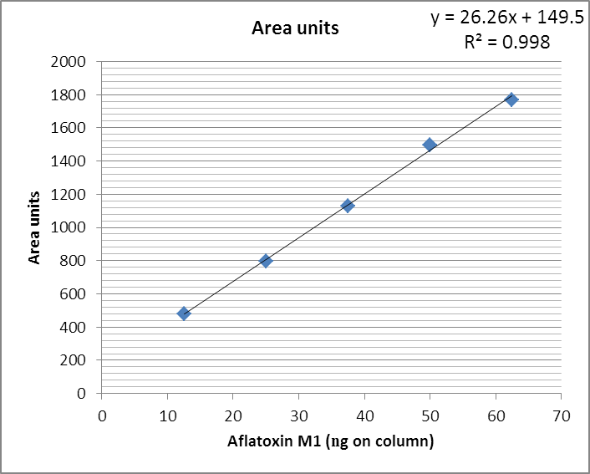
Figure 1.Chromatogram of raw camel milk AFM1 standard curve.

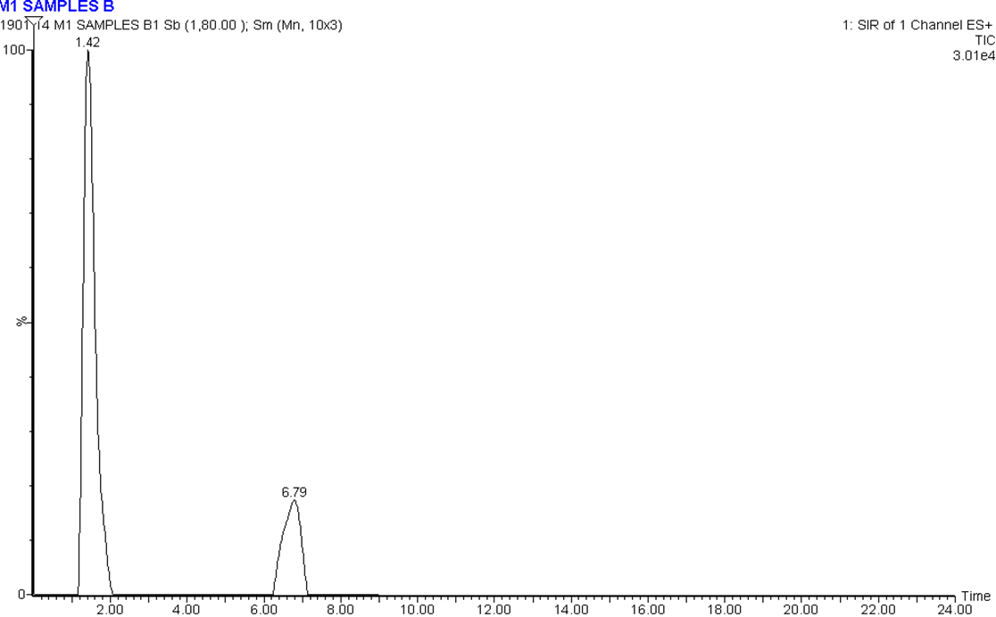
Figure 2. Chromatogram of raw camel milk AFM1 contaminated sample.

limit (Diaz & Espitia, 2006). Same results were stated by Motawee et al. (2009) with highest observed AFM1 level of 250 ng/l. in Punjab, City of Pakistan, 44% of raw camel milk exceeded the EC maximum limit (Muhammad et al., 2012).
The variations in AFM1 levels among studies could be associated to different reasons such as geographical region, country, season, feeding systems, farm management practices and analytical methods (Ayhan et al., 2010). One of the imperative reasons is hot and cold seasons, in almost all the districts the concentration of AFM1 in raw milk was lower in summer season and maximum in winter one. In view of the high levels of AFM1 in raw camel milk evidenced in our results and according to numerous authors, a seasonal effect influences AFM1 occurrence. Higher incidence of AFM1 contamination during cold seasons has been expressed by many researchers (Kamkar, 2005; Hussain & Anwar, 2008; Tajkarimi et al., 2008; Fallah, 2010 and Ruangwises & Ruangwises, 2010).
Increasing AFM1 levels in winter, as recorded in our results, may be due to shortage or unavailability of fresh green feed. Over and above in urban and semi-urban areas, as in our sampling area, there is less availability of green fodder and there is excessive use of conserved or stored concentrated feed such as corn, soybean, barley, wheat straw, paddy straw, and wheat bran. All these commodities are vulnerable to the attack of moulds and there is a high possibility of AFB1 presence in these commodities (Dutton & Kinsey, 1996). Moreover, green fodder and hay preserved as silage under inadequate storage conditions may be infected with toxigenic Aspergillus fungi and aflatoxins may be formed, as silage was reported to be a vector for AFB1 contamination in some studies(Tajkarimi et al., 2008; Herzallah, 2009; Heshmati&Milani, 2010 and Pereyra et al., 2011).
The specific Saudi Arabian climatic conditions prevalent during the winter of 2013, when our study was conducted, was ideal for promotion of Aspergillus fungal growth in silage and cereal feedstuffs with consequent production and accumulation of AFB1. The aflatoxigenic Aspergilli are generally regarded as storage fungi, proliferating under conditions of relatively high moisture/humidity and temperature. Aflatoxin is produced at a temperature of 12-40°C and requires 3-18% moisture (Duncan & Hagler, 2008). These conditions can be come to pass during transportation, processing and storage of imported animal feed ingredients, the main source of animal feed in Saudi Arabia beside local dried green fodders,. Beyond a doubt, there is a linear relationship between AFB1 in dietary intake of animals and levels of AFM1 in milk (Dragacci et al., 1995). So both environmental factors and type of feedstuffs used will influence AFM1 levels in milk (Van Egmond, 1989).
Milk production in Saudi Arabia is done in industrial and traditional dairy farms. Traditional dairy farming is most common system for camel breeding in Saudi Arabia, where camel feed is on farms and ranches. In Saudi Arabia, more than 90 percent of camel milk is consumed as raw so could be main source of the toxin for end users. Sorghum, alfalfa and barley are the main source of energy in feeding systems of the traditional dairy farms, which have been considered as an important source of the AFB1. There is a meaningful and significant effect of the farm type on the level of AFM1 contamination. Milk samples collected from industrial farms had low contamination AFM1 (39.5%) compare on traditional dairy farms samples (62.9%)(Da Silva et al., 2004). Therefore it is possible to say that the results obtained in the present work could be explained and came parallel to the results of prior researches.
According to results obtained in this study and other studies in Saudi Arabia and further countries, incidence and contamination levels of AFM1 in raw milk is alarming high and may pose a serious public health problem to human health. In this regard, camel milk have to be inspected and controlled continuously for AFM1 contamination. Our results indicate that feed/ration for the dairy camel might be heavily contaminated with AFB1. With the intention that, dairy camel AFB1 exposure must be reduced by regular checking of feed for AFB1 (Akkaya et al., 2006).The amount of AFB1 in animal feed can be minimized by taking care of cultural phases, including harvest and storage practices, that present critical points for fungal growth and mycotoxin production (Prandini et al., 2009).The present work is only a survey of AFM1 contamination in raw camel milk. A large-scale investigation is necessary to complete the risk assessment.

References
- Akkaya L, Birdane Y, Oguz H, Cemek M. Occurrence of aflatoxin M1 in yogurt samples from afyonkarahisar, Turkey. Bull Vet InstPulawy.2006; 50: 517-19.
- Amer A, Ibrahim M. Determination of aflatoxin M1 in raw milk and traditional cheeses retailed in Egyptian markets. Journal of Toxicology and Environmental Health Sciences.2010; 2: 50-53.
- Ayhan F, Sinan I, Fusun T. Survey of the occurrence of aflatoxin M1 in cheeses produced by dairy ewe’s milk in Urfa city, Turkey. Ankara Univ Vet FakDerg.2010; 57: 197-99.
- Balata M, Bahout A. Aflatoxin M1 in Camel’s Milk. Vet. Med. J. Giza. 1996; 44(2):109-11.
- Baskaya R, Aydin A, Yildiz A, Bostan K. Aflatoxin M1 levels of some cheese varieties in Turkey. Medycyna Wet 2006; 62: 778-80.
- CAST, Council for Agricultural Science and Technology. Mycotoxins: Risks in Plant, Animal, and Human Systems. CAST. 2003; Ames, IA, USA.
- Creppy E. Update of survey, regulation and toxic effects of mycotoxins in Europe. Toxicology Letters. 2002; 127(1e3): 19-28.
- Da Silva J, Dilkin P, Fonseca H, Correa B. Production of aflatoxins by Aspergillus flavus and of fumonisins by Fusarium species isolated from Brazilian sorghum. Brazilian Journal of Microbiology.2004; 35: 182-186.
- Dashti B, Al-Hamli S, Alomirah H, Al-Zenki S, Bu Abbas A, Sawaya W. Levels of aflatoxin M1 in milk, cheese consumed in Kuwait and occurrence of total aflatoxin in local and imported animal feed. Food Control. 2009; 20: 686-90.
- Diaz G, Espitia E. Occurrence of aflatoxin M1 in retail milk samples from Bogotá, Colombia. Food Additives and Contaminants.2006; 23: 811-15.
- Dragacci S, Gleizes E, Fremi J, Candlish A. Use of immunoaffinity chromatography as a purification step for the determination of aflatoxin M1 in cheeses. Food Additives and Contaminants. 1995;12(1): 59-65.
- Duncan H, Hagler M. Aflatoxins and other mycotoxins. Oklahoma Cooperative Extension. Fact Sheet (CR-2105-1203), Oklahoma, USA. 2008.
- Dutton M, Kinsey A. A note on the occurrence of mycotoxins in cereals and animal feedstuffs in Kwazulu Natal, South Africa. South Africa 1984–1993. J. Anim. Sci. 1996; 26: 53-57.
- EC, European Commission. Regulation no. 401/2006 of 23 February 2006, laying down the methods of sampling and analysis for the official control of the levels of mycotoxins in foodstuffs. Official Journal of the European Union. 2006; L70(12): 20-23.
- EU, European Union. European Commission Recommendation of 17 August 2006. On the prevention and reduction of Fusarium toxins in cereals and cereal products. Off. J. Eur. Union. 2006; L 234/35–L 234/40.
- Fallah, A. Aflatoxin M1 contamination in dairy products marketed in Iran during winter and summer. Food Control.2010; 21: 1478-81.
- Fallah A, Jafari T, Rahnama M. Determination of aflatoxin M1 levels in Iranian white and cream cheese. Food and chemical Toxicology.2009; 47: 1872-75.
- FAO, Food and Agriculture Organization, Worldwide regulations for mycotoxins in food and feed, Food and Agriculture Organization, Rome.FAO Food and Nutrition.2004; Paper, 81.
- GCC, Standardization Organization for Gulf Corporation Countries. The Maximum Limits of Aflatoxins in Foods and Feeds.1997; No. 1151.
- Hampikyan H, BarisBingol E, Cetin O, Colak H. Determination of Aflatoxin M1 levels in Turkish white, kashar and tulum cheeses. Journal of Food Agriculture and Environment 2010; 8: 13-15.
- Herzallah S. Determination of aflatoxins in eggs, milk, meat and meat products using HPLC fluorescent and UV detectors. Food Chemistry.2009; 114: 1141-46.
- Heshmati A, Milani J. Contamination of UHT milk by aflatoxin M1 in Iran. Food Control.2010; 21: 19-22.
- Hussain I, Anwar J.A study on contamination of aflatoxin M1 in raw milk in the Punjab province of Pakistan. Food Control, 2008; 19: 393-95.
- Hussain I, Anwar J, Asi M, Munawar M, Kashif M. Aflatoxin M1 contamination in milk from five dairy species in Pakistan. Food Control. 2010; 21;122-24.
- IARC, International Agency for Research on Cancer. Aflatoxins. In IARC Monographs on the Evaluation of Carcinogenic Risks to Humans; IARC Press: Lyon, France, 2002; 62: 171-300.
- Kamkar A. A study on the occurrence of aflatoxin M1 in raw milk produced in Sarab city of Iran. Food Control.2005; 16: 593-99.
- Kamkar A, JahedKhaniki G, Alavi S. Occurrence of aflatoxin M1 in raw milk produced in Ardabil of Iran. Iran. J. Environ. Health, Sci. Eng. 2011; 8: 123-28.
- Karimi G, Hassanzadeh M, Teimuri M, Nazari F, Nili A. Aflatoxin M1 Contamination in Pasteurized Milk in Mashhad, Iran. Iranian Journal of Pharmaceutical Sciences. 2007; 3(3):153-56.
- Kensler T, Roebuck B, Wogan G, Groopman J. Aflatoxin: A 50-year odyssey of mechanistic and translational toxicology. Toxicol. Sci. 2011; 120: S28-S48.
- Kocabas C, Sekerel B. Does systemic exposure to aflatoxinB(1) cause allergic sensitization? Allergy. 2003; 58(4): 363-65.
- Kuilman M, Maas R, Judah D, Fink-Gremmels J. Cytochrome P450-mediated metabolism and cytotoxicity of aflatoxin B1 in bovine hepatocytes. Toxicol. In Vitro.2000; 14: 321-327.
- Mahmoud M, Motawee M, Bauer J, Donald J. Survey of Aflatoxin M1 in Cow, Goat, Buffalo and Camel Milks in Ismailia-Egypt McMahon Bull Environ Contam Toxicol. 2009; DOI 10.1007/s00128-009-9840-3.
- Motawee M, Bauer J, McMahon D. Survey of Aflatoxin M1 in Cow, Goat, Buffalo and Camel Milks in Ismailia- Egypt. Bulletin of Environmental Contamination and Toxicology. 2009; 83 (5): 766-69.
- Motawee M, Meyer K, Bauer J. Incidence of aflatoxins M1 and B1 in raw milk and some dairy products in Damietta, Egypt. Journal of Agriculture Science, Mansoura –Egypt.2004; 29: 711-18.
- Muhammad R, Shahzad Z, Agustín A, Hussain A. Effect of seasonal variations and lactation times on aflatoxin M1 contamination in milk of different species from Punjab, Pakistan Food Control. 2012; 25: 34-38.
- Panahi P, Kasaee S, Mokhtari A, Sharifi A, Jangjou A. Assessment of Aflatoxin M1 Contamination in Raw Milk by ELISA in Urmia, Iran. American Eurasian Journal of Toxicological Sciences.2011; 3: 231-33.
- Paterson R. Aflatoxins contamination in chili samples from Pakistan. Food Control.2007; 18: 817-820.
- Pereyra M, Chiacchiera S, Rosa C, Sager R, Dalcero A, Cavaglieri L. Comparative analysis of the mycobiota and mycotoxins contaminating corn trench silos and silo bags. Journal of the Science of Food and Agriculture. 2011; 91:1474-81.
- Prandini A, Tansini G, Sigolo S, Filippi L, Laporta M, Piva G. On the occurrence of aflatoxin M1 in milk and dairy products. Food Chem Toxicol. 2009; 47(5): 984-91.
- Rastogi S, Dwivedi S, Khanna M. Detection of aflatoxin M1 contamination in milk and infant milk products from Indian markets by ELISA. Food Control.2004; 15: 287-90.
- Ruangwises N, Ruangwises S. Aflatoxin M1 contamination in raw milk within the central region of Thailand. Bulletin of Environmental Contamination and Toxicology. 2010; 85: 195-98.
- Sarimehmetoglu B, Kuplulu O, Celik T. Detection of aflatoxin M1 in cheese samples by ELISA. Food Control, 2004; 15: 45-49.
- Srivastava V, Bu-Abbas A, Alaa-Basuny Al-Johar W, Al-Mufi S, Siddiqui M. Aflatoxin M1 contamination in commercial samples of milk and dairy products in Kuwait. Food Additives and Contaminants.2001; 8: 993-97.
- Steel R, Torrie J. Principles and procedures of statistics.2nd ed. McGraw Hill, New York.1977; 137-67.
- Stoloff L, Van Egmond H, Parks, D. Rationales for the establishment of limits and regulations for mycotoxins. Food Additives and Contaminants. 1991; 8:213-21.
- Tajkarimi M, Aliabadi-Sh F, Nejad A, Poursoltani H, Motallebi A, Mahdavi H. Aflatoxin M1 contamination in winter and summer milk in 14 states in Iran. Food Control. 2008; 19,:1033-36.
- Tsakiris I, Tzatzarakis M, Alegakis A, Vlachou M, Renieri E, Tsatsakis A. Risk assessment scenarios of children’s exposure to aflatoxin M1 residues in different milk type from the Greek market. Food & Chemical Toxicology.2013; 56: 261-265.
- Van Egmond H. Aflatoxin M1: Occurrence, Toxicity, Regulation. In Mycotoxins in Dairy Products. Elsevier Applied Science: London, UK. 1989; 11–55.
- Yiannikouris A, Jouany J. Mycotoxins in feeds and their fate in animals: A review. In: Anim. Res. 2002; 51: 81-99.
- Zheng H, Yunliang Z, Lianjun L, ZengxuanC, Yiping R, Yongjiang W. An ultrahigh-performance liquid chromatographytandemmass spectrometry method for simultaneous determination of aflatoxins B1,B2, G1, G2, M1 and M2 in traditional Chinese medicines. Analytica Chimica Acta. 2010;664: 165-71.

3/5/2014

