**Progress of Joint Forest Management in India with Special Reference to Jammu and Kashmir**

Nasir Rashid Wani1, Tanweer Hussain Malik2

1Faculty of Forestry, Sher-e-Kashmir University of Agricultural Sciences and Technology of Kashmir, Shalimar (J & K) India

2Department of Agriculture, Government of Jammu and Kashmir, India

[nasirwani2012@gmail.com](mailto:nasirwani2012@gmail.com)

## Abstract: The state of Forest Report, 2011 represents a grim situation vis-a vis the country’s forest cover, of the total 328.7 million hectares of the country’s geographical cover, only 67 million hectares (23.65%) is under forest tree cover, well behind the holistic goal of 33 per cent set in the National Forest Policy of 1988. Earlier overwhelming importance was given to commercial forestry and protection of forestry from the forest side rural community and forest dwellers by exclusion. This trend was reversed and local interests, environmental and ecological aspect were made paramount in the National Forest Policy (1988).To ensure that massive people involvement especially women and socially disadvantaged groups were to be organised in village institutions for protection and development of forest land, if need be, by interface of committed voluntary agencies (VA’s)/Nongovernmental during the 1990’s. This was particularly important to address the expectations and needs of society and by involving the local population in managing the forests sustainably. Though a successful programme ever since its inception for the first time in the state of West Bengal, implementation of Joint Forest Management in the country has highlighted several issues like appropriate mechanism of participation between the parties involved, its institutionalisation, lack of objectives, sustainability, adequacy of benefits to village community and pleasant experience for both – the dwindling status of country’s forest cover and the poor masses of our country.

**[**Nasir Rashid Wani, Tanweer Hussain Malik. **Progress of Joint Forest Management in India with Special Reference to Jammu and Kashmir.** *Nat Sci* 2014;12(3):127-131]. (ISSN: 1545-0740). <http://www.sciencepub.net/nature>. 19

**Key Words:** Forest department; Village committee; Joint forest management

## 1. Introduction

The forests in India have been a source of sustenance to millions of people. Presently about 23.65 per cent of the total area of India is under forest tree cover and is under the control of government in our country. Several independent estimates suggest that only about 10 per cent of the forest area is under good vegetation. The remaining forest lands are gradually reaching a stage of degradation where regeneration may became a very difficult task indeed. If left unattended the situation may assume such proportions as to make it almost impossible to recover the lost vegetation. The challenge before us is to work out how to revegetate such a large denuded lass mass and how to protect the lands with good forests. The most significant development in this aspect was the issuance of government of India’s circular dated 1st June, 1990 recommending all the states to adopt participatory approaches to forest management. Joint forest management is a fairly well known concept which came in the country after 1988 and West Bengal was the first state to adopt JFM (Tripathi, 2005). In India about 350 million people in around 200 000 villages are living in forest fringe areas. The state can effectively protect forests only by soliciting people’s participation in forest management. On the other hand, village communities as forest users take the responsibility for protecting and managing their forests with the forest department. In the late 1970's local communities got together and begun protesting against the indiscriminate destruction of the forests which had been relatively intact over centuries. They launched a movement called Chipko movement of the Himalayas (Gupta, 2006). The National Forest Policy of 1988 in India has also recognized the interdependence between people and forests, and envisages active community participation in the protection and development of forestlands for sustainability of forest management (Sarker and Das, 2008).

Joint Forest Management (JFM) is the sharing of products, responsibilities, control and decision making authority over forest lands and forest produce between forest department and local communities based on formal agreement. Joint Forest Management which become the prominent agenda of Indian forestry in the beginning of the last decade basically introduced a need to focus on people rather than trees. It establishes mechanisms through which local communities take part in decision making power and implementation agency (Lise, 2000).

However, while the arguments of JFM are both powerful and convincing implementation and delivery has been complicated and organisationally challenging (Jattan and Pratima, 2001). Efficiently implementing JFM necessitates a careful and difficult blending a local national and sometimes international interests and institutions as well as reconciling multiple and sometimes conflicting objectives. In this process various psycho-social factors operate as far as forest service officers and community relationship building is concerned (Bahuguna, 1997). They also suggests that unless socio-cultural inputs are properly analysed and give due weightage the efficacy of JFM will always remain at stake. Relevance of behavioural issues of JFM has been further increased to learn the process of change in forestry organisations, local people and the interface between the two.

## 2. Objectives of JFM

* To elicit active participation of villagers in creation, management and protection of plantations.
* To achieve ecological needs consonant with sustainable productivity of wood and other non-timber forest resources.
* To wean way the land owing communities from shifting cultivation by adopting an alternative i.e., tree farming.
* To productively utilize the degraded Jhum lands there by checking soil erosion.
* To conserve biodiversity through peoples action.
* To create and generate forest based economy for the villagers

## 3. Objectives of National Forest Policy (1988) related to JFM

Government of India on June 1st, 1990 issued guidelines to the state government for involving local communities in the protection and development of the degraded forest lands. Formulation of the national forest policy of 1988 is seen as the beginning of the present shape of JFM in the country. Among the basic objectives related to JFM of this policy are:

* Meeting the requirement of fuel wood, fodder, minor forest products and small timber of the rural and tribal population
* Creating a massive peoples movement with involvement of women for achieving these objectives and to minimize the pressure on existing forests.

Based on these objectives Ministry of Environment and Forests issued a circular (No. 06-21/89-F.P. dated: 1st June, 1990) to forest secretaries of all states and union territories of the country. It made a call for people’s involvement in regeneration of degraded forest lands. This was followed by JFM resolutions by different state governments which provide the basic frame work for the peoples participation in forest management. The JFM resolution contains benefits to the communities, responsibility of community and forest department and also provides a concrete basis for detailed instructions to implement staff of Forest Department (FSI, 2008).

The JFM programme has been launched in 22 states. The (Table 1) gives a clear picture regarding the programmes of JFM in these states.

Table 1. Progress of Joint Forest Management in India

|  |  |  |  |
| --- | --- | --- | --- |
| S. No. | State | No. of JFM committees | Area under JFM (ha-1) |
| 01. | Andra Pradesh | 6575 | 1,6632,190,00 |
| 02. | Arunachal Pradesh | 10 | 5,285,00 |
| 03. | Assam | 101 | 3,060,00 |
| 04. | Bihar | 1675 | 935,065,50 |
| 05. | Gujarat | 706 | 91,071,28 |
| 06. | Himachal Pradesh | 203 | 62,000,00 |
| 07. | Haryana | 350 | 60,735.00 |
| 08. | Jammu and Kashmir | 1559 | 79,273.00 |
| 09. | Karnataka | 1212 | 12,800.00 |
| 10. | Kerala | 21 | 4,000.00 |
| 11. | Madhya Pradesh | 12038 | 5,8000,000.00 |
| 12. | Maharashtra | 502 | 94,727.00 |
| 13. | Mizoram | 103 | 5,879.00 |
| 14. | Nagaland | Nil | Nil |
| 15. | Orissa | 3704 | 419,306.00 |
| 16. | Punjab | 89 | 38,991.00 |
| 17. | Rajasthan | 2705 | 235,634.00 |
| 18. | Sikkim | 98 | 2,191.00 |
| 19. | Tamil Nadu | 599 | 224.,382.00 |
| 20. | Uttar Pradesh | 157 | 16,227.30 |
| 21. | Uttar Pradesh | 197 | 34,589,36 |
| 22. | West Bengal | 3431 | 490,582.00 |
|  | Total | 36075 | 10,247,959.41 |
|  | (MOEF, 2006) | | |

The table indicates that highest numbers of JFM committees were formed in M.P. i.e., 12038 whereas no committee was formed in Nagaland. The total number of JFM committees in all the states was 36075. Madhya Pradesh also ranked 1st in terms of area under JFM which was 5.8 million hectare whereas, the total area under JFM was 10.247 million hectare.

## 4. Conditions for successful Joint Forest Management

Society for promotion of waste lands development (SPWD) has suggested that JFM will be most successful where there is:

* There should be strong community forest management group;
* There should be high degree of homogeneity within the community; the highest being in a tribal group;
* There should be degree of effective leadership;
* The local people should have easy access to rules and regulations;
* There should be relatively high degree of environmental concern;
* There should be high level of importance to social/religious role of forests, given by the community
* There should be shared perception of acute resource scarcity

**Care and share in JFM**

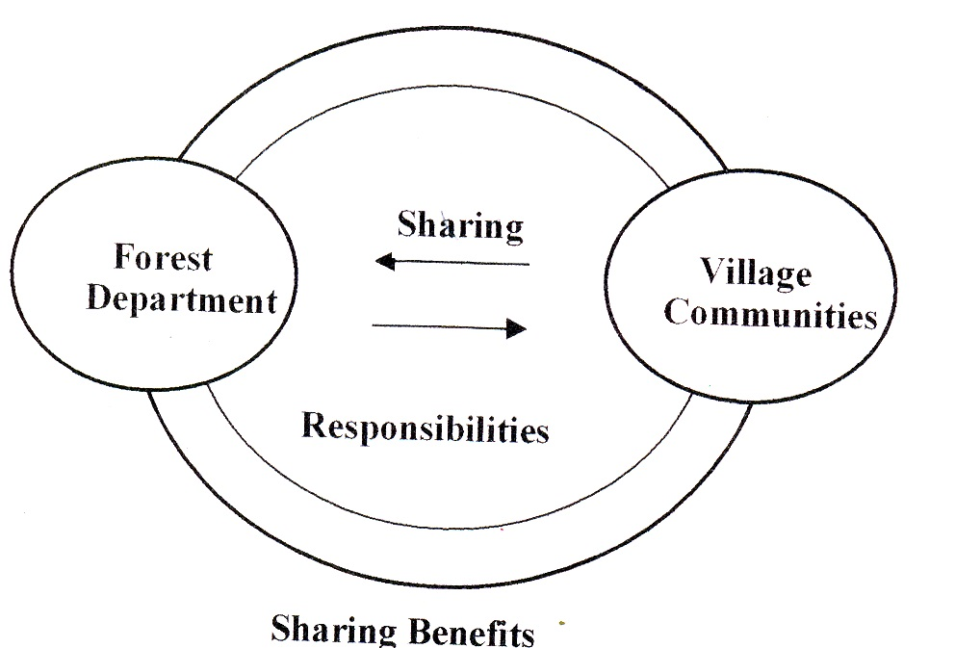

The Joint Forest Management is the sharing of three basis things:

* **Sharing the benefits**

Exchange of benefits from forest department to village community and vice versa e.g., exchange of tangible goods from forest department like (fire wood, timber and NWFP) to village community and vice versa i.e., village community in turn given protection, FYM and labour availability etc.

* **Sharing the responsibilities**

Forest department is bound to provide fuel wood, timber; NWFP and other intangible benefits to village community and village community in turn are bound to provide FYM, labour available forest wealth.

* **Sharing the concerns**

A forest department should clear heartedly provide overall welfare to village community and village community should sincerely provide their serves for forest department.

**5.** **Progress of Joint Forest Management**

**5.1 Preparatory phase**

* **Environment creation**

An overall environment for Joint Forest Management can be created through suitable policy Changes and on appreciation of participatory approach.

* **Team building**

A good tem of dedicated field workers is a must for initiating dialogue with communities. The team should involve not only motivated staff but also those who could be easily motivated over a short period of time.

* **Vision sharing**

The members of the team should share a common vision about the ultimate goal and the process of participation. This would ensure harmony and result into conflictless effective working.

* **JFM oriented human resource development**

Human resource development within the organisation is also a crucial aspect of JFM. The team of selected field workers would require special training in “social skills” and techniques like PRA. People oriented new silvicultural practices could be developed only by such people through a continuous dialogue with the participating communities.

**5.2 Operational phase**

* **Village level institution building**

Building a strong and self-sustaining institution at the village level is a pre-requisite of successful JFM. This would be in accordance with the JFM resolution of the State Government concerned. Identification of suitable village, regular meetings with the villagers and discussion on objectives of JFM would be followed by constitution of village level JFM committee (Forest Protection Committee or named otherwise) with members from each household. Election of Chairperson, vice-chairperson and constitution of an executive body would ensure systematic functioning of the committee.

* **Micro planning**

A micro plan is a village level document prepared with active participation of the residents of the village, keeping in view the local requirements, local resources, local people and local opportunities. A good micro plan has to be ecologically sound, economically workable and socially acceptable.

* **Resource mobilisation**

It includes systematic and well planned mobilization of different resources for the implementation of the approved micro plan. These may be, human resource, financial resource or natural resources. It is very necessary to adopt an open and transparent pattern or resource mobilisation for proper conflictless working of the JFM committees.

* **Field operations**

These include protection measures like elimination of illicit felling and forest fires; reduction in grazing incidence and soil erosion in forest areas allotted to the communities. Improved forest floor management, adoption of naturally available seedlings and saplings, cut-back operations to promote coppice growth, soil and water conservation measures and gap planting of species preferred by local people are other forestry activities to be taken up under field operations.

* **Sharing benefits**

After successful protection and management of the area allotted to the committees, over a period of time, harvesting and sharing of usufructs becomes the most important aspect of JFM. A very transparent and unambiguous system of sharing benefit should be developed to sustain JFM.

**6. Basic JFM traits**

**6.1 Participation**

People’s participation brings to a programme the full contributions of local knowledge, skills and resources, resulting in more effective, efficient and sustainable initiatives

**6.2 Transparency**

Transparency should be at two levels within :

* Forest protection committee level (FPC)
* FPC-Forest Deptt. Interface

**6.3 Self imposed rules**

Acceptance of rules by the communities is much better if rules are self imposed.

**6.4 Awareness**

High awareness among communities about their forest resources and rules governing forest protection would leaf to the effectie JFM

**6.5 Initiatives and independence**

Degree of freedom and independence in decision making process is another vital aspect of proper functioning of forest protection committee.

**6.6 Tenure**

Regeneration of forest becomes possible because of their protection and a strong sense of ownership.’

**6.7 Satisfaction of needs**

Satisfaction of bonafide needs of communities from the forest under protection leads to the sustained existence of forest protection committee.

**7. Emerging issues of JFM**

There should be mechanism of participation between the parties involved.

**7.1 Problems in institutionalisation of the programme:** Once the programme is implemented there should be no problems in its utilization. The implementation programme should be adequate and trust worthy.

**7.2 Lack of clarity between objectives of JFM:** The objective of JFM should be well defined. Nothing should be obscured.

**7.3 Adequacy of benefits from JFM to village communities:** Maximum benefits should be given to village community.

**7.4 Sustainability of programme:** The program should be sustainable it should be long lasting so that welfare of the village communities is met.

**7.5 Integration of JFM and rural development:** The JFM and rural development should be fully integrated. The sole objective of JFM should be overall development of rural communities.

Table 2. Progress of Joint Forest Management in Jammu and Kashmir

|  |  |  |  |
| --- | --- | --- | --- |
| S. No. | Forestry development  agency | No. of VDC | Area covered  in hectares |
| 01. | Udhampur | 20 | 430 |
| 02. | Ramnagar | 19 | 513 |
| 03. | Billawar | 25 | - |
| 04. | Kathua | 18 | - |
| 05. | Jammu | 22 | 468 |
| 06. | Doda | 19 | 250 |
| 07. | Marwah | 32 | 400 |
| 08. | Ramban | 44 | 540 |
| 09. | Batote | 15 | 376 |
| 10. | Kishtwar | 53 | - |
| 11. | Mahore | 29 | - |
| 12. | Poonch | 28 | 450 |
| 13. | Rajouri | 21 | - |
| 14. | Reasi | 14 | 730 + |
| 15. | Nowshera | 11(+) | 400 |
| 16. | Leh | 23 | - |
| 17. | Kargil | 34 | 552 |
| 18. | Kehmil | 54 | 263 |
| 19. | Kamraj | 58 | 393 |
| 20. | Langate | 40 | 507 |
| 21. | Baramulla | 39 | 365 |
| 22. | Bandipora | 39 | 190+ |
| 23. | Ganderbal | 27 | 530 |
| 24. | Peer Panjal | 77+ | 530 |
| 25. | Lidder | 30 | 502 |
| 26. | Shopian | 30 | 500 |
|  | Total | 869 | 8727 |

(Anon, 2006)

In Jammu and Kashmir there are 27 forest development agencies involved in Joint Forest Management. The (Table 2) indicates that the highest number of committees was found in Peer Panjal (77) where as lowest number was formed in Nowshera (11). The total number of committees formed in these areas was 869. Whereas, the highest area covered was found in Reasi i.e., 730 hectares and lowest number was found in Bandipora 190 hectares and total area covered was 8727 hectares.

**8. Adoption of JFM in Jammu and Kashmir**

In Jammu and Kashmir State, formation of village forest committee (VFC’s) was started in 1987 and it was in 1990 when MOEF, Government of India issue a circular to State Government to involve local communities in protection and development of degraded forest areas. 121 such communities had already been constituted in our state. Though the village forest committees had been constituted and functioning in the field there were no clear guidelines for the constitution of these committees as well as defining of their role and responsibilities. It was only in the year 1992 when government order regarding JFM was issued as SRO 61 dated 19th March, 1992 that all these things were finalized. Separate rules have been formed regarding formation and functioning or committees as well as sharing of benefits from degraded forest areas and community lands.

**8.1 Community lands**

Plantation on community lands are being raised by Social Forestry wing as per provisions of Government Orders – at each major harvest after establishment of plantation, social forestry department will recover 25 per cent share from the sale of fuel wood and 75 per cent of cash balance will be given to the village plantation committee free of cost.

**8.2 Degraded forest areas**

Under this the locals will be given 50 per cent share from each major harvest. The villagers are entitled to collected free of royalty without causing any damage to the plantation, fodder, dry and fallen timber etc.

### 9. Conclusion

### The pressure on forests and demand on forest produce are increasing every year and this has resulted in drastic reduction of forest areas. Our immediate aim is to prevent continuing degradation of forests and to reduce demand and supply imbalances by increasing productivity of forests. The problem of forest conservation and protection cannot be separated from the lives of dwellers and local population. Local communities have symbiotic relationship with forest and should be accepted as partner in the forestry development efforts. The best protective device for the existing forests and new additions is to create an interest of people in the forest wealth. Successful models of JFM are already available in various parts of the country. Realisation has come to recognise forest dwellers as part of forest ecosystem and treating their needs as first charge on the forests. Joint Forest Management (JFM) helped to reduce illicit felling of trees, reduce area under illegal encroachments, forest fire prevention and control by community involvement and to enhance the forest cover through afforestation programme and non-timber forest products which have impacted on the livelihood of the villagers.

**Corresponding Author:**

Nasir Rashid Wani

Faculty of Forestry, Sher-e-Kashmir University of Agricultural Sciences and Technology of Kashmir, Shalimar (J & K) India

E- mail: [nasirwani2012@gmail.com](mailto:nasirwani2012@gmail.com)

**References**

1. Anonymous. Annual Administrative Report, forest statistics division, J&K forest department, Kashmir 2006.
2. Bahuguna VK. Joint Forest Management: Emerging issues. Indian Forester 1997; 123(1):472-476.
3. FSI. State Forest Report 2009. Dehradun, India 2008; 199pp.
4. Gupta HK. Joint Forest Management: Policy, Participation and Practices in India. International book distributors Dehradun, India 2006; 47pp.
5. Jattan SS, Pratima. Participatory Forest Management objectives in India. Indian Forester 2001;127(5):505-511.
6. Lise W. Factors influencing peoples participation in Forest Management in India. Ecological Economics 2000; 34:379-392.
7. MOEF. Annual Report, Ministry of Environment and Forests, government of India 2006.
8. Sarker DN, Das N. A study of economic outcome of joint forest management programme in West Bengal: the strategic decisions between government and forest fringe community. Indian Economic Review 2008; 43(1):17-45.
9. Tripathi SP. Status of Joint Forest Management in Nagaland. Indian Forester 2005; 1158-1170.

3/1/2014