Micropropagation of Some Peach Rootstocks

Edriss M. H., Baghdadi G.A., Abd El-Razek, A. M., Abdrabboh G. A. and Abdel-Aziz, H. F.

Department of Horticulture, Faculty of Agriculture, Al-Azhar University, Nasr city, Cairo, Egypt.
gabdrabboh65@yahoo.com

Abstract: This work was an attempt to develop an In vitro technique for propagation of Nemaguard and Okinawa peach rootstocks. The two rootstocks were cultured on MS medium supplemented with different concentrations of BA and IAA either alone or in combinations. Axillary buds were evaluated as explants. Data reported that addition of 0.5 mg / L BA to MS medium encouraged shoot proliferation compared with other treatments and control. Also, adding IAA at 0.1 mg /L to MS medium enhanced shoot proliferation compared with control. Addition of BA alone at multiplication stage at any concentration used was superior to 2iP regarding multiplication rate of shoots. The combination between BA and 2iP at 2.0+2.0 mg / L for each recorded the highest shoot number in comparison to other treatments and control. Moreover, maximum root number and root length was occurred when MS medium was supplemented with combination between NAA and IBA at 1.0 mg / L for each.
[Edriss M. H., Baghdadi G.A., Abd El-Razek, A. M., Abdrabboh G. A. and Abdel-Aziz, H. F. Micropropagation of Some Peach Rootstocks. Nat Sci 2014;12(3):106-114]. (ISSN: 1545-0740). http://www.sciencepub.net/nature. 16

Keywords: Micropropagation, Nemaguard, Okinawa peach Rootstocks.

1. Introduction
Peach tree is one of the most important deciduous fruit grown in Egypt, while the harvested area reached 33017 ha and produced 333487 tons (FAO, 2012). Peaches, Prunus persica L., which belong to the family Rosacea, are originated in China. Peach ranks second to apple among temperate zone deciduous fruit trees from the standpoint of production and value, (Childers 1978). A peach tree is highly demanded by Egyptian consumers. There are many peach varieties growing more widely now throughout the world. Peaches are native to China and their culture dates back to at least 4000 years (Wang, 1985).Advantages of Nemaguard peach rootstock exploited as a suitable, compatible rootstock for peach varieties, have high tolerance to nematodes, less fertile soils. Chilling requirements with high. Nemaguard’ seedlings are uniform and vigorous, compatible with peach and nectarine cultivars, and impart excellent scion vigor and productivity. It has good resistance to M. incognita, M. javanica and M. arenaria that can reproduce in the roots of ‘Nemaguard’ (Nyczepir and Beckman, 2000). Nemaguard’ is fairly tolerant to crown gall, but is sensitive to P. vulnus, fungal root rots, Verticillium, iron chlorosis and root water logging and may reduce winter hardiness of scion cultivars in cold climates. On the other hand Okinawa peach rootstock, exploited as a suitable, compatible rootstock for peach varieties, have high tolerance to nematodes, less fertile soils, less chilling requirements, primary of ripening and propagated with seeds (Ehsanpour and Amini 2001). Genotype might be an efficient technique for overcoming conventional peach propagation problems such as resolve the seasonal dependence for grafting. This technology has the potential for large scale of Prunus spp. plants production in a short period. Finally, the technique presents several advantages and could offer serious opportunities for rapid mass propagation for healthy plant materials. Growth regulators are the most important influence factors in shoot regeneration (Bhojwani & Razdan 1996). In Prunus spp., some growth regulators such as Benzyl aminopurine (BAP), kinetin (Kin) and (2ip) have been exploited for shoot regeneration (Mant et al. 1989). Adventitious shoot formation is being significantly affected by the type and concentration of the cytokinin used in regeneration media. Also, Indole-butyric acid (IBA) and NAA could improve adventitious bud development in almond (Ainsley et al. 2001). To induce this process, growth regulators (cytokinins) are added to the culture medium in order to reduce apical dominance. For peach, the most frequently used growth regulators are benzyl aminopurine (BAP) and kinetin, with concentrations varying from a minimum 0.5–0.6mg/1 to a maximum of 1–1.2 mg/1 in relation to the genotype and type of explant (Loreti et al. 1988). Therefore, the main goal of this study was to establish a micropropagation protocol for Nemaguard and Okinawa peach rootstocks in order to produce a large scale of plants in a short period.

2. Materials and Methods
Axillary buds of the two rootstocks were collected from peach seedlings grown in greenhouse of Department of Horticulture, Faculty of Agriculture, Al-Azhar University. The experiments were carried out at the laboratory of plant tissue culture, Department of Horticulture, Faculty of Agriculture Al-Azhar University during the period from 2012 to 2013. Axillary buds were surface sterilized by immersion in 70 % ethanol for 30 sec, then washed with dsd water (1x) then immersed in 0.1% mercuric chloride (Hg Cl₂) solution for 3 min and then washed with dsd water (1x) and then immersed in 10 % of commercial Clorox solution containing a few drops of tween-20 for 15 min and subsequently rinsed several times with sterile distilled water. The cultivation was done in 300 ml glass jars containing 50 ml of basal MS- medium, (Murashige & Skoog, 1962). Media were solidified by 0.7% agar added prior autoclaving at 1.2 kg / cm² for 20 min. Then PH of the medium was adjusted to 5.8 by addition of 0.1 N HCl or 0.1 N NaOH. The incubation was done in a growth chamber at 27±2 ^{о}C and exposed to a 16 h / day photoperiod at an intensity of 1500 lux from cool white fluorescent lamps, or incubated in the darkness. These cultures were used as a mother stock for the subsequent proliferation experiments. The following experiments were done.
Starting stage.
Effect of some growth regulators on plant regeneration.
To study the effect of growth regulators on plant regeneration of both Nemaguard and Okinawa peach rootstocks, MS- media were supplemented with IAA at 0.0 and 0.1 mg /L or BA at 0.0, 0.5, 1.0, 2.0 and 4.0 mg /L either alone or in combinations to achieve this goal. In this regard five explants per jar and five replicated jars per treatment were used. Shoot fresh weight, shoot length, shoot number and leaves number were recorded as a growth parameters.
Multiplication stage.
This experiment was conducted to study the effect of BA and 2iP either alone or in combinations on shoot multiplication of the two tested rootstocks. In this regard, shoots which were obtained from starting stage were transferred to jars containing MS medium supplemented with BA or 2iP at concentrations of 0.0, 1.0, 2.0 and 4.0 mg / L for each either alone or in combinations. Shoot number, shoot length, leaves number and shoot fresh weight were recorded either after four or eight weeks, as growth parameters. Shoots were subjected to light with photoperiod of 16 h / day. There explants per jar and 5 replicated jars were used.
Rooting stage.
Effect of auxins on root formation.
This experiment was carried out to study the effect of NAA and IBA at 0.0, 1.0 and 2.0 mg /L either individually or in combinations on rooting percentage, roots number and root length of both Nemaguard and Okinawa peach rootstocks, which were recorded as root growth parameters.
Statistical Analysis: a complete randomized design was followed and analysis of variance (ANOVA) was performed using two ways ANOVA Co-stat software according to Stern (1991).

4. Results and Discussion
4.1. In vitro production of Nemaguard peach rootstock.
Starting stage.
Effect of growth regulators on the morphogenesis.
4.1.1. Effect of BA
Data in Fig. 1 showed the effect of BA on the morphogenetic characteristics of Nemaguard and Okinawa peach rootstocks. It was clear that shoot length (cm), leaves number and shoot fresh weight (g) as parameters indicating the morphogenesis and growth as well as shoot number that expressed the multiplication rate were dependent to a great extent on both concentration of BA and genotype. In general, all tested BA concentrations enhanced the morphogenetic characteristics of Nemaguard and Okinawa peach rootstock in comparison to those of control treatments. Also, data cleared that MS media supplemented with BA enhanced both shoots number and shoot fresh weight (g) in comparison to those of control. In this regard, BA at 1.0 mg /L caused the highest values of both fresh weight and shoot numbers in comparison to those of control and other treatments. Okinawa peach rootstock was superior to Nemaguard. The results are in agreement with those of Mahdavian et al. (2011), who reported that maximum shoot length of cherry rootstock was achieved when culturing on MS media supplemented with 0.5 mg / L BA followed by those cultured on 1.0 mg / L of BA. The increase all morphogenetic characteristics (parameters) of Nemaguard peach rootstock may be due to the physiological role of BA which is thus to break the apical dominance and stimulate growth of new shoots. (Pruski et al 2005).
4.1.2. Effect of IAA on the morphogenesis and plant regeneration.
Data in Fig. 1. showed the effect of IAA on the morphogenetic characteristics of Nemaguard and Okinawa peach rootstocks. Shoot length (cm), leaves number and shoot fresh weight (g) parameters of the two tested rootstocks were enhanced by adding IAA at 0.1 mg / L to MS media in comparison to those cultured on control treatments. There was a significant difference between the two rootstocks in their morphogenetic characteristics such as average of shoots length (cm), leaves number and shoot fresh weight (g) where Okinawa rootstock possessed the highest values after four and eight weeks compared with Nemaguard peach rootstock.
4.1.3. Effect of combination between BA and IAA on the morphogenesis and plant regeneration.
Data in Fig. 1. also showed the effect of combination between BA and IAA on the morphogenetic characteristics of Nemaguard and Okinawa peach rootstock. Shoot length (cm), leaves number and shoot fresh weight (g) as parameters indicating the morphogenesis and growth as well as shoot number that expressed the multiplication rate were dependent to a great extent on kind of growth regulator concentrations and genotype. In general, all tested BA concentrations combined with 0.1mg / L of IAA enhanced the morphogenetic characteristics of Nemaguard and Okinawa peach rootstocks in comparison to those of control treatment, where both shoot length and leaves number parameters recorded the highest values when MS media were supplemented with 0.5 mg / L of BA plus 0.1 mg / L of IAA. The results are in agreement with those of Sharifmoghaddam et al. (2011), who reported that maximum shoot length of GF677 rootstock was obtained when MS medium supplemented with 1.0 mg / L of BA and 0.5 mg / L of IAA. The increase in shoot proliferation may be due to the physiological role of currently BAP is the most widely used cytokinin in the micropropagation industry due to its effectiveness and affordability. (Bairu et al. 2007).

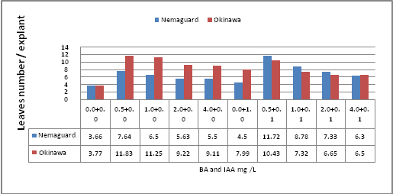 | 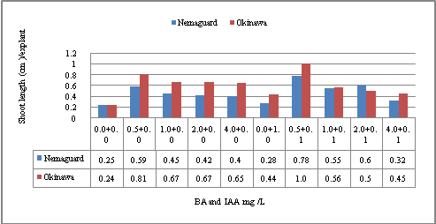
LSD at 5% T = 0.76 R = 0.34 T x R = 1.01 | LSD at 5% T = 0.05 R = 0.02 T x R = 0.08
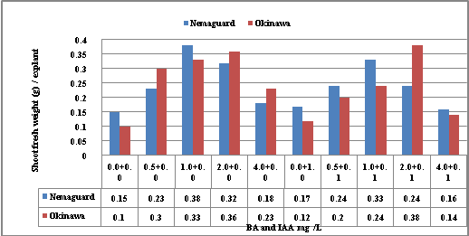 | 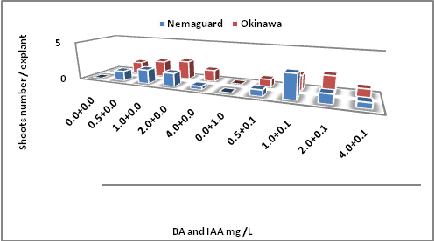
LSD at 5% T = 0.06 R = 0.02 T x R = 0.08 | LSD at 5% T = 0.18 R = 0.08 T x R = 0.25
Fig. 1. Effect of MS media supplemented with BA and IAA either individually or in combination on the morphogenetic characteristics of Nemaguard and Okinawa peach rootstock after eight weeks

Multiplication stage.
4.2. Effect of cytokinins on shoot multiplication.
4.2.1. Effect of BA
Data in Fig. 2 showed the effect of BA on the morphogenetic characteristics of Nemaguard and Okinawa peach rootstock. Data showed that the shoot length (cm), leaves number and shoot fresh weight (g) as parameters indicating the morphogenesis and growth as well as shoot number that expressed the multiplication rate were dependent to a great extent on kind and concentration of cytokinin used. In general, all tested BA concentrations enhanced the morphogenetic characteristics of Nemaguard and Okinawa peach rootstocks in comparison to those of control treatments. The results indicated that the effect of BA on enhancing morphogenetic characteristics was dependent on the concentration used where both shoot length and leaves number parameters of Nemaguard and Okinawa recorded the highest values when MS media were supplemented with 1.0 mg / L of BA, while the maximum shoot number and shoot fresh weight (g) / explant parameters were obtained at 2.0 mg /L of BA. Increasing the concentration of BA than 2.0 mg / L led to a significant decrease in all morphogenetic characteristics (parameters) where the results indicated that MS media supplemented with 4.0 mg / L of BA gained the least values in comparison to those of 1.0 and 2.0 mg /L of BA. There was a significant difference between the two rootstocks as the highest average of shoots length (cm), leaves number, and shoot fresh weight (g) recorded with Okinawa rootstock after four and eight weeks compared with those of Nemaguard peach rootstock, which possessed the least values. The results are in agreement with those of Radmann et al. (2011), who found that an increase in sprout percentage of Florida guard rootstock. They also reported that maximum shoot number / explant was obtained when medium supplemented with 4.0 mg / L.
The increase in shoot proliferation could be attributed to the physiological role of BA however high BAP concentrations can induce reduction in shoot height and increase in the hyperhydricity rates in plum trees (Leontiev- Orlov et al., 2000a).

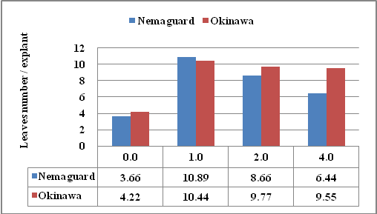 | 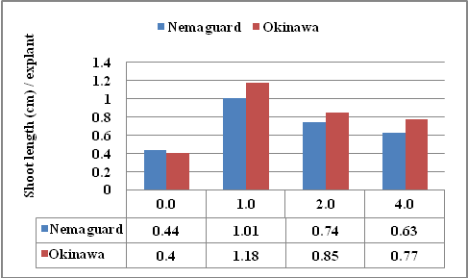
LSD at 5% T = 0.95 R = 0.64 T x R = 1.50 | LSD at 5% T = 0.11 R = 0.08 T x R = 0.16
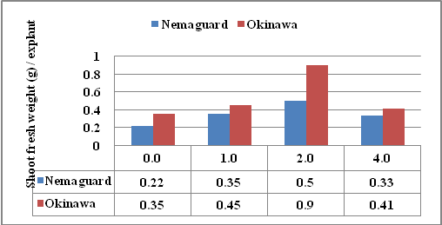 | 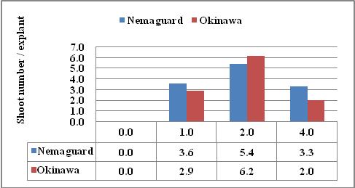
LSD at 5% T = 0.09 R = 0.06 T x R = 0.13 | LSD at 5% T = 0.41 R = 0.29 T x R = 0.58
Fig.2. Effect of MS media supplemented with BA at different concentrations on morphogenetic characteristics of Nemaguard and Okinawa Peach rootstock after eight weeks.

4.2.2. Effect of 2iP
Data in Fig. 3. showed the effect of 2iP on the morphogenetic characteristics of Nemaguard and Okinawa peach rootstock. It was clear that the shoot length (cm), leaves number and shoot fresh weight (g) as parameters indicating the morphogenesis and growth as well as shoot number that expressed the multiplication rate were dependent to a great extent on concentration of 2iP. In general, all tested 2iP concentrations enhanced the morphogenetic characteristics of Nemaguard and Okinawa peach rootstock in comparison to those of control treatments. The results also indicated that the effect of 2iP on enhancing morphogenetic characteristics was dependent on the concentration used where both shoot length and leaves number parameters of the two tested rootstocks recorded the highest volume when MS media were supplemented with 1.0 mg / L of 2iP. On the other hand, shoot number and shoot fresh weight (g) / explant parameters possessed the maximum values at 4.0 mg /L of 2iP. There was a significant difference between the two rootstocks as the highest average of shoots length (cm), leaves number, and shoot fresh weight (g) recorded with Okinawa rootstock after four and eight weeks compared with Nemaguard peach rootstock. Non-significant difference between the two rootstocks was noticed regarding shoots number after eight weeks. The results are in agreement with those of Soliman (2013), who found that maximum number of shoots obtained from a single shoot when cultured on WP medium containing 2 mg / L BA, 0.5 mg / L 2iP and 0.5 mg / L kinetin. The increase in shoot proliferation may be due to the effect of cytokinins especially when added in appropriate concentration where it regulates shoot proliferation, cell division and differentiation (Gross and Partiner, 1994). Plant growth regulator 2iP proved to be unsuitable for the proliferation of Sweet cherry Rivan cv.(Sedlák et al., 2007).

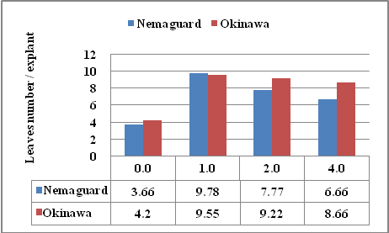 | 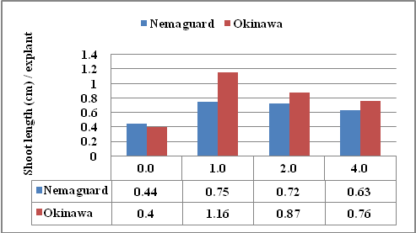
LSD at 5% T = 0.94 R = 0.66 T x R = 1.33 | LSD at 5% T = 0.09 R = 0.07 T x R = 0.14
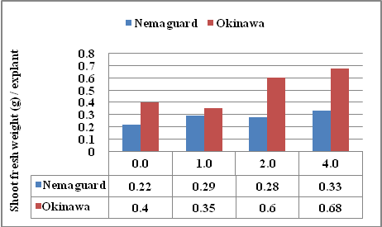 | 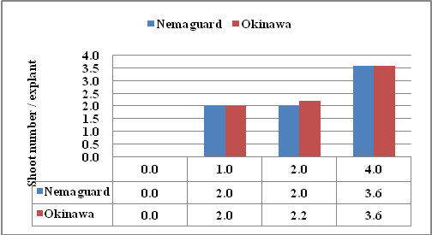
LSD at 5% T = 0.04 R = 0.03 T x R = 0.06 | LSD at 5% T = 0.35 R = 0.24 T x R = 0.49
Fig.3. Effect of MS media supplemented with 2iP at different concentrations on morphogenetic characteristics of Nemaguard and Okinawa peach rootstock after eight weeks.

4.2.3. Effect of combination between BA and 2iP
Data in Fig. 4. showed the effect of two types of cytokinins namely BA and 2iP on the morphogenetic characteristics of Nemaguard and Okinawa peach rootstock. It was clear that the shoot length (cm) leaves number and shoot fresh weight (g) as parameters indicating the morphogenesis and growth as well as shoot number that expressed the multiplication rate were dependent to a great extent to kind and concentration of the applied cytokinins. In general, all types of cytokinins enhanced the morphogenetic characteristics of Nemaguard and Okinawa peach rootstocks in comparison to those of control treatments. The results indicated that the effect of BA and 2iP on enhancing morphogenetic characteristics was dependent on the concentration used where both shoot length and leaves number parameters recorded the highest volume when MS media were supplemented with 1.0 or 2.0 mg / L of BA and 1.0 mg / L of 2iP while the shoot number and shoot fresh weight (g) / explant parameters possessed the maximum values at 2.0 mg /L of both BA and 2iP. Growth parameters such as shoot length (cm), leaves number, shoots number and shoot fresh weight (g) increased by increasing both BA and 2iP concentration up to 2.0 mg/L, while increasing BA and 2iP up to 4.0 mg/L decreased all morphogenetic characteristics (parameters) of the two tested rootstocks. Non-significant difference between the two rootstocks was noticed regarding to effect of combination between BA and 2iP at different concentration on shoot length (cm) and leaves number after eight weeks, while significant difference was noticed regarding the shoots number and shoot fresh weight (g) parameters. The results are in agreement with those of Lamrioui et al .(2011) who reported that maximum sprouting of Cherry obtained when juvenile material cultured on QL medium supplemented with 2.0 and 4.0 mg /L of BA in comparison to those cultured on QL media supplemented with 4.0mg /L 2iP.The increase in shoot proliferation may be due to kind and concentration of Cytokinin. The influence of cytokinins on tissue or organ cultures can be differed based on the kind of culture, the variety of plant and the age of explant. It also reported that BA is required at low concentrations ranging from 0.5 to 2.5 mg / L (Thorpe et al. 2008).

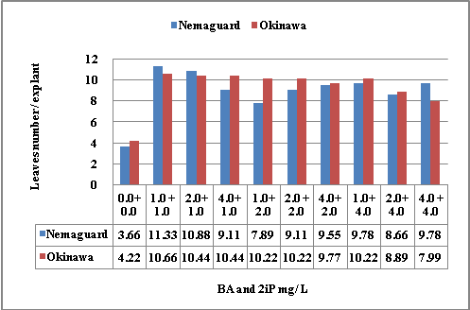 | 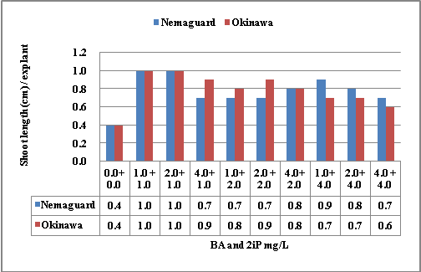
LSD at 5% T = 0.86 R = 0.38 T x R = 1.22 | LSD at 5% T = 0.10 R = 0.04 T x R = 0.15
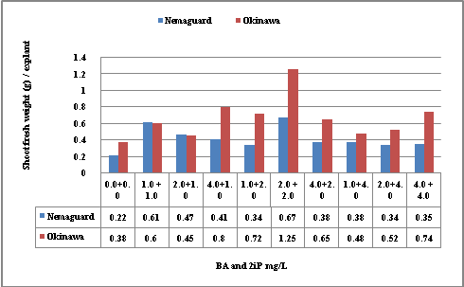 | 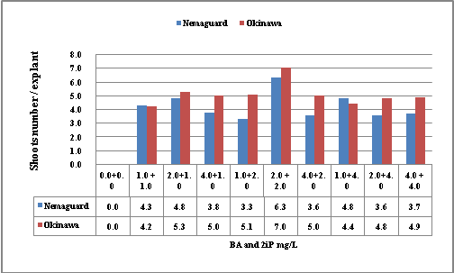
LSD at 5% T = 0.05 R = 0.02 T x R = 0.07 | LSD at 5% T = 0.44 R = 0.19 T x R = 0.62
Fig.4. Effect of MS media supplemented with combination between BA and 2iP at different concentrations on morphogenetic characteristics of Nemaguard and Okinawa peach rootstock after eight weeks.

4.3. Rooting stage.
The obtained shoots from the previous two stages (starting and multiplication) were transferred to rooting media containing half strength of the basal MS medium supplemented with two auxins, Naphthalene acetic acid (NAA) and Indole butyric acid (IBA) at concentration of 0.0, 1.0 and 2.0 mg /L Both auxins were supplemented either singly or in combination aiming to induce roots.
4.3.1. Effect of auxins on rooting characteristics.
4.3.1.1. Root number.
Data in Fig. 5. indicated that the greatest number of initiated roots per shoot obtained when shoots of Nemaguard and Okinawa peach rootstocks were cultured on half-strength MS medium supplemented with 2.0 mg /L of NAA in two tested rootstocks. Okinawa peach rootstock had the highest root number / shoot followed descendingly by Nemaguard. The data cleared that root number in the tow tested rootstock decreased significantly by decreasing NAA concentration in the growth medium. NAA at moderate concentration 2.0 mg / L stimulated root number more than low concentration 1.0 mg / L. It is worthy to mention that half-strength MS media without NAA produced no roots / shoot in the two tested peach rootstocks. These results are in agreement with that obtained by Fouad et al. (1995) who mentioned that cultures of the peach cultivars Nemaguard and Meet-Ghamre were rooted when cultured on half-strength MS medium supplemented with different concentrations of NAA, IAA and IBA. The highest rooting percentages were obtained with 2.0 mg/l NAA, 1.5 mg /L IAA and 1.0 or 1.5 mg /L IBA. Increasing the growth regulator concentration from 0.5 to 2.5 mg/l increased the number of roots/explant. Data in Fig. 5 also indicated that the highest average root number per shoot occurred when half-strength MS media was supplemented with 2.0 mg /L of IBA in the two tested rootstocks. Nemaguard peach rootstock had the highest root number / shoot followed by Okinawa. The data cleared that root number in the tow tested rootstock decreased significantly by decreasing IBA concentration in the growth medium. It is worthy to mention that half-strength MS media without IBA produced no roots / shoot in two tested rootstock. The results are in full agreement with those previously reported by many workers who found that root formation depended to a great extent on kind and concentration of auxins used (Hassanen and Gabr, 2012; Rogalski et al., 2003 and Canli and Tian, 2008)
Data also cleared that root number attained the maximum values when half-strength MS media were supplemented with combination of both NAA and IBA at 1.0 mg / L followed descendingly by NAA at 1.0mg /L and IBA at 2.0 mg /Lin comparison to those other treatments and control. The results are in full agreement with those. Sari-Eldeen et al. (1998) who found that Bourgen and Nitsch medium supplemented with 1.0 mg / L of either IBA or NAA or in combination, gave the maximum values of roots number and root length for both tested peach rootstocks
4.3.1.2. Root length
Results in Fig. 5 showed that supplementing half – strength MS media with auxins increased the root length in comparison to those cultured on MS media free auxins. The results indicated also that root length (cm) was enhanced when the media were supplemented with NAA at 1.0 mg / L compared with other treatments and medium free of auxins. IBA at 1.0 mg / L stimulated also the root length of Nemaguard and Okinawa peach rootstock compared with medium free of auxins, but to a less degree than did NAA. The increasing of IBA concentration to 2.0 mg / L led to a decreased in shoot length. A significant difference was noticed between the two rootstocks were maximum roots number recorded with Nemaguard rootstock after four weeks compared with Okinawa peach rootstock. These results are in agreement with that obtained by Alsalihy et al. (2004) who found that shoots cultivated on the MS medium with 1.5 mg / L of IBA produced the highest number of roots and the longest roots. Data also cleared that root length per explant as a parameter for root growth was enhanced in the presence of auxins, NAA or IBA at low concentrations compared with culturing the shoot on a medium free of auxins in the two tested Nemaguard and Okinawa peach rootstocks. The highest average root length per shoot was obtained in the presence of both NAA and IBA compared with those other treatments and control. Root length per explant of the two tested rootstocks were slightly depressed and inhibited in the presences of combination between IBA and NAA at high concentrations of Nemaguard and Okinawa peach rootstocks compared with control. There was a significant difference between the two rootstocks regarding root length Nemaguard rootstock possessed the highest values after four weeks compared with Okinawa peach rootstock. These results are in agreement with that obtained by Nagaty (2012)who found that the medium consists of half strength MS salts supplemented with NAA at 5.37 and 10.74 μ M was the best medium for rooting. These concentrations were significantly higher than IBA at 4.90 and 9.80 μ M whereas NAA proved to be superior to IBA with Okinawa and Nemaguard peach rootstocks and increasing the concentration of auxin was positively affected the average number of roots/explants.
4.3.1.3. Rooting percentage.
Data in Fig. 5 also showed the supplementing half –strength MS media with auxins increased the rooting percentage in comparison to those cultured on MS media free of auxins. NAA at 2.0 mg / L gave the maximum rooting percentage in tow tested rootstocks, against other treatments and control. The results also indicated that rooting percentage was somewhat enhanced when the media were supplemented with NAA at 1.0 mg / L compared with medium free of auxins. There was a significant difference between the two rootstocks were Okinawa rootstock possessed maximum rooting percentage after four weeks compared with Nemaguard of peach rootstock. These results are in agreement with that obtained by Zilkah et al. (1993) who found that the best rooting percentage of prunusobtained when shoots were cultured on half-strength MS medium containing 2.7 mg / L NAA. The data presented in in Fig. 5also indicated that the highest average rooting percentage of Nemaguard and Okinawa peach rootstocks occurred when half-strength MS medium supplemented with 1.0 and 2.0 mg / L of IBA. These results are in agreement with that obtained by Canli and Tian (2008)who found that the shoots of plum cultivars gained the highest rooting percentage when cultured on MS supplemented with NAA or IBA through rooting stage and were higher with 5.4 µm NAA than that of 14.8 µm IBA. Data also revealed that supplementing ½ MS media with combination between NAA at 1.0 mg / L and IBA at 1.0 mg / L caused the highest values of root percentage of two tested rootstocks in comparison to those of control and other treatments. There was a significant difference between the two rootstocks where maximum rooting percentage recorded with Okinawa rootstock after four weeks compared with Nemaguard of peach rootstock. These results are in agreement with that obtained by Canli and Tian (2008) who found that shoots of plum cultivars recorded the maximum values when cultured on MS supplemented with NAA or IBA through rooting stage. Rooting percentages were higher with 5.4 µm NAA than with that of 14.8 µm IBA.
The increase in root formation may be due to the physiological role of auxins. The beneficial effect of IBA on rooting has been observed in many plant species (Amri et al 2010; Cheniany et al. 2010 and Linh, 2001). Lack of rooting morphogenesis may be due to lack of cell sensitivity to respond to morphogenesis (Hartmann et al. 1997). Similarly, auxins are involved in the process of adventitious root formation. In many woody plants, IBA is commonly used to promote root initiation and the absence of IBA in the rooting medium did not lead to root formation (Torrey, 1976).

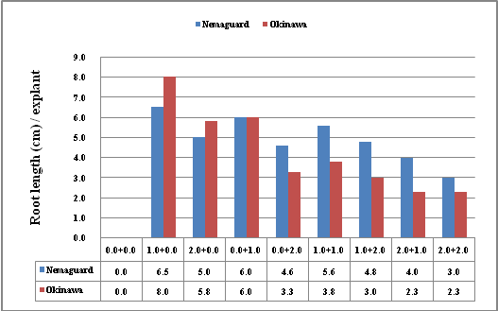 | 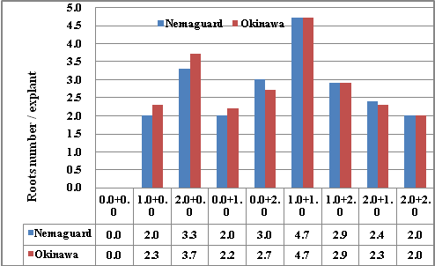
LSD at 5% T = 0.56 R = 0.26 T x R = 0.79 | LSD at 5% T = 0.36 R = 0.17 T x R = 0.63

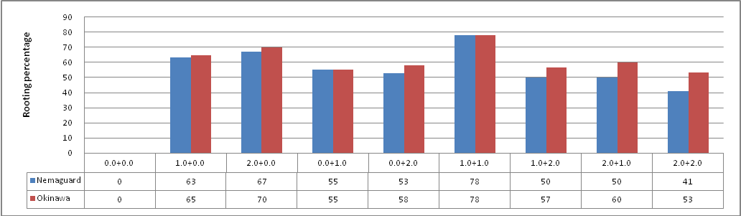
LSD at 5% T = 6.06 R = 2.80 T x R = 2.16
Fig.5. Effect of supplementing ½ MS medium with NAA and IBA either alone or in combinations on rooting characteristics of Nemaguard and Okinawa peach rootstock.

References
- Ainsley P. J., Hammerschlag F. A., Bertozzi T., Collins G. G., and Sedgley M., (2001). Regeneration of almond from immature seed cotyledons. Plant Cell Tiss Organ Cult. 67:21-226.
- Alsalihy A.W., Křižan B., Klemš M., Fišerová H., and Hradilík J. (2004). The effect of growth regulators on the rooting of sholte of the peach rootstock Ishtara in in vitro conditions. Hort. Sci., Pratur, 31: 124–131.
- Amri E, Lyaruu H V M, Nyomora A S, and Kanyeka. Z. L (2010).Vegetative propagation of African Blackwood (Dalbergia melanoxylon Guill. & Perr.): effects of age of donor plant, IBA treatment and cutting position on rooting ability of stem cuttings. New Forests 39:183-194.
- Bairu M W, Stirk W A, Dolezal K, and Staden J V (2007).Optimizing the micropropagation protocol for the endangered Aloe polyphylla: can meta-topolin and its derivatives serve as replacement for benzyladenine and zeatin. Plant Cell Tissue and Organ Culture 90:15–23
- Bhojwani S. S., and Razdan M. K., (1996). Plant tissue culture: theory and practice. Studies in Plant Science Vol. 5.
- Canli. F.A and Tian. L (2008).In vitro shoot regeneration from stored mature cotyledons of sweet cherry (Prunus avium L.) cultivars. Scientia Horticulture. 116 (1): 34-40.
- Cheniany M, Ebrahimzadeh H, Masoudi-nejad A, Vahdati K, and Leslie C (2010).Effect of endogenous phenols and some antioxidant enzyme activities on rooting of Persian walnut (Juglansregia L). African Journal of Plant Science 4(12):479-487.
- Childers, N. F. (1978).Modern fruit science, 8th edition, Horticulture Publication Rutgers University, the state University. New Brunswick, New Jersey, 08903 U.S.A.
- Ehsanpour A., and Amini, F., (2001). Plant cell and tissue culture. First edition. Jihad-edaneshgahi-e-Isfahan.
- Food and Agriculture Organization (2012). Available at: http://faoestat.fao.org. Accessed 24th Feb.
- Fouad, M.M; Gomaa. A. H; ElZaher, M. H. A; George, A. P and Shaltout, A. D. (1995). Factors in flouncing In vitro establishment and multiplication states of peach. Acta Horticulture 409:191-196
- Gross D. and Partiner B (1994) Novel natural substances acting in plant growth regulation. Journal of Plant Growth Regulation 13(2):93-114
- Hartmann, H.T., Kester, D.E., Davies, F.T., and Geneve, R.L., (1997). Plant Propagation Principle and Practices, 6th ed. Prentice-Hall of India Private Limited, New Delhi.
- Hassanen. S. A. and Gabr M. F. (2012). In vitro propagation of Pear Pyrus betulaefolia rootstock. American -Eurasian. J. Agric. & Environ .Sci (4).484-489.
- Lamrioui .A, Louerguioui. A, Bonaly. J, Yakoub-Bougdal. S, Allili N and Gana-Kebbouche. S (2011). Proliferation and rooting of wild cherry: The influence of cytokinin and auxin types and their concentration. African Journal of Biotechnology Vol. 10(43), 8613-8624,
- Leontiev-Orlov, O; Mossi, A. J ; Cansian, R. L.; Rogalski, M and Vendruscolo, T. (2000a). Diferentes reguladores de crescimentona multiplicação in vitro de ameixeira (Prunus domestica L.) cultivar Kantimirovskaja. Revista Brasileira de Fruticultura. 22(2):268-271
- Linh Le C (2001). Factors influencing in vitro rooting of chestnut. Forest Snow Landscape Research 3:468–470.
- Loreti, F., Morini, S. and Concetti, S. (1988). Effect of potassium and nitrogen concentration on growth of peach shoots cultured in vitro. Acta-Horticulturae 227, 311–317.
- Mahdavian. M, Bouzari. N And Abdollah. H. (2011). Effects of media and plant growth regulators on micropropagation of a dwarfing cherry rootstock (PHL-A) Biharean Biologist 5(2):86-90.
- Mant S., Scorza R., and Cordts J., (1989).Plant regeneration from cotyledons of Prunus persica, Prunus domestica and Prunes Ceraasus. Plant Cell Tiss Organ Cult 19:1-11.
- Murashige, T. and Skoog, F. A. (1962). A revised medium for rapid growth and bioassays with tobacco tissue cultures. Physiological Plant arum, 15: 473-479.
- Nagaty. M. A (2012). Establishment of Regeneration system for Taif peach (Prunus persica L. Batsch) cultivar (Balady cultivar) in Taif, KSA. Journal of American Science, 8(4): 232-239.
- Nyczepir, A.P. and Beckman, T.G. (2000).Host status of Guardian peach rootstock to Meloidogyne incognita and M. javanica. Hort-Science 35, 772.
- Pruski, K., Astatkie, T., and Nowak, J. (2005).Tissue culture propagation of Mongolian cherry (Prunus. Froticosa) and Nanking cherry (P. Tomentosa). Plant Cell, Tissue and Organ Culture 82: 207-211.
- Radmann, E. B., Bianchi, V. J., Fachinello, J. C., Ferreira, L. V., & Oliveira, R. P. D. (2011). In vitro multiplication of 'Flordaguard 'rootstock: cytokinin source and concentration effects, explants orientation and period of permanence in the culture medium. Brazilian Archives of Biology and Technology, 54(1), 25-34.
- Rogalski, M.; De-Moraes, L. K. A.; Feslibino, C.; Crestani, L.; Guerra, M. P.; Da-Silva, A. L.; De-Moraes, L. K. A. and Da-Silva, A. L. (2003). In vitro rooting of Prunus rootstocks. Revista-Brasileira-de-Fruticultura, 25: (2) 293-296.
- Sari-Eldeen, S. A.; Saeed, W. T. and Hassablla, I. A. (1998).Micropropagation of peach rootstocks. Bulletin-of-Faculty-of-Agriculture,-University-of-Cairo, 49: (4) 549-562.
- Sedlák,\J.,VyzkumnaSlechtitelskyUstavOvocnarsky, H., &Paprstein, F. (2007).In vitro propagation of blue honeysuckle. Horticultural Science-UZPI, 34.
- Sharifmoghaddam .N, JAD. A.S and Mohammad. S. (2011). The Effect of Plant Growth Regulators on Callus Induction and Regeneration of Amygdalus communis. Notulae Scientia Biological Not SciBiol, 2011, 3(3):97-100.
- Soliman. H (2013). In Vitro Regeneration and Genetic Transformation of Peach (Prunus Persica L.) Plants Life Science Journal, 10(2). 487-496.
- Stern, R. D. (1991). Review of 'CoStat- Statutical Software 'Experimental Agriculture, 27, pp 87-87.
- Thorpe, T., Stasolla, C., Yeung, E.C., de Klerk., G.J., Roberts, A. and Georg, E.F, (2008).plant growth regulators II: Cytokinins, their Analogues and Antagonsist. Plant propagation by tissu culture. third Ed, Vol 1, 115-173.
- Torrey J.G., (1976). Root hormones and plant growth. Annu. Rev. Plant Physiol., 27 435-459.
- Wang, Y. (1985). Peach growing and germplasm in China.ActaHort. 173:51-55.
- Zilkah, S.; Faingersh, E.; Rotbaum, A. and Stein, A. (1993).In vitro micropropagation of indicator plants for indexing Prunus necrotic ring spot virus. Acta-Horticulturae, No. 336, 121-125.

3/1/2014

