**Estimation of indoor Radon, Thoron and their progeny levels in some dwellings of District Yamuna Nagar of India using SSNTD**

Anil Pundir1, Sunil Kamboj2, Rajinder Singh3

1. Department of Electronics, M L N (PG) College, Yamuna Nagar, India
2. Department of Physics, GSSS Camp, Yamuna Nagar, India
3. Department of Electronics, SD (PG) College, Ambala Cantt, India

[anil.pundeer@rediffmail.com](mailto:anil.pundeer@rediffmail.com)

#### **Abstract:** The main source of indoor radon is 226Ra in soil, building materials, and tap water. The pathway for radon generation in rock and soil to its indoor accumulation is controlled by a number of geogenic and anthropogenic factors. Generally, indoor radon concentration is subject to seasonal variability. The exposure to alpha radiation emitted from radon, thoron and their progeny poses health hazards not only to workers at industrial units like thermal power plants, coal fields and oil fields but also to the dwellers in normal houses in their surroundings. Radon, thoron and their progeny are the major contributors in the radiation dose received by general population of the world. Radon being an inert gas can easily disperse into the atmosphere immediately on its release. The solid alpha active decay products of radon like 218Po and 214Po become airborne and get themselves attached to the aerosols, dust particles and water droplets suspended in the atmosphere. When inhaled during breathe, these solid decay products along with air may get deposited in the tracho-bronchial and pulmonary region of lungs resulting in the continuous irradiation of the cells which may be the cause of lung cancer. Keeping this in mind the environmental monitoring of radon, thoron and their progeny in some dwellings of Shivalik foot hills-India has been carried out. The radon thoron twin dosimeter cups are being used for the study. Three pieces of LR-115 solid-state nuclear track detectors are fixed in the dosimeters and are suspended in the dwellings for three months during a season. One gives radon, thoron and progeny concentration, second gives radon and thoron concentration while the third gives only the radon concentration. Out of different types of dwellings under study the levels are found to be higher in some dwellings in village Kaleser as compare to other places. The annual dose received due to radon-thoron and their progeny by the inhabitants in the dwellings under study have also been calculated.

**[**Anil Pundir, Sunil Kamboj, Rajinder Singh. **Estimation of indoor Radon, Thoron and their progeny levels in some dwellings of District Yamuna Nagar of India using SSNTD.** *Nat Sci* 2014;12(3):94-97]. (ISSN: 1545-0740). <http://www.sciencepub.net/nature>. 13

**Keywords:**Radon; Thoron; LR-115 type-II detectors; Shivalik Foot hills.

1. **Introduction**

Radon and thoron are the inert gases which arise from the radioactive decay chains of 238 U and 232 Th series[1]. Since radon and thoron are the members of different chains, so their ratio in the atmosphere depends upon the ratio of uranium to thorium in local soils, rocks or building materials etc. The radioactive half-lives of radon, thoron and their respective decay products are important in determining the exposure of people in work places and homes. Radon and thoron are ubiquitous in the air at ground level and offer significant contributions to the average dose from the natural background sources of radiation[2].

There are large number of small solid and liquid particles of air called as aerosols. These particles range in size from almost atomic dimension up to several micrometers in diameter. Radon and its progeny are found through the volume of building due to radioactive decay of radon[3]. Unlike radon, progeny can attach to the aerosol particles. The rate of attachment of the progeny to the ambient aerosol increases as the aerosols concentration increases. The attachment of radon and thoron progeny to aerosol particles is generally treated as electrostatic force guided diffusion process governed by the laws of kinetic theory of gases[4]-[5].

In tropical climates, indoor and outdoor concentrations are essentially the same because of rapid exchange between indoor and outdoor air[6]. The world wide outdoor levels of radon and thoron are about 10 Bqm-3 while that of indoor radon and thoron are estimated to be 40 Bqm-3 and 10 Bqm-3 respectively. Workers involved in the nuclear power plants and in the mining of uranium receive an average annual dose of 4.8 mSv. This is the largest average annual dose received by any type of workers and is considered entirely due to radon [2].

Radon itself may not be considered as serious health hazard, when it is inhaled and exhaled as only a small fraction of it decays within the lungs. 218Po and 214Po are the two immediate decay products of radon, which are alpha emitters. Due to high quality factor of alpha particles, they are more hazardous to health than gamma rays and beta particles. Most of the radon progeny, 218Po, is electrically charged (88%) as a result of the decay process, and a large proportion (90%) becomes attached to the aerosol particles due to high diffusivity. When these daughter particles are inhaled, they may get deposited within the bronchial regions causing hazard to lung tissues. [7]-[8]. Various studies also have shown that the largest and most radio logically significant doses to the population exposed to radon, thoron, and their air borne progeny arise from the alpha particles irradiation of sensitive lung tissue cells[9].

Radon and thoron enter into our dwellings by diffusion from building materials and soils (36%), advection from earth’s surface (41%), infiltration from outdoor air (20%), and from water supply and domestic gas (3%) [10]. The concentration of radon, thoron, and their progeny in the atmosphere varies depending on the place, time, height and depth from the surface of earth and meteorological conditions like atmospheric pressure, wind velocity, humidity, temperature etc, causing seasonal variations and hence show large temporal and local fluctuations in the concentration of these gases across the indoor atmosphere [11]. This is also based on the type of construction material used and soil beneath the floor of dwellings [12]-[3].

In the present study, variation of radon, thoron, and their progeny concentration along with annual effective dose have been reported in the dwellings located in Yamuna Nagar district of Haryana.

1. **Geography of Study Area**

The main study areas belong to Yamuna Nagar district of Haryana state, which is situated in India’s northwest between 27° 37´and 30° 35´ Northern Latitude and 74° 28´ to 77° 36´ East Longitude. The slope is from north to south. The climate of the area is of pronounced character, very hot in summer and markedly cold in winter. The normal temperature is recorded as 460 C in the month of May and June which may even rise to 480C in some areas of study. The location of study area is shown in “fig 1”.

1. **Experimental Technique Used**

For the measurement of concentration of radon, radon and thoron both, and total sum of radon, thoron and their progeny, in the dwellings, the radon-thoron mixed field dosimeter popularly known as, ‘Twin Chamber Radon-Thoron Dosimeters, as shown in “Fig 2” have been employed. Each twin chamber dosimeter cup having a provision for three detectors in bare, filter and membrane modes was loaded with LR-115 type II plastic track detectors and placed at suitable height in dwellings and away from the walls in order to protect the detectors from the reach of alpha particles emitted from the floor and the building construction materials [11].

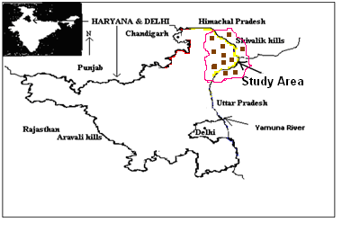

Figure 1: Geographical map of the study area for radon and progeny measurements

The detectors were removed after every 100 days and subjected to chemical etching in 2.5 N NaOH solutions at 600C (+/-1oC) for 90 minutes. The detectors were washed, dried and the tracks produced by the alpha particles were observed under an optical microscope at 600X for finding track density (track/cm2/day). The measured track density was converted into radon, thoron and their progeny concentrations using calibration factors [14]-[15].

If T is taken as track density observed on a SSNTD due to exposure in a given mode to a concentration C for a time t, then in general we take

T= K × C× t, (1)

where, K is calibration factor.

Therefore, following relations were used to determine the concentration of Radon (CR), thoron (CT), and progeny levels of radon {CR (WL)} and that of thoron {CT (WL)} [14]-[15]-[16].

CR  = TM**/** t KRM (2)

CT = TF - KRF CR t**/**t KTF  (3)

Progeny levels of Radon (WL) = CR (Bqm-3) x FR /3700 (4)

Progeny levels of Thoron (WL) = CT (Bqm-3) x FT /3700, (5)

Where TM = track density in membrane compartment

TF = track density in filter compartment

t = total exposure time

KRM= Calibration factor for radon in membrane mode

= 0.021 tr cm-2 d-1/ Bqm-3 (here tr stands for tracks)

KRF = Calibration factor for radon in filter mode

= 0.023 tr cm-2 d-1/ Bqm-3

KTF =Calibration factor for thoron in filter mode

= 0.019 tr cm-2 d-1/ Bqm-3

FR = Equilibrium factor for Radon having value of 0.4

FT = Equilibrium factor for Thoron having value of 0.1

Indoor inhalation dose received due to 222 Rn and its progeny, and 220 Rn and its progeny, has been estimated using the following relation [14]-[15].

D = {(0.17+ 9FR) CR+ (0.11+32FT) CT} x 7000 x10-6,

where FR = equilibrium factor for radon = 0.4

FT = equilibrium factor for thoron = 0.1 [2]

The relations given below evaluate the inhalation dose rate due to 222Rn and its progeny, and that of 220Rn, and its progeny i.e. for radon [17].

DR(mSv.y-1)=0.0265.CR (6)

and for thoron,

DT(mSv.y-1)=0.0233.CT, (7)

where DR is the indoor inhalation dose rate due to 222Rn and its progeny (mSv.y-1), CR is the indoor radon concentration (Bqm-3), DT is the indoor inhalation dose rate due to 220Rn and its progeny (mSvy-1), and CT is the indoor thoron concentration (Bqm-3).

Total inhalation dose will be the sum of doses obtained from eq. (6) and (7).

Here, the indoor occupation factor is taken as 0.8; equilibrium factor for indoor 222Rn as 0.4, and for 220Rn it is taken as 0.1[2].

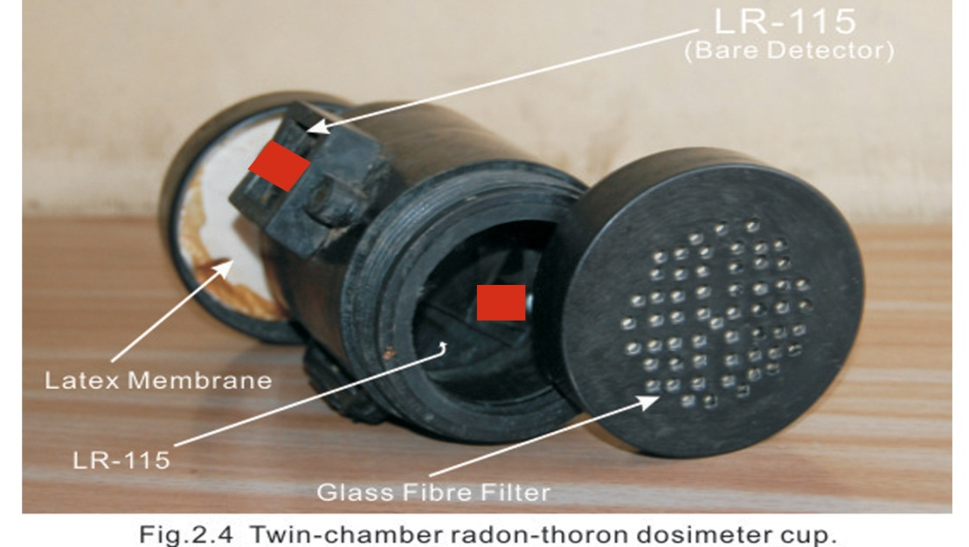

Figure 2: Twin Chamber Radon-Thoron Dosimeters

1. **Results**

The radon concentration in dwellings of Yamuna Nagar district of Northern Haryana varied from 140 – 196 Bq m-3 with an average of 166± 7 Bq m-3 while the thoron concentration in the same dwellings varied from 51 - 84 Bq m-3 with an average of 68 ±5 Bq m-3. The radon progeny levels in the dwellings under study varied from 15.1-21.2 mWL with an average of 18.0 ± 0.6 mWL while the thoron progeny levels varied from 1.38 – 2.27 mWL with an average of 1.84 ± 0.12 mWL. Annual dose received by the inhabitants in the dwellings under study varied from 4.90 – 7.1 mSv with an average of 5.96 ± 0.31 mSv in the present study as shown in Table 1 and graphical variation in radon & thoron concentration is shown in” Fig 3.

1. **Discussion**

There is a variation in the concentration of radon, thoron, and their progeny from one location to another in Yamuna Nagar district of Haryana, which may be due to the composition of the soil beneath the dwellings and the type of construction material used in the dwellings.The Kalesar (Tajewala) region of Yamuna Nagar district was found to have highest level of radon, thoron and its progeny level. It may be due to the higher uranium contents in the soil of hilly area.

In similar studies the radon levels in dwellings of Haryana are reported between 40-134 Bq m-3 (Kant et al., 2004) while in neighboring states (Punjab and Himachal) between 37-240 Bq m-3 (Singh et al 2005; Kumar et al., 1994). The radon levels are within ICRP limits of 200 Bqm-3 for dwellings.

The concentration of radon, thoron, and their progeny levels are found to be slightly lower in dwellings existing in cities than dwellings in villages and small town, which may be due to poor quality of construction of houses allowing more entry of radon from the soil beneath dwellings due to poor sealing from the earth. Also, poor ventilation and confined spaces may be the cause of enhanced level of radon and thoron (Papachristoboulou et al., 2004).



Figure 3: Radon & Thoron levels in some dwellings of district Yamuna Nagar of Haryana

Table 1: Radon, thoron and their progeny levels in some dwellings of district Yamuna Nagar of Haryana

|  |  |  |  |  |  |  |
| --- | --- | --- | --- | --- | --- | --- |
| **Location** | **Location codes** | **Radon concentration**  **(Bq m-3)** | **Thoron concentration**  **(Bq m-3)** | **Progeny levels**  **(mWL)**  **Radon Thoron** | | **Annual Dose received**  **(mSv)** |
| Sadhora | SD1 | 152 | 54 | 16.4 | 1.46 | 5.28 |
| SD2 | 160 | 62 | 17.3 | 1.68 | 5.68 |
| SD3 | 176 | 75 | 19.0 | 2.02 | 6.41 |
| SD4 | 162 | 68 | 17.5 | 1.58 | 5.79 |
| **AM ± SE** | **163±5** | **65±5** | **17.6±0.5** | **1.69±0.12** | **5.79±0.23** |
| Kaleser  (Taje wala) | KL1 | 196 | 84 | 21.2 | 2.27 | 7.1 |
| KL2 | 180 | 81 | 19.5 | 2.19 | 6.66 |
| KL3 | 170 | 74 | 18.4 | 2.00 | 6.39 |
| KL4 | 184 | 78 | 19.9 | 2.22 | 6.69 |
| **AM ± SE** | **183±5** | **79±2** | **20.0±1.6** | **2.17±0.06** | **6.70±0.2** |
| Chhachhroli | CH1 | 180 | 79 | 19.5 | 2.14 | 6.61 |
| CH2 | 172 | 76 | 18.6 | 2.05 | 6.32 |
| CH3 | 160 | 71 | 17.3 | 1.92 | 5.89 |
| CH 4 | 164 | 67 | 17.7 | 1.81 | 5.91 |
| **AM ± SE** | **169±5** | **73±3** | **18.3±0.5** | **1.98±0.07** | **6.18±0.17** |
| Yamuna  Nagar | YN1 | 160 | 62 | 17.3 | 1.67 | 5.68 |
| YN2 | 152 | 56 | 16.4 | 1.51 | 5.30 |
| YN3 | 140 | 51 | 15.1 | 1.38 | 4.90 |
| YN4 | 146 | 53 | 15.8 | 1.43 | 5.10 |
| **AM ± SE** | **150±4** | **56±2** | **16.2±0.5** | **1.50±0.12** | **5.20±0.23** |

**Corresponding Author:**

Dr. Anil Pundir

Department of Electronics

M L N(PG) College

Yamuna Nagar-135001, India

E-mail: [anil.pundeer@rediffmail.com](mailto:anil.pundeer@rediffmail.com)

**References**

1 Puranik, V.D., and Ramachandran, T.V., 2005. J. Environ. Geochem. 8,60.

2 UNSCEAR, United Nation Scientific Committee on the Effects of Atomic Radiation, 2000. Sources and Effects of Ionizing Radiations. U.N.New York.

3 Gogolak, C.V., Beck, H.L., 1980. Nat. Rad. Environ. 3, 259.

4 Porstendorfer, J., Robig,G., Ahmed, A., 1979. J. Aero. Sci. 10,21.

5 Porstendorfer, J., Zock, Ch., Reineking , A., 2000. J. Environ. Radio. 51,37.

6 Chittapron, P. and Harley, H.S., 2000. Radon and outdoor 222Rn measurement in Bangkok and Chiang Mai, Thialand, Technology. 7, 491-495.

7 Pagelkolpf, P. and Porstendorfer, J. 2003. Atm. Environ., 37 : 1057-1064.

8 Reddy, Yadagiri. P., Reddy, K. Viney Kumar., Reddy, Gopal., Reddy, Rama. K., 2005. J. Environ. Geochem. 8,104.

9 NRC; 1991. National Research Council, Washington, DC. National Academy Press.

10 Dwivedi, K.K., Mishra,R., Tripathy, S.P., Kulshreshtra, A., Sinha, D., Srivastva, A., Deka, P., Bhattacharjee, B., Ramachandran, T.V., and Nambi, K.S.V; 2001. Rad. Meas. 33, 7.

11 Singh,S., Mehra,Rohit.,Singh, Kulwant; 2005. Atm. Environ.39, 7761.

12 Ngachin , M., Garavaglia, M., Giovani, C., Kwato Njock, M.G., Nourreddine A., 2007. Rad. Meas. 42, 61.

13 Sathish, L.A.,Nagaraja,K.,Rammna,H.C., Nagesh, V., Sundareshan., 2009. Iran. J. Radiat. Resi., 7(1): 1-9.

14 Sannapa, J., Chandra Shekhara, M.S., Sathish, L.A., Paramesh, L., and Venkataramaiah, P., 2003. Rad. Meas.37, 55.

15 Mayya, Y.S., 2004. Rad. Prot. Dos.111(3), 305.

16 Eappen, K.P.and Mayya, Y.S., 2004. Rad. Meas. 38, 5.

17 UNSCEAR, United Nation Scientific Committee on the Effects of Atomic Radiation, 1993. Exposures from Natural Sources of Radiation, Annex A, A/Ac., 82/R. 526.

2/19/2014