# Detection of Natural gas leakage in Al-Ahmadi area, South of Kuwait: A preliminary study

Ahmed Al-Rashed

Department of Science, College of Basic Education, PAAET, Kuwait.

[ahmedbufarsan@yahoo.com](mailto:ahmedbufarsan@yahoo.com)

**Abstract:** The Block No.1 of Al-Ahmadi Town suffers from repeated cycles of natural gas leakage in the last decade. Each cycle has its own characteristics regarding the leaking period and gas intensity. Some inhabitants of this Block moved out of their houses due to their fear about the spread of diseases such asthma and possible disaster such as fires due to gas emission. The earlier investigations has not yet reached the reasons behind the gas leakage, but limited the reason to one of the following: geological factors; the 50 year old gas network; and the new gas network. Intensive geochemical survey represented by 47626 gas readings has been conducted inside and around the Block No. 1 of Al-Ahmadi Town. This is to shed light on the possible reasons behind the repeated natural gas leakage phenomena. This is to locate and identify the leakage source, which will be helpful for planning to solve the gas leakage problem and to prevent any possible further gas leakage from the subsurface and also to prevent any possible untoward incident due to gas leakage. The survey has been run using an up-to -date Soil Gas Detector (Crowcon Gas-Detector) that based technically of the Flame Ionization Detection (FID) technique and utilizing a stream-mode surveying technique. Inspection of the iso-methane contour map of the surveyed area revealed that the study area is characterized by low to medium gas leakage intensity (0-500 CPS). Extremely high local anomalies are recorded to the west of the study area, which attains gas intensity up to 4000 (CPS). However, probable source of gas leakage may exist NE ward of the study area as an increase in the gas intensity up to 1000 CPS is remarkable at this direction. The probable reasons of the gas leakage is may either due to near surface artificial or natural gas leakage sources. The differentiation between these possible sources requires detailed background on the sub surface infrastructures, such as pipeline network, as well as the near-surface joints or fractures (neotectonics) of the study area. Further shallow geophysical surveys are recommended for mapping the near surface weakness zones, microstructures and neotectonics.

[Al-Rashed, A. **Detection of Natural gas leakage in Al-Ahmadi area, South of Kuwait: A preliminary study.** *Nat Sci* 2014;12(3):87-93]. (ISSN: 1545-0740). <http://www.sciencepub.net/nature>. 12

**Keyword:** Gas Leakage, Al-Ahmadi, Kuwait

1. **Introduction**

The state of Kuwait (Fig.1) is situated at the northeastern corner of the Arabian Peninsula. It comprises an area of approximately 17,600 km2 extending between latitudes 28830XN and 30805XN and between longitudes 46833XE and 48833X E. In addition to the mainland, it also includes a few islands like Bubiyan, Failaka and Al-Qubbar.

Kuwait Provinces are locally known as Kuwait Governorates. There are principally six provinces i.e, Al-Kwait Al-Asimah, Al-Farwanaiya, Mubarak Al-Kabeer, Hawalli, Al-jahra and Al-Ahmadi. Bubiyan and Warbah the uninhabited island lying in the north-east are also a part of the country of Kuwait. However, most of the oil fields and their activities are located southern and northern of the State of Kuwait.

Al-Ahmadi town is the capital of Al-Ahmadi Governorate (see Fig. 1) forms the south eastern portion of Kuwait, with geographical location 29° 1' N and 48° 1' E. It is covering an area of 5,120 sq. km. It is famous for its oil refineries and peaceful green surroundings. During the beginning of 1940s British expats started settling in Al Ahmadi. Areas close to the sea have buildings on the sea facing hill slopes. Abu Halifa, Mangaf and Riqqa are the main residential areas in Al Ahmadi.

Al-Ahmadi Town consists of a number of Blocks (Fig. 2), from which the study area (Block No. 1) is subjected to the present investigation. This block suffers from repeated cycles of natural gas leakage in the last decade. Each cycle has its own characteristics regarding the leaking period and gas intensity. Some inhabitants of the Block No. 1 at Al-Ahmadi, expressed their fear about the spread of diseases such asthma and possible disaster such as fires due to gas emission, which led to some families moved out of their houses.

The earlier investigations has not yet reached the reasons behind the gas leakage, but limited the reason to one of the following: geological factors; the 50 year old gas network; and the new gas network.

Experts from the United States and the UK as well as a team of experts from the Kuwait Oil Company are keeping an eye on the gas leaks and conducting tests to determine how this issue is to be dealt with. The main culprit is gas leaks from the old gas network in Ahmadi City, which was built in 1950. "In 2001, the KOC replaced the old gas network with a new one. After that, and when the gas leak issues repeated, the new the new network is tested in order to see if there were any faults in installation, but couldn't find any leaks from there. The government evacuated the homes of 58 families living in danger in Ahmadi, Block 1 to treat the gas leak problem effectively.

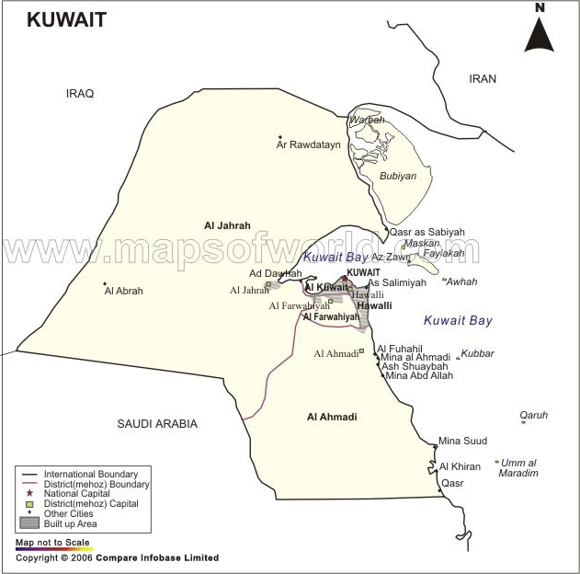

Figure 1. The geographical location of Kuwait and its neighboring countries.

Figure 2. Limits of Block No. 1 map of Al-Ahmadi Town.

The KOC team, which is responsible for excavating and solving the gas dilemma, explained that the homes in Block 1 or south Ahmadi are government-owned homes that sadly don't follow safety precautions and measurements. "It is difficult to access the homes, as they are build right next to each other with no space in between them and only one entrance, meaning there are no emergency exits. They added that the unsafe design of the houses in Block 1 is certainly one of the reasons why this is taking us longer time.

Meanwhile, some sources implied that when the KOC installed the new network, it did not completely isolate the old network properly, which might have caused a gas leak to occur occasionally. Yet, if the leaking continues, then the malfunction will have to be in the new network, which then will require repairmen as soon as possible. However, the KOC officials for ordering the continuous digging in suspected locations to determine the exact spot of the gas leakage and constantly communicating with the residents in the area.

Great efforts that have been exerted, by the Kuwait National Petroleum Company (KNPC)and the Kuwait Petroleum Company (KOC), to stop the gas leakage through inspecting the causes of leakage and making necessary repair of any possible artificial sources (Fig. 3). However, more than 50 shallow holes were dug by the KOC team in suspected locations of Al-Ahmadi Town to decrease the volume of gas in the soil and to determine the exact spot of the gas leakage.

Inspite, the artificial leakage source possibility was ruled out after removing the old gas-pipe network, it will be clear if whether or not it was the cause behind the leakage, especially the gas odor still periodically existing in the Block No.1 area. This encourages the authors to investigate the area of Block No. 1 and evaluate the possible gas-leakage sources to make sure that if there are possible geological factors behind the leakage.

[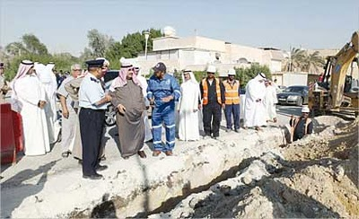](http://3.bp.blogspot.com/_mPeDq32RN9c/TPLJUrxsGRI/AAAAAAAAAv8/929DSRsTVFA/s1600/02_01_01.jpg)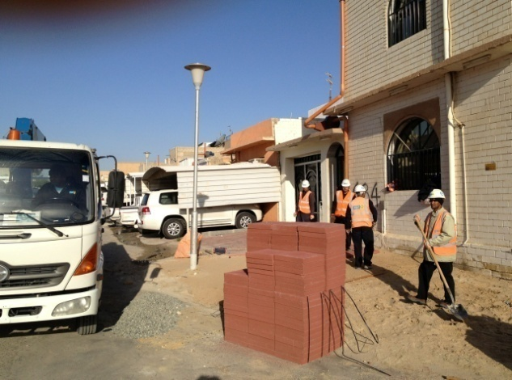

Figure 3. Sides of Gas-leakage treatment processes of at Block No. 1 of Al-Ahmadi Town.

Hydrocarbon gas leakage occasionally contaminates the soil zone from different sources, and represents a significant air and possibly groundwater aquifers pollution source particularly in oil producing countries, like the State of Kuwait. There are some surface and subsurface site-specific characteristics affecting natural gas widespread from the subsurface such as: nature and depth of the source, possible new tectonics, soil type and porosity, air-filled porosity, groundwater level, surface temperature, wind spread and direction.

Identifying of these gas contaminants and relative concentrations and locating their sources are helpful in monitor the progress of cleanups guide placement of subsequent confirmatory samples (soil borings, monitoring wells) as well as for planning to prevent a possible future seepage.

Typical primary sources include surface spills, leaking underground storage tanks, pipes, trenches, dry wells, or landfills. Contaminants from such sources frequently reach the water table, causing the groundwater to become a source of contamination to down gradient sites. The nature of the source will influence the vertical and horizontal dispersion of gas-phase contaminant vapors.

Burns (2009), based on geochemical studies, stated that seepage of natural gas was reported from some bore wells located in a few agricultural fields in Piparia, Bhutoli and Rahatgarh areas, Sagar District, Madhya Pradesh, India. Geochemical prospecting survey has been carried out in Sagar District to study the seepage of natural gas associated with adsorbed soil gas anomalies in order to establish an upward migration of hydrocarbons from the subsurface reservoir. The study revealed, trough adsorbed light gaseous hydrocarbon analyses, that the presence of moderate to low concentrations of methane (C1) 1 to 104 ppb, ethane (C2) 1 to 14 ppb, propane (C3) 1 to 10, i-butane (iC4) 1 to 9 ppb and n-butane (nC4) 1 to 8 ppb in the soil samples. The carbon isotopic composition of methane ranges between –29.9‰ and –52.2‰ (PeeDee Belemnite), suggesting that these gases are of thermogenic origin. Adsorbed soil gas and carbon isotope studies show good regional evaluation of hydrocarbon potential.

Trethewey and Gore (2010) based on Passive soil gas sampling and rigorous statistical and geochemical modeling techniques to characterize the pathway of hydrocarbon migration into an active quarry in California. The quarry site lies near a major regional fault and consists of a plutonic outcrop containing relatively intact Cretaceous hornblende gabbro blocks within a highly sheared matrix. This matrix is characterized by a series of closely spaced joints and small scale faults. The matrix system is suspected of allowing the passage of thermogenic hydrocarbons, (crude oil and gas sourced from the prolific Monterey Shale) which have been observed at observation wells located throughout and surrounding the quarry. Although a natural phenomenon, the presence of “macro seeping” oil and gas hydrocarbons needs to be understood and managed as the quarry is expanded both laterally and vertically, as well as when the quarry is ultimately closed. By applying advanced statistical processing and discriminant classification modeling to the passive sampling results, the primary fault and fracture networks responsible for hydrocarbon macro-seepage at the quarry were identified. To supplement the geochemical modeling, hydrocarbon compound summation maps were developed to assist management analysis. This process proved to be an economical and effective means to manage further expansion of the quarry.

Noomen et. al., (2003), based on field observations and Lab. Experiments to study the influence of gas seepage on vegetation reflectance, concluded that a high gas concentration in the soil - whether from natural hydrocarbon seepage or from leaking gas pipelines–affects the vegetation reflectance. However, the exact mechanism that is responsible for the changes in reflectance is not known. Besides, it is not known exactly how the reflectance reacts on gas seepage.

Harbert et. al., (2006), based on geological-geochemical studies, revealed sites containing anomalously high concentrations of gases directly above the faulted, eastern limb of the Whip Cove anticline that defines the productive structure. Although the soil gas signatures would not have predicted the correct composition for the Lost River dry gas reservoir, the higher concentration samples do fall along strike and within the boundaries of the structural high that forms the trap for the deep gas reservoir.

Rice et. al., (2002), based on geochemical studies, concluded that decreasing soil-gas hydrocarbon concentrations during oil-reservoir depletion were demonstrated near production wells. Production from two separate reservoirs resulted in decreased near-surface soil-gas hydrocarbon concentrations. Conversely, increased soil-gas hydrocarbon concentrations occurred surrounding injection wells. These results illustrate the dynamics of soil-gas measurements and establish vertical migration rates of at least tenths of meters (a few feet) per day. Such rapid response supports effusion as the predominant vertical migration mechanism in this oil field.

Soil-gas concentration patterns, or their geometry, for produced portions of reservoirs can be determined by mapping soil-gas concentrations and comparing them with preproduction data. This study suggests that measuring soil gas is a valid geochemical technique for managing enhanced-recovery programs.

Vertical migration rates are sufficiently rapid that near-surface soil-gas hydrocarbon data can be used as an additional communication link between the surface and a petroleum reservoir. Therefore, vertical migration of hydrocarbons from petroleum reservoirs to the surface offers a source of information about fluid content and movement within petroleum reservoirs. This study suggests the use of vertical migration monitoring techniques for both exploration and field development. In a producing field, soil-gas hydrocarbon data can define recent reservoir changes related to production. Additional research is needed to prove the value of soil-gas data as a routine reservoir-monitoring tool. However, current technology is sufficient for evaluating these concepts in deeper fields and in other geologic areas.

Jones (2002) stated that soil gas sampling is an accurate surveying method that can quickly and inexpensively measure the presence and horizontal extent of contamination from a large variety of volatile organic chemicals such as gasoline, jet fuel, diesel and even other volatiles such as chlorinated solvents.

Soil gases reveal the presence of volatile contaminants, but do not directly image nor reflect the actual concentration of residual phase, the thickness of free phase, or the concentration of dissolved phase hydrocarbons in the ground water. Because the horizontal extent of subsurface contamination is determined by geologic factors, a surface geochemical map should never be considered to provide an exact picture of any or all contaminated layers. Each layer can and will have its own variability and identity. The most common mistake in the use of soil gas data is to extend the interpretation beyond the survey design. Permeable horizons in the vadose zone do not necessarily match the direction of ground water flow. Multi-site and multi-depth samples must be taken and analyzed to fully evaluate the horizontal and vertical contamination within any given area. Proper geological models can help to reduce this complexity.

This article deals with identification and location of the natural gas leakage sources in the Block No. 1 of Al-Ahmadi Town. This is through the following:

1. Determination of the natural gas concentration within the soil of the study area.
2. Evaluation the habit and depth of the possible natural gas leakage source and relating them to the different near surface- and subsurface factors that control the widespread of leakage.
3. Establishing the possible solutions and recommendations for preventing the natural gas leakage.
4. **Materials and Methods of Study**

**The materials used in the present study include:**

1. survey teams to track progress and pinpoint areas of significant interest (Fig. 4).

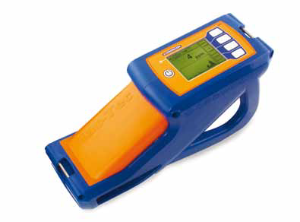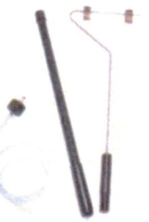

Figure 4. The Crowcon Gas detector and probe

1. Previously published literature on the soil gas and gas-leakage.
2. Softwares specialized for processing, interpretation of the geochemical data and presentation of the results.

**The methods used in the present study include:**

1. Geochemical survey using the Crowcon Gas-Detector entrustment. This to determine the hydrocarbon (Methane) gas concentration with the soil zone and its areal distribution within the Block No.1 of Al-Ahmadi area. This method of soil gas surveys is cost and time save. However, this technology can be used in congested areas, like the study area, within a refinery or gas plant where no other method can be as easily deployed.
2. Evaluation of the surface, climatic and subsurface conditions that may affect the intensity and rate gas leakage in the soil of the study area.
3. Graphical representation of the data and results utilizing up-to-date specialized softwares.
4. Evaluation of the possible reasons of gas leakage based on Integration view of the results arrived from the meteorological data and soil analyses.
5. **The Field Survey**

A total number of 47626 gas readings have been gained through an intensive steam-mode geochemical survey conducted inside and around the Block No. 1 of Al-Ahmadi Town. This is to shed light on the possible reasons behind the repeated natural gas leakage phenomena. This is to locate and identify the leakage source, which will be helpful for planning to solve the gas leakage problem and to prevent any possible further gas leakage from the subsurface and also to prevent any possible untoward incident due to gas leakage.

The field survey has been done using "Crowcon" Gas-Detector that based technically of the Flame Ionization Detection (FID) technique and utilizing a stream-mode surveying technique for high precision measurements and subsequently reasonable interpretation (Fig. 5).

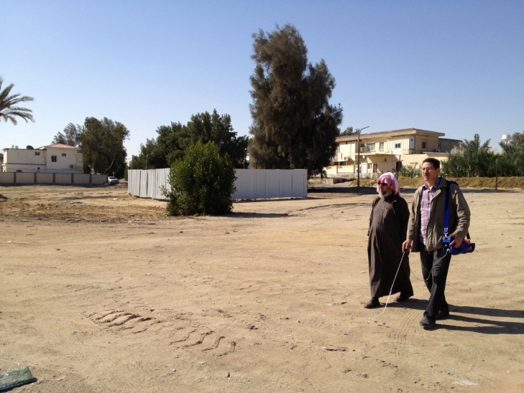

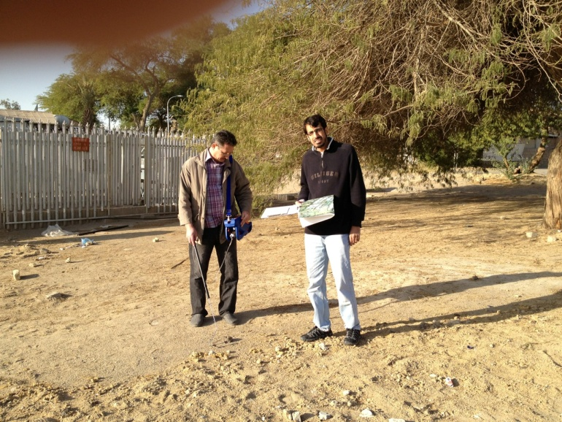

Figure 5. Stream-mode geochemical survey using Crowcon-Gas Detector instrument at the Block No. 1 of Al-Ahmadi (in yellow dashed lines).

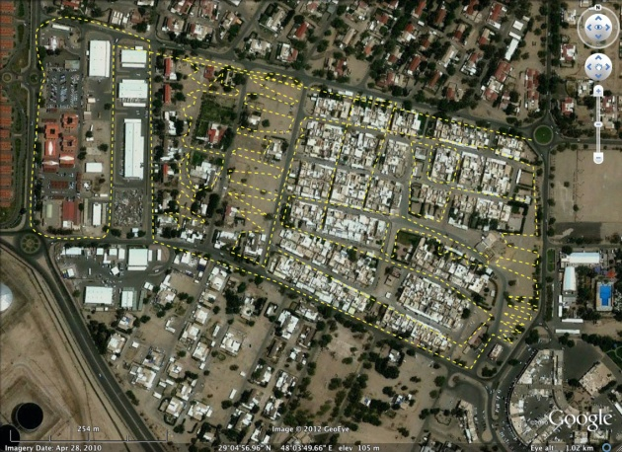

Figure (6) illustrates the stream-mode surveying lines at the study area and a filed data sample using the Crowcon Gas-Detector is illustrated in Table (2).

Figure 6 shows the satellite image of the Block No. 1 of Al-Ahmadi with the stream-mode geochemical field survey traverses (in yellow dashed lines).

Table 2. A sample of the field acquired data utilizing the Crowcon Gas-detector.



1. **Results and Discussions**

Inspection of the iso-methane contour map of the surveyed area (Fig. 7) revealed that the study area, represented by the Block No. 1 of Al-Ahmadi area is characterized by low to medium (0-500 CPS) gas leakage intensity, which may refer generally to normal biogenic activity. Extremely high local anomalies are recorded to the west of the study area, which attains gas intensity up to 4000 (CPS). However, probable source of gas leakage may exist NE ward of the study area as an increase in the gas intensity up to 1000 CPS is remarkable at this direction.

The probable reasons of the gas leakage is may either due to near surface artificial or natural gas leakage sources. The differentiation between these possible sources requires detailed background on the sub surface infrastructures, such as pipeline network, as well as the near-surface joints or fractures (neotectonics) of the study area. However, due to the confidentiality of the study area, as it is a Petroleum Prospect, there are lack of infrastructure as well as shallow exploration data.

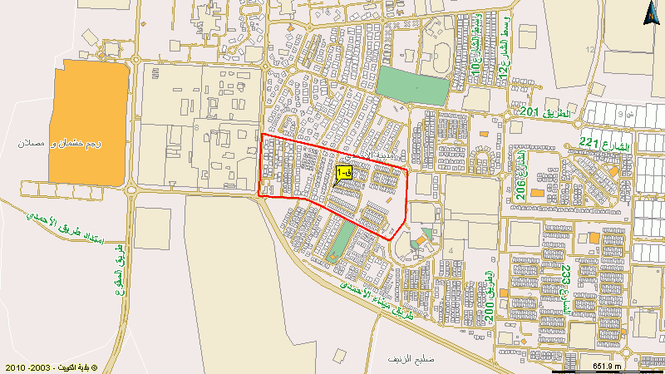

Figure 7. Iso-Methane contour map of the Block No.1 of Al-Ahmadi area.

1. **Summary and Conclusions**

The Block No.1 of Al-Ahmadi Town suffers from repeated cycles of natural gas leakage in the last decade. Each cycle has its own characteristics regarding the leaking period and gas intensity. The earlier investigations has not yet reached the reasons behind the gas leakage, but limited the reason to one of the following: geological factors; the 50 year old gas network; and the new gas network.

Intensive geochemical survey has been conducted inside and around the Block No. 1 of Al-Ahmadi Town to shed light on the possible reasons behind the repeated natural gas leakage phenomena. This is to locate and identify the leakage source, which will be helpful for planning to solve the gas leakage problem and to prevent any possible further gas leakage from the subsurface and also to prevent any possible untoward incident due to gas leakage.

The survey has been run using an up-to -date Soil Gas Detector (Crowcon Gas-Detector) that based technically of the Flame Ionization Detection (FID) technique and utilizing a stream-mode surveying technique for high precision measurements and subsequently reasonable interpretation.

Interpretation of the geochemically conducted iso-methane map of the surveyed area revealed that the study area, is characterized by low to medium gas leakage intensity (0-500 CPS), which may refer generally to normal biogenic activity. Extremely high local anomalies are recorded to the west of the study area, which attains gas intensity up to 4000 (CPS). However, probable source of gas leakage may exist NE ward of the study area as an increase in the gas intensity up to 1000 CPS is remarkable at this direction.

The probable reasons of the gas leakage is may either due to near surface artificial or natural gas leakage sources. The differentiation between these possible sources requires detailed background on the sub surface infrastructures, such as pipeline network, as well as the near-surface joints or fractures (neotectonics) of the study area.

1. **Recommendations**

Certain recommendations are given here regarding future planning of gas monitoring at Al-Ahmadi and similar oil and gas provinces. Such recommendations will be valuable for precise and accurate location of possible gas leakage sources, whatever, natural and/or artificial sources. These recommendation are as follows:

1. Further shallow geophysical survey should be conducted in the study area for mapping the near surface structural elements that may help for interpretation the geochemical data.
2. Infrastructure map of the study area should be available for relating the high anomalous gas leakage areas with possible near surface artificial leajkage sources
3. Soil sampling at the gas-leaked areas for gas chromatographical and mechanical analyses.
4. Drilling a number of exploratory shallow wells at the high anomalies sites revealed from the geochemical survey.

**Acknowledgements**

The authors are greatly indebted to the authorities of the Public Authority of Applied Education and Training (PAAET), for the financial support and facilitate the requirements of conducting the research work under the project No. BE-11-07. Sincere thanks are also due to the authority of the College of Basic Education and the Department of Science for their continuous help during the progress of this work. Grateful thanks are also due to Mr. Yousef Al-Hamad, Dept. of Science, for his fruitful help during the field geochemical survey and data acquisition.

**Corresponding Author:**

Dr. Ahmed Al-Rashed

Department of Science

College of Basic Education,

PAAET, Kuwait.

E-mail: [ahmedbufarsan@yahoo.com](mailto:ahmedbufarsan@yahoo.com)

**References**

1. Burns, K. A. 2009. [Diversity in sediments associated with hydrocarbon seeps in the Timor Sea area, SPE., Vol. 32, No. 1,](http://www.pubmedcentral.nih.gov/articlerender.fcgi?tool=pmcentrez&artid=2786413&rendertype=abstract) 12-21 pp.
2. Doezema, L. A., 2003. [Extensive regional atmospheric hydrocarbon pollution in the Southwestern United States](http://www.pubmedcentral.nih.gov/articlerender.fcgi?tool=pmcentrez&artid=218698&rendertype=abstract). Oil and Gas J., Vol. 15, No. 3, 10-14 pp.
3. Harbert, W., Jones V.T., Izzo, J. and Anderson, T.H., 2006. Analysis of light hydrocarbons in soil gases, Lost River region, West Virginia: Relation to stratigraphy and geological structures. Proceeding of the Soil, Sediment, Water and Energy, the 24th annual International Conference, Massachusetts. Univ., 45-65 pp.
4. Hood, K. C., Wenger, L., M., Gross, O. P. and Harrison, S. C., 2002. Hydrocarbon systems analysis of the northern Gulf of Mexico: Delineation of hydrocarbon migration pathways using seeps and seismic imaging, in surface exploration case histories. AAPG Studies in Geology No. 48, 25-40 pp.
5. Jones, V. T., 2002. Application of forensic geochemical methods in assessment of hydrocarbon releases characterization and mapping of underground product contamination using soil vapor techniques. Manual of Exploration Technologies, Inc. Houston, Texas, 78 p.
6. Matthews, M. D., Hodgson, R. A. M., Komai, O. T., Okada, J., Ohhashi, K. and Kuniyasu, T., 2009. Remote sensing and soil gas geochemical study, Railroad valley. Marine Geosciences, Vol. 45, No. 3, 232-252 pp.
7. Noomen, M.F., Skidmore, A.K., Van der Meer, F. D., 2003. Detecting the influence of gas seepage on vegetation using hyperspectral remote sensing. The 3rd EARSEL workshop on Imaging Spectroscopy, Kiel University, Germany, 234 p.
8. Oldenburg, C. M. and Lewicki, J. L., 2003. [Leakage and seepage in the near-surface environment: An integrated approach for monitoring and detection](http://www.etde.org/etdeweb/details.jsp?query_id=1&page=0&osti_id=837241). J. of Science and Technology, Vol. 21, No. 2, 12-18 pp .
9. Rice, G. K., Belt Jr., J. Q. and Berg, G. E. 2002. Soil-gas hydrocarbon pattern changes during a west Texas waterflood, in surface exploration case histories: Applications of geochemistry, agnetics, and remote sensing,. AAPG Studies in Geology No. 48, No. 11, 157–174 pp.
10. Page, D. S., Boehm, P. D., Douglas, G. S., Bence, A. E., Burns, W. A., Mankiewicz, P. J., 1997. [An estimate of the annual input of natural petroleum hydrocarbons to seafloor sediments in Prince William Sound, Alaska](http://inisdb.iaea.org/?nRN=29058085),J. of Geochemistry, Vol. 34, No.7,110-130 pp.
11. Prasanna, V.M., Rasheed, M.A., Madhavi, T., Kalpana, G., Patil D.G. and Dayal, A. M., 2010. Light gaseous hydrocarbon anomalies in the near-surface soils of Sagar district, Vindhyan basin, India. Current Science, Vol. 99, No. 11, 143-165 pp.
12. Trethewey, H.G. and Gore, W. L., 2010. Characterizing thermogenic hydrocarbon migration through highly fractured bedrock using advanced passive soil gas sampling. Proceeding of the Soil, Sediment, Water and Energy, the 26th annual International Conference, Massachusetts. Univ., 220-231 pp.

2/19/2014