Influence of Slag on the improvement of engineering properties of different soils, Nile Delta, Egypt.

A. I. M. Ismail and Z. L. Belal

Geological Sciences Department, National Research Centre, Dokki, Cairo, Egypt
ali_Ismail_2000@yahoo.com

Abstract: Recent soft soil is widespread along the Nile Delta, Egypt. Some foundation problems were susceptible to cracks in the area of study. The cracking is fundamentally due to the lack of a clear and detailed understanding of the geotechnical and geo-engineering properties. In this context, this paper studies the engineering implications of two types of soils and their improvement by granulated blast furnace slag (GBFS). GBFS percentages (5%, 10% and 20%) were added to both soil types. The laboratory test results showed that GBFS additives increased the pH value and reduced the plasticity index in both soil types but the slag stabilizer is more effective in the second type of soil. The maximum dry density (MDD) decreased and optimum moisture content (OMC) increased especially in the first soil type. MDD and the OMC increased with increasing the percentages of slag. Unconfined compressive strength showed that, the slag additive was more effective in the second type of more clay rich compared to the first one. With increasing the curing time to 28 and 139 days, the strength values were clearly decreased suggesting that the slag was used as workable additives in soil improvement.
[A. I. M. Ismail and Z. L. Belal. Influence of Slag on the improvement of engineering properties of different soils, Nile Delta, Egypt. Nat Sci 2014;12(3):73-78]. (ISSN: 1545-0740). http://www.sciencepub.net/nature. 10

Keywords: Engineering Characteristics; Foundation Problems; Soil Improvement; Granulated Blast Furnace Slag.

1. Introduction
Soils with undesired properties (high water content and low workability) can present great problems underlying pavement. They are often unstable under structure and they are susceptible to problems from changes in moisture content. It is possible to prevent the problems by strengthening the soil underlying the structure. These rules can be taken by modifying the foundation system and /or altering the soil itself or improving the properties of the soils, which can be achieved by stabilization Bowles (1984). There are various stabilization methods one of which is chemical stabilization. Chemical stabilization involves blending the soil with chemically active compounds such as (lime, cement and fly ash) or industrial by-product stabilizers. Several studies have been carried out on the stabilization of soils by traditional stabilizers (Lime, Cement and Fly ash) (Croft 1967; Ferguson 1993; Bell 1996; Ramadan 1996; Kaniraj and Havanagi 1999; Reik and Ismail 2003; Ismail 2004; Nalbantoğlu 2004; Sezer et al., 2004; Al Rawas et al., 2005; Cai et al., 2006; Lin, et al., 2007; Degirmenci et al., 2007 and Sakr et al., 2009). Also many researchers have investigated the use of by-product in alternative to traditional stabilizers for stabilization/modification of the different soils (Ingles and Metcalf 1973; Harris et al., 2007 and Moses et al., 2012). Large quantities of by-products are produced every year. With the increasing need to recycle industrial by-product and to protect the environment, there is attempt to disposal large quantities of by-product in construction projects. By product improving the properties of soils (Al-Rawas 2002)
In this investigation, two types of soils were selected due to building problems which some minor cracks have been observed and settlement in the ground. An industrial by-product granulated blastfurnace slag (GBFS) has been used as chemical stabilizer to improve the engineering properties of the two selected soil materials. This work is a part from PhD Thesis of Belal (2013).

2 Material and Methods
2.1 Soil Material
Two types of soil at different localities in the Nile Delta were selected (Fig. 1). The first soil (I) was obtained from the north of the Nile Delta (Nasyma area) beside Manzala Lake and another one was obtained from the center of the Nile Delta (El-Mahala El Kobra area) (Fig. 1). These soils were selected due to the occurrence of some minor cracks in the buildings constructed above the first soil (Soil I) (Fig.1a) and settlement in the second type of soil (Soil II) (Fig.1b).

2.2 Stabilizer
The stabilizer used in this study was granulated blastfurnace slag (GBFS) occurred as solid by-product generated from the manufacturing of steel (Fig. 2). As the iron stay down in large container, it has higher density, impurities stay in the top layer and then transported to large area for solidification in the air. The GBFS stabilizer used in this study was derived from El Tbeen iron and steel plant, Cairo and its chemical composition illustrated in Table 2.

2.3 Methods
Laboratory works soil/slag mixes include pH, Atterberg limit, compaction and unconfined compressive strength testing. pH of soil/slag mixtures were determined by shaking the desired mixture (BS, 1975).
Atterberg limit tests were conducted on each soil mixed with slag and then blending with water for 1 day, liquid and plastic limit tests were performed in accordance with BS, 1975.
The unconfined compressive strength was performed on soil- slag mixture molded with standard proctor (5 cm diameter and 10 cm height) to obtain the optimum moisture content and maximum dry density then cured the cylindrical samples at 7, 14 and 28, 60 and 139 days prior testing (BS 1975).
Scanning electron microscopy for the untreated and treated soils using SEM Model Quanta 250 FEG (Field Emission Gun) attached with EDX Unit (Energy Dispersive X-ray Analyses) with accelerating voltage 30 K.V., magnification 14 X up to 1000000.

3 Results and Discussion
3.1 Effect of the Stabilizers on the pH
GBFS caused an increase in the pH values of both soil types (I and II) (Fig. 3) compared to the pH values of the untreated soils I and II (7.99 and 8.26, respectively).

3.2 Effect of Stabilizers on the Atterberg Limits
A series of tests with different slag 5%, 10% and 20% were conducted to determine the effects of the slag on the Atterberg limits of the soil types under study (Soil I and II) (Table 3). The results of Atterberg limits for the soil types (I and II)/slag percentages are shown in Figs. 4, 5 and 6. In soil I, the plasticity index is remained nearly constant with increasing slag content. On the other hand, the plasticity index decreases with increasing slag content for soil II. The reduction in the plasticity index values were resulted from the decrease in liquid limit and plastic limit. With decreasing the plasticity index and liquid limit, the engineering properties of soil II (high plasticity clay) are improved and become more workable.

3.3 Effect of Stabilizers on the Compaction
The relation between the optimum moisture content (OMC) and maximum dry density (MDD) for soil/slag mixture using standard proctor are shown in Figs.7 and 8. It is noticed that, the MDD decreases and the OMC increases with increasing the slag percentages specially in soil I (Fig. 9) and the similar trend is also observed in soil II with the addition of 5 % slag. On the other hand at higher percentage of slag (more than 5%), the MDD and OMC increase with increasing slag content (Fig.10).
3.4 Effect of Stabilizers on the Unconfined Compressive Strength
Different quantities of slag (5 %, 10 % and 20 %) were used to evaluate soil stabilizer compared to the untreated soil I and soil II (Table 4). The low quantity was the amount of additives (lime and cement) recommended to use, but in this work the disposal large quantities of by-products (slag) are required.
The soils with slag were tested by hydraulic press at curing time 1, 7, 28, 60 and 139 days. The results are given in Table 4. The unconfined compressive strength values of the soil II with 5 %, 10 %, and 20 % slag increased in 7 day compared to the untreated soil II (Fig.11). Generally, increasing the amount of slag did not provide any benefit to certain soil strength.

3.5 Scanning Electron Microscope (SEM)
The improvement of soil materials by slag stabilizer is the result of a number of chemical processes that take place include cation exchange and flocculation as well as pozzolanic reaction in which the soil morphology of the untreated soil disappeared due to the slag addition (Figs.12 and 13 ). Flocculation – agglomeration process change the fine grain soil material to a more granular soil due to the increase of Ca⁺² in this process (Herzog and Mitchel 1963). Firstly, the calcium silicate gel is formed from the hydration of slag containing Cao (Table 2) and the removal of silica from clay minerals in the soil. Figure 13 shows that by slag-soil material interaction, needle shaped and cotton like shape as well as euhedral to subhedral crystals are formed. Short needle shaped crystals of calcium silicate hydrate C-S-H are also formed due to the interaction of slag with silica derived from the treated soil materials (Fig. 13).

4 Summary and Conclusions
The addition of slag to the soil materials improved the engineering properties of the native soil derived from some localities in the Nile Delta, Egypt. The engineering properties of soil improvement by adding slag include consistency index (liquid limit, plastic limit and plasticity index), compaction effort and unconfined compressive strength. From the results of this study, it concluded that, the addition of slag improved the engineering properties of clayey to silt soils in the areas of study. Generally, optimum moisture content was found to increase and maximum dry density decreases with increasing the slag contents. The unconfined compressive strength of the soil was found to increase significantly with increasing slag content, especially after 7 days curing period.
The improvement occurred due to the reaction of slag with soil materials including cation exchange, flocculation and pozzolanic reactions. The cation exchange take place between the anion associated in the surface of the soil and the calcium ions in slag. The effect of ion exchange causes attraction between particles of soil, forming flocculation. Flocculation is primarily responsible for the modification of the engineering properties of clay soil. The cementing agents are called calcium silicate hydrate (CSH) and calcium aluminates hydrate (CAH) respectively, which cause soil to become more workable and less plastic.
The effect of slag stabilizer depends on the composition of soil materials. With increasing the amount of clay content and plasticity, the slag is much more effective especially in the second type of soil. From the results obtained the slag is recommended to make the soil materials more workable.

Table1 Engineering properties of the selected soils used.
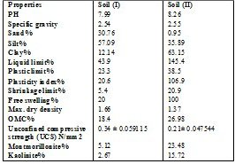

Table 2 Chemical compositions of the studied soil samples (I & II) and GBFS.
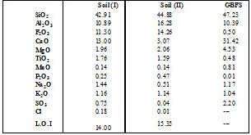

Table 3 Geotechnical results of the treated soils samples.
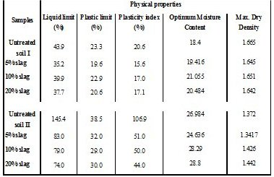

Table 4 Unconfined compressive strength data of the treated soils I & II.
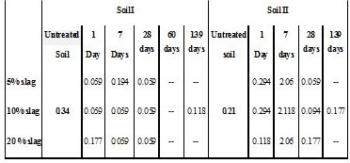

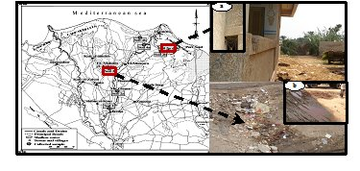
Fig.1 Showing the location map of the studied areas (a) Inclination and minor crack in soil I (b) Settlement of the ground in soil II.

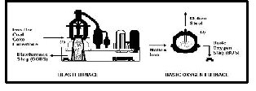
Fig.2 The Basic Oxygen (BOS) steel making process, showing the production of blast furnace slag and Basic Oxygen (BOS) steel slag.

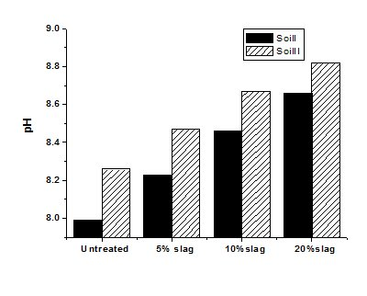
Fig. 3 pH of soil-slag mixture for soils I & II.

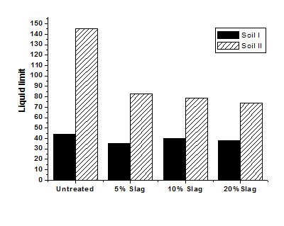
Fig. 4 Liquid limit vs slag % for soil I &II.
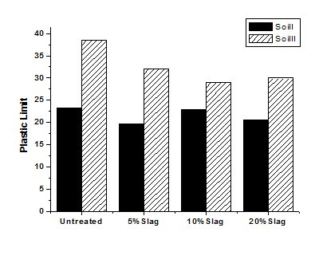
Fig. 5 Plastic limit vs slag % for soil I &II.

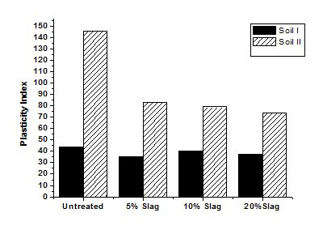
Fig. 6 Plasticity index vs slag % for soil I &II.

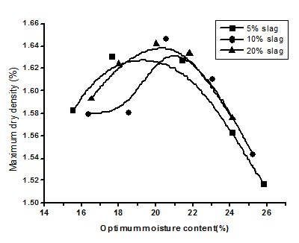
Fig. 7 Maximun dry density Vs Optimum moisture content for the soil I

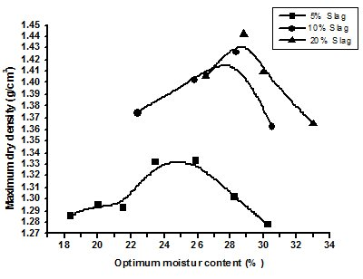
Fig. 8 Maximun dry density Vs Optimum moisture content for the soil II.
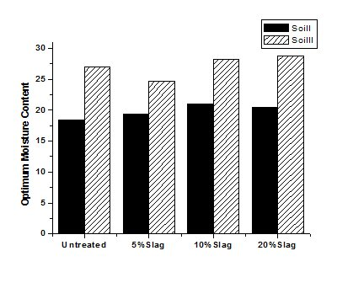
Fig. 9 Optimum Moisture Content vs Slag % for soil I &II.
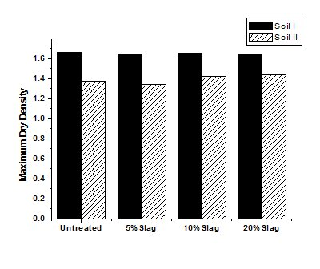
Fig. 10 Maximum dry density vs Slag % for soil I &II.

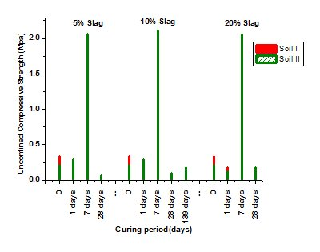
Fig. 11 Unconfined compressive strength vs curing time of the soils I &II.

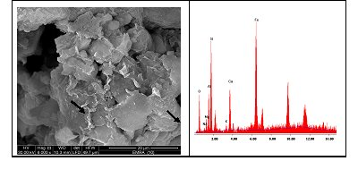
Fig. 12 SEM and EDX of native soil materials.
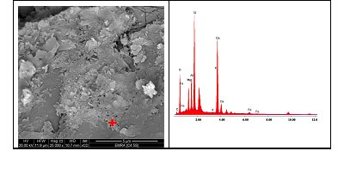
Fig. 13 Soil-slag 7 days curing period showing skeleton calcium silicate hydrate binding phase with high silica, calcium and Al peaks.

References
- Al Rawas AA, Hago AW, Al-Sarmi H (2005) Effect of lime, cement and Sarooj (artificial pozzolan) on the swelling potential of expansive soil from Oman". Building and Environment 40, pp 681-687
- Al-Rawas AA, Taha R, Nelson JD, Al-shab TB, Al-Siyabi H (2002) A comparative evolution of various additives in the stabilization of expansive soils. Geotech Test J 25(2), pp 199-209
- Belal ZL (2013) Effect of stabilizers in the improvement of engineering properties of soil in some localities of the Nile Delta, Egypt. Ph.D Thesis, Geology Department, Ain Shams University, 157 p
- Bell FG (1996) Lime stabilization of clay minerals and soils. Eng Geol 42(4), pp 223-237
- Bowles JE (1984) Physical and geotechnical properties of soils. McGraw-Hill, London, 2nd ed., 587p
- BS (1975) methods of test for soils for civil engineering purposes, BS 1377, British Standard Institution, London, UK
- Cai, YShi B, Charles WW, Tang CS (2006) Effect of polypropylene fiber and lime admixture on engineering properties of clayey soil. Eng Geol 87, pp 230-240
- Croft JB (1967) The influence of soil mineralogical composition on cement stabilization. Geotechnique, London, England17, pp 119-135
- Degirmenci N, Okucu A, Turabi A (2007) Application of phosphagypsum in soil stabilization". Building and Environment 42, pp 3393-3398
- Ferguson G (1993) Use of self-cementing fly ashes as a soil stabilizition agent. In fly ash for soil improvement, ASCE, New York, Geotechnical special publication 36, pp 1-14
- Harris P, Joré von Holdt1, JV, Sebesta1 S, Scullion1 T (2007) Cementitious, Chemical, and Mechanical Stabilization: Recommendations for Stabilization of High-Sulfate Soils in Texas. 1952, p 71-79
- Herzog A and Mitchel JK (1963) Reactions Accompanying Stabilization of Clay with Cement. -Highway Research Record, National Research Council,Washington, DC., 36, p 166-171
- Ingles OG, Metcalf, JB (1972) Soil stabilization, principles and practice. -Sydney-Melbourne-Brisbane (Butterworths), 374 p
- Ismail, A. I. M. (2004): Engineering and Petrological Characteristics of Clayey Silt Soils to be used as Raod Base and their Improvement by Lime and Cement, PhD Thesis, Technical Unversity of Clausthal, Germany, ISBN 3-8920-716-8, 192p
- Kaniraj S, Havanagi VG (1999) Compressive strength of cement stabilized fly ash-soil mixtures, cement and concrete Research, 29 (25), pp 673-677
- Lin DF, Lin, KL, Hung MJ, Luo HL (2007) Sludge ash\ hydrated lime on the geotechnical properties of soft soil. Jour. Of Hazardous Mater.145, p 58-64
- Moses GK, Saminu A (2012) Cement Kiln Dust Stabilization of Compacted Black Cotton Soil. EJGE, p 825-836
- Nalbantoğlu Z (2004) Effectiveness of class C fly ash as an expansive soil stabilizer. Construction and Building Materials 18 , pp 377-381.
- Ramadan EH (1996) In-Situ chemical stabilization of expansive clay soil by lime additive". Seventh International Colloquium on structural and Geotechnical Engineering, p 403-419
- Reik G, Ismail AM (2003) Improvement of some Engineering properties of silty clay soils to be used as Road Base by lime and cement". Fifth international conference on the Geology of the Middle East. P 441-454
- Sakr MA, Shahin M, Metwally YM (2009) Utilization of Lime for Stabilizing Soft Clay Soil of High Organic Content, Geotechnical and Geological Engineering Journal, 27 (1) , pp 105-113
- Sezer A, Inan G, Yilmaz HR, Ramyar K (2004) Utilization of a very high lime fly ash for improvement of Izmir clay. Build Environ; 41(2), pp 150-155.

2/19/2014

