**Structural and Functional Observations on the Appendages of Gill Parasite, *Lernanthropus Kroyeri* (Copepoda: Lernanthropidae) Infesting the Sea Bass *Dicentrarchus Labrax***

Abd El-Aziz A. Khidr, Ola A. Abu Samak, Ashraf E. Said, Ahmed M. Ghoneim and Shereen A. Fahmy

Zoology Department, Faculty of Science, Damietta University, Egypt

[shereenfahmy80@yahoo.com](mailto:shereenfahmy80@yahoo.com)

**Abstract:** About 60 parasitic copepods of the species *Lernanthropus kroyeri* were isolated from the gills of sea bass *Dicentrarchus labrax* and the morphological and functional characteristics of their appendages were investigated by both light and electron microscopy. The first maxillae were bilobate and ended by two horny spines and a setule cover. The second maxillae were uniramous with a distal calamus claw armed with two sharp denticles. Maxillipeds appeared with a robust, terminal claw. The first and second thoracic legs were smaller than the other thoracic appendages and ended with hand fingers-like spines. This structure is thought to serve in the attachment to the adjacent secondary gill lamellae and to increase the parasite stability. The third and fourth thoracic legs were the largest appendages and appeared free of any cuticular structures. This unique structure is suggested to serve in adjusting the parasite position and in providing tight attachment. Light and scanning electron microscopy shows that the second antenna of *Lernanthropus kroyeri* is characteristically prehensile and uncinate and thus provides the main force for the attachment to the host tissue. The assisting action in the process of attachment is thought to be achieved by first maxillae, second maxillae, maxillipeds and the first four thoracic legs. The present study reveals that *Lernanthropus kroyeri* is well adapted to the attachment to the gill filaments of the sea bass and, therefore, can cause severe damage to the host tissues.

**[**Abd El-Aziz A. Khidr, Ola A. Abu Samak, Ashraf E. Said, Ahmed M. Ghoneim and Shereen A. Fahmy. **Structural and functional observation of the appendages of gill parasite, *Lernanthropus kroyeri* (Copepoda: Lernanthropidae) infesting the sea bass *Dicentrarchus labrax*.** *Nat Sci* 2014;12(2):101-107]. (ISSN: 1545-0740). <http://www.sciencepub.net/nature>. 15

**Key words:** Structure; appendages; *Lernanthropus kroyeri*; copepoda; *Dicentrarchus labrax*.

**1. Introduction**

The genus Lernanthropus (Copepoda: Lernanthropidae) includes more than 100 species of gill parasites and some species such as *Lernanthropus kroyeri* can cause high mortalities in small sized European sea bass *Dicentrarchus labrax* **(Kabata, 1979; Ho and Do, 1985; Athanassopoulou *et al.*, 2001 and Henry *et al.*, 2009)**. As compared to other copepods infecting gills, lernanthropids are larger in size and can be seen with the naked eye. They usually feed on the gill tissues and blood of their host and can seriously damage host tissues **(Kinne, 984)**. Normally, they cause only minor harm to their hosts when present in small numbers. However, heavy infections can cause severe damage to gill tissues and respiratory impairment accompanied by secondary infections and result in stress and osmoregulatory failure **(Abu Samak, 2005)**. Cultured *D. labrax* infested with *L. kroyeri* in the gill shows signs of respiratory distress, increase in mucus production and swim in surface water **(Toksen, 2007)**. Lamellar necrosis, anaemia and secondary bacterial infection have also been reported in European sea bass infested with *L. kroyeri* **(Manera and Dezfuli, 2003)**.

In Egypt, sea bass farming developed progressively all over the country and it became one of the most economically farmed fish **(Holder, 2003)**. Some studies reported the infection of *D. labrax* with *Lernanthropus kroyeri* in Greece **(Manera** and **Dezfuli, 2003)** and in Egypt **(Abu Samak, 2004).** However, the description of the parasite appendages and the mechanics of its attachment to the host were not considered in detail. Hence, the present study aimed to investigate the external structures of the parasite, specially its appendages, and to describe the mode of its attachment to the host based on both light and scanning microscopy.

**2. Material and Methods**

About 40 females and 20 males of the parasitic copepod *Lernanthropus kroyeri* were collected from the gills of sea bass fish (*Dicentrarchus labrax*) caught from Damietta port on the Mediterranean Sea, Damietta Province, Egypt.

For scanning electron microscopy (SEM), some parasites were cleaned in bidistilled water then fixed in 2.5% glutaraldehyde fixative at 4ºC for 2-24 hours before washing in 0.1M sodium cacodylate–HCl buffer (pH 7.2) for 30 minutes and post-fixed in 1% aqueous Osmium Tetroxide for 1-2 hours **(McDowell** and **Trump, 1976)**. The copepods were further washed in distilled water for 10 minutes before dehydration in a series of ethanol (50%, 75%, 85%, 95% and 100%). The specimens were dehydrated in 1-2 ml of hexamethydisilazane (HMDS) for 10 minutes and air dried at room temperature then coated with gold before viewing under JEOL – JSM 5200 LV Field Emission SEM.

For light microscope studies, individual copepod parasites were preserved in 10% buffered formalin solution. For whole mount preparation parasites were stained with borax carmine, cleared in xylene and finally mounted in DPX before examining under compound microscope (Leica 5000) connected to a digital camera.

**3. Results**

The body of female and male isolated copepods appeared elongate and, in both sexes, the cephalon and the first thoracic segment were fused to form a cephalothorax which was slightly wider than long. The cephalothorax was narrower anteriorly with a dorsal shield curved ventrally on each side in female and flat in male. The cephalothorax was divided into a large posterior thoracic plate and a small anterior cephalic plate by two dorsolateral prominent sutures **(Figs. 1a,d &2a).** Based on this morphology, this gill copepod was identified as *L. kroyeri* Beneden, 1851.

Female *L. kroyeri* parasites with the characteristic oblong cephalothorax and egg-string were seen on most of the gills of examined sea bass **(Figs. 1a & b).** Under SEM and light microscope, the antenna, maxilla and maxilliped of *L. kroyeri* were seen grasping or holding tightly to the gill filament of the host **(Figs. 1c & d).**

In both sexes, the remaining thoracic segments were fused together forming a genital complex that was markedly distinguished by constrictions **(Figs. 1a &2a)**. The genital complex was longer than wide in female but length and width were comparable in male**.** Inside the genital complex, the reproductive organs of female **(Fig. 3b)** and those of the male **(Figs. 3c,d)** could be easily detected**.** Two uniseriate, elongate egg sacs were also observed in females **(Figs. 1a,b & 3a,b).** Each sac emerged from a genital orifice containing 72 (66-80) disc-shaped eggs **(Fig. 1b & 3a,b).** The dorsal shield of the genital complex in female expanded posteriorly and dorsally forming a sac (dorsal plate) with a supporting dorsal layer completely covering the abdomen, fifth thoracic legs, uropods as well as half the length of egg sacs and the fourth legs **(Figs. 3a,b).**

In both sexes of the copepod, the abdomen was short **(Figs. 1b & 3a,c )** and could be distinguished easily at beginning of the dorsal plate extension in the femalebut could not be clearly delimited in the male. Inside the abdomen of some males, two spermatophores in posterior vasa deferentia were seen with the light microscope **(Fig. 3d).** UnderSEM and light microscope, the spermatophore sac was seen attached to the vaginal opening in some females **(Figs. 1b & 3b).**

The first antenna, in both sexes, was seven-segmented **(Figs. 1c & 2b )** and the armature was: 1, 3, 1, 3, 1, 2, 8.

The parabasal flagellum, in both sexes, had a broader base and a pointed distal part **(Fig. 2b).** Thesecond antenna was sturdy and two-segmented in both sexes **(Figs. 1a, b & 2b)** and subchelate in both sexes. Subchela was curved inwards with a spiniform process on the inner surface close to the base **(Figs. 1c, d & 2b).**

In both sexes of the copepod, the first maxilla was biramous **(Fig. 1a, c, e)** and the second maxilla was uniramous, brachiform and two-segmented **(Fig. 1c).**

The maxilliped was subchelate in both sexes **(Figs. 1a, d, e & 2a, c)**. The subchela consisted of marginally denticulate shaft armed with single subterminal seta on inner margin and apicaly directed claw with longitudinal ridges.

In both sexes, The mouth tube was conical with a tip directed posteriorly **(Fig. 2a,b)** andsituated between maxillae.

The first thoracic leg in both sexes was biramous **(Figs. 1a,d & 2a,c)**; the exopod was broad and distally armed while the endopod was smaller, tapering distally. Margins of exopods were denticulate, with apical pilose seta in female. The second thoracic leg in both sexes was biramous **(Figs. 1a,e & 2a,c)**; the exopod had five distal spines and denticles covering the distal base in male and the medial region of the frontal surface in female. The endopod was denticulate armed with short apical seta. The third thoracic leg in both sexes **(Figs. 1a, 2a, 3a)** was long, unarmed, foliaceous and protruding posteroventrally from the medial region of the genital complex. They were parallel to each other in female and bilobed with long lateral lobe in male. The fourth thoracic leg in both sexes was bifurcate, unarmed **(Figs. 1a, 2a &3b, d)** and protruding ventrolaterally from the distal region of the genital complex. The fifth leg not observed.

The uropod in both sexes was unsegmented **(Figs. 1b, 2d &3d),** fusiform with 5 setules.

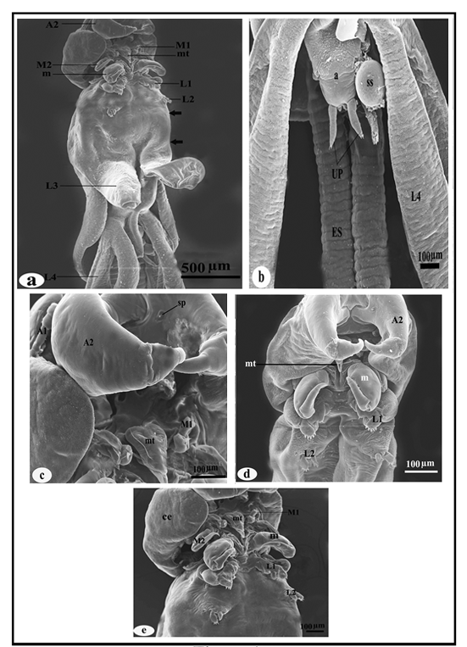

**Figure 1.** Scanning electron micrographs of female *Lernanathropus kroyeri* Beneden, 1851. (a) female in ventral view, (b) abdomen, (c) appendages of cephalothorax, (d and e) cephalothorax in ventral view. A1, 1st antenna; A2, 2nd antenna; M1, 1st maxilla; M2, 2nd maxilla; m, maxilliped; mt, mouth tube; L1, 1st thoracic leg; L2, 2nd thoracic leg; L3, 3rd thoracic leg; L4, 4th thoracic leg; a, abdomen; ES, egg sac; SS, spermatophore sac; CE, cephalothorax and UP, uropods. Small arrows indicate the genital complex.



**Figure 2.** Scanning electron micrographs of male *Lernanathropus kroyeri* Beneden, 1851. (a) male in ventral view, (b) cephalothorax in ventral view, (c) appendages of cephalothorax, (d) abdomen. A1, 1st antenna; A2, 2nd antenna; pb, parabasal flagellum; sp, spiniform process; M2, 2nd maxilla; m, maxilliped; mt, mouth tube; L1, 1st thoracic leg; L2, 2nd thoracic leg; L3, 3rd thoracic leg; L4, 4th thoracic leg; a, abdomen; and UP, uropods. Small arrows indicate genital complex.

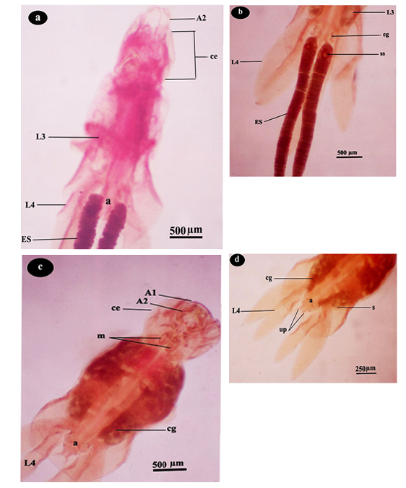

**Figure 3.** Light micrographs of *Lernanathropus kroyeri* Beneden, 1851. (a) female in ventral view, (b) posterior end of female, (c) male in ventral view, (d) posterior end of male. A1, 1st antenna; A2, 2nd antenna; m, maxilliped; ce, cephalothorax; L3, 3rd thoracic leg; L4, 4th thoracic leg; cg, cement glands; ES, egg sac; ss, spermatophore sac; s, spermatophore; a, abdomen; and UP, uropods. Small arrows indicate genital complex.

**4. Discussion**

In this study, the sea bass fishes obtained from Damietta province have been examined for the detection of ectoparasites. The parasitic copepod *Lernanthropus kroyeri* **van Beneden, 1851** was found to be one of the most important parasites well adapted to the attachment to the gill filaments of sea bass.

Some species of *Lernanthropus* are strictly host specific, but many are parasitic on several species of fish belonging to one genus, or on several genera of one family **(Lugue** and **Paraguass, 2003** and **Sharp *et al.*, 2003).**

The Lernanthropidae, following the Lernaeopodidae and Caligidae, is the 3rd largest family of fish-parasitizing Siphonostomatoida. The family contains over 150 species, with the great majority of them occurring in tropical waters. According to the copepod database produced by **Boxshall (2011)** *Lernanthropus* is the largest genus of lernanthropids comprising 111 species.

**Kabata (1979)** reported that *Lernanthropus* species attach to the host gill by means of the piercing action of the antennae, which are assisted by the maxillipeds and the modified third legs**.**

The present study described in detail the shape of the cephalothoracic appendages. **Abu Samak (2005)** observed thatboth sexes of parasitic copepod *Lernanthropus kroyeri* were attaching to host tissue by cephalothoracic appendages including 2nd antennae, second maxillae and maxillipeds. **Abu Samak (2005)** suggested thatthe second antennae have a main and primary role during attachment while the second maxillae, maxillipeds and the third legs have secondary role during this process.

Observations under light microscope by **Ho *et al*.** **(2011)** showed that lernanthropids used their prehensile antennae, maxillipeds and the third leg to attach to the gill filaments.

The present study indicated that the first maxillae were bilobate with the inner lobe smaller than the outer. The first maxillae ended by two terminal horny spines and setule cover. The second maxillae were uniramous with a distally calamus claw armed with two sharp rows of denticles. Each row comprised 13 teeth. This enforces the suggestion that the first and second maxillae have a second role in the attachment of the parasite to the host tissue. Maxillipeds were robust ending with a terminal claw with longitudinal ridges and, therefore, the maxillipeds are suggested to assist in the parasite attachment. First and second thoracic legs were smaller and differed in their structure from the other thoracic appendages. They ended with hand fingers-like spines. This structure is suggested to serve in the attachment to the adjacent secondary gill lamellae and to increase the parasite stability. Third and fourth thoracic legs were the largest appendages and they appeared foliaceous without any cuticular structures. This unique structure is suggested to serve in adjusting the parasite position and in making a tight attachment. The shape of these legs seems to be suitable in the parasite habitat and they may help in resisting the water current and in the secondary attachment of the parasite.

Furthermore, the current study, based on SEM and light microscopy, indicated that only the second antenna plays a role in the primary attachment to the gill filaments. One possible reason behind this could be the loose attachment of the parasite to the gill filaments by the first and second maxillae, the maxillipeds and the four pairs of legs when compared to the attachment by the second antenna.

**References**

1. Abu Samak, O.A., Mode of attachment and histopathological impacts associated with the parasitic copepod *Lernanthropus kroyeri* infesting gills of the sea bass fish, *Dicentrarchus labrax* in Egypt. J. Egypt. Ger. Soc. Zool., (2005); 48D 1-21.
2. Abu Samak, O.A., Redescription of *Lernanthropus kroyeri* (Copepoda: Lernenthropidae) infesting gills of sea bass fish (*Dicentrarchus labrax*) from Egyptian Mediterranean waters. J. Egypt. Ger. Soc. Zool., (2004); 43D 87-103.
3. Athanassopoulou, F., Ragias, V., Tavla, J., Christofilloyannis, P. & Liberis, N., Preliminary trials on the efficacy of ivermectin against *Lernathropus kroyeri* (Crustacea) in cultured sea bass *D. labrax L.* Aquaculture and Research (2001); 32: 77.
4. Boxshall,GA., Lernanthropidae. In TC Walter, G Boxshall, eds. World Copepoda database. Available at <http://www.marinespecies.org/copepoda/aphia>. php?p=taxdetails & id=135526 Accessed (2011); 22 Apr.
5. Henry, M.A., Alexis, M.N., Fountoulaki, E., Nengas, I. & Rigos, G., Effects of a natural parasitical infection (*Lernanthropus kroyeri*) on the immune system of European sea bass, *Dicentrarchus labrax* Parasite Immunology (2009); 31 729-740.
6. Ho, J.S & Do, T.T., Copepods of the family Lernanthropidae parasitic on Japanese marine fishes, with a phylogenetic analysis of the lernanthropid genera. Report of the Sado Marine Biological Station. Niigata University (1985); 5 31-76.
7. Ho, J.S., Liu, W.C. & Lin, C.L. Six species of the Lernanthropidae (Crustacea: Copepoda) parasitic on marine fishes of Taiwan, with a key to 18 species of the family known from Taiwan Zoological Studies (2011); 50(5): 611-635.
8. Holder, J., Aquaculture in the Egyptian desert. Hatchery International (2003); 5 8-9.
9. Kabata Z, Parasitic Copepoda of British Fishes. Ray Society, London, (1979); 468 pp.
10. Kabata, Z., Parasitic Copepoda of Australian fishes, XII. Family Lernanthropidae. Crustaceana (1979); 37 198-213.
11. Kinne, O., Diseases of Marine Animals. Hamburg, Biologisches Anstalt Helgoland (1984); 521pp.
12. Lugue L.J., Paraguass A.R. Redescriptions of two species of Lernanthropus (Copepoda, Siphonostomatoida, Lernanthropidae) parasitic on teleost marine fishes from Rio de Janeiro, Brazil. Acta Parasitol, (2003); 48: 119-124.
13. Manera, M. & Dezfuli, B.S., *Lernanthropus kroyeri* infections infarmed sea bass *Dicentrarchus labrax*: pathological features. Diseases of Aquatic Organisms (2003); 57 177-180.
14. McDowell, E.M. & Trump, B.F., Histologic fixatives suitable for diagnostic light and electron microscopy. Archives of Pathology and Laboratory Medicine (1976); 100 405.
15. Sharp N.J., Poortenear C.W., Diggles B.K., Willis T.J., Metazoan parasites of yellowtail kingfish, Seriola lalandi lalandi in New Zealand: prevalence, intensity and site preference. New Zealand Journal of Marine and Freshwater Research (2003); 37: 273-282.
16. Toksen, E., Lernanthropus kroyeri van Beneden, 1851 (Crustacea: Copepoda) infections of cultured sea bass (Dicentrarchus labrax L.). Bulletin of the European Association of Fish Pathologists (2007); 27(2) 49.

3/8/2014