Ginkgo biloba leaf extract inhibits and treated Entamoeba histolytica infection

Areej Jameel M. Alghabban

Biology Department, Faculty of science, University of Tabuk, KSA
a_alghabban@ut.edu.sa

Abstract: Entamoeba histolytica constitutes one of the commonest protozoal infections on a global scale, and it is estimated to infect 10% of the world’s population, up to 50 million cases of invasive amebiasis, and about 100,000 deaths and probably represent the third leading parasitic cause of death, behind only malaria and schistosomiasis. Oral inoculation of rabbits with 5x10³ cysts of E. histolytica isolated from the feces of 30 patients resulted in an infection between 2-3 days among all the infected rabbits as shown by the presence of trophozoites in the large intestine and colon. The cysts were first observed in the stool as early as 3rd day post inoculation, however, no trophozoites were observed. Body weight gain in infected rabbits with E. histolytica was significant decrease as compared to control group, however, it significantly increase in treated infected rabbits with ginkgo when compared to infected group. Experimentally infected rabbits with E. histolytica and treated with extract of Ginkgo biloba leaves for 7 days (G4) in significantly (p <0.05) devoided cyst gradually from day 1 after treatment. Both cysts and trophozoites were detected in the rabbit stools after the 1st day of treatment with ginkgo extracts. The cysts and trophozoites count started decreasing and became E. histolytica free by the 6th day of Ginkgo biloba extract administration indicated 100% cure rate at the end of treatment. Trophozoites of E. histolytica were highly sensitive to ginkgo extracts (24% viability) at a dose of 200 mg/Kg body weight/ day that was significant in relation to the control (500% viability after 3 day of infection) which indicates progression of infection. Many histological abnormalities in the large intestine were detected in experimentally infected rabbits with Entamoeba histolytica. These abnormalities as necrosis, severe hemorrhage, increased in numbers of goblet cells, cytoplasmic vacuoltions, congested blood vessels and lymphocytes proliferation were. Treatment with ginkgo helps in improving the adverse effect of E. histolytica infections; also the histological study confirms this finding.
[Alghabban AJM. Ginkgo biloba leaf extract inhibits and treated Entamoeba histolytica infection. Nat Sci 2014;12(2):63-68]. (ISSN: 1545-0740). http://www.sciencepub.net/nature. 10

Keywords: Entamoeba; Ginkgo biloba; Rabbit; Histopathology; PCNA

1. Introduction
Several members of the genus Entamoeba infect humans. Among these only Entamoeba histolytica is considered pathogenic and the disease it causes is called amoebiasis or amebic dysentery. Amebiasiss is a common worldwide disease in developing countries, caused by infection with protozoan parasite Entamoeba histolytica (Stanley, 2003; Huston, 2004; Mukherjee et al., 2008; Shahran and Petri, 2008; Khalaf, 2013). It is much more common in the tropics and wherever sanitation is poor, in all climatic zones (Paniker, 2002). It constitutes one of the commonest protozoal infections on a global scale, and it is estimated to infect 10% of the world’s population, up to 50 million cases of invasive amebiasis, and about 100,000 deaths and probably represent the third leading parasitic cause of death, behind only malaria and schistosomiasis (Georgopoulos et al., 2001; Bansal et al., 2004). Amoebiasis is a major problem in developing countries such as India. This is primarily because of inadequate sanitation and contaminated food and drinking water.
Entamoeba histolytica, an intestinal parasite that exists in two forms, the trophozoite which is the active, dividing form and the cyst which is dormant and can survive for prolonged periods outside the host (Stanley, 2003; Huston, 2004; Khalaf, 2013). Entamoeba histolytica exhibits a typical fecal–oral life cycle consisting of infectious cysts passed in the feces and trophozoites which replicate within the large intestine (Joyce and Ravdin, 1988). The infection is acquired through the ingestion of cysts and the risk factors are similar to other diseases transmitted by the fecal–oral route. Contaminated food and water are probably the primary sources of infection (Stanley, 2003; Huston, 2004; Khalaf, 2013).
Intestinal amebiasis is still an important health problem in developing countries of the world. All drugs can have side effects. Sometimes, the side effects are serious but most of the time they are not. Over the years, plants have been used as valuable sources of natural products for maintaining animal and human health.
Plants have been reported to contain large varieties of chemical substances that possess important preventative and curative therapies (Nascimento et al., 2000). Since prehistoric times and continuing to our modern days, people from all over the world have grown or collected plants for the prevention and treatment of diseases. Herbal medicine is increasingly gaining acceptance from the public and medical professionals due to advances in the understanding of the mechanisms by which herbs positively influence health and quality of life (Panda and Naik, 2009).
Ginkgo biloba is one of the oldest herbal medicines that have been used as a therapeutic agent in modern pharmacology (Jaracz et al., 2004). Ginkgo biloba leaves extract is believed to provide beneficial effects in memory impairment, stroke, edema, inflammation, Alzheimer’s dementia and vasooclusive disorders (Diamond et al., 2000). Based on these evidences, the present study was aimed to evaluate the beneficial action of Ginkgo biloba leaves extract as an alternative drug against amoebiasis in experimental animals.

2. Materials and Methods:
Stool samples:
The present study included (30) stool samples were collected from patients naturally infected with Entamoeba histolytica, in Arab Saudi children hospital and from some an official analysis laboratories in Tabuk city, KSA, directly awet slide prepared by using Logls iodine stain to search about Entamoeba histolytica, the positive samples saved in cool containers and transferred to Tabuk university. The cyst of Entamoeba histolytica from patients stool were purficate according to Bingham and Meyer method (1979) and counted with haemocytometer chamber and suspended in phosphate buffer saline (pH 7.2) to contain (5×10³ cyst /1.0ml).
Animals and Experimental Design:
Experiments were performed on local domestic rabbits (Oryctolagus cuniculus). A total number of 20 growing male rabbits at 12-14 weeks of age (with an average weight about 1200±50 g) were kept under the same managerial and hygienic conditions and were free from intestinal pathogens. The rabbits were housed in galvanized wire cages (50 x 60 cm) provided with feeds and automatic nipple drinkers. Feed and water were offered ad libitum.
Rabbits were individually weighed and randomly distributed into four groups of four rabbits.
G₁: Control group includes animals that did not receive any treatment and dissected after 10 days.
G₂: Positive control group includes animals that received extract of Ginkgo biloba leaves (200 mg/Kg body weight/ day) and dissected after 7 days.
G₃: Experimental infected group includes animals that orally infected with single challenge dose of about 5×10³ cysts of Entamoeba histolytica and dissected after 5 days (Bingham and Meyer, 1979; Fotedar et al., 2007).
G₄: Treated group includes animals that orally infected with single challenge dose of about 5×10³ cysts of Entamoeba histolytica and after 3 days of infection the infected rabbits treated orally with extract of Ginkgo biloba leaves (200 mg/kg body weight/ once daily) for 7 days.
Entamoeba histolytica cyst in rabbit faces:
In each group the rabbits isolated one by one indifferent cages and one gram of fresh passed fecal were collected from each rabbits dissolved in 5ml of normal saline and homogenized, saline was prepared and cyst stained with iodine and counted every day (Shegal et al., 1996).
Entamoeba histolytica counts in rabbit faces:
On the other hand, at the begging of treatment of infected rabbit with extract from Ginkgo biloba leaves; the Stool specimens were examined microspically for viable trophozoites, and the numbers of these trophozoites were counted with haemocytometer chamber (Fotedar et al., 2007).
At the end of treatment period, rabbit in each group were sacrificed, dissected and the intestine of each rabbit were removed immediately and fixed with 10% buffer neutral formalin, dehydration through graded alcohols for a total of 6 hr, followed by 3 hr clearing with xylene and 4 hr tissue impregnation with embedding medium. The processed intestine tissues were then embedded in paraffin wax to produce tissue blocks. Five µm thick paraffin embedded tissue sections were cut with a microtome and subsequently stained with Hematoxylin and Eosin; Van Gieson's and Mallory stains according to Avwioro (2010) were then examined by light microscopy.
PCNA immunohistochemistry:
The distribution of PCNA receptor subunits were examined in paraffin sections (5μm thick) of fixed rat intestines that mounted on gelatin chromalum–coated glass slides using an Avidin-Biotin-Peroxidase (ABC) immunohistochemical method (Elite–ABC, Vector Laboratories, CA, USA) against PCNA (dilution 1:200, DAKO Japan Co, Ltd, Tokyo, Japan) according to Tousson et al. (2012).
All stained slides were viewed by using Olympus microscope and images were captured by a digital camera (Cannon 620). Brightness, contrast and analysis of the images were adjusted using Adobe Photoshop software (version 4.0.1; Adobe Systems, Mountain View, CA).
Statical analysis
All the data are expressed as mean + Standard error of mean. P<0.05 was considered
Significant and results were expressed as:

Percentage of viability =
Number of viable trophozoites after treatment

Number of viable trophozoites before treatment X 100

3. Result and discussion
Oral inoculation of rabbits with 5x10³ cysts of E. histolytica isolated from the feces of 30 patients resulted in an infection between 2-3 days among all the infected rabbits as shown by the presence of trophozoites in the large intestine and colon.
The cysts were first observed in the stool as early as 3rd day post inoculation. However, no trophozoites were observed in the stool of experimentally infected rabbits as in group 3. None of infected rabbits showed any clinical symptoms like diarrhea and death. Several factors are involved in the successful infection with E. histolytica in rabbits. The present results are agreed with Al-Jumaily (1983); Georgopoulos et al. (2001) and Al-Mukhtar and Barwari (2008).
These include strain of E. histolytica (clinical isolate) used; age, weight, and the most important factors are the strain and the susceptibility of the host to E. histolytica. The infection persisted among control group and the cure rate was 0%.
On the other hand, Das et al. (1983) reported that the experimental infection of rats with E. histolytica (clinical strain) are all virulent to rats, whereas those isolated from carriers were either unable to produce ulcers or had low virulence as compared to strains of E. histolytica isolated from acute cases.

Table 1: Changes in body weight gain (gm) and average daily gain (gm/d) in different groups under study.
 | G1 | G2 | G3 | G4
body weight, gain | 45.0±2.5^{b}  (7 day) | 48.3±4.7^{b}  (7 day) | 15.2±3.6ª  (5 day) | 31.9±5.1^{ab}  (7 day)
Average  Daily  gain | 7.9±0.06^{b} | 8.2±0.18^{b} | 4.7±0.03ª | 5.7±0.12ª
a and b: Values having different superscripts within the same column for each factor are significantly different at (P<0.05) .

The effect of E. histolytica infections on the body weight gain of rabbits is shown in Table 1. Body weight gain in control and ginkgo groups showed significant increase as compared to infected group. While body weight gain was significant increase in treated infected rabbits with ginkgo when compared to experimentally infected group. However, body weight gain showed significant decrease in treated infected rabbits with ginkgo when compared to ginkgo group. Our results agreed with Al-Mukhtar and Barwari (2008) and not agreed with Khalaf (2013) who reported that experimentally infections of mouse with 10³-10⁴ E. histolytica cysts not effected on body weight gain.
The extract of Ginkgo biloba leaves that used was effective in the treatment groups with 95% cure rate (Table 2). Trphozoites of E. histolytica were highly sensitive to ginkgo extracts (24% viability) at a dose of 200 mg/Kg body weight/ day that was significant in relation to the control (500% viability after 5 day of infection) which indicates progression of infection. Experimently infected rabbits with E. histolytica and treated with extract of Ginkgo biloba leaves for 7 days (G4) in significantly (p <0.05) devoided cyst gradually from day 1 after treatment. Both cysts and trophozoites were detected in the rabbit stools after the 1st day of treatment with ginkgo extracts. The cysts and trophozoites count started decreasing and became E.histolytica free by the 6th day of Ginkgo biloba extract administration.

Table 2: The percentage of cured rabbits in different groups under study.
 | No. of infected rabbits | No. of cured rabbits after 7 days of treatment with ginkgo | % of cured rabbits
G1 | 0 | 0 | 0
G2 | 0 | 0 | 0
G3 | 5 | 0 | 0
G4 | 5 | 5 | 95%

The number of trophozoites after treatments/1gm faces at zero day of treatment was zero and the percentage of infection was 100%, at 1st day of treatment was 325±19.5; however the numbers of trophozoites were significantly increased at 2nd and significantly decreased at 4th days of treatment were 980±25.5 and 535±20.0 respectively.
Our results agree with Stanley (2003) who fined the number of cysts and trophozoites significantly decreased after treatments. On the other hand, the number of trophozoites /1gm faces at the 7th day of treatment was zero where the experimentally infected rabbits with E.histolytica became free from infections and the percentage of infection was 0%.
Examination of H&E stained sections in control and ginkgo groups in rectum and ileum showed normal structural appearances of the mucosa, submucosa, crypt of Lieberkuhn and goblet cells (Figure 1A & 1B). The mucosa of colon showed closely packed simple tubular straight glands (crypts of Lieberkuhn). They were aligned parallel to each other and extended down to muscularis mucosa. The lamina propria appeared filling the space between the crypts and contained mononuclear cells (Figure 1A & 1B). Cysts of E.histolytica survive the acidic pH of the stomach and pass into the intestine.

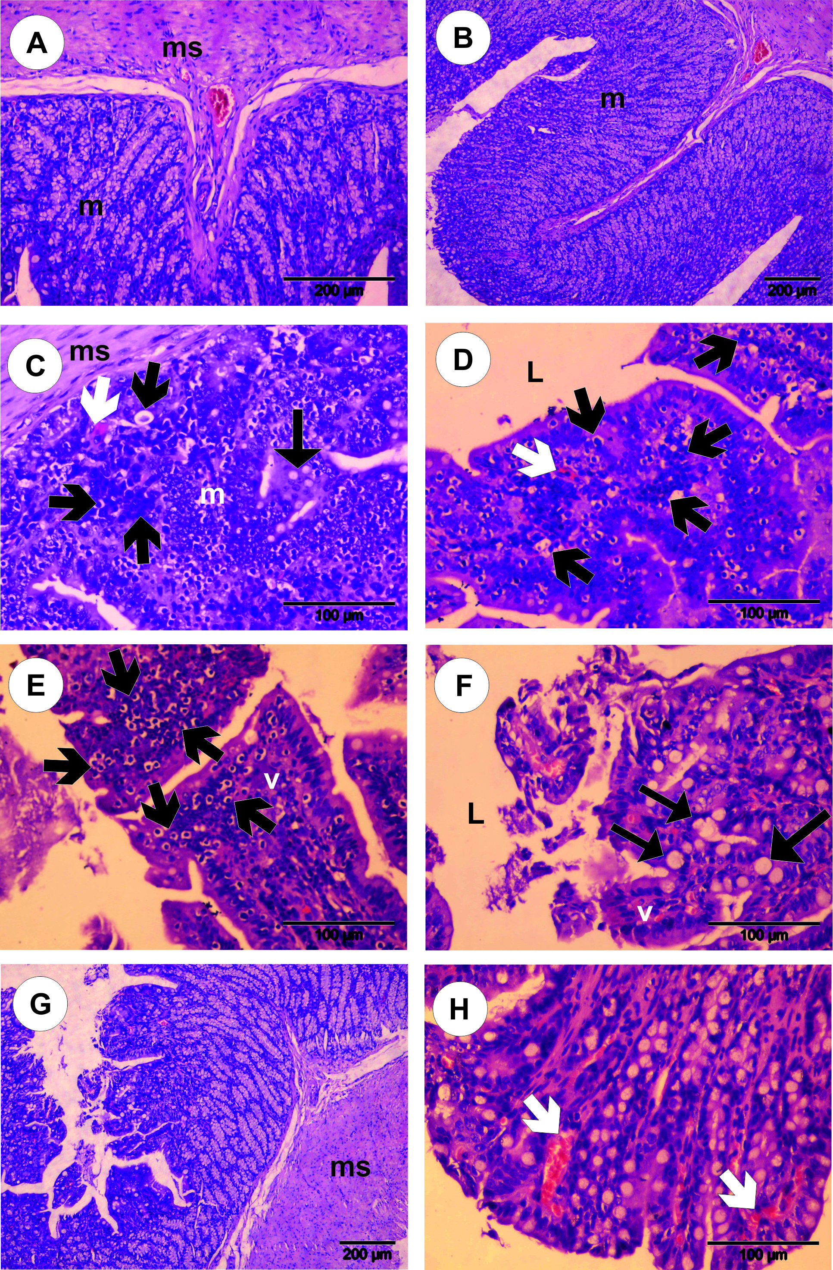
Figure 1: Photomicrographs of large intestine sections stained with Hematoxylin & Eosin. A&B: Large intestine sections in control and ginkgo groups showing normal structural appearances of the mucosa, submucosa, crypt of Lieberkuhn and goblet cells. C-F: Large intestine sections in the infected rabbits showed the trophozoites (Black arrows) within mucosa shortening of the microvilli, mucosal degradation, necrosis, severe hemorrhage (White arrows), increased in numbers of goblet cells, cytoplasmic vacuoltions, congested blood vessels and lymphocytes proliferation. G&H: Large intestine sections in of treated infected rabbits with ginkgo revealed a few hemorrhage (White arrows), a few cytoplasmic vacuoltions with decreased in numbers of goblet cells (V, Villi; L, Lumen; m, Mucosa; ms, Muscularis mucosa).

In the ileo-cecal region, cysts undergo excystment and each cyst gives rise to eight trophozoites. These migrate to and multiply in the colon. In most cases, trophozoites in the intestine live as commensals. Occasionally, however, trophozoites attack and invade the intestinal mucosa causing dysentery and/or progress through the blood vessels to extra-intestinal locations like liver, brain and lungs, where they may form life-threatening abscesses.
In the current study; many histological abnormalities in the intestine were detected after experimentally infected rabbits with about 5×10³ cysts of Entamoeba histolytica. After three days of infections, some of trophozoites are found in the intestinal lumen and within mucosa and this agree with Brandt and Perez-Tamayo (1970); Guerrant et al. (1981) and Salata et al. (1985).
Most of trophozoites were found attached to interglandular epithelium, the trophozoites have been found associated with the microulcerations of the mucosa associated with thinning of the mucus layer, a shortening of the microvilli, bleeding, degradation of the extracellular matrix, cell vacuolation, necrosis, hemorrhage with compression and distortion of individual cells resulting from the presence of large numbers of trophozoites (Figs. 1C-1F, 2A, 2B & 2E). This results agree with Ravdin et al. (1985) and Shahran and Petri (2008).
Also, increased in numbers of goblet cells, cytoplasmic vacuoltions, congested blood vessels and lymphocytes proliferation were also observed in infected rabbits (Figs. 1C, 2C & 2E). Another histopathological changes in the submucosa was manifested in the form of remarkable congestion of the blood vessels and severe hemorrhage. Our current results agree with Al-Jumaily (1983) and Mukherjee et al. (2008) who reported more or less smaller histopathological finding. In the present study, three days after infections not enough for ulcer formed. Amoebiasis is treated with metronidazole or one of 5-nitromidazol family of drugs such as tinidazole. Metronidazole is the only drug approved for the treatment of invasive amoebiasis, but it has side effects such as gastric upset, optic atrophy, bitter taste, dermatitis, seizures, and possible carcinogenesi (Ravdin, 1995). In addition, treatment failure which is about 28%, raises concern about possible resistance to the used drugs and their use during pregnancy is risky (Georgopoulos et al., 2001). Metronidazole or one of 5-nitromidazol family drug present negative secondary effects, moreover new reports show evidence of resistance of Entamoeba histolytica for this drug on the other hand, recent researches report the use of probiotic in the treatment of infections disease as: giardiasis, Listeriasis and rota virus and have been considered as an option to be used in clinical medicine, beyond nutritional option (Haque et al., 2003; Shukla et al., 2009; Maria, 2012).

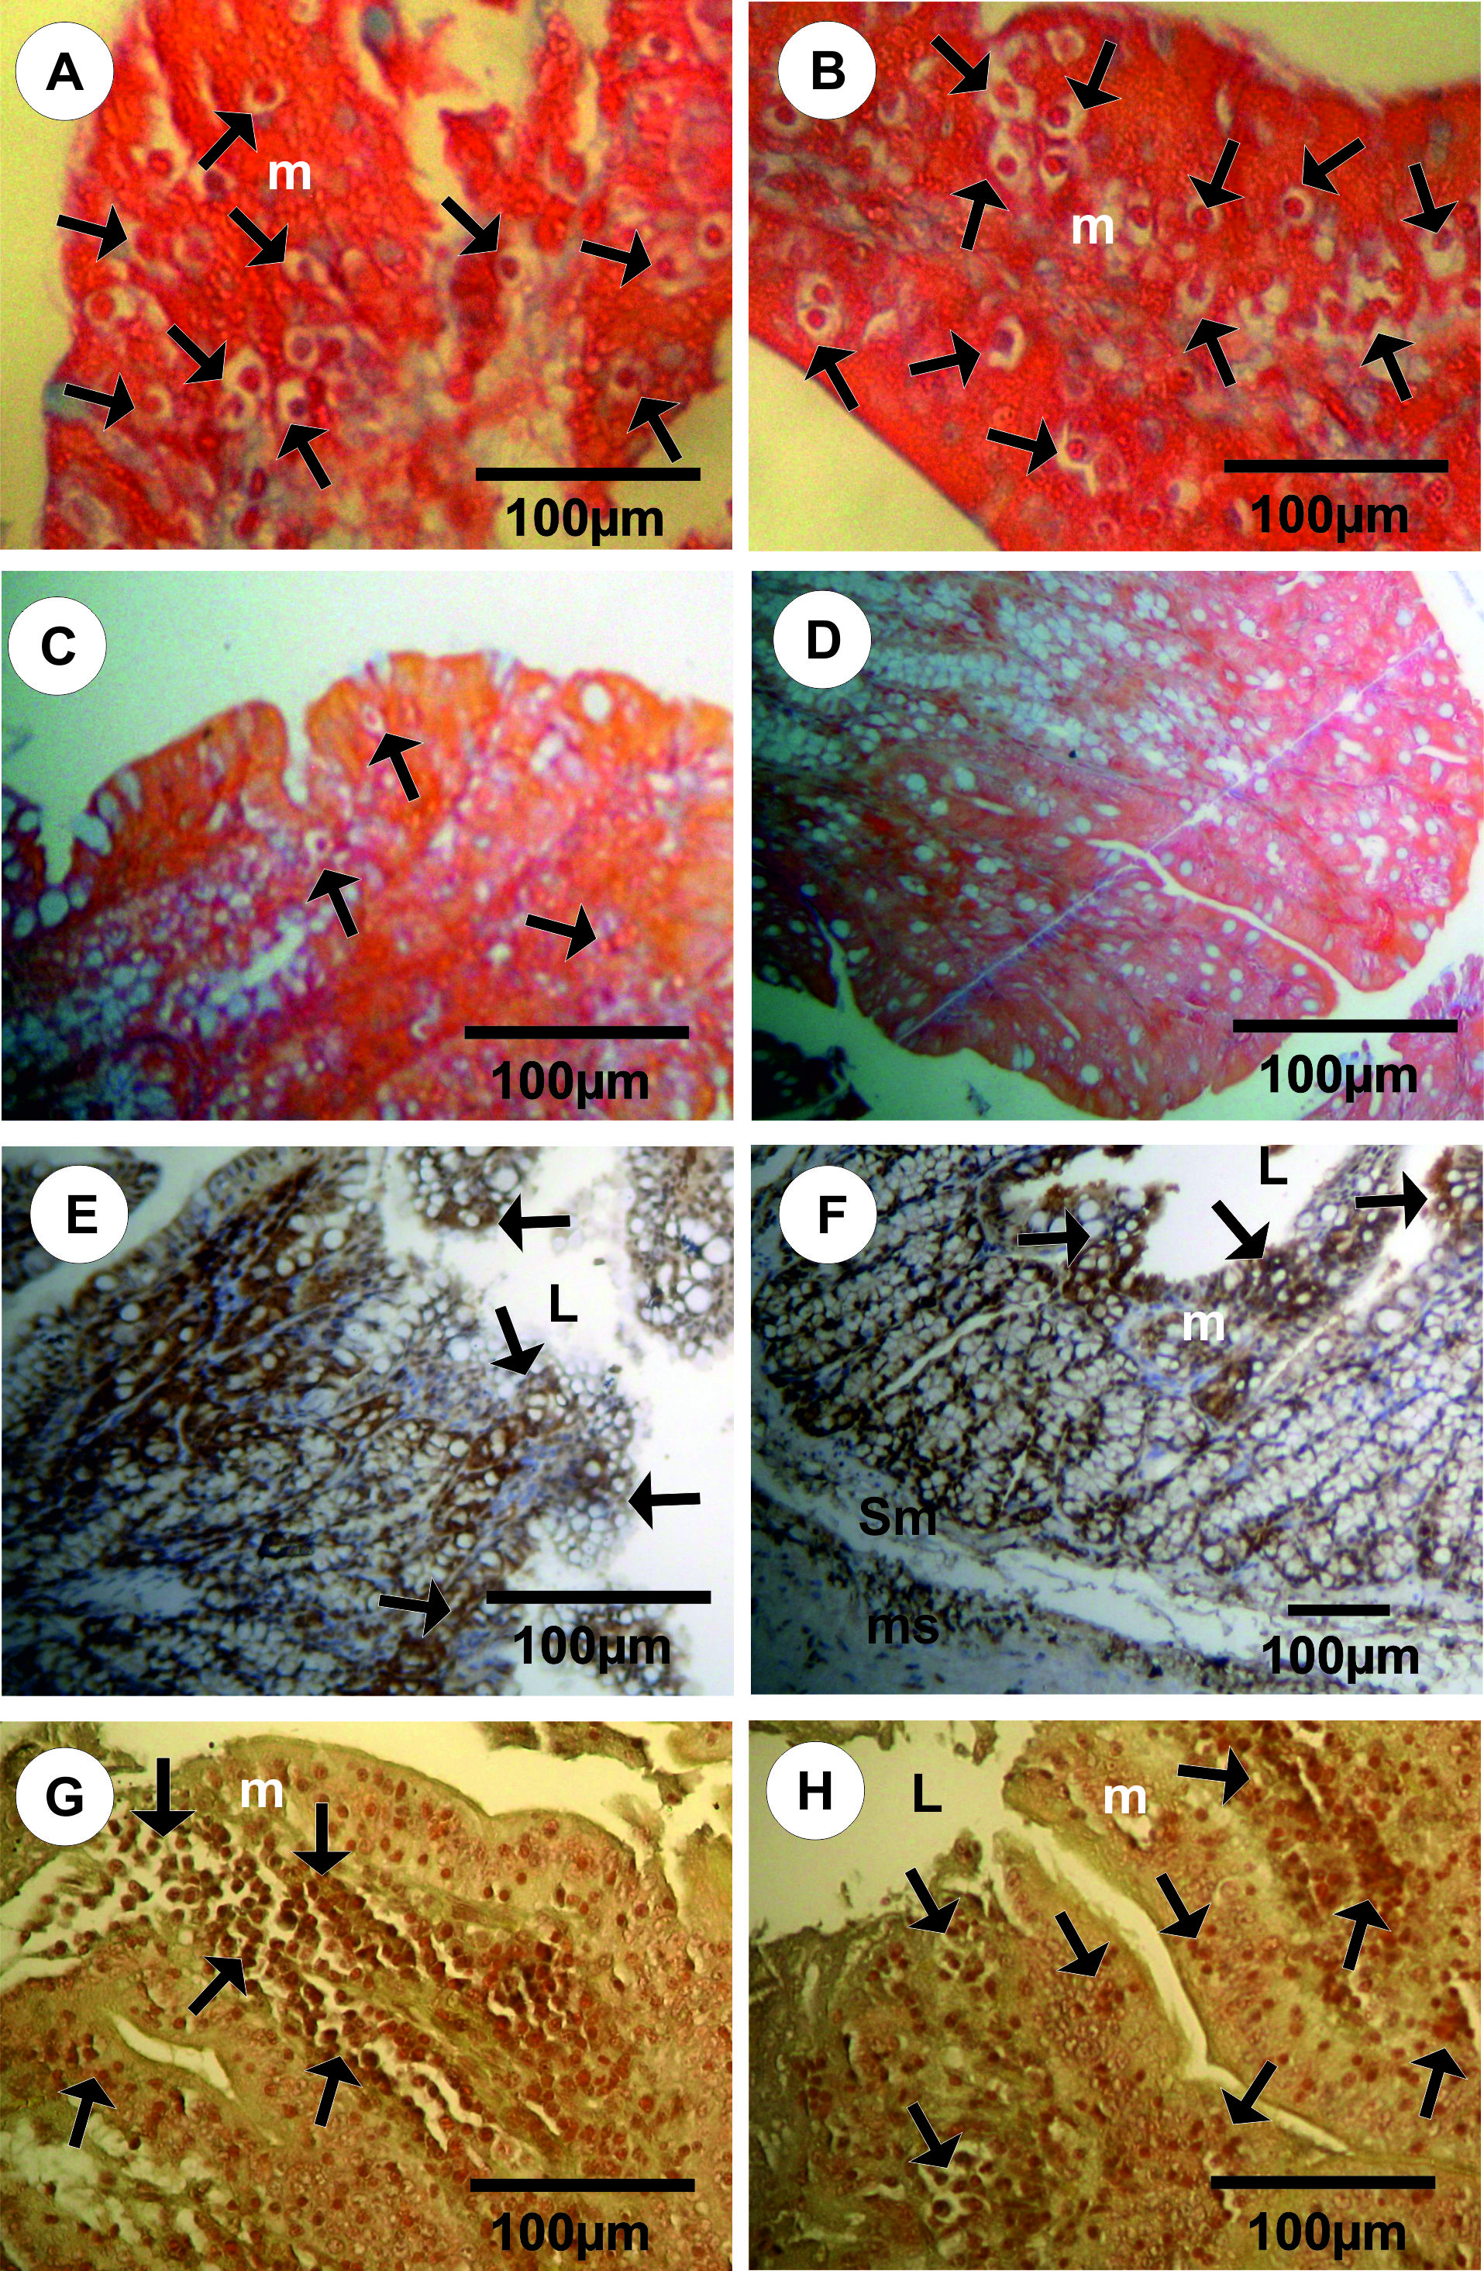
Figure 2: A-D: Photomicrographs of large intestine sections stained with Mallory. A&B: Large intestine sections in the infected rabbits showed a huge numbers of trophozoites (Black arrows) within mucosa C: Large intestine sections in of treated infected rabbits with ginkgo showed a few numbers of trophozoites (Black arrows) within mucosa and a few cytoplasmic vacuoltions. D. No trophozoites within mucosa in large intestine sections in of treated infected rabbits with ginkgo were observed at the end of treatment. E&F: Sections of large intestine stained with Van Gieson's. E: large intestine sections in the infected rabbits showed an increased in numbers of goblet cells, congested blood vessels and lymphocytes proliferation. F: Large intestine sections in of treated infected rabbits with ginkgo showed decreased in numbers of goblet cells. G&H: Sections of large intestine (stained with PCNA immunostaining) in the infected rabbits showed strong positive reactions for PCNA-ir (grade 4) in the crypts of Lieberkuhn. (V, Villi; L, Lumen; m, Mucosa; ms, Muscularis mucosa; sm, Sub mucosa).

Treatment of infected rabbits with extract of Ginkgo biloba leaves (200 mg/kg body weight/ once daily) for 7 days improving the adverse effect of E.histolytica infections; also the histological study confirms this finding improved (Figs. 1G, 1H, 2D & 2F). Only hemorrhage, decreased in numbers of goblet cells, a few cytoplasmic vacuoltions, congested blood vessels and lymphocytes proliferation were observed in large intestine of treated infected rabbits with ginkgo (Figs. 1G, 1H & 2F).
Ginkgo leaf extract has shown beneficial effects in treating neurodegenerative diseases like Alzheimer’s, cardiovascular diseases, cancer, stress, memory loss, tinnitus, geriatric complaints like vertigo, age-related macular degeneration, and psychiatric disorders like schizophrenia. These multifaceted activities of the Ginkgo leaf extract may work through various mechanisms of action. DeFeudis and Drieu (2000) and Smith and Luo (2003, 2004) who suggested the mechanisms of the ginkgo leaf extract are its antioxidant effect and decreased expression of peripheral benzodiazepine receptor for stress alleviation and stimulation of endothelium derived relaxing factor to improve blood circulation.
When PCNA immunostaining was used to evaluate the proliferative activity of cells high numbers of nuclear positive cells were detected in the large intestine of infected and treated rabbits. Large intestine sections in control and ginkgo groups showed mild positive reaction for PCNA-ir (grade 2) in the lower third of the crypts, while strong positive reactions for PCNA-ir (grade 4) in (Fig. 2G & 2H). Treatment of infected rabbits with ginkgo revealed moderate positive reactions for PCNA-ir (grade 3) were observed in the crypts of Lieberkuhn. Several drugs are available for the treatment of amebiasis and the choice of drug(s) depends on the clinical stage (i.e., noninvasive or invasive) of the infection. Noninvasive or asymptomatic infections are treated with luminal amebicides such as paromomycin, diloxanide furoate, or iodoquinol. These luminal agents are not well absorbed and therefore not effective against the tissues stages. Availability of a single agent efficacious against all forms of amoebae and with low levels of toxicity as in ginkgo leaf extract would be a major therapeutic advance, especially if the drug was safe to use during pregnancy. The current results indicate that Ginkgo leaf extract has beneficial effects in treatment of intestinal protozoa.

References:
- Al-Jumaily, AR. The effect of immunosupression of experimental amoebiasis in laboratory animals. M.Sc. thesis. College of Medicine, University of Baghdad.1983.
- Al-Mukhtar AM, Barwari WO. Effectiveness of albendazole against viability of entamoeba histolytica in mice and rabbits. Ann. Coll. Med. Mosul 2008; 34(1): 64-68.
- Avwioro OG. Histochemistry and Tissue Pathology, Principles and Techniques. Claverianum press, Nigeria. 2010
- Bansal D, Sehgal R, Chawla Y, Mahajan RC, Malla N. In vitro activity of antiamoebic drugs against clinical isolates of Entamoeba histolytica and Entamoeba dispar. Annals of Clinical Microbiol and Antimicrobials, 2004; 3: 27-32.
- Bingham AK, Meyer EA. Giardia lamblia excystation can be induced in vitroin acidic solution .Nature (London ), 1979; 277: 301-302.
- Brandt Η, Perez-Tamoyo H. Pathology of human amoebiasis; Hum. Pathol. 1970; 1: 351-385.
- Das SR, Sharma RK, Ghoshal S. Virulence of strains of Entamoeba histolytica to rats and hamsters and their encystment In vitro. Indian J. Parasitol. 1978; 2: 15-18.
- DeFeudis FV, Drieu K. Ginkgo biloba extract (EGb 761) and CNS functions: basic studies and clinical applications. Curr Drug Targets, 2000; 1:25–58.
- Diamond L S and Clark C G 1993 A redescription of E. histolytica Schaudinn, 1903 (Emended Walker, 1911) separating it from E. dispar Brumpt, 1925; J. Euk. Microbiol. 40 340-344
- Fotedar, R., Stark, D., Beebe, N., Marriott, D., Ellis, J. and Harkness, J. (2007) Laboratory diagnostic techniques for Entamoeba species. Clin. Microbiol. Rev. 20: 511–532.
- Georgopoulos, A., Linnau K.F., Buxbaum A., Coste C., Santos M.A., Shabpar A., and Graninger W. Efficacy of macrolides vs. metronidazole against Entamoeba histolytica clinical isolates. The Middle European J of Medicine 2001; 113/15-16: 593-596.
- Guerrant RL, Brush J, Ravdin J I, Sullivan J A and Mandell G L Interaction between Entamoeba histolytica and human polymorphonuclear neutrophils; J. Infect. Dis. 1981;143: 83-93
- Haque R, Huston CD, Hughes M et al. Amebiasis. N Engl J Med., 2003; 348(16): 1565–1573
- Huston CD. Parasite and host contributions to the pathogenesis of amebic colitis. Tr. Parasitol. 2004; 20: 23–26.
- Jaracz S, Malik S, Nakanishi K. “Isolation of ginkgolides A, B, C, J and bilobalide from G. biloba extracts,” Phytochemistry, 2004; 65: 2897–2902.
- Joyce ΜΡ, Ravdin JI. Pathology of Human amoebiasis: in Amoebiasis: Human infection by Entamoeba histolytica (ed.) J I Ravdin (New York: John Wiley) 1988; pp 129-146.
- Khalaf KJ. Study of lactobacillus acidophilus as atreatment and Prophylaxis for entamoeba histolytica infected mice. World Journal of Pharmaceutical research, 2013; 2 (5): 1229-1237.
- Maria PBG. Inhibition invitro of the growth and encystations of Entamoeba histolytica by probiotic . Probiotic, 2012; 19-21.
- Mukherjee C, Clark CG, lohia A. Entamoeba shows Reversible variation inploidy under different growth conditions and between life cycle phases , Plos Negl Trop Dis. 2008; 2:e281.
- Nascimento GGF, Locatelli J, Freitas PC, Silva GL. Antibacterial activity of plant extracts and phytochemical on antibacterial-resistant bacteria. Braz. J. Microbiol. 2000; 31(4): 247-256.
- Panda VS, Naik SR. “Evaluation of cardioprotective activity of Ginkgo biloba and Ocimum sanctum in rodents,” Alternative Medicine Review, 2009; 14 (2): 161–171.
- Paniker, CKJ. Text book of Medical Parasitology, 5th ed., New Delhi, India. Jaypee brothers Medical Publishers (P) LTD. 2002; pp. 15-27.
- Ravdin, JI. Amebiasis. Clin. Infect. Dis. 1995; 20: 1453–1566.
- Salata R A, Pearson R Ρ, Murphy C F and Ravdin JI. Interaction of human leukocytes with Entamoeba histolytica: killing of virulent amoebae by macrophage; J. Clin. Invest. 1985; 76: 491-499
- Ravdin JI, John JE, Jonston LI, Innes DJ, Guerrant RL Adherence of Entamoeba histolytica trophozoites to rat and human colonic mucosa; Infect. Immun. 1985; 48: 292-297
- Shahran SM, Petri WA, Jr. Intestinal invasion by Entamoeba histolytica. Subcell. Biochem. 2008; 47: 221–232.
- Shegal D, Bhattacharya A, Bhattacharya S. Pathogensis of infection by Entamoeba histolytica J. Bio Sci . 1996; 21(3): 423 -432.
- Shukla G, kaur T, Sehgal R, Rishi P, Prabha V. Protective potential of L.acidophilus in murine giardiasis .Central European Journal of Medicine. 2009; 5: 456-463.
- Smith JV, Luo Y. Elevation of oxidative free radicals in Alzheimer’s disease models can be attenuated by Ginkgo biloba extract EGb 761. J Alzheimers Dis 2003; 5: 287–300.
- Smith JV, Luo Y. Studies on molecular mechanisms of Ginkgo biloba extract. Appl Microbiol Biotechnol., 20043; 64: 465–72.
- Stanley S.L., Jr. Amoebiasis. Lancet, 2003; 361: 1025–1034.
- Tousson E, El-Moghazy M, Massoud A, Akel A Histopathological and immunohistochemical Changes in the testes of rabbits after injection with the growth promoter boldenone. Reproductive Sciences, 2012; 19(3): 253-259.

1/29/2014

