Microbiological Quality of Meats Sold In Port Harcourt Metropolis, Nigeria

Omorodion NJPN and Odu NN

Department of Microbiology, University of Port Harcourt, P.M.B. 5323, Choba, East-West Road, Port Harcourt, Nigeria
nigwiloh@yahoo.com

Abstract: Three different meat samples namely; beef, chicken and pork obtained from Creek road market, Mile 3 market and Rumokoro market were analyzed for their microbiological quality using differential, selective and routine media. A total of thirtyone bacterial isolates covering six genera and thirteen fungal isolates covering three genera were isolated and characterized as Bacillus spp., Enterobacter spp., Escherichia spp., Klebsiella spp., Pseudomonas spp. and Staphylococcus spp., Aspergillus spp., Mucor spp. and Penicillium spp. From the analysis, it was observed that the total bacteria viable count of the meat samples ranged from 8.6x10⁵ CFU/g to 2.6x10⁶CFU/g, while that of fungi ranged from 6.0x10⁴CFU/g to 4.4x10⁵CFU/g. In the detection method for pathogens (Salmonella and Shigella) after adopting the normal culture procedures of selective enrichment, differential and selective plating; no pathogen was detected. Appropriate measures such as chilling, freezing, treatment with salt, nitrites, phosphate, lactic acid, etc should be adopted to prevent contamination of meat by bacteria and fungi; this will ensure good microbiological quality of meat products. It is essential to store the meat at lower than 4°C immediately after slaughtering and during transport and storage as it is critical for meat hygiene, safety, shelf life, appearance and eating quality.
[Omorodion NJPN and Odu NN. Microbiological Quality of Meats Sold In Port Harcourt Metropolis, Nigeria. Nat Sci 2014;12(2):58-62]. (ISSN: 1545-0740). http://www.sciencepub.net/nature. 9

Key words: contamination; meats samples; microbiological quality; preservation

1. Introduction
Meat is every edible part of any slaughtered animal, whether the same is in its natural state or has been subjected to freezing, chilling, salting, canning or other preservative processes (OYSGN, 1978). The source of water for abattoir activities is very paramount to meat hygiene as water is needed in maintaining cleanliness of the abattoir environment and for washing off blood from the meat. Meat contamination in abattoirs and meat stalls could result from contaminated water, unhygienic practices like poor handling, use of contaminated tables to display meat meant for sale and the use of contaminated knives in cutting operations. Contamination of meat and meat products occur when raw meat is exposed or makes contact with pathogenic microbes (WHO, 1982).
The quality of meat and meat products degrade as a result of digestive enzymes, microbial spoilage and fat oxidation (Berkel et al., 2004). Lipid oxidation, protein degradation and the loss of other valuable molecules are the consequence of meat spoilage process. Pre-slaughter handling of livestock and post-slaughter handling of meat play an important part in deterioration of meat quality. The glycogen content of animal muscles is reduced when the animal is exposed to pre-slaughter stress which changes the pH of the meat, to higher or lower levels, depending on the production level of lactic acid (Miller, 2002; Chambers and Grandin, 2001). Lactic acid is produced due to the breakdown of glycogen content of animal muscles via an anaerobic glycolytic pathway. Higher levels of pH (6.4-6.8) result in dark, firm and dry (DFD) meat. Long term stress causes DFD meat which has a shorter shelf life (Miller, 2002; Chambers and Grandin, 2001). Sever short term stress results in a pale, soft and exudative (PSE) meat. PSE meat has a pH lower than normal ultimate value of 6.2 which is responsible for the breakdown of proteins, providing a favorable medium for the growth of bacteria (Miller, 2002; Chambers and Grandin, 2001). There are three main mechanisms for meat and meat products spoilage after slaughtering and during processing and storage: (a) microbial spoilage, (b) lipid oxidation and (c) autolytic enzymatic spoilage.
Meat and meat products provide excellent growth media for a variety of microflora (bacteria, yeasts and molds) some of which are pathogens (Jay et al., 2005). The intestinal tract and the skin of the animal are the main sources of these microorganisms. The composition of microflora in meat depends on various factors: (a) preslaughter husbandry practices (free range Vs intensive rearing), (b) age of the animal at the time of slaughtering, (c) handling during slaughtering, evisceration and processing, (d) temperature controls during slaughtering, processing and distribution (e) preservation methods, (f) type of packaging and (g) handling and storage by consumer (Cerveny et al., 2009).
Microbial contamination of meat and meat products must not exceed levels which could adversely affect the shelf life of the product; if it does ,it renders the meat unwholesome and hence not fit for human consumption (Fasanmi and Sansi, 2008). Reduction of risk for human illness associated with raw produce can be better achieved through controlling points of potential contamination in the field, during harvesting, during processing or distribution, or in retail markets, food- service facilities, or the home (Scates et al., 2003; FDA, 2007).
Mold species include Cladosporium, Sporotrichum, Geotrichum, Penicillium and Mucor while yeasts species include Candida spp., Cryptococcus spp. and Rhodotorula spp. (Garcia-Lopez et al., 1998). Bacteria species include Pseudomonas spp., Micrococcus spp., Streptococcus spp., Sarcina spp., Lactobacillus spp., Salmonella spp., Escherichia spp., Clostridium spp. and Bacillus spp. (Lin et al., 2004). Hayes et al. (2003) found Enterococcus spp. to be the most dominant bacteria on 971 of the 981 samples (99%) of all meat (chicken, turkey, pork and beef) in the state of Iowa. Cerveny et al. (2009) stated that storage conditions affect the type of microbes found in meat and meat products.
Enterobacteriaceae are frequently present on refrigerated meat product. They also indicated that psychrotrophic lactic acid bacteria, Enterococci, Micrococci and yeasts are predominately found in raw, salted-cured products such as corned beef, uncooked hams and bacon due to their resistance to curing salts. Garcia-Lopez et al. (1998) reported that the growth of Enterobacteriaceae and Pseudomonas spp. were more prevalent on modified atmosphere packed meat than on vacuum packed meat, their growth being favoured by storage at 5°C. Proteolytic enzymes are active at low temperatures (5°C) which lead to deterioration of meat quality due to growth of microbes and biogenic amines production (Kuwahara and Osako, 2003)

2. Materials and methods
2.1. Sample collection
Beef, chicken and pork were aseptically collected from three different markets namely; Creek road market, Mile 3 market and Rumokoro market all in Port Harcourt Rivers State. After the collection, the samples were transported to Microbiology Laboratory, University of Port Harcourt for immediate analysis. The samples were analyzed for total viable count, total coliform count, total fungal count and pathogen (Salmonella and Shigella) detection. The media used for the analysis were, Plate Count Agar (PCA), Eosine Methylene Blue (EMB), Salmonella Shigella Agar (SSA), Nutrient Agar, Sabouraud Dextrose Agar (SDA).
2.2. Enumeration, Isolation and Identification of Bacteria Isolates
The meat samples were obtained from different locations were weighed and grinded using stomacher. Twenty-five grams of each homogenized sample was dispensed into a prepared 225 ml of normal saline. The content was shaken for homogenous mixture. Ten fold serial dilutions were used to prepare culture plates by pour plate method. About 0.1 ml of the 10⁻⁵ dilution of the samples from different location were pipetted out and pour plated using Plate Count agar (PCA), Nutrient agar (NA), MacConkey agar (MCA), Eosin Methylene Blue Agar (EMB), Salmonella-Shigella agar (SSA) and potato dextrose agar (PDA) for total aerobic counts, total coliform counts, total Salmonella-Shigella counts and total fungi count. These plates were incubated at 37⁰C for 24-48 hours. The streak technique in the Nutrient agar was employed for bacterial colony purification. The discrete colonies from these subcultured plates and series of biochemical tests were done for proper characterization and identification. The bacterial isolates were also identified by comparing their characteristics with those of known taxa, as described by Jolt et al. (1994) and Oyeleke and Manga (2008). For isolation and conﬁrmation of Salmonella and Shigella, procedures recommended by Speck (1976) were followed. The pre-enriched samples in lactose broth were subcultured into selenite F broth for selective enrichment, and on Salmonella–Shigella agar (SSA). Typical colonies were Gram-stained and characterized (Speck, 1976). The pure isolated fungi were identified using cultural and morphological features according to the most documented keys in fungal identification (Samson and Varga, 2007).

3. Resulits analysis
Three different meat samples namely; beef, chicken, and pork got from three different markets, and Creek road market, Mile 3 market and Choba market were analyzed for their microbiological quality. A total of thirty-one bacterial isolates covering six genera were isolated and characterized as Bacillus, Enterobacter, Escherichia, Klebsiella, Pseudomonas and Staphylococcus. The isolated bacteria belong to various groups of Gram negative (67.74%) and Gram positive bacteria (32.26%). Among the bacteria isolates, Escherichia genera had the highest frequency (25.81%) while Bacillus, Enterobacter and Pseudomonas had the least frequency (9.68%) as shown in Figure 2.
From the analysis, it was observed that the total viable count of the meat samples ranged from 8.6x105 CFU/g to 2.6x106CFU/g. The highest colony forming unit was observed in the pork meat from Creek road market while the least was observed in the chicken from Rumokoro market as shown in Table 1. In determination of the total coliform count using standard plate count methodology, the highest count was observed in the beef got from Rumokoro market, while the least count was observed in the pork got from Creek road market; the count ranged from 1.6x10⁵CFU/g to 4.2x10⁵CFU/g, no coliform was found in the chicken got Creek road market (Table 3).

Table 1: Total viable counts of the differentmeat samples
Sample | Creekroad market (CFU/g) | Creekroad market  (Log CFU/g) | Mile 3 market (CFU/g) | Mile 3 market (Log CFU/g) | Rumokoro market (CFU/g) | Rumokoro market(Log CFU/g)
Beef 2.2x106 6.34 2.2x106 6.34 1.54x106 6.19
Chicken 1.04x106 6.0 8.8x105 5.94 8.6x105 5.93
Pork 2.6x106 6.41 2.4x106 6.38 1.80x106 6.23

Table 2: Total fungal counts of the different meat samples .
Sample | Creekroad market (CFU/g) | Creekroad market(Log CFU/g) | Mile 3 market (CFU/g) | Mile 3 market (Log CFU/g) | Rumokoro market (CFU/g) | Rumokoro market(Log CFU/g)
Beef 4.4x105 5.64 1.25x105 5.08 6.0x104 4.78
Chicken No growth No growth 8.0x104 4.90 No growth No growth
Pork 1.85x105 5.27 6.0x104 4.78 8.0x104 4.90

Table 3: Total coliform countof thedifferent meat samples
Sample | Creekroad market (CFU/g) | Creekroad market(Log CFU/g) | Mile 3 market (CFU/g) | Mile 3 market (Log CFU/g) | Rumokoro market (CFU/g) | Rumokoro market(Log CFU/g)
Beef 2.2x105 5.34 3.6x105 5.56 4.2x105 5.62
Chicken No growth No growth 2.6x105 5.41 2.8x105 5.45
Pork 1.6x105 5.20 3.2x105 5.51 4.0x105 5.60

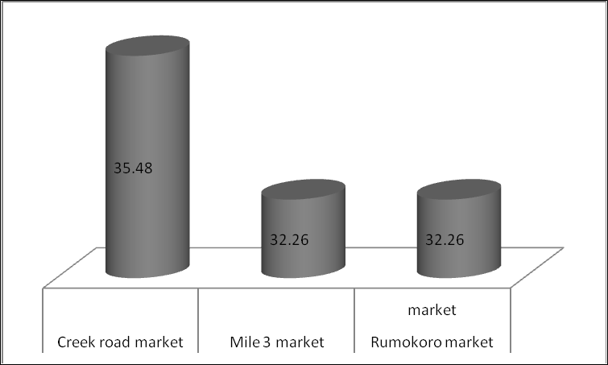
Figure 1: Frequency of bacteria isolated from the three markets

From the nine meat samples analyzed for fungi, a total of thirteen fungal isolates covering three fungal genera were characterized as Aspergillus, Mucor and Penicillium with Mucor having the highest frequency (46.15%) of occurrence, while Penicillium had the least frequency (20.08%) of occurrence (Figure 4). The total fungal count ranged from 6.0x104CFU/g to 4.4x105CFU/g. No fungi were isolated from chicken samples got from Creek road market and Rumokoromarket.In the detection method for pathogen (Salmonella and Shigella) after adopting the normal culture procedures of selective enrichment, differential and selective plating; no pathogen was detected.

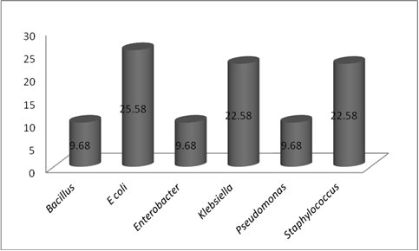
Figure 2: Frequency of bacteria genera isolated from the samples.
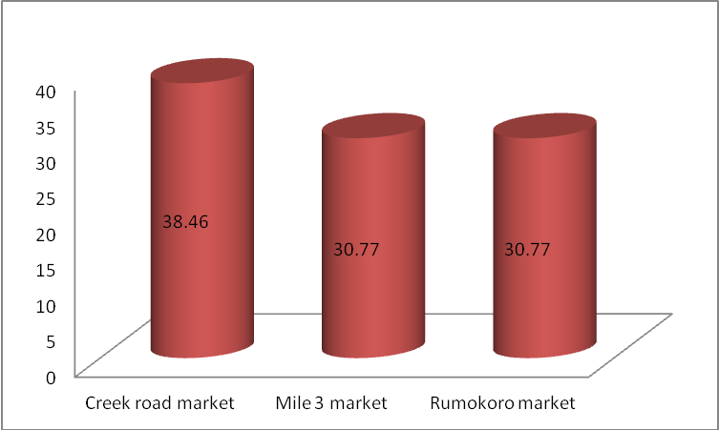
Figure 3: Frequency of fungal isolates from the three markets

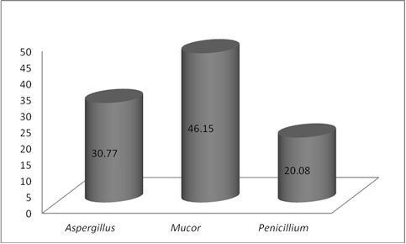
Figure 4: Frequency of fungal genera from the samples

4. Discussion
Meat and meat products provide excellent growth media for a variety of microflora (bacteria, yeasts and molds) some of which are pathogens (Jay et al., 2005). Raw meat quality is reported to be severely affected by the stress conditions during slaughtering process and the slaughtering methods (Miller et al., 2002; Chambers and Grandin, 2001). Fat, protein, minerals, carbohydrate and water are the constituents of meat (Heinz and Hautzinger, 2007). The microbiology quality of meat of three different meat samples namely; beef, chicken, and pork obtained from three different markets, and Creek road market, Mile 3 market and Choba market were analyzed using diffential, enrichment, routine and selective media. A total of thirty-one bacterial isolates covering six genera were isolated and characterized as Bacillus (9.68%), Enterobacter (9.68%), Escherichia (25.81%), Klebsiella (22.58%), Pseudomonas (9.68%) and Staphylococcus (22.58%).
The predominance of Escherichia coli was attributed to the handling process such as killing equipment and the water used in washing the meat. Escherichia coli is commonly used as surrogate indicator, its presence in food generally indicate direct and indirect faecal contamination (Clarence et al., 2009). Clarence et al. (2009) and and Oyeleke (2009) reported the presence of Staphylococcus aureus, Escherichia coli, Bacillus spp., Enterobacter, Pseudomonas and Klebsiellain meat pie and yoghurts respectively.
The predominance of Gram negative bacteria (67.74%) have also been reported by other researchers. Clarence et al. (2009) reported that 69% of cases of bacterial food borne diseases are caused by Gram negative bacteria. Bacillus spp. is spore-forming bacteria that are frequently isolated from soil and some food. Some species of Bacillus (Bacillus Subtilis, Bacillus licheniforms, etc) have been implicated in food- borne disease (Lurie, 2007). It is important to note that not all species of Bacillus are pathogens (Lurie, 2007).
Other researchers have reported the presence of Pseudomonas, Escherichia, and other gram negative bacteria in raw meat samples (Lin et al., 2004). Hayes et al. (2003) found Enterococcus spp. to be the most dominant bacteria on 971 of the 981 samples (99%) of all meat (chicken, turkey, pork and beef) in the state of Iowa. The occurrence of such bacterial isolates on the meat samples is determined by the storage and handling conditions adopted. Cervenyet al. (2009) stated that storage conditions affect the type of microbes found in meat and meatproducts. They reported that Pseudomonas spp., Moraxella spp., Psychrobacter spp., Acinetobacter spp. and Gram-negative psychrotrophic members of the family.
Enterobacteriaceae are frequently present on refrigerated meat product. Turtura (1991) reported that the most frequent coliform identified on meat were Clostridium freundii, Escherichia coli, Enterobacteragglomeram and less frequent strains are of the genera Klebsiella, Shigella sonnie and Proteus. Escherichia coli and Staphylococcus aureusare normal flora in humans and animals, their presence in foods are indications of excessive human handling (Clarence et al., 2009). No Salmonella and Shigella was determined, this may be as a result of some preventive measures adopted by the meat handlers to prevent contamination.
Meat is the first-choice of animal protein for humans and consumption of meat is continuously increasing worldwide. The contamination of meat by bacteria and fungi pose threat to its consumption by humans. Consumption of contaminated meat may lead to food poisoning. Appropriate measures such as chilling, freezing, treatment with salt, nitrites, phosphate, lactic acid, etc should be adopted to prevent the growth of bacteria and fungi on meat; this will ensure good microbiological quality of meat products. For controlling enzymatic, oxidative and microbial spoilage, low temperature storage and chemical techniques are the most common in the industry today. It is essential to store the meat at lower than 4°C immediately after slaughtering and during transport and storage as it is critical for meat hygiene, safety, shelf-life, appearance and eating quality.

References
- Belitz, H. D., W. Grosch and P. Schieberle (2009). Food Chemistry (4th Edition). Springer-Verlag Berlin Heidelberg, Germany, 596.
- Berkel, B. M., B. V. Boogaard and C. Heijnen (2004). Preservation of fish and meat. Agromisa Foundation, Wageningen, The Netherlands, 8: 78-80.
- Cerveny, J., J. D. Meyer and P. A. Hall (2009). Microbiological Spoilage of Meat and Poultry Products In: Compendium Of The Microbiological Spoilage, Of Foods And Beverages. Food Microbiology and Food Safety, W.H. Sperber and M.P. Doyle (Eds.). Springer Science and Business Media, NY, 69-868.
- Chambers, P.G. and T. Grandin (2001). Guidelines for humane handling, transport and slaughter of livestock. G. Heinz and T. Srisuvan (Eds.).
- Christie, W. W., (2010). Triacylglycerols Part 2. Biosynthesis and Metabolism. AOCS Library.
- Clarence, S. Y., C. N. Obinna, N.C. Shalom (2009). Assessment of bacteriological quality of ready to eat food (Meat pie) in Benin City metropolis, Nigeria. Afr. J. Microb. Res., 3(6): 390-395.
- Comaposada, J., P. Gou and J. Arnau (2000). The effect of sodium chloride content and temperature on pork meat isotherms. Meat Sci., 55: 291-295.
- Enser, M. (2001). Muscle lipids and meat quality. fermented-sausages-safety-hurdles.htm.
- FAO (2007).“FAO guidance to governments on the application of HACCP in small and/or less-developed food businesses’. Retrieved on 14 October.
- Fasanmi OG, Sansi JAA (2008): Essentials of Meat and Milk Inspection and Hygiene, 1st Ed., published by Tunmid Printronic, Ibadan
- Garcia-Lopez, M. L., M. Prieto and A. Otero (1998). The physiological attributes of Gram-negative bacteria associated with spoilage of meat and meat products. In: The microbiology of meat and poultry, A. Davies and R. Board (Eds.), London: Blackie Academic and Professional, 1-34.
- Ghaly, A. E., D. Dave, S. Budge and M. S. Brooks (2010). Fish spoilage mechanisms and preservation techniques: Review. Am. J. Applied Sci., 7: 846-864.
- Hayes, J. R., L. L. English, P. J. Carter, T. Proescholdt and K.Y. (2003). Prevalence and antimicrobial resistance of Enterococcus species isolated from retail meats. Applied Environmental Microbiology, 69: 7153-7160.
- Heinz, G., and P. Hautzinger (2007).Meat Processing Technology. For Small-To Medium scale Producers. Food and Agriculture Organization of the United Nations Regional Office for Asia and the Pacific.
- Jay, J. M., M. J. Loessner and D. A. Golden (2005). Modern Food Microbiology, 7th Edn., Springer Science and Business Media. NY, 63-101.
- Kuwahara, K and K. Osako (2003). Effect of sodium Gluconate On Gel Formation Of Japanese Common Squid Muscle. Nippon Suisan Gakkaishi, 69: 637-42.
- Lin, M., M. Al-Holy, M. Mousavi-Hesary, H. Al-Qadiri and A.G. Cavinato (2004). Rapid and quantitative detection of the microbial spoilage in chicken meat by diffuse reflectance spectroscopy (600-1100 nm). Letters in Applied Microbiology, 39:148-155.
- Linares, M. B., M. I. Berruga, R. Bornezv and H. Vergara (2007). Lipid oxidation in lamb meat: Effect of the weight, handling previous slaughter and modified atmospheres. Meat Sci., 76: 715-720.
- Lurie Curtis (2007). Bacillus species Harzard identification.
- Miller, R. K. (2002). Factors affecting the quality of raw meat, In: Meat processing Improving quality. Joseph, K., K. John and D. Ledward (Eds.), CRC Press, FL, USA, 26-63.
- Oyo State Government of Nigeria (1978) Oyo State of Nigeria Gazette, The Meat Edict 1978, 23 (31) June 1978-Part A
- Scates P, Moran L, Madden RH (2003). Effects of incubation temperature on isolation of Campylobacter jejuni genotypes from food enriched in Preston broth. J. Environ. Microbiol. 69: 4658 -4661
- Simitzis, P. E. and S. G. Deligeorgis (2010).Lipid oxidation of meat and use of essential oils as antioxidants in meat products.
- Toldra, F. and M. Flores (2000).The use of muscle enzymes as predictors of pork meat quality. Food Chemistry, 69: 387-395.
- Turtura, G. C. (1991). Enterobacteriaceae and Other Gram Negative Bacteria in Slaughtered Poultry. Microbiology Ailments and Nutrition, 1991; 9(2):139-146.
- WHO (1982): World Health Organisation, Geneva. Guidelines for organization and management of surveillance of food-borne disease. WHO monograph No. VPH/82. 39

1/29/2014

