Male age effect on male fitness is independent of rearing temperatures in D. melanogaster

Abolhasan Rezaei, M. S. Krishna*

1: Drosophila stock center, Department of Studies in Zoology, University of Mysore, ‎Manasagangotri,
Mysore - 560 006. Karnataka, India‎
drosokrish@gmail.com, rezaei54@gmail.com

Abstract: Male age effect on male fitness has been studied in rearing temperatures in D. melanogaster. It was noticed that in all the three rearing temperatures females of all the three age classes preferred to mate with the younger of two competing males more frequently than with old males. Young males mated performed greater courtship acts and mated faster than middle aged and old males. However except at 29ºC±1ºC, no significant variation was noticed in duration of copulation among male age classes. Further young male inseminated more females and produced greater progeny numbers than middle aged and old males. This result was found to be similar in all the three rearing temperatures. Thus these studies suggests that in D. melanogaster male age has significant influence on age based female mate preference and age related changes in male courtship activities, male mating ability and progeny production were independent of rearing temperatures.
[Abolhasan Rezaei, M. S. Krishna. Male age effect on male fitness is independent of rearing temperatures in D. melanogaster. Nat Sci 2014;12(2):10-19]. (ISSN: 1545-0740). http://www.sciencepub.net/nature. 2

Keywords: D. melanogaster, male mating ability, Age based female mate preference, progeny number.

Introduction
Studies of sexual selection have shown that females use a great diversity of male traits to assess male quality. These traits include body size, brightly colored tail features, and elaborate courtship dances (Zahavi, 1975; Beck and Powell, 2000; Beck, 2002). Male age is another trait that female may use to predict direct and indirect benefits of mating (Trivers, 1972; Hansen and Price, 1995; Kokko and Lindstrom, 1996). Thus, male age may represent a reliable indicator of male quality. However male age effect on reproductive success, female mate preference, fitness and offspring fitness, remains controversial in the field of evolutionary biology (Beck and Powell, 2000).
Age in male insects may affect reproductive activities including success in intersexual encounters, sperm procedure and female fecundity. However, the importance of male age on sexual behavior is not straight forward, and in most cases, only one or a few aspects of male fitness like success in intermale competition, fecundity, fertility, and longevity have been studied (Somashekar and Krishna, 2011). Both theoretical and experimental studies have shown age based female mate preference in many taxa (Kokko and Lindstrom, 1988; Beck and Promislow, 2007). These studies have shown that female preference with respect to male age differs among species in some species, female preference old males (Avent et al., 2008; Somashekar and Krishna, 2011; Prathibha et al., 2011) while in other she prefers young male (Hansen and Price, 1995) or intermediate aged males (Hoikkala and Liimatainen, 1992). Age specific variation in mating, fecundity and reproductive performance are also known to occur in animals (Walter, 1988). Recently, in D. bipectinata (Somashekar and Krishna 2011), and D. ananassae (Prathibha et al., 2011) occurrence of age specific fecundity and ovarioles number have been reported. They found that middle aged females had significantly greater ovarioles number and fecundity than young and old females. Similarly, temperature is another important external factor that has profound effects on the physiology, ecology, and fitness of ectotherm (Dillon et al., 2009). As an individual undergoes aging, its physiology will also be affected and the quality of gametes. But whether such age related changes independent of rearing temperature or not has not been studied.
Drosophila melanogaster has long been used as a model species to investigate age-related male mating success. During the past decade, model organisms such as D. melanogaster have been used extensively to study aging. These model systems have been particularly useful for genetic studies of aging because of their small genome size, short generation time, and short life span compared with mice and humans. In addition, Drosophila species exhibit complex behaviors, many of which decline with age. Furthermore, there is no parental care in Drosophila, and females receive only seminal fluid, which contains accessory gland secretions and sperm from the male (Gillott, 2003). Therefore present study has been undertaken in D. melanogaster to study age based female mate preference age related changes in courtship activities male mating ability and progeny production are independent of rearing temperatures or not.

Materials and Methods
The experimental stock was established from progenies of 50 isofemale lines of D. melanogaster that were collected in Mysore, India. These progenies were mixed together, and 20 males were placed together with 20 females in each culture bottle. Crosses were maintained at 22ºC±1ºC with 70% relative humidity on a medium of wheat cream agar. Flies were kept in a 12-h light: 12-h dark cycle for three generations to acclimatize to laboratory conditions. At 4th generation, eggs were collected from this stock using Delcour’s procedure (1969). Eggs (100) were transferred into a vial containing wheat cream agar medium and these vials were reared separately at 15ºC±1ºC, 22ºC±1ºC and 29ºC±1ºC. When adults started emerging, virgin females and unmated males were isolated within 3 hours of their eclosion and were aged until they were used in their respective rearing temperatures. However, the experiments were conducted at 22ºC±1ºC.
Assignment of age classes
For assigning age classes to males, the longevity (number of days from eclosion until death) of unmated males was determined by maintaining individuals in a vial until their death. Flies were transferred to a clean vial each week. Fifty replicates were performed, and the mean longevity was 61±2 days for the temperature 22ºC±1ºC, 65±2 days for the temperature 15ºC±1ºC, 58±2 days, for the temperature 29ºC±1ºC, 58±2 days. We also studied male mating activities from eclosion until death. Similar results were obtained for all the three rearing temperatures. Males showed low levels of activity on day 1 after eclosion. During days 2–54, however, males performed all mating activities and mated with females. After day 55, male mating activities declined greatly. “Based on these data, male age classes were defined as: young (2–3 days), middle-aged (4–28 days), and old (>28 days).”
The first set of emerged flies was aged 52–53 days (to obtain old males). When these flies were 25 days old the next set of flies was isolated and aged 27–28 days (to obtain middle-aged males). When these males were 25 days old (and the old set was 50 days old) the next set of flies was isolated and aged 2–3 days (to obtain young males). This procedure allowed us to culture and maintain young, middle-aged, and old males under the same conditions and to conduct experiments using these three sets of flies at the same time. Most (99%) cross-sectional studies on aging have used this protocol.
Female age classes were selected based on female rejection behavior toward courting males. Female rejection behavior was analyzed from day 2 to day 32 (females rarely mate after day 33) resulting in the following female age classes: young females (2–3 days), middle-aged females (17–18 days), and old females (32–33 days).
Age-based female mate preference
To study female mating preferences for males of different ages, a virgin female obtained from the main culture bottle was placed in an Elens-Wattiaux mating chamber(1964) along with two unmated males.The virgin female was either young, middle-aged, or old, whereas the two males were of different ages (young with middle-aged, middle-aged with old, or young with old). Each pair was observed for 1h, and 50 trials were run for each age-class combination. Copulating pairs were aspirated from the mating chamber. The rejected male in the female-choice experiment was also transferred to a new vial. We also measured wing length of 50 selected and rejected males from each age-class combination, following the procedure of Hegde and Krihsna (1997). Separate experiments were run for each of the three rearing temperature. At the start of these experiments the effect of paint was tested by painting the thoracic region of one of the males of same age classes middle aged old and allowing with a virgin female. The presence of paint did not affected mating probability (all groups, p > 0.05). General Linear model was applied on mating success data using SPSS 10.1 programme.
Effect of male age on courtship activities
A virgin female (5–6 days old) and a male (young, middle-aged, or old) were placed in an Elens-Wattiaux mating chamber (Elens-Wattiaux, 1964) and observed for 1 h. Pairs that did not mated were discarded. If mating occurred,mating latency(time between introduction of male and female into the mating chamber until initiation of copulation) and the duration of copulation(time between initiation to termination of copulation of each pair) was recorded. The courtship acts of tapping, scissoring, vibrating, licking, and circling were quantified, as were the female rejection behaviors of ignoring, extruding, and decamping. These behaviors were quantified according to Hegde and Krishna (1997). Tapping is when a male initiates courtship with a foreleg motion. He partially extends and simultaneously elevates one or both forelegs and then strikes downward, thus bringing the ventral surface of the tarsus in contact with the partner. Scissoring occurs during the interval between wing vibrations when a courting male opens and closes both wings using a scissor-like movement. Licking is when a courting male positions himself closely behind the female, extends his proboscis, and licks her genitalia. Circling is when a male, after posturing at the side or rear of a non-receptive female, faces her as he moves. Sometimes he moves to face her and then retraces his path to the rear. Other times he moves around her in a full circle. The female rejection behavior of ignoring is when a courted, non-receptive female continues activity and apparently ignores the actions of the male. Extruding is when a non-receptive female presses the vaginal plates together, contracts certain abdominal muscles, and apparently relaxes other muscles. Decamping is when a non-receptive female attempts to escape by running, jumping, or flying away from the courting male.
The behavior of males and females engaged in courtship were recorded simultaneously by two observers for 1h. One observer quantified female behavior, and the other quantified male behavior. Fifty pairs that successfully mated pair from each age class were used. Separate experiments were run for each of the three rearing temperatures. One way ANOVA followed by Tukey’s post hoc test has been carried out on data of courtship activities using SPSS 10.1 programme.
Male age and male mating ability
A virgin female (5-6 days old) and an unmated male (young, intermediate-aged, or old male) were aspirated into an Elens-Wattiaux mating chamber (1964) and observed for 1 h. Pairs that did not mated were discarded. If mating occurred, pair was allowed to complete copulation. Soon after copulation, the mated female was individually aspirated into a new vial containing wheat cream agar medium every week. This process was continued until her death. Total number of progeny produced were also recorded. The mated male was allowed to mate with a 2nd virgin female (5-6 d old). If mating occurred with the 2nd female, they were allowed to complete copulation, mated female was transferred to a new vial as described above. This process was continued. The number of females inseminated by each male in 1 h (male mating ability), and total number of progeny emerged from all mated females were also been recorded. In total, male mating ability of 50 young, middle aged and old mated males were separately tested. This was separately carried out for each of the 3 three rearing temperatures. One- way ANOVA followed by Tukey’s post hoc test was carried out on data of male mating ability and progeny number. We used SPSS 10.1 program (SPSS, USA) for all analyses.

Results
For all the three rearing temperatures D. melanogaster, virgin females of all ages(young, middle aged and old) preferentially mated the youngest of the two competing males (Table 1). Significant variation was noticed in mating success between different male age classes. Difference in mean wing length between selected and rejected males in these experiments were not significant (all groups, P>0.05). Results was found to be similar in all the three rearing temperatures.
In all the rearing temperatures, young males showed the highest frequency of tapping, scissoring, circling, and licking behaviors toward females, whereas old males showed the lowest levels of courtship behaviors (Table 2a). In turn, female generally showed fewer rejection responses (decamping, ignoring, and extruding) to young males than to middle-aged and old males. Similar results were measured for all the three rearing temperatures. Significant variation was found in male courtship activities between males of different ages. In addition, there was significant variation in female decamping behavior toward males of different ages, but similar levels of ignoring and extruding behaviors were presented to males of all age classes. Young males exhibited significantly more courtship activities than middle-aged males, and middle-aged males courted more than old males. Principle component analysis revealed that in male, tapping and scissoring had greater influences on mating success than licking and circling. While in female decamping and extruding had greater influences on mating success than ignoring and extruding (Table 2b).
The mean mating latency of young, middle aged and old males of all the three rearing temperatures of D. melanogaster are given in figure 1. It was noticed that in all the three rearing temperatures, old male had greater mating latency to females compared to young and middle aged males. The mean mating latency data subjected to one-way ANOVA followed by Tukey’s post hoc test showed significant differences in the mean mating latency between male age classes (Table 3). Tukey’s post hoc test showed that young male had taken significantly lesser time to initiate copulation than middle aged and old males.
The mean copulation duration at young, middle aged and old males of all the three rearing temperatures of D. melanogaster are given in Figure 2. It was noticed that in all the three rearing temperatures, young male had shorter copulated to females compared middle aged and old males. The mean copulation duration data subjected to one-way ANOVA followed by Tukey’s post hoc test showed except of flies reared temperature in 29ºC±1ºC, insignificant differences in the mean copulation duration was noticed between male age classes (Table 4).
The mean male mating abilities of young, middle aged and old males of all the three rearing temperatures of D. melanogaster are given in Figure 3. It was noticed that in all the three rearing temperatures, young male had inseminated more females than middle aged and old males. The mean male mating ability data subjected to one-way ANOVA followed by Tukey’s post hoc test showed significant differences in the mean male mating ability between male age classes (Table 5). Tukey’s post hoc test showed that young males inseminated significantly more number of females than those of middle aged and old males.
It was noticed that in all the rearing temperatures, Figure 4 shows progeny number of females mated with young, middle aged and old males in all the three rearing temperatures. It was found that females mated with young male produced greater number of progeny than females mated with middle aged or old males. One way ANOVA followed by Tukey’s post hoc test showed significant variation in progeny number of females mated between male age classes. Tukey’s post hoc test showed that females mated with young male had produced significantly greater number of progeny than females mated with middle aged or old males (Table 6).

Table 1. Female mate preference for male age classes in three rearing temperatures of D. melanogaster (N=50; df. 1)
Themperatures | Female age | Males | Wald chi-square (mating success) | Sig. level
 |  | Young Old
 | Young | 34(68%) 16(32%) | 2.13 | 0.073
 | Middle | 37(74%) 11(22%) | 5.08 | 0.014
 | Old | 37(74%) 13(26%) | 6.71 | 0.005
15ºC±1ºC |  | Middle Young
 | Young | 35(70%) 15(30%) | 3.21 | 0.0031
 | Middle | 37(74%) 13(26%) | 6.01 | 0.012
 | Old | 40(80%) 10(20%) | 5.231 | 0.012
 |  | Old Middle
 | Young | 20(40%) 30(60%) | 5.312 | 0.110
 | Middle | 18(36%) 32(64%) | 4.523 | 0.012
 | Old | 17(34%) 33(66%) | 3.812 | 0.012
 |  | Young Old
 | Young | 19(38%) 31(62%) | 8.421 | 0.003
 | Middle | 17(34%) 33(66%) | 9.423 | 0.001
 | Old | 15(30%) 35(70%) | 4.821 | 0.015
22ºC±1ºC |  | Middle Young
 | Young | 21(42%) 29(58%) | 7.523 | 0.001
 | Middle | 18(36%) 32(64%) | 9.451 | 0.001
 | Old | 22(44%) 28(56%) | 9.412 | 0.001
 |  | Old Middle
 | Young | 19(38%) 31(62%) | 8.421 | 0.003
 | Middle | 17(34%) 33(66%) | 9.423 | 0.001
 | Old | 15(30%) 35(70%) | 4.821 | 0.015
 |  | Young Old
 | Young | 33(66%) 17(34%) | 4.21 | 0.003
 | Middle | 39(76%) 11(22%) | 5.87 | 0.001
29ºC±1ºC | Old | 35(70%) 15(30%) | 4.678 | 0.011
 |  | Middle Young
 | Young | 32(64%) 18(36%) | 3.60 | 0.001
 | Middle | 37(74%) 13(26%) | 5.231 | 0.003
 | Old | 37(74%) 13(26%) | 6.891 | 0.001
 |  | Old Middle
 | Young | 20(40%) 30(60%) | 5.312 | 0.001
 | Middle | 19(38%) 31(62%) | 5.500 | 0.002
 | Old | 17(34%) 33(66%) | 3.123 | 0.003

Table 2a. Male age effect on male courtship activities in three different rearing temperatures of D. melanogaster [values are mean ±SE].
Temperatures | Male courtship activities | Males
 |  | Young male | Middle aged male | Old male | F value
15ºC±1ºC | Tapping (in no.) | 17.47± 0.39 (a) | 17.4± 0.39 (b) | 16.1± 0.39 (b) | 8.893**
 | Scissoring (in no.) | 6.4±0.61 (a) | 5.21±0.5 (b) | 4.96± 0.41 (c) | 10.597**
 | Circling (in no.) | 3.21±0.45 (a) | 2.98±0.21 (b) | 2.5± 0.31 (c) | 12.163**
 | Licking (in no.) | 4.3±0.51 | 3.0±0.21 | 2.50±0.22 | 0.301^{NS}
 | Vibrating (in no.) | 3.6±0.32 (a) | 2.98±0.2 (b) | 2.51± 0.2 (c) | 12.590**
22ºC±1ºC | Tapping (in no.) | 11.84±1.34 (a) | 8.34±1.17 (b) | 4.66±0.398 (c) | 9.893**
 | Scissoring (in no.) | 5.11± 0.67 (a) | 2.28±0.54 (b) | 1.88±0.49 (c) | 9.597**
 | Circling (in no.) | 5.61±1.21(a) | 1.12±0.17(b) | 0.64±0.127 (c) | 17.163**
 | Licking (in no.) | 1.58± 0.20 | 1.54±0.40 | 1.32±0.222 | 1.301^{NS}
 | Vibrating (in no.) | 8.84±1.34 (a) | 7.34±1.17 (b) | 5.66±0.398 (c) | 9.811**
 | Tapping (in no.) | 18.3±0.81 (a) | 16.3± 0.61 (b) | 11.3±0.83 (c) | ‎43.79**‎
 | Scissoring (in no.) | 7.81±1.17 (a) | 5.7±0.84 (b) | 3.98± 0.79 (c) | 34.597**
29ºC±1ºC | Circling (in no.) | 2.6±0.32 (a) | 2.5±0.21 (b) | 2.1±0.81 (c) | 121.163**
 | Licking (in no.) | 2.2±0.51 (a) | 1.58±0.21 (b) | 1.31±0.41 (c) | 112.23**
 | Vibrating (in no.) | 1.98± 0.41 (a) | 1.95±0.21 (b) | 1.21±0.71 (c) | 15.876**
 | Female rejection responses
 | Decamping (in no.) | 0.34±0.24 (a) | 1.21±0.134 (b) | 3.91±0.97 (c) | 12.161**
15ºC±1ºC | Ignoring (in no.) | 0.98±0.28 (a) | 1.08±0.54 (b) | 2.01±0.511 (c) | 9.546**
 | Extruding (in no.) | 0.12±0.06 | 0.23±0.07 | 0.98 ±0.182 | 0.804 ^{NS}
22ºC±1ºC | Decamping (in no.) | 0.64±0.24 (a) | 1.44±0.134 (b) | 5.91±0.97 (c) | 24.161**
 | Ignoring (in no.) | 1.88±0.28 (a) | 2.48±0.54 (b) | 3.12±0.511 (c) | 11.546**
 | Extruding (in no.) | 0.28±0.06 | 0.44±0.07 | 1.08±0.182 | 1.804 ^{NS}
29ºC±1ºC | Decamping (in no.) | 0.31±0.24 (a) | 1.20±0.134 (b) | 3.23±0.97 (c) | 10.121**
 | Ignoring (in no.) | 0.89±0.28 (a) | 1.03±0.54 (b) | 1.98±0.511 (b) | 7.546**
 | Extruding (in no.) | 0.11±0.06 | 0.22±0.07 | 0.99 ±0.182 | 0.694 ^{NS}
** Significant at p < 0.001. NS- Insignificant (p >0.05).
Different letter in the superscript indicates significance at 0.05 levels by Tukey’s post hoc test.

Table 2b. Principal component analysis of male age effect on courtship activities in three rearing temperatures of D. melanogaster.
Experimental stocks | Male courtship activities | Initial Eigenvalues
 |  | Total | % Variance | Cumulative %
15ºC±1ºC | Tapping (in no.) | 1.004 | 30.100 | 30.100
 | Scissoring (in no.) | 1.000 | 22.300 | 54.465
 | Circling (in no.) | 1.800 | 20.003 | 64.468
 | Licking (in no.) | 1.621 | 16.532 | 100.000
 | Vibrating (in no.) | 1.341 | 15.98 | 78.98
22ºC±1ºC | Tapping (in no.) | 1.351 | 58.776 | 58.776
 | Scissoring (in no.) | 0.920 | 23.007 | 81.783
 | Circling (in no.) | 0.714 | 17.850 | 99.633
 | Licking (in no.) | 0.015 | 0.367 | 100.000
 | Vibrating (in no.) | 1.341 | 15.98 | 78.98
 | Tapping (in no.) | 1.300 | 45.700 | 47.700
29ºC±1ºC | Scissoring (in no.) | 1.920 | 23.007 | 81.783
 | Circling (in no.) | 0.700 | 13.800 | 99.600
 | Licking (in no.) | 1.015 | 0.457 | 98.000
 | Vibrating (in no.) | 0.341 | 13.98 | 77.98
 | Female rejection responses
15ºC±1ºC | Decamping (in no.) | 0.130 | 33.670 | 33.670
 | Ignoring (in no.) | 0.952 | 38.051 | 76.721
 | Extruding (in no.) | 0.712 | 22.200 | 98.000
22ºC±1ºC | Decamping (in no.) | 1.212 | 40.389 | 40.389
 | Ignoring (in no.) | 1.151 | 38.366 | 78.755
 | Extruding (in no.) | 0.637 | 21.245 | 100.000
 | Decamping (in no.) | 0.987 | 29.670 | 29.670
29ºC±1ºC | Ignoring (in no.) | 1.098 | 27.051 | 54.721
 | Extruding (in no.) | 1.000 | 23.245 | 79.000

Table 3: One way ANOVA of male age effect on mating latency of female mated with males of different age classes in rearing temperatures of D. melanogaster.
Rearing temperatures | Parameter | Source | Type III Sum of Squares | df | Mean Square | F-value
 |  | Age | 1576.120 | 2 | 788.060 | 4.170**
15ºC±1ºC | Mating latency | Error | 42537.840 | 1 | 42537.840
 |  | Total | 71896.000 | 150
 |  | Age | 1428.013 | 2 | 714.007 | 11.450**
22ºC±1ºC | Mating latency | Error | 9166.760 | 147 | 62.359
 |  | Total | 43510.000 | 150
 |  | Age | 350.760 | 2 | 175.380 | 1.124**
29ºC±1ºC | Mating latency | Error | 22940.740 | 147 | 156.059
 |  | Total | 64129.000 | 150
** Significant at p < 0.001.

Table 4: One way ANOVA of male age effect on copulation duration of females mated with male of different age classes in rearing temperatures of D. melanogaster.
Rearing temperatures | Parameter | Source | Type III Sum of Squares | df | Mean Square | F-value
 |  | Age | 0.360 | 2 | 0.180 | 0.004^{NS}
15ºC±1ºC | Copulation duration | Error | 27782.040 | 147 | 188.993
 |  | Total | 76411.000 | 150
 |  | Age | 176.853 | 2 | 88.427 | 1.78^{NS}
22ºC±1ºC | Copulation duration | Error | 5239.040 | 147 | 35.640
 |  | Total | 43510.000 | 150
 |  | Age | 557.853 | 2 | 278.927 | 9.150**
29ºC±1ºC | Copulation duration | Error | 4481.140 | 147 | 30.484
 |  | Total | 89103.000 | 150
** Significant at p < 0.001; NS- Insignificant at p >0.05.

Table 5: One way ANOVA of male age effect on male mating ability in three rearing temperatures of D. melanogaster
Rearing temperatures | Parameter | Source | Type III Sum of Squares | df | Mean Square | F-value
 |  | Age | 10.893 | 2 | 10.447 | 8.462**
15ºC±1ºC | Male mating ability | Error | 142.100 | 147 | 0.967
 |  | Total | 211.000 | 150
 |  | Age | 6.253 | 2 | 3.127 | 19.459**
22ºC±1ºC | Male mating ability | Error | 23.620 | 147 | 0.161
 |  | Total | 263.000 | 150
 |  | Age | 7.853 | 2 | 3.927 | 12.902**
29ºC±1ºC | Male mating ability | Error | 44.740 | 147 | 0.304
 |  | Total | 167.000 | 150
** Significant at p < 0.001

Table 6: One way ANOVA of male age effect on fertility(progeny production) of females mated with male of different age classes in rearing temperatures of D. melanogaster
Rearing temperatures | Parameter | Source | Type III Sum of Squares | df | Mean Square | F-value
 |  | Age | 44245.853 | 2 | 22122.927 | 8.772**
15ºC±1ºC | Fertility | Error | 370720.840 | 147 | 2521.910
 |  | Total | 2310930.000 | 150
 |  | Age | 323659.560 | 2 | 161829.780 | 42.076**
22ºC±1ºC | Fertility | Error | 565381.880 | 147 | 3846.135
 |  | Total | 4609034.000 | 150
 |  | Age | 50193.773 | 2 | 25096.887 | 58.590**
29ºC±1ºC | Fertility | Error | 62966.900 | 147 | 428.346
 |  | Total | 535253.000 | 150
** Significant at p < 0.001

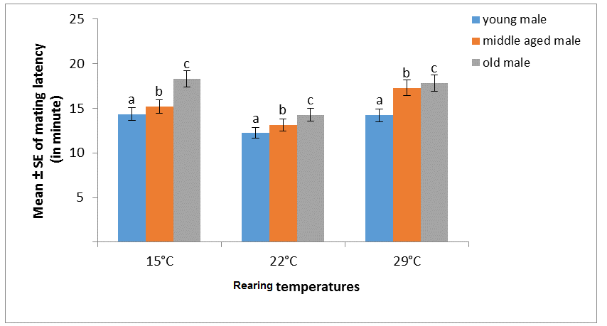
Figure 1. Male age effect on mating latency in three rearing temperatures of D. melanogaster
[Different letter in superscript on the bar graph indicate significant at 0.05 level by Tukey’s post hoc test].

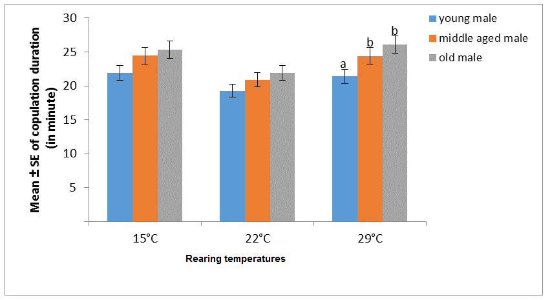
Figure 2. Male age effect on copulation duration in three rearing temperatures of D. melanogaster
[Different letter in superscript on the bar graph indicate significant at 0.05 level by Tukey’s post hoc test].

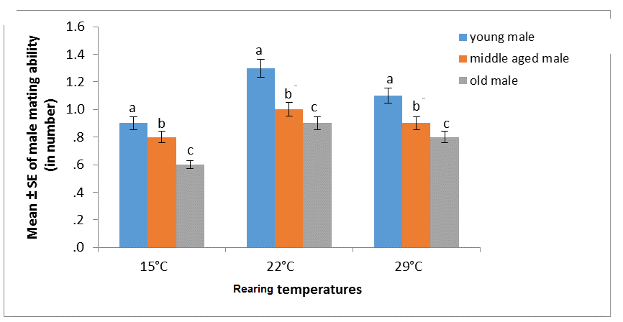
Figure 3. Male age effect on male mating ability in three rearing temperatures of D. melanogaster
[Different letter in superscript on the bar graph indicate significant at 0.05 level by Tukey’s post hoc test].

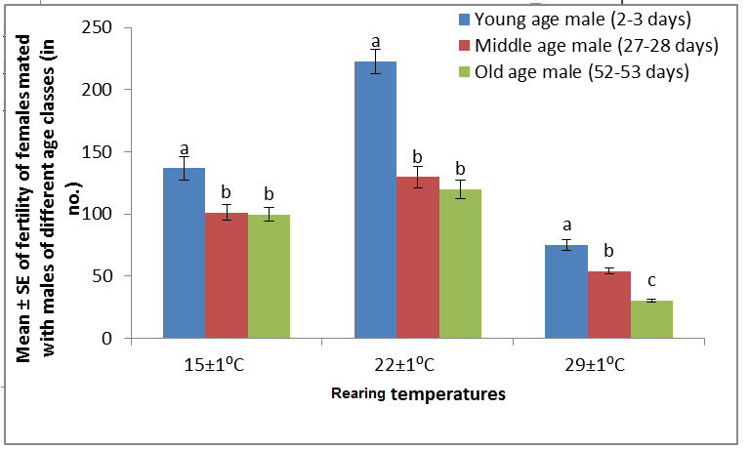
Figure 4. Male age effect on fertility (progeny prodution) of females mated with young, middle and old age males in three different rearing temperatures of D. melanogaster.

Discussion
For a species with no parental care, it was proposed that females may choose to mate with older males to obtain good genes because older males have survived for a longer time and thus proven their genetic ability (Trivers, 1972; Markow and Akney, 1984; Andersson, 1994; Radwan, 2003; Prokop et al., 2007). Drosophila is one such species; in Drosophila, mating is resource independent in that males do not contribute resources to their mate or protect their mate or offspring. In the present study, eggs collected from outbred populations of D. melanogaster were rared in three different temperatures to study female preference for male age classes. The present study provides evidence that in all rearing temperatures, female D. melanogaster discriminated between males on the basis of age and preferred to mate with younger males more frequently than with old and middle-aged males (Table 1). Herein, females mated more frequently with young males than old /middle aged males in the presence of male-male competition and accepted young males more rapidly than old and middle-aged males in the female-choice experiment. Although the 2-male experiment (female-choice experiment) design allowed male-male competition to occur, a similar result was also noted in a no-choice experiment (single-male tests; unpubl. data), which suggests that male-male competition was not an important factor influencing female choice. Results of both the female-choice and no-choice experiments provide strong support of a female preference for younger males. Our study does not support the work of Avent et al., (2008) in D. pseudobscura, Prathibha et al., (2011) in D. ananassae, Somashekar and Krishna (2011) in D. bipectianata, and Meghan et al., (2012) in D. persimilis. These investigators found that females prefer older males and suggested that, for Drosophila species, the female preference for older males may be a stable evolutionary strategy. However, our results in D. melanogaster provide strong evidence that female mate preference is species specific concerning the age of the male.
Many male phenotypes can affect mating success in Drosophila. These include mating history, wings length, rearing conditions, courtship activities, the courtship song, and difference in cuticular hydrocarbons (Hegde and Krishna, 1997; Avent et al., 2008; Prathibha et al., 2011; Somashekar and Krishna, 2011; Havens and Etges, 2012). Here we used unmated males that were reared in groups of two prior to female exposure. In addition, there was no difference in wing length between selected and rejected males, suggesting that male wings length did not affected female mate preference. As rearing conditions and wings size were controlled, the observed mating success of young males likely reflected the age of the male.
Sexual behaviour in species of Drosophila have shown that successful mating depends on male activity and female receptivity, because the female is usually the discriminating partner in the mating act, i.e., she actively accepts or rejects a courting male (Bastock, 1956; Bateman, 1948). Mating in Drosophila is resource independent, in that males do not contribute resources to their mate or protect their mate or offspring. Therefore, the display given by males before mating is the only grounds on which females can differentiate between potential mates (Hoikkala and Liimatainen, 1992). Hedge and Krishna (1997) who while studying size assortative mating in D. melarkotliana have showed that the greater the activity of courting pairs, the greater the mating success, indicating that activity during courtship is important for greater mating success. In addition to mate choice, age in male insects can also affect reproductive activities such as mating latency and copulation duration. Mating latency or courtship time, i.e., the time from the beginning of courtship to copulation (Spieth and Ringo, 1983), is a good estimate of sexual receptivity of females and sexual activity in males. During this period, acts of courtship such as tapping, scissoring, vibrating, and circling are performed by the male, to increase the receptivity of female and to make her sexually excited (Spieth, 1968 a,b; Manning, 1985). Thus, these studies suggest that mating latency might also be used to indicate both the activity level of males and the receptivity of females. The higher the activity of males and the receptivity of females, the shorter is the mating latency. Our study (Figure 1, Table 3) revealed that younger males spent significantly less time in mating latency than middle aged or old male. This result was found to be similar in all three rearing temperatures. Flies which spend less time are fast maters, while those flies which take more time are slow maters. This suggests an influence of male age on mating latency. This supports the work of Long et al., (1980) who studied D. melanogaster and found an influence of male age on courtship. During mating latency younger males more quickly performed courtship acts such as tapping, scissoring, vibrating, licking, circling, etc., thereby more rapidly increasing the receptivity of females than old males, suggesting that young males had greater activity than old males. Consequently, young males had a shorter mating latency (Table 2 a,b).
Courtship activity of a male or female in courtship culminates in copulation (Spiess, 1970). Copulation duration was frequently observed and measured in many insects. In the genus. Drosophila, copulation duration is highly variable, ranging from 30 s in D. muller to more than 1 h in some species (Spieth, 1952). Copulation duration is the time elapsed between initiation of copulation by both the male and female until separation of the male and female of a copulating pair. During copulation, sperm from the male are transferred to the female reproductive tract, and therefore the duration of copulation has great significance in an animal’s life. Copulation duration is known to be influenced by male size, female size, male age, strain, etc., as seen in our study (Somashekar and Krishna, 2011). Females mating with young males copulated shorter than females mating with old and middle aged males (Figure 2, Table 4). There are 3 main hypotheses could be proposed to explain this. First, young males may be able to rapidly transfer sperm and hence require shorter copulation. Second, young males may rapidly transfer larger quantities of sperm therefore they require shorter time. Third, young males might rapidly transfer accessory fluid in their ejaculations hence they took shorter time the three explanation suggests that young males are good .The 2nd and 3rd explanations suggest that young males invest more resources per mating, which could be the underlying cause of a female preference for young males. These explanations are not mutually exclusive and cannot be directly evaluated from our study because we did not quantify the amount of sperm and accessory fluid transferred. However, in D. melanogaster, sperm transfer is completed in the first 20% of the overall copulation duration (Gilchrist and Partridge, 2000). Sperm transfer commences after 90s of copulation in D. pseudoobscura (Snook, 2000). It is also possible that the extended copulation duration increases transfer of seminal fluids which are released at a constant rate during copulation and can significantly affect a female’s egg-laying rate and delay re-mating (Gilchrist and Partridge, 2000). However, whether this is true in D. melanogaster is not presently known.
Reproductive success of males not only depends on his success in mating alone but it also depends on number of females inseminated by a male in a given until of time. The primary function of mating is the transfer of sperm to females, since each mating offers an opportunity to father offspring. Males can generally increase their fitness by mating with many mates, and high mating rates are thus typically associated with high male reproductive success. Male Drosophila, like most male insects, provides no parental care to offspring following female insemination (Thornhill and Alcock, 1983). Male fitness is therefore related to the number of females inseminated and prevention of females from re-mating (Parker, 1970; Jones and Elgar, 2004; Jones et al., 2007). In the present study, the influence of male age on male mating ability was studied in D. melanogaster in three different rearing temperatures (Figure 3, Table 5). It was also noted that in all the three rearing temperatures young male inseminated more females in a given unit of time than did old males. This suggests that male age has a significant influence on male mating ability, and young males have greater fitness than old males. This supports earlier studies on the influence of age on mating activities in Drosophila (Long et al., 1980; Long and Pischedda, 2005). Young males had greater activities during mating because they took less time to convince a female to mate and inseminated more females in a given unit of time than did old males. Further females mated with young male had produced significantly greater number of progeny than females mated with middle aged or old males (Figure 4, Table 6).
Thus these studies in D. melanogaster suggests that females of D. melanogaster discriminate their mate’s on the basis of their age and she prefers to mated with younger males more frequently than with either middle aged or old male. Young male performed greater courtship acts and convince the female faster than middle-aged or old males. Further young male copulated longer inseminated more females in given until of time and females mated with young males produced greater number of progenies than females mated with middle aged or old males. These results were found to be similar in all the rearing temperatures suggests that age based female mate preference and age related changes in courtship activities, male mating ability and progeny production were found to be independent of rearing temperatures.

Acknowledgement:
The authors are grateful to the Chairman, Department of Studies in Zoology, University of Mysore, and Drosophila stock center, University of Mysore for providing facilities to carry out this work.

Corresponding Author: Dr. M. S. Krishna
Drosophila stock center, Department of Studies in Zoology, University of Mysore, Manasagangotri, Mysore - 560 006. Karnataka, India‎
Email, drosokrish@gmail.com

References
- Andersson M. Sexual selection. Princeton, NJ: Princeton Univ. Press.1994.
- Avent TD, Price TAR and Wedell N. Age based female preference in the Fruit Fly D. pseudoobscura. Amin Beh 2008; 75 (4): 1413-1421.
- Beck CW, Powell LA. Evolution of female mate choice based on male age: are older males better mates? Evol Eco Res 2000; 2: 107–118.
- Beck CW, Shapiro B, Choksi S, Promislow DEL. A genetic algorithm approach to study the evolution of female Preference based on male age. Evo Eco Res 2002; 4: 275-292.
- Beck CW, Promislow DEL. Evolution of Female Preference for Younger Males. PLoS ONE 2007; 2(9): e939. doi:10.1371/journal.pone.0000939.
- Bastock M. A gene mutation that changes a behaviour pattern. Evol 1956; 34: 421-439.
- Bateman AJ. Intra sexual selection in Drosophila. Here 1948; 2: 349-368.
- Delcour J. A rapid and efficient method of egg collecting. Dros Inf Ser 1969; 44: 133-134.‎
- Dillon, ME, Wang G, Garrity PA, Huey RB. Thermal preference in Drosophila. 2009; J Bio 34: 109-119.
- Elens AA, Wattiaux JM. Direct observation of sexual isolation. Dros Inf Ser 1964; 39: 118-119.
- Hansen TF, Price DK. Good genes and old age, do old mates provide superior genes? Evo Bio 1995; 8: 759-778.
- Havens JA, Etges WJ. Premating isolation is determined by larval rearing substrates in cactophilic Drosophila mojavensis. IX. Host plant and population specific epicuticular hydrocarbon expression influences mate choice and sexual selection. J Evo Bio 2012; 26:562–576.
- Hegde SN, Krishna MS. Size assortative mating in Drosophila malerkotlianaa. Anim Beh 1997; 419-426.
- Hoikkala A, J Liimatainen. Competitive mating success and attractiveness of sterile and fertile males of Drosophila montana. Eth 1992; 91: 122-133.
- Gillott C. Male accessory gland secretions: modulators of female reproductive physiology ‎and behaviour. Ann ‎Rev Entom 2003; 48:163-184.
- Gilchrist AS, L Partridge. Why it is difficult to model sperm displacement in Drosophila melanogaster. The relation between sperm transfer and copulation duration. Evo 2000; 54: 534-542.
- Jones TM, A Balmford, RJ Quinnell. Adaptive female choice for middle-aged mates in a lekking sandfly. Proc R Soc B 2000; 267: 681-686.
- Jones TM, MA Elgar. The role of male age, sperm age and mating history on fecundity and fertilization success in the hide beetle. Proc R Soc B 2004; 271: 1311-1318.
- Kokko H, Lindstrom J. Evolution of female preference for old males. Proc R Soc L 1996; 263:1533-1538.
- Kokko H. Good genes, old age and life-history trade-offs. Evo Eco 1988; 12: 739-750.
- Long CE, TA Markow, P Yeager. Relative male age, fertility, and competitive mating success in Drosophila melanogaster. Behav Genet 1980; 10: 163-169.
- Long TAF, A Pischedda. Do female Drosophila melanogaster adaptively bias offspring sex ratios in relation to the age of their mate? Proc R Soc B 2005; 272: 1781-1787.
- Manning JT. Choosy females and correlates of male age. J Theor Biol 1985; 116: 349–54.
- Markow TA, PF Akney. Drosophila males contribute to oogenesis in a multiple mating species. Sci 1984; 224: 302-303.
- Meghan L, Amanda J, Moehring. The Genetic Basis of Female Mate Preference and Species Isolation in Drosophila. I J Evo B 2012; 1-14.
- Parker GA. Sperm competition and its evolutionary consequences in the insects. Biol. Rev. 1970; 45: 525-568.
- Prathibha M, Krishna MS, Jayaramu S C. Male age influence on male reproductive success in Drosophila ananassae (Diptera: Drosophilidae). Ita J Zoo 2011; 78(2): 168-173.
- Prokop ZM, M Stuglik, I Zabinska, J Radwan. Male age, mating probability, and progeny fitness in the bulb mite. Behav Ecol 2007; 18: 597-601.
- Radwan J. Male age, germ line mutations and the benefits of polyandry. Ecol Lett 2003; 6: 581-586.
- Snook RR, Y So. Associations between female remating behavior, oogenesis and oviposition in Drosophila melanogaster and Drosophila pseudoobscura. J Insect Physiol 2000; 46: 1489-1496.
- Somashekar K, Krishna MS. Evidence of female preference for older males in Drosophila bipectinata. Zoo Stu 2011; 50:1-15.
- Spieth HT. Mating behaviour within the genus Drosophila (Diptera). Bull Am Mus Nat Hist 1952; 99:395-474.
- Spieth HT. Evolutionary implications of the sexual behavior in Drosophila. In T Dobzhansky, MK Hecht, WC Steere, eds. Evolutionary biology. Vol. 2. New York: Abbleton-Century-Crofts, 1968a; 157-191.
- Speith HT. Evolutionary implications of mating behaviour of the species of Antopocerus (Drosophilidae)in Hawaii. Stud. Genet. Univ. TX Publ. 1968b; 4: 319-333.
- Spiess EB. Mating propensity and its genetic basis in Drosophila. In MK Hecht, WC Steere, eds. Essay in evolution and genetics in honour of Theodosious Dobzhansky. New York: Appleton-Century-Crofts, 1970; 315-379.
- Trivers RL. Parental investment and sexual selection. In: Campbell B, ed. Sexual Selection and the Descent of Man 1871–1971. Chicago: Aldine Press. 1972; 136-179.
- Thornhill R, J Alcock. The evolution of insect mating systems. Cambridge, MAs: Harvard Univ. Press.1983.
- Walter, VR.. Age specific patterns of reproduction in the glaucous-winged gull: increased effort with age? Eco 1988; 69,(5): 1454-1465.
- Wedell N, MJG Gage, GA Parker. Sperm competition, male prudence and sperm-limited females. Trends Ecol Evol 2002; 17: 313-320.
- Zahavi A Mate selection - a selection for a handicap. J The Bio 1975; 53: 205–214.

1/13/2014

