Protective Role of Vitamin K Against Impaired Glucose Homeostasis in Ovariectomized Exercised and Nonexercised Rats

Aziza Khalil, Gehan A. Youssef and Hanan F. Al-Saeed

Medical Physiology Departments, Faculty of Medicine (Girls) Al-Azhar University, Egypt.
gehanphysiology@yahoo.com

Abstract: Objective: The objective of this study was to assess the protective role of vitamin K supplementation for 9 weeks on impaired glucose homeostasis, among ovariectomized exercised and nonexercised rats. Methods: Forty ovariectomized rats with an average weight of 150 gm were used in this study. They were equally divided into four groups. Group I: ovariectomized nonexercised group served as control. Group II: ovariectomized exercised group, the animals were exercised on treadmill 7days/week for 9 weeks. Group III: ovariectomized nonexercised & supplemented with vitamin K. The animals were given daily dose of vitamin K by gavage. Group IV: ovariectomized exercised, & supplemented with vitamin K. The rats were given vitamin K daily by gavage in the same previous doses during the same period of performing treadmill exercise. Blood samples were taken from all groups. We investigated the circulating concentrations of lipocalin-2, adiponectin, and their relationships to vitamin K supplementation with and without exercise. Results: Exercise alone, Vitamin K Supplementation alone or combined with exercise produce significant increase in insulin, adiponectin and lipocalin-2 with significant decrease of glucose blood level. Conclusions: Vitamin K supplementation for 9 weeks at doses attainable in the diet may reduce progression of insulin resistance in ovariectomized nonexercised and exercised rats.
[Aziza Khalil, Gehan A. Youssef and Hanan F. Al-Saeed. Protective Role of Vitamin K Against Impaired Glucose Homeostasis in Ovariectomized Exercised and Nonexercised Rats. Nat Sci 2014;12(2):1-9]. (ISSN: 1545-0740). http://www.sciencepub.net/nature. 1

Keywords: Vitamin K, lipocalin-2, adiponectin, insulin resistance.

1. Introduction
Regular exercise improved insulin sensitivity, glucose metabolism and β-cell function in both Sham and OVX rats. Exercise also overcame reduced pancreatic β-cell mass in OVX rats via increased proliferation and decreased apoptosis of β-cells (Choi et al., 2005).
Also Mason et al. (2011) found that exercise significantly improved insulin sensitivity and restored normal fasting glucose in mid-aged and older women. Therefore, menopausal women, to improve insulin sensitivity and β-cell function and mass, should be recommended to do regular, moderate exercise.
Vitamin K as menaquinone-7 has a dramatic prevention on typical bone-loss biochemistry that is associated with the aging process. It also normalized the function of parathyroid hormone, an important regulator of vitamin D and calcium balance. It offsets inflammation that provokes bone loss. It improved glucose metabolism in bone tissue – indicating better bone tissue energetic metabolism. Vitamin K works in harmony with the bone-building carpenter cells called osteoblasts. These cells produce a protein called osteocalcin. To become biologically active osteocalcin must be carboxylated by vitamin K. Biologically active osteocalcin not only acts to build bone it also acts as a hormone that travels to fat and boosts the production of the blood sugar regulating hormone known as adiponectin.
Human and animal studies suggest that vitamin K may be inversely associated with insulin resistance (Sakamoto et al., 1999). In an observational study, higher dietary and supplemental vitamin K intakes were associated with greater insulin sensitivity and better glycemic status in a community-based cohort of men and women (Yoshida et al., 2008). In a small metabolic study of young men (n = 12), short-term (one week) vitamin K supplementation improved the insulin response after an oral glucose challenge (Sakamoto et al., 2000). Although these studies support a potential novel role for vitamin K in insulin resistance, the available human data are limited. Furthermore, biological mechanisms behind the association between vitamin K, insulin and glucose metabolism are uncertain. Vitamin K and vitamin K–dependent proteins (prothrombin and protein S) have been identified in organs important for glucose and insulin metabolism, such as liver and pancreas (Thijssen and Drittij-Reijnders, 1996 and Stenberg et al., 2001). However, the function of vitamin K is not well understood beyond its role as an enzyme cofactor for γ-carboxylation of certain glutamic acid residues in vitamin K–dependent proteins (Furie et al., 1999).
Lipocalin:-
Lipocalin family proteins, including adipocyte fatty acid-binding protein (A-FABP), lipocalin-2 and retinol-binding protein 4 (RBP4), have recently been identified as novel adipokines associated with obesity, type 2 diabetes and the metabolic syndrome. (Jun et al., 2011).
Lipocalin 2 (LCN2), a protein derived from neutrophils, macrophages, adipocytes, and other cells, has been proposed to be a link between obesity and insulin resistance (IR). (Jun et al., 2011).It is a small secreted protein that binds a variety of hydrophobic ligands including retinoids, fatty acids, prostaglandins, various steroids, and bacterial siderophores. It is expressed in many tissues and has a number of roles, including apoptosis, cancer, inflammation, iron homeostasis, and innate immunity. (Li and Chan, 2011). Lcn2 was fairly recently recognized as an adipokine that is secreted from adipose tissue to display anti-inflammatory effects, so that increased LCN2 levels in obesity and insulin resistance may constitute a protective mechanism against inflammation (Jin et al., 2011). Moreover, LCN2 upregulated peroxisome proliferator–activated receptor (PPAR)-γ and its target genes, adiponectin, leptin, fatty acid synthase, and lipoprotein lipase in adipocytes. Concurrently, LCN2 antagonized TNF-α effects on adipocytes and macrophages: LCN2 protected adipocytes from TNF-α–induced production of IL-6 and monocyte chemoattractant protein-1 (MCP-1), attenuated TNF-α effect on glucose uptake, and completely reversed TNF-α inhibition of leptin and adiponectin secretion from adipocytes. The stimulatory effect of lipopolysaccharide on cytokine gene expression in macrophages was also significantly attenuated by LCN2 (Jin et al., 2011).
Adiponectin:-
Adiponectin, is produced almost exclusively by mature adipocytes, is the prototype of anti-inflammatory adipocytokines.
Adiponectin production is well known to be regulated by different cyto-kines. Adiponectin gene expression is known to be reduced by TNF- and IL-6, whereas insulin sensitizers and PPAR- agonists have been shown to increase adiponectin levels in mice and humans (Kadowaki and Yamauchi, 2005). The negative relationship between adiponectin and adipose tissue is stronger with visceral fat rather than subcutaneous fat. For instance, obese adolescents with a high proportion of visceral fat and relatively low abdominal subcutaneous fat have decreased adiponectin and leptin levels independent of body weight (Taksali et al., 2008). Adiponectin and insulin sensitivity Circulating adiponectin levels are positively correlated with insulin sensitivity evaluated by using different insulin sensitivity techniques (Kadowaki et al., 2006).
Adiponectin gene expression and circulating adiponectin levels are lower in patients with type 2 diabetes than in nondiabetic individuals (Kadowaki et al., 2006). It decreased in obesity, and inversely correlated with insulin resistance, glucose intolerance, dyslipidemia, and atherosclerosis.
Adiponectin deficient mice develop insulin resistance, glucose intolerance, increased lipid deposition in muscle, hyperlipidemia, and increased susceptibility to atherosclerosis (Kadowaki et al., 2006). Adiponectin plays a special role in insulin sensitivity in the liver. Adiponectin lowers hepatic gluconeogenesis in mice (Kadowaki and Yamauchi, 2005), enhances the effects of insulin to decrease glucose production by isolated hepatocytes, and decreases hepatic triglyceride deposition (Kadowaki and Yamauchi 2005).
Adiponectin receptors (Adi-poR)1 and 2 are expressed in peripheral tissues and in the brain, where adiponectin mediates fatty acid metabolism and modulates energy homeostasis (Kadowaki and Yamauchi 2005) adiponectin exerts its effects on energy homeostasis, and glucose and lipid metabolism through phosphorylation and activation of adenosine monophosphate-activated protein kinase (AMPK) (Kadowaki and Yamauchi 2005).
The AMPK activation stimulates phosphorylation of acetyl CoA carboxylase, fatty acid oxidation and glucose uptake in myocytes, and reduces enzymes involved in gluconeogenesis in liver, leading to re-duction of glucose levels (Kadowaki and Yamauchi 2005).
Female rats, like premenopausal women, are generally protected from the insulin resistance and inflammation associated with obesity. With aging and menopause, levels of estrogens fall and women tend to gain body fat and become as susceptible as men to obesity-related metabolic diseases like diabetes mellitus (Kadowaki et al., 2006).

2. Methods:
Forty ovariectomized rats with an average weight of 150 gm were used in this study. They were equally divided into four groups.
Group I: Ovariectomized nonexercised group served as control. Ovariectomy was done for all rats under complete sanitary conditions using a single dorsal midline incision (Olson et al., 1986).
Group II: Ovariectomized exercised group, the animals were exercised on treadmill 7days/week for 9 weeks( for 63 successive days), running on treadmill began for 5 min/day and increased gradually by 5 min every 2 days till it reached 30 min /day after 2 weeks and continued for this duration for the following 7weeks (Kim et al., 2002).
Group III: Ovariectomized nonexercised with vitamin K supplementation group, the animals were given 0.0009 mg/gm body weight of vitamin K daily by gavage (El-Morsy et al., 2011).
Group IV: Ovariectomized exercised with vitamin K supplementation group: the rats were given vitamin K daily by gavage in the same previous doses during the same period of performing treadmill exercise.
Blood samples were taken from all groups and sera were separated. The serum levels of lipocalin-2, adiponectin, fasting glucose and insulin concentrations were measured.
- Serum Lipocalin-2 use CircuLex Rat NGAL/Lipocalin-2 ELISA Kit according to (Mishra et al., 2005).
- Serum Adiponectin according to Human Adiponectin ELISA Development Kit ( Xu et al., 2004)
- Immunoassay Kit for determination of Insulin hormone according to (Wayne, 1998).
Statistical Analysis:
All statistical analysis was computed by SPSS version 14. The values obtained were revealed as mean ± S.E. Data were analyzed using student's‘t’-test and results were considered significant at P < 0.05.

3. Results:
The blood glucose level, decreased significantly in ovariectomized Exercise rats (group II), ovariectomized rats supplemented with vitamin K (group III) and ovariectomized exercised rats supplemented with vitamin K (group IV) in comparison to ovariectomized rats (Control group) as shown in table (1) & figure (1).
There was a significant increase in serum level of insulin hormone was significant increase in groups II, III and IV versus ovariectomized rats (control group) as shown in table (1) & Figure (2).
Regarding to lipocalin, there was significant increase in its serum level in groups II, III and IV versus ovariectomized rats (control group) as shown in table (1) & figure (3).
However, serum level of adiponectin was increased significantly only in groups III and IV, while it shows insignificant change in group II in comparison with ovariectomized rats (control group) as shown in table (1) & figure (4).

Table (1): Mean ± SE of measured parameters in studied groups compared to control.
Group  Parameter | Group I (ovariecto-mized; Control) | Group II (ovariectomized +exercised) |  | Group III (ovariectomized + vitamin K) |  | Group IV (ovariectomized + exercised + vitamin K)
 | Mean  ±S.E | Mean  ±S.E | P value | Mean  ±S.E | P value | Mean  ±S.E | P value
Glucose  (mg/dl) | 121.00  ±7.30 | 104.86 ±4.0 | P <0.05* | 100.00  ±6.40 | P <0.05* | 87.83  ±4.92 | P <0.05*
Insulin | 38.29  ±2.87 | 45.43  ±1.96 | P <0.05* | 49.29  ±2.07 | P <0.05* | 54.33  ±2.28 | P <0.05*
Lipocalin | 91.00  ±4.32 | 96.00  ±4.06 | P <0.05* | 102.00  ±4.39 | P <0.05* | 106.50  ±3.06 | P <0.05*
Adiponectin | 38.13  ±2.22 | 41.21  ±1. 90 | P >0.05† | 43.11  ±1.73 | P <0.05* | 45.78  ±1.23 | P <0.05*
* Significant Insignificant

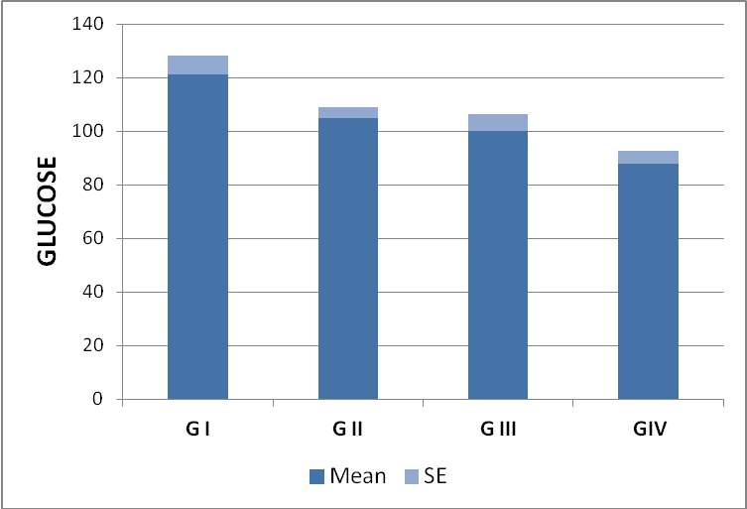
Figure (1): Blood glucose level in all studied groups.

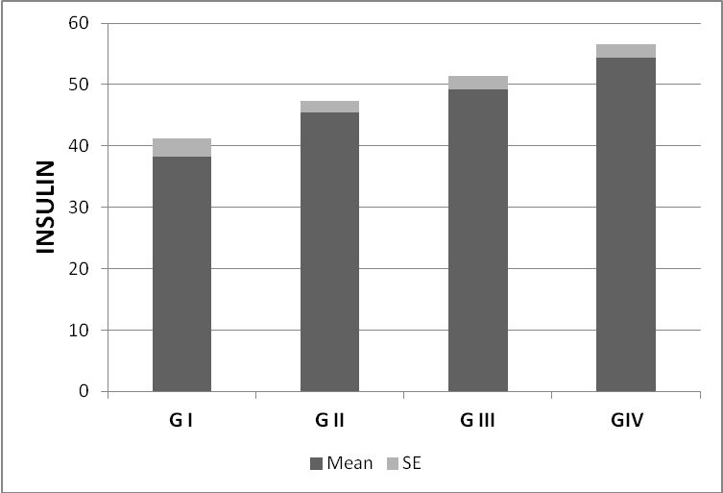
Figure (2): Serum insulin hormone level in all studied groups.

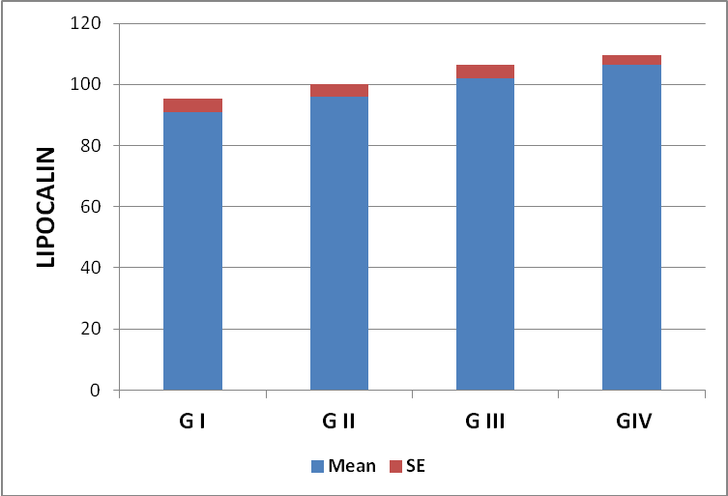
Figure (3): serum lipocalin level in all studied groups.

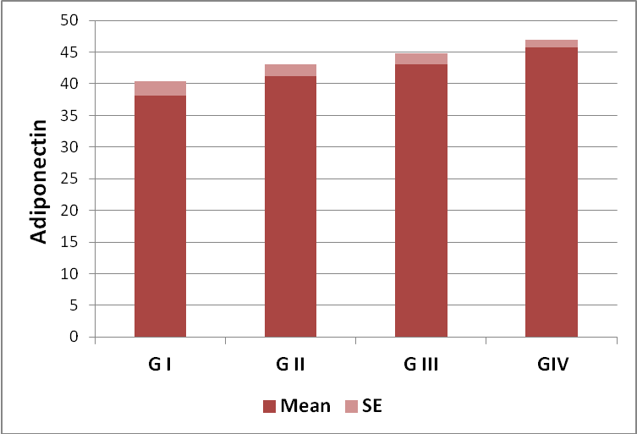
Figure (4): serum adiponectin level in all studied groups.

4. Discussion:
The present study demonstrated the protective effects of vitamin K and/or exercise, against the risks of diabetes in adult female rats under estrogen-deprivation conditions.
This study indicates that these favorable effects observed following vitamin K treatment and/or can be attributed to multiple actions including their potentiating effects on some anti-inflammatory adipocytokines.
It is well documented that estrogen removal causes a marked impairment of glucose homeostasis in ovariectomized (OVX) rats (Carr, 2003 and Sternfeld et al., 2005).
In consistence with our results Saengsirisuwan et al. (2009) found that prolonged ovariectomy leads to the development of systemic metabolic conditions displaying key features of insulin resistance syndrome, such as increased visceral fat content, dyslipidemia, impaired glucose tolerance and decreased insulin-mediated glucose uptake in skeletal muscle. Others indicated that, hepatic insulin resistance and impaired skeletal muscle glucose transporter (GLUT)-4 expression are accounted for the impaired glucose tolerance and reduced insulin sensitivity in estrogen receptor alpha (ERa) knockout mice (Bryzgalova et al.,2006 and Barros et al.,2006).
On the other hand, Hansen et al. (1996) found that moderate duration of ovariectomy does not alter insulin action on muscle glucose transport but instead leads to a decline in contraction stimulated glucose transport activity. Others reported reduction of glucose disposal rates, insulin secretion capacity, and β-cell mass in these animals (Jhala et al.,2003).
According to some human studies, postmenopausal women are at risk for increased incidence of obesity, type 2 diabetes, cardiovascular disease, and insulin resistance syndrome, whereas estrogen therapy reduces the incidence of insulin resistance and type 2 diabetes risks (Park et al.,2003). Alterations in lipid metabolism and body fat distribution with estrogen deficiency are thought to be substantial causal factors, which are believed to contribute to an increased prevalence of insulin resistance syndrome in postmenopausal women compared with premenopausal population (Zegura et al.,2006).
Moreover Rachoń et al. (2007), OVX rat becomes hyperphagic and gains weight with an increase in visceral fat accumulation due to ovarian hormone depletion. Increasing evidence suggests that abdominal obesity and concomitant development of inflammation are major components of insulin resistance (Luca et al., 2008).
In this study, the OVX exercised rats show improvement in glucose homeostasis as manifested by significant decrease in serum glucose and lipocalin levels together with significant increase in serum levels of insulin, and adiponectin.
In agreement with our result Shen et al. (2001) who reported that exercise enhances the expression and phosphorylation of cAMP response element binding protein (CREB) in rats. Activation of CREB increases insulin receptor substrate (IRS) 2 expression (Hennige et al., 2003), leading to potentiation of the Insulin-like growth factor 1 (IGF-1) /insulin signaling cascade and subsequently enhanced β-cell function and mass.
Choi et al. (2005), indicated that in estrogen-deficient states, weight loss or estrogen replacement is beneficial treatments for diabetes prevention, but regular moderate exercise is the most effective treatment to restore metabolic homeostasis. Regular exercise improved insulin sensitivity, glucose metabolism and β-cell function in both Sham and OVX rats. Exercise also overcame reduced pancreatic β-cell mass in OVX rats via increased proliferation and decreased apoptosis of β-cells. In their study, the effects of estrogen deficiency on IRS2 expression was investigated and found to be reduced in OVX rat islets. Exercise reversed this effect to normal levels of IRS2 expression through the activation of CREB that improves β-cell function and subsequently reverses insulin resistance leading to preventing the prevalence of DM and delaying its progression.
Moreover, previous studies clearly demonstrated that endurance exercise training enhances whole-body insulin sensitivity and insulin action on muscle glucose disposal in healthy individuals (Zegura et al., 2006) and in normal rodent models (Saengsirisuwan et al., 2002). For example, improved insulin action on the glucose transport process after exercise training in the obese Zucker rat, an animal model of severe skeletal muscle insulin resistance, occurs primarily through an up-regulation of GLUT–4 protein expression, enhanced GLUT-4 translocation to the sarcolemma and increased expression of some of the insulin signaling molecules, such as insulin receptor substrate–1 (Saengsirisuwan et al.,2004).
Also Mason et al. (2011) found that exercise significantly improved insulin sensitivity and restored normal fasting glucose in mid-aged and older women. Therefore, menopausal women, to improve insulin sensitivity and β-cell function and mass, should be recommended to do regular, moderate exercise.
In general, exercise with moderate weight loss has been found to improve insulin sensitivity (Albright et al.,2000, Ryan, 2000, and Wareham et al. 2005) and prevent type 2 diabetes (Gill and Cooper 2008, Physical Activity Guidelines Advisory Committee 2008). Exercise may improve insulin sensitivity by promoting fat loss and preserving lean body mass and independently of fat loss by increasing the number and activity of glucose transporters in muscle and adipose tissue (Ryan, 2000).
Only a few studies have addressed the effects of exercise on lipocalin and adiponectin.
It is well known that, adiponectin levels have an inverse association with adiposity and insulin resistance. It has been reported that Exercise lowers the levels of the obesity-related inflammatory markers, tumor necrosis factor-a, and interleukin 6, thereby increasing adiponectin gene expression and secretion (Bruun et al.,2003). Although randomized controlled trials (RCT) evidence relating chronic exercise to circulating adiponectin has been inconclusive (Simpson & Singh 2008), it is hypothesized that its levels increase with sufficient weight loss (Kraemer and Castracane 2007, Christiansen et al., 2010). Others observed significantly greater increases in the adiponectin/leptin (A/L) ratio, and insulin in exercisers than in controls. This finding indicates improved insulin sensitivity (Friedenreich et al.,2011).
In this study, the ovx rats with vitamin K supplimintation show improvement in glucose homeostasis as manifested by significant decrease in serum glucose and lipocaline levels together with significant increase in serum level of insulin and adiponectin.
Sakamoto et al.(2000) first demonstrated that low vitamin K intake induced impaired glucose tolerance in the intravenous glucose tolerance test in rats, which consisted of delayed glucose clearance and late hyperinsulinemia (Christ-Roberts et al.,2004). Results of this study were confirmed later in humans [Christakis et al.,2007]. It was reported that healthy young males with low dietary vitamin K intake had poorer acute insulin response in the glucose tolerance test (Christ-Roberts et al., 2003), whereas supplementation of 90 mg/d menaquinone for 1 week significantly improved glucose intolerance (Christakis et al.,2007). Recent findings reported by Lee et al. (2007) and Ferron et al. (2008) have further expanded our knowledge of vitamin K in glucose metabolism at the molecular level and have highlighted the potential roles of vitamin K in glucose and energy regulation mediated through osteocalcin. Together, these data point to another potential avenue for the prevention of the metabolic syndrome (MetS). and type 2 diabetes; however, the exact functions and molecular mechanisms by which osteocalcin influences the metabolic syndrome (MetS) remain unknown. From a human nutrition perspective, it will be interesting to learn whether and how vitamin K nutrition influences metabolic communication between osteocalcin and the metabolic syndrome (MetS). Future research is needed to address these questions.
Balducci et al. ( 2006) showed that dietary vitamin K phylloquinone intake is associated with an improvement of cytokines and other markers related to insulin resistance and diabetes, thus extending the potential protection by dietary phylloquinone on chronic inflammatory diseases. Accordingly, it has been proposed that vitamin K may have a potential biological role in glucose homeostasis. Vitamin K may affect glucose and energy metabolism beneficially through osteocalcin.
A recent study proposed that osteocalcin, one of the vitamin K–dependent proteins in the bone, may improve insulin sensitivity and increase β-cell functions, partially through the enhancement of adiponectin expression (Lee et al.,2007). Alternatively, it has been suggested that vitamin K has potential physiologic functions in addition to its classic role as a cofactor for γ-carboxylation (Kaneki et al.,2006). In vivo, in vitro, and observational studies showed that vitamin K decreases inflammation-induced cytokines (Shea et al.,2008), so it is plausible that phylloquinone may improve insulin sensitivity and glycemic status by the suppression of inflammation.
Law et al. (2010),he found that LCNs has been claimed to display anti-inflammatory effects,so that increased LCN2 levels in obesity and insulin resistance may constitute aprotective mechanism against inflammation.
More over,LCN2 unregulated peroxisome proliferation –activated receptor ( PPAR) –δ and its target genes, Adiponectin,leptin,fatty acid synthase, and lipoprotein lipase in adipocytes. Concurrently, LCNS antagonized TNF-α affects on adipocytes and macrophages,LCNs protected adipocytes from TNF-α induced production of IL-6 and monocyte chemoattactant protein -1( MCP-1) attenuated TNF-α effect on glucose uptake,and completely reversed TNF-α inhilution of leptin and Adiponectin sectretion from adipocytes. The stimulatory effect of lipopolysaccharide on cytokine gene expression in macrophages was also significantly attenuated by LCN2.
Wang et al. (2007) they suggested that increased levels of lipocalin-2 are found to be associated with both aging and obesity In human obese subjects, like other insulin resistance–inducing adipokines and cytokines, circulating lipocalin-2 levels are markedly elevated (Guo et al.,2012).
Guo et al. ( 2010) they suggested that lipocalin-2 deficiency attenuates the development of aging- and obesity-associated insulin resistance, hyperglycemia, and hyperinsulinemia. Lipocalin-2 elicits its adverse effects at least partly by activating the arachidonate 12-lipoxygenase metabolic pathway and stimulating adipose expression of TNF-α, which may in turn magnify the local inflammation and cause impaired energy homeostasis and systemic insulin resistance. Although lipocalin-2 belongs to a family of proteins that can bind to lipids, its endogenous ligands have not been identified. Acute lipocalin-2 treatment causes a rapid but transient reduction of the circulating FFA levels. It can also enhance fatty acid uptake into fat tissue, suggesting that the inducing effect of this adipokine on 12-lipoxygenase may also involve transportation of lipid species into the adipocytes.
In obese mice, increased serum levels of lipocalin-2 are mainly due to the selective augmentation of its expression in adipose tissue and liver (Wang et al., 2007). Both stimulatory and inhibitory effects of lipocalin-2 on insulin sensitivities in 3T3-L1 adipocytes have been reported (Zhang et al.,2008). lipocalin-2 plays critical roles in regulating TNF-α expressions in fat tissues, at least partly through upregulating 12-lipoxygenase expression and activity. TNF-α induces a state of insulin resistance in several systems, including adipocytes and myocytes (. Lorenzo et al.,2008) Obese mice lacking either TNF-α or TNF-α receptors are protected against insulin resistance (Uysal et al.,1997). Infusion of TNF-α to adult rats reduces systemic insulin sensitivity, which is associated with major changes of gene expression in adipose tissue (Ruan et al., 2002). A decline in fat-free mass and a relative increase in fat mass are common findings in aged subjects and are associated with a rise in TNF-α concentration and a deterioration of insulin action (. Paolisso et al.,1999). Neutralization of TNF-α reverses age-induced impairment of insulin responsiveness (Borst et al., 2004).
Kadowaki et al. ( 2006) they found that circulating adiponectin levels are positively correlated with insulin sensitivity evaluated by using different insulin sensitivity techniques. Adiponectin gene expression and circulating adiponectin levels are lower in patients with type 2 diabetes than in nondiabetic individuals.
Several single-nucleotide polymorphisms and mutations in the adiponectin gene have been reported to be linked to type 2 diabetes and hypoadiponectinemia in different ethnic groups .
Adiponectin plays a special role in insulin sensitivity in the liver. Adiponectin lowers hepatic gluconeogenesis in mice, enhances the effects of insulin to decrease glucose production by isolated hepatocytes, and decreases hepatic triglyceride deposition (Kadowaki and Yamauchi 2005). Moreover, adiponectin can also reduce ectopic fat deposition in muscle via increases of fat oxidation (Kadowaki et al.,2006), improving insulin signal transduction. Accordingly, low adiponectin concentrations in obese adolescent subjects are associated with increased intramyocellular lipid deposition and impaired insulin action (Weiss et al.,2003).
Adiponectin exerts its effects on energy homeostasis, and glucose and lipid metabolism through phosphorylation and activation of adenosine monophosphate-activated protein kinase (AMPK). The AMPK activation stimulates phosphorylation of acetyl CoA carboxylase, fatty acid oxidation and glucose uptake in myocytes, and reduces enzymes involved in gluconeogenesis in liver, leading to reduction of glucose levels Kadowaki and Yamauchi 2005).
Adiponectin also increased the expression levels of PPAR-α in vivo, increasing fatty acid combustion and energy consumption, which led to decreased triglyceride content in the liver and skeletal muscle, and thus increased insulin sensitivity. Moreover, PPAR-α activation prevented inflammation in adipose tissue and enhanced the action of adiponectin by increasing both adiponectin and adiponectin receptors, which can result in the amelioration of obesity-induced insulin resistance (Kadowaki et al.,2006)and ( Kim et al., 2007).

References:
- Ahmed Said El-Morsy, Samia Riad Beshir, Kawther Abd El-Raheem Farrag,Mohamed Saber Mohamed and Ghada Galal Hamam (2011): Comparative study on the effect of vitamin K versus combined Ca and vitamin D administration on the prevention of experimentally-induced osteoporosis in adult male albino rats.The Egyptian Journal of Histology 34:5–14.
- Albright A, Franz M, Hornsby G et al.(2000): American College of Sports Medicine position stand. Exercise and type2 diabetes. Medicine and Science in Sports and Exercise 32: 1345–1360.
- Balducci S, Iacobellis G, Parisi L, et al. (2006): Exercise training can modify the natural history of diabetic peripheral neuropathy. J Diabetes Complications. 20(4):216–23.
- Barros RP, Machado UF, Warner M et al. (2006): Muscle GLUT4 regulation by estrogen receptors ERbeta and ERalpha. Proc Natl Acad Sci USA 103:1605-1608.
- Borst SE, Lee Y, Conover CF et al. (2004): Neutralization of tumor necrosis factor-alpha reverses insulin resistance in skeletal muscle but not adipose tissue. Am J Physiol Endocrinol Metab 287: E934–E938.
- Bruun JM, Lihn AS, Verdich C et al. (2003): Regulation of adiponectin by adipose tissue-derived cytokines: in vivo and in vitro investigations in humans. American Journal of Physiology. Endocrinology and Metabolism 285: E527–E533.
- Bryzgalova H, Gao H, Ahren B et al. (2006): Evidence that oestrogen receptor-α plays an important role in the regulation of glucose homeostasis in mice: insulin sensitivity in the liver. Diabetologia 49:588-597.
- Carr M (2003): The emergence of the metabolic syndrome with menopause. J Clin Endocrinol Metab 88:2404-2411.
- Choi SB, Jang JS, and Park S (2005): Estrogen and Exercise May Enhance β-Cell Function and Mass via Insulin Receptor Substrate 2 Induction in Ovariectomized Diabetic Rats. Endocrinology 146(11):4786–4794.
- Christakis NA and Fowler JH (2007): The spread of obesity in a large social network over 32 years. N Engl J Med 357(4): 370–9.
- Christiansen T, Paulsen SK, Bruun JM et al. (2010): Exercise training versus diet-induced weight-loss on metabolic risk factors and inflammatory markers in obese subjects: a 12-week randomized intervention study. American Journal of Physiology, Endocrinology and Metabolism 298: E824–E831.
- Christ-Roberts CY, Pratipanawatr T, Pratipanawatr W et al. (2003): Increased insulin receptor signaling and glycogen synthase activity contribute to the synergistic effect of exercise on insulin action. J Appl Physiol 95(6):2519–29.
- Christ-Roberts CY, Pratipanawatr T, Pratipanawatr W, et al. (2004): Exercise training increases glycogen synthase activity and GLUT4 expression but not insulin signaling in overweight non- diabetic and type 2 diabetic subjects. Metabolism 53(9):1233–42.
- Ferron M, Hinoi E, Karsenty G et al. (2008): Osteocalcin differentially regulates beta cell and adipocyte gene expression and affects the development of metabolic diseases in wild-type mice. Proc Natl Acad Sci USA105: 5266– 5270.
- Friedenreich CM, Neilson HK, Woolcott GW et al. (2011): Changes in insulin resistance indicators, IGFs, and adipokines in a year-long trial of aerobic exercise in postmenopausal women. Endocrine-Related Cancer 18: 357–369.
- Furie B, Bouchard BA and Furie BC (1999): Vitamin K-dependent biosynthesis of γ-carboxyglutamic acid. Blood 93:1798–1808.
- Gill JM and Cooper AR (2008): Physical activity and prevention of type 2 diabetes mellitus. Sports Medicine 38: 807–824.
- Guo H, Jin D, Zhang Y et al. (2010): Lipocalin-2 deficiency impairs thermogenesis and potentiates diet-induced insulin resistance in mice. Diabetes 59:1376–1385
- Guo H, Zhang Y, Brockman D et al. (2012): Lipocalin 2 deficiency alters estradiol production and estrogen receptor signaling in female mice. Endocrinology 153:1183–1193.
- Hansen PA, McCarthy TJ et al. (1996): Effects of ovariectomy and exercise training on muscle GLUT-4 content and glucose metabolism in rats. Am J Physiol 80:1605-11.
- Hennige AM, Burks DJ, Ozcan U et al. (2003): Upregulation of insulin receptor substrate-2 in pancreatic cells prevents diabetes. J Clin Invest 112:1521–1532.
- Jhala US, Canettieri G, Screaton RA et al. (2003): cAMP promotes pancreaticβ-cell survival via CREB-mediated induction of IRS2. Genes Dev 17:1575–1580.
- Jin D, Guo H, Bu SY et al. ( 2011): Lipocalin 2 is a selective modulator of peroxisome proliferator-activated receptor-γ activation and function in lipid homeostasis and energy expenditure. FASEB J 25:754–764.
- Jun LS, Siddall CP and Rosen ED (2011): A minor role for lipocalin 2 in high-fat diet-induced glucose intolerance. Am J Physiol Endocrinol Metab 301:E825–E835.
- Kadowaki T and Yamauchi T(2005): Adiponectin and adiponectin receptors. Endocr Rev; 26: 439– 451.
- Kadowaki T, Yamauchi T, Kubota N et al. (2006): Adiponectin and adiponectin receptors in insulin resistance, diabetes, and the metabolic syndrome. J Clin Invest 116: 1784– 1792.
- Kaneki M, Hosoi T, Ouchi Y et al. (2006): Pleiotropic actions of vitamin K: protector of bone health and beyond? Nutrition 22:845–52.
- Kim JY, van de Wall E, Laplante M et al. (2007): Obesity-associated improvements in metabolic profile through expansion of adipose tissue. J Clin Invest 117: 2621–2637.
- Kim, SH.; Kim,HB.; Jang,MH.; Lim,BV.; Kim,YJ.; Kim,YP.; Kim,SS.; Kim,EH. and Kim, C J. (2002): Treadmill exercise increases cell proliferation without altering of apoptosis in dentate gyrus of Sprague-Dawley rats. Dongdaemoon-gu;Seoul.;130-701.
- Kraemer RR and Castracane VD (2007): Exercise and humoral mediators of peripheral energy balance: ghrelin and adiponectin. Experimental Biology and Medicine 232: 184–194.
- Law IK, Xu A, Lam KS et al. (2010): Lipocalin-2 deficiency attenuates insulin resistance associated with aging and obesity. Diabetes 59:872–882
- Lee NK, Sowa H, Hinoi E et al. (2007): Endocrine regulation of energy metabolism by the skeleton.Cell130: 456– 469.
- Li C and Chan YR (2011): Lipocalin 2 regulation and its complex role in inflammation and cancer. Cytokine 56:435–441.
- Lorenzo M, Fernández-Veledo S, Vila-Bedmar R et al. (2008): Insulin resistance induced by tumor necrosis factor-alpha in myocytes and brown adipocytes. J Anim Sci 86: E94–E104.
- Luca C and Olefsky JM (2008): Inflammation and insulin resistance. FEBS Lett 582:97-105.
- Mason C, Foster-Schubert KE, Imayama I et al. (2011): Dietary Weight-Loss and Exercise Effects on Insulin Resistance in Postmenopausal Women. Am J Prev Med 41(4): 366–375.
- Mishra J, Dent C, Tarabishi R et al. (2005): Neutrophil gelatinase-associated lipocalin (NGAL) as a biomarker for acute renal injury after cardiac surgery. Lancet 365: 1231-1238.
- Oslon, R. J. Watras, C. W, Chisholm, S W. (1986): Patterns of individual cell growth in marine centric diatoms.J. gess. Microbiol 132:1197-1204.
- Paolisso G, Tagliamonte MR, Rizzo MR et al. (1999): Advancing age and insulin resistance: new facts about an ancient history. Eur J Clin Invest 29: 758–769.
- Park YW, Zhu S, Palaniappan L et al. (2003): The metabolic syndrome: prevalence and associated risk factor findings in the US population from the Third National Health and Nutrition Examination Survey, 1988-1994. Arch Intern Med 163:427-36.
- Rachoń D, Vortherms T, Seidlová-Wuttke D et al. (2007): Effects of dietary equol on body weight gain, intra-abdominal fat accumulation, plasma lipids, and glucose tolerance in ovariectomized Sprague-Dawley rats. Menopause 14:1-8.
- Ruan H, Miles PD, Ladd CM et al. (2002): Profiling gene transcription in vivo reveals adipose tissue as an immediate target of tumor necrosis factor-alpha: implications for insulin resistance. Diabetes 51: 3176–3188.
- Ryan AS (2000): Insulin resistance with aging: effects of diet and exercise. Sports Medicine 30: 327–346.
- Saengsirisuwan V, Perez FR, Kinnick TR et al. (2002): Effects of exercise training and antioxidant R-ALA on glucose transport in insulin-sensitive rat skeletal muscle. J Appl Physiol 92:50-8.
- Saengsirisuwan V, Perez FR, Sloniger JA et al. (2004): Interactions of exercise training and alpha-lipoic acid on insulin signaling in skeletal muscle of obese Zucker rats. Am J Physiol Endocrinol Metab 287:E529-36.
- Saengsirisuwan V, Pongseeda S, Prasannarong M et al. (2009): Modulation of insulin resistance in ovariectomized rats by exercise training and estrogen replacement. Metabolism 58:38-47.
- Sakamoto N, Nishiike T, Iguchi H et al. (1999): Relationship between acute insulin response and vitamin K intake in healthy young male volunteers. Diabetes Nutr Metab12: 37–41.
- Sakamoto N, Nishiike T, Iguchi H et al. (2000): Possible effects of one week vitamin K (menaquinone-4) tablets intake on glucose tolerance in healthy young male volunteers with different descarboxy prothrombin levels. Clin Nutr 19:259–263.
- Sakamoto N, Wakabayashi I and Sakamoto K (1999 ): Low vitamin K intake effects on glucose tolerance in rats. Int J Vitam Nutr Res 69:27–31.
- Shea MK, Booth SL, Massaro JM, et al. (2008): Vitamin K and vitamin D status: associations with inflammatory markers in the Framingham Offspring Study. Am J Epidemiol 167:313–20.
- Shen H, Tong L, Balazs R et al. (2001): Physical activity elicits sustained activation of the cyclic AMP response element-binding protein and mitogenactivated protein kinase in the rat hippocampus. Neuroscience 107(2):219-29.
- Simpson KA and Singh MA (2008): Effects of exercise on adiponectin: a systematic review. Obesity 16: 241–256.
- Stenberg LM, Nilsson E, Ljungberg O et al. (2001): Synthesis of γ-carboxylated polypeptides by α-cells of the pancreatic islets. Biochem Biophys Res Commun 283:454–459.
- Sternfeld B, Bhat AK, Wang H et al. (2005): Menopause, physical activity, and body composition/fat distribution in midlife women. Med Sci Sports Exerc 37:1195-1202.
- Taksali SE, Caprio S, Dziura J et al. (2008): High visceral and low abdominal subcutaneous fat stores in the obese adolescent: a determinant of an adverse metabolic phenotype. Diabetes 57: 367–371.
- Thijssen HH and Drittij-Reijnders MJ (1996 ): Vitamin K status in human tissues: tissue-specific accumulation of phylloquinone and menaquinone-4. Br J Nutr 75:121–127.
- Uysal KT, Wiesbrock SM, Marino MW et al. (1997): Protection from obesity-induced insulin resistance in mice lacking TNF-alpha function. Nature 389: 610–614.
- Wang Y, Lam KS, Kraegen EW et al. (2007): Lipocalin-2 is an inflammatory marker closely associated with obesity, insulin resistance, and hyperglycemia in humans. Clin Chem 53: 34–41.
- Wareham NJ, Brage S, Franks PW et al. (2005): Physical activity and insulin resistance. In Insulin Resistance: Insulin Action and its Disturbances in Disease, pp 317–400. Eds S Kumar & S O’Rahilly. Chichester, UK: Wiley.
- Wayne PA(1998):National Committee For Clinical Laboratory Standerds procedure for the collection of diagnostic blood specimen by venipuncture,approved standerd 4th ed. NCCLS Document H3-A4.
- Weiss R, Dufour S, Groszmann A et al. (2003): Low adiponectin levels in adolescent obesity: a marker of increased intramyocellular lipid accumulation. J Clin Endocrinol Metab 88: 2014–2018.
- Xu A, Yin S, Wong L et al. (2004): Adiponectin ameliorates dyslipidemia induced by the human immunodeficiency virus protease inhibitor ritonavir in mice. Endocrinology.145: 487–494.
- Yoshida M, Booth S, Meigs J et al. (2008): Phylloquinone intake, insulin sensitivity, and glycemic status in adult men and women. Am J Clin Nutr 88:210–215.
- Zegura B, Guzic-Salobir B, Sebestjen M et al. (2006): The effect of various menopausal hormone therapies on markers of inflammation, coagulation, fibrinolysis, lipids, and lipoproteins in healthy postmenopausal women. Menopause 13:643-50.
- Zhang J, Wu Y, Zhang Y et al. (2008): The role of lipocalin 2 in the regulation of inflammation in adipocytes and macrophages. Mol Endocrinol 22: 1416–1426.

1/12/2014

