**Retrofitting steel special moment frame using ADAS metallic yielding dampers**

Bahman farokh i1, ramin ghoochi2

1Student, Ph.D of civil engineering, university of malayer, iran (corresponding Author)

bahman.farokhi78@yahoo.com

**Abstract:** In recent years, new equipment for use in earthquake-resistant structures have been developed. Energy dissipation devices such as ADAS metallic dampers are among them which have been used in the design of the new generation of earthquake-resisting buildings. In this study, systems with ADAS metallic dampers are evaluated in terms of behavior and performance and are compared with conventional earthquake-resistant steel systems such as the system of Chevron with steel special moment frame. Therefore, dampers needed for the design and performance of frames are evaluated by using the nonlinear dynamic analysis with Perform 3D. Also by applying the earthquake records of Bam-northridge-Elcentro-Naghan-Rudbar-Tabas-Lamaperia it is tried to obtain more comprehensive results. By installing the dampers, parameters such as relative and absolute displacement, base shear and hysteresis energy dissipation are reduced significantly by structural members and the performance of the dampers are improved with the increase in height and stories of the structure.

[Bahman farokh i, ramin ghoochi. **Retrofitting steel special moment frame using ADAS metallic yielding dampers.** *Nat Sci* 2014;12(1):106-113]. (ISSN: 1545-0740). <http://www.sciencepub.net/nature>. 17

**Keyword:** energy dissipation, ADAS metallic yielding dampers, steel special moment frames, seismic retrofitting, nonlinear dynamic analysis.

**1. Introduction**

In general, earthquake-resistant systems can be divided into conventional systems and modern systems. Earthquake-resistant design method is based on the resistance to seismic lateral loads, so that in the small and intermediate earthquakes, by providing the necessary structural stiffness and strength, lateral displacement is controlled and collapse of the structural and non-structural members are avoided and in the severe earthquakes by providing ductility and energy absorption through structural members collapse is prevented [1, 2]. Different types of conventional earthquake-resistant systems are: lateral bracing system, shear wall system, etc. Different modern earthquake-resistant systems are: base isolation systems, active, semi-active and passive control systems. Among the passive energy dissipation systems, ADAS metallic dampers are of particular importance due to lack of need of sophisticated technology for manufacturing and their practical applications in structure, stable behavior against earthquake and free from the effects of environmental factors (temperature, humidity, etc.) in their mechanical behavior [3, 4]. Using steel sheets for absorbing and dissipating energy, was first used at nuclear facility exclusively. Kelly et al at University of California, Berkeley, tested the XADAS energy dissipaters in a 3-story building on an earthquake simulator. A detailed experimental program was done by Whittaker et al at University of California, Berkeley. Xia & Hanson conducted a series of numerical studies on XADAS damping parameters. Tsai et al done some experimental and numerical studies on the triangular plate dampers (TADAS). According to the promising aspects of XADAS metallic yielding dampers, in this study, retrofitting of steel special moment frames with ADAS (Added Damping And Stiffness) and its comparison with Chevron system is investigated [5, 6].

**2. ADAS dampers**

Among the displacement-dependent energy dissipation devices which dissipate the energy by yielding of metal, steel plate elements increase stiffness and damping [7]. These elements are installed at certain points on the structure (in this study, on top of the brace (Chevron)) and thereby ensuring efficient structural stiffness, strength and energy dissipation due to the yielding of metal in the structure. By using these dampers, collapse does not occur on the skeletal structure rather it happens to the predetermined piece which is replaceable after loading. Steel sheet plates which are used in manufacturing ADAS elements either have hourglass form (X shape) or a triangular form which in engineering literature the first one is called ADAS or XADAS and second one is referred to as TADAS or TPEA elements. An example of both elements is shown in Figure 1 [8].

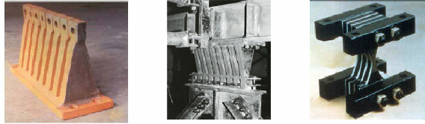

A. Hourglass damper (XADAS); B. Triangular plate damper (TADAS); C. Triangular plate damper (TADAS)

Figure 1. Metallic dampers

Yield action is performed by placing rigid boundaries in the device, so that the device will deform due to the movement of these two rigid plates located at the top and bottom.



Figure 2. XADAS damper performance due to lateral loading

**3. Models under consideration**

Frames examined in this report, all have three bays and different heights of 4, 8 and 12 stories which represent low, intermediate and high-rise structures, respectively. Bays length and stories height are 4m and 3.2m, respectively. All the frames are steel special moment frames and all have Chevron braces in the middle span [9].

All the sections used for columns, beams and braces are European profiles of UPN, IPE and IPB. Ceilings are made from joists. Dead load for each story is 600Kg/m2 and for roof is 550Kg/m2.

Live load for each story is 200Kg/m2 and for roof is 150Kg/m2 [10]. Studied frames, are the middle ones with loading area of 4m. Construction site is Tabriz and seismic lateral loads are applied according to the 2800 code, 3rd revision [11]. Frames under consideration are modeled and designed using ETABS ver9.7.4, it is obvious that the frames are weak and they need to be retrofitted.

**4. Retrofitting**

Characteristics of the dampers used in the studied frames, according to the Tsai method [12], for values of (U=2 & SR=2) which are explained briefly below are determined and are used for modeling in PERFORM 3D [13], also in the bilinearized model the strain hardening of the damper is considered with the slope of 5%, therefore, with the determination of yield displacement of stories  and their stiffness ****, damper stiffness and damper yielding force are calculated according to the assumed SR and U values. For calculation of  a nonlinear static analysis is used. In the following tables, results due to the damper calculation are presented. All the steps of designing TADAS and XADAS (ADAS) are similar to each other and in designing ADAS damper the formulations given for the design of TADAS damper are used except that presented formulas for TADAS damper must be multiplied by 2 and then used for designing ADAS damper [14]. Tsai design approach can be briefly stated as follows:

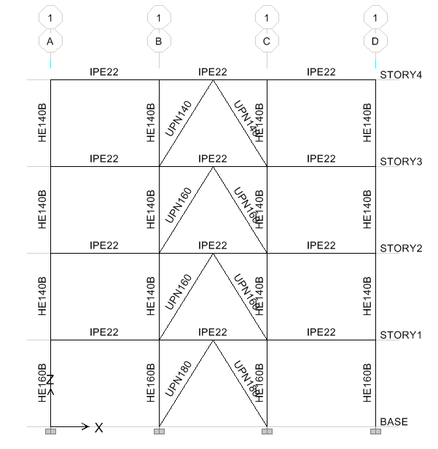



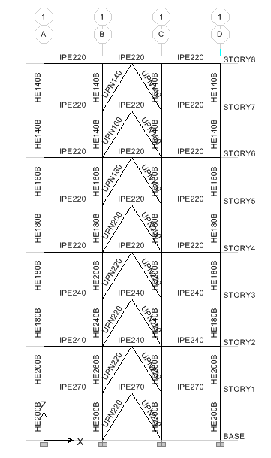

Figure 3. Configuration of 4, 8 and 12-story frames

1- Seismic design is defined according to the site service level.

2- Select an appropriate value for SR. (usually 4 for short and medium periods and less than 2 for larger periods).

3- Frame without damper should withstand 25% of the earthquake force. After the frame design, lateral stiffness of each story  and yield displacement  of each story is determined.

4- With the selected SR and having the value of hardening after yielding SHRA (usually 0.05) and the strength ratio, one can determine the values of damper stiffness  and damper yield displacement****.



(1)

5- The piece stiffness is calculated using the following relations.

 (2)

6- Plastic strength Pp for the piece is calculated as: 

7- N,b,h and t are obtained by simultaneous solutions of the following relations :



Results associated to the dampers calculation of 4-story frame (As an example)

**Table 1.** Details of damper design process for 4-story frame

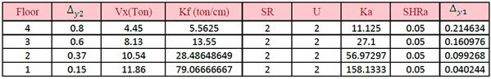

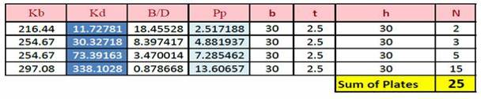

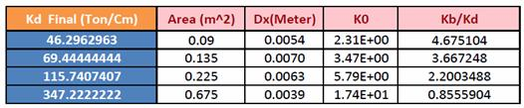

**5. Evaluation of analytical results**

By studying the tables, graphs and outputs of the software, the following results are obtained:

1- Nonlinear dynamic analysis of frames without dampers show that the connections of special moment frame absorb considerable energy which indicate their significant stiffness and ductility in seismic hysteresis energy absorption and dissipation.

2- With respect to that the connections of the special moment frame absorb considerable amount of energy which lead to their malfunction, failure and roof collapse, proper design and implementation of these connections and their retrofitting according to a reliable regulation is necessary.

3- ADAS dampers have a very simple behavioral mechanism, hence they’re very practical for retrofitting existing and under construction structures. One of the important characteristics of these dampers is that there is no disruption in the activity of the retrofitted structures.

4- After the installation of ADAS dampers, it is observed that in the target structures, important factors such as overall displacement, relative displacement, period, base shear values and base moment of the structure are substantially decreased which indicate a very good performance of this damper in retrofitting structures.

5- After the installation of ADAS dampers in the target structures it is observed that the number of plastic hinge formation are reduced dramatically and this demonstrates the role of these dampers in ductility enhancement and hysteresis energy absorption and concentration.

6- After retrofitting the frames with damper it is observed that the share of connections in special moment frame, in absorbing energy is highly reduced, instead the most hysteresis energy is dissipated in the dampers which reflects the extraordinary ductility in these dampers due to yielding of the volume of steel plates and the reduction in the share of energy absorption in connections.

7- Percentage of hysteresis energy dissipated by the XADAS damper increases by increasing the story numbers and height, in other words, an increase in height will improve the performance of the damper, the 12-story frame is better than 8-story and the 8-story is better than the 4-story.

8- After installing the XADAS dampers, the value of base shear in 8-story is greater than the 4 and 12-story, in other words, in the 8-story frame the performance of the XADAS damper in reducing the base shear is better than the 4 and 12-story frames.

9- The performance of the XADAS dampers in reducing the overall and relative displacement of the stories in 4 and 12-story frames is better than the 8-story frame.

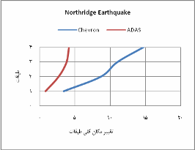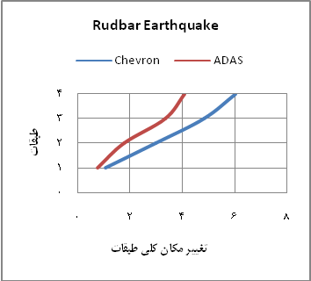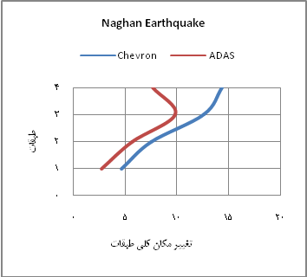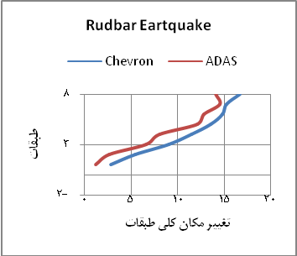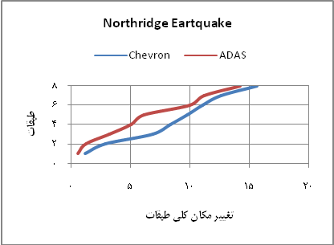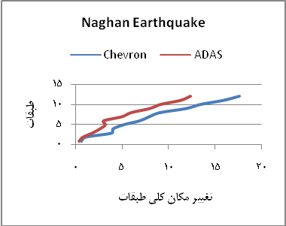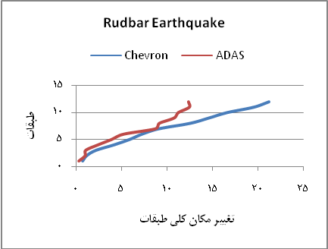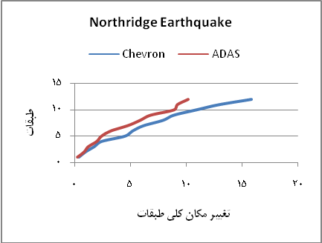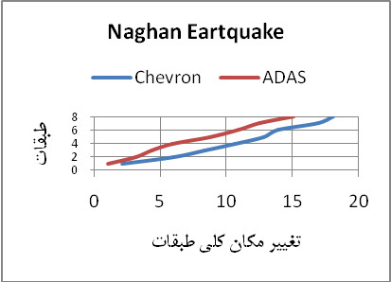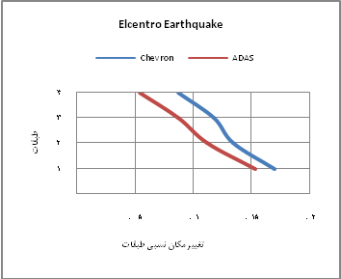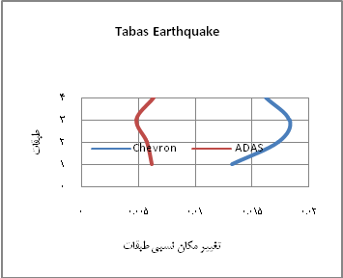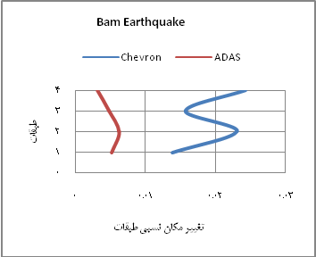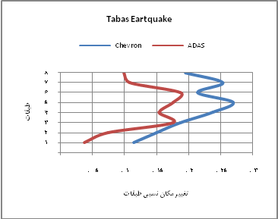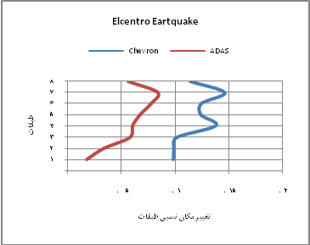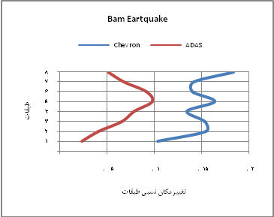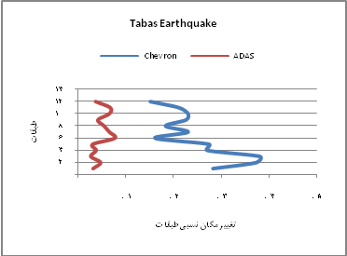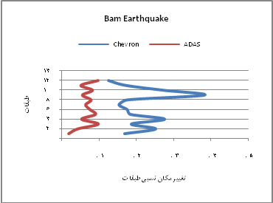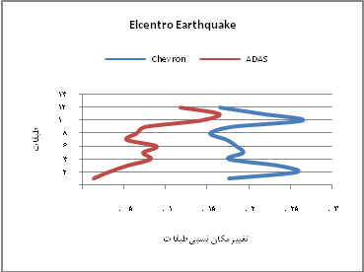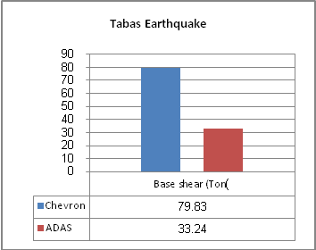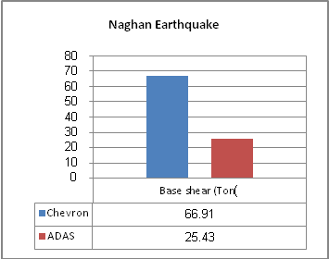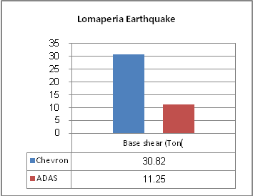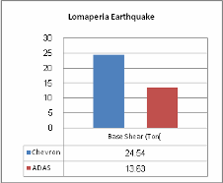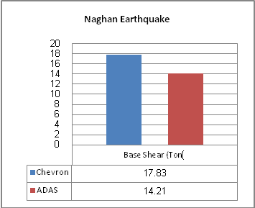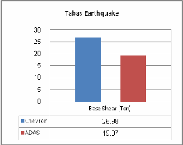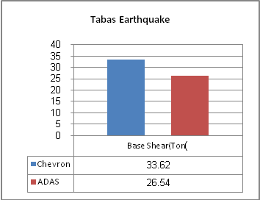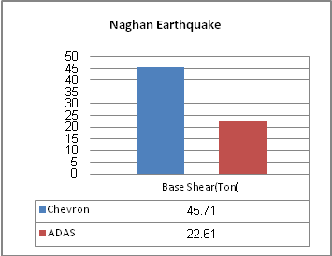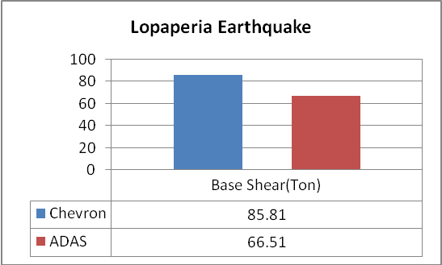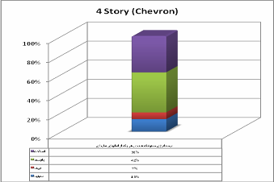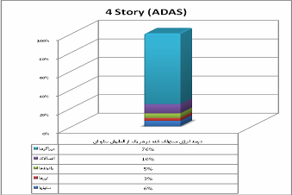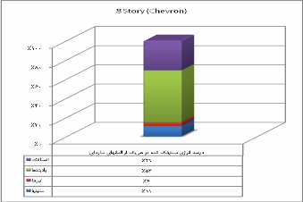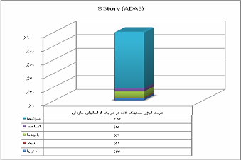

**References**

1. T.T. Soong, B.F. Spencer Jr, Supplemental energy dissipation: state-of-the-art and state-of-thepractice, Engineering Structures 24 (2002) 243–259.
2. Soong T.T., Dargush G.F, Passive Energy Dissipation System in Structural Engineering, wiely, Chichester-Engeland,1997
3. Tsai, K.C., Chen, H.W., Hong, C.P., and Su, Y.F., “Design of Steel Triangular Plate Energy Absorbers for Seismic-Resistant Construction,” Earthquake Spectra, Vol. 9, No. 3, pp. 505-528, 1993.
4. Powell, G.H., Perform-3d Userguid & Element Description, (2003), Ram International Company.
5. Whittaker, A, Bereero, Alonso, G., and Thompson C; Earthquake Simulator Testing of Steel Plate added Damping and Stiffness Elements, Report No. UBC/EERC-89/02, Eartquake Engineering Reasearch Center.

1/6/2014