**Sequence analysis of alpha toxin produced by *C. perfringens* isolated from different sources**

1Helmy Ahmed Torky and 2Mohamed Abdel gawad Hassan

Microbiology department, Faculty of Vet. Med. Alexandria University, Egypt.

Department of Microbiology.Animal Health Research Institute, Damanhour branch, Egypt.

[m.gawad82@gmail.com](mailto:m.gawad82@gmail.com)

**Abstract:** The phylogenic and phenotypic relationships between *C. perfringens* strainsisolated from different sources were evaluated. In which 400 samples were collected from chicken, rabbit, sheep and calves and subjected to anaerobic examination and identification. The incidence of *C. perfringens* isolated from chicken, rabbit, sheep and calves were 70%, 42%, 63% and 55% respectively. The recovered isolates were biochemically identified. Molecular typing of the isolates was performed by multiplex PCR using of three sets of primers specific for toxin producing genes of *C.perfringens* [alpha (402bp), beta (236bp) and epsilon (541bp) toxin]. Sequence analysis was performed on alpha toxin of 12 C*. perfringens* isolates (three isolates from each species) in which the products of PCR reaction of alpha toxin were sequenced and aligned with the alpha toxin sequences published in Gen bank and with reference strains. The results of Sequencing revealed that, alpha toxin gene sequences of recovered isolates has high similarity with each other, reference strains and with published sequences on gene bank. These results indicate that *C. perfringens* alpha toxin is highly conserved region among *C. perfringens* isolated from different origin as the identity percentage was greater than 95% and approached to 100 %.

[Helmy Ahmed Torky and Mohamed Abdel gawad Hassan. **Sequence analysis of alpha toxin produced by *C. perfringens* isolated from different sources.** *Nat Sci* 2014;12(1):55-61]. (ISSN: 1545-0740). [http://www.sciencepub.net/nature. 9](http://www.sciencepub.net/nature.%209)

**Keywords:** Sequence analysis; alpha toxin; *C. perfringens*; source

**1. Introduction:**

Clostridium perfringens (C. perfringens) is a Gram-positive spore-forming anaerobic bacterium present in the intestinal ﬂora of humans and animals as well as in soil and water, where its presence might be indicative of fecal contamination ***(Florence et al.., 2011).***

*C. perfringens* is classiﬁed into 5 toxinotypes (A, B, C, D, and E) according to the production of 4 toxins, namely alpha (CPA), beta (CPB), epsilon (ETX) and iota (ITX). Several other toxins (e.g. enterotoxin (CPE), beta 2 (CPB2) and perfringolysin O (PFO) can also be produced by some strains of all types of *C. perfringens*, but they are not currently used in the classiﬁcation of this microorganism *(****Songer and Uzal, 2005).***

Alpha toxin is commonly produced by all five types and is a phospholipase C that can hydrolyze lecithin into phosphorylcholine and diglyceride and is believed to be a major factor responsible for the organism’s tissue pathology ***(Jolivert-Reynaud et al., 1988).***

*C. perfringens* has been associated with a variety of diseases in both humans and domestic animals including: lamb dysentery, enterotoxaemia, gas gangrene, hemorrhagic enteritis, food poisoning and many other severe enterotoxemic diseases ***(Titball, 2009).***

Various PCR protocols including multiplex PCR assays have been established to genotype *C. perfringens* isolates with respect to the genes *cpa*, *cpb*, *etx*, *iap*, *cpe* and *cpb*2, encoding the α-, β-, ε-, ι-, entero- and β2-toxin, respectively **(*[Garmory et al., 2000).](http://www.sciencedirect.com/science/article/pii/S0378113503001263" \l "ref_BIB5)***

16S rRNA gene sequencing has emerged as a more objective, accurate, and reliable method for bacterial identification, with the added capability of defining taxonomical relationships among bacteria as the traditional identification of bacteria on the basis of phenotypic characteristics is generally not as accurate as identification based on genotypic methods. 16S rRNA gene sequence analysis can better identify poorly described, rarely isolated, or phenotypically aberrant strains ***(Clarridge, 2004).***

Measurement of the evolutionary distances between strains of different types would facilitate the elucidation of their genetic relationships. Analysis of the rRNA nucleotide sequences has been performed to construct a phylogenetic tree for many Clostridial species, including *C. perfringens* ***(Collins et al., 1994)****.*

Furthermore, comparison between isolates from different sources can improve our knowledge of the existing evolutionary relationship and the genetic diversity of *C. perfringens* present in nature and this may reflect on current classification based on toxigenicity or not. Moreover are the toxinotype agreed with the genotype? Consequentely

**The aim of the present study was to** determine the phylogenic relationships between *C. perfringens* strainsisolated from different sourcesand for comparing between genotyping and phenotyping characters of *C. perfringens* isolates**.**

**2.Material and Methods**

***. Sample Collection and Isolation of C. perfringens*:**

The samples collected either from (intestinal tract and liver) from chicken and rabbits showed symptoms of enteritis or samples of (liver, spleen, kidney and intestinal tract) from sheep and calves showed symptoms enteritis and sudden death. All samples were obtained from different farms and small holders at El-Behera and Alexandria Governorates. The samples were labeled and placed in sterile plastic bags and transported in ice e box as soon as possible for anaerobic bacteriological examination. The samples were inoculated into tubes of freshly prepared and previously boiled cooked meat medium (Oxoid) ***(Willis, 1977)****.* Such enriched medium were incubated anaerobically at 37 C for 24-48 hours in anaerobic Gas pack jar. A loopful from the previously incubated broth was streaked onto the surface of 10% sheep blood agar with neomycin sulphate 200ug/ml ***(Carter and Cole, 1990)***. The plate was incubated anaerobically at 37 0C for 24-48 hours. The suspected colonies of *C. perfringens* that were characterized by double zone of haemolysis were picked up and subjected to macroscopic examination (shape, size, hemolysis and texture) on blood agar plates and microscopically by Gram-stained films.

***Biochemical identification of isolates:***

Suspected isolates werebiochemically identified according to the schemes of ***(Koneman et al., 1992 and Macfaddin, 2000)*** depending on the following tests catalase test, gelatin hydrolysis test, fermentation of sugars (glucose, lactose, sucrose, galactose, manitol, maltose xylose and mannose), indole test, H2S production and lecithinase activity.

***Typing of toxigenic C. perfringens******isolates:***

The isolated and identified *C. perfringens* isolates were typed by dermonecrotic reaction in Albino Guinea pigs which was carried out according to ***(Sterne and Batty, 1975*** *and* ***Quinn et al.., 2002)****.*

***Genotyping of C. perfringens isolates Using multiplex PCR Assay and Sequence analysis of alpha toxin:***

***(1) Multiplex PCR:***

***(A) Extraction of DNA***

Genomic DNA of *C. perfringens* was extracted by using an extraction kit (QIAamp®DNA Mini Kit, Qiagen).

***(B)PCR Master Mix for PCR:***

Through using of PCR 1.1 xs ReddyMix TM Master Mix (**Thermo Scientific**) that is ready to use.

***(C) Oligonucleotide primers (100 pmol):***

Primers for the three toxin genes (alpha, beta, and epsilon) of *C. perfringens* were selected according **Yoo *et al.* (1997**) in concentration of 10 pmol. As shown in **table (1).**

**Multiplex PCR**:

DNA samples were amplified in a total of 50 μl of the following reaction mixture: contained 25 µl of PCR master mix, 1µl of forward primer for each toxin gene (alpha, beta and epsilon), 1µl of reverse primer for each toxin gene (alpha, beta and epsilon), 14 µl of PCR grade water and 5 µl of the template DNA

**PCR cycling program:**

That performed in the thermal cycler **table (2).**

-The PCR reaction mixtures were analyzed by electrophoresis on a 1.5% (w/v) agarose gel in the presence of 100-bp DNA ladder (QIAGEN). the agarose gel was supplemented with ethidium bromide in order to visualize the DNA on an UV transilluminator.

**(2) Sequence analysis for alpha toxin:**

PCR amplified products of partial *cpa* gene of *C*. *perfringens* were subjected for sequencing in which PCR products were purified using ***QIAquick gel extraction kit*** **(*Qiagen Inc. Valencia CA*)**and sequenced in the forward and reverse directions on an automated DNA Sequencer ***(ABI, 3130, USA).*** Using a ***ready reaction*** ***Bigdye Terminator V3.1 cycle sequencing kit. (Perkin-Elmer/Applied Biosystems, Foster City, CA)***. The sequence reaction was doneaccording to the instruction of the manufacture. Partial sequences obtained were submitted to BLAST analysis *(****Altschul et al., 1990)*** to determine the similarities to other sequences available in Gen Bank. The recovered sequences were compared with reference strains (chicken and rabbit reference stain ) which obtained from *(****Effat and Abdallah, 2008)*** and other sequences available in Gen Bank and Phylogenetic tree was constructed with MEGA 4 software ***(Tamura et al., 2007)*** using the neighbor-joining approach and the evolutionary distances computed using the Poisson correction method.

**3. Results and Discussion**

*C. perfringens* is causative agents of enterotoxaemia in farm animals. They are normally inhabitant in alimentary tract and under certain conditions, the organism proliferate rapidly in the intestine and produce lethal quantities of exotoxin causing severe tissue damage and death of the body cells ***(Radostits et al., 2000).***

The identification of *C*. *perfringens* by conventional methods revealed that *C*. *perfringens* is Gram positive short plumb rarely sporulated and non motile bacilli. It was clear that sheep blood agar with neomycin sulphate (200 ug/ml) is a perfect medium for isolation of C. *perfringens* rather than other *Clostridium* species and gave double zones of haemolysis **(*Peter******et al., 1986).***

**Table (1): Primers for the three toxin genes** **of C. perfringens**

|  |  |
| --- | --- |
| **Nucleotide sequence** | **Primer name and direction** |
| **5**`GTT GAT AGC GCA GGA CAT GTT AAG **3`**  **5`** CAT GTA GTC ATC TGT TCC AGC ATC **3`** | **alpha (cpa):**  Forward  Reverse |
| **5`**ACTATACAGACAGATCATTCAACC **3`**  **5`**TTAGGAGCAGTTAGAACTACAGAC **3`** | **beta (cpb):**  Forward  Reverse |
| **5`** ACT GCA ACT ACT ACT CAT ACT GTG **3`**  **5`** CTG GTG CCT TAA TAG AAA GAC TCC **3`** | **epsilon (cpe):**  Forward  Reverse |

**Table (2): PCR cycling protocol for multiplex PCR (Yoo et al., 1997).**

|  |  |  |
| --- | --- | --- |
| **Fragment sizes (bp)** | **PCR condition** | **Amplified DNA** |
| *cpa:* 402  *cpb:* 236  *etx:* 541 | **A)Initial denaturation:**  95°c for 5 min  **B) Actual cycles:**  30cycles of  1- 94°c for 1 min  2- 55°c for 1 min  3- 72°c for 1 min  **c)final extension:**  72 °c for 3 min. | ***C.perfringens* toxin genes (alpha, beta and epsilon)** |

In biochemical reactions all the recovered strains were fermentative to different sugars as glucose, maltose, lactose, sucrose and mannose with production of acid and gases. Neither mannitol nor salicin was fermented. Gelatin liquefiers, litmus milk positive, catalase, oxidase and indole tests negative. Most of the strains reduced nitrate.Similar results were recorded by **(Assis** ***et al.,* 2002).**

The incidence of *C. perfringens* isolated from chicken, rabbit, sheep and calves were 70%, 42%, 63% and 55% respectively and this illustrated in **table( 3).**

**Table (3) Incidence and typing of C. perfringes isolated from different hosts**

|  |  |  |  |  |  |  |  |  |  |  |  |
| --- | --- | --- | --- | --- | --- | --- | --- | --- | --- | --- | --- |
| **Type of perfringens isolates** | | | | | | | | **Positive** | | **No**  **Examined** | **Species** |
| **Type D** | | **Type A** | | **Toxigenic** | | **Non Toxigenic** | |  |  |
| **%** | **N** | **%** | **N** | **%** | **N** | **%** | **N** | **%** | **N** |
| **16.6** | **15** | **83.3** | **75** | **85.7** | **90** | **14.3** | **15** | **70** | **105** | **150** | **Chicken** |
| **25** | **4** | **75** | **12** | **76.2** | **16** | **23.8** | **5** | **42** | **21** | **50** | **Rabbits** |
| **39.2** | **20** | **60.8** | **31** | **81** | **51** | **19** | **12** | **63** | **63** | **100** | **Sheep** |
| **62** | **20** | **38** | **16** | **76.3** | **42** | **23.7** | **13** | **55** | **55** | **100** | **Calves** |

**Multiplex PCR** was used for genotyping of *C. perfringens* by using three sets of primers specific for toxin -producing genes of *C. perfringens* (alpha, beta and epsilon).

**Photo (1)** showed that 15 *C. perfringens* isolates were examined by multiplex PCR.The results revealed that 10 of the examined field isolates were identified as *C. perfringens* type"A" (alpha toxin) which gave a characteristic band at 402 bp ***(Yoo et al., 1997)****.* And 5 isolates were identified as *C. perfringens* type "D" which produce (alpha and epsilon toxins) and gave two types of bands one of them at 402 bp (alpha toxin) and the other at 540 bp (epsilon toxin ). On the other hand, all *C. perfringens* isolates gave no band with beta toxin primers exhibiting the absence of *C. perfringens* types B and C.

* ***Sequence analysis of alpha toxin:***

Sequence analysis was performed on alpha toxin gene of 12 *C. perfringens* isolates (three isolates from each species).The isolates No (1, 3 and 10) were isolated from chicken, the isolates No (7, 8 and 11) were isolated from rabbit, the isolates No (4, 5 and 12) were isolated from sheep and the isolates No (2, 6 and 9) were isolated from calves.

The obtained nucleotide sequences comparisons and their multiple alignments with the Egyptian *C. perfringens* reference strains and other related strains sequences published on Gen Bank were done and the phylogenic tree was constructed as in figure (1).

M 1 2 3 4 5 6 7 M 8 9 10 11 12 13 14 15 16

402 pb

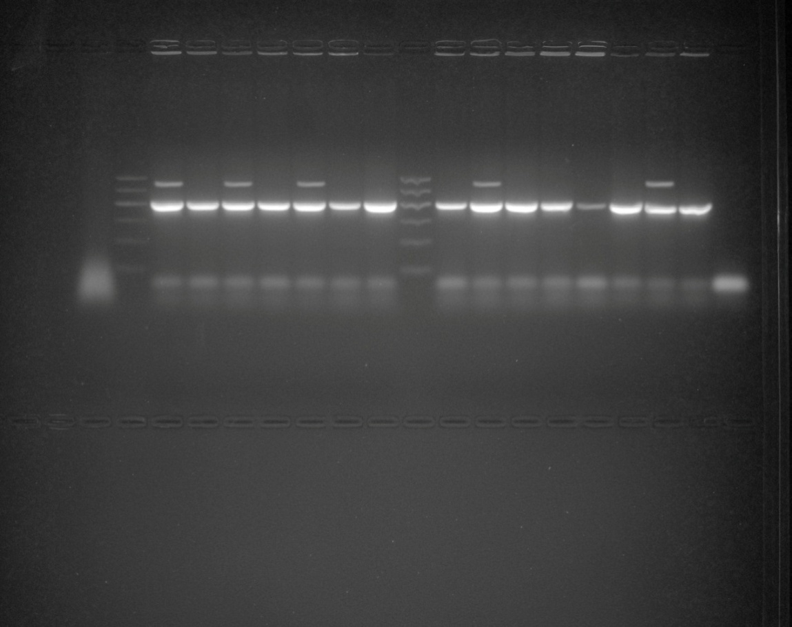

**Photo (1):** Agarose gel electrophoresis of PCR products obtained from *C. perfringens* isolated from different hosts showed that. M: marker (DNA ladder, 100 bp); lanes 2, 4,6,7, 8, 10, 11, 12, 13 and 15 are *C. perfringens* type A isolates (alpha toxin) which gave a characteristic band at 402 bp and lane 1,3, 5, 9,14 are *C. perfringens* type D isolates (alpha and epsilon toxins) which gave two types of bands one of them at 402 bp (alpha toxin) and the other at 540 bp (epsilon toxin ).lane 16 was control –ve.

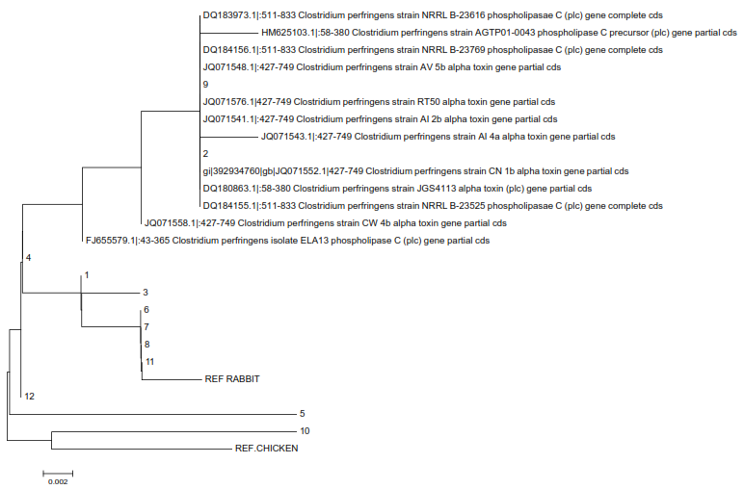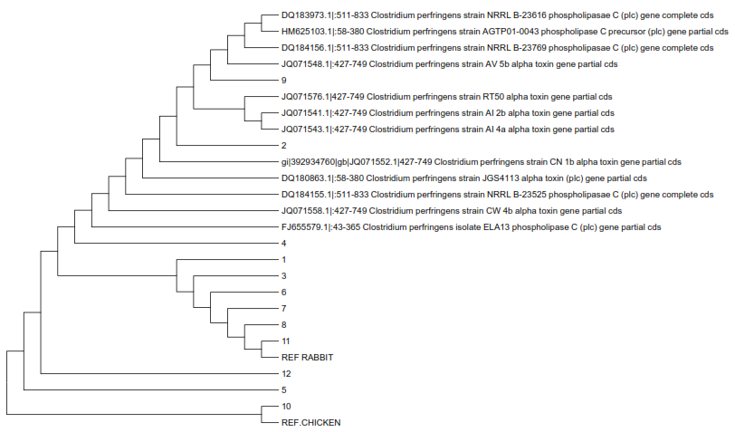

**Figure (1)** Phylogenetic tree of nucleotide sequence from the 402-bp alpha gene fragment of 12 C. perfringens field isolates from various hosts and C. perfringens strains published in GenBank and reference strains.

**-Figure (1)** revealed that:

- The nucleotide sequences of alpha-toxin from the chicken isolates No **1** and **3** were closely grouped together and this indicate the close similarity between each other as the identity percentage was 99.23% and this agree with **Sheedy *et al.* (2004)** concluded that the *C. perfringens* strains from chickens suffering necrotic enteritis have highly conserved alpha-toxin sequences that closely resemble to each other. And that from the chicken isolate No **10** was closely grouped with the reference chicken strain (*C. perfringens* type A- alpha-toxin) and this indicate the close similarity between them. While it was far distantly separated branch from sequence of isolates No 1 and No 3 as the identity percentage between isolate No 10 and isolates No 1 and 3 were 96.62% and this may be due to variation in geographical site of isolation.

- The nucleotide sequences of alpha-toxin from the sheep isolates No **4** and **12** were very closely grouped together and this indicate the close similarity between them as the identity percentage was 100% and this may be due to that two isolates recovered from the same outbreak. **Johansson *et al.* (2006)** reported that C*. perfringens* isolates from the same outbreak seemed to be similar genetically, while isolates with no obvious epidemiological connection differed more noticeably.

- The nucleotide sequences of alpha-toxin from the rabbit isolates No **7**, **8** and **11** were closely grouped with each other and with reference rabbit strain and this indicate the close similarity between them.

- The nucleotide sequences of alpha-toxin from the calves' isolates No 2 and 9 were closely grouped together and this indicate the close similarity between them as the identity percentage was 99.62 % and this may be due to that two isolates recovered from the same outbreak **Johansson *et al.* (2006)** also have the same origin.

- The nucleotide sequence of alpha-toxin from the calves isolate No **6** was grouped with the nucleotide sequences of rabbit isolates No 7, 8, 11 and this indicate the close similarity between them as the identity percentage of isolate No 6 with isolates No 7, 8, 11 were 99.62%, 100% and 100% respectively. **Tsutsui *et al.* (1995**) reported that toxin typing of *C. perfringens* strains is unrelated to their evolutionary relationships. And found that the sequences of two strains, NCTC8237 (type A) and NCIB10691 (type B), are tightly linked to each other, forming a cluster distinct from others. One type D strain, NCIB10663, is tightly linked to a type E strain, NCIB10748, forming a cluster distinct from the other cluster comprising one type A and another type D strain. These results clearly indicate that the toxin type does not agree with the genotype, **Sawires and Songer (2006)** reported that there was a lack of association between strains phylogeny and host species or disease. And found that among 9 *C. perfringens* strains isolated from poultry with necrotic enteritis, three (JGS4059, 4066, 1521) are phylogenetically related to type E strains isolated from bovine enteritis cases. And **Siqueira *et al.* (2012)** observed that some phospholipase C sequences from *C. botulinum* isolates (AEB75759, EES91309) were more closely phylogenetically linked to *C. haemolyticum* sequences than to other *C. botulinum* sequences (AEB77536, EDS77236).

**The Figure** provided also a characterization of available *C. perfringens* alpha toxin sequences deposited into the NCBI database in combination with sequences deﬁned during the course of this study and revealing that:

-Sequence analysis of alpha toxin gene of calve isolate No **9** revealed close similarities (identical) **(100%)** with Clostridium perfringens strain JGS4113 alpha toxin (plc) gene (Gene Bank accession number DQ180863.1). (Country (USA) ----- source b**ovine** type A). This result may help in epidemiological purposes especially in international outbreaks investigations of *C. perfringens* as it enable the accurate and rapid comparison of isolates from different countries and we can follow up to the source of infection.

- Sequence analysis of alpha toxin gene of calve isolate 2 revealed close similarities (99.63%) with Clostridium perfringens strain JGS4113 alpha toxin (plc) gene (Gene Bank accession number DQ180863.1). (country (USA)----- source bovine type A).

-Sequence analysis of alpha toxin gene of chicken isolate No1 revealed close similarities (98.46%) with Clostridium perfringens strain CW 4b alpha toxin gene (Gene Bank accession number JQ071558.1).(country ( Brazil)----- source poultry stool).

- Sequence analysis of alpha toxin gene of isolates No 12, 4 and 1 revealed close similarities (99.23-99.62%) with Clostridium perfringens isolate ELA13 phospholipase C (plc) gene toxin (Gene Bank accession number (FJ655579.1). (Country (Canada) ----- source composted biosolids).

- Sequence analysis of alpha toxin gene of sheepisolate 4 and 12 revealed close similarities (98.4-98.8%) with Clostridium perfringens strain JGS4113 alpha toxin (plc) gene (Gene Bank accession number DQ180863.1).(country ( USA)----- source bovine type A).

**The Figure** concluded that Sequence analysis of alpha toxin gene of *C. perfringens* isolates No **2** and **9** were the most related isolates with available related sequences on gen bank so revealed very close similarities with them as the identity percentage was ranged from 99- 100% while isolates No 5, 7 and 10 were the lowest related isolates with available related sequences on gen bank so revealed somewhat low similarities with them as the identity percentage was ranged from 95-96%.

**Our results revealed that** alpha toxin gene sequences of recovered isolates revealed high similarity with each other, reference strains and with published sequences on gene bank these results indicate that *C. perfringens* alpha toxin is **highly conserved region** among *C*. *perfringens* that isolated from different origin as the identity percentage was greater than 95% and approached to 100 % and **this agree** with **Tsutsui *et al.* (1995)** who reported that no significant difference in the nucleotide sequence of the plc promoter region was observed for any of the plc genes, **Ginter *et al.* (1996)** found the highly conserved *cpa* sequences and a close homology between the *cpa* sequences of *C*. *perfringens,* isolated from human and animals, **Sheedy *et al.* (2004)** found that *C. perfringens* strains from chickens suffering necrotic enteritis have highly conserved alpha-toxin sequences that closely resemble to each other and those of the alpha-toxins found in mammalian isolates of *C. perfringens* but are significantly different from that of the SWCP isolate obtained from a diseased swan, **Das *et al.* (2008)** who reported that phylogeny of partial alpha toxin sequences from chicken (India) showed greater than 97.6% to 100% sequence identity with chicken (Denmark), bovine (USA) and soil (Japan). The encoded proteins were also found to highly conserved in all, irrespective of different source of isolation, health status and geographical distribution.And **Effat and Abdallah (2008)** reported that no nucleotide sequence differences inside the alpha toxin gene were detected and the gene seems to be conserved among the 5 types of *C. perfringens* studied and the identities percentage among all studied alpha toxin gene sequences with the published ones was nearly 96-98%.

On the other side our results **disagre**e with **Johansson *et al.* (2006)** who used pulsed-field gel electrophoresis (PFGE) to examine the genetic diversity of 95 *C. perfringens* *type A* isolates from eight different sources (various animals, food poisoning outbreaks and sludge) and mentioned that PFGE (pulsed-field gel electrophoresis) revealed a wide genetic diversity among the *C. Perfringens type A* isolates and the genetic relatedness of the isolates ranges from 58 to 100%, **Siqueira *et al.* (2012)** who demonstrated a high level of genetic diversity in the plc gene. As identiﬁed 71 polymorphic sites in the 1113 plc gene base pairs analyzed. And **Eman *et al.* (2013)** who reported that the nucleotide sequence analysis of alpha toxin gene showed diversity among *C. perfringens* field isolates type A and D isolated from necrotic enteritis cases, the degree of similarities with published data on gene bank were 84 and 75% respectively and similarity between them was 54%.

**In conclusion**

This study showed that:

* *C. perfringens* is widely distributed in nature and causing of various diseases in different species of animals and chicken.
* PCR is a rapid, sensitive and accurate assay to detect toxigenic isolates of *C. perfringens*.
* Gene sequencing is more objective identification tool, unaffected by phenotypic variation and has the potential to reduce laboratory errors.
* Nucleotide sequence analysis of alpha toxin genes of *C. perfringens* from different sources showed high similarity with each other and with related published sequences on gene bank. This indicates that *C. perfringens* alpha toxin is highly conserved region among *C. perfringens* isolated from different sources. These results are encouraging for the development of diagnostic tests and vaccines for the control and treatment of *C. perfringens* infections in different hosts as when using of α- vaccine composed of the C-domain of α -toxin (α -toxoid) could prove useful tool for protecting against Clostridial diseases where the *C. perfringens* α -toxin is a major virulence determinant. And this may signify that the vaccines and tests used in one host may be able to be used in another host species.

**References**

1. Altschul, S.F., W. Gish, W. Miller, E.W. Myers and D.J. Lipman, (1990): Basic local alignment search tool. J.Mol. Bio., 215: 403-410.
2. Assis, R.A., Uzal, F.A.; Santana, F.J.F.; Dias, L. and Parreiras, P. M. (2002): Isolation of *C. Perfringens* type D from a suckling calf with ulcerative abomasitis. Arch. Med. Vet., 2: 287-292.
3. Carter, G.R. and Cole, J.R. (1990): Diagnostic procedures in veterinary bacteriology and m ycology.” 5th Ed., Academic Press, Harcourt, Boace Jov., P ublisher, New York, Boston, Tokyo, Toronto.
4. Clarridge, J. (2004): Impact of 16S rRNA gene sequence analysis for identification of bacteria on clinical microbiology and infectious diseases. Clin. Microbiol. Rev.17:840-862.
5. Collins, M. D.; Lawson, P. A.; Willems, A.; Cordoba, J. J.; Fernandez, G. J.; Garcia, P.; Cai, J.; Hippe, H. and Farrow, J. A. E.(1994): The phylogeny of the genus Clostridium: proposal of five new genera and 11 new species combinations. Int. J. Syst. Bacteriol. 44:812-826.
6. Das, A.; Mazumder, Y.; Dutta, B.K.; Shome, B. R.; Bujarbaruah,K.M and Ashok Kumar (2008): *Clostridium perfringens* Type A from Broiler Chicken with Necrotic Enteritis. Inter. J.Poult. Sci. 7 (6): 601-609.
7. Effat M.M. and Abdallah Y.A. (2008): Comparison of alpha toxin gene among different types of *Clostridium perfringens*, Arab J. Biotech., Vol. 11, No. (2): 253-262.
8. Eman A. K.; Sohad M. D.; Bakry. M.A and Hakim A.S (2013): Molecular Diversity of Alpha Toxin Produced by *Clostridium perfringens* Strains Causing Avian Necrotic Enteritis.World Appl. Sci. J., 21 (1): 15-20.
9. Florence, L.C.H.; Hakim, S.L.; Kamaluddin, M.A. and Thong, K.L., (2011): Determination of toxinotypes of environmental *Clostridium perfringens* by polymerase chain reaction. Trop. Biomed. 28 (1), 171–174.
10. Garmory, H.S.; Chanter, N.; French, N.P.; Bueschel, D.; Songer, J.G and Titball, R.W. (2000): Occurrence of *Clostridium perfringens* beta2-toxin amongst animals, determined using genotyping and subtyping PCR assays. Epidemiol Infect 124:61–67.
11. Ginter, A.; Williamson, E. D.; Dessy, F.; Coppe,P.; H. Bullifent, A. Howells, and Titball, R. W. (1996): Molecular variation between the alpha-toxins from the type strain (NCTC 8237) and clinical isolates of *Clostridium* *perfringens* associated with disease in man and animals. Microbiology 142:191–198.
12. Johansson A.; Aspan A.; Bagge E.; Baverud V.; Engstrom B. E.and Johansson K-E (2006): Genetic diversity of *Clostridium perfringens* type A isolates from animals, food poisoning outbreaks and sludge. BMC Microbiology, 31: 6:47
13. Jolivert-Reynaud, C.; Moreau, H. and Alouf, J. E. (1988): Purification of alpha toxin from *Clostridium perfringens*; phospholipase C. Methods Enzymol. 165: 91- 94.
14. Koneman, E.W.; Allen, S.D.; Dowell, V.R. and summers, H.W. (1992): “Colour atlas and text book of diagnostic microbiology.” 4 Ed.J.B. Lippin Cott, New York, London.
15. MacFaddin J.F(2000).: Biochemical tests for identification of medical bacteria. Baltimore: Lippincott Williams & Wilkins; 1-450. **39**pp. 1781–1791.
16. Peter, H.A.; Nicholas, S.; Elisabeth, S. and John, G. (1986): “Bergey’s Manual system ic Bacteriology, Vol. 2, William s and Wilkins.
17. Qunin, P. J.; Markey, B.K.; Carter, M.E., Donnelly, W.J.; Leonard, F.C. and Maguire, D. (2002): Veterinary microbiology and microbial diseases.2nd Ed., Blackwell Science, 84-96.
18. Radostits, O. M.; Gay, C. C.; Blood, D. C. and Hincheliff,K. W. (2000): "Veterinary Medicine. A textbook of the Diseases of Cattle, Sheep, Goats and Horses." J. Clin. Microbiol., 31 (2): 467-469.
19. Sawires, Y.S. and Songer, J.G.(2006): *Clostridium perfringens*: Insight into virulence evolution and population structure. Anaerobe. 12: 23–43.
20. Sheedy, S. A.; Ingham A. B.; Rood, J. I. and Moore R. J (2004): Highly Conserved Alpha-Toxin Sequences of Avian Isolates of *Clostridium perfringens.* J. Clin.Microbiol. Vol. 42, No. 3 p. 1345–1347.
21. Siqueira, F. F.; Almeida, M. O.; Barroca, T. M.; Horta C. C.R.; Carmo, A. O.; Silva, R. O.S.; Pires, P. S.; Lobato F. C.F and Kalapothakis, E (2012): Characterization of polymorphisms and isoforms of the *Clostridium perfringens* phospholipase C gene (plc) reveals high genetic diversity. Vet. Microbiol. (159). 397-405.
22. Songer, J.G. and Uzal, F.A. (2005): Clostridial enteric infections in pigs. J. Vet. Diagn. Invest. 17, 528–536.
23. Sterne, M. and Batty, I. (1975): Pathogenic Clostridia.Butterworth, London, England.
24. Tamura, K., Dudley, J., Nei, M., Kumar, S., (2007):MEGA4: Evolutionary Genetics Analysis (MEGA) software version 4.0. Mol. Biol.Evol. 24, 1596–1599.
25. Titball, R.W. (2009): *Clostridium perfringens* vaccines.Vaccine;27 (Suppl. 4)):D44–7.
26. Tsutsui, K.; Minami, J.;Matsushita, O.; Katayama, S.;Taniguchi, Y.;Nakamura,S.; Nishioka, M. and Okabe, a., (1995): Phylogenetic analysis of phospholipase C genes from *Clostridium perfringens* types A to E and Clostridium novyi. J. Bacteriol. 177 (24), 7164–7170.
27. Willis, A. T. (1977): Characteristics of the pathogenic and related Clostridia. Anaerobic Bacteriology. Clinical laboratory practice 3rd Ed.
28. Yoo, H.S.; Lee, S.U.; Park K.Y and. Park, Y.H, (1997): Molecular typing and epidemiological survey of prevalence of *Clostridium perfringens* types by multiplex PCR. J Clin Microbiol, **35:**, pp. 228–232.

1/2/2014