**Biodegradation of phenanthrene by native bacterial strains isolated from the river Nile water in Egypt**

Hossam S. Jahin, Seleem E. Gaber and Ayman Y. Ewida

Central Laboratory for Environmental Quality Monitoring, National Water Research Center, Egypt

[Seleem_gaber@hotmail.com](mailto:Seleem_gaber@hotmail.com)

**Abstract: The selection of appropriate bacterium species is critical in the successful application of biodegradation techniques**. **The present study is an attempt to isolate and identify new indigenous bacterial strains from a contaminated site in the river Nile water, and to assess their capability to degrade high concentrations of phenanthrene (PHE) as a model for** polycyclic aromatic hydrocarbons (PAHs)**.** In order to demonstrate the potential of the isolated bacterial strains in degrading high concentration of PHE, batch reactors were conducted using mineral salt base (MSB) and river Nile water as media, supplemented with 100 mgL-1 PHE as sole carbon and energy source. Determination of PAHs in Nile water samples and monitoring of the PHE biodegradation process was analyzed by the gas chromatography with a flame ionized detector (GC/FID). The total concentration of PAHs in the examined water samples ranged from 59.7 to 78.5 µg l-1. And the overall composition pattern of PAHs was dominated by low molecular weight PAHs, which distinguishes its petrogenic origin. The examined bacterial isolates successfully achieved PHE biodegradation from the solutions through 21 days. The 16S rDNA-based phylogenetic analysis suggested that the bacterial strains involved in the process of biodegradation of PHE are *Bacillus cereus*, *Pseudomonas protegens* strain Pf-5 and *Pseudomonas flourscens* strain SBW 25.

[Hossam S. Jahin, Seleem E. Gaber and Ayman Y. Ewida. **Biodegradation of phenanthrene by native bacterial strains isolated from the river Nile water in Egypt.** *Nat Sci* 2014;12(1):1-8]. (ISSN: 1545-0740). <http://www.sciencepub.net/nature>. 1

**Keywords:** River Nile, Biodegradation, Phenanthrene, **Bacteria**, Bacillus, Pseudomonas.

**1.Introduction**

River Nile is the main source of drinking water in Egypt, unfortunately, oil is sometimes present due to the accidental pollution or river transportation. Oil is a complex mixture made up of hundreds of compounds, and these compounds are classified into four groups, namely; saturates, aromatics, resins and asphaltenes **(Dutta and Harayama, 2001).** Aromatics are the second most abundant hydrocarbons in crude oil. Polycyclic aromatic hydrocarbons (PAHs), hydrocarbons containing two or more fused benzene rings, are a group of ubiquitous organic pollutants of great environmental concern **(Manoli *et al.,* 2000)**. Due to their ubiquitous occurrence, recalcitrance and suspected carcinogenicity and mutagenicity, 16 parent PAHs are included in the U.S. Environmental Protection Agency (EPA) as priority lists of pollutants (**EPA, 2001**).

Although PAHs may undergo adsorption, volatilization, photolysis and chemical degradation, microbial degradation is the major treatment process (**Bumpus, 1989; Yuan *et al.,* 2001**). Both bacteria and fungi have been extensively studied for their ability to degrade xenobitics including PAHs (**Korda, 1997; Head, 1998; Kapley *et al.,* 1999; Del Arco and De Franca, 2001; Zohreh *et al.,* 2012**). Microorganisms could be native of contaminated sites or might be separated from the other sites (**Head IM, and** **Swannell RP 1999**). But many of researchers believe that native microorganisms have high efficiency in biodegradation of oil pollution because they are more compatible with environmental conditions and nationally degrade pollution (**Zohreh *et al.,* 2012).**

Phenanthrene with three fused benzene ring is one of the PAHs whose high toxicity promote the research for its remediation from the soil and water resources **(Muckian *et al.,* 2009).** For examples, *Pseudomonas* *aeruginosa* isolated from a stream heavily polluted with petroleum refinery was found to be actively growing over high dosages of phenanthrene with complete removal of the pollutant in a period of 30 days **(Tam *et al.,* 2002).** *Bacillus thermoleovorans* has been reported by **Annweiler *et al.,* (2000)** to degrade naphthalene. Indigenous bacterial cultures isolated from the Yellow river of China, were used by **Xia *et al.,* (2006)** to degrade phenanthrene, chrysene and benzo(a)pyrene. **Zohreh *et al.* in 2012** have been isolated two bacterial strains from contaminated sediment and check their abilities to degrade high concentration of phenanthrene. The two isolates were identified as *Pseudomonas aeruginsa* and *Bacillus subtilis*, and the average degradation rates were 99.655 and 97.489%, respectively.

The present study aimed first, to isolate and identify new environmental bacterial strains from PAHs contaminated sites in the river Nile water, and second, to demonstrate their abilities to degrade high concentrations of phenanthrene as a model for polycyclic aromatic hydrocarbons (PAHs).

**2. Materials and methods**

***2.1. Study sites and sample collection***

The river Nile sampling sites were located at Mezallat city, Cairo governorate which extends between latitudes 30o 06' N and longitudes 31o 14' E. Three samples were collected from three different points at ship settlement stations (Figure 1) and a control sample was collected at 5 km upstream the sampling points. All samples were collected and transported to the laboratory for analyses according to APHA, 2005 And the study was conducted though 2012.

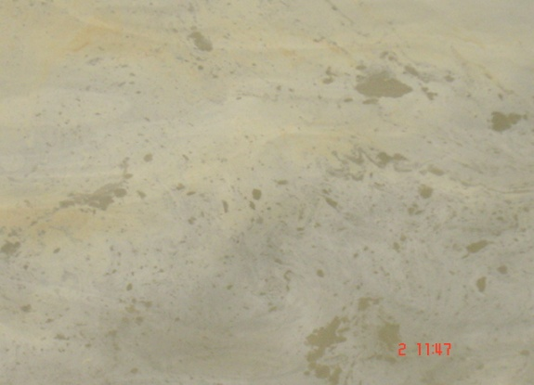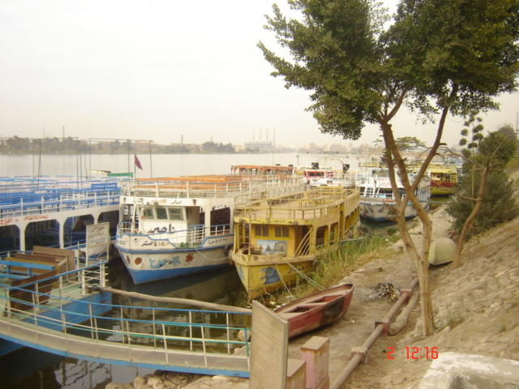

**Figure (1):** The river Nile at Mezallat, oil spills was noticed on the surface of water

***2.2. Water quality analyses***

The quality of the river Nile water at the selected sites was determined according to APHA, 2005as follow; pH was measured with HANNA Model HI-9321, pH meter and Electric conductivity (EC) was measured with JENWAY model 4310 conductivity meter after standardizing with KCL and NaCl solutions. Total suspended solids (TSS) and total dissolved solids (TDS) were measured using gravimetric method and alkalinity was determined using standard titration techniques.

Major cations were also determined (Ca2+, Mg2+, Na+ and K+) using Inductively Coupled Plasma (ICP-OES) and the concentrations of major anions Cl- and SO42- and NO3- were determined using ion chromatography (IC). For the analysis of heavy metals {Copper (Cu), Zinc (Zn), Iron (Fe), Manganese (Mn), Nickel (Ni), Cadmium (Cd), Lead (Pb) and Chromium (Cr)} samples were acidified (HNO3, pH < 2) and analyzed using the Inductively Coupled Plasma with Mass Spectroscopy (ICP-MS).

Microbiology analyses were carried out by detecting the total count of viable bacteria (TBC 22 oC and 35 oC) by pour plate method using plate count agar media (Difco, USA). Total coliform count (TC) and Fecal coliform count (FC) by membrane filter technique, using m-endo agar LES and m-FC agar media, respectively (Difco, USA).

***2.3. Biodegradation of phenanthrene (PHE)***

Few studies have been carried out on biodegradation of PAHs by indigenous bacteria in natural waters **(Xia *et al.,* 2006)**. Furthermore, the present study aimed to perform the biodegradation of PHE, using bacterial cellsisolated from contaminated sites. So, two different ways were used to perform this process; first; different bacterial isolates from the TBC plates were purified and pre-identified then screened on mineral salt agar plates (NaNO33 gm, KH2PO4 2.5 gm, K2HPO4 2 gm, MgSO4 0.2 gm, Fe2(SO4)3 0.1 gm, agar 20 gm and 1L dist. water) sprayed with 10% PHE **(Kiyohara *et al.,* 1982)**. Then the growing colonies have been purified and grown to prepare inocula containing 106 cells mL-1 to inoculate 500 ml Erlenmeyer flasks containing 100 ml mineral salt base medium supplemented with 10% PHE. The flasks were incubated at 30 oC for 60 days on a rotary shaker operating at 150 rpm.

Second, the river Nile water was collected from the contaminated sites with PAHs, and 100 ml were placed in 500 ml Erlenmeyer flasks supplemented with 10 mg phenanthrene to get final concentration of PHE in each flask 100 mg L-1, then the flasks were incubated at 30 oC on a rotary shaker operating at 150 rpm for 60 days. The biodegradation process was followed up by developing a yellowish orange or reddish brown color **(Kasai *et al.,* 2002)**.

***2.4. Identification of bacteria***

Bacterial strains which showed abilities to degrade PHE were purified and identified using 16S rDNA-based phylogenetic analysis.

***2.5. Analytical methods***

***2.5.1. Chemicals and reagents***

Sixteen PAHs of primary environmental concern according to the EPA, were analyzed in this study: naphthalene, acenaphthylene, acenaphthene, fluorine, phenanthrene, anthracene, fluoranthene, pyrene, benzo[a]anthracene, chrysene, benzo[a]-pyrene, benzo[b]fluoranthene, Benzo[k]fluoranthene, dibenzo[a, h]anthracene, indeno[1,2,3-cd]pyrene and benzo[g, h, i]perylene. The PAHs were purchased from Supelco (Bellefonte, PA, USA) as mixed solution of 2000 μg mL-1 each in dichloromethane: benzene (50:50). C18 Solid Phase Extraction disks (47 mm C18 Empore) were purchased from 3M (St. Paul, MN, USA). Millipore filtration apparatus was used for the SPE of samples. Glass fibers were obtained from Cole- Palmer (Vernon Hills, IL, USA). Solvents used (dichloromethane, ethyl acetate, n, hexan and methanol) were HPLC grade. Deionized water was taken from a Milli-Q system (Millipore, Watford, UK). Phenanthrene with purity greater than 98% purchased from Merck.

***2.5.2. Extraction and analysis***

The water samples were extracted for PAHs according to standard method APHA, 2005 using solid phase extraction (SPE) system. The SPE disks were initially conditioned with 2x5 ml of methanol followed by 2x5 ml deionized water. Water samples were passed through the SPE disks at a flow of approximately 10 ml/min under vacuum. The disks were eluted with 10 ml of dichloromethane. After the water was removed from the extract by anhydrous Na2SO4 the volume of the extract was reduced using N2 gas in a water bath (30 oC) to final volume of 1 ml. The recovery efficiency of the extraction procedure was in the range 68.3 to 103.6% with RSD from 0.9 to 7.1%. PAHs were analyzed using a gas chromatography system with flam ionization detector (GC-FID) (Agitech 7890A series). The GC-FID was operated using HP-5 capillary column (30m, 0.320mm, 0.25 µm). The oven temperature was programmed from 60 oC (holding time 1 min) to 175°C at 6 °C min-1 (holding time 4 min) to 235 °C at 3 °C min-1 and finally to 300 °C at 8 °C min-1, keeping the final temperature constant for 5 min. Injection was performed in spletless mode with injector temperature of 300 oC, pressure of 9.1 psi and septum purge of 30 ml min-1. FID working condition was; temperature (300 oC), Hydrogen flaw (30 ml min-1), Air flaw (400 ml min-1) and Make up N2 (25 ml min-1).

The degradation of phenanthrene was monitored as follows; 1 ml sample was taken, weekly, from each flask of the experiment and extracted with 3 equal volume of n, Hexane then dried over anhydrous sodium sulfate, and concentrated with a gentle stream of high purified nitrogen gas to final extract volume of 1ml and the phenanthrene concentration was estimated using GC-FID method pre-described. The pH of solutions in each flask was also monitored through the time of the test.

**3. Results and discussion**

***3.1. Characterization of the river Nile water samples***

The physico-chemical features of the water samples collected from the river Nile at the -studied areas were given in Table (1) and Fig. (2). They found within the permissible limits except for BOD and COD concentrations which exceeded the maximum permissible limit of the Egyptian law 48/1982 article [60]. That may be related to the pollution with organic hydrocarbons at these sites.

Furthermore, the microbiological assessments of the studied water samples indicated by total coliform and fecal coliform counts (Figure 3) were also in the normal ranges where the former did not exceed 1000 CFU/ 100 ml and the second did not exceed 200 CFU 100 ml-1 **(Egyptian law 48/1982 article [60])**.

**Table (1):** The Physico-chemical features of the tested samples of the river Nile

|  |  |  |  |  |  |  |
| --- | --- | --- | --- | --- | --- | --- |
| **Parameters** | **Unit** | **Control Sample** | **Minimum** | **Maximum** | **Average** | **Law 48/1982 article 60** |
| **Temperature** | oC | 19.3 | 19 | 21 | 19.7 ±0.19 | ….. |
| **pH** | - | 7.2 | 7.03 | 7.6 | 7.28 ±0.25 | 6.5 – 8.5 |
| **Total Alkalinity** | mg l-1 | 143 | 142 | 148 | 145.7 ±2.87 | 150 |
| **Electrical Conductivity (EC)** | µmhos cm-2 | 420 | 450 | 483 | 464 ±8.16 | ….. |
| **Total Dissolved Solids (TDS)** | mg l-1 | 276 | 285 | 309.12 | 296 ±6.6 | 500 |
| **Total suspended Solids (TSS)** | mg l-1 | 17 | 19 | 28 | 22.6 ±3.77 | …. |
| **Turbidity** | NTU | 15 | 17 | 20 | 19 ±1.4 | …. |
| **Ammonia** | mg l-1 | 0.15 | 0.18 | 0.28 | 0.245 ±0.04 | 0.5 |
| **Dissolved Oxygen (DO)** | mg l-1 | 5.5 | 4 | 5.04 | 4.345 ±0.47 | …. |
| **Biochemical Oxygen Demand (BOD)** | mg l-1 | 8 | 16 | 28 | 22 ±6 | < 6 |
| **Chemical Oxygen Demand ( COD)** | mg l-1 | 12 | 38 | 53 | 45±7 | <10 |

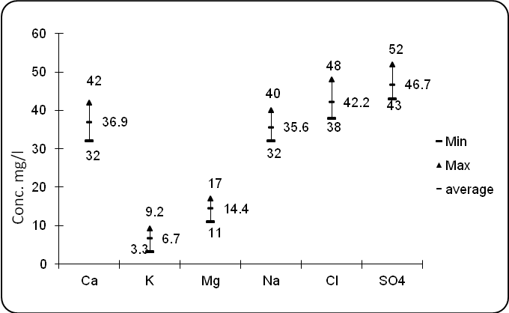

**Figure (2):** Concentrations of some ions and cations in the tested samples of the river Nile

**Figure (3):** Microbiological assessment of the tested

samples of the river Nile

The PAHs concentration in the tested water samples of the river Nile at Mezallat area was ranged from 59.7 to 78.5 µg l-1 (Table 2). The two- and three-ring PAHs (naphthalene, acenaphthylene, acenaphthene, fluorene, phenanthrene and anthracene) are the most abundant, which ensures the petrogenic origin of these PAHs **(Jahin *et al.,* 2009)**. That could be related to oil spill and the ship settlement stations found at these sites. Phenanthrene was chosen to carry out the study of biodegradation as a three-ring aromatic hydrocarbon representative for all detected PAHs compounds.

**Table (2): The concentrations of PAHs in the tested water samples of the river Nile at Mezallat**

|  |  |  |  |  |  |  |
| --- | --- | --- | --- | --- | --- | --- |
| PAHs |  | Control Sample | The river Nile water samples at Mezallat | | | |
| 1 | 2 | 3 | Average ±SD |
| Anthracene | µg l-1 | 0.9 | 11.78 | 10.7 | 12.3 | *11.6±0.8* |
| Acenaphthylene | µg l-1 | 1.4 | 7.9 | 5 | 6.7 | 6.5±1.4 |
| Acenaphthene | µg l-1 | 1.9 | ND* | 10.2 | 8.5 | 9.4±1.2 |
| phenanthrene | µg l-1 | 4.3 | 18 | 11.4 | 15.6 | 15±3.3 |
| Fluorine | µg l-1 | 2.3 | 8.6 | 4.8 | 5.9 | 6.4±1.9 |
| Naphthalene | µg l-1 | ND | 8.4 | ND | 10.1 | 9.3±1.2 |
| Pyrene | µg l-1 | 1.7 | 1.2 | ND | 6.3 | 3.8±3.6 |
| Chrysene | µg l-1 | ND | 6.8 | 4.7 | ND | 5.8±1.4 |
| Benzo(*b)*fluoranthene | µg l-1 | ND | 2.1 | 3 | ND | 2.6±0.6 |
| Benzo(A)acenaphthene | µg l-1 | ND | ND | ND | ND | ND |
| Benzo(k)fluoranthene | µg l-1 | ND | ND | 3.9 | 5.1 | 4.5±0.8 |
| Benzo(a) pyrene | µg l-1 | ND | 1.9 | ND | 1.3 | 1.6±0.4 |
| Dibenz(a, h)anthracene | µg l-1 | ND | 1.8 | ND | 2.8 | 2.3±0.7 |
| Indino(1,2,3-c-d) Pyrene | µg l-1 | ND | 3.1 | 4.7 | ND | 3.9±1.1 |
| Flouranthen | µg l-1 | ND | 3.2 | ND | 2.1 | 2.7±0.7 |
| Benzo(ghi)perylene | µg l-1 | ND | ND | 1.3 | 1.8 | 1.6±0.3 |
| Total PAHs |  | 12.5 | 74.78 | 59.7 | 78.5 | 71±9.9 |

*ND = Not detected

***3.2.* *Biodegradation of phenanthrene (PHE)***

***3.2.1. Screening of the isolated bacterial strains for biodegradation oh PHE.***

Twenty six bacterial strains were isolated from TBC plates of the river Nile water. Each strain was incubated with phenanthrene (10%) on mineral salt agar medium, as a sole carbon source, to check their abilities to biodegrade PHE. Three different bacterial isolates (from the 26 tested) showed their potential to degrade PHE (Figure 4). The pre-identification by biochemical reactions indicated that one of the three PHE+ bacterial isolates was Gram positive rod shaped and the others were Gram negative rods. They were given codes of (I), (II) and (III).

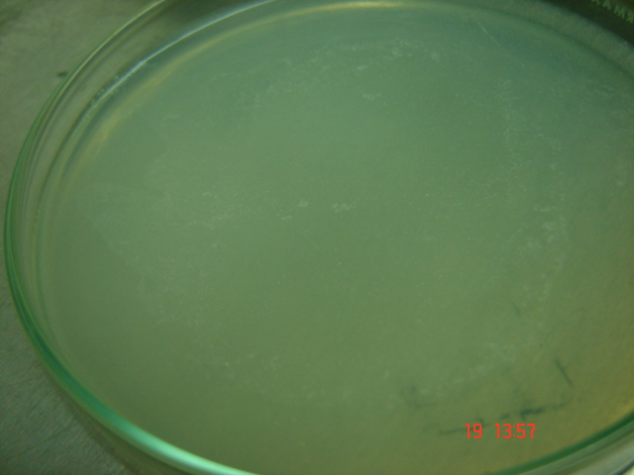

A

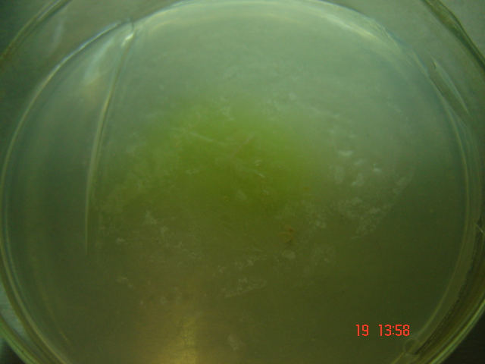

B

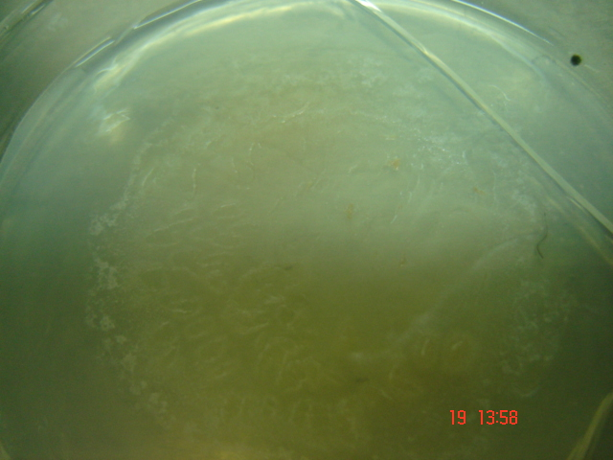

C

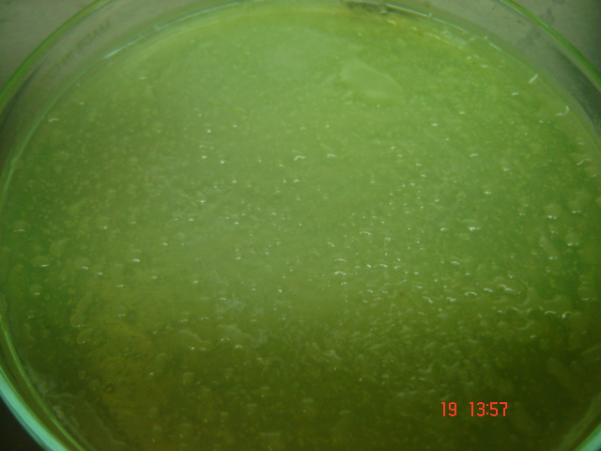

D

**Figure (4):** Utilization of phenanthrene by bacteria on mineral salt agar plates sprayed with PHE (10%) and incubated at 30 oC for 7 days; A is for the control, B is for isolate no. I, C is for isolate no. II and D is for isolate no. III

In comparison between the three selected bacterial isolates, each one of them was inoculated in 100 ml Mineral salt base medium containing 10% PHE. It was found that, isolate no. (I) showed weak ability to utilize phenanthrene as energy source; it could remove only 13.3% of PHE concentration through the 60 days of the experiment, while isolate no. (II) showed moderate ability to do so; it could remove about 32% of PHE. Furthermore, isolate no. (III) showed strong ability to utilize phenanthrene as energy source where it could removed up to 57% of PHE concentration through the 60 days of the experiment ( Figure 5).

**Figure (5):** PHE biodegradation by the three PHE– degrading bacterial isolates

***3.2.2. Phenanthrene biodegradation using the river Nile water.***

100 ml of the river Nile water inoculated with phenanthrene (to get final concentration of PHE 100 mg l-1) were incubated at 30 oC for 60 days, on a rotary shaker at 150 rpm. The concentration of PHE fallen down to 12 mg l-1 on the day 14, and it have been completely removed on the day 21 (Figure 6 and 7).

Obtaining such results is considered of great environmental importance **(Dean-Ross *et al.,* 2001)** as such microorganisms naturally found in the river Nile water, and they showed their abilities to remove high concentrations of phenanthrene (100 mg l-1).

Considering such results by using the river Nile water may be depending on the presence of mixed cultures of microbes **(Nasrollahzadeh *et al.,* 2010)**. These achievements are in accordance with those obtained by **Kasai *et al.,* (2002)** who performed the same test using marine water inoculated with phenanthrene and/or anthracene and found that genus *Cycloclusticus* was play a primary role in PAH degradation. The same results were also obtained by **(Kiyohara *et al.,* 1982; Xia *et al.,* 2002; Abd-Elsalam *et al.,* 2009; Farshid and Fatemeh, 2012)**.

Figure (7): A is the control indicating the white particle of intact PHE through the 60 days of the experiment; B is the test, indicating the complete degradation of PHE as it assured by the yellowish-brown color as a result of benzene ring cleavage.

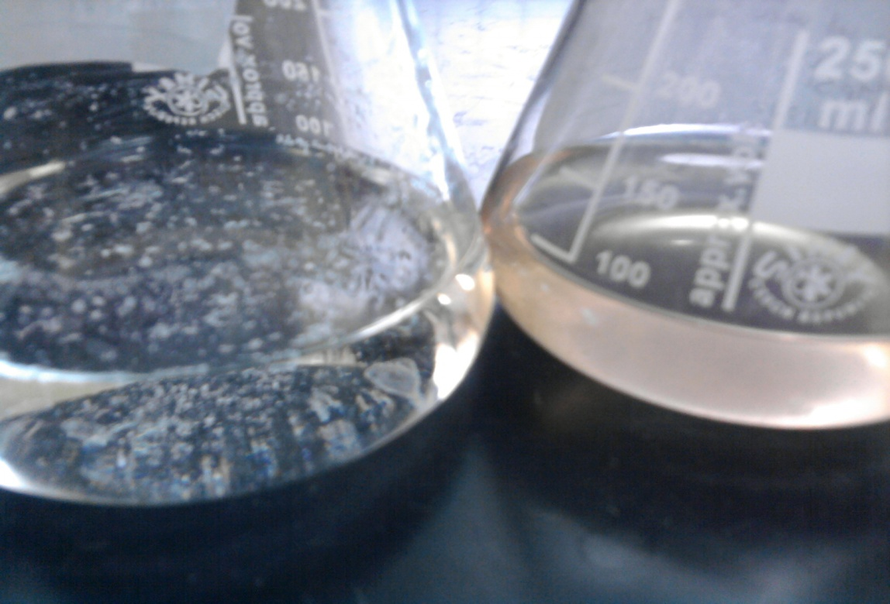

(A)

(B)

Figure (6 & 7): Phenanthrene biodegradation with the river Nile water

***3.2.3. Following up Phenanthrene biodegradation.***

The rate of PHE biodegradation was monitored using GC-FID method. The chromatograms for the biodegradation experiment showed the decrease in the PHE peak at the starting time compared with that at the end of the experiment (Figure 8).

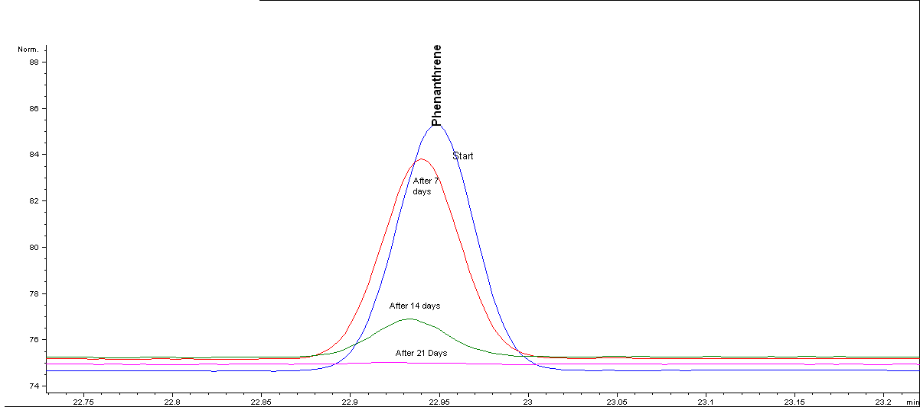

**Figure (8)**: Monitoring of PHE biodegradation by the river Nile water, using GC-FID

The variation of the medium pH along with PHE biodegradation was also monitored and the obtained results are presented in Figure (9). The pH fluctuation was dropped to acidic region that was due to the production of acidic intermediate compounds resulted by the PHE biodegradation. It has been reported that the biodegradation of PHE leads to 1-hydroxy-2-naphthoic acid (1H2NA), which is an intermediate product accumulated in the medium **(Prahbu and Phale 2003)**. And as illustrated in Figure (9), the pH in the test of the river Nile water was fallen down to higher acidic conditions than the other tested single bacterial strains. That could be interpreted by what achieved by **(Nasrollahzadeh *et al.,* 2010)**, where they found that the concentration of (1H2NA) was very low for the tested single strains while in a mixed culture, it was increased due to the broad enzymatic capabilities of the mixed culture. As a result the level of aromatics in the medium was dropped drastically at day 14 (Figure 6).

**Figure (9):** Monitoring of pH in PHE biodegradation

***3.3. Identification of PHE - degrading bacterial strains***

The phylogeny of the bacterial strains and closely related species was analyzed using the multi-sequence alignment program. The results obtained indicated that, isolate no (I) was related to *Bacillus cereus* (98%), isolate no (II) was related to *Pseudomonas protegens* Pf-5 (96%) and isolate no (III) was related to *Pseudomonas flourescens* strain SBW 25 (96%). These bacterial strains together as mixed culture played the basic role in removing 100% of PHE using the river Nile water as medium through 21 days.

**Conclusions**

The water quality assessments of the river Nile water indicated the contamination of Mezallat site with anthracene, acenaphthylene, phenanthrene, fluorine, naphthalene, chrysene and Benzo(*b)* fluoranthene in average concentrations of 1.16, 0.65, 1.5, 0.64, 0.93, 0.58 and 0.26 µg l-1 respectively. The compositional pattern of the ring size of the PAHs along the study area showed that two- and three-ring PAHs (naphthalene, acenaphthylene, acenaphthene, fluorene, phenanthrene and anthracene) are the most abundant, indicating their protogenic origin. Biodegradation of PHE (using high concentration 100 mg l-1) was successfully achieved by the isolated strains from the river Nile water and also by mixed culture. Three native Egyptian phenanthrene degrading bacterial strains were identified as *Bacillus cereus*, *Pseudomonas protegens* Pf-5 and *Pseudomonas flourescens* strain SBW 25. The average removal of PHE in concentration of 100 mg l-1 was 13%, 33% and 57%, respectively through the 60 days of the experiment. While using the river Nile water as it is, mixed cultures could remove 100% of the PHE concentration through 21 days.

**Recommendations**

*Bacillus cereus*, *Pseudomonas protegens* Pf-5 and *Pseudomonas flurescens* strain SBW 25 are native bacterial strains used in the present research and recommended for further applications in biodegradation field. Further studies should be performed to enhance these bacterial strains to biodegrade crude oil, for application on pilot scale.

**Acknowledgements**

The authors wish to acknowledge the support of this research by the National Water Research Center through the call of 2011/2012. The authors also want to thank the Central Laboratory for Environmental Quality Monitoring (CLEQM) staff.

**References**

1. Abd-Elsalam H E, Hafez E E, Hussain A A, Ali A G and El-Hanafy A A (2009). Isolation and identification of three-rings PAHs (anthracene and phenanthrene) degradating bacteria. Agric. & Environ. Sci., 5(1): 31 – 38.
2. Annweiler, E., Richnow, H.H., Antranikian, G., Hebenbrock, S., Garms, C. and Francke, W. (2000). Naphthalene degradation and incorporation of Naphthalene -derived carbon into biomass by the thermophile B. thermoleovorans. J. Appl. Environ. Microbiol. 66: 518 – 523.
3. Bumpus, J.A., (1989) Biodegradation of polycyclic aromatic hydrocarbons by Phanerochaete chrysosporium, Appl. Environ. Microbiol. 61, 2631–2635.
4. Dean-Ross, D., Moody, J., Freeman, J., Doerge, D. and Cerniglia, C., (2001). Metabolism of anthracene by a Rhodococcus species. FEMS, Microbiology letters 204: 205 – 21
5. Del Arco JP, De Franca FP (2001). Influence of oil contamination levels on hydrocarbon biodegradation in sandy sediment. Environ. Pollut., 1: 515-519.
6. Dutta, T.K. and Harayama, S. (2001). Analysis of long-chain alkyl-aromatics in crude oil for evaluation of their fate in the environment. *J. Environ. Sci. Technol.* **35:** 102 – 107.
7. United States Environmental Protection Agency, Office of Environmental Information (EPA), Emergency Planning and Community Right-to-Know Act– Section 313: Guidance for Reporting Toxic Chemicals: Polycyclic Aromatic Compounds Category, EPA 260-B-01-03, Washington, DC, August 2001.
8. Farshid K., Fatemeh H.P (2012) Degradation of naphthalene, phenanthrene and pyrene by Pseudomonas sp. and Corynebacterium sp. in the landfills. Vol. 2, No. 9, p. 77-84.
9. Head IM (1998). Bioremediation: towards a credible technology. Microbiology, 144: 599–608.
10. Head IM, and Swannell RP (1999). Bioremediation of petroleum hydrocarbon contamination in marine habitats. Curr. Opin. Biotech., 10: 234-239.
11. Jahin H., Barsoum B., Tawfic T. and J.V. Headley, (2009). Occurrence and Distribution of Polycyclic Aromatic Hydrocarbons in the Egyptian Aquatic Environment, Journal of Environmental Science and Health, Vol. A44, No.12.
12. Kapley A, Heman J, Chhatre JP, Shanker R, Chakrabarti K (1999). Osmotolerance and hydrocarbon degradation by a genetically engineered Microbial consortium. Bioresour. Technol., 61: 241-245.
13. Kasai, Y., Kishira, H. and Harayama, S. (2002). Bacteria belonging to genus Cycloclasticus play a primary role in the degradation of aromatic hydrocarbons released in a marine environment. J. Appl. & Environ. Microbiol. 68(11): 5625 – 5633.
14. Kiyohara H, Nagao K. and Yana K., (1982). Rapid screen for bacteria degradation water-insoluble, solid hydrocarbons on agar plates. J. Appl. & Environ. Microbiol. 43(2): 454 – 457.
15. Korda A, Santas P, Tenente A, Santas R (1997). Petroleum hydrocarbon bioremediation. Appl. Microbial. Biotechnol., 48: 677-689.
16. Manoli, E., Samara, C., konstiantinou, I., Albanis, T., (2000) polycyclic aromatic hydrocarbons in the bulk precipitation and surface waters of northern Greece, chemosphere 41, 1845-1855.
17. Muckian, L., Grant, R., Clipson, N., Doyle, E., (2009) Int. Biodeterior. Biodegrad. 63, 52-56.
18. Nasrollahzadeh, H., Najafpour, G., Pazouki, M., Younesi, H., Zinatizadeh, A. and Mohammadi, M. (2010). Biodegradation of phenanthrene in an anaerobic batch reactor: growth kinetics. Chem. Indust. & Chem. Eng. Quart. 16(2): 157 – 165.
19. Prahbu Y., Phale P. (2003). Biodegradation of phenanthrene by Pseudomonas sp. strain PP2: novel metabolic pathway, role of biosurfactant and cell surface hydrophobicity in hydrocarbon assimilation. J. Appl. Microbiol. Biotechnol. 61: 342 – 351.
20. Standard Methods for the Examination of Water and Wastewater (2005). American Public Health Association (APHA), 21st Edition.
21. Tam, N.F.Y., Guo, C.L., Yau, W.Y., Wong, Y.S., (2002) Preliminary study on biodegradation of phenanthrene by bacteria isolated from mangrove sediments in Hong-Kong, Mar. Poll. Bull. 42, 316–324.
22. Xia, X.H., Yu, H., Yung, Z.F., and Huang, G.H., (2006). Biodegradation of polycyclic aromatic aydrocarbons in the natural waters of the Yellow River: effects of high sediment content on biodegradation. J. Chemosphere (65), 457-466.
23. Yuan, S.Y., Chang, J.S., Yen, J.H., Chang, B.V., (2001) Biodegradation of phenanthrene in river sediment, Chemosphere 43, 273–278.
24. Zohreh R., Alireza S., Fatemeh M., Hossein Z., Kamal G. and Hajar A. (2012), Phenanthrene biodegradation by Pseudomonas aeruginosa and Bacillus subtilis isolated from Persian gulf sediments, African J. of Microbiol. Res. Vol. 6(21), pp.4585-4591.

12/2/2013