Inhibitory Effect of Different Probiotic Bacterial Strains on Salivary Streptococcus mutans and Identification of the most Suitable Dairy Product for Delivery of the most Potent One: An In-vitro Study

Shakir Abdalaziz Abdallah Osman¹, Ali Ali Mortada², Randa Youssef²& Osama Ibrahim A. El-Batawy³

¹ B.D.S, Faculty of Oral & Dental Medicine, University of Khartoum.
²Department of Pediatric Dentistry & Dental Public Health, Faculty of Oral & Dental Medicine, Cairo University
³Department of Food Science & Technology, Faculty of Agriculture, Ain- Shams University
Shakirabdalaziz@gmail.com

Abstract: Aim: to evaluate the possible inhibitory effect of selected Probiotic bacterial strains against Streptococcus mutans (SM) and to identify the most suitable Dairy product in which most potent Probiotic strain will exhibit inhibitory activity against SM. Material & Methods: Six Probiotic strains including (Lb reuteri ATCC 23272, Lb rhamnosus ATCC7469, Lb acidophilus ATCC 4356, Lb acidophilus TISTR 450, Lb plantarum ATCC 14917 and Bifi bifidium DSM 20082) were tested against SM. Bioyoghurt, stirred fermented milk and kareish cheese were prepared and tested as delivery vehicle for most potent Probiotic strain. Results: All Probiotics in Group 1-6 significantly reduce % survival rate of SM at all ratio subgroups i.e. A- C (ratio of 3:1, 1:1 and 1:3 SM: Probiotic strain, respectively), with exception of Group 6 at ratio subgroup A. With exception of Groups 4 & 5 at ratio subgroup A, statistically significant difference between all Probiotics in the inhibitory activity against SM at all tested ratio subgroups (A-C). Lb reuteri ATCC 23272 displayed strongest inhibitory activity followed by Lb. rhamnosus ATCC7469, Bifi. bifidium DSM 20082, Lb. plantarum ATCC 14917 then Lb. acidophilus ATCC 4356 and last Lb. acidophilus TISTR 450 displayed weakest inhibitory activity. Lb reuteri ATCC 23272 on stirred fermented milk showed strongest inhibitory activity against SM, followed by Bio-yoghurt then kareish cheese, with statistically significant difference between them. Conclusion: Different Probiotics under study reduce the oral carriage of SM with varying degrees. Stirred fermented milk containing Lb reuteri ATCC 23272 is considered the best Probiotic delivery vehicle for dental caries prevention.
[Shakir Abdalaziz Abdallah Osman, Ali Ali Mortada, Randa youssef & Osama Ibrahim A. El-Batawy. Inhibitory Effect of Different Probiotic Bacterial Strains on Salivary Streptococcus mutans and Identification of the most Suitable Dairy Product for Delivery of the most Potent One: An In-vitro Study. Nat Sci 2013;11(12):188-195]. (ISSN: 1545-0740). http://www.sciencepub.net/nature. 27

Key words: Probiotics, Lactobacilli, Bifidobacteria, Streptococcus mutans, Caries prevention.

1- Introduction
Dental caries remains the most prevalent chronic disease in children. It can be controlled by several strategies used either alone or in combination. These strategies include approaches that involve altering the bacterial flora in the oral cavity, modifying the diet, increasing the resistance of tooth enamel to acid attack or reversing the demineralization process⁽¹⁾.
Despite the use of conventional physical and chemotherapeutic agents for caries management, dental caries still continues to be the most prevent oral infectious disease. Clearly, additional caries prevention approaches which can augment the existing ones (e.g.fluoride, brushing, flossing, etc.), are clearly desirable ⁽²⁾.
Probiotic bacteria, defined as "live microorganisms which when administered in adequate amounts confer a health benefit on the host" (FAO/WHO 2001), are suggested to play a role in the maintenance of oral health ^{(3,4)}. Such health promoting bacteria are added to different commercial dairy products such as milk, cheese and yogurt as well as chewing gums and fruit drinks. Possible actions of probiotic bacteria in the oral environment are competition of binding sites, production of antimicrobial substances and activation and regulation of the immune response ⁽⁵⁾.
For some decades now, bacteria known as Probiotics have been added to various foods because of their beneficial effects for human health. Probiotics are commonly consumed as part of fermented foods with specially added active live cultures; such as in yogurt or as dietary supplements. The number of products containing Probiotics entering the market is increasing. These products usually contain lactobacilli or bifidobacteria. The application of Probiotics strategies may, in the near future, provide an end to many infections occurring in oral cavity ⁽⁶⁾.
The present study aimed to evaluate the possible inhibitory effect of some Probiotic bacterial strains against caries producing SM and to identify most suitable dairy product in which the most potent Probiotic strain will exhibit inhibitory activity against SM.

2- Materials and methods
Microorganisms and culture conditions:
SM isolated from Egyptian child saliva, identified using Biolog system ⁽⁷⁾ ,were used in the study. The isolate was grown in Trypticase soy broth supplemented with 0.5% yeast extract (TSBY) incubated at 37°C in anaerobic incubator with 5% CO₂.
Cells were harvested during the exponential growth phase by centrifugation at 1000 RPM, washed twice with Phosphate buffer saline (PBS), resuspended in the same buffer and subjected to a low-intensity ultrasonic treatment to disperse bacterial aggregates according to Nikawaa et al., ⁽⁸⁾.
Six Probiotic strains provided by Cairo Microbiological Resources Centre, Ain -Shams University, were used in the study includes Lb reuteri ATCC 23272, Lb rhamnosus ATCC7469, Lb acidophilus ATCC 4356, Lb acidophilus TISTR 450, Lb plantarum ATCC 14917 and Bifi bifidium DSM 20082.
Each strain was grown in brain–heart infusion broth (BHI: Difco), harvested during the exponential growth phase by centrifugation at 1000 RPM, washed twice with PBS (pH 6.8) and resuspended in the same buffer. The optical densities of the bacterial suspensions were measured in a 1.0-ml cuvette with a 1 cm light path, and the suspensions were adjusted to a final concentration of 1.0×10⁸ colony forming unit (CFU)/ml before use ⁽⁸⁾.
Inhibitory effect of Probiotic bacterial strains:
Bacteriological assay was conducted according to Nikawa et al., ⁽⁸⁾. The suspensions of SM and Probiotics and PBS were mixed in sterile test tubes and divided to 7 groups; Group (1- 6): SM mixed with (Lb. reuteri ATCC-23272, Lb. rhamnosus ATCC- 7469, Bifi. bifidium DSM- 20082, Lb. plantarum ATCC- 14917, Lb. acidophilus ATCC- 4356 and Lb. acidophilus TISTR- 450 respectively).
According to the ratio of mixing, previous groups were subgrouped to: Subgroup (A- C): ratio of mixing was 3:1, 1:1and 1:3 SM: tested Probiotics respectively. Group 7(Control): SM was mixed with the same amount of PBS. Then 100 µl were added to 10 ml of BHI broth and vortex mixed for 10 s, followed by incubating for 90 min at 37º C with gentle shaking.
Afterwards each suspension was centrifuged at 1000 RPM, washed twice with PBS, and plated on Mitis Salivarius Agar Base supplemented with 1% Potassium Tellurite solution modified by adding 0.2 units/ml Bacitracin and 20% sucrose (MSB) ⁽⁹⁾ and sealed in anaerobic jar with Gas Generating Kit incubated in electric incubator at 37°C for 24 hrs to determine the number CFU of SM.

The % survival rate of SM was obtained using the formula mentioned by Nikawa et al., ⁽⁸⁾:
$$\% survival rate of SM=\frac{CFU of SM incubated with probiotic strain}{CFU of SM incubated with PBS}×100$$
The assays were carried out on two independent occasions, with quadruplicate samples on each occasion.
Production of dairy products containing Lb. reuteri ATCC 23272:
Kareish cheese was made according to Francois et al., ⁽¹⁰⁾ with some modifications: reconstituted skim milk (14% w/v) was pasteurized at 65±1ºC for 30 mins, and then cooled to 32±1ºC. The heat treated milk was inoculated with Lb. reuteri ATCC 23272 (3% in milk at 32±1ºC) until curding. The formed curd was ladled into wooden frames lined with muslin cloth and 1% salt was dispersed. Resultant cheese was stored in refrigerator (5±1ºC) for 24 hrs.
Low-fat bio yoghurt was prepared using (14% w/v) reconstituted skim milk powder according to El-Batawy, ⁽¹¹⁾ with some modifications: The reconstituted milk was heated at 90ºC for 10 min, cooled to 42ºC and inoculated with 3% mixed starter culture; (1.5% yoghurt starter culture Strep thermophilus & Lb. delbrueckii subsp. bulgaricus1:1) and 1.5% Lb. reuteri ATCC 23272. The inoculated milk were aseptically transferred into 100 ml plastic containers, and incubated at 42ºC till coagulation (pH 4.7), then cooled to 4ºC.
Stirred bio fermented milk was manufactured by the method of Farahat and El-Batawy, ⁽¹²⁾ with some modifications: reconstituted milk was prepared by reconstitute 14% skim milk powder in water. The mix was heated to 85ºC for 10 min, and cooled to 45ºC. Lb. reuteri ATCC 23272 was added at the rate of 3% (w/v). The mix was filled into 2 kg plastic cups and incubated at 43°C. Incubation was terminated till pH 4.5. At this point, the fermented milk was stirred, filled into 250g plastic cups and stored in a refrigerator (5±1ºC) for 1 day. Three replicates were done for each product.
Anti- SM activity test:
The antimicrobial activity test for dairy product prepared with Lb reuteri ATCC 23272 was performed using an agar diffusion test ⁽⁸⁾ with some modifications: The SM was subcultured and grown in TSBY incubated in anaerobic jar and 100 µl of overnight SM were plated on MSB supplemented with 1% Potassium Tellurite modified by adding 0.2 units/ml Bacitracin and 20% sucrose. Plates were air dried for 15 min and filter disc (6mm in diameter) impregnated with 30 µl of each extract product. After incubation at 37°C for 24 hrs, zone of inhibition was measured.
As negative and positive controls sterile distilled water and penicillin (Benzathine Penicillin G) were used respectively. The diameter of inhibition zones was scored as mentioned by Pan et al., ⁽¹³⁾: 6 mm equals no inhibition (-), 0 - 3 mm (weak, +), 3 - 6 mm (good, ++) and diameter > 6 mm (strong, +++).
Data were presented as mean and standard deviation (SD) values. One-way ANOVA followed by Tukey’s post-hoc were used for comparisons between the groups. The significance level was set at P ≤ 0.05. Statistical analysis was performed with IBM® SPSS® Statistics Version 20 for Windows.

3.Results
Inhibition effect of different Probiotics on SM in different Groups (1-6) represented as decrease in the % survival rate of SM regarding: (I) Different ratio subgroups (A-C) of the same group and (II) Different groups at the same ratio subgroup.
I. Comparison between % Survival rate of SM in different ratio subgroups (A- C) of the same Group:
Loss of viability of SM was noted via incubation with Lb reuteri ATCC 23272 in a ratio-dependent manner, i.e. highest inhibitory effect shown in subgroup C, followed by subgroup B, then subgroup A.% survival rate of SM in Group (1-6) at different ratio subgroups were presented in (Table 1, Fig 1). It can be observed that, subgroup C showed the statistically significant lowest mean % survival rate, followed by subgroups B & A respectively .

Table (1): % survival rate of SM in different Groups at different ratio subgroups:

Ratio subgroup  Group | Subgroup A (ratio of 3:1) |  | Subgroup B (ratio of 1:1) |  | Subgroup C (ratio of 1:3)
 | Mean % | ±SD | Mean % | ±SD | Mean % | ±SD
Group 1 | 82.8 ^{e} | 2.7 | 57 ^{g} | 0.8 | 11 ^{g} | 0.8
Group 2 | 87 ^{d} | 0.8 | 60.5 ^{f} | 1.9 | 14.5 ^{f} | 0.3
Group 3 | 90.4 ^{c} | 0.9 | 64.6 e | 1 | 21.9 e | 0.9
Group 4 | 94.3 ^{b} | 2.5 | 75.2 ^{d} | 1 | 45.5 ^{d} | 0.9
Group 5 | 96.1 ^{b} | 0.9 | 83.1 ^{c} | 0.4 | 71.2 ^{c} | 0.7
Group 6 | 98.5 ª | 0.6 | 89.2 ^{b} | 2 | 77.7 ^{b} | 1.2
Group 7 (control) | 100 ª | 0 | 100 ª | 0 | 100 ª | 0
P-value | <0.001* |  | <0.001* |  | <0.001*

*: Significant at P ≤ 0.05, Different letters in the same column are statistically significantly different

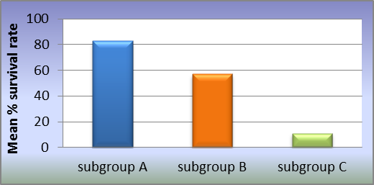
Group (1)

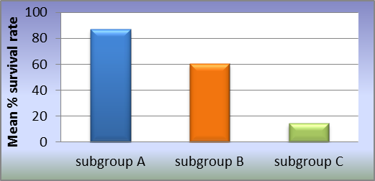
Group (2)

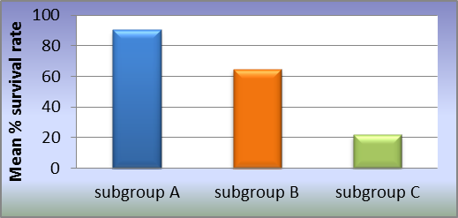
Group (3)

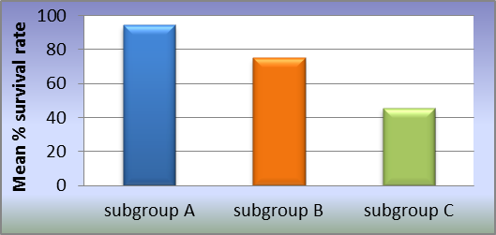
Group (4)

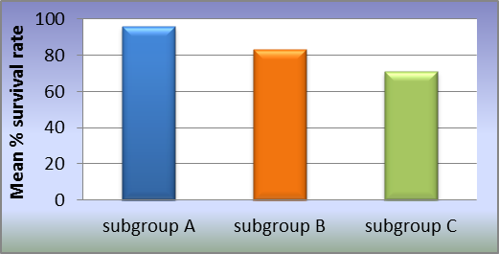
Group (5)

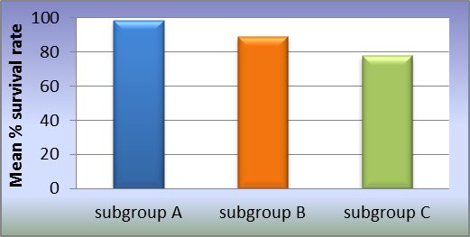
Group (6)

Figure (1): A bar chart representing mean % survival of SM in different ratio subgroups of different Groups.

II. Comparison between % survival rates of SM in different Groups at the same ratio subgroup:
Table 1, Fig (2): Group 1, subgroup A, showed the statistically significant lowest mean % survival rate, followed by Groups 2 & 3 respectively. There was no statistically significant difference between Groups 4 & 5(higher mean % survival rates). There was no statistically significant difference between Groups 6 & 7 (highest mean % survival rates).

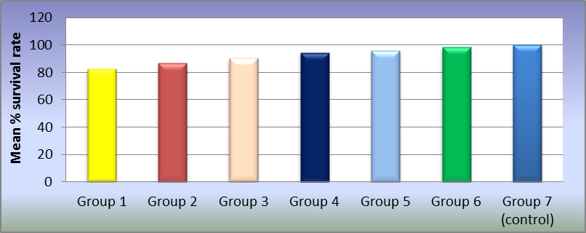
Subgroup A (ratio of 3:1)

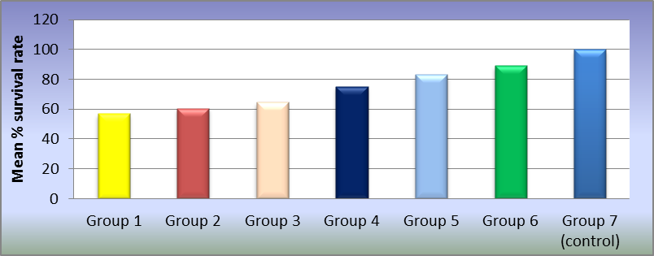
Subgroup B (ratio of 1:1)

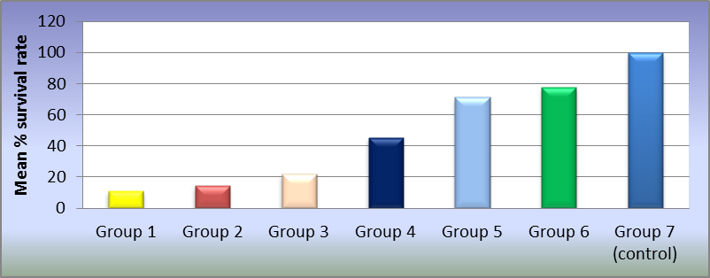
Subgroups C (ratio of 1:3)

Figure (2): A bar chart representing % survival rate of SM in different Groups at ratio different subgroups.

Group 1, subgroups (B & C) showed the statistically significant lowest mean % survival rate, followed by Groups 2, 3, 4, 5 & 6 respectively with a statistically significant difference between them. Group 7 showed 100% mean survival rate.
Evaluation of the inhibitory effect of different delivery vehicles containing Probiotic Lb reuteri on SM: were shown in (Table2, Fig3).

Table (2): Diameter of inhibition, mean values of inhibition zones of SM, score and description of control and different delivery vehicle groups:
Tested material | Negative control |  | Positive control |  | Fermented milk |  | Bioyoghurt |  | Kareish Cheese
Diameter (mm) | 6 |  | 16.3 |  | 13.3 |  | 11.3 |  | 9
Inhibition zone (mm) | Mean | ±SD | Mean | ±SD | Mean | ±SD | Mean | ±SD |  | Mean | ±SD
 | 0 ^{e} | 0 | 10.3ª | 0.5 | 7.3 ^{b} | 0.5 | 5.3 ^{c} | 0.5 |  | 3 ^{d} | 0.8
Score | - |  | +++ |  | +++ |  | ++ |  | +
Description | No inhibition |  | Strong |  | Strong |  | Good |  | Weak

P-value ˂0.001, Significant at P ≤ 0.05, Different letters in the same row are statistically significantly different

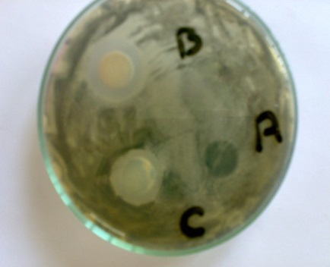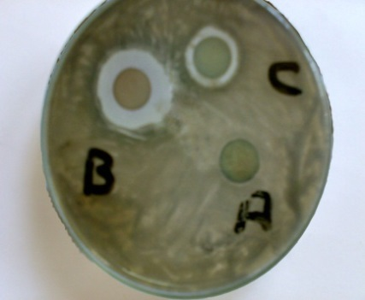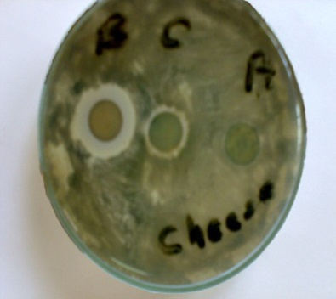
Fermented milk Bioyoghurt Kareish cheese

Figure (3): Photograph showing inhibition zone of positive control, negative control and different dairy products containing Lb reuteri on SM

Positive control group showed the statistically significant highest mean inhibition zone, followed by fermented milk, then Bioyoghurt. Kareish cheese and negative control showed statistically significant lower and lowest mean inhibition zones respectively (Table 2, Fig, 4).

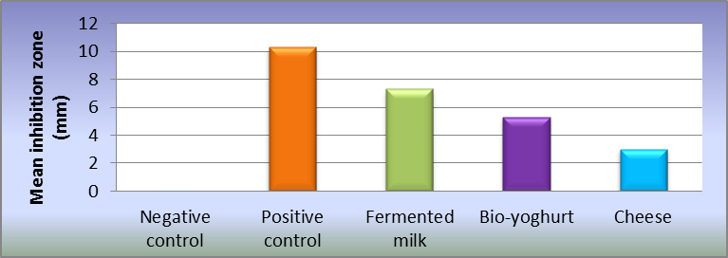
Figure (4): Bar chart representing mean inhibition zone of control and different delivery vehicle groups.

4- Discussion
As shown in Figs (1, 2), loss of viability of SM was noted via incubation with all probiotics (Group 1-6) in a ratio-dependent manner. These results are in agreement studies of Nikawa et al., ⁽⁸⁾ who stated that Lb reuteri showed a significant growth inhibitory effect against SM, and Hasslöf et al., ⁽¹⁴⁾ who studied strains of Lb. reuteri, Lb. rhamnosus ,Lb. plantarum and Lb. acidophillus La5 where the first three inhibited the growth of SM completely at concentration ranging from 10⁹ to 10⁵ CFU/ml, while a slight inhibition at concentration corresponding to 10⁷ and 10⁵ CFU/ml was observed in the last.
The previous results also agree with in vivo studies of Çaglar et al., ⁽¹⁵⁾ who concluded that short-term daily ingestion of Lb. reuteri ATCC 55730 delivered by prepared straws or lozenges reduced the levels of salivary SM in young adults, Çaglar et al., ⁽¹⁶⁾ who found that daily chewing gums containing probiotic Lb. reuteri ATCC 55730 reduced the levels of salivary SM significantly, and daily ingestion of Lb reuteri ATCC 55730 delivered via medical device reduced the levels of salivary SM. Näse et al., ⁽¹⁷⁾, Ahola et al., ⁽¹⁸⁾ and Zaazou et al., ⁽¹⁹⁾ concluded that Lb. rhamnosus GG reduce SM counts significantly.
The results are in concordance with Çaglar et al., ⁽²⁰⁾, Çaglar et al., ⁽²¹⁾, Cildir et al., ⁽²²⁾ and Polka et al., ⁽²³⁾ who mentioned that, Bifidobacteria strains significantly inhibit SM. However, early administration of Bifi. lactis Bb-12 did not result in permanent oral colonization of this Probiotic or significantly affect SM colonization in the study of Taipale et al., ⁽²⁴⁾.
Fig (2) showed that ,with exception of Group 6 at ratio of subgroup A, all other tested Probiotics were significantly lower the SM CFU and % survival rate of i.e. significantly inhibit the growth of SM at different tested ratio. These findings come in agreement with Simark-Mattsson et al., ⁽²⁵⁾ and Hasslöf et al., ⁽²⁶⁾.
The previous results of Probiotics under study were explained on the bases that, Probiotics secret active molecules (e.g. bacteriocins, antibiotics, free fatty acids, hydrogen peroxide) that control growth and/or survival of surrounding microorganisms ⁽²⁷⁾. Whether production of bacteriocin, or of other factors, was the main source of lactobacillus-mediated interference, remains to be determined ⁽²⁴⁾.The final pH in the medium has been suggested to be an important factor for growth inhibition, either directly or due to the production of bacteriocins at low pH ^{(28).}
Similar strain-dependant differences have previously been observed concerning the metabolic capacity to form acids from dietary sugars that differs significantly between various Probiotics ^{(14, 29)}.However, also some bacteria with fairly weak acid production proved to be effective against SM. This indicates that other inhibitory substances also may be involved with hydrogen peroxide being among the primary metabolites with inhibitory capacity against microbial pathogens. The antimicrobial glycerol derivative reuterin is another example of a growth inhibitory substance produced by Lb reuteri ^{(30, 31)}.
The most commonly consumed Probiotics are fermented dairy products such as yogurt and butter milk ⁽³²⁾. Probiotics can currently be administered in the form of sachets or capsules, or can be added to the food supply. Some data show that adequate colonization may be achieved at a lower dose if Probiotics are administered in food ⁽³³⁾.
Administration of Lb reuteri ATCC 23272 in three forms of dairy products to inhibit SM was tested in this study using and the results are shown in Table 3, Figs 3-4; positive control showed the statistically significantly highest mean inhibition zone, followed by fermented milk then Bio-yoghurt. kareish cheese and negative control showed statistically significantly lower and lowest mean inhibition zones respectively.
Significant difference between tested dairy products may be related to several factors as previously discussed by Vinderola et al., ⁽³⁴⁾ who stated that, mixed-strain cultures of lactic acid starter and Probiotics are commonly used in the manufacture of Probiotic fermented milks and cheeses. In these bacterial combinations, interactions among different strains can result in stimulation, inhibition, or absence of effects on microbial growth rate and metabolic activity. The low pH values that Probiotics are submitted to during the processing of dairy products, such as yogurts and fermented milk, is also a matter of concern. Since that with the exception of few Lactobacillus and Leuconostoc species, lactic acid bacteria are neutrophilic, that is, have optimum growth pH between 5 -9⁽³⁵⁾ .

Conclusion
In conclusion, it could be reported that, different Probiotics under study displayed inhibitory effect against SM with varying degrees. Lb. reuteri ATCC 23272 is considered the Probiotic with the most promising results SM. Different dairy products could be used as Probiotic delivery vehicle for inhibition of caries producing bacteria and stirred fermented milk is the best Probiotic delivery vehicle for dental caries prevention.

References
- Rao SK, Bhat GS, Aradhya S et al. Study of the efficacy of toothpaste containing casein phosphopeptide in the prevention of dental caries: a randomized controlled trial in 12- to 15-year-old high caries risk children in Bangalore, India. Caries Res. 2009; 43(6), 430-435.
- Gupta S, Marwah N. 'Use a Thorn to Draw Thorn' Replacement Therapy for Prevention of Dental Caries. Int J Clin Pediatr Dent. 2010; 3(3), 125-137.
- Meurman JH, Stamatova I. Probiotics: contributions to oral health. Oral Dis. 2007, 13:443-451.
- Twetman S, Stecksén-Blicks C. Probiotics and oral health effects in children. Int. J. Paediatr Dent. 2008, 18:3-10.
- Meurman JH. Probiotics: do they have a role in oral medicine and dentistry? Eur. J. Oral. Sci. 2005, 113:188-196.
- Sheikh S, Pallagatti S, Kalucha A et al. Probiotics, going on the natural way.J ClinExp Dent.2011; 3(2), 150-154.
- Biolg, Inc Microlog. Instruction manual. (http://wiki.bio.dtu.dk). 2007; 20-74.
- Nikawaa H, Makihiraa S, Fukushimaa HT et al. Lactobacillus reuteri in bovine milk fermented decreases the oral carriage of mutans streptococci. Int J Food Microbiol.2004; 95, 219-223.
- Gold OG, Jordan HV, Van Houte J. A selective medium for Streptococcus mutans. Arch oral Biol. 1973; 18, 1357-1364.
- François ZN, Ahmed NE, Félicité MT et al. Effect of ropy and capsular exopolysaccharidesproducing strain of Lactobacillus plantarum162RM on characteristics and functionality of fermented milk and soft Kareish type cheese.Afr J Biotechnol. 2004; 3 (10), 512-518
- El-Batawy OI. Studies on probiotics, prebiotics and synbiotics in production of some functional dairy products. Thesis (PhD) - Ain shams University. 2010.
- Farahat AM, El-Batawy OI. Proteolytic Activity and Some Properties of Stirred Fruit Yoghurt Made Using Some Fruits Containing Proteolytic Enzymes. World J. Dairy & Food Sci. 2013; 8 (1), 38-44.
- Pan X, Chen F, Wu T et al. The acid, bile tolerance and antimicrobial property of Lactobacillus acidophilus NIT. Food Control. 2009; 20, 598-602.
- Haukioja A, Loimaranta V,Tenovuo J. Probiotic bacteria affect the composition of salivary pellicle and streptococcal adhesion in vitro. Oral Microbiol Immunol. 2008; 23(4), 336-343.
- Caglar E, Cildir SK, Ergeneli S et al. Salivary mutans streptococci and lactobacilli levels after ingestion of the probiotic bacterium Lactobacillus reuteri ATCC 55730 by straws or tablets. Acta Odontol Scand. 2006; 64(5), 314-318.
- Caglar E¹, Kuscu OO, Cildir SK et al. A probiotic lozenge administered medical device and its effect on salivary mutans streptococci and lactobacilli. Int J Paediatr Dent. 2008; 18(1), 35-39.
- Näse L, Hatakka K, Savilahti E et al. Effect of long-term consumption of a probiotic bacterium, Lactobacillus rhamnosus GG, in milk on dental caries and caries risk in children. Caries Res. 2001; 35(6), 412-420.
- Ahola AJ, Yli-Knuuttila H, Suomalainen T et al. Short-term consumption of probiotic-containing cheese and its effect on dental caries risk factors. Arch Oral Biol. 2002; 47(11), 799-804.
- Zaazou MH, Abu El-Yazeed M, Galal M et al. A Study of the Effect of Probiotic Bacteria on Level of Streptococcus mutans in Rats. Journal of Applied Sciences Research. 2007; 3(12), 1835-1841.
- Caglar E, Sandalli N, Twetman S et al. Effect of yogurt with Bifidobacterium DN-173 010 on salivary mutans streptococci and lactobacilli in young adults. Acta Odontol Scand. 2005; 63(6), 317-320.
- Caglar E², Kuscu OO, Selvi Kuvvetli S et al. Short-term effect of ice-cream containing Bifidobacterium lactis Bb-12 on the number of salivary mutans streptococci and lactobacilli. Acta Odontol Scand. 2008; 66(3), 154-158.
- Cildir SK, Germec D, Sandalli N et al. Reduction of salivary mutans streptococci in orthodontic patients during daily consumption of yoghurt containing probiotic bacteria. Eur J Orthod. 2009; 31(4), 407-411.
- Polka SR, Damle SG, Chawla A. Salivary mutans streptococci and lactobacilli modulations in young children on consumption of probiotic ice-cream containing Bifidobacterium lactis Bb12 and Lactobacillus acidophilus La5. Acta Odontol Scand. 2011; 69(6), 389-394.
- Taipale T, Pienihäkkinen K, Salminen S et al. Bifidobacterium animalis subsp. lactis BB-12 administration in early childhood: a randomized clinical trial of effects on oral colonization by mutans streptococci and the probiotic. Caries Res. 2012; 46(1), 69-77.
- Simark-Mattsson C, Emilson C-G, Grahn Hakansson E et al. Lactobacillus-mediated interference of mutans streptococci in caries-free vs. caries-active subjects. Eur J Oral Sci. 2007; 115, 308–314.
- Hasslöf P, Hedberg M, Twetman S et al. Growth inhibition of oral mutans streptococci and candida by commercial probiotic lactobacilli-an in vitro study. BMC Oral Health. 2010; 10, 18.
- Travers MA, Florent I, Kohl L et al. Probiotics for the control of parasites: An overview. J Parasitol Res. 2011; 2011, 610-769.
- Simark-Mattsson C, Jonsson R, Emilson CG et al. Final pH affects the interference capacity of naturally occurring oral Lactobacillus strains against mutans streptococci. Arch Oral Biol. 2009; 54(6), 602-607.
- Hedberg M, Hasslöf P, Sjöström I et al. Sugar fermentation in probiotic bacteria--an in vitro study. Oral Microbiol Immunol. 2008; 23(6), 482-485.
- Dunne C, O'Mahony L, Murphy L, Thornton G, Morrissey D et al. In vitro selection criteria for probiotic bacteria of human origin: correlation with in vivo findings. Am J Clin Nutr. 2001; 73(2), 386-392.
- Jones SE, Versalovic J. Probiotic Lactobacillus reuteri biofilms produce antimicrobial and anti-inflammatory factors. BMC Microbiol. 2009; 9, 35.
- Brown AC, Valiere A. Probiotics and Medical Nutrition Therapy. Nutr Clin Care. 2004; 7(2), 56–68.
- Reddy P, Srivastava R. Probiotics the next savior in oral diseases. International Journal of Dental Clinics. 2011; 3(2), 54-57.
- Vinderola CG, Mocchiutti P, Reinheimer JA. Interactions among Lactic Acid Starter and Probiotic Bacteria Used for Fermented Dairy Products. J Dairy Sci. 2002; 85(4), 721-729.
- Granato D, Branco GF, Cruz AG et al. Probiotic Dairy Products as Functional Foods. Comprehensive Reviews in Food Science and Food Safety. 2010; 9(5), 455–470.

