Spermidine as modulator of growth, some metabolic activities and reproductive development of Helianthus tuberosus plants grown in two types of soil

Mahmoud R. Sofy ¹* and Hossam M. Fouda ²

^{1&2.} Botany and Microbiology Department, Faculty of Science, Al-Azhar University, 11884 Nasr City, Cairo, Egypt
*mahmoud_sofy@yahoo.com

Abstract: Growth, yield and some metabolic activities of Helianthus tuberosus plants were studied in response to the treatment with spermidine under normal and saline soil. The obtained results revealed that, under saline conditions, treatments with spermidine (50 & 100 ppm) generally enhanced most of the growth and yield characteristics (shoot length, root length, fresh and dry weights of shoots and roots/ plant, number of tubers / plant and tubers weights) of Helianthus tuberosus plants. Plants which planted in saline soil showed significant decreases in contents of chlorophyll (a), (b) & (a + b), carbohydrates, soluble proteins, while phenols, carotenoids and free proline contents were increased throughout the experimental period. At saline conditions, catalase activities (CAT) and peroxidase activities (POX) were increased. Treatment with spermidine caused significantly increases in CAT and POX activities in plants grown in saline or non-saline soil.
[Sofy MR and Fouda HM. Spermidine as modulator of growth, some metabolic activities and reproductive development of Helianthus tuberosus plants grown in two types of soil. Nat Sci 2013;11(12): 161-171]. (ISSN: 1545-0740). http://www.sciencepub.net/nature. 24

Keywords: spermidine; saline soil; Helianthus tuberosus; metabolic activities

1. Introduction
Soil salinity considered the major factors that reduce plant growth in many regions in the world. Two important limitations for crop production in arid and semi–arid regions are water shortage and salinity (Sepaskhah and Yousofi-Falakdehi, 2010). In salt–affected soil, there are many salt contaminants, especially NaCl which readily dissolves in water to yield the toxic ions, sodium ion (Na⁺) and chloride ion (Cl⁻). Also, the water available in the salt–contaminated soil is restricted, inducing osmotic stress (Pagter et al., 2009; Siringam et al., 2011).
Jerusalem artichoke (Helianthus tuberosus), which is also called the sunchoke, sunroot or earth apple, is an Angiosperm plant species of Asteraceae family (Tassoni et al., 2010). More importantly, as Helianthus tuberosus possesses prophylactic and medicinal properties for sufferers of sugar diabetes, and act as a biogenetic factor for the development of natural intestinal microflora after disbacteriosis (Rakhimov et al., 2003), it has been becoming an interesting research topic and it is even labeled as a new cultivated crop (Terzic and Atlagic, 2009).
Approaches have been carried out to minimize the adverse effect of salinity by using polyamines a foliar spray (Amri and Shahsavar, 2010). Polyamines influence plant development in many ways and the response of plants to abiotic stress involves complex physiological and biochemical responses, including changes in the concentration and ratio of different metabolites (El-Bassiouny et al., 2008). Although most of the known polyamines are regulators of growth, maximum plant growth may depend on the ratio rather than the absolute levels of these substances in plants. These ratios may change dramatically in response to salinity stress, thereby leading to physiological disturbances associated with a general reduction in growth (Sood and Nagar, 2003). Also pretreating seed with optimal concentrations of polyamines can effectively improve germination as well as growth and yield of crops under both normal and stress conditions (Abd El Monem, 2007; Karimi and Rahemi, 2012). So, the aim of the present work was to evaluate the use of polyamines for improving growth and productivity as well as increasing salt tolerance of Helianthus tuberosus plant, and also to study the oxidative defense mechanism of Helianthus tuberosus plants against salt stress. Via determination of the growth characters and some essential metabolites throughout the different stages of the growth.

2. Material and Methods
2.1. Methods of planting, treatments and collection of samples
Uniform buds Helianthus tuberosus L. tubers were planted in two types of soils in Kafr El_Shikh one represented non-saline soil (Table 1) and the other place is saline soil (Table 2) in terraces. The developed plants were irrigated whenever required. Plants grown in either saline or non-saline soil were divided into 3 groups representing the following treatments:
- Treated with distilled water (control).
- Spermidine (50 ppm spd as spermidine).
- Spermidine (100 ppm spd as spermidine).
The plants of Helianthus tuberosus L. were treated twice with the above mentioned treatments (as foliage spraying). The first treatment was made when the age of plants was 60 days, while the second treatment was made when the age of plants was 90 days of sowing. The plant samples were collected for analysis when the plants were 70 (Stage I) and 100 (Stage II) days old. At the end of the growth season (180 days), analyses of the tubers yielded from the different treatments as well as the control were done.

Table 1. Chemical properties of the used soil (Non-saline soil)
TSS  ppm | pH | E.C.  mmhos/cm | Cations meq/L |  |  |  | Anion meq/L
768 | 7.9 | 1.24 | Na⁺ | K⁺ | Ca⁺⁺ | Mg⁺⁺ | Cl⁻ | SO4⁻ ⁻ | HCO3⁻ | CO3⁻⁻
 |  |  | 2.5 | 0.5 | 2 | 1 | 4 | 1 | 1 | Zero

Table 2. Chemical properties of the used soil (Saline soil)
TSS  ppm | pH | E.C.  mmhos/cm | Cations meq/L |  |  |  | Anion meq/L
4760 | 8.3 | 7.25 | Na⁺ | K⁺ | Ca⁺⁺ | Mg⁺⁺ | Cl⁻ | SO4⁻ ⁻ | HCO3⁻ | CO3⁻⁻
 |  |  | 4.75 | 1.5 | 5 | 2.5 | 7 | 5.25 | 1.5 | zero

2.2. Measurement of growth parameters
Plant height (m),root length (cm), number of leaves per / plant, fresh and dry weights of shoots (Kg/plant), fresh and dry weights of roots (g/plant), number of tubers, weight of tuber were determined at different growth stages.

2.3. Chemical analysis
Three plant samples were taken during the growing season, at vegetative growth stage, flowering stage and yield stage.
Photosynthetic pigments were estimated using the method of Vernon and Selly (1966). Contents of soluble carbohydrates were measured according to the method of Umbriet et al. (1969). Contents of soluble proteins were estimated according to the methods of Lowery et al. (1951). Phenolic compounds were estimated according to the methods of Daniel and George (1972). Proline contents tubers were hand-homogenized in 3% of sulfosalicylic acid and centrifuged at 3000g at 4°C for 10 min. The supernatants were used for proline estimation according to the method of Bates et al. (1973). Enzymes catalase (CAT) and peroxidese (POX) were estimated according to the methods of Kong et al. (1999).

2.4. Statistical analysis
The data were subjected to the proper statistical analysis of variance of a randomized complete block design For comparison between treatments means, using t test, (PASW® Advanced Statistics 20, 2010) at 5%level was used.The values recorded in the values of the biochemical analysis are means of three replicates. Discriminant analysis is used to classify several observations, into these known groups (Härdle and Simar, 2007).

3. Results and Discussion
3.1. Growth responses
The obtained results (Figs. 1-8) showed a retarded growth in salt-stressed plants. Plant height, fresh and dry weight of both shoots and roots and the number of leaves/plant were significantly decreased under saline condition. The reduction in root and shoot development may be due to toxic effects of the NaCl used as well as unbalanced nutrient uptake by the plants competitors between Na⁺ and Cl⁻ and further anions and cations may result in a reduced plant growth and yield (keutgen and Pawelizik, 2008). Many studies have shown that biomass partitioning between roots and shoots is strongly influenced by the most limiting resource under stress growth conditions, and resource deficiency is often ameliorated by increasing the biomass allocation to the part of the plant responsible for acquiring the most limiting resource (Jamil et al., 2006).
Results of the present study (Fig. 8) showed that, with a few exceptions application of spd was of stimulatory effects regarding the growth characters as well as the yield of the tested plants. This was the case in plants grown under both saline and non-saline conditions. These results are in agreement with the previous data obtained by El-Bassiouny et al. (2008); Mostafa et al. (2010). The use of polyamine to improve the yield and yield components was recommended by other investigators. In this regard, Abd El-Wahed and Gamal El-Din (2005) on chamomile indicated that the sprayed plants with polyamine showed a marked increase in the number of pods/ plant, weight of pods/ plant and seed index.
The improving of plant growth under salt stress conditions by spraying with PAs may be due to the role of PAs on enhancing cell division activity, increasing of proline accumulation (Hussein et al., 2006). Polyamines are currently considered to be regulators of plant growth and development owing to their effects on cell division and differentiation (Verma and Mishra, 2005). Alsokari (2011) investigate the control of physiological stress resulted from salinity on cowpea plants using foliar spray with certain growth regulators (spermine). He found that, growth regulation treatments alleviated, with variable degrees, the harmful effects of salt stress on plant growth measurements of different criteria during different periods of growth.
Hussein et al. (2006) also reported that PAs improved all metabolic activities in pea plants under salinity stress conditions and make plants more tolerant to stress, thereby increase growth and yield of pea plants. In addition, Suleiman et al. (2002) stated that PAs associated in the regulation of cellular ionic environments, maintenance of membrane integrity and prevention of chlorophyll loss and stimulation of synthesis of proteins and nucleic acids. Furthermore, PAs were effective in improving grain yield in wheat under saline conditions (Iqbal et al., 2006).

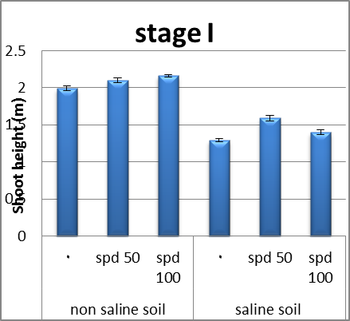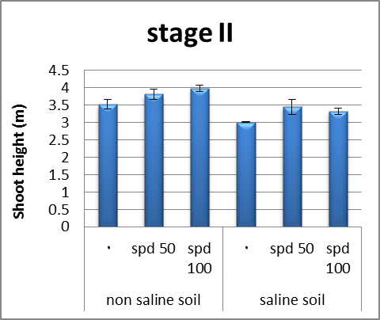
Figure 1. Effect of salinity, spermidine and their interactions on shoot height of Helianthus tuberosus plants

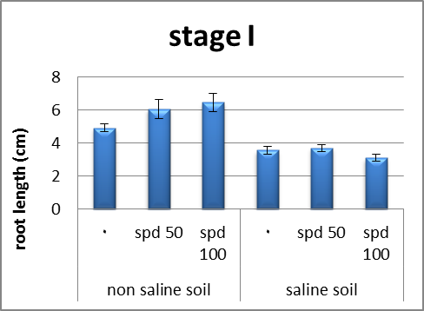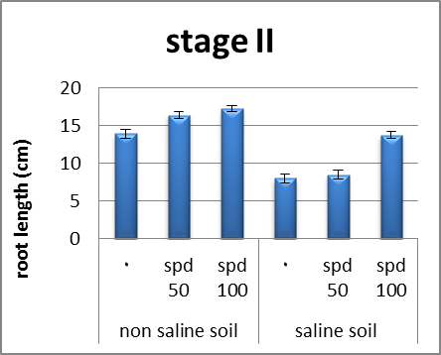
Figure 2. Effect of salinity, spermidine and their interactions on root length of Helianthus tuberosus plants

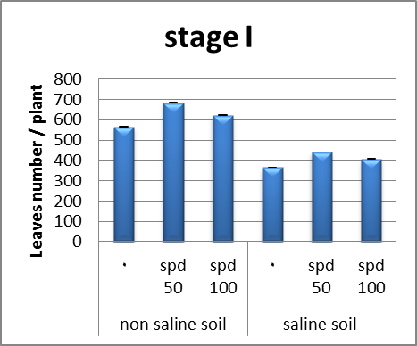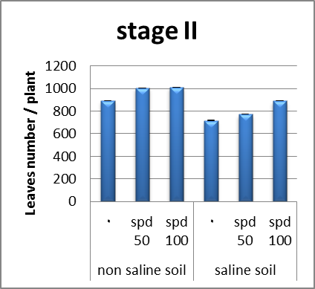Figure 3. Effect of salinity, spermidine and their interactions on no. of leaves of Helianthus tuberosus plants

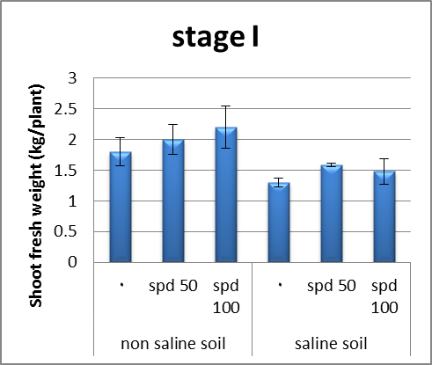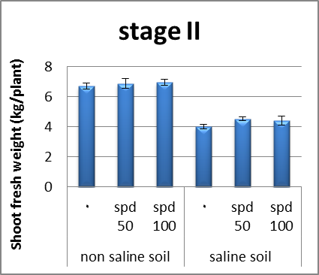
Figure 4. Effect of salinity, spermidine and their interactions on fresh weight of shoot (kg) of Helianthus tuberosus plants

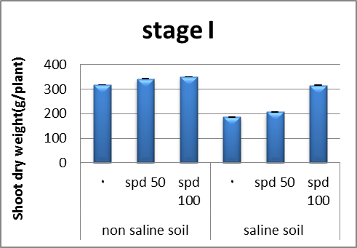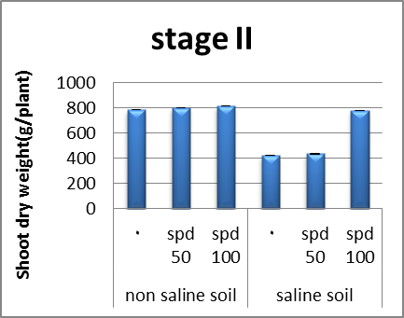Figure 5. Effect of salinity, spermidine and their interactions on dry weight of shoot (g) of Helianthus tuberosus plants

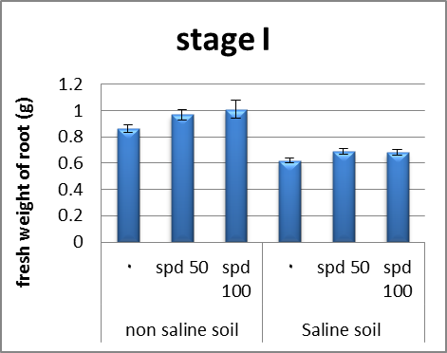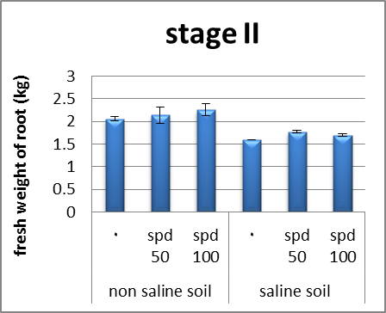Figure 6. Effect of salinity, spermidine and their interactions on fresh weight of root (g) of Helianthus tuberosus plants

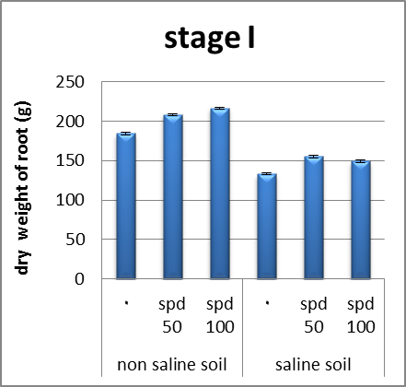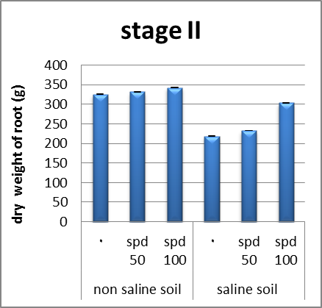
Figure 7. Effect of salinity, spermidine and their interactions on dry weight of root (g) of Helianthus tuberosus plants
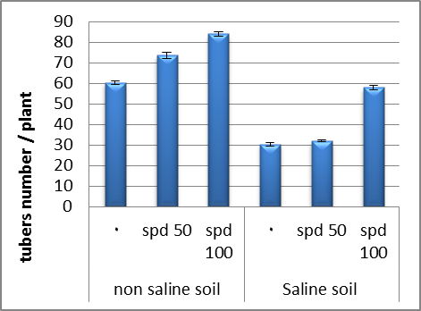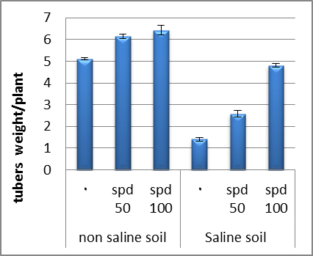
Figure 8. Effect of salinity, spermidine and their interactions on No.of tubers and tubers weight of Helianthus tuberosus plants

3.2. Photosynthetic pigments
Photosynthesises is essential for the normal growth and metabolism of plants. It depends on the normal availability of chlorophylls in the chloroplasts and on several enzymes which function during the light and dark phases. A normal functioning of the dark phase results in the production of monosaccharide, disaccharides and polysaccharide by the plant.
In the present investigation, results (Figs. 9-12) clearly reveal a reduction in the photosynthetic pigment levels (chlorophyll a, chlorophyll b and carotenoids) in the leaves of helianthus plants due to saline soil. This finding is supported by the study of Almodares et al. (2008) on sorghum, and Sofy (2011) on lentil. The reduction in chlorophyll contents due to salinity is probably due to the inhibitory effect of the accumulated ions (Na⁺ and Cl) on the biosynthesis of the different chlorophyll fractions (Mohammed, 2007).
Results of the present work (Figs. 9, 10, 11) showed that, at different soils, contents of chlorophyll (a) and (b) as well as total chlorophyll (a + b) were, mostly, significantly increased due to the application of spd. Also, contents of cartenoids were significantly increased throughout the two stages of growth spesialy in plants grown under saline condition. In this regard, El-Bassiouny and Beckheta (2001) reported that PAs mitigate stress through modulating stomatal movement, providing a link between stress condition, PAs levels and stomatal regulation. The addition if PAs in nutritive solution reduced rice growth in the absence of NaCl and did not offered protection in the presence of salt (Ndayiragijc and Lutts, 2006).
Chattopadhayay et al., (2002) added that PAs prevented chlorophyll loss, inhibition of photochemical reactions of photosynthesis. Also Huiguo et al. (2006) found that exogenous application of PAs protect PSll against water stress at both transcriptional and translational levels and allow PSll to retain a higher activity level during stress in wheat seedling resulting in the increase in chlorophyll contents.
Gupta et al. (2003) found that PAs increased the total chlorophyll contents of wheat plants. Also El-Bassiouny and Bekheta (2001) reported that exogenous application of putrescine (1.25 mM) induced significant increase in chlorophyll, Mg contents and total soluble sugars.
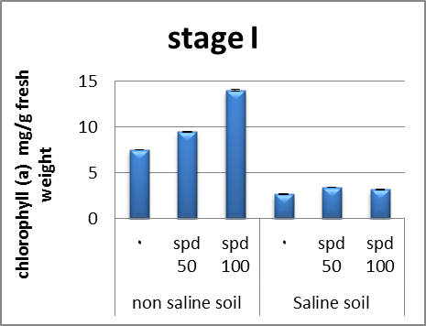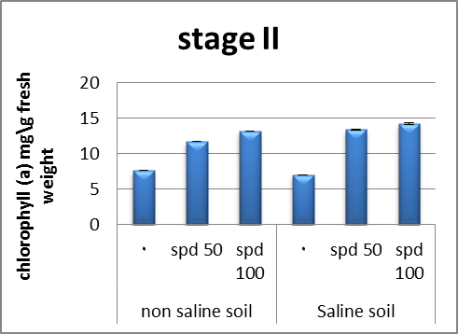
Figure 9. Effect of salinity, spermidine and their interactions on chlorophyll a content of Helianthus tuberosus plants
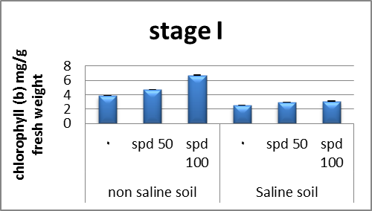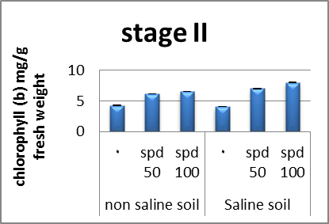
Figure 10. Effect of salinity, spermidine and their interactions on chlorophyll b content of Helianthus tuberosus plants
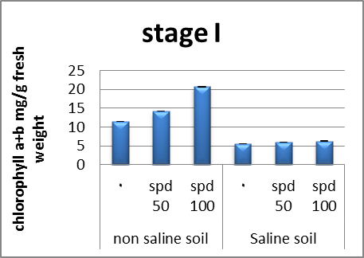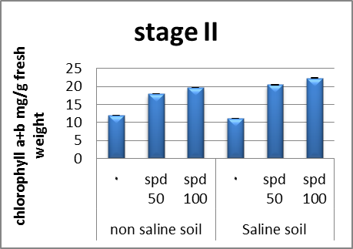
Figure 11. Effect of salinity, spermidine and their interactions on chlorophyll a+ b content of Helianthus tuberosus plants

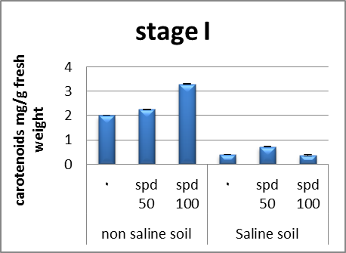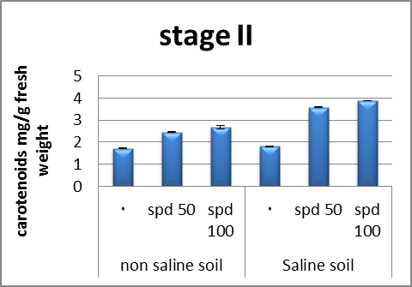
Figure 12. Effect of salinity, spermidine and their interactions on Carotenoids content of Helianthus tuberosus plants

3.3. Carbohydrates
In the present study, results show that total soluble carbohydrates decreased in helianthus plants grown in saline soil. Rejeskova et al. (2007) indicated that salinity caused a decrease in total carbohydrates in Olea europaea L. shoots. The decrease was probably not due only to osmotic stress but also to the presence of toxic Na⁺ and Cl ⁻ ions.
Results of the present work (Figs. 13, 14, 15) showed that contents of total carbohydrates (total soluble sugars) were, generally, significantly increased in shoots, roots and in yielded tubers in response to the treatment with spd. In this regard, several investigators proved that polyamine plays an important role in carbohydrate metabolism El- Bassiounyet al., (2008) found that application of PAs treatment had favourable effect on the synthesis and accumulation of carbohydrates in leaves of wheat plants. In most cases, plants sprayed with PAs at the different concentrations had higher contents of total carbohydrates in their leaves, compared to the untreated control. Moreover, Liu et al. (2002) found that spraying Brassica plants with PAs gave the highest value of total soluble sugar percentage. PAs alleviated the adverse effects of salt stress on total soluble sugars concentration and this is at least partially due to enhanced amylase activity and chlorophyll content, reported as a response (Sood and Nagar, 2003).
Data of the present investigation (Figs. 13, 14, 15) reveal that the reduction in the total carbohydrate levels induced by high salinity counteracted by low and high applied concentrations of spd. These effects were observed at all growth stages but with different degrees. Application of spd generally increased the total soluble carbohydrates in helianthus plants in saline soil. It suggested that in the presence of spd, the leaves accumulated more compatible osmolytes as soluble sugar, glucose and fructose, a sugar alcohol, sorbitol and proline (Szepesi, 2006).
Hussein et al. (2006) reported that increasing the sugars concentration by putrescine application may be due to the role of putrescine on improving plant growth; carbohydrate content resulted in increasing plant tolerance to salinity stress.
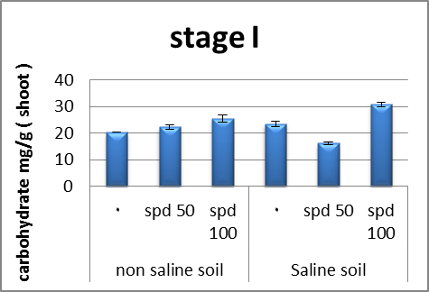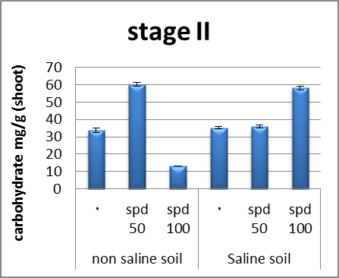
Figure 13. Effect of salinity, spermidine and their interactions on carbohydrate content (shoot) of Helianthus tuberosus plants
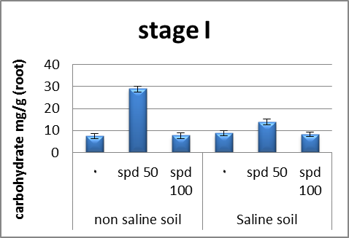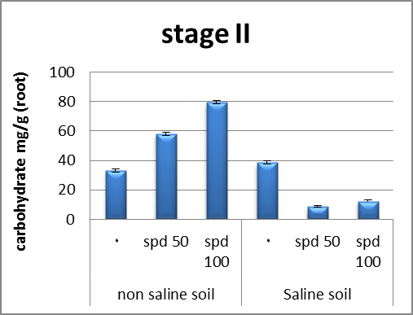
Figure 14. Effect of salinity, spermidine and their interactions on carbohydrate content (root) of Helianthus tuberosus plants
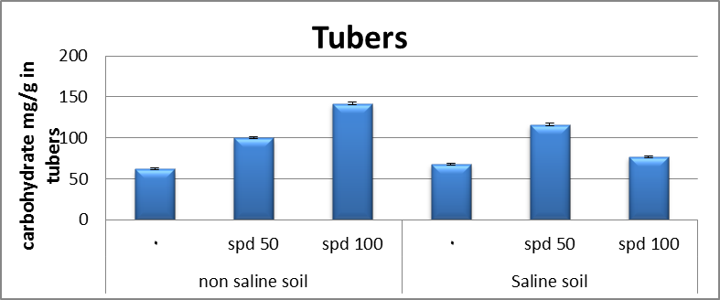
Figure 15. Effect of salinity, spermidine and their interactions on carbohydrate content (tubers) of Helianthus tuberosus plants

3.4. Protein
Our results (Figs. 16, 17, 18) showed that the total soluble protein decreased significantly in shoots roots and yielded with saline soil. In phyllanthus amarus plants, NaCl reduced the protein content (Jaleel et al., 2008); these results were in agreement with Sofy (2011) in lentil.
Results of the present study (Figs. 16, 17, 18) indicated that protein contents in shoots, roots as well as in the yielded tubers of helianthus plants were, generally, increased in response to the all used concentrations of spd. The obtained results are in agreement with those of Jaleel et al. (2008) on Phyllanthus amarus plant, indicated that foliar application of PAs markedly increased the protein contents in the yielded seeds. El Tayeb (2005) found that PAs treatment significantly increased the contents of soluble protein in the shoots of barley plants. Sood and Nagar (2003) mentioned that spraying wheat plants with PAs gave the greatest values of crude protein present per rose.
Results of the present work(Figs. 16, 17, 18) revealed that, helianthus plants, treatment with spd, in saline soil, resulted in, mostly, significant increases in protein contents in shoots, roots and also, in the yielded tubers. These results are in harmony with those obtained by Amira Abdul Qados (2010) on mung bean, where they found that, contents of proteins increased as a result of PAs application with saline soil.
El-Bassiouny et al. (2008) who indicated that PAs was the most effective compound in increasing soluble carbohydrate, poly saccharides, total carbohydrates, proline, total amino acid and protein contents of wheat plants and grains under normal or stressed condition.
3.5. Total phenols
Phenols act as free radical scavengers as well as substrates for many antioxidant enzymes (Martin-Tanguy, 2001). In the recent study of phenol levels (Figs. 19, 20, 21) were significantly increased in the shoot, root as well as yield tuber of helianthus plants which grown in saline compared with those of unstressed control plant through the experimental period.
Results of the present study revealed that contents of total phenol in shoots of spd-treated plants were significantly increased throughout the stages of growth. These increases were found to be in response to the applied concentrations of spd. The potent effect of spd as regards the contents of total phenols was recorded by other investigators. In this regard, Agastian et al. (2000) deduced that application of various concentrations of PAs induced high significant increases in the total phenol content of cowpea shoots. This increase in total phenol contents in response to PAs treatments concurrently with increase in IAA contents in shoots of cowpea plants led to the suggestion that most of phenol compounds are diphenols and polyphenols which may inhibit IAA oxidase activity resulting in auxin accumulation, which reflected in stimulated growth and yield of the treated plants.
The exogenous application of putrescine significantly increase the accumulation of phenols in stressed cowpea shoots and roots as being compared with their reference controls (grown at 100 and 200 mM NaCl). The increase in the accumulation of the phenolic compounds in stressed cowpea shoots and roots might be due to their increase in their biosynthesis. The increase in phenol levels have been reported in a number of plants grown under stress condition (Farag Abeer, 2009).
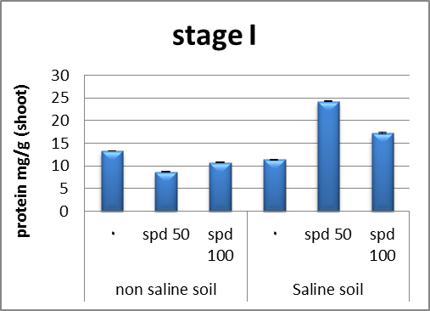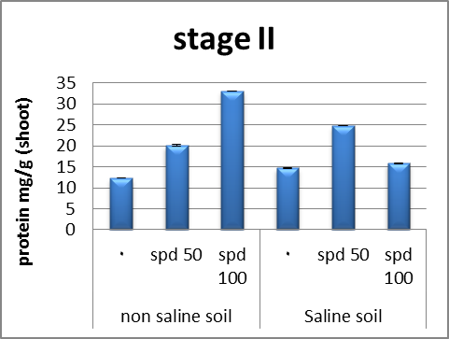
Figure 16. Effect of salinity, spermidine and their interactions on protein content (shoot) of Helianthus tuberosus plants
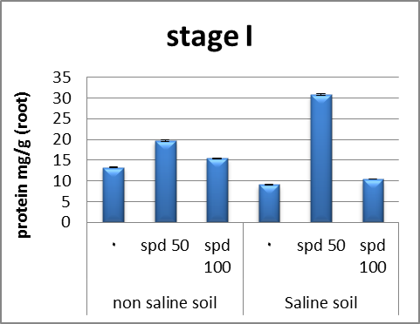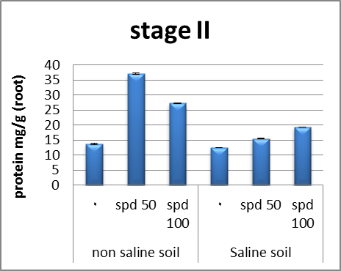
Figure 17. Effect of salinity, spermidine and their interactions on protein content (root) of Helianthus tuberosus plants
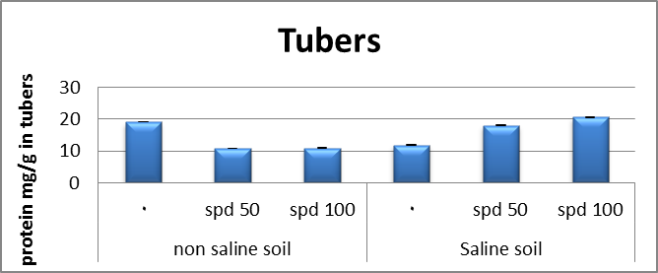
Figure 18. Effect of salinity, spermidine and their interactions on protein content (tubers) of Helianthus tuberosus plants
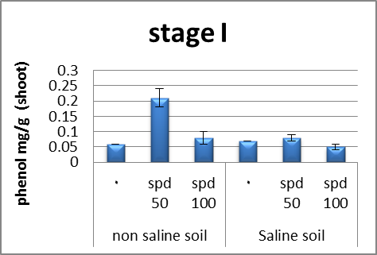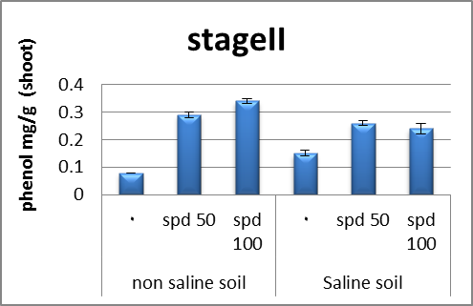
Figure 19. Effect of salinity, spermidine and their interactions on phenol content (shoot) of Helianthus tuberosus plants

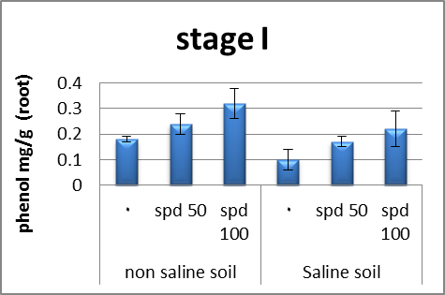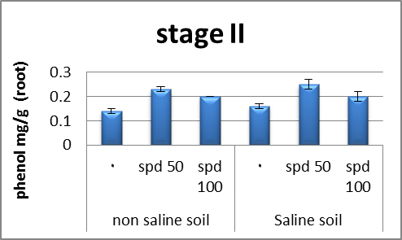
Figure 20. Effect of salinity, spermidine and their interactions on phenol content (root) of Helianthus tuberosus plants
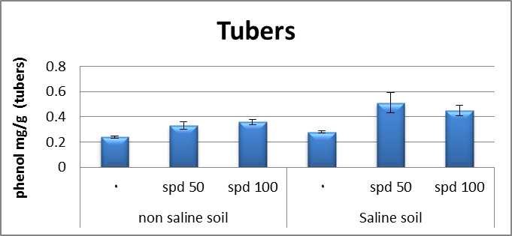
Figure 21. Effect of salinity, spermidine and their interactions on phenol content (tubers) of Helianthus tuberosus plants

3.6. Total proline
In organisms ranging from bacteria to higher plants, there is strong correlation between increased cellular proline levels and the capacity to survive under salt stress. In addition to its role as an osmolyte for osmotic adjustment, proline contributes to stabilizing sub cellular structure (membrane and proteins) scavenging free radicals and buffering cellular redox potential under stress conditions (Ashraf and foolad, 2007).
Our results (Figs. 22, 23, 24) showed that the proline contents increased significantly in plants which grown in saline soil. These results are in agreement with Lobato et al. (2008) in Vigna unguiculata L. and Sofy (2011) in lentil.
Many plant species naturally accumulate proline and glycine betaine as major organic osmolytes when subjected to different a biotic stress such as drought, salinity, extreme temperature and heavy metals. Proline is thought to play adaptive roles in mediating osmotic adjustment and protecting sub-cellular structure in stressed plants (Ashraf and Foolad, 2007).
Furthermore, Kavi Kishor et al. (2005) suggested that proline which is accumulated under stress conditions might serve as a sink for excess reductants providing the NAD⁺ and NADP⁺ necessary for maintenance of respiratory and photothetic processes. When proline synthesis generates NADP⁺, its degradation produces NADPH which is essential for buffering cellular redox potential in the cytosol as well as plastids.
Proline was markedly increased in salt-stressed plants. Used polyamine affects the proline level of these plants. The interaction was significant spd, in control conditions, significantly increased proline concentration in Vigna plants as compared with corresponding untreated plants. The data presented showed that proline concentration was greatly increased in the salt-stressed plants and this is compatible with the fact that many higher plants accumulate free proline in response to salt stress (Kavi Kishore et al., 2005).
Hussein et al. (2006) found that salinity stress increased proline content in pea shoots, whereas foliar application of putrescine caused a highly significant increase of proline contents over the untreated plants (control) but still lower than that of the salinized ones. They reported that the increase in proline contents in pea shoots may be during the catabolic processes of polyamines.
Accumulation of some compatible solutes (proline and free amino acids) in stressed plants produced lower solute potential, which allows plant cell to maintain a higher water content than the corresponding control. These solutes play an important role in plants under stress conditions, where major functions of sugars are osmoprotection and/or osmotic adjustment as reported by Parida et al. (2002).
Duan et al. (2008) reported that exogenous spermidine substantially increased the level of proline in cucumber roots under salinity stress.Although the proline level was increased by NaCl in salinized cowpea plants, yet putrescine reduced this measure below them. Despite of putrescine induced reduction in proline level, it was still significantly greater than the control ones (0.0 mM NaCl). Similar results were obtained by Mansour et al. (2002) who found that PAs treatment decreased ethylene production and proline accumulation which were increased by NaCl. They postulated that PAs inhibits proline accumulation under salt stress via the change in the properties of P-5-C.
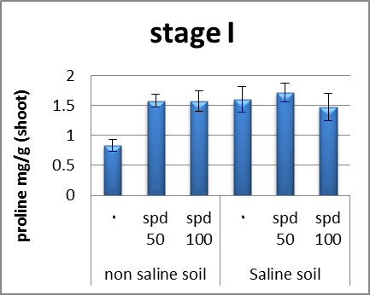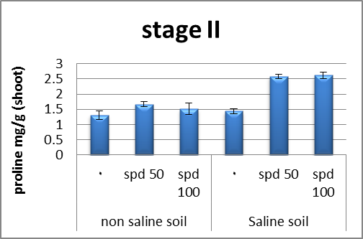
Figure 22. Effect of salinity, spermidine and their interactions on proline content (shoot) of Helianthus tuberosus plants

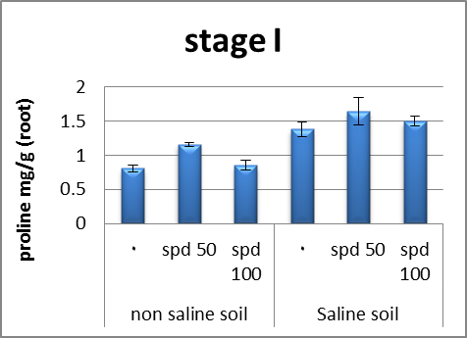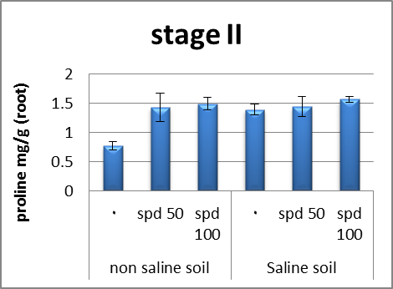
Figure 23. Effect of salinity, spermidine and their interactions on proline content (root) of Helianthus tuberosus plants
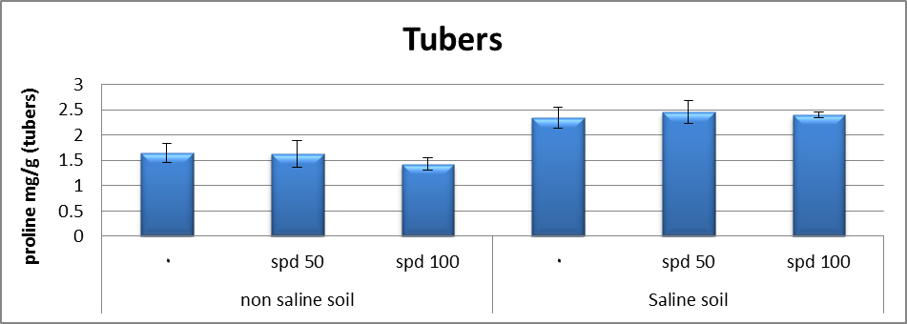
Figure 24. Effect of salinity, spermidine and their interactions on proline content (tubers) of Helianthus tuberosus plants

3.7. Antioxidant enzymes
Environmental stresses result in the generation of reactive oxygen species (ROS) in plants. ROS accumulate in cells and lead to the oxidation of proteins, chlorophyll, lipids, nucleic acids, carbohydrates etc. Cells have evolved intricate defence systems including enzymatic (superoxide dismutase (SOD), catalase (CAT), ascorbate peroxidase (APX), non-enzymatic systems such as ascorbic acid (ASH), phenolic compounds, alkaloids, non-protein amino acids and α-tocopherol, which can scavenge the indigenously generated ROS. Plant stress tolerance mediated by antioxidants has been shown by many workers. Antioxidant resistance mechanisms may provide a strategy to enhance plant stress tolerance. Various enzymes involved in ROS-scavenging have been manipulated, over-expressed or down-regulated to add to the present knowledge and understanding of the role of antioxidant system. ROS induce the synthesis of several plant hormones, such as ethylene, salicylic acid (SA), jasmonic acid, brassinosteroids, abscisic acid (ABA) etc. These Phytohormones are required for growth and development of plants and deafens responses during environmental stresses. The present review throws light on the enzymatic and non-enzymatic antioxidants in plants to enhance stress tolerance in plants and also in particular the role of brassinosteroids and ethylene during a biotic stress tolerance in plants (Parvaiz et al., 2010).
ROS are scavenged by plant antioxidant defense systems, comprising both enzymatic and non-enzymatic components (Ashraf, 2009). Environmental stresses, such as salt stress, may lead to an imbalance between antioxidant defenses and ROS levels, resulting in oxidative stress (Foyer and Noctor, 2003).
Soil salinization caused osmotic stress which stimulates the production of ROS such as anion radical (O₂⁻) hydrogen peroxide (H₂O₂) and hydroxyl radical (OH⁻) (Azevedo Neto et al., 2006) the resistance to environmental stress may therefore depend at least partially on the inhibition of ROS production by enhancing the antioxidant defense system.
In this investigation, CAT activity was significantly increased in Jerusalem plants shoots which grown in saline soil compared to unsalinized control plants. These results are in accordance with results obtained by Vardhini and Rao (2003) observed that CAT activity decreased in susceptible sorghum and maize varieties but increased in resistance varieties as compared to unstressed control.
In addition, the inhibition of CAT activity is a phenomenon that occurs in many plant species exposed to oxidative stress and is related to the accumulation of SA (Shim et al., 2003). However, Cai-Hong et al. (2005) observed that the activity of CAT increased significantly in halophyte suaeda salsa L. grown under high concentration of NaCl (200 m M). They deduced that the increase in Cat activity might be related to the result of lowered H₂O₂ level.
An increase in peroxidase (POX) activity is considered as a second line of defence for scavenging the H₂O₂ under salinity (Sharma et al., 2005). Data presented in this study showed that POX activity increased during salt stress and this increase was positively related to NaCl concentration. The increase in POX activity by salinity stress is established by (Cavalcanti et al., 2004).
The increase in POX activity appears to be caused either by by activation of existing enzymes isoforms. High reduction of plant growth ( Lin and Kao, 2002) and this reduction has been attributed to POX catalysis of feruloylation of hemicelluloses and insolublization of hydroxyproline rich glycoprotein causing cell wall stiffening (Dionisio-Sese and Tobita, 1998) resulted in the inhibition of growth elongation (Sudhaker et al., 2001).
Our results showed that (Figs. 25, 26), spd increase the activities of key enzymes involved in oxidative stress such as CAT, POX as being compared with their corresponding controls (NaCl), such effect of spermdine 100 ppm was greater at NaCl. Similar results are obtained by Farag abeer (2009) observed that putrescine increase the activities of key enzymes involved in oxidative stress such as CATand POX, as being compared with their corresponding controls (100 and 200 mM NaCl), such effect of putrescine was greater at 100 mM NaCl.. Similar results are obtained by Tang and Newton (2005) on Virginia pine. However, Kubis (2008) showed that exogenous application of spermidine differentially influenced enzymes of the antioxidative system under stress conditions. He observed an increase of POX activity and to a lesser degree, and reduction of SOD and CAT in spermidine treated cucumber exposed to water stress. It was proposed that the protective effect of polyamine against the damage of the superoxide depended on their conversion to conjugated forms (Langerbartels et al., 1991).
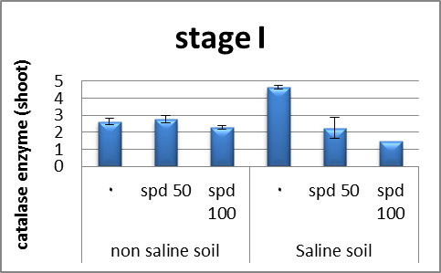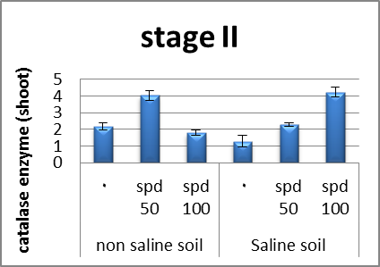
Figure 25. Effect of salinity, spermidine and their interactions on catalase enzyme (shoot) of Helianthus tuberosus plants
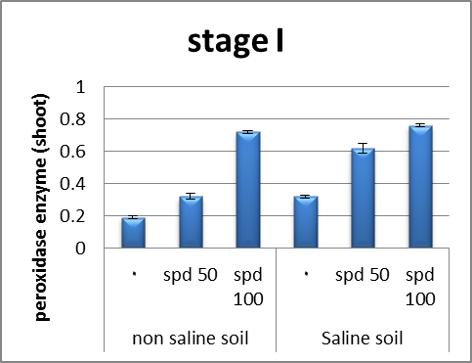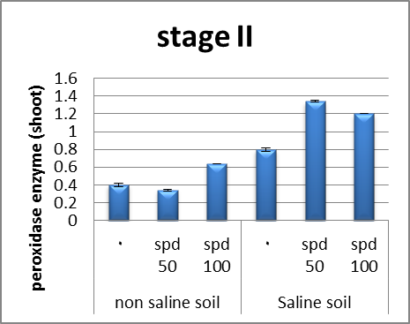
Figure 26. Effect of salinity, spermidine and their interactions on peroxidase enzyme (shoot) of Helianthus tuberosus plants

Corresponding Author:
Dr. Mahmoud Ramadan Sofy
Botany and Microbiology Department
Faculty of Science
Al-Azhar University, 11884 Nasr City, Cairo, Egypt
E-mail: mahmoud_sofy@yahoo.com

References
- Abd El-Monem, A.A. (2007). Polyamines as modulators of wheat growth, metabolism and reproductive development under high temperature stress. Ph.D. Thesis, Ain Shams Univ., Cairo, Egypt.
- Abd El-Wahed, M.S.A. and Gamal El-Din, K.M. (2005). Effect of putrescine and atonik on growth and some biochemical constituents as well as essential oil composition of chamomile plant.J. Agric. Sci., Mansoura Univ.,30: 869-882.
- Agastien, P.; Kingsley, S.J. and Vivekanondon, M. (2000). Effect of salinity on photosynthesis and biochemical characteristics in mulberry genotypes. Photosynthetica, 38:287-290.
- Almodares, A.; Hadi, M.R. and Dosti, B. (2008). Effect of salt stress on growth parameters and carbohydrates contents in sweet sorghum. Research J. of Enviro. Sci., 2(4):298-304.
- Alsokari, S.S. (2011). Synergistic effect of kinetin and spermine on some physiological aspects of seawater stressed Vigna sinensis plants Saudi. J. of Biolo. Sci. 18, 37–44
- Amira Abdul Qados, M.S. (2010). Effect of arginine on growth, nutrient composition, yield and nutritional value of mung bean plants grown under salinity stress. Nature and Sci. 8(7)..
- Amri, E. and Shahsavar, A. (2010). Response of lime seedlings (Citrus aurantifolia L.) to exogenous spermidine treatments under drought stress. AJBAS, 4(9): 4483-4489.
- Ashraf, M. (2009). Biotechnological approach of improving plant salt tolerance 3 using antioxidants as markers. Biotech. Adv., (in press).
- Ashraf, M. and Foolad, M.R. (2007). Roles of glycine betaine and proline in improving plant abiotic resistance. Environ. and Expe. Botany, 59:206-216.
- Azevedo Neto, A.D.; Prisco, J.T.; Eneas-Filho, J.; De Abreu, C.E.B. and Gomes-Filho, E. (2006). Effect of salt stress on antioxidative enzymes and lipid peroxidation in leaves and roots of salt- tolerant and salt- sensitive maize genotypes. Environ. and Expe. Botany, 56: 87-94.
- Bates, L.S.; Waldren, R.P. and Teare, I.D. (1973). Rapid determination of free proline for water stress studies plant and soil, 39: 205-207.
- Cai-Hong, P.; Su-Jun, Z.; Zhi-Zhong, G. and Bao-Shan, W. (2005). NaCl treatment markedly enhances H₂O₂⁻ Scavening system in leaves of halophyte Suaeda salsa. Physiol. Plantarum, 125:490-499.
- Cavalcanti, F.R.; Oliveira, T.A.; Martins-Miranda, A.S.; Viegas, R.A. and Silvera, J.A.G. (2004). Superoxide dismutase, catalase asnd peroxidase activities do not confer protection against oxidative damage in salt stressed cowpea. New Physiol., 163:563-571.
- Chattopadhayay, M.K.; Tiwari, B.S.; Chattopadhyay, G.; Bose, A.; Sengupta, D.N. and Ghosh, B. (2002). Protective role of exogenous polyamineson salinity-stressed rice (Oryza sativa) plants. Physiol Plant 116: 192-199.
- Daniel, H.D. and George, C.M. (1972). Peach seed dormancy in relation to endogenous inhibitors and applied growth substances. J. Amer. Soc. Hort. Sci. 97:651-654.
- Dionisio-Sese, M.L. and Tobita, S. (1998). Antioxidant responses of rice seedlings to salinity stress. Plant Sci., 135: 1-9.
- Duan, J.J.; LI, J.; Guo, S.R. and Kang, Y. (2008). Exogenous spermidine affects polyamine metabolism in salinity stressed Cucumis sativus roots and enhances short term salinity tolerance. J. Plant Physiol., 165:1620-1635.
- El-bassiouny, H.M.S. and Bekheta, M.A. (2001). Role of putrescine on growth, regulation of stmatal aperture, ionic contents and yield by two wheat cultivars under salinity stress. Egypt. J. Physiol. Sci., 2-3:239-258.
- El-Bassiouny, H.M.S.; Mostafa, H.A.; El-Khawas, S.A.; Hassanein, R.A.; Khalil, S.I. and Abd El-Monem, A.A. (2008). Physiological responses of wheat plant to foliar treatments with arginine or putrescine. Austr. J. of Basic and Applied Sci., 2(4): 1390-1403.
- El-Tayeb, M.A. (2005). Response of barley grains to the interactive effect of salinity and salicylic acid. Plant Growth Regulation, V. 45, N. 3, pp. 215-224.
- Farag, Abeer, A.A. (2009). Increasing tolerance of Vigna sinensis L. to salt stress using an organic acid and polyamine. Ph.D. Thesis, Ain Shams Univ. Egypt.
- Foyer, C.H. and Noctor, G. (2003). Redox sensing and signaling associated with reactive oxygen in chloroplasts, peroxisomes and mitochondria. Physiol. Plant., 119: 355-364.
- Gupta, N.K.; Gupta, S.; Shukla, D.S. and Deshmukh, P.S. (2003). Differential responses of BA injection on yield and specific grain growth in contrasting genotypes of wheat (Triticum aestivum L.) plant growth Regul. 40:201-205.
- Härdle, W. and Simar, L. (2007). Applied Multivariate Statistical Analysis. 2nded, Springer, 420pp.
- Huiguo, D.; Shu, Y.; Wenjuan, L.; Dehui, X.; Donghong, Q.; Houguo, I. and Honghui, L. (2006). Effect of exogenous spermidine on photosystem II of wheat seedling under water stress. G. Integrative plant Biol., 45(8):920-927.
- Hussein, M.M.; El-Gfereadly, N.H.M. and El-Desuki, M. (2006). Role of putrescine in resistance to salinity of pea plants (pisum csativum L.). J. of Applied Sci. Research, 2(9): 598-604.
- Iqbal, N.; Ashraf, M.Y.; Farrukh, J.; Vicente, M. and Kafeel, A. (2006). Nitrate reduction and nutrient accumulation in wheat grown in soil salinized with four different salts. J. Plant Nutr, 29: 409- 421.
- Jaleel, C.A.; Kishorekumar, A.; Manivannan, P.; Sankar, B.; Gomathinay agam, M. and panneerselvam, R. (2008). Salt stress mitigation by calcium chloride in Phyllanthus amarus. Acta Bot. Croat., 67(1):53-62.
- Jamil, M.; Lee, D.B.; Jung, K.Y.; Ashraf, M.; Lee, S.C. and Rhal, E.S. (2006). Effect of salt (NaCl) stress on germination and early seedling growth of four vegetables species. Cent. Eur. Agric., 7: 273-282.
- Karimi, S. and Rahemi, M. (2012). Growth and Chemical Composition of Pistachio Seedling Rootstock in Response to exogenous Polyamines under Salinity Stress. J. of Nuts 3(2):21-30, 2012.
- Kavi Kishore, P.B.; Sangam, S.; Amrutha, R.N.; Laxmi, P.S.; Naidu, K.R.; Rao, K.R.S.S.; Rao, S.; Reddy, K.J.; Theriappan, P. and Sreenivasulu, N. (2005). Regulation of proline biosynthesis degradation, uptake and transport in higher plants: its implications in plant growth and abiotic stress tolerance. Curr. Sci. 88:424-438.
- Keutgen, A. and Pawelizik, E. (2008). Quality and nutritional value of strawberry fruit under long term salt stress. Food Chemistry, 107: 1413-1420.
- Kong, F.X.; Hu,W.; Chao, S.Y.; Sang, W.L. and Wang, L.S. (1999). Physiological responses of mexicana to oxidative stress of SO₂. Enviro. and Exp. Bot. 42: 201-209.
- Kubis, J. (2008). Exogenous spermidine differentially alters activities of some scavenging systems, superoxide radical levels in water stressed cucumber leaves. J. of plant physiol., 165:397-406.
- Langerbartels, C.; Kerner, K.; Leonardi, S.; Schraudner, M.; Trost, M.;Heller, W. and Sanderman, H. (1991). Biochemical plant responses to ozone Differential induction of polyamine and ethylene biosynthesis in tobacco. Plant Physiol., 95:882-887.
- Lin, C.C. and Kao, C.H. (2002). Osmatic stress- induced changes in cell wall peroxidise activity and hydrogen peroxide level in roots of rice seedling. Plant growth Rgulation, 37:177-184.
- Liu, A.R.; Zhang, Y.B. and Ling, N. (2002). Eeffect of spermine and spermidine on several physiological indexes of Brassicacompestris. Plant physiol., Comm. Chinese Academy Agric. Sci. (CAAS) Scientech Documentation and Information Center, Beijing, China, 38(4):349-351.
- Lobato, A.K.S.; Oliveria Neto, C.F.; Costa, R.C.L.; Santos Filho, B.G.; Cruz, F.J.R. and Laughinghouse IV, H.D. (2008). Biochemical and physiological behaviour of vigna unguiculata L. Walp. Under water stress during the vegetative phase. Asian J. of Plant Sci., 7(1):44-49.
- Lowery, O.H.; Rosebrough, N.J.; Farr, A.L. and Randall, R.J. (1951). Protein measurement with the folin reagent. J. Biol.Chem.193:265-275.
- Mansour, M.M.F.; Al-Mutawa, M.M.; Salama, K.H.A. and Abou Hadid, A.M.F (2002). Salt acclimation of wheat salt sensitive cultivar by polyamines. In: Prospect for Saline Agriculture, 155-160.
- Martin-Tanguy, J. (2001). Metabolism and function of polyamines in plants: recent development (New approaches). Plant Growth Regul., 34:135-148.
- Mohammed, A.M.A. (2007). Physiological aspects of mingbean plant (Vigna radiate L.) in response to salt stress and gibberellic acid treatment. Res. J. Agric. & Biol. Sci., 3(4):200-213.
- Mostafa, H.A.M.; Hassanein, R.A; Khalil, S.I.; El-Khawas, S.A.; El-Bassiouny, H.M.S. and Abd El-Monem, A.A. (2010). Effect of Arginine or Putrescine on Growth, Yield and Yield Components of Late Sowing Wheat. J. of Applied Sci. Research, 6(2): 177-183.
- Ndayiragije, A. and Lutts, S. (2006). Exogenous putrescine reduces sodium and chloride accumulation in NaCl treated calli of the salt-sensitive rice cultivar I Kong Pao. Plant Growth Regulation, 48: 51-63.
- Pagter, M.; Bragato, C.; Malagori, M. and Brix, H. (2009). Osmotic and ionic effects of NaCl and Na₂SO₄ salinity on Phragmites australis. Aquat. Bot. 90: 43-51.
- Parida, A., Das, A.B. and Das, P. (2002). NaCl stress causes changes in photosynthetic pigments, proteins and other metabolic components in the leaves of true mangrove Bruguiera parviflora in hydroponics cultures. J. Plant Biol., 45: 28-36.
- Parvaiz Ahmad, Shahid Umar, and Satyawati Sharma (2010). Mechanism of Free Radical Scavenging and Role of Phytohormones in Plants Under Abiotic Stresses Plant Adaptation and Phytoremediation 99-118.
- Rakhimov, D.A.; Arifkhodzhaev, A.O.; Mezhlumyan, L.G.; Yuldashev, O.M.; Rozikova, U.A.; Aikhodzhaeva, N. and Vakil, M.M. (2003). Carbohydrates and proteins from Helianthus tuberosus. Chem. Nat. Comp., 39(3): 312- 313.
- Rejeskova, A.; Patkova, L.; Stodulkova, E. and Lipavska, H. (2007). The effect of abiotic stresses on carbohydrate status of olive shoots (Olea europaea L.) under in vitro conditions. J. of plant physiol., 164:174-184.
- Sepaskhah, A.R. and Yousofi-Falakdehi, A. (2010). Rice yield modeling under salinity and water stress conditions using an appropriate macroscopic root water uptake equation. Pak. J. Biol. Sci. 13, 1099–1105.
- Sharma, N.; Gupta, N.K.; Gupta, S. and Hasegawa, H.(2005). Effect of NaCl salinity on photosynthetic rate, transpiration rate, and oxidative stress tolerance in contrasting wheat genotype. Photosynthetica, 43(4):609-613.
- Shim, I.S.; Momose, Y.; Yamamoto, A.; Kim, D.W. and Usui, K. (2003). Inhibition of catalase activity by oxidative stress and its relationshipe to salicylic acid accumulation in plants. Plant Growth Regul., 39:285-292.
- Siringam, K.; Juntawong, N.; Cha-um, S. and Kirdmanee, C. (2011). Salt stress induced ion accumulation, ion homeostasis, membrane injury and sugar contents in salt-sensitive rice (Oryza sativa L. spp. indica) roots under isoosmotic conditions. Afr. J. Biotech. 10(8), 1340– 1346.
- Sofy, M.R. (2011). Physiological and Biochemical responses of plant to growth regulators and stress condition. PhD. Plant Physiology, Faculty of Science, Al- Azhar University.
- Sood, S. and Nagar, P.K. (2003). The effect of polyamines on leaf senescence in two diverse rose species. Plant Growth Regul., 39: 155-160.
- Sudhakar, C.; Lakshmi, A. and Giridarakumar, S. (2001). Changes in the antioxidant enzyme efficacy in two high yielding genotypes of mulberry (Morus alba L.) under NaCl salinity. Plant Sci., 161: 613-619.
- Suleiman, S.; Wilson, C. and Grieve, C. (2002). Effect of salinity and exogenous applied polyamines on growth and ion relations in spinach. Journal of Plant Nut., 25(12): 2705-2717.
- Szepesi, A. (2006). Salicylic acid improves the acclimation of Lycopersicon esculentum Mill. L. to high salinity by approximating its salt stress response to that of the wild species L. pennellii. Acta Biological Szegediensis, 50(3-4):177.
- Tang, W. and Newton, R.J. (2005). Polyamines reduce salt induced oxidative damage by increasing the activities of antioxidant enzymes and decreasing lipid peroxidation in Virginia pine. Plant Growth Regul., 46:31-43.
- Tassoni, A.; Bagni, N.; Ferri, M.; Franceschetti, M.; Khomutov, A.; Marques, M.P.; Fiuza, S.M.; Simonian, A.R. and Serafini, F.D. (2010). Helianthus tuberosus and polyamine research: Past and recent aplications of a classical growth model. Plant Physiol. Bioch., 48(7): 496-505.
- Terzic, S. and Atlagic, J. (2009). Nitrogen and sugar content variability in tubers of Jerusalem artichoke (Helianthus tuberosus). Genetika, 41(3): 289-295.
- Umbriet, W.W.; Burris, R.H.; Stauffer, J.F.; Cohen, P.P.; Johsen, W.J.; Lee page, G.A.; Patter, V.R. and Schneicter, W.C. (1969). Manometric techniques, manual describing methods applicable to the studs of tissue metabolism. Burgess publishing co., U.S.A; P.P.239.
- Vardhini, B.V. and Rao, S.S. (2003). A melioration of osmotic stress by brassinosteroids on seed germination and seedling growth of three varieties of sorghum. Plant Growth Regul., 4: 25-31.
- Verma, S. and Mishra, S.N. (2005). Putrescine alleviation of growth in salt stressed Brasssica Juncea by inducing antioxidative defense system. J. Plant Physiol., 162: 669-677.
- Vernon, L.P. and Selly, G.R. (1966). The chlorophylls. Academic press. New York and London.

10/15/2013

