Trends of Annual Mean Surface Air Temperature over Iraq

S. M. Robaa and Zhian J. AL-Barazanji

Astronomy, Space Science and Meteorology Department, Faculty of Science, Cairo University, Giza, Egypt
zhdilshad@gmail.com

Abstract: Iraq is one of the sensitive regions to climate variation particularly temperature change in the World. This study aims to show the change of the mean annual temperature in Iraq. Complete and homogenous time series of mean surface air temperature (T ºC), for different eleven sites over Iraq have been used in this study. RH test software package used as a reference set of homogenous time series well correlated with a base series. Also, Sen's non-parametric estimator of slope has been frequently used to estimate the magnitude of trend, whose statistical significance was assessed by the Mann-Kendall test. The trends in temperatures at annual and seasonal time scales were examined and discussed. Trends of T showed a rising trend at all stations and it experienced an increase of 0.5 °C/decade.
[S. M. Robaa and Zhian J. AL-Barazanji. Trends of Annual Mean Surface Air Temperature over Iraq. Nat Sci 2013;11(12): 138-145]. (ISSN: 1545-0740). http://www.sciencepub.net. 21

Key Words: Climate, Surface air temperature, Mann-Kendall Test, Trends, Iraq.

1.Introduction
The climate is always changing and has forever been a hot topic of discussion at all levels. In the late 20th century, the natural sciences have increasingly focused on the problems and risks of modern societies. Climate change is considered as the most serious environmental challenge that threatens the developed and less developed countries. It has reached a critical magnitude with a serious impact on society, human welfare and quality of human life. So, the impact on the environment, food security, and socioeconomic systems, at the present time, is seriously taken into consideration by international authorities and has been receiving considerable recent attention from governments.
The detection and attribution of global climate change resulting from anthropogenic activities are one of the main themes of current climatologically research. Recent investigations have shown an increase in global mean temperature of approximately 0.48–0.88 ºC during the twentieth century (e.g., Panel on Reconciling Temperature Observations 2000); however, this trend has not been uniform either spatially or temporally. Many previous studies [including those incorporating general circulation models (GCMs)] focused on changes in long-term average (i.e., annual, seasonal) temperature (Kattenberg et al., 1996). Another important aspect involves characteristics of daily temperature and in particular, changes to the extreme ends (or tails) of the daily temperature distribution. Numerous task groups, including the Intergovernmental Panel on Climate Change (IPCC), have identified the detection of trends and variability in extreme temperatures as critical factors toward an improved understanding of past and potential future global change. To describe accurately the spatial and temporal characteristics of daily and extreme temperatures, long-period time series of reliable and homogeneous daily values are required. Recently, there have been several observational analyses involving daily and/or extreme temperature trends and variability over various regions of the globe. The majority of the findings revealed significant decreases in days with extreme low daily temperature but no significant increases in the number of extreme warm days [e.g., over the contiguous United States (Karl et al., 1996); Canada (Zhang et al., 2000) Great Britain (Jones et al., 1999); northern and central Europe (Brazdil and Coauthors, 1999); Australia and New Zealand (Plummer et al., 1999); and China (Zhai et al., 1999)].
The main objective of this paper is to identify whether or not the frequency or intensity of climate events have increased during a climate warming period over Iraq through. The detailed analysis and understanding of trends of climate events in the Iraq are important to reduce the climate-induced dryness and the impact of temperature extremes on society, agriculture, environment, and so on.
2. Study area and data
Iraq is located in southwest Asia between latitudes 29ᵒ 5´ to 37ᵒ 22´ N and longitudes 38ᵒ 45´ to 48ᵒ 45´ E. Iraq, with a total area of 438 317 km², is bordered by Turkey to the north, Iran to the east, the Persian Gulf to the southeast, Saudi Arabia and Kuwait to the south, and Jordan and the Syrian to the west. (Figure1). Topographically, Iraq is shaped like a basin, consisting of the Great Mesopotamian alluvial plain of the Tigris and the Euphrates rivers (Mesopotamia means, literally, the land between two rivers). This plain is surrounded by mountains in the north and the east, which can reach altitudes of 3611 m above sea level, and by desert areas in the south and west, which account for over 40 percent of the land area. Iraq is characterized by four distinct topographic features:
- Mesopotamian plain: Alluvial plain occupies a quarter of the area of Iraq.
- Desert plateau: Located in the west of Iraq and occupies about less than half the size of Iraq.
- Mountainous region: Mountainous region is located the northern and the north-eastern part of Iraq.
- Undulating region: A transition zone between the low-lying Mesopotamian plain in the south and the high mountains in the far north and the north-eastern Iraq.
Diverse topography of Iraq plays an essential role in its climate. Iraq being situated in the north part of semi tropic region which distinguishes it by winter of relatively low temperature, dry and hot summer, and with two short seasons which they are spring and autumn. It seems that the differences in temperature have great impacts on Iraq's extreme climate. Iraq lies within the northern temperate zone, but the climatic is continental and subtropical. Winters are usually cool to cold, with an average daily temperature that might reach 16°C dropping at night to 2°C. Summers are dry and hot to extremely hot, with a shade temperature of over 43°C during July and August, yet dropping at night to 26°C (Al-Ansari et al., 2013).
The monthly mean daily values of surface air temperature, T (ºC) for different periods at eleven selected stations have been taken from four sources and used in this study. The data sources are:
- Iraq Meteorological Authority (IMA),
- Sulaymaniya meteorological station,
- Arbil meteorological station,
- Duhok meteorological station.
The stations have been chosen based on data availability and to cover the whole of Iraq. Worth mentioning that the site of data collection has remained the same, with almost negligible change since the beginning of the data measurements at each station. The selected stations and their geographical coordinates as well as the observation periods of temperature is given in Table 1 and Figure 1.

Table1. List of the eleven under study stations, their geographical coordinates and the observation periods of the surface air temperature at each station.
Length of available recorded period (Years) | Observation period | Elevation (m) above M.S.L | Latitude (N) | Longitude (E) | Stations
29 | 1982-2010 | 434 | 37ᵒ 08´ | 42ᵒ 41´ | Zakho
70 | 1941-2010 | 223 | 36ᵒ 19´ | 43ᵒ 07´ | Mosul
29 | 1982-2010 | 420 | 36ᵒ 11´ | 44ᵒ 00´ | Arbil
38 | 1973-2010 | 885 | 35ᵒ 32´ | 45ᵒ 26´ | Sulaymaniya
70 | 1941-2010 | 331 | 35ᵒ 28´ | 44ᵒ 23´ | Kirkuk
70 | 1941-2010 | 32 | 33ᵒ 19´ | 44ᵒ 25´ | Baghdad
38 | 1973-2010 | 631 | 33ᵒ 02´ | 40ᵒ 17´ | Rutba
70 | 1941-2010 | 17 | 32ᵒ 01´ | 46ᵒ 02´ | Al-Hai
38 | 1973-2010 | 20 | 31ᵒ 59´ | 44ᵒ 59´ | Diwaniya
70 | 1941-2010 | 5 | 31ᵒ 03´ | 46ᵒ 14´ | Nasiriya
70 | 1941-2010 | 3 | 30ᵒ 30´ | 47ᵒ 50´ | Basra

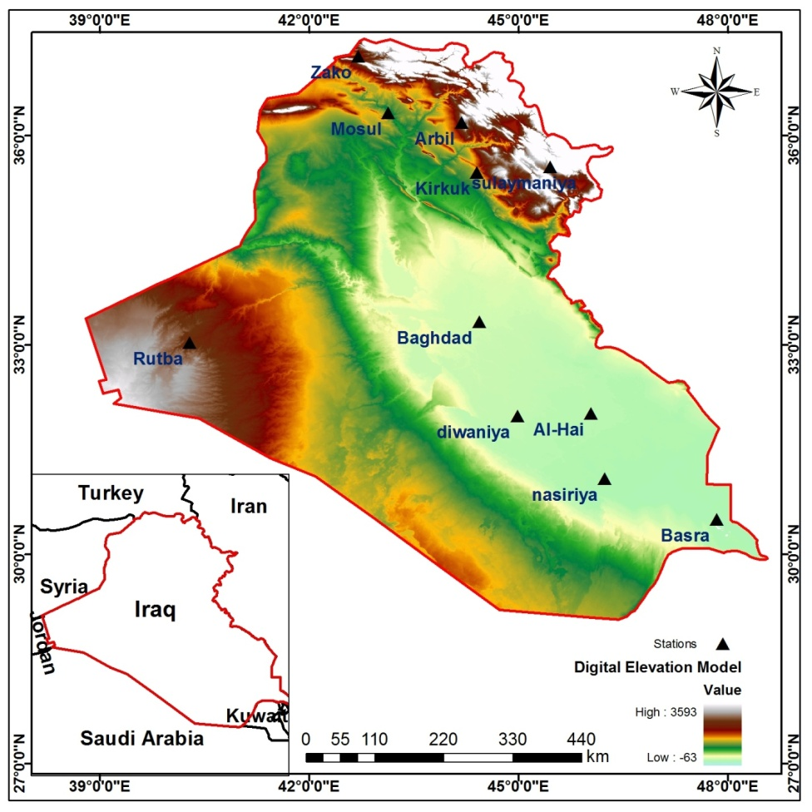
Figure1. Map of Iraq including the eleven selected stations (▲).

3. Methodology
3.1. Homogeneity testing
Data homogeneity is assessed using an R-based program, RHtest, developed at the Climate Research Branch of Meteorological Service of Canada, and available from the ETCCDMI Web site. This program is capable of identifying multiple step changes at documented or undocumented change points. It is based on a two-phase regression model with a linear trend for the entire base series [Wang, 2003]. Detailed discussion about this model can be found in the work of Wang [2003].
We use the R software, which is one of the most flexible and powerful statistical package that currently exists to perform statistical tasks of all kinds, from the most elementary to the most advanced. It has been improved from previous versions and it is maintained by some of the most prestigious statesmen. It's free and open source software that can be download and installs easily from the web page http://www.r-project.org/
3.2. Significance of trend
a. Mann-Kendall test (M-K)
By M-K test, we want to test the null hypothesis H₀ of no trend, i.e. the observations x_{i} are randomly ordered in time, against the alternative hypothesis, H₁, where there is an increasing or decreasing monotonic trend. The data values are evaluated as an ordered time series. Each data value is compared with all subsequent data values. If a data value from a later time period is higher than a data value from an earlier time period, the statistic S is incremented by 1. On the other hand, if the data value from a later time period is lower than a data value sampled earlier, S is decremented by 1. The net result of all such increments and decrements yields the final value of S (Shahid 2011). The M-K test statistic S is calculated using the formula:
S -) (1)
sgn ( = 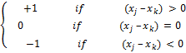 (2)
Where _{j} and _{k} are the annual values in years j and k, j > k, respectively.
If n < 10, the value of |S| is compared directly to the theoretical distribution of S derived by Mann and Kendall (Gilbert, 1987). The two tailed test is used. At certain probability level H₀ is rejected in favor of H₁ if the absolute value of S equals or exceeds a specified value S_{α/2}, where S_{α/2} is the smallest S which has the probability less than α/2 to appear in case of no trend. A positive (negative) value of S indicates an upward (downward) trend (Salmi et al., 2002, Luo et al., 2008).
For n ≥ 10, the statistic S is approximately normally distributed with the mean and variance as follows:
E(S) = 0 (3)
VAR(S) = _{p} (t_{p} -1)(2t_{p} +5)] (4)
Where q is the number of tied groups t_{p} is the number of data values in the p^{th} group.
The standard test statistic Z is computed as follows:

Z= (5)

The presence of a statistically significant trend is evaluated using the Z value. A positive (negative) value of Z indicates an upward (downward) trend. To test for either an upward or downward monotone trend (a two-tailed test) at α level of significance, H₀ is rejected if the |Z| > Z_{1-α/2}, where Z_{1-α/2} is obtained from the standard normal cumulative distribution tables. Trends of temperature (mean temp) time series over Iraq (11 stations) were computed from the available data, from table (1), as a long-term trend. Trend during this study has been presented as a rate of change per decade (10* Q/decade).
B. Sen´s slope estimator
If a linear trend is present in a time series, then the true slope (change per unit time) can be estimated by using a simple nonparametric procedure developed by Sen (1968). This means that linear model f (t) can be described as
ƒ (t) = Qt + B (6)
Where Q is the slope and B is a constant.
To derive an estimate of the slope Q, the slopes of all data pairs are calculated

Q_{i} = ( χ_{j} – χ_{k} ) / ( j – k ) , i= 1,2,…N , j > k (7)

If there are n values χ_{j} in the time series we get as many as N = n(n-1)/2 slope estimates Q_{i}.
The Sen’s estimator of slope is the median of these N values of Q_{i}. The N values of Q_{i} are ranked from the smallest to the largest and the Sen’s estimator is
Q = Q _{[(N+1)/2]} , if N is odd
Or (8)
Q = (Q _{[N/2]} + Q _{[(N+2) /2]}), if N is even.
A 100(1-α) % two-sided confidence interval about the slope estimate is obtained by the nonparametric technique based on the normal distribution. The method is valid for n as small as 10 unless there are many ties (Salmi et al., 2002).
At first we compute
C _{α} = Z _{1- α/2} , (9)
Where VAR (S) has been defined in equation (4), Z_{1-α/2} is obtained from the standard normal distribution.
Next M₁ = (N - C_{α} )/2 and M₂ = ( N + C_{α} )/2 are computed. The lower and upper limits of the confidence interval, Qmin and Qmax, are the M₁th largest and the (M2 +1)^{th} largest of the N ordered slope estimates Q_{i}. If M₁ and/or M₂ are not a whole numbers, the respective limits are interpolated.
To obtain an estimate of B in equation (6) the n values of differences χ_{i} – Qt_{i} are calculated. The median of these values gives an estimate of B (Sirois 1998). The estimates for the constant B of lines of the 99 % and 95 % confidence intervals are calculated by a similar procedure. Data were processed using an Excel macro named MAKESENS created by (Salmi et al. 2002).

4. Results and discussion
4.1. Mean surface air temperature
The mean surface air temperature in Iraq increased gradually from lowest value during January month to highest value during July month over all parts of the country. It was noticed that the lowest value of mean surface air temperature (-2.6ºC) occurred over Iraq in 1964 at Baghdad in the midst part of the country while the highest value (41.1ºC) occurred in 2010 at Basra in the extreme southern part of Iraq (see Table 2). It could be noticed that the lowest value of mean surface air temperature occurred over Iraq before 1980 while the highest value occurred after 1990 year. This is attributed to the effect of war series which started in Iraq in 1980.
4.2 Tends of mean temperature (T ºC)
Figure (2) illustrates the annual anomalies of mean surface air temperature (T ºC). Statistical properties of the seasonal and annual T series were also tested and presented in Table (3). It was found that, according to Mann-Kendall test for trend; all stations have experienced positive significant trends (warming pattern) of the annual mean temperature.
In winter season, all stations have experienced significant positive trend. Also, it could be noticed that Arbil in the north has the highest positive trend (1.10ᵒC/decade) while Mosul in the north has the lowest positive trend (0.13ᵒC/decade) (Figure 2 and Table 3). On the other hand, there is no any station has significant negative trend (See Table 4).
During spring, all stations show strong upward tendency trends except Zakho station which reported non-significant trend (0.45ᵒC/decade). Arbil which located in the northern part of the country experienced highest positive trend (0.97ᵒC/decade), while Mosul in the northern part experienced lowest positive trend (0.24 ᵒC/decade) (Figure 2 and Table 3). As in winter, there is no any station has significant negative trend during spring season.

Table 2. The lowest and highest values of mean surface air temperature (ºC) that occurred at the selected eleven stations during their available study periods
Station | Period | Lowest mean surface  air temperature (ºC)  (Year) | Highest mean surface  air temperature (ºC)  (Year)
Zakho | 1982-2010 | 2.75 (1992) | 36.25 (2000)
Mosul | 1941-2010 | 2.75 (1964) | 36.90 (2000)
Arbil | 1982-2010 | 4.35 (1983) | 37.25 (2000)
Sulaymaniya | 1973-2010 | 1.45 (1992) | 35.70 (2000)
Kirkuk | 1941-2010 | 4.35 (1964) | 39.10 (2000)
Baghdad | 1941-2010 | -2.6 (1964) | 37.40 (2000)
Rutba | 1973-2010 | 4.45 (1992) | 34.70 (2000)
Al - Hai | 1941-2010 | 5.85 (1964) | 39.75 (2001)
Diwaniya | 1973-2010 | 7.95 (1977) | 38.50 (2000)
Nasiriya | 1941-2010 | 6.25 (1964) | 39.85 (2000)
Basra | 1941-2010 | 7.5 (1964) | 41.10 (2010)

All eleven stations also showed strong evidence of a significant positive trend during summer season while there is no any station has negative trend during this season. It could be also noticed that the values of significant positive trend ranged between 1.25ᵒC/decade at Arbil station and 0.18ᵒC/decade at Baghdad station.
In autumn, the significant positive trend could be generally identified at all stations except Baghdad station which shows a very slightly non-significant negative trend (-0.03ᵒC/decade) while the highest significant positive trend (1.05ᵒC/decade) occurred at Arbil (Figure 2 and Table 3).
Annually, it is noticed that the mean temperature showed a significant positive trend in at 100% of the stations, while there is no any station has significant/non-significant negative trend in the whole Iraq (See Figure 2 and Tables 3 and 4). It was also found that the positive significant trends varied between the lowest value (0.16°C/decade) at Baghdad in the middle country and the highest value (1.18°C/decade) at Arbil in the north.
Generally, the analysis of the whole dataset in the Table (3) indicates that the annual mean surface air temperature over study period has spatially average of (0.50°C/decade) which is mainly controlled strongly by spring and summer temperatures and caused for such that high annual warming. This result indicates that the annual mean temperature increased, especially after 1995. In brief, study period located under enhanced of greenhouse warming conditions and the impact of years of wars on Iraq.
The findings of this result agree with the findings of Tomozeiu et al. (2002), who found a significant upward shift in the air temperature over Romania from 1985 onward. As well as Karaburun et al. (2012) who also found that the annual mean temperatures experienced an increase of 1.86°C over the 32-year period at Marmara region, which located in the north west of Turkey.

5. Conclusions
- In general, trend of Iraq annual mean is 0.50ºC/decade, which is mainly derived by summer mean (0.58ºC/decade) temperature.
- Positive high significant trends (warming pattern) of the mean annual temperature were observed at all studied stations (which controlled strongly by summer pattern).
- There are clear increases in annual temperature for the 11 stations in Iraq.
- Annual mean temperature series showed a rising trend at all of the stations and it experienced an increase of 0.50°C/decade. The annual mean temperature increased, especially after 1995.

Table3. Trends of mean surface air temperature (⁰C/ decade), by Mann- Kendall Sen's test
Station | Period | Winter | Spring | Summer | Autumn | Annual
Zakho | 1982-2010 | 0.73* | 0.45⁻ | 0.61*** | 0.71* | 0.62***
Mosul | 1941-2010 | 0.13* | 0.24** | 0.22*** | 0.19* | 0.19***
Arbil | 1982-2010 | 1.10*** | 0.97** | 1.25*** | 1.05*** | 1.18***
Sulaymaniya | 1973-2010 | 0.73** | 0.62*** | 0.59*** | 0.43* | 0.62***
Kirkuk | 1941-2010 | 0.23** | 0.34*** | 0.29*** | 0.15* | 0.26***
Baghdad | 1941-2010 | 0.13⁺ | 0.28*** | 0.18** | -0.03⁻ | 0.15**
Rutba | 1973-2010 | 0.48* | 0.64*** | 0.68*** | 0.70*** | 0.59***
Al - Hai | 1941-2010 | 0.29*** | 0.57*** | 0.48*** | 0.25*** | 0.39***
Diwaniya | 1973-2010 | 0.62** | 0.65*** | 0.67*** | 0.54** | 0.61***
Nasiriya | 1941-2010 | 0.20** | 0.46*** | 0.58*** | 0.23*** | 0.38***
Basra | 1941-2010 | 0.21** | 0.56*** | 0.78*** | 0.31*** | 0.47***
Average |  | 0.44 | 0.53 | 0.58 | 0.41 | 0.50
The tested significance levels are 0.001, 0.01, 0.05 and 0.1 as follows: *** = 0.001 level of significance, ** = 0.01 level of significance,* = 0.05 level of significance, + = 0.1 level of significance, - =the significance level is > 0.1

Table4. Number of station with significant positive or negative trends (Mann-Kendall test).
 | (Positive trend) |  |  |  |  | (Negative trend)
α | 0.001 | 0.01 | 0.05 | 0.1 | >0.1 | 0.001 | 0.01 | 0.05 | 0.1 | >0.1
Winter | 2 | 5 | 3 | 1 | 0 | 0 | 0 | 0 | 0 | 0
Spring | 8 | 2 | 0 | 0 | 1 | 0 | 0 | 0 | 0 | 0
Summer | 10 | 1 | 0 | 0 | 0 | 0 | 0 | 0 | 0 | 0
Autumn | 5 | 1 | 4 | 0 | 0 | 0 | 0 | 0 | 0 | 1
Annual | 10 | 1 | 0 | 0 | 0 | 0 | 0 | 0 | 0 | 0

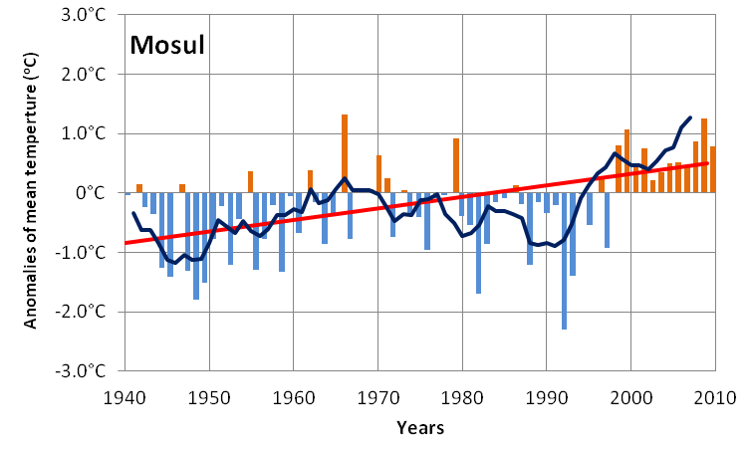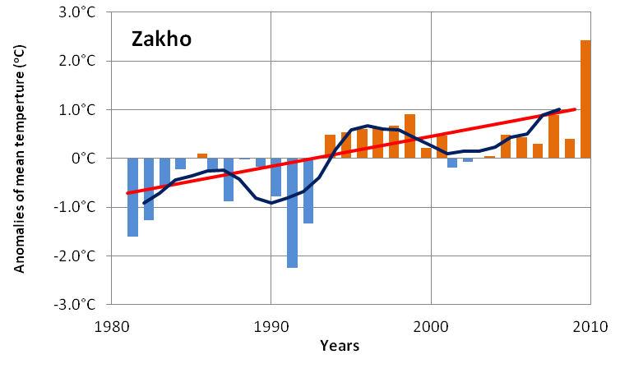
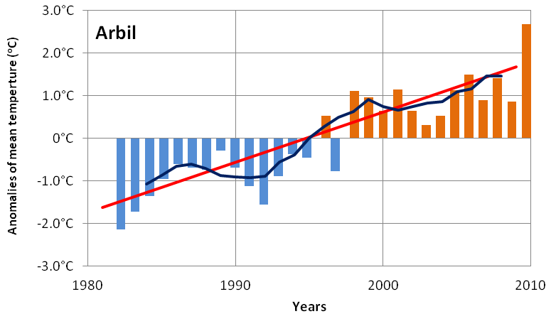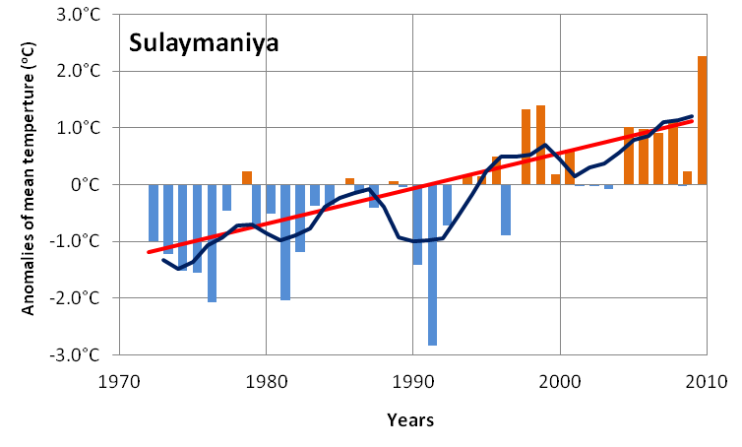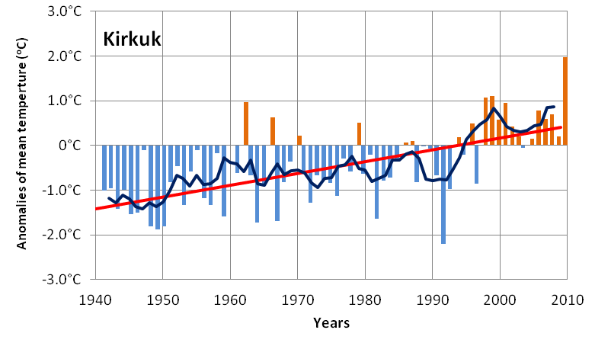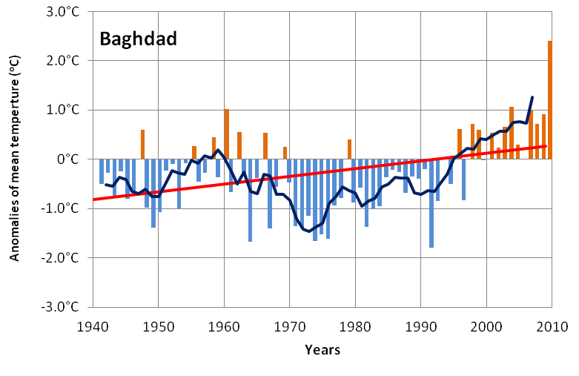
Figure (2a) Anomalies of mean annual temperatures (T ºC) for Zakho, Mosul, Arbil, Sulaymaniya, Kirkuk and Baghdad.
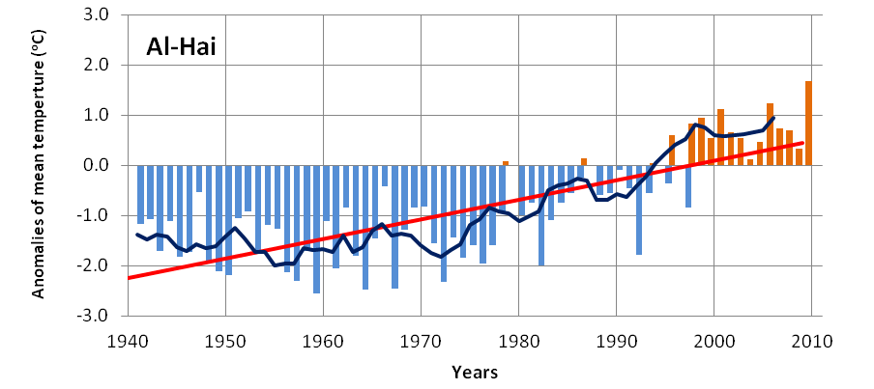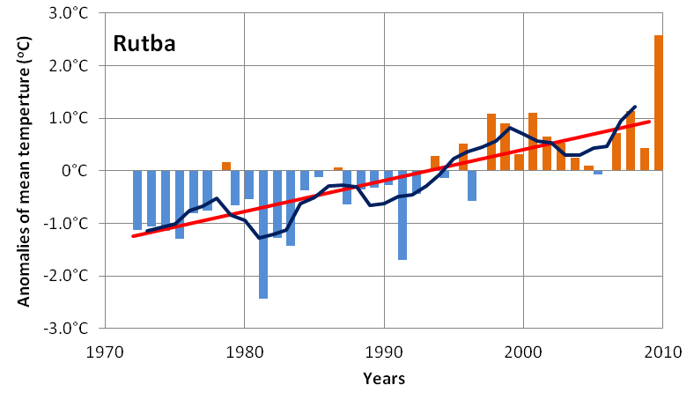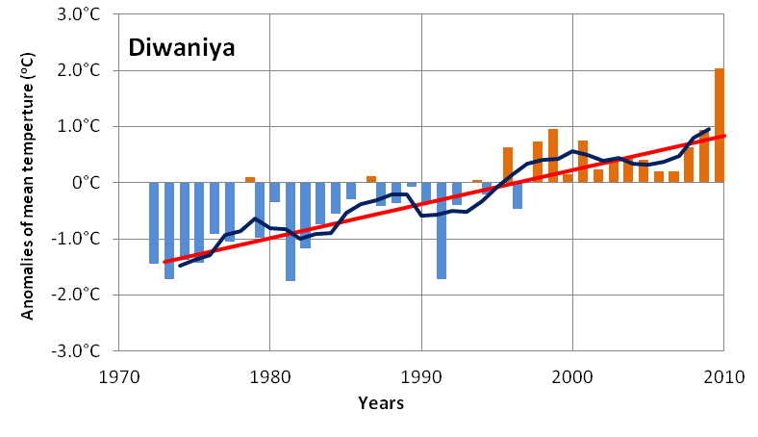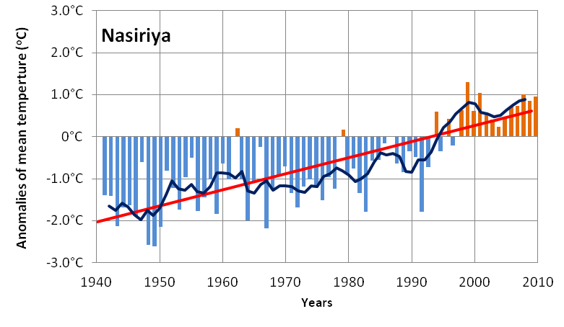
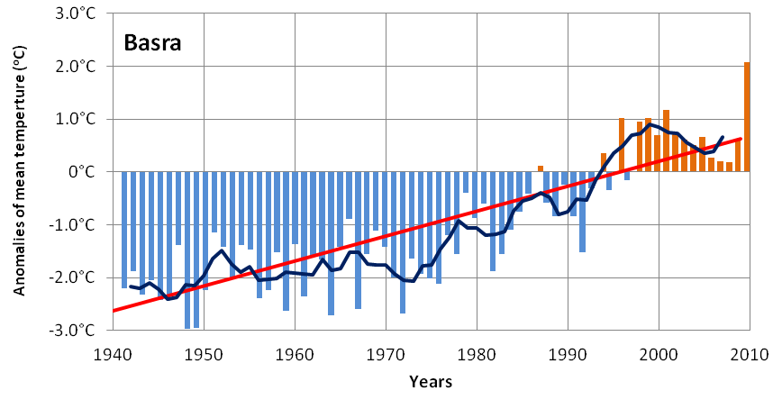
Figure2b. The same as Fig. 2a. But for Rutba, Al-Hai, Diwaniya,Nasiriya and Basra

References
- Al-Ansari N., Al-Oun S., Hadad W., Knutsson S.(2013): Water loss in Mafraq Governorate, Jordan, Natural Science, Vol.5, No.3, 333-340.
- Brazdil H. R. and Coauthors (1999): Progress in the study of climatic extremes in northern and central Europe. Climatic Change, 42, 151–181.
- Gilbert, R. O. (1987): Statistical methods for environmental pollution monitoring. Van Nostrand Reinhold Co., New York, 320 pp.
- Jones, P. D., E. B. Horton, C. K. Folland, M. Hulme, D. E. Parker, and T. A. Basnett (1999): The use of indices to identify changes in climatic extremes. Climatic Change, 42, 131–149.
- Karaburun Ahmet, Ali Demirci and Fatih Kara (2012): Analysis of Spatially Distributed Annual, Seasonal and Monthly Temperatures in MARMARA REGION FROM 1975 to 2006. Ozean Journal of Applied Sciences Journal 5 (2): 1943-2429, 2012.
- Karl TR, Knight RW, Easterling DR, Quayle RG (1996): Indices of climate change for the United States. Bull Amer Meteor Soc, 77: 279–292.
- Kattenberg, A., and Coauthors (1996): Climate models—projections of future climate. Climate Change 1995: The Science of Climate Change, J. T. Houghton et al., Eds., Cambridge University Press, 285–357.
- Luo, Y., Liu, S., Fu, S. F., Liu, J., Wang, G., Zhou, G. (2008): Trends of precipitation in Beijiang River Basin, Guangdong Province, China. Hydrological Processes, 22: 2377–2386.
- Plummer N, Salinger MJ, Nicholis N, Suppiah R, Henhessy KJ, Leichton RM, Trewin B, Page CM, Lough GM (1999): Changes in climate extremes over the Australian region and New Zealand during the twentieth century’s. Climate Change, 42: 183–202.
- Salmi, T., Maata, A., Antilla, P., Ruoho-Airola, T., Amnell, T. (2002): Detecting trends of annual values of atmospheric pollutants by the Mann– Kendall test and Sen’s slope estimates – the Excel template application Makesens. Finnish Meteorological Institute, Helsinki, Finland, 35 pp.
- Sen, P. K. (1968): Estimates of the regression coefficient based on Kendall’s tau. Journal of the American Statistical Association, 63:1379–1389.
- Shahid, S. (2011): Trends in extreme rainfall events of Bangladesh. Theoretical and Applied Climatology, 104: 489–499.
- Sirois, Allan (1998): A Brief and Biased Overview of Time Series Analysis or How to Find that Evasive Trend. In WMO report No. 133: WMO/EMEP workshop on Advanced Statistical methods and their Application to Air Quality Data sets (Helsinki, 14-18 September 1998).
- Tomozeiu, R. Busuioc, A. and Stefan, S. (2002): Change in seasonal mean maximum air temperatures in Romania and their connection with large-scale circulation. International Journal of Climatology, 22, 1181-1196.
- Wang, X. L. (2003): Comment on ‘‘Detection of undocumented change points: A revision of the two-phase regression model,’’ J. Clim., 16, 3383– 3385.
- Zhai PM, Sun AJ, Ren FM (1999): Changes of climate extremes in China. Climate Change, 42(1): 203–218.
- Zhang, X., L. A. Vincent, W. D. Hogg, and A. Niitsoo, (2000): Temperature and precipitation trends in Canada during the 20th century. Atmos.–Ocean, 38, 395–429.

11/12/2013

