Morphological and Histological Changes in the Camel Testes In Relation To Semen Characteristics During Breeding and Non-Breeding Seasons

Maiada, W.A. Allam¹ E.B. Abdalla¹, A.E.B. Zeidan², M.H. Farouk³, and A.M. Abd El-Salaam²

¹Animal Production Department, Faculty of Agriculture, Ain Shams University, Cairo, Egypt
²Animal Production Research Institute, Dokki, Giza, Egypt
³Animal Production Department, Faculty of Agriculture, Al-Azhar University, Nasr City, Cairo, Egypt.
mhfarouk@hotmaik.com

Abstract: A total number of 65 clinically healthy male dromedary camels were used in the present study. The age of these camels ranged from 5 to 10 years and their weights were approximately 500 kg an average. The experimental work aimed to investigate the effect of breeding and non-breeding seasons either hot-humid or hot-dry months on testicular measurements, epididymal semen characteristics and histological changes in the right and left testes of the dromedary camels. The obtained results showed that, the testis weight, testicular volume, scrotal circumference, testis tone firmer score and the percentage of sperm motility, sperm-cell concentration of the dromedary camels were significantly (P<0.05) higher during breeding than non-breeding season either hot-dry or hot-humid months, while the percentages of dead spermatozoa, sperm abnormalities and acrosomal damage of spermatozoa were significantly (P <0.05) higher during hot-humid months as compared to both hot-dry months and breeding season. Semen colour was creamish white, milky white and watery white during breeding season, hot-dry and hot-humid months, respectively. Semen consistency was viscous during breeding season and hot-dry months and semi-viscous during hot-humid months. Seminal pH value was significantly (P <0.05) higher during hot-humid months as compared to both breeding season and hot-dry months. The testis of the male dromedary camels during breeding season showed consisted of numerous semineferous tubules (ST) with different shapes and size (oval, ovaid and circular) were highly active. The ST lined by spermatogenic cells at different maturation stages (spermatogonium, spermatocytes, spermatid and spermatozoa) are present as compared to camels during non-breeding season either hot-dry or hot-humid months.
[Maiada, W.A. Allam, E.B. Abdalla, A.E.B. Zeidan, M.H. Farouk, and A.M. Abd El-Salaam. Morphological and Histological Changes in the Camel Testes In Relation To Semen Characteristics During Breeding and Non-Breeding Seasons. Nat Sci 2013;11(12): 129-137]. (ISSN: 1545-0740). http://www.sciencepub.net 20

Keywords: Male camel, semen, breeding season, hot-humid, hot-dry, testes histology

1. Introduction:
The camel is a domesticated animal whose full agricultural reproductive potential has not yet been achieved. It is fully adapted to the rigours of the extreme diurnal variations of temperature of the arid zones of Africa and Asia and therefore requires little expenditure in terms of housing or shelter. The dromedarius camels are regarded as seasonal breeders (Wilson, 1984). The impression gained is that decreasing day length is the stimulus to seasonally, but it is obvious that, in dromedary camels near the equator factors such as rainfall, nutrition and management (Wilson, 1984), may override the effect of photoperiod (Merkt et al., 1990) and allow breeding to occur throughout the year (Arthur et al.,1982).
The breeding season of camels varies geographically, since the environmental factors affect temporally the pattern of reproduction in this species (Gombe and Okelo, 1977). Daylight ratio and temperature are the two main climatic factors influencing the seasonal physiological and biochemical changes which, in turn affect the sexual behavior. However, numerous investigations have shown that the most efficient climatic factors are the variation in the daylight ratio (Hafez, 2000), although the length of daylight seems to be the primary stimulus for seasonally in reproduction.
Testicular sperm achieve fertilizing ability through the epididymis (Bedford, 1975). Although the process of sperm maturation is not clearly understood, it is believed that the epididymis provides a specific milieu (Ariyaratna et al., 1996), this milieu results from interepithelial ion exchange and secretory and absorptive activities of the epithelium and is regulated by androgenic hormones (Brooks and Higgins, 1980).
The present study aimed to investigate the effect of breeding and non-breeding seasons either hot-humid or hot-dry months on testicular measurements, epididymal semen characteristics and histological changes in the right and left testes of the male dromedary camels.
2. Materials and methods
The present study was conducted in the Department of Animal Production, Faculty of Agriculture, Ain Shams University, Cairo, Egypt. The experimental work was carried out in Private Camel Farm and Abattoris in Belbies City, Sharkiya Governorate, located in the north eastern part of the Nile Delta (30°N).
The present study aimed to investigate the effect of breeding season (December to May) and non-breeding season either hot-humid (June to August) or hot-dry (September to November) months on testicular measurements (testis weight, testicular volume, scrotal circumferences and testis tone firmer score), epididymal semen characteristics (semen colour , semen consistency, hydrogen-ion concentration (pH), percentages of sperm motility, dead spermatozoa, sperm abnormalities, acrosomal damage of spermatozoa and sperm cell-concentration) and histological changes in the right and left testes of the dromedary camels. A total number of 65 clinically healthy male dromedary camels were used in this study. The age of these camels ranged from 5 to 10 years and their weights were approximately 500 kg an average.
Testicular measurements:
Testes were weighed to the nearest gram by an ordinary balance after slaughtering. Testicular volume was determined as the method described by Weibel (1989) using the following formulae:
Testicular volume | = | π × L × B × T
 |  | 6
Where: π = 3.14
L = Length of the longitudinal axis of the testis,
B = Breadth of the testis,
T = Thickness of the testis.
Scrotal circumference was measured with a flexible cloth measuring tape around the largest diameter of the testis and scrotum placed after pushing the testes firmly into the scrotum (Mickelson et al., 1982).
Testes tone firmer (score) was determined via manual palpation (scored from 1: very soft and 9: very firm) as described by Wildeus and Hammond (1993).
Camel semen collection:
Epididymal semen was collected from the dromedary camels after slaughtering. A total number of 65 clinically normal testes were collected during breeding (n=23) and non-breeding seasons (n=42) either hot-humid (n=22) or hot-dry (n=20) months.
Transportation of the samples:
The genitalia (epididymes attached to the testes) were removed from the carcass and transferred to the laboratory for semen analysis in a thermos flask containing sterile physiological saline (0.9% NaCl) supplemented with 100 μg/ml streptomycin at 25°C according to Goto et al. (1989) within 2-3 hours post-slaughtering.
Sperm recovery:
The epididymis (n=65) was thoroughly cleaned and the superficial blood vessels of the cauda were punctured, so that most of the blood could be wiped off. Epididymal semen was collected directly after slaughtering from the body of epididymis (corpus of epididymis). Each corpus epididymis region was cut to allow the escape of its contents in buffer citrate solution (0.5 ml NaCl) for the determination of semen characteristics immediately after collection (Kaabi et al., 2003).
Semen colour of the dromedary camels was determined directly from the collecting tube. Semen consistency of the dromedary camels was qualified as viscous when semen did not drop from a Pasteur pipette, semi-viscous when semen dropped from the Pasteur pipette to glass slide and liquid when semen was fluid and dropped readily from the Pasteur pipette according to Bravo et al. (1997).
Hydrogen-ion concentration (pH):
The pH value of the semen of the male dromedary camels was measured by using universal indicator paper and standard commercial stains according to Karras (1952).
Percentage of sperm motility (%):
Generally, camel sperm motility (%) detected as an oscillatory motion the flagellum, but not progressive due to the viscous materials according to Campbell et al. (1956). Sperm motility was estimated by adding one drop of the diluted fresh semen with physiological saline (0.9% sodium chloride) on the dry, clean and pre-warmed (37°C) glass slide.
Sperm motility was estimated by observing the approximate percentage of spermatozoa moving forward motion across the field of vision with a normal vigorous swimming motion according to Plasson (1975).
Percentages of dead spermatozoa and sperm abnormalities were recorded according to Salisbury et al. (1978). The percentage of acrosomal damage was done according to Watson (1975).
Sperm-cell concentration (×10⁶/ml):
The spermatozoa were counted using haemocytometer according to Khan (1971).
Histological changes of the camel testes:
For histopathological studies, the testes (right and left) were taken and put in neutral formal saline (10%) to be preserved, then it passes in ordinary histological set (puttig small pieces of the fresh tissues in the proper fixative as 10% formaline saline). Then after, fixed tissues were washed in running tap water to remove fixative from them and then the water was removed by treatment with ethyl alcohol (70, 80, 90 and 100%). These ascending grades of alcohol prevent shrinkage of tissues and they remove the water completely from the fixed tissues. Then the tissues were treated with clearing agents as xylol to remove alcohol and to allow the fixed tissues to be miscible with paraffin wax which will be used in the next step. Then the tissues are put in melting soft paraffin wax at 60°C. The paraffin will penetrate in between the cells of the tissue. This process of paraffin wax infiltration is a necessary step to harden the tissues before their embedding. The tissues were then embedded in the center of melted paraffin. The paraffin wax was then allowed to be cooled-down in order to form a block of hard paraffin with tissues in its center. The block of hard paraffin with tissues in its center was cut into thin sections by means of rotatory microtome. The thin paraffin sections (4-6 micrometer) were placed on clean glass slides smeared with albumin and glycerin mixture (1:1) to flow beneath the sections and then slides were warmed on hot plate. Thereafter, the sections were preserved for several hours in the incubator to dry. The sections were stained by Haematoxylin and Eosin (H&E) stains according to Culling (1975). After staining, the slides were examined by binuclear microscope and photographed by magnification x 10 & 40.
Data were statistically analyzed by one way ANOVA, using General Linear Model (GLM) procedure of SAS (Goodnight et al., 1986) and Duncan’s New Multiple Range test (Duncan, 1955) was used to detect significant differences among means.
3. Results and Discussion
Testicular measurements
Data presented in Table (1) showed that, the testis weight, testicular volume, scrotal circumference and testes tone firmer score of the dromedary camels were significantly (P <0.05) higher during breeding than non-breeding season either hot-dry or hot-humid months. The testis weight, testicular volume and scrotal circumference during non-breeding season in hot-humid months were significantly (P<0.05) lower than hot-dry months. The highest (P<0.05) values of the testis weight, testicular volume and scrotal circumference were recorded during breeding season, while the lowest (P<0.05) values were recorded during hot-humid months. Similar trend was reported by Volcani (1954) who found that the testis size was bigger during rutting season in winter than hot summer months (non-breeding season). Similarly, Ahmadi (2001) and Zeidan et al. (2001) found that the testis weight was significantly higher during winter and spring than summer and autumn seasons. The variation of the testis weight in between the active and inactive stages amounts to about 30% (average of 96.0 and 66.0 gm, respectively). El-Sherief (1997) and Zeidan and Abbas (2004) also found that the testis increased in winter (breeding season) and decreased in summer (non-breeding season). These findings may be due to the increase in the amount of interstitial tissues and spermatogenesis and the growth of the soft palate that takes place during the rutting season (Charnot and Racadot, 1963 and Charnot, 1964). In addition, the reduction in testis weight during summer may be due to exposure to heat stress which due to degeneration in the germinal epithelium and to a partial atrophy in the seminiferous tubules (Chou et al., 1974). However, Ismail (1979) found that testis weight of the camel in Egypt was highest in the summer (71.3gm) and lowest in winter months (56.0gm).
In respect to testicular volume, Charnot (1965) found that the size of the testis was greatly increased due to increased in the development of interstitial tissue during rut season. Zeidan and Abbas (2004) showed also that testicular volume was significantly higher during the rutting as compared with the non-breeding season in the dromedary camels. The increased of testicular volume during winter and spring may be attributed to the increase spermatogonia, spermatocytes, spermatids and spermatozoa. In addition, the interstitial tissue increased markedly with evidence of oedema (Hemeida et al., 1985). The testes dimensions increased during breeding season reflecting higher spermatogenesis is activity affected by increasing testosterone concentration and development of interstitial tissues.
In scrotal circumference, Zeidan and Abbas (2004) showed that scrotal circumference was significantly higher during the rutting as compared with the non-breeding season in the dromedary camels. These results may be attributed to the high environmental temperature during late summer causing a more pendulous arrangement of the scrotum with reduced scrotal wrinkling (Zeidan et al., 2001).
The testis tone firmer score during non-breeding season in hot-humid months was insignificantly lower than hot-dry months. The highest (P<0.05) value of the testis tone firmer score was recorded during breeding season, while the lowest (P<0.05) value was recorded during non-breeding season in hot-humid months. These results are in agreement with those reported by Ahmadi (2001) and Zeidan et al. (2001) who found that the testes tone firmer was significantly higher during winter and spring than summer and autumn seasons. Similar trend was reported by Zeidan and Abbas (2004) showed that testis tone firmer score was significantly higher during the rutting as compared with the non-breeding season in the dromedary camels.
Generally, photoperiod seems to play a major role in regulating the seasonal activity (rutting season) of the camel testes which are regarded as short day breeders. In which change from long to short day seems to stimulate synthesis and release of gonadotropins hormones from the anterior pituitary gland, which in turn stimulate testicular activity and sexual behaviour (Lincoln et al., 1977).

Table 1. Effects of breeding and non-breeding seasons either hot-humid or hot-dry months on testicular measurements in the dromedary camels (Means ± SE).
Items | Season
 | Breeding | Non-breeding
 |  | Hot-humid months | Hot-dry months
Testis weight (gm) | 128.61 ± 2.06ª | 102.27 ± 2.11^{c} | 114.15 ± 2.21^{b}
Testicular volume (cm³) | 116.30 ±1.79ª | 82.18 ± 1.83^{c} | 101.75 ± 1.92^{b}
Scrotal circumference (cm) | 26.83 ± 0.95ª | 14.23 ± 0.96^{c} | 20.15 ± 1.02^{b}
Testis tone firmer (Score) | 7.80 ± 0.27ª | 6.45 ± 0.27^{b} | 6.82 ± 0.29^{b}
^{a-c}Values with different superscripts within a row are significantly different (P<0.05).

Epididymal semen characteristics Semen colour
Data presented in Table (2) showed that, semen colour of the dromedary camels was creamish white, milky white and watery white during breeding season, hot-dry and hot-humid months, respectively. These results are in agreement with those reported by Rai et al. (1997) and Zeidan and Abbas (2004) who showed that, semen was creamy in colour during the breeding season, while watery white during the non-breeding season in the dromedary camels. Similar trend was reported by Abd El-Azim (1996), Ahmadi (2001) and Zeidan et al. (2001) they found that semen colour was yellowish white, creamish white and milky white during winter and spring, grayish white, watery white and light milky white in summer and autumn in the dromedary camels at 3-5, 6-11 and 12-20 years old, respectively. The different colour of semen during different seasons of the year may be due to the different concentrations of spermatozoa and semen consistency (Zeidan et al., 2000).
Semen consistency
Data presented in Table (2) showed that, semen consistency of the dromedary camels was viscous during breeding season and hot-dry months and semi-viscous during hot-humid months. These results are in agreement with those reported by Rai et al. (1997) who found that semen consistency was medium and thick jelly during breeding and non-breeding seasons, respectively. Zeidan et al. (2007) showed that semen consistency was viscous in the camels at 5 to 10 and 10 to 15 years and semi-viscous in the camels at 15 to 20 years old. Viscosity of the camel semen is usually attributed to the presence of mucopolysaccharides (Mann, 1964, Garnica et al., 1993 and Hassan et al., 1995) which only secreted from bulbourethral or the prostate glands. Immediately after semen collection, the ejaculate becomes aqueous in consistency. The physiological role of mucopolysaccharides is not clear.
The hydrogen-ion concentration (pH)
Data presented in Table (2) showed that, the hydrogen-ion concentration (pH) of the male dromedary camels semen was significantly (P<0.05) higher during hot-humid months than breeding seasons or hot-dry months. The hydrogen-ion concentration (pH) during breeding season was significantly (P<0.05) decreased as compared with the non-breeding season. The hydrogen-ion concentration (pH) during non-breeding season in hot-dry months was significantly (P<0.05) lower than hot-humid months. The highest (P <0.05) value of hydrogen-ion concentration (pH) was recorded in hot-humid months, while the lowest (P<0.05) value was recorded in hot-dry months. Similar trend was reported by Agarwal and Khanna (1993), Abd El-Azim (1996) and Abd El-Samee et al. (2006). The alkalinity reaction of the camel semen was increased during the sexual activity (rutting seasons) than during the sexually rest period (Musa et al., 1992). Ahmadi (2001) found that the hydrogen-ion concentration (pH) was insignificantly higher during winter and spring than summer and autumn seasons.
Percentage of sperm motility and the sperm-cell concentration
Data presented in Table (2) showed that, the percentage of sperm motility and the sperm-cell concentration of the dromedary camels were significantly (P <0.05) higher during breeding than non-breeding seasons either hot-dry or hot-humid months. The percentage of sperm motility and the sperm-cell concentration during non-breeding season in hot-humid months were significantly (P <0.05) lower than hot-dry months. The highest (P <0.05) values of the percentage of sperm motility and the sperm-cell concentration were recorded during breeding season, while the lowest (P <0.05) values were recorded during the non-breeding season in hot-humid months. Similar trend was reported by Abd El-Raouf and Owaida (1974) and Abd El-Azim (1996) in camels. Ahmadi (2001) and Zeidan et al. (2001) found that the percentage of sperm motility of the dromedary camel was significantly higher during winter than spring, summer and autumn seasons. Similarly, Zeidan and Abbas (2004) showed that percentage of sperm motility was significantly higher during the rutting as compared with the non-breeding season in the male dromedary camels. These results may be attributed to increase of the mature Leydig cells and spermatogenesis process are increased significantly during the rut season than during the summer one (non-breeding season). As the Leydig cells are mainly responsible for testosterone production. So, an improvement in the semen quality is expected to occur during the rut season (Charnot, 1965).
In addition, the low sperm-cell concentration of the camel semen during non-breeding season (summer) may be attributed to the long day length, as well as, heat stress which lead to reduction in the interstitial cells stimulating hormones and consequently, reduction in androgen production (Sinha and Prasad, 1993). Moreover, the increase of sperm-cell concentration during the rutting season (winter and spring) may be expected and parallel with the results obtained by Fat-Halla and Ismail (1980) who found that FSH concentrations in the male camels were the highest during the rutting season. A positive relationship between FSH level and spermatogenesis was reported by Franchimont (1972). The sperm concentration in the semen is affected by multitude of factors such as virility of the bull, frequency of services, season of the year and the intensity of sexual excitement. Some of these factors might have been responsible for the disparity in the findings of this investigation and those of other workers (Agarwal et al., 2004).
Percentage of dead spermatozoa, sperm abnormalities and acrosomal damage of spermatozoa
Data presented in Table (2) showed that, the percentages of dead spermatozoa, sperm abnormalities and acrosomal damage of spermatozoa of the dromedary camels were significantly (P <0.05) higher during hot-humid months than hot-dry months or breeding season. The percentage of dead spermatozoa, sperm abnormalities and acrosomal damage of spermatozoa during non-breeding season in hot-humid months was significantly (P <0.05) higher than hot-dry months. The highest (P <0.05) values of the percentage of dead spermatozoa, sperm abnormalities and acrosomal damage of spermatozoa were recorded during hot-humid months, while the lowest (P <0.05) values were recorded during breeding season. These results are in agreement with those reported by Ahmadi (2001) and Zeidan et al. (2001) who found that the percentage of dead spermatozoa was significantly higher during summer than autumn, winter and spring seasons. Similar trends were reported by Abd El-Azim (1996), Rai et al. (1997), Zeidan and Abbas (2004) and Abd El-Samee et al. (2006) in camels. These results may be due to the decline of temperature during winter and short photoperiods which have effect on the pituitary gland and activity of spermatogenic process and the critical temperature that inhibits spermatogenesis (Rhynes and Ewing, 1973). In addition, heat stress during summer (non-breeding season) which may be cause disturbance in spermatogenesis process due to degenerative changes with diminished number of mature spermatozoa or destruction or even death of spermatozoa (Abd El-Raouf and Owaida, 1974; Musa et al., 1992 and Zeidan et al., 2001).
Zeidan and Abbas (2004) and Abd El-Samee et al. (2006) found that the percentage of acrosomal damage of spermatozoa was significantly higher during spring, summer and autumn than winter. These results may be attributed to the onset of rut which is marked by increase in activity in the Alpha and Beta secreting cells in the anterior pituitary and increase in Leydig cells active in the rut season with a resulting reduction in steriodogenic activity by the testes and high testosterone levels which due to improvement of spermatogenesis and decrease of acrosomal damage of spermatozoa.

Table 2. Effects of breeding and non-breeding seasons either hot-humid or hot-dry months on the epididymal semen characteristics in the dromedary camels (Means ± SE).
Items | Season
 | Breeding | Non-breeding
 |  | Hot-humid months | Hot-dry months
Semen colour | Creamish white | Watery white | Milky white
Semen consistency | Viscous | Semi-viscous | Viscous
Hydrogen-ion concentration (pH) | 7.85 ± 0.102^{b} | 8.27 ± 0.104ª | 7.62 ± 0.11^{b}
Sperm motility (%) | 80.43 ± 1.12ª | 58.18 ± 1.15^{c} | 72.25 ± 1.20^{b}
Dead spermatozoa (%) | 12.83 ± 0.92^{b} | 23.18 ± 0.94ª | 15.20 ± 0.98^{b}
Sperm abnormalities (%) | 8.91± 0.83^{b} | 15.73 ± 0.85ª | 10.35 ± 0.89^{b}
Acrosomal damage(%) | 5.74 ± 0.77^{b} | 11.05 ± 0.79ª | 6.15 ± 0.83^{b}
Sperm-cell concentration (×10⁶/ml) | 426.30 ± 11.70ª | 281.59 ± 11.96^{c} | 345.25 ± 12.55^{b}
^{a-c}Values with different superscripts within a row are significantly different (P<0.05).

Histological changes of the testes
The histological section in the right testis of the camel during breeding season revealed that, the right testis (Plate 1) was the highly active and consisted of numerous seminiferous tubules (ST) with the different shapes and size (oval, ovaid and circular). The ST lined by spermatogenic cells of different maturation stages (spermatogonium, spermatocytes, spermatid and spermatozoa) in the left testis during breeding season (Plate 2). The ST surrounded by interstitial cells "Leydig cells" which characterized by numerous ovoid cells.
In the right testis of the camel during the non-breeding season in hot-humid months showed some degenerations and vacuolations in the ST (Plate 3). Meanwhile, the left testis during the non-breeding season in hot-humid months showed the number of the Leydig cells was numerous (Plate 4).
The right testis of the camel during the non-breeding season in hot-dry months showed that the ST were numerous of different shapes, sizes and physiological states (Plate 5). The left testis of the camel during the non-breeding season in hot-dry months showed that the cells of the ST characterized by depletion in the high season of non-breeding in the form of vacuolation and desquamation of some spermatogenic cells (Plate 6). Whereas, it appeared as inert with intact spermatogenic cells and numerous interstitial cells in the right testis in hot-dry months (Plate 5).
The left testis of the camel during the non-breeding season in hot-dry months showed that it also appeared in the same sample as vacuolated spots in the spermatogenic series of cells in the ST with increased interstitial connective tissue (Plate 6). It also appeared as depleted cells with desquamated spermatogenic cells and numerous connective tissues (CT) fibres, intact spermatogonium and atrophy in the Leydig cells (Plate 6). In addition, the left testes during breeding season showed that the ST were highly convoluted, more activity in the spermatogenesis, all stages of spermatogenesis, primary spermatocytes, secondary spermatocytes and mature spermatozoa (Plate 1). So, the left testes being to be more active than the right one (Plate 2).
In respect to the non-breeding season in the hot-humid months, the right testes revealed dormant stage and the ST less in activity than the left testes (Plate 3). The stage of spermatogenesis is also inactive and the interstitial tissues were less vascularized (Plate 4). With regard to hot-dry months, the left testes (Plate 5) showed highly active, all the spermatogenesis stages are present and spermatozoa inside the lumen of the ST were highly convoluted as compared to the right testes (Plate 6). Also in the left testes during hot-dry months showed slightly and nearly as the breeding season. Similar trends were recorded by Zayed (1994), Ahmadi (2001), Zeidan and Abbas (2004) and Abdel-Samee et al. (2006) in the dromedary camels. In addition, the histological status in the camel’s testes during breeding season showed the ST with active spermatogenesis and the Sertoli cells increased in size and nuclei become large, enlarged with distinct nucleoli and light eosinophilic cytoplasm. The Leydig cells increased also in size more than in camel testes during the non-breeding season either hot-humid or hot-dry months.
In general, the histological status in the testes of the dromedary camels as affected by different seasons of the year and side of testes revealed highly active during the breeding season at the left testes, slightly active during the non-breeding season in hot-dry months and inactive during the non-breeding season in the hot-humid months and right testes. Similar trends were reported by Osman and Ploen (1986), Zeidan and Abbas (2004) and Abdel-Samee et al. (2006) in the dromedary camels.
In conclusion, the male dromedary camels (Camelus dromedaries) during breeding season (short day light) showed testicular activity and epididymal semen characteristics of the dromedary camels were better as indicated by higher the percentage of sperm motility, sperm-cell concentration and histological status and lower the hydrogen-ion concentration (pH), the percentages of dead spermatozoa, sperm abnormalities and acrosomal damage of spermatozoa than non-breeding season either hot-dry or hot-humid months (long day light). So, the epididymal spermatozoa of the dromedary camels has the potential of being used in the laboratory investigations related to in vitro fertilization (IVF) and artificial insemination (AI) as a useful tool in animal breeding programmes. Further detailed studies are required to establish the reproductive efficiency of the male dromedary camels through the non-breeding season especially in both hot-humid and hot-dry months under Egyptian environmental conditions.

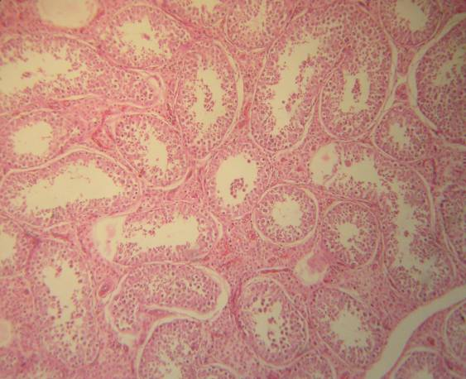
Plate 1. Photomicrograph of the right testis in the breeding season, showing; seminiferous tubules (ST) of different shape and size (H & E ×10).

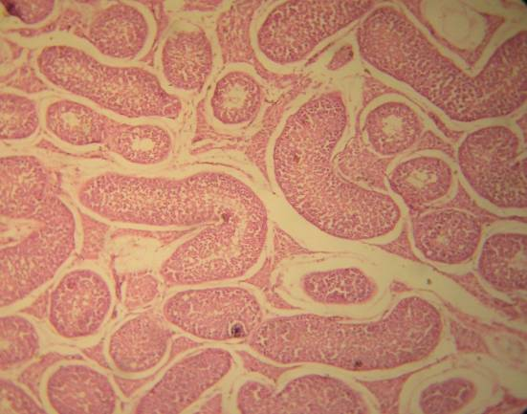
Plate 2. Photomicrograph of the left testis in the breeding season, showing; the lining epithelium of the seminiferous tubules (ST), spermatogonium, spermatocytes, spermatid and spermatozoa (H & E ×40).
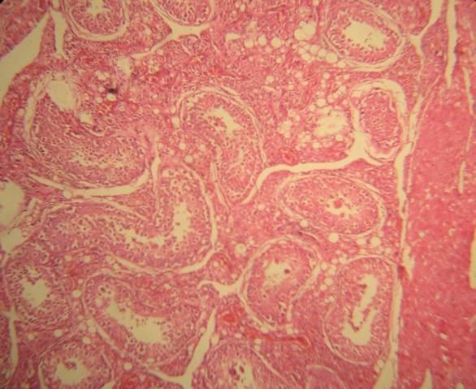
Plate 3. Photomicrograph of the right testis in the hot-humid months, showing; degeneration and vacuolation in the seminiferous tubules (ST) (H & E ×40).
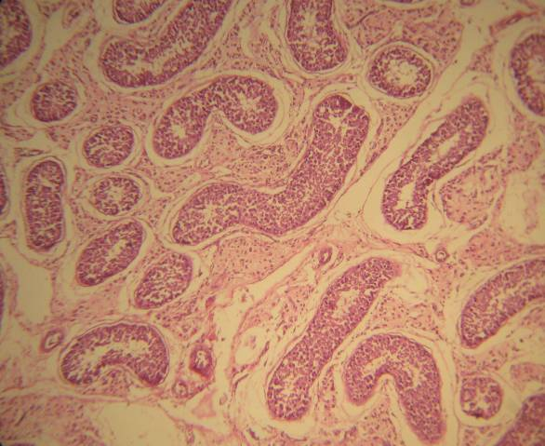
Plate 4. Photomicrograph of the left testis in the hot-humid months, showing; numerous, ovoid shape leydig cells (H & E ×10).

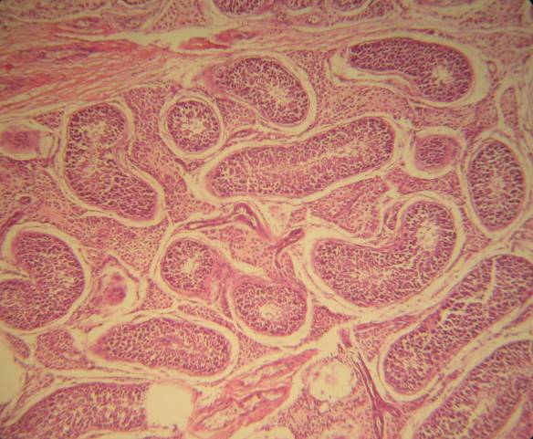
Plate 5. Photomicrograph of the right testis in the hot-dry months, showing; inert, non active spermatogenic series of cells (H & E ×20).

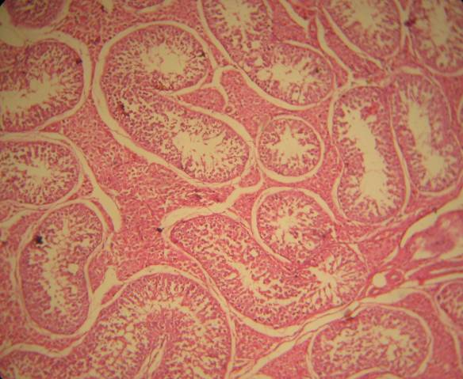
Plate 6. Photomicrograph of the left testis in the hot-dry months, showing; depletion and vacuolation in the spermatogenic cell series and desquamation of the cells (H & E ×20).

References
- Abd El-Azim, A.M. (1996). Aging and its effect on the reproductive performance of male one-humped camel during different seasons. Ph.D. Thesis, Fac. Vet. Med., Zagazig Univ., Zagazig, Egypt.
- Abd El-Raouf, M.F. and Owaida, M.M. (1974). Studies on reproduction in camels (Camelus dromedarius). IV. Gross changes in the morphology of the testis in relation to age and season. Assuit Vet. Med. J., 1: 213-223.
- Abd El-Samee, A.M.; Zeidan, A.E.B.; Abbas, H.E. and Ahmadi, E.A.A. (2006). Semen quality and testicular histology with special reference to different seasons of the year and ages of the male dromedary camel. Proc. Intern. Scientific Conf. Camels, 10-12 May, Qassim Univ., K.S.A.
- Agarwal, S.P. and Khanna, N.D. (1993). Endocrine profiles of the Indian camel under different phases of reproduction. Etudes et Syntheses de L’IE MVT, 41: 77-101.
- Agarwal, V.K.; Ram, L.; Rai, A.K.; Khanna, N.D. and Agarwal, S.P. (2004). Physical and biochemical attributes of camel semen. J. Camel Sci., 1: 25-30.
- Ahmadi, E.A.A. (2001). Physiological and reproductive studies on camels. Ph.D. Thesis, Fac. Agric., Zagazig Univ., Zagazig, Egypt.
- Ariyaratna, H.B.S.; Gunawardana, U.K. and Navaratne, M.A. (1996). The epididymis of the prepubertal swamp buffalo (Bubalus bubalus), histochemistry of phospatase. Anat. Histol. Emdryol., 25: 161-165.
- Arthur, G. H.; Noakes, E. and Pearson, H. (1982). Veterinary Reproduction and Obstetrics. Fifth edition. Bailliere Tindall, London, UK.
- Bedford, J.M. (1975). Maturation, transport and fate of spermatozoa in the epididymis, In: Astwood E.B.and Creep R.O. (Ed.): Handbook of Physiology: Endocrinology. Washington, DC, American, Phsiology Soc., pp. 303-318.
- Bravo, P.W.; Flores, U. and Ordonez, C. (1997). Effects of repeated collection on semen characteristics of alpacas. Biol. Reprod., 57: 520-524.
- Brooks, D.E. and Higgins, S.J. (1980). Characterization and androgen-dependence of proteins associated with luminal fluid and spermatozoa in the rat epididymis. J. Reprod. Fertil., 59: 363-375.
- Campbell, R.C.; Dott, H.M. and Glover, T.D. (1956). Nigrosin-Eosine as stain for differentiating live and dead spermatozoa. J. Agric. Sci., 48: 1-8.
- Charnot, Y. (1964). Le cycle testiculaire du dromedaire. Bulltain Sec. Sci. Nat. Phys. Maroc., 44: 37-45.
- Charnot, Y. (1965). Endocrinologie sexualle et eshydration cheze dromadaire male. C.R. Séance, Soc. Biol., 159: 1103-1105.
- Charnot, Y. and Racadot, M. (1963). An evidence on the cellular categories of the anterior lobe of the hypophyses in dromedary camels. Bull. Microse Applied, 133: 144-158.
- Chou, I.P.; Chuan, L. and Chen, C. (1974). Effect of heating on rabbit spermatogenesis. Chines Med. J., 6: 365-367.
- Culling, C.F.A. (1975). Handbook of Histopathological and Histochemical techniques 3rd Ed. Buhx. Worth, London, UK.
- Duncan, D.B. (1955). Multiple range and multiple F-test. Biometrics, 11: 1-42.
- El-Sherief, R.H.M. (1997). Studies on camel spermatozoa. Ph.D. Thesis, Fac. Vet. Med. Alexandria Univ., Egypt.
- Fat-Halla, M.M. and Ismail, A.A. (1980). Seasonal variation in gonadotrophins of the one humped male camel (Camelus dromedarius). Proc. 9th Int. Conf. Anim. Reprod. A.I., Madrid, Spain. pp. 237-250.
- Franchimont, P. (1972). Human gonadotrophin secretion. J. R. Coll. Physicians, London, 6: 283-289.
- Garnica, J.; Achata, R. and Bravo, P.W. (1993). Physical and biochemical characteristics of alpaca semen. Anim. Reprod. Sci., 32: 85-90.
- Gombe, S. and Okelo, O. (1977). Effect of temperature and relative humidity on plasma and gonadal testosterone concentration in camels (C. dromedarius). J. Reprod. Fert., 50:107-108.
- Goodnight, J.H.; Sall, J.P. and Sarle, R.F. (1986). The GLM procedure. In SAS User’s Guide. Statistics. SAS Institute Inc., NC, USA.
- Goto, K.; Kajihara, Y.; Koba, M.; Kosaka, S.; Nakamishi, Y. and Ogawa, K. (1989). In vitro fertilization and development of in- vitro matured bovine follicular oocytes. J. Anim. Sci., 76: 2181-2185.
- Hafez, S. E. S. (2000). Reproduction in Farm Animal. 7th Edition, Lea and Febiger, Philadelphia, USA, pp 55-67.
- Hassan, M.M.; Saeed, M. and Rizwan-Ul-Muqtadir (1995). Semen collection by artificial vagina and cryopreservation of camel (Camelus dromedarius) spermatozoa. Pakistan Vet. J., 15: 105-108.
- Hemeida, N.A.; El-Wishy, A.B. and Ismail, S.T. (1985). Testicular abnormalities in the one humped camel. Proc. of 1st Intern. Conf. Applied Sci., Zagazig Univ., Zagazig, Egypt.
- Ismail, S.T. (1979). Factors affecting sperm production in the one humped camel (Camelus dromedarius). M.V.Sc. Thesis, Fac.Vet. Med., Cairo Univ., Egypt.
- Kaabi, M.; Paz, P.; Alvarez, M.; Anel, E.; Boixo, J.C.; Rouissi, H.; Herraez, P. and Anel, L. (2003). Effect of epididymis handling conditions on the quality of ram spermatozoa recovered post-mortem. Theriogenology, 60: 1249-1259.
- Karras, W. (1952). Waerme wasserbad und Registratur, ihre entwicklung und anwendung Deutschland Tieraerzlt-Wochenschr. 59. (suppl.2) 60-62 and 68-69.
- Khan, A.A. (1971). Sexual behaviour of the male camel (Camelus dromedarius) and studies on semen. M.V.Sc. Thesis, Bikaner Univ., Udaipur, India.
- Lincoln, G.A.; Peet, M.J. and Gunninghan, R.A. (1977). Seasonal and circadian changes in the episodic release of follicle stimulating hormone, luteinizing hormone and testosterone in ram exposed to artificial photoperiods. J. Endocrinol., 72: 337-348.
- Mann, T. (1964). Fructose, polyols and organic acids. In: The Biochemistry of Semen of the Male Reproductive Tract. Wiley, New York, USA, p. 240.
- Merkt, H.; Musa, B. R. and El-Nagger, M. A. (1990). Reproduction in Camel. FAO Animal Production Health, paper, No.82, Rome, Italy.
- Mickelsen, W.D.; Paiosley, L.G. and Dahmen, J.J. (1982). The relationship of libido and serving capacity test scores in rams on concentration rate and lambing percentage in the ewe. Theriogenology, 18: 79-86.
- Musa, B.; Sieme, H.; Merkt, H. and Hago, B.E.D. (1992). Artificial insemination in dromedary camels. Proc. 1st Intern. Camel Cong., Dubai, U.A.E. pp. 179-182.
- Osman, D.I. and Ploen, L. (1986). Fine structure of epididymal spermatozoa in the camel (Camelus dromedarius). Anim. Reprod. Sci., 10: 117-184.
- Plasson, S.J. (1975). Veterinary Obstetries and Gynecology. William and Wilson Company, 4th (Ed.), New York, USA, pp. 415-486.
- Rai, A.K.; Sharma, N.; Manivannan, B. and Khanna, N.D. (1997). Camel semen during breeding and non-breeding season. Indian J. Anim. Sci., 67: 397-399.
- Rhynes, W.E. and Ewing, L.L. (1973). Testicular endocrine function in Hereford bulls exposed to high ambient temperature. Endocrinology, 92: 509-517.
- Salisbury, G.W.; Van Demark, N.L. and Lodge, J.R. (1978). Physiology of Reproduction and Artificial Insemination of Cattle. WH Freeman and Company, San Francisco, USA.
- Sinha, H.S. and Prasad, R.B. (1993). Seasonal variation in semen character. Indian Dairy Sci., 19: 83-85.
- Volcani, R. (1954). Seasonal variations in spermatogenesis of some farm animals under the climatic conditions of Israel and Rafuah. Veterinarith, 11: 109-174.
- Watson, P.F. (1975). Use of a Giemsa stain to detect changes in acrosomes of frozen ram spermatozoa. Vet. Rec., 97: 12-15.
- Weibel, E.R. (1989). Stereological methods. Vol. 1. Practical methods for biological morphometry. Academic press, New York.
- Wildeus, S. and Hammond, A.C. (1993). Testicular, semen and blood parameters in adapted and nonadapted Bos taurus bulls in the semi-arid tropics. Theriogenology, 40: 345-355.
- Wilson, R.T. (1984). The Camel, 1st (Ed.), Longman Publishing, London and New York, USA.
- Zayed, A.E.Z. (1994). Morphological studies on the seasonal changes in the testis of camel. M.V.Sc. Thesis, Fac. Vet. Med., Assuit Univ., Assiut, Egypt.
- Zeidan, A.E.B. and Abbas, H.E. (2004). Physiological and biochemical changes in the male dromedary camels during rutting and non-breeding seasons. Zagazig Vet. J., 32: 37-48.
- Zeidan, A.E.B.; Abou-Aiana, R.M.; El-Baz, M.M.; Abd El-Salaam, A.M. and Bahgat, L.B. (2007). Effects of different ages on testicular measurements, copulation time, semen characteristices and blood components in the dromedary camels. Zagazig Vet. J., 35: 48-60.
- Zeidan, A.E.B., El-Darawany, A.A., Absy, G. and Abdel-Ghaffar, A.E. (2000). Testicular measurements, semen characteristics, blood components and penetrating ability of the dromedary camels spermatozoa into cervical mucus in different seasons of the year. Zagazig Vet. J., 28: 43-52.
- Zeidan, A.E.B.; Habeeb, E.A.M.; Ahmadi, E.A.; Amer, H.A. and Abd El-Razik, M.A. (2001). Testicular and physiological changes of the male dromedary camels in relation to different ages and seasons of the year. Proc. 2nd Intern. Conf. Anim. Prod. Health in Semi-Arid Areas, El-Arish North Sinai, Egypt, pp. 147-160.

11/12/2013

