**Čerenkov Radiation: The Space-Time Paradox**

Preecha P. Yupapin1 and Jalil Ali2

1Advanced Studies Center, Department of Physics, Faculty of Science, King Mongkut’s Institute of Technology Ladkrabang (**KMITL**), Ladkrabang, Bangkok 10520, Thailand; [kypreech@kmitl.ac.th](mailto:kypreech@kmitl.ac.th)

2Department of Physics, Faculty of Science, Universiti Teknologi Malaysia, Johor Bahru 81300, Malaysia; [jalilali@utm.my](mailto:jalilali@utm.my)

**Abstract:** Čerenkov radiation has become the interesting phenomenon which can be occurred in many aspects, where in this article, a new model of space-time paradox concept is proposed to describe the <conscious│subconscious> situation, where the connection between whispering gallery mode (WGM) probe and brain signal can be formed and the mind and mater interfacing information described, which is useful for possible mind and dream investigations. The uncertainty of the paradox pair is also involved and discussed.

[Yupapin PP and Ali J. **Čerenkov Radiation: The Space-Time Paradox**. *Nat Sci* 2013; 11(12):116-119]. (ISSN: 1545-0740). <http://www.sciencepub.net/nature>. 18

**Keywords:** Čerenkov radiation, Subtle energy, Space-time paradox, Enlightenment, Extrasensory perception

**Introduction:**

In general, the natural phenomenon is basically localized by a couple (pair), which is defined by the orthogonal state of the possible outcomes, which is an early and influential critique leveled against [quantum mechanics](http://en.wikipedia.org/wiki/Quantum_mechanics), where only one in each pair can be seen, i.e. measured in the certain situation. In which [Albert Einstein](http://en.wikipedia.org/wiki/Albert_Einstein) and his colleagues ([Podolsky](http://en.wikipedia.org/wiki/Boris_Podolsky) and[Rosen](http://en.wikipedia.org/wiki/Nathan_Rosen)) designed a thought experiment intended to reveal what they believed to be inadequacies of quantum mechanics, which is known as EPR paradox. To that end, they hypothesized a consequence of quantum mechanics that its supporters had not noticed but looked unreasonable at the time ([Einstein](http://publish.aps.org/search/field/author/A.%20Einstein) et al., 1935). The routine explanation of this effect was, at that time, provided by [Heisenberg's uncertainty principle](http://en.wikipedia.org/wiki/Heisenberg's_uncertainty_principle). Physical quantities come in pairs which are called [conjugate quantities](http://en.wikipedia.org/wiki/Conjugate_quantities). Examples of such conjugate pairs are position and momentum of a particle and components of spin measured around different axes. When one quantity was measured, and became determined, the conjugated quantity became indeterminate. Heisenberg explained this as a disturbance caused by measurement. The other pairs of EPRs can be categorized by the followings such as Particle**│**Anti-particle: **<P│A>**; Dark**│**Bright soliton pair: **<D│B> (**Phatharaworamet et al., 2010); Entangled photon: **<0│1>**; polarization: <H**│**V>; Conscious**│**Sub-conscious: **<C│SC>**; **Č**erenkov radiation: **<S│ T>**, where few of them have been proposed.

**Čerenkov radiation**:

Two states of radiation can be occurred only one state in each appearance, so we use the terms of space-time paradox for the two states as **<S│T>**. Čerenkov radiation is the [electromagnetic radiation](http://en.wikipedia.org/wiki/Electromagnetic_radiation), which is emitted when a [charged](http://en.wikipedia.org/wiki/Electric_charge) [particle](http://en.wikipedia.org/wiki/Particle_physics) (such as an [electron](http://en.wikipedia.org/wiki/Electron)) passes through a [dielectric](http://en.wikipedia.org/wiki/Dielectric) medium at a [speed](http://en.wikipedia.org/wiki/Speed) greater than the [phase velocity](http://en.wikipedia.org/wiki/Phase_velocity) of [light](http://en.wikipedia.org/wiki/Speed_of_light) in that medium. The charged particles polarize the molecules of that medium, which then turn back rapidly to their ground state, emitting radiation in the process ([Georgescu](http://www.nature.com/nphys/journal/v8/n10/full/nphys2447.html" \l "auth-1), 2012)**. Č**erenkov luminescence imaging is an emerging optical preclinical modality based on the detection of Čerenkov radiation induced by beta particles when traveling though biological tissues**,** for instance,human brain or body tissues with a velocity greater than the speed of light. We present the first human **Č**erenkography obtained by detecting Čerenkov radiation escaping the thyroid gland of a patient treated for hyperthyroidism. The **Č**erenkov light was detected using an electron multiplied charge coupled device and a conventional C-mount lens.

**Rabi oscillation:**

A two-state atom (an atom in which an electron can either be in the excited or ground state) in an electromagnetic field with frequency tuned to the excitation energy, the probability of finding the atom in the excited state is found (Fischer et al., 1998), which means that the ripple of beta particles in brain may cause the Rabi oscillation and finally the Čerenkov radiation is formed, where in this case the Rabi oscillation is forced the particle (beta particle) move(oscillate) with speed exceed the speed of light in the brain liquid.

**Meditation:**

This is the practical method of human noise reduction, where in this case the propagation of beta particle in the human tissues can travel faster than light within the medium, where finally it is possible to obtain a planar image of Čerenkov beta particle escaping from a human tissue. Čerenkography is a potential novel medical tool to image superficial organs of patients treated with beta minus radiopharmaceuticals and can be extended to the imaging of beta plus emitters (Spinelli et al., 2013). In Buddhism, there were number of monks can obtain the Čerenkography after meditation, for instance, Buddha, where the Čerenkov radiation is appear as shown in Figure 1, which is known as an “Enlightenment”. In the physical interpretation concept, if the model of beta particle propagate (circulate) in human brain (or body) is configured by a shiny path as shown in Figure 2, so the Čerenkov radiation can be taken place as shown in Figure 3. When the Buddha was in the Enlightenment status, the bright light around Buddha can be occurred as shown in Figure 1. In Figure 4, it presents the leaky or whispering gallery modes (WGMs) of brain signals can be generated and concentrated (Tamee et al., 2013; Rosch, 2009; Yupapin, 2013; Tamee et al., 2013). By using the proposed conceptual model of WGMs, the extrasensory perceptions such as telepathy, clairvoyance, precognition, and psycho-kinesis can be described, which can be used to make many researches and investigations.

**Whispering gallery mode** (WGM):

WGM of light can be easily generated by using a PANDA ring resonator (Spinelli et al., 2013; Tamee et al., 2013), where the left (R1) and right (R2) rings are placed as the nonlinear coupling modulation part. Figure 4 shows the simulation result of light when the leaky modes and whispering gallery mode within a PANDA ring waveguide are generated***,*** the material is I***nGaAsP/InP***, where the used parameters are the radius R1 = R2 = 1.0 m and R3 = 2.0 µm, Aeff = 0.30 µm2, neff = 3.14, n2 = 1.3 x 10-17 cm2/W, all coupling coefficients (i) are 0.5, = 0.01, 0 = 1.50 µm. The obtained result of the Gaussian pulse with center wavelength of 1.50 μm and power of 10 mW is input into the input port of the PANDA ring circuit as shown in Figure 4, where (a) leaky and whispering gallery modes, (b) WGM probe for particle trapping and transportation.



**Dreaming** is the situation occurred while we are sleeping, which may be in the gap between Conscious │Subconscious, which is under the Čerenkov radiation. It can be described by the two states of conscious and subconscious, <C│SC>, in which there is no time in the gap between the states <CS│C>, which is may be caused by the **Č**erenkov radiation. Apparently, there are 3 dimensions in space localized and 1 time, where time is a free dimension that can go through. During the dream, a 4D (dimensions) person would be capable of passing through walls, disappearing and reappearing at will, seeing through buildings and finding hidden objects, and performing a surgery without even cutting the skin (Hallman, a, b, c, 2012). One can only imagine what it would be like if doctors could observe cancerous growths within the body and then surgically remove them without leaving any bodily scars simply by learning to access the fourth dimension. To date, many dreamers have reported manipulating objects with some degree of control during lucid dreaming.



**Figure 1**: Buddha enlightenment situation (Enlightenment, Google search)

**Furthermore,** the aurora (Frank et al., 1986) borealis is also caused by the Čerenkov radiation, when the atmosphere is bombarded by a lot of high energy charged particles, which occurs predominantly at the earth's poles, where may also be caused by the earth’s magnetic fields. Aurora borealis which is also seen in the living creatures (Kollareddya et al., 2008), for instance, when the Buddha was in the enlightenment situation, however, there is no memory during this situation, the enlightenment person cannot have self-sensory of such a status. In healthcare, the aurora status is also seen because the beta particle can have the speed exceed the speed of electromagnetic wave within the human organ medium.

**Conscious│Subconscious:**

It can be defined by the EPR form as **<C│SC>**, which means that it can be occurred only one event in each appearance. In human, the subconscious can work while they are sleeping, where sometime they can obtain good outcomes better than they are in the waking situations, for instance, good works or ideas can be generated and obtained good after waking up but they have lost the connection of the paradox states, in which all details or procedures of the result methodology were lost, which is no time in the subconscious state, where the imagination can move freely in time within the localized space under the Čerenkov radiation, i.e. a space-time paradox, **<S│T>**. The proposed detection scheme can be plugged to the required paradox state by using the WGM probe, where the condition is that the measurement instrument must be in the same paradox generated by the Čerenkov radiation, otherwise, it will be disappear, i.e. the information is lost.

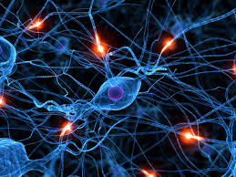

**Figure 2**: Brain electrical signals (beta signals) (Brain signal, Google search)

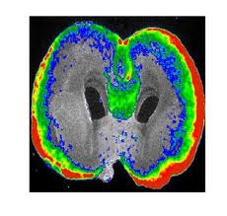

**Figure 3**: Brain signal propagation structure form (Brain signal, Google Search)

We have proposed that the extrasensory perception (imagination) can be occurred when we are in the sub-conscious state, where we can travel freely in time with noiseless condition, which means that there is no time involved in this situation, so there is no recorded data (memory), so we cannot perfectly remember after waking.Imagination is recognized as the most important human creative thinking generation, which was also said by Albert Einstein as “Imagination is more important than knowledge”. However, the extrasensory imagination is not generally found in the common people, in fact, it is an extraordinary case, where sometime it cannot occur in the ordinary life, for instance, it can appear during the sleeping period. Imagination can be described by the paradox pair of Čerenkov radiation (**<S│T>**), which means that these two states are in the orthogonal (entangles) states, which can be randomly occurred in the realistic situation.

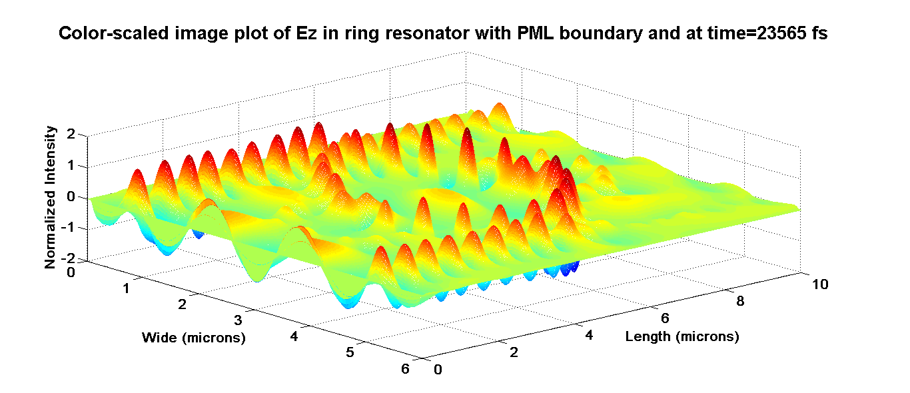

(a)

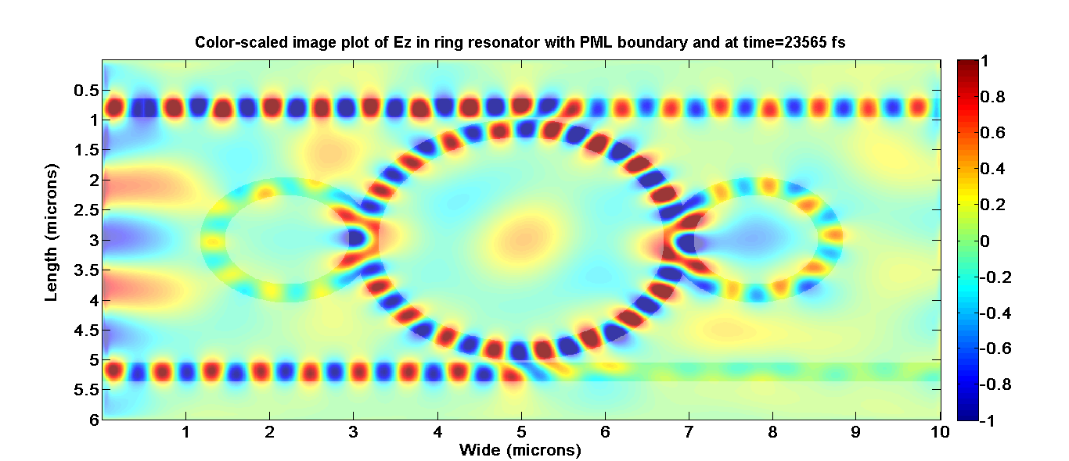

(b)

**Figure 4**: Brain signal propagation model: leaky and whispering gallery modes, where WGM probe, (b) particle travelling track

In conclusion, an element in each pair of paradox states can be investigated by using WGMs within a thin optical film device, in which the interaction between the state of interest and WGM probe can be established and investigated, however, the introduced measurement will cause the uncertainty of the remain state due to the [Heisenberg's uncertainty principle](http://en.wikipedia.org/wiki/Heisenberg's_uncertainty_principle), i.e. the remaining states will be lost.

**Acknowledgment:**

We would also like to give the acknowledgment for the laboratory and research facilities from the King Mongkut’s Institute of Technology Ladkrabang (**KMITL**), Bangkok 10520, Thailand.

**References**

1. Brain signals, Google search, November, 2013.
2. [Einstein](http://publish.aps.org/search/field/author/A.%20Einstein) A et al. (1935) Can quantum-mechanical description of physical reality be complete? Physical Review, 47: 777-780.
3. Enlightenment, Google search, November, 2013
4. Fischer MC et al. (1998) Observation of Rabi oscillations between Bloch bands in an optical potential. Physical Review, A 5: 2648-2651.
5. Frank LA et al. (1986) The theta aurora. J Geophys. Res., 91(A3), 3177-3224.
6. [Georgescu](http://www.nature.com/nphys/journal/v8/n10/full/nphys2447.html#auth-1) J (2012) Čerenkov radiation: Light from ripples. Nature Physics, 8(10): 695-769.
7. Hallman CJ (2012);
8. A multidimensional model of the dreaming state of consciousness Part I. *Subtle Energies & Energy Medicine.* 18(2): 75-89.
9. A multidimensional model of the dreaming state of consciousness Part II. *Subtle Energies & Energy Medicine,* 18(3): 89-111.
10. (c) A multidimensional model of the dreaming state of consciousness Part III. *Subtle Energies & Energy Medicine*, 19(2): 57-91.
11. Kollareddya M et al. (2008) Aurora kinases: structure, functions and association with cancer,” *Biomed Pap Med Fac Univ Palacky Olomouc Czech Republics,* 152(1), 27-33.
12. Phatharaworamet et al. (2010) Random binary code generation using dark-bright soliton conversion control within a PANDA ring resonator. *J. Lightwave Technol.*, 28:2804–2809.
13. Rosch PJ (2009) Bioelectromagnetic and Subtle Energy Medicine: the interface between mind and matter, [*Ann N Y Acad Sci*](http://www.ncbi.nlm.nih.gov/pubmed/19735252#_blank), 1172:297-311.
14. Spinelli AE et al. (2013) [First human Cerenkography](javascript:loadDetail('http://spie.org/x648.html?product_id=2022284')). *J Bio Medical Optics*, 18(02): 020502-1-3.
15. Tamee K et al., (2013) Brain signal monitoring and encoding for humanoid robots use. *J. Biosensors & Bioelectroni,* 4(5):13e-124.
16. Tamee K et al. (2013) Psychiatric investigation using WGMs using a nonlinear microring circuit. *J Innovative Optical Health Sciences*, 6(4) : 1350044-1-7.
17. Yupapin PP (2013) Nonlinear coupling effects of waves in a panda ring, *Science Discovery*. 1: 1-5.

11/28/2013