South American Leaf Blight: Identification and Management of disease outbreak in Nigeria

Ogbebor, O. Nicholas

Plant protection Division, Rubber Research Institute of Nigeria, PMB 1049 Benin City, Nigeria.
Ogbeb06@gmail.com

Abstract: South American Leaf Blight is identified as one of the world’s five most threatening plant diseases that affect rubber. Until today it is the single factor responsible for the failure of economically rubber cultivation in its motherland, South America. The hectares of rubber plantations in Nigeria are over 247,000 hectares with more than 70% of the holdings by small-scale farmers. Nigeria contributes more than 60,000 tons of rubber to the international market. The rubber industry provides employment opportunities in the non-oil sector in Nigeria. An outbreak will have a far-reaching economic effect on the resource poor farmers and poverty alleviation program in the country. Presently Nigeria is currently free from South American Leaf Blight. However, based on the level of interaction between Nigeria, and South and Central America in such aspect as economic and cultural relationship, the spread of South American Leaf Blight to Nigeria is possible. The major means to prevent the spread of South American Leaf Blight if eventually introduced is to continually educate those involve in rubber production especially our small scale farmer who form the bulk of rubber producers in the industry in the country of the symptoms and biology of the dreaded disease South American Leaf Blight.
[Ogbebor N. O. South American Leaf Blight: Identification and Management of disease outbreak in Nigeria.
Nat Sci 2013;11(12):106-109]. (ISSN: 1545-0740). http://www.sciencepub.net/nature. 16

Keywords: Disease, Identification, Management

1. INTRODUCTION
South American Leaf Blight is identified as one of the world’s five most threatening plant diseases that affect rubber. Until today it is the single factor responsible for the failure of economically rubber cultivation in its motherland, South America. The causal agent responsible for SALB is the obligate parasite Microcyclus ulei (P. Henn.) v. Arx. It affects all the above ground parts: leaves, Petioles, Stem, Young Bark, Inflorescence and Fruit. It causes repeated defoliation during favourable condition leading to the death of the rubber tree.
Ford motor company in Brazil established a plantation of 3,200 ha at Fordlandia in 1927 and the plantation was abandoned in 1933. Another plantation of 6,478 ha was established by Ford motor Co. at Belterra in 1936 and was abandoned in 1943. Under PROBOR programme (1967-1987) 150, 000 ha were planted of which 100,000 ha suffered severe SALB by 1967. In Surinam, a plantation (40,000 trees) was established in 1911 and was abandoned in 1918.
The hectares of rubber plantations in Nigeria are over 247,000 hectares with more than 70% of the holdings by small-scale farmers. Nigeria contributes more than 60,000 tons of rubber to the international market. The rubber industry provides employment opportunities in the non-oil sector in Nigeria. This is more so as the bulk of the field labour is derived from the rural areas.
Any threat to the rubber industry will have a significant adverse effect on the resource poor farmers in the rubber belt, the agricultural sub sector of the economy and serious socio-economic consequences in Nigeria.
The dangers posed by the threat of outbreak of Microcyclus ulei in Nigeria, could be imminent if adequate phytosanitary control measures are not taking into account. An outbreak will have a far-reaching economic effect on the resource poor farmers and poverty alleviation program in the country. SALB would directly affect rubber plant mortality, reduction in latex yield, reduction of rubber wood production, investment eradication, increases in production costs, Loss of income and employment within affected regions, environmental impact, loss in aesthetic value, loss in foreign exchange; and indirectly affect loss of market opportunity (International trade), intensified research and development, social dislocation-urbanization and migration of rubber labour force, and eventual decline in the standard of living of people involved in rubber industries, especially small holders.

PRESENT SITUATION OF SALB
Nigeria and indeed the whole of Africa and Asia are currently free from South American Leaf Blight (SALB); aside the malady of SALB one can observe the incidence of Colletotrichum gloeosporioides, Corynespora cassiicola and white root rot disease. The last field survey carried out in late 2008 in the rubber growing region in the country revealed that the country is free from SALB (Ogbebor et al., 2009). However, despite phytosanitary measures, the spread of SALB to Nigeria is possible. This is based on the level of interaction between Nigeria, and South and Central America in such aspect as economic and cultural relationship.

FUTURE ACTIVITIES TO PREVENT ENTRY OF SALB INTO NIGERIA
Currently only two possible checks to SALB are in place, the first are the quarantine services of each country including Nigeria. This exercise if normally targeted at introduction of live materials through regular checks for foreign bodies before they are allowed entry or if found, infected the materials are destroyed.
However, apart from live materials, sources of inoculums could be inanimate or human carriers who may bear such inoculums unconsciously on their persons or personal effects. The second check to the possible spread is the consensus under the Association of Natural Rubber Countries (ANRPC) that scientist of rubber producing countries that visit Brazil for studies should spend some time in Europe before coming to their home country. It is expected that during such stay in Europe, spores of the causal organism of SALB carried on the person or personal effect will be dislodged. Since the environmental condition in Europe is not conducive for the growth of the spores, such natural quarantine will not predispose the transit country to the treat of SALB. The Rubber Research Institute of Nigeria has complied with this regulation. Consequently a stake holder’s forum was held on the 3rd of March, 2009 at RRIN main station, Iyanomo, Benin City to raise the awareness of SALB and quarantine protocol for introduction of SALB tolerant rubber clones to the country.
It is necessary for the African countries that produce rubber to create a network concerned with SALB to strengthen the measures that up until now have prevented the introduction of SALB. The training that I received on the SALB and management in Michelin Plantations at Bahia, Brazil is very important in terms of continuing the future activities towards management practices of SALB and in effectively operating quarantine measures.
The major means to prevent the spread if it is eventually introduced is to continually educate those involve in rubber production especially our small scale farmer who form the bulk of rubber producers in the industry in the country of the symptoms and biology of the dreaded disease SALB.

BIOLOGY OF SALB
Hosts
M. ulei affects the genus Hevea, namely H. brasiliensis Muell, H. benthamiana Muell Arg., H. guianensis Aubl and H. spruceana (Benth.) Muell. among the several thousand genera in the Plant kingdom. Inoculation of other plants of the same family (Euphorbiaceae) as Hevea rubber was unsuccessful. M. ulei failed to successfully infect and sporulate on cassava plant (Jens, et al., 2003)). On Hevea rubber, M. ulei infects the young aerial part of the plant. Infection is most common on young leaves; however leaf petioles, young stems, inflorescences, flowers and young fruit are also infected.

Spore
Microcyclus ulei is in the group Ascomycete and produces three types of spores in sequence on the same leave; the conidia (Plate 1a), the pycnospores (plate 1b) and the ascospores (Plate1c). The conidia are produced abundantly during the asexual state of the disease while the pycnospores and the ascospores are produced during the sexual state of the fungus. The conidia are mainly two celled with a broad proximal cell and a tapered distal cell. The unique character of the conidia is that they are twisted. The length of the conidia is 23-62 µm and the width is 5-10 µm (Holliday, 1970). The size of the conidia varied with location and season. The conidia, sometimes, have only one cell and the one-celled conidia are more common during dry weather conditions. One celled conidia are also more common from laboratory cultures.
The pycnospores are dumbbell shape and small (6-10 µm long and 2-5 µm in width). The ascospore is oblong shaped and is made up of two cells of unequal size. The ascospores are 12-20 x 2-5 µm in size. The ascospores are protected from desiccation by thick wall of ascocarp and are responsible for the survival of the pathogen from one season to another.

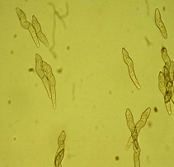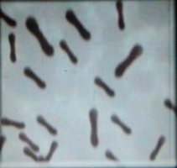
Plate 1. Spores of Microcyclus ulei: (a). The two-celled conidia of Microcyclus ulei with a characteristic “twist” (b). Pycnospores (c). Ascospores

Symptoms
Shortly after infection of young rubber leaflets, the first visible symptom is the distortion in shape of the leaflets (Plate 2a). Two to 12 days old leaves showed symptoms of SALB about 2-3 days after inoculation (Blazquez and Owen, 1963). A few days later, irregular-shaped disease lesions developed on the undersurface of the young brown colored leaflets. Heavily infected susceptible leaflets shriveled turn black and dropped off. The petioles remain on the stem for several more days before they also drop-off (Plate 2b). The characteristic lesions with abundant conidia are visible on young green leaves remaining on the plant. Then, the lesions produce abundant conidia and appear dark to olive green in colour (Plate 2c). The size of lesions and the amount of conidia produced is influenced by the age of leaflets, the susceptibility of the clones and the prevailing weather conditions. The infected leaves are deformed in shape and smaller in size than healthy leaves.

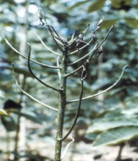
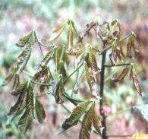
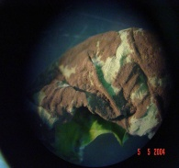

Plate 2. Symptoms: (a). The early symptoms of SALB on young rubber leaflets (b). Petioles remaining on the stems after the infected leaflets fall-off (c). Disease lesions covered with conidia on the undersurface of young leaflets.

About two to three weeks after infection started, the lesions stop producing conidia (Plate 3a). Then, the leaf tissues on the upper surface of leaf immediately above the disease lesions on the lower leaf surface turn yellowish (Plate 3b) and later small round black raised structures called the pycnidia are formed (Plate 3c). The pycnidia are 120-160 µm in diameter and these fruiting bodies produce the pycnospores. Several weeks later, the round dark raised structures enlarge and form another dark colored raised bodies called the perithecia especially around the edges of the disease lesions (Plate 3d). The perithecium produces the fruiting structure called the ascus that bears the ascospores. The number of perithecia varies with infection and susceptibility of leaves. In certain cases, the whole upper surface of the lamina is covered with numerous perithecia. As the leaf aged, the leaf tissues at the centre of the lesions die and turn papery white and later tear off leaving shot-holes in the leaf (Plate 4a).

Plate 3. (a). Older lesions on the lower leaf surface of leaflets that had ceased to produce conidia (b). Yellowish discoloration form on the upper leaf surface immediately above the lesions (c). Pycnidia formed on the upper surface of leaflets immediately above the lesions on the lower leaf surface (d). Perithecia forming on the upper surface of leaves immediately above the lesions on the lower leaf surface.

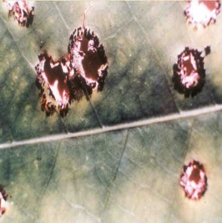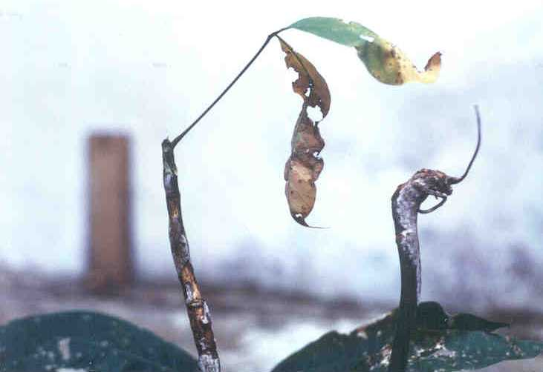
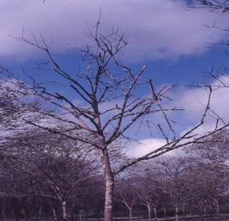
Plate 4. The leaf tissues at the centre of the colonies
of perithecia died and form a “shot hole” (b). stem (c). Infection of SALB on the fruits of rubber (d). Dead trees caused by severe infection of SALB

M. ulei also infects other parts of the plant, the leaf main vein, leaf petiole, bud, stem (Plate 4b), inflorescence and fruit (4c). The process of infection and defoliation occur repeatedly under favourable weather condition in susceptible clone. If control measures are not adopted the result will be the shot die back and death of rubber tress (Plate 4d).

Disease Development
The conidia and the ascospores are responsible for disease infection. The pycnospores do not caused infection even under artificial inoculation, but germinated in vitro (Holliday, 1970). The reaction of the host to infection is influenced by the degree of resistance of the leaves. In susceptible leaves, the fungus spreads intercellularly in the leaf without apparent hindrance. However, in certain highly resistant or immune clones, the fungus penetrates into the leaf but disease spread was inhibited.
In infected rubber plantations ascospores are present throughout the year with peak concentrations occurring during the wet seasons. The wet season also marks the period of maximum production and dispersal of conidia (Chee 1976a,b).

2. CONCLUSION
Application of fungicides is the most popular strategy to control SALB. Farmers are advised to regularly look out for these common symptoms of SALB in their plantations/ farms and quickly report any detectable symptom or resemblance in symptoms of SALB in Nigeria to Rubber Research Institute of Nigeria who in turn after confirmation of the detected symptoms of SALB shall report to the plant quarantine service. As early detection is the surest remedy in the eradication of the disease in case of its eventual introduction into the country.

ACKNOWLEDGEMENTS:
I am grateful to the IRRDB – CFC – Michelin - Rubber Research Institute of Nigeria for SALB training workshop in Michelin Plantation, Bahia, Brazil.

CORRESPONDING AUTHOR:
Dr. Ogbebor, Nicholas Obehi
Rubber Research Institute of Nigeria
PMB 1049
Iyanomo, Benin City, Nigeria
Cell Phone: +2348055338839
Email: ogbeb06@gmail.com

REFERENCES
- Ogbebor O.N (2009). South American leaf blight (SALB): the causal pathogen and the disease; key to its identification and control. Seminar presented to large and small scale holders of Rubber in Nigeria and flyers distributed, held on the 3rd of March, 2009 in RRIN conference hall, Iyanomo.
- Jens, H., Gasparotto, L. and Moraes, V. (2003). Reacao de folhas de mandioca ao Microcyclus ulei agente causal do mal das folhas da seringueira. Fitopatologia Brasileira, 28:477-480.
- Holliday, P. (1970a). South American leaf blight (Microcyclus ulei) of Hevea brasiliensis. Phytopathological Papers no.12, Commonwealth Mycological Institute, England, 31p.
- Blazquez, C.H. and Owen, J.H. (1963). Histological studies of Dothidella ulei on susceptible and resistant Hevea clones. Phytopathology, 53: 58-65.
- Chee, K.H. (1976a). Factors affecting discharge, germination and viability of spores of Microcyclus ulei. Transaction British Mycology Society, 66,499-504.
- Chee, K.H. (1976b). Assessing susceptibility of Hevea clones to Microcyclus ulei. Annual Applied Biology, 84, 135-145.

11/25/2013

