Histological Characterization and Embryonic Development In the fertilizing eggs of the Red Palm Weevil, Rhynchophorus ferrugineus (Oliver)

Mona M. Al-Dawsary *¹, Eman B. Moursy ², Abdullah M. AlBakairi ³

Biology Dept., College of Science and Humanities, Salman bin AbdelAziz Univ., Saudi Arabia¹.
Dept. of Entomology and Pesticides, Faculty of Agriculture, Cairo Univ. Egypt².
c Dept., of Pharmacology College of Pharmacy, King Saud Univ., Saudi Arabia³.
wisdom1425@yahoo.com

Abstract: This research paper is a laboratory description for the characteristics, the tissues structures and the successive phases for the embryos development of the Red Palm Weevil, R. Ferrugineus (Oliver) in the deposited fertilized eggs, by the light and transmission electron microscopy. The study included a description of the initiation of cleavage, blastula, gastrula and the formation of extra-embryonic membrane before hatching. The 6h old egg is typical of undifferentiated cell, containing regular reticulum of much cytoplasm and a thick periplasm. The zygote daughter nucleus (energids) and the yolk granules are in cytoplasmic continuity. The energids and yolk granules spread regularly all round the egg periphery and arrange in a layer in the 12 h old eggs. However, the rest of irregular cytoplasm remains at the center. The cleavage energids move apart as they divide and form the cellular blastoderm, while the yolk granules appear around them in the 24 h old eggs. Large masses and spherules of vitellophages and vacuoles are also observed through the clear cytoplasm. In 30 h old eggs, many folds of the plasma membrane are developed, extended between and beyond the preblastoderm nuclei. The preblastoderm nuclei of the 48h old eggs are bounded by the cytoplasmic islands and form the cellular blastoderm which differentiate into germ band and the extra -embryonic membranes in the 60h old eggs. Gastrulation and, differentiation of the ectodermal and mesodermal tissues e.g. the trachea, fore and mid gut become overgrown in the 72h old eggs.While, the ectodermal layer, the connective tissue, the muscles , the fat body and the malppighian cells are differentiated in the 84h old eggs.
[Al-Dawsary M, Moursy E, AlBakairi A. Histological Characterization and Embryonic Development In the fertilizing eggs of the Red Palm Weevil, Rhynchophorus ferrugineus (Oliver). Nat Sci 2013;11(12):90-98]. (ISSN: 1545-0740). http://www.sciencepub.net/nature. 14

Keywords: Rhynchophorus ferrugineus, Embryo, Cleavage, Energids, Blastoderm, Germ band, Gastrulation, Differentiation, Embryonic membranes.

1. Introduction
The Red palm weevil, Rhynchophorus ferrugineus (Olivier) is one of the most destructive pests of date palms, Phoenix sylvestris Rox., and Phoenix dactyleferous in the Arab Gulf States (Bokhari & Abuzuhari, 1992), Egypt (Salama & Hamdy, 2001), and of coconut, Cocos nucifera L., in South and Southeast Asia (Sivapragasam et al., 1990; Sadakathulla, 1991). During the last decade, multiple introductions of R. ferrugineus to the Middle East from India and Pakistan have occurred. Often, palm weevil infestations are not detected before extensive damage caused by larval mining in the trunk and it is not possible for the tree to recover (Sivapragasam et al., 1990). In date palms, the only visible sign of attack may be oozing out of palm sap from the trunk, and infestations are often not discovered until trees are blown over. Delay between detection and destruction permits emergence and migration of adult weevils prior to destruction. Transporting infested trees and offshoots for burning introduces the weevil to new areas.
Insect eggs are typically large relative to the size of the females that produce them because they contain a great deal of yolk. It is generally believed that the eggs of Endopteryogota contain less yolk and are smaller than those of Exopteryogota (Anderson, 1972b). Immediately following fertilization, as the egg is laid, the zygote nucleus divides and the daughter nuclei migrate to the periphery of the egg to form a layer of cells, the blastoderm, surrounding the yolk. Part of this cell layer becomes thickened to form the germ band from which the embryo develops (Anderson, 1972a, b; Haget, 1977; Nagy, 1995; Sander et al, 1985).
The purpose of the present study is to investigate the embryogenesis for fertilizing 6 to 84 hour old eggs. The details of cleavage and formation blastoderm cells, the germ band and extraembryonic, gastrulating, structural bodies in the eggs of Red Palm Weevil, R. ferrugineus (Oliver) were described.
This study may be considered a standard reference in the egg embryology descriptions of the insect, however, no ultrastructures embryogenesis or histological characterized of egg were described before, for this species.

2. Methodology
2-1. Source and Insects rearing
Adults of the Red Palm Weevil, R. ferrugineus (Oliver) were obtained from infested wild date palm in Al-Kharj, and maintained on sugarcane in the laboratory. The adults were fed with fresh sugarcane and later allowed to mate. Isolated females were supplied with pieces of split sugarcane to oviposit on it. The sugarcanes were replaced every day.
2-2. Collection of eggs
After mating the adult females laid their eggs between sugar cane fibers and stuck them so strongly. The process of collecting eggs by minutes, brush placed inside the Petri dish on a layer of cloth moistened with water, Eggs were taken on the ages of 6,12, 18, 24.30, 36, 42.48, 54, 60.66, 72, 78.84 hours and then placed each group in the installer in preparation for the histological study.
2-3. Preparation the samples using binocular microscope of BM
Taken different ages of eggs to be photographed with a binocular microscope (BM) and monitoring changes of the external egg, was used with a microscope specifications.
2-4. Preparation the samples using Transmissing Electron Microscope
Primary Fixative by buffered Glutaraldehyde 2.5% over night in refrigerator ,wash by phosphate buffer pH=7.2, secondary fixative by buffered Osmium Tetraoxide 1% over night in refrigerator ,then dehydration using series conc. of ethanol, embedding by resin mixture from SPI (SPI-Pon™ - Araldite® Epoxy Embedding Kit), the block well cutting by (leica UC6 ultramicrotome) the section thickness is between 70-80 nm and it lode in cupper grid then stain by aqua's uranyl acetate and lead citrate, examined under Transmission Electron microscope (TEM) (Jeol JSM-1011 electron microscope).

3. Results and Discussion
3-1. Description of Egg Stage
The Red Palm Weevil eggs is 2 mm long and 1.6 mm wide characterized by elongated, creamy in color. It has two poles: the anterior pole has tapered a respiratory openings, the posterior pole has the slot to enter the sperm (Fig. 1). The insect lays its eggs individually in the Palm’s tissues where embedded it strongly and eggs hatch over a period of 3-5 days.
Few hours later, they begin to harden and become white, calm and transparent at the bilateral two external edges (Al- Dossary et al, 2010). Corley and Tinker (2003) described the oblong eggs of Rhynchophorus weevils, which were 2–3 mm long. They added that, the eggs of the Red-Stripe Weevil Rhynchophorus schach Oliv., were whitish-yellow, ovocylindrical in shape and measured 2.4 mm long and 0.9 mm wide.

3-2. Incubation Period of Eggs
The incubation period ranged between 3-5 days where the fetus swallows the amniotic fluid and part of the air that spreads inside the egg, during that period, major divisions at the level of the cell and the cytoplasm result in the formation layers of the body wall, and leads to the rupture and torn of the outer shell of the egg, as well as rupture of fetal membranes (Fig. 2A- F). According to Al- Dossary et al., (2010) the hatching region of R. ferrugenius was observed on the anterior part at the opposite side. The hatching region was observed on the opposite side of the micropylar apparatus and appeared as a set of imprints separated by furrows and oriented along the longitudinal axis of the egg (Fig 2- F). Chorion morphology and the polygonal ornament of the outer chorionic surface show broad apparent phylogenetic trends in various insect eggs ^{29,16,17} reveal the imprints of the follicle cells that have participated in the egg shell formation ¹¹. This hatching region was not clearly visualized on the eggs of other species¹⁸.

3-3. Embryogenesis
Includes all the developments that occur between the zygote formation and totally grown individual out of the egg. Red Palm Weevil eggs contain a large amount of yolk (Fig. 3), and thus the split occurs at the level of the nucleus and cytoplasm, and this meroblastic is called partially meroblastic.

3-4. Cleavage and formation blastoderm cells
After 12-13 hours of incubation, the first cleavage occurred. Fig. (4) shows the stages of the indirect division in the nucleus and cytoplasm of the embryo 12 h- old. The chromosomes appears in the primary development (Fig. 4 a). Fig 4 (b) shows the chromosomes in the final development, where they arrays on both sides of the spindle. By repeating this division, there are numerous of new cells that migrate towards the outer edge of the egg (Fig. 5), and arrange themselves in a single layer below the yolk membrane. The cytoplasm adjacent to the outer membrane combines with the divided nucleuses to form the blastoderm cells that surround the yolk while the yolk is concentrated in the center of the embryo 12h- old (Fig. 6 a, b).
Chapman (1998) stated that few eggs of insect does not happen by cleavage surface spread in eggs of most insects, and the surface is characterized by eggs containing copious amounts of yolk, but in races of less yolk another type of cleavage occurs. Takesue (1890) observed that the morphology of the just-completed blastoderm cell was very different from the above and under its nucleus of Bombyx mori. Above the nucleus the cytoplasm was dense, full of a great number of mitochondria and poor in vacuoles, and microprojections on the surface were few and small. On the other hand, the nucleus have small densely-stained dots, a lot of vacuoles of different sizes and, sometimes, some yolk granule in the peripheral region.
3-5. The germ band and Extra embryonic
The blastoderm wrap around the egg is completed to form blastula and the internal vacuum is filled with yolk to form what is known the Blastocoele after 30 hours (Fig. 7). Within 12–18 h-old the germ band and formation of extra-embryonic membranes were detected, After remaining for a short period in its extended state, the germ band reverses its movement and shortens (Fig. 5). The beginning of shortening of the germ band, the contraction of the yolk this time and, leaving a spacious haemocoele between itself and the body wall. As shortening of the germ band is nearing completion in the embryo of 36–42 h-old, the lateral body walls begin to grow up and eventually fuse in the mid-dorsal line. The germ band consists of some cells blastula and takes the shape of columnar, while the other cells involved in the formation of blastula extra embryonic membranes (Fig. 8) where the amnion is formed towards the inside to surround the embryo and the serosa outward. After the germ-band had invaginated and sunk completely into the yolk, the serosa formed an uninterrupted outer layer to the yolk. The serosa was a very thin cellular layer, and its nuclei are extremely flattened. In some Lepidoptera, the blastoderm is differentiated into germ band and extra- embryonic tissue from the time of its first appearance, In some other insects, such as Mallophaga and Apis, the whole blastoderm is thick initially but subsequently becomes thinner except for the germ band (Chapman, 1998).
3-6. Gastrulation
Gastrula formation in eggs of red palm weevil in the early stage of embryonic development, begins after 30 hours of laying eggs where the formation of the middle layer starts, as well as the formation of the inner layer by failing indentation layer of the outer layer and this is illustrated in both Fig. (9 and 10). As illustrated in the Fig. (9), the ectoderm layer and the beginning of formation of the trachea, while in (Fig. 10) it shows the formation of the mesoderm layer and the beginning of the emergence of fat bodies after one day and six hours from laying eggs. Johannsen and Butt (1941) stated that there was a difference in the way Gastrula formation in insects than in animals where the insect sharp indentation does not occur. It consists of only an internal layer of cells below the germ band. In most insects, these cells become columnar and then migrate inward so that a mid- ventral groove is formed. They are isolated progressively from the outside by more lateral cells spreading beneath them. In most beetles, the invagination is so marked that it is at first almost tubular, while in Apis a broad middle plate sinks in the embryo (Jura, 1972).
3-7. Structural bodies
3-7-.1. Cuticle
Fig (11) shows the beginning of cuticle formation and the internal surface after 39 hours of the egg-laying in a rate of one day and fifteen hours, which means that the cuticle layer is the skin secretion, which in turn formed from ectoderm layer. In fact, that the secretion of cuticle coincides with the formation of organs of its constituent, which means that the formation of the blastoderm layer after - one day and six hours, then after nine hours, the cuticle formation begins, which appears as winding sheaves arranged on top of each other. Also, the cuticle surface is observed which appears dark (Fig.12). (Fig.13) shows the completion of cuticle formation that appears dense sheaves and other light sheaves after 84 hours of egg-laying and the formation of the pore channels, as evidenced by formation foraminalis in the same figure for the cross section. According of Chapman (1998) and Hoffmann and Laguex (1985), the first cuticle to be produced during the embryonic development of many insects is the serosal cuticle which is secreted by the blastoderm and forms a continuous layer on the inside of the eggs hell until the first stage larva hatches. Another very thin cuticle is produced by embryos of Acrididae after about 35% of the developmental period has elapsed. A similar cuticle is present in Phasmatodea and at least some Heteroptera and Lepidoptera (Chapman, 1998; Hoffmann and Lagueux, 1985).
3-7-.2. Respiratory system
Fig. (9) shows the beginning of the composition of the trachea and chtinidia after 30 hours of the egg-laying and continue to grow until they are completely configured Sell after 66 hours (Fig. 14, and created the trachea, which are the most important components of the device layer of the bronchial ectoderm, They were formed and emerged after 24 hours of embryonic development (Fig. 15). Chapman (1998) stated that the respiratory system in insects arises as a double bending on the segments and takes the form of a letter T and T ribs adjacent to the brain to be established and longitudinal logs bindings, to create finer branches of the bronchial system (Chapman, 1998)
3-7-.3. Fat bodies
Also, the formation of the Fat bodies begin after 30 hours of embryonic development (Figure 10), and continue to do so until the composition is completed after 66 hours of its growth (Figure 14 B, C). These bodies are created from mesoderm layer which is the layer, which in turn originated from the inner layer of the wall of the body. Chapman (1998) said that the fat body in insects is a loose or compact clusters of cells associated with endothelial membrane suspended in the cavity haemolymph in terms of food stores within the body as in some insects directorial store materials.
3-7-4 muscles
Fig. (15) shows the completion -of the muscles configuration in the embryo of 78 h- old, the muscle composition of the tapes and the presence of nuclei. the muscles configuration is formed from the inner layer (layer mesoderm). The mesoderm is derived from the inner layer of the germ band which forms two lateral strands running the length of the body and joined across the midline by a thin sheet of cells. In some insects orders a pair of coelomic cavities is present in each segment of the protocorm, while, in the protocephalon, pairs of cavities develop in association with the premandibular and antennal segments. Sometimes, one or two more pairs are present in front of the antennae. Subsequently, in Coleoptera, the thoracic and abdominal coelomic cavities become confluent forming a tube on either side (Chapman, 1998). once the muscles formed , the walls of the coelomic sacs break down so the outer walls of the coelomic sacs form the somatic muscles and the inner walls of the coelomic sacs form the visceral muscles.
3-7-.5. Alimentary canal
Fig. (16) shows the divisions alternation of nuclei in cytoplasm of embryo of 66 h- old primary formation of foregut, mid and hind gut (Figure 17- 18), and notice of epithelial layer which coated alimentary canal provider numerous microvilli (Figure 19- 20). The foregut and hind gut arise early in development as ectodermal invaginations, the stomodeum and proctodeum. These invaginations carry the anterior and posterior rudiments of the mid gut into the embryo. Then, these rudiments extend towards each other forming two longitudinal strands of tissue beneath the yolk and above the visceral mesoderm. From these strands, midgut tissue spreads out over the surface of the yolk, eventually completely enclosing it (Skaer, 1993).
Malbigian tubules originated of receptor for hind gut. Normally originated to 2- 3 pairs in embryo but may be formation of malbigian tubules may appear in larval stage (Savage, 1956).

4. Conclusion
Table (1) shows that our results in this study agree with what we have mentioned in a previous study (Al- Dossary et al, 2010), germ band formation, gastrulation and the extension of the germ band and formation of extra-embryonic membranes were detected at the embryo of 12–18 h-old (Figure 4, 5, 6). After remaining for a short period in its extended state, the germ band reverses its movement and shortens (Fig. 7, 8). The beginning of shortening of the germ band, the contraction of the yolk plasmodium at this time, leaving a spacious haemocoele between itself and the body wall, characterize the embryo of 18– 24 h–old. As shortening of the germ band is nearing completion in the embryo of 36–42 h-old, the lateral body walls begin to grow up and eventually fuse in the mid-dorsal line (Fig. 8). Organs formation and segmental divisions begin to appear in the embryos epidermis of the embryo of 48–72 h-old.
The embryological studies of insect orders are the most important for understanding the ground plan of insecta as well as for clarifying insect evolution (Weissling and Davis, 1995; Stanley and Grundmann, 1970; Handel et al., 2000; Kobayashi et al., 2002; Tojo, 2003).

Table 1: R. ferruginues: time-table of early development
No. of Hour after being Laid. | Stage reached in Development
6 | large amount of yolk and thus the split occurs at the level of the nucleus and cytoplasm, and this is meroblastic.
12–18 | germ band formation, gastrulation and the extension of the germ band and formation of extra-embryonic membranes.
18– 24 | The beginning of shortening of the germ band, the contraction of the yolk at this time, leaving a spacious haemocoele between itself and the body wall.
36- 42 | As shortening of the germ band is nearing completion in  the lateral body walls begin to grow up and eventually fuse in the mid-dorsal line .
48- 84 | Organs formation and segmental divisions begin to appear in the embryos epidermis.

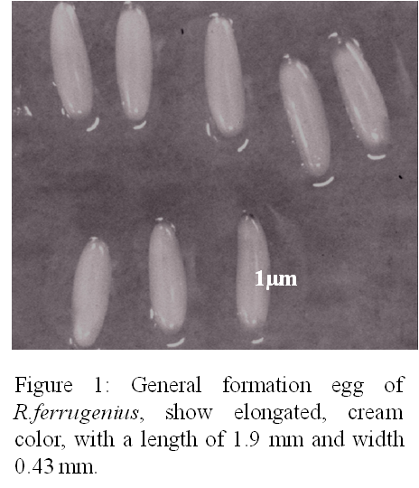

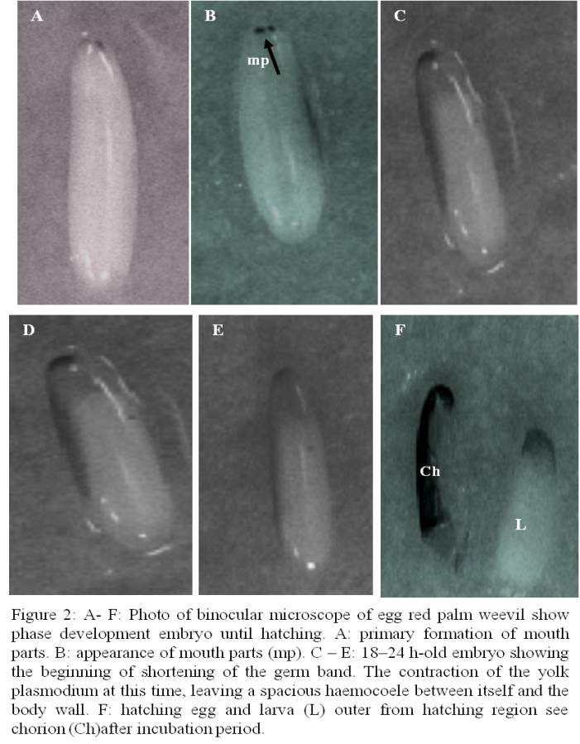

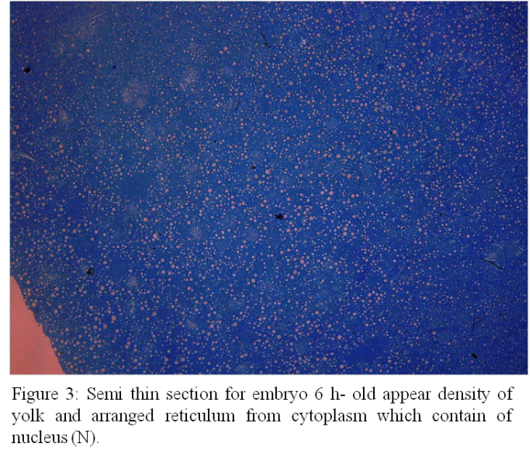

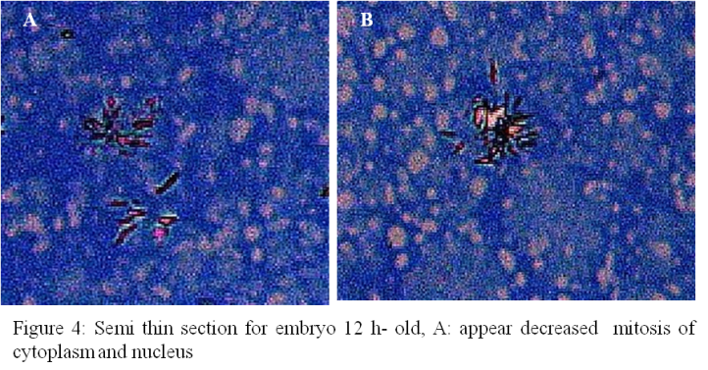

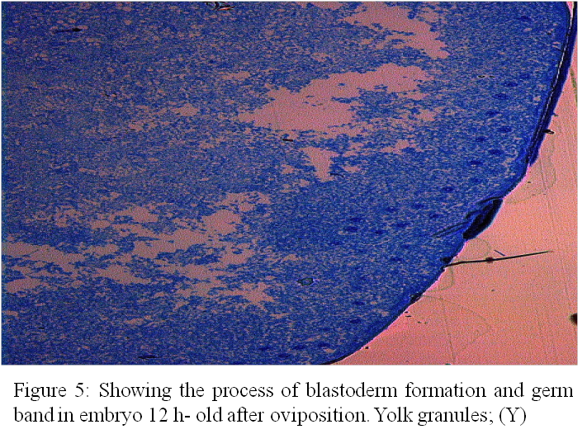

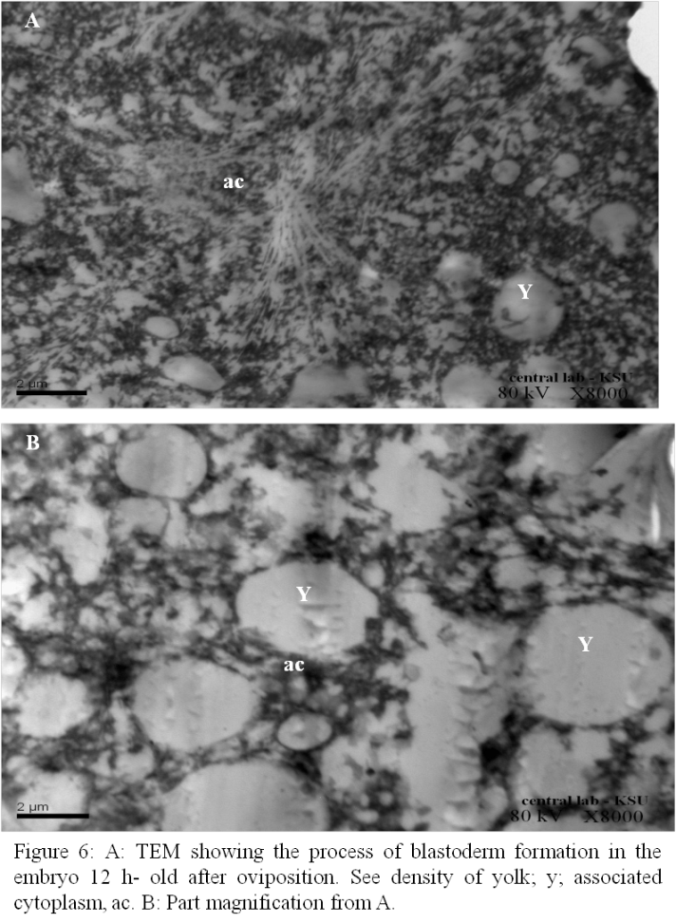

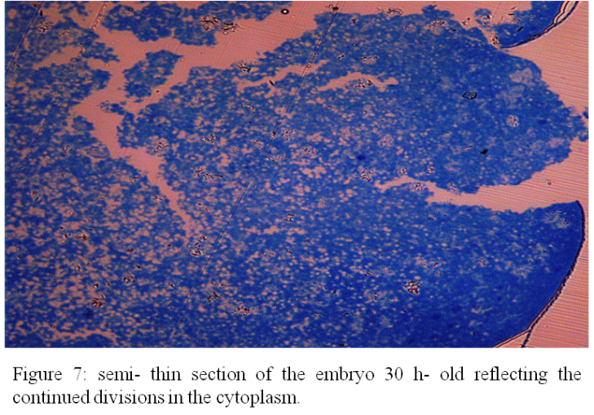

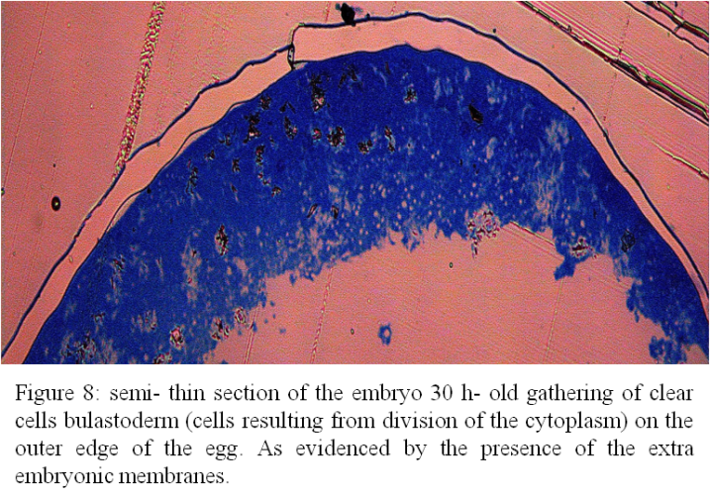

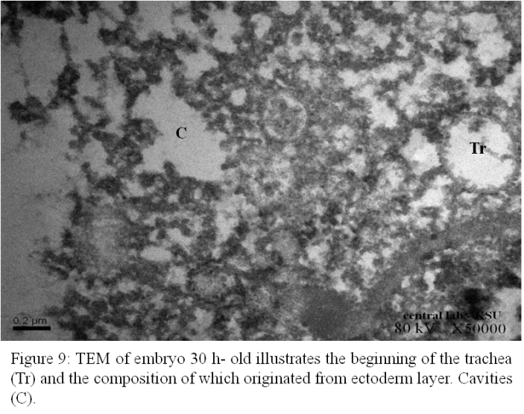

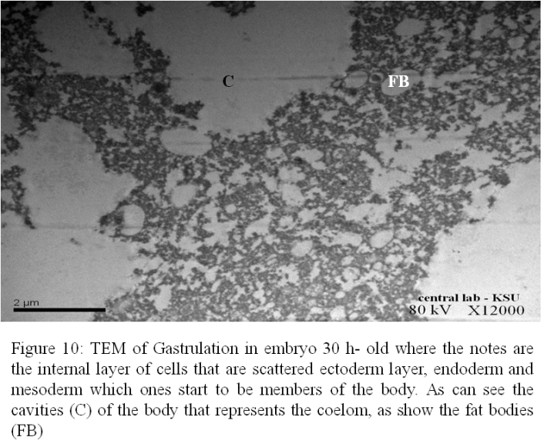

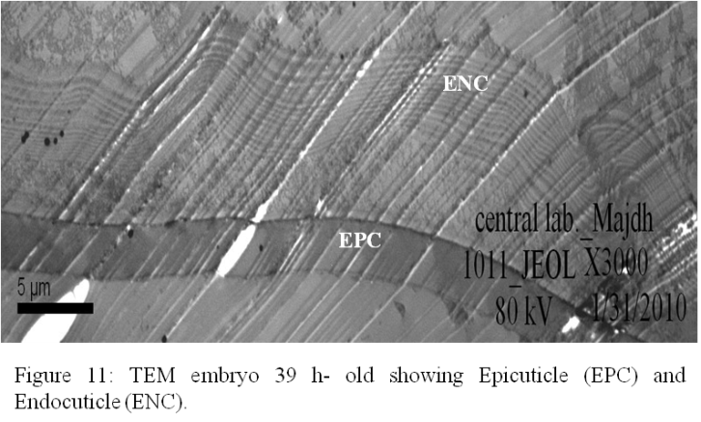

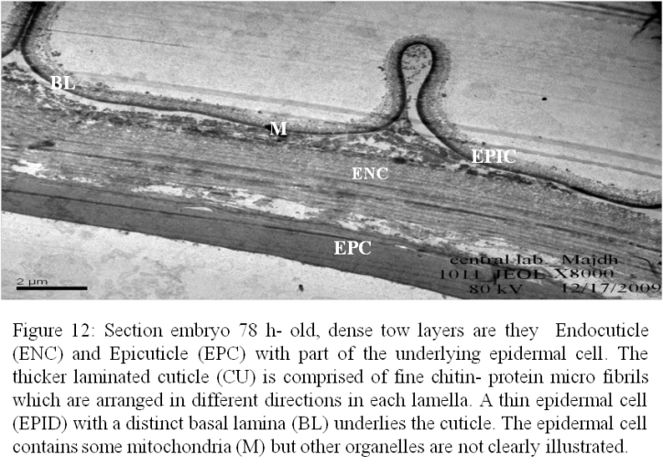

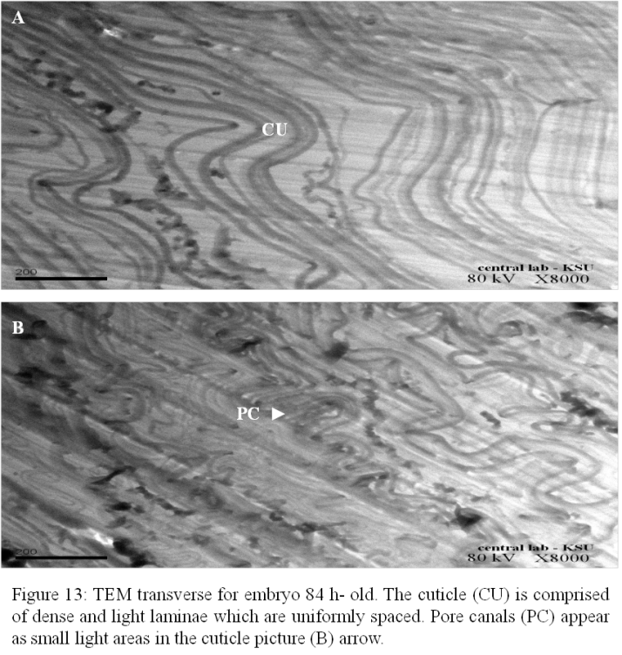

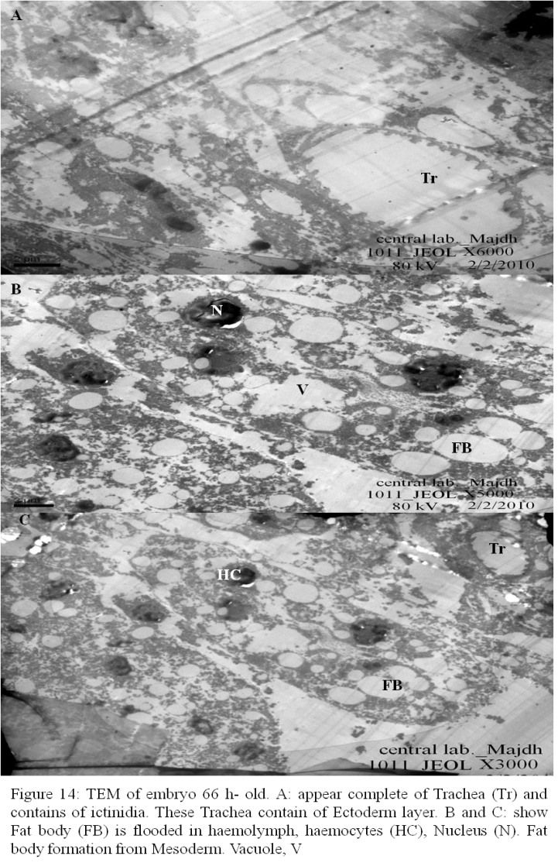

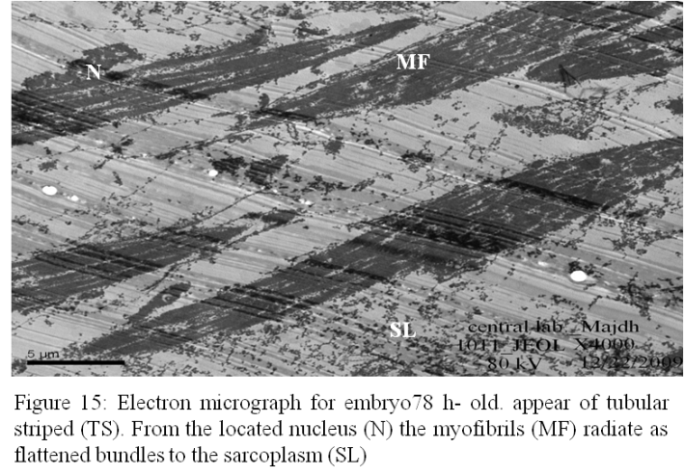

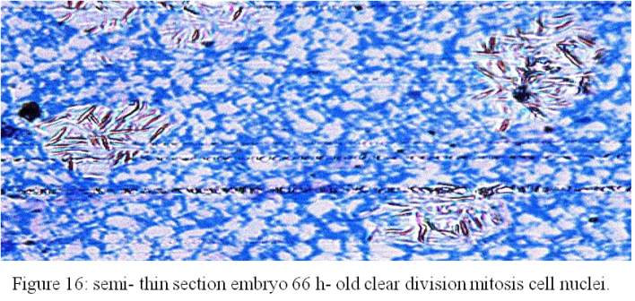

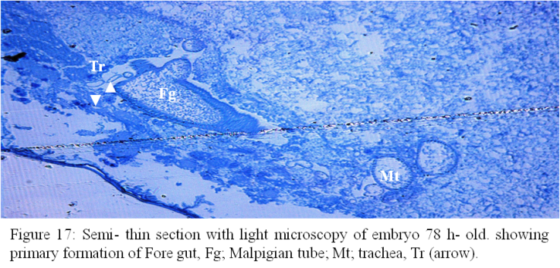

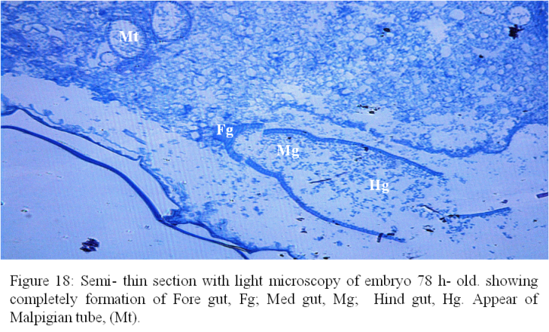

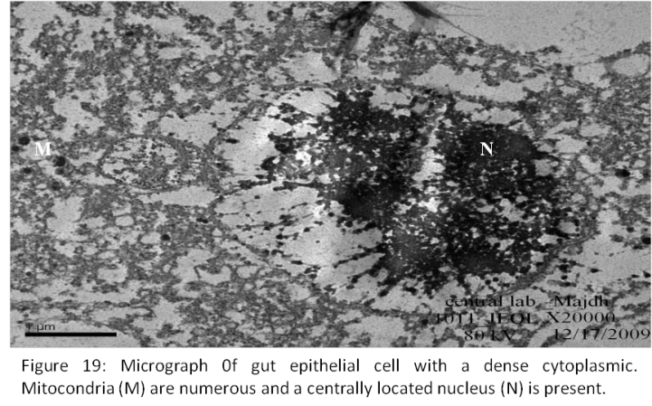

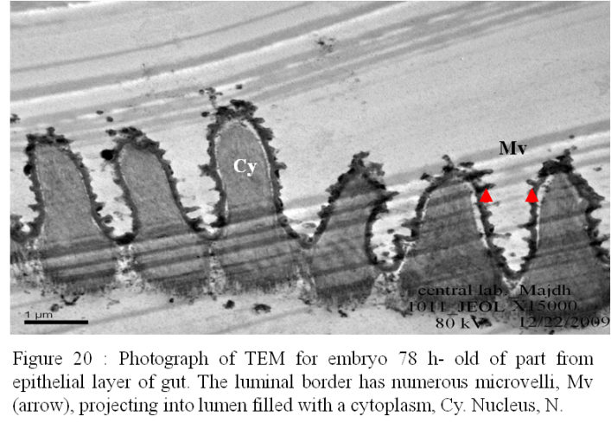

Acknowledgements:
Authors extend our sincere thanks to the Deanship of Scientific Research, the University Salman bin AbdelAziz for its support to this research and is part of the project No.37/H/1432 H., which was supported by the Deanship.

Corresponding Author:
Dr. Mona Al-Dawsary
Department of Biology,
College of Science and Humanities,
Salman bin AbdelAziz University
Saudi Arabia
E-mail: wisdom1425@yahoo.com

References
- Al- Dosary, M.M., El- Bekairi, A. M., Moursy, E. B.. Morphology of the egg shell and the developing embryo of the Red Palm Weevil, Rhynchophorus ferrugineus (Oliver). Saudi Journal of Biological Sciences. 2010; 17 : 177- 183.
- Anderson. D. T. The development of hemimetabolous. In Developmental System: Insects, vol.1, ed. S. J. Counce & C. H. Waddington, 1972a; 95- 163. New York: Academic Press.
- Anderson. D. T. The development of holometabolous insects. In Developmental System: Insects, vol.1, ed. S. J. Counce & C. H. Waddington, 1972b; 165- 242. New York: Academic Press.
- Bokhari U.G; Abuzuhari, R. Diagnostic tests for red palm weevil, Rhynchophorus ferrugineus, infested date palm trees. Arab Gulf J. Sci. Res., 199.2; 10: 93–104.
- Bong, J; Choon-Fah, Chin-Chin, E.R; Yiu, Pang-Hung, Rajan, A. Growth performance of the Red-Stripe Weevil Rhynchophorus schach Oliv. (Coleoptera: Curculionidae) on meridic diets. Am. J. Agr. Biol. Sci. 2008; 3 (1), 403–409.
- Chapman, R.F. The Insects: Structure and Function. Cambridge University Press, 1998; London.
- Corley, R.H.V. Tinker, P.B. World Agriculture Series: The Oil Palm, 4th ed. Blackwell Science Ltd., 2003; pp. 422–440.
- Haget. A. L’embryologie des insects. In Traité de Zoologie, 1977; vol 8, part 5B, ed. P- P. Grassé, 1-387. Paris: Masson et Cie.
- Halpern, S.D., Ubel, P.A., Caplan, A.L. Solid-organ transplantation in HIV-infected patients. N. Engl. J. Med., 2002; 347(4): 284-7.
- Handel, K., Gru¨ nfelder, C.G., Roth, S., Sander, K., 2000. Tribolium embryogenesis: a SEM study of cell shapes and movements from blastoderm to serosal closure. Dev. Genes Evol. 210, 167–179.
- Hinton. H. F. Biology of Insect Eggs. 1981; Oxford: Pergamon Press.
- Hoffmann. J. A; Lagueux. M . Endocrine aspects of embryonic development in insects. In Comprehensive Insect Physiology, Biochemistry and Pharmacology, 1985; vol. 1, ed. G. A. Kerkut & L. I. Gilbert, pp. 435- 460. Oxford: Pergamon Press.
- Johanssen, O. A; Butt, F. H. Embryology of Insect and Myriapods. 1941;New York: McGraw- Hill.
- Jura. C. Development of apteryogote insects. In Developmental System: 1972; vol.2, ed. S. J. Counce & C. H. Waddington, 49- 94. London: Academic Press.
- Kobayashi, Y., Suzuki, H., Ohba, N. Embryogenesis of the glowworm Rhagophthalmus ohbai wittmer (Insecta: Coleoptera, Rhagophthalmidae), with emphasis on the germ rudiment formation. J. Morphol. 2002; 253, 1–9.
- Margaritis, L.H. Structure and physiology of the eggshell. In Comprehensive Insect Physiology, Biochemistry and Pharmacology, vol.1, ed. G. A. Kerkut & L. I. Gilbert, 1985; 153- 230. Oxford: Pergamon Press.
- Margaritis, L.H., Mazzini, M. Structure of the egg. In: Harrison, F.E., Locke, M. (Eds.), In: Microscopic Anatomy of Invertebrates Insecta, 1998; vol. 11C. Wiley-Liss, New York, pp. 995– 1037.
- Mazzini, M. Fine structure of the insect micropyle––III. Ultrastructure of the egg of Chrysopa carnea Steph. (Neuroptera: Chrysopidae). Int. J. Insect Morphol. Embryol. 1976; 5, 273–278.
- Nagy., L. M. A summary of lepidopteran embryology. In Molecular Model System in the Lepidoptera, ed. M. R. Goldsmith & A. S. Wilkins, 1995; 136- 64. Cambridge: Cambridge University.
- Sadakathulla, S. Management of red palm weevil, Rhynchophorus ferrugineus F., in coconut plantations. Planter, 1991; 67: 415–9.
- Salama, H.S., Hamdy, M.K. Some ecological parameters of the egg and larval stages of the red pal weevil, Rhynchophorus ferrugineus (Oliv.) (Coleoptera) (Curculionidae). Arch. Phytopath. Pflan., 2001; 34: 155–64.
- Sander, K., Gutzeit, H. O., Jäckle, H. Insect embryogenesis: morphology, physiology, genetical and molecular aspects. In Comprehensive Insect Physiology, Biochemistry and Pharmacology, vol.1, ed. G. A. Kerkut & L. I. Gilbert, 1985; 319- 85. Oxford: Pergamon Press.
- Savage., A. A. The development of the malpighian tubules of Schistocerca gregaria (Orthoptera). Q. fl microsc. Sci, 1956; 97: 599- 615.
- Sivapragasam, A., Arikiah ., Ranjit, A. C.A. The red stripe weevil, Rhynchophorus schach Olivier (Coleoptera: Curculionidae): an increasing menace to coconut palms in Hilir Perak. Planter, 1990; 66: 113– 23.
- Skaer. H. The alimentary canal. In The Development of Drosophila melanogaster, ed. M. Bate & A. M. Arias, 1993; 941- 1012. New York: Cold Spring Harbor Laboratory Press.
- Stanley, M.S.M., Grundmann, A.W. The embryonic development of Tribolim confusum. Ann. Entomol. Soc. Am. 1970; 63, 1248– 1256.
- Takesue, T; Hiroomi, K., Kazuo, O. Blastoderm formation in the silkworm egg {Bombyx mori L.). /. Embryol. exp. Morph. 1890; Vol. 60,pp. 117-124.
- Tojo, K. Techniques in embryological studies of mayflies (Insecta: Ephemeroptera). Life History Reprod., 2003; 205–209.
- Weglarska, B. The formation of the blastoderm and embryonic membranes in Polydrosus impar gozis (Coleoptera, Curculionidae). Bull. Entomol. Pol., Wrocaw, 1955; 25 (13), 193–211.
- Weissling, J., Davis, G.M. Oligidic diets for culture of Rhynchophorus cruentatus (Coleoptera: Curculionidae). J. Rhynchophorus Cruentatus Diets, 1995; 225.

10/11/2013

