Impact of driving style on fuel consumption

Saleh Mobasseri¹, Hassan Soltani²

¹Beyza branch, Islamic Azad University, Beyza, Iran
²Neyriz branch, Islamic Azad University, neyriz, Iran

Abstract: The aim of this paper has studied the effects of changes in the speed and acceleration of the driving style on fuel consumption cars. First, it is indicated cycles with constant acceleration in three ranges: Local driving; a slower pace than km/h32, City driving; between 32 km/ to72 km/ h, The highway driving; With faster than72 km/h. then they calculate the fuel consumption rate of cars in each group. In this way, we can evaluate the effect of acceleration on fuel consumption in each of them. Also, the cycle with the same acceleration can be estimated by comparing the fuel consumption. In the end, we can see that at low driving speeds, fuel consumption will increase compared to driving at high speed. It is important that in city driving, acceleration is the fuel consumption of determining factor.
[Saleh Mobasseri, Hassan Soltani. Impact of driving style on fuel consumption. Nat Sci 2013;11(12):87-89]. (ISSN: 1545-0740). http://www.sciencepub.net/nature. 13

Keywords: Average speed, acceleration, fuel consumption, Local driving (Low speed driving), Average speed driving (City driving), the highway driving

1. Introduction
The main purpose of this paper in order to reduce fuel consumption includes: Increase in fuel prices in recent years and Air pollution caused by emissions greenhouse gases. Despite advances in automotive technology and high technology cars entering into the transportation system, it is still necessary to create new techniques to reduce fuel consumption in the transportation fleet. To reduce oil consumption and greenhouse gases released by them. There are many ways to reduce fuel consumption and greenhouse gas emissions; For example, the replacement of vehicles with more advanced technology, to reduce the distance, to reduce the weight and size of cars, Use public transport for transportation.
One of the main obstacles to achieving a significant reduction in fuel consumption replaces them very late. It takes more than 30 years; all the cars can be replaced. Due to the slow movement of the fleet, the fuel consumption is about 10 years late. Therefore, the special methods are needed to fuel cars (vehicles especially common) to decrease. Some studies indicate that personal behavior of drivers is one of the factors on fuel consumption and greenhouse gas emissions. Bin 2005 has shown that personal behaviors have been allocated 40% of total CO2 emissions in the United States. Driving style changes include high-speed driving and the lack of appropriate driving speed. Some studies have shown that drivers can reduce their fuel consumption by up to 15% with the change in driving style. West and et al (1998) have estimated a reduced speed from 70 mph to 65 mph reduces fuel consumption by as much as 8%. Shavarby et al (2005) found the lowest fuel consumption is between60 km/h to 90km/h. Wang et al (2008) found the lowest fuel consumption is between 50km/h to 70km/h. Tests done by Lisa Bard in 2009 as has been summarized in Table 1.

Table 1: The Fuel Consumption Test on cycles at a constant speed for several cars
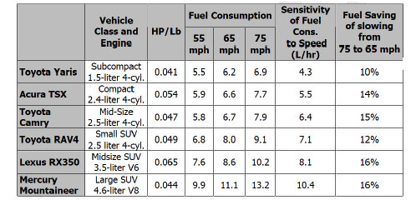
In addition, Berry ( 2010) showed When the average speed of an actual driving pattern is changed without the change in the ratio of the acceleration, The fuel consumption, it will follow the same U-shaped curve was observed for driving speed. This is shown in Figure1.
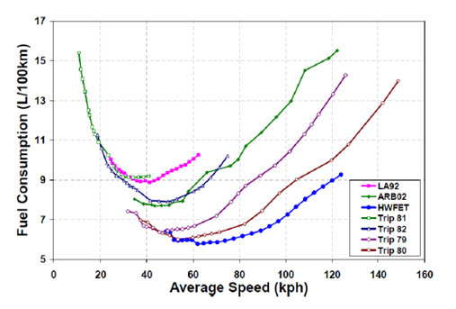
Figure1: The relationship between fuel consumption and average speed

Each point represents the average speed and fuel consumption for a specific route. For the seven paths-speeds, the minimum fuel consumption has been seen at intermediate speeds between 30km/h and 60km / h. Jones 1980, showed that fuel consumption, by constant acceleration, almost will increase linearly with the acceleration. The software results of simulation by Barry have been emphasizing the impact for various paths - speed.

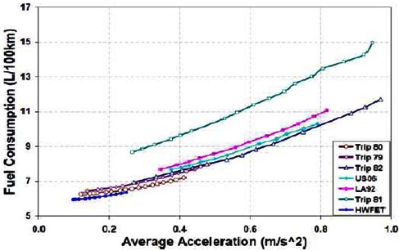
Figure 2: The relationship between fuel consumption and average speed for The seven pahts-speed

It has been seen in Figure 3, which has been a constant acceleration cycle at different speeds from the 8km / h to speed 132km / h. In each of these speeds is made of 8 or 9 cycles, with acceleration amplitude 0.7 . the method of the construction of cycles is that to achieve the specified speed, the variety of acceleration is caused. To achieve more accurate results, this cycle can be repeated up to 10 times. 2 seconds per cycle is considered to stop

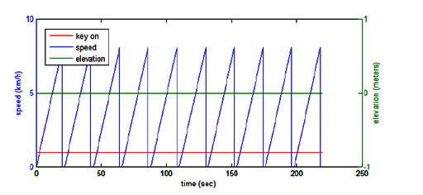
Figure 3: The example of a cycle with constant acceleration (The Acceleration: 0.8 and the maximum speed: 8 km / h)

2. The Simulation results:
The values of the fuel consumption can be changed by changing the parameters. The Figure 4 shows, the graph of fuel consumption changes associated with accelerated for 13 various speeds. As you can see the whole range of speed, a momentum increment leads to increased fuel consumption. It should be noted that perfect fuel consumption can be achieved when driving at a constant speed much as possible.
The Figure 5 shows that in a range of speeds (below km/h32), velocity variations strongly effect on the fuel consumption. So that with increased speed is being reduced fuel consumption. Another range of speeds (32 km/h to 72km / h), the changes of speeds will have a significant impact on fuel consumption. In the high speed 72km/h, increased speed will cause an increase in fuel.

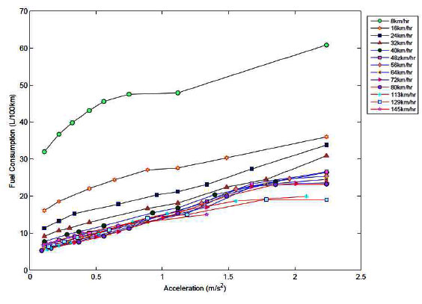
Figure 4: The fuel consumption for the different values of acceleration

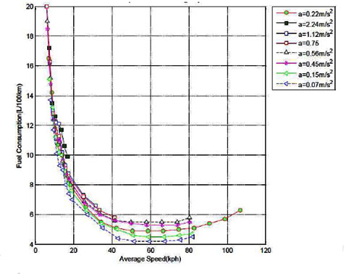
Figure 5: Relationship between fuel consumption and different speeds

3. Low speed driving (local):
Speed is less than 32km/h. As shown in Figure 6, fuel consumption for the four ranges of speed from 8km / h to 32km /h is calculated for a range of acceleration 11.5to 24.2 .
The relationship between fuel consumption and acceleration is incremental. In this range of speeds, acceleration increases fuel consumption. In low-speed driving, the average speed plays the main role on fuel consumption.

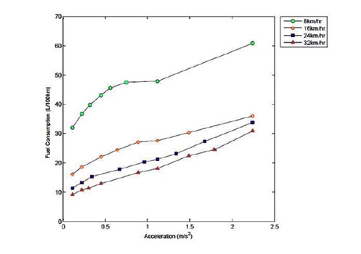

Figure 6: Fuel consumption for different values of acceleration in the low speeds(32 km/h)

4. Average speed driving
The speed in the this group is Between 32km / h to 72km / h. In the low-speed driving, Speed has any significant effect on fuel consumption but acceleration, it plays the main role on fuel consumption.

5. High speed driving (highway):
Figure 7 shows the more speed 72 km / h.

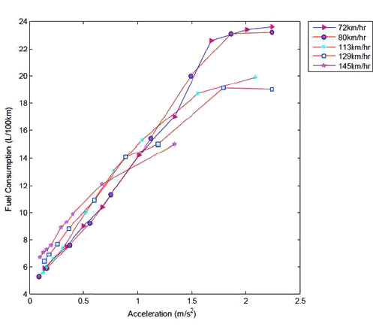
Figure 7: The more speed 72 km / h

5. Discussions
The variable-speed drive, the impact accelerations and speed are different. In driving at low speed (the average speed: 32km / h), the acceleration increases fuel consumption. In this type of driving, the average speed plays a major role. In high speed driving (average speed more than 72km/h), both parameters (i.e., speed and acceleration) are effective on fuel consumption.

Acknowledgements:
Authors are grateful to Beyza branch, Islamic Azad University for financial support to carry out this work.

Corresponding Author:
Saleh Mobasseri
beyza branch, Islamic Azad University, beyza, Iran

References
- Bandivadekar, Anup, Kristian Bodek, Lynette Cheah, Christopher Evans, Tiffany Groode, John Heywood, et al., ”On the Road in 2035:Reducing Transportation’s Petroleum Consumption and GHG Emissions,” LFEE 2008-5 RP (Cambride, MA: MIT Laboratory for Energy and the Environment, July 2008.
- Bin and Dowlatabadi, 2005S. Bin and H, Dowlatabadi. “Consumer lifestyle appoarch US energy use and the related CO2 emissions”, Energy Policy, vol. 33.no.5 (January 2005,pp. 197-208).
- Greene, David L., “Near tern Options to Increase Fuel Economy and Decrease Petrolum Demand”, Testimonyto the U.S. Senate Committee on Energy and Natural Resources, (23 July 2008).
- West, B.H., R.N. McGill, J.W. Hodgson, S.S. Sluder, and D.E. Smith, “Development and Verirication of Light Duty Modal Emissions and Fuel Consumption Values for Traffic Modals,” (U.S. DOT Federal HighwayAdministration, April 1997).
- El_Shawarby, Ihab, Kyounglo Ahn,and Hesham Rakha, “Comparative field evaluation of vehicle cruise speed and acceleration level impacts on hot stabilized amissions, “Transportion Research and the Environment, vol. 10,no 1(January 2005),app. 13-30.
- Wang, Haikun Lixin Fu,Yu Zhou.He Li, “Modeling or the fuel consumption for passenger cars regarding driving characteristics,” Transportaion Research PartD:Transport and the Environment, Vol. 13, no. 7 (October 2008). pp.479-482.
- Barth, Liza, “Tested:Speed vs fuel economy,” (Yonkers, NY: Consumer Reports, 9September 2009.
- Berry,Irene Michelle, “The Effect of Driving Style and Vehcle Performance on the Real-World Fuel Consumtion of U.S. Light Vehicles,” (Massachusett Institute of Technology February 2010.
- Jones, R., “Quantitative Effects of Acceleration Rate Fuel Rate in Fuel Consumption,” PB-80-191299 (Ann Arbor, MI:U.S. EPA,April 1980.

11/28/2013

