Assessment of Drought Impact in Africa Using Standard Precipitation Evapotranspiration Index

Hassanein M. K.; A.A. Khalil; Y.H. Essa

Central Laboratory for Agricultural Climate (CLAC), Agricultural Research Center (ARC), Ministry of Agriculture and Land Reclamation (MALR), Egypt
Alaa_armka@yahoo.com

Abstract: This paper assesses the impact of drought in Africa and selects the vulnerable areas to drought by using Standard Precipitation Evapotranspiration Index (SPEI) as a new index for drought monitoring during the period from 1960 to 2008 at time scales 12. Results of this study refer to the characteristic of drought over Africa using the Stander Precipitation Evapotranspiration Index (SPEI) at time scale 12 for month of Dec. during the period from 1960 up to 2008 was analyzed. Results concluded that the first decades were less drought area and the drought increased with time. Frequency of drought (SPEI values ≤ -1) increased in last decades. There are most difference between extreme drought and wet events while the severe and moderate classes were closer. The assessment of the drought impact in Africa needs to determine several systems (water resource, natural vegetation and crops) to quantify the impact of drought in terms of both system's resistance and resilience, to produce drought impact curve for each system and region.
[Hassanein M. K.; A. A. Khalil; Y. H. Essa. Assessment of Drought Impact in Africa Using Standard Precipitation Evapotranspiration Index. Nat Sci 2013;11(12):75-81]. (ISSN: 1545-0740). http://www.sciencepub.net. 11

Key words: Drought, Drought index Assessment, Impact and Standard Precipitation Evapotranspiration Index (SPEI)

1. Introduction
Droughts are recognized as an environmental disaster and have attracted the attention of environmentalists, ecologists, hydrologists, meteorologists, geologists and agricultural scientists. Droughts occur in virtually all climatic zones, such as high as well as low rainfall areas and are mostly related to the reduction in the amount of precipitation received over an extended period of time, such as a season or a year. Temperatures; high winds; low relative humidity; timing and characteristics of rains, including distribution of rainy days during crop growing seasons, intensity and duration of rain, and onset and termination, play a significant role in the occurrence of droughts. In contrast to aridity, which is a permanent feature of climate and is restricted to low rainfall areas (Wilhite, 1992), a drought is a temporary aberration. In Africa drought is the natural hazard that affects a large number of people with the most negative consequences, being responsible for famine (Scrimshaw, 1987), epidemics and land degradation (Bandyopadhyay, et al., 2012; UN, 2008). Among the most important natural disasters affecting the world, drought record the two highest number killed between years 1974 and 2007, where it killed 450,000 and 325,000 persons in 1984 and 1974 in Ethiopia/Sudan and the Sahel region, respectively (UN, 2008). Drought increases the structural problems of the African continent and in the last decades has caused a decrease of crop yields, unemployment, impoverishment and even forced migrations (Scheffran et al., 2012d; UN, 2008). The problem may increase in the future since the current population projections predict a demographic increase in the regions affected by chronic water deficits in Africa, and climate change models also indicate the likely increase of drought severity during the 21st century (Dai, 2011), which are likely to increase famine (Marta M. Jankowska et al., 2012) social conflicts and the risk of civil wars in African countries (Burke et al., 2009). Understanding, monitoring and mitigating drought is a very difficult task as a consequence of the intrinsic nature of the phenomenon. In addition, assessing the impact of drought on ecosystems and societies is also a complex task, because the same drought severity may have different consequences in different regions and systems due to the underlying vulnerabilities. New technologies based on geospatial information are available to determine the risk and vulnerability of a system to a drought and to develop monitoring and early warning systems based on real-time information to support decision making (Sergio M. et al 2012). The objective of this study is to monitoring, assessing drought impact in Africa, and selected the vulnerable areas to drought by using Standard Precipitation Evapotranspiration Index (SPEI).

2. Material and method:
Monitoring and assessing drought in Africa has been done using the Standard Precipitation Evapotranspiration index (SPEI) (Vicente-Serrano et al. 2010b), which takes into account both precipitation and potential Evapotranspiration (PET) demand of the atmosphere. This index is calculated as the difference between monthly precipitation (P) and the potential evapotranspiration (PET),

D = P – PET

The probability distribution of cumulative D series is aggregated at selected time scales. The 3-parameter Log-logistic distribution adopted for standardizing the D series for all time scales. And then transform it to Z –score by converting F(x) values obtained to z-standardized values. For example, following the classical approximation of Abramowitz and Stegun (1965):

(C₀+C₁W+C₂W²)
SPEI = W -
(1+d₁W+d₂W²+d₃W³)

Where W =$\sqrt{- 2*ln(P)}$ for P ≤ 0.5, P is the probability of exceeding a determined D value, P =1−F(x). If P > 0.5, P is replaced by 1−P, and the sign of the resultant SPEI value is reversed. The constants are: C₀ = 2.515517, C₁ =0.802853, C₂ = 0.010328, d₁ = 1.432788, d₂ = 0.189269 and d₃ = 0.001308.

The average value is 0, and the standard deviation is 1.
Global gridded dataset of the Standard Precipitation - Evapotranspiration Index (SPEI) at time scale 12 months is downloaded from http://digital.csic.es/handle/10261/48169 with spatial resolution of 0.5º lat/lon. Temporal coverage between January 1901 and December 2009. The FAO-56 Penman - Monteith's method has been used for computing PET. Unbiased probability weighted moments (ub-pwm) method has been used for fitting the log-Logistic distribution. The whole world is put in one single netCDF file.

3. Result and Disscusion
The Standard Precipitation Evapotranspiration index (SPEI) as drought index has been showed in figures (1 and 2) from 1960 upto 2008 for month of Dec. at time scale 12 to include all months of each year for decades 1960, 1970, 1980, 1990, and 2000 respectively. It’s observed that the older decades have less area of drought events, where the decade 1960 has most wet categories percentage area and decade 2000 has most drought categories percentage area compared with other studied decades. Year of 1961 has the most extreme wet area percentage while year of 1996 has the most extreme drought area percentage. Years of 1976, 1991, 1999, 2001, and 2006 haven’t exposed to extreme drought.
The frequency distribution of SPEI values in 7 classes of drought category (%) over Africa at time scale 12 for month of Dec. during studied decades showed in table (1). As it observed all drought categories are increasing with time and all wet categories are decreasing with time, while the normal condition was nearly close during study period.
Figure (3) represents the average distribution of SPEI categories over Africa during study period, and it shows the normal condition around 79 % out of total values, moderate drought and wet were around 10.3 % and 5.1%, severe drought and wet were around 1.7% and 2.5%, and extreme drought and wet were around 0.2% and 2.3%.

Table (1): The frequency distribution of SPEI values in 7 classes of drought category (%) in Africa at time scale 12.
Classification | decade 60 | decade 70 | decade 80 | decade 90 | decade 2000
Extreme Drought | 0.1 | 0.1 | 0.2 | 0.3 | 0.4
Severe Drought | 0.6 | 1.2 | 2.2 | 2.1 | 2.3
Moderate Drought | 5.2 | 8.0 | 12.5 | 12.8 | 13.1
Normal | 75.7 | 81.0 | 76.4 | 80.5 | 80.5
Moderate Wet | 7.8 | 5.3 | 6.1 | 3.2 | 3.0
Severe Wet | 5.2 | 2.9 | 2.1 | 1.3 | 1.2
Extreme Wet | 5.4 | 2.6 | 1.6 | 1.0 | 0.9

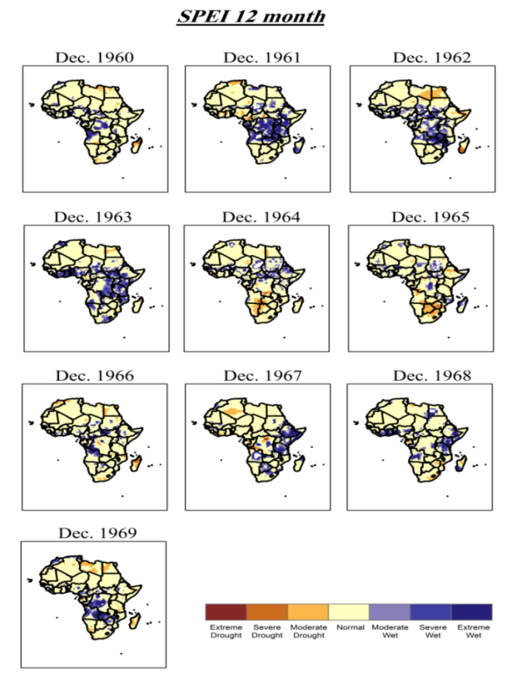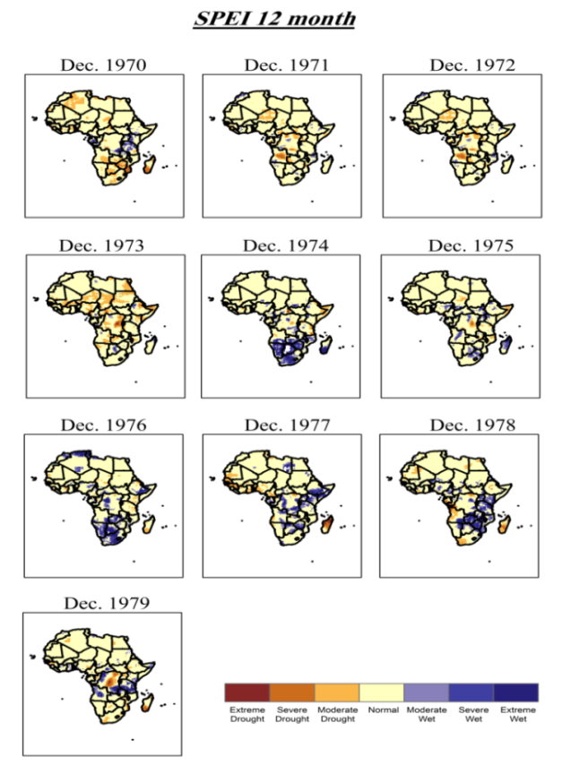

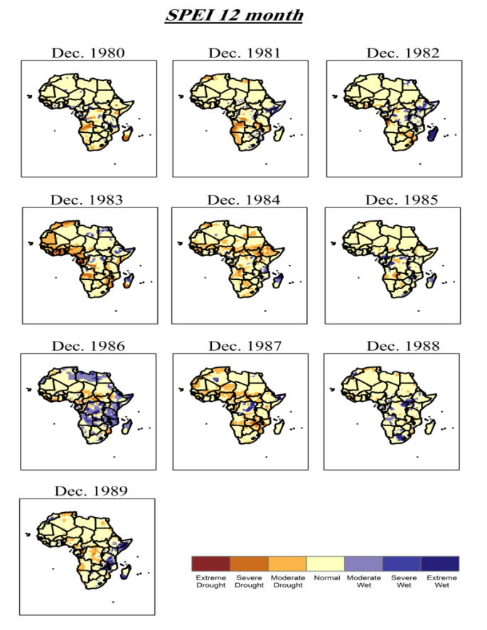
Figure (1): SPEI at time scale 12 for month of Dec. during the period from 1960 to 1989.

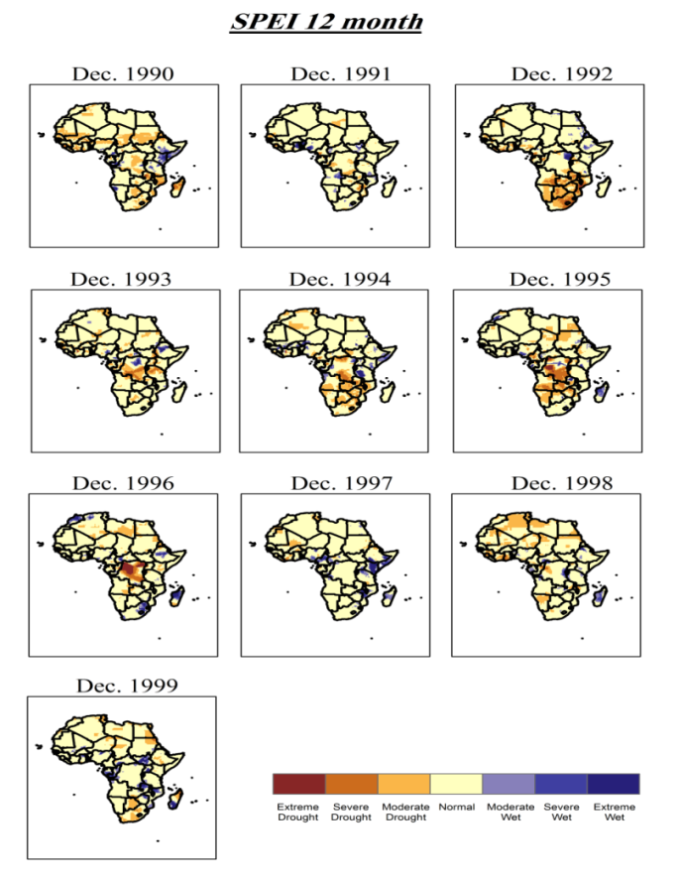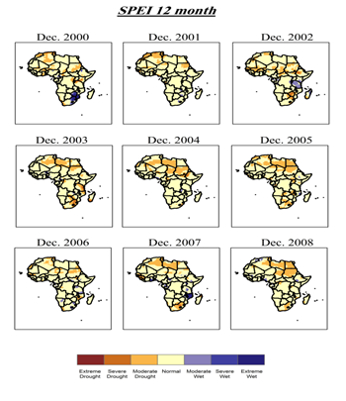
Figure (2): SPEI at time scale 12 for month of Dec. during the period from 1990 to 2008.
Figure (2): SPEI at time scale 12 for month of Dec. during the period from 1990 to 2008.

Figure (3): Average distribution of SPEI categories in Africa.

Figure (4) show the comparison between the average percentage of total drought (values ≤ -1) and wet categories (values ≥1) from 1960 up to 2008, where it was noted the predominance of wet event during decades 1960, then it approached a lot of drought event at 1970 decade, then followed by decreasing, and increasing of drought event.
By separating each drought and wet classification for studied decade as shown in figure (5) it was noted that, the biggest difference was between the extremes drought and wet events and this difference was less in sever and moderate classes. Also the extreme wet event greater than extreme drought in all studied decades.
In recent years, large scale intensive droughts have been observed on all continents affecting large areas in Europe, Africa, Asia, Australia, South America, Central America and North America (Le Comte, 1995) and high economic and social costs have led to increasing attention to drought (Downing and Bakker, 2000). Since the late 1960s, the Sahel (a semiarid region in West Africa between the Sahara desert and the Guinea coast rainforest) has experienced a drought of unprecedented severity in recorded history. Drought has a devastating impact on this ecologically vulnerable region and was a major impetus for the establishment of the United Nations Convention on Combating Desertiﬁcation and Drought (Zeng, 2003). While the frequency of droughts in the region is thought to have increased from the end of the 19th century, three long droughts have dramatic environmental and societal effects upon the Sahel nations. Famine followed severe droughts in the 1910s, 1940s, 1960s, 1970s and 1980s, although a partial recovery occurred from 1975–1980. While at least one particularly severe drought has been conﬁrmed in each century since the 1600s, the frequency and severity of the recent Sahelian drought stands out the famines and dislocation on a massive scale from 1968 to 1974 and again in the early and mid-1980s was blamed on two spikes in the severity of the 1960– 1980s drought period (Batterbury and Warren, 2001). Bordi and Sutera (2001) found dry conditions over Europe, Eastern Asia, Central Africa and the Caribbean region to be interconnected and affected by the tropical climatic variability.

Figure (4): Comparison between the average percentage of total drought and wet categories.

Figure (5): Comparison between drought and wet classification in each decade.

Conclusion
The characteristic of drought over Africa using the Stander Precipitation Evapotranspiration Index (SPEI) at time scale 12 for month of Dec. during the period from 1960 up to 2008 was analyzed. Results concluded that the first decades were less drought area and the drought increased with time. The frequency of drought (SPEI values ≤ -1) increased in last decades. There are big difference between extreme drought and wet events while the severe and moderate classes were closer. Assessment of the drought impact in Africa needs to determine of several systems (water resource, natural vegetation and crops) to quantify the impact of drought in terms of both system's resistance and resilience, and to produce drought impact curve to each system and region.

References
- Abramowitz, M., Stegun, I.A., (1965): Handbook of Mathematical Functions. Dover Publications, New York.
- Bandyopadhyay, S., Kanji, S., & Wang, L. (2012). The impact of rainfall and temperature variation on diarrheal prevalence in Sub-Saharan Africa. Applied Geography, 33, 63e72.
- Batterbury, S.P.J., Warren, A., 2001. The African Sahel 25 years After the Great Drought: Assessing Progress and Moving Towards New Agendas and approaches. Global Environmental Change, pp.1–8.
- Bordi, I., Sutera, A., 2001. Fifty years of precipitation: some spatially remote teleconnections. Water Resour. Manage. 15, 247–280.
- Burke, Marshall, Edward Miguel, Shanker Satyanath, John Dykema, and David Lobell. (2009). Warming increases the risk of civil war in Africa. Proceedings of the National Academy of Sciences 106, no. 49: 20670.
- Dai, A., 2011: Drought under global warming: A review. Wiley Interdisciplinary Reviews: Climate Change, 2, 45-65. DOI: 10.1002/wcc.81.
- Downing, T.E., Bakker, K., 2000. Drought discourse and vulnerability. In: Wilhite, D.A. (Ed.), Drought: A Global Assessment, Natural Hazards and Disasters Series. Routledge Publishers, UK.
- Le Comte, D., 1995. Weather highlights around the world. Weatherwise 48, 20–22.
- Marta M. Jankowska, David Lopez-Carr, Chris Funk, Gregory J. Husak, and Zoë A. Chafe, (2012). Climate change and human health: Spatial modeling of water availability, malnutrition, and livelihoods in Mali, Africa. Applied Geography, Volume 33, April 2012, Pages 4–15
- Scheffran, J., Marmer, E. and Sow, P. (2012d) Migration as a contribution to resilience and innovation in climate adaptation: Social networks and co-development in Northwest Africa. Applied Geography, 33 (0), pp. 119-127.
- Scrimshaw, N. S. (1987). The phenomenon of famine. Annual Review of Nutrition, 7,1-21
- Sergio M. Vicente-Serrano, Santiago Beguería, Luis Gimeno, Lars Eklundh, Gregory Giuliani, Derek Weston, Ahmed El Kenawyg, Juan. López-Moreno, Raquel Nieto, Tenalem Ayenewh, Diawoye Konte, Jonas Ardö, Geoffrey G.S. Pegramj(2012). Challenges for drought mitigation in Africa: The potential use of geospatial data and drought information systems. Applied Geography 34, 471-486
- United Nation (UN) 2008. Trends in sustainable development. Agriculture, rural development, land, desertification and drought. United Nations. New York: Department of Economic and Social Affairs.
- Vicente-Serrano SM, Beguería S, López-Moreno JI (2010b). A multi-scalar drought index sensitive to global warming: the standardized precipitation evapotranspiration index SPEI. J Clim 23: 1696−1718
- Wilhite, D.A., 1992. Preparing for Drought: A Guidebook for Developing Countries,Climate U nit, United Nations Environment Program, Nairobi, Kenya.
- Zeng, N., 2003. Drought in the Sahel. Science 302, 999–1000.

11/22/2013

