Prevalence and Monetary Loss due to Bovine Fasciolosis in Juba Slaughter House South Sudan

Amal A. MOUSA¹, Khitma H. El MALIK², Erneo B. OCHI¹

¹National Ministry of Agriculture, Tourism, Animal Resources, Fisheries, Cooperatives and Rural Development, Animal Resources and Fisheries Sector, P.O. Box 126 Juba South Sudan
²University of Khartoum, Faculty of Veterinary Medicine, Khartoum North Sudan. P.O. Box 321

Abstract: Study on Prevalence and Monetary Loss from liver condemnations due to bovine fasciolosis was conducted in Juba main slaughter house for three months as of May to July 2012. A total of 4,642 indigenous Nilotic and exotic Ankole cattle breeds were investigated. Nilotic cattle revealed high prevalence of 96.8% compared to 2.5 % in Ankole cattle attributed to Fasciola gigantica during post-mortem examination. Likewise, fecal examination revealed a prevalence of 89.6% in Nilotic and 2.9 % in Ankole cattle breed. This significant difference in prevalence rate between the two breeds might be attributed to de-worming regimens taken prior to importation of Ankole cattle from Uganda to South Sudan. Fasciolosis was found to be responsible for a condemnation of 36.4% inspected livers suggesting fasciolosis as one of the priority diseases of economic importance in South Sudan. The sum of monetary losses revealed 45,180 SSP (15,227.5 USD) and 17,560 SSP (5,918.4 USD) in total and partial liver condemnations, respectively. Further epidemiological and molecular studies are needed to develop strategies for the control of bovine fasciolosis in South Sudan.
[Amal A. MOUSA, Khitma H. El MALIK, Erneo B. OCHI. Prevalence and Monetary Loss due to Bovine Fasciolosis in Juba Slaughter House, South Sudan. Nat Sci 2013;11 (11):145-148]. (ISSN: 1545-0740). http://www.sciencepub.net/nature. 20

Key words: Prevalence, Monetary Loss, Liver Condemnations, Bovine Fasciolosis, Nilotic, Ankole, cattle breeds, South Sudan

1. Introduction
Bovine fasciolosis due to Fasciola hepatica and F.gigantica is one of the economically important snail–borne parasitic diseases of cattle in tropical and subtropical countries that limits animals productivity (Dechasa et al., 2012).The snails Lymneae natalensis, the intermediate hosts of F.gigantica, commonly occur in northern Gezira and southern Khartoum State, Sudan culminating in high prevalence of fasciolosis (Atta Elmanan et al., 2001). Recent evidence has shown that bovine fasciolosis is endemic in swampy areas of Northern Bahr el- Ghazal, Jonglei, Lakes and Central Equatoria States (Anon,2010). Furthermore, previous reports in the then southern Sudan showed higher incidence of the disease as 33%, 56% and 47% in Equatoria, Bahr El Ghazal and Upper Nile Provinces, respectively (Karib,1962).
The economic losses due to bovine fasciolosis are enormous. They are attributable to a number of factors including livers condemnation, increased susceptibility to secondary infections and expense of control measures (Ibrahim et al., 2010). However, no or little progress has been made to investigate the prevalence and estimate the monetary loss due to bovine fasciolosis in Central Equatoria State (CES), South Sudan.
The purpose of the study was to determine the prevalence of the disease and estimate the monetary losses due to livers condemnation among indigenous Nilotic and exotic Ankole cattle in Juba main Slaughter House, South Sudan.
2. Material and Methods
2.1 Study Area
Juba lies in the tropical climate at 0346475 and 0346484 °N and 0535105 and 0535139 °E, and at the elevation of 460 meter using global positioning system (GPS). Annual ambient temperature ranges from 24.7°C to 34.5°C, the mean relative humidity stands at 55% and the rainy season usually commences in April and ends in November. Livestock are brought daily for marketing and slaughter purposes from various locations such as Rumbek, Terekaka, Bor, Pibor and the neighbouring Uganda.
2.2. Study Design
A total of 4,642 adult cattle which included 713 indigenous (Nilotic) and 3,929 exotic (Ankole) breed imported from Uganda were investigated. 150 fecal samples were collected from 48 indigenous Nilotic and 102 exotic Ankole cattle for detection of fasciola eggs employing sedimentation techniques. The study was designed based on cross sectional type to determine the prevalence rate and estimate monetary loss due to liver condemnations using anti-mortem and post-mortem examinations for each adult indigenous and exotic cattle. Estimation of monetary losses was assessed through participatory approaches including meetings and interviews with retailers, cattle owners and butchers. The prices were taken from the current retail price of 40 SSP per 1 Kg of liver. The calculation was made from 439 partially and 251 totally condemned livers.
2.3 Data Management and Analysis
Data from the Slaughter house figures during meat inspection were recorded on daily basis. Data analysis was made using a computerized programme package.
3. Results
3.1 Prevalence of fasciolosis
The prevalence of the disease in indigenous Nilotic cattle ranged from 85.3% to 99.2% with an average of 96.8%. Similarly, such a prevalence in the exotic Ankole breed ranged from 2.3% to 2.8% with an average of 2.5%. (fig. 2 and tab.1). However, the overall prevalence of fasciolosis in the study area was 17.0 % (790/4,642). In indigenous breed, the prevalence was high compared to the exotic cattle breed. Fasciola eggs were detected in 46 fecal samples of which 30.7% showed fasciolosis. Comparatively, Ankole cattle showed only 3 positive cases (2.9%) while Nilotic cattle had the majority of 43 cases (89.6%) as depicted in table 2.

3.2 Monetary Losses
Monetary loss due to condemnation of 251 out of 713 livers amounted to 45,180 South Sudanese pound (SSP) and 17,560 SSP for total condemnation and partial condemnation, respectively.

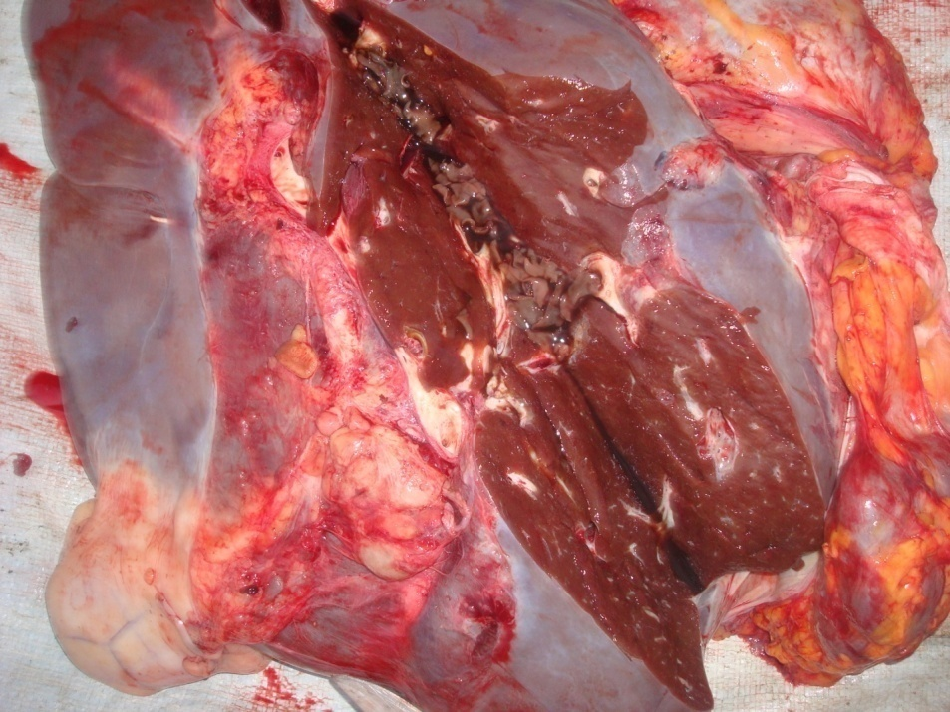

Figure 1: Fasciola gigantica in a bile duct of a condemned liver at Juba main S/House.

Table (1) : Prevalence of Bovine fasciolosis in indigenous Nilotic and exotic Ankole cattle examined at Juba main Slaughter House, May - July 2012.
 | Post-mortem Examination |  |  |  |  |  | Total
Month
 | Ankole cattle | No. +ve | Prevalence % | Nilotic cattle | No. +ve | Prevalence %  (Mean) | No. of Cattle  examined/m | Overall  Prevalence %
 |  |  | (Mean) |  |  |  | onth | (Mean)
May | 1,273 | 29 | 2.3 | 198 | 169 | 85.4 | 1,471 | 13.5
June | 1,316 | 37 | 2.8 | 264 | 257 | 97.3 | 1,580 | 18.6
July | 1,340 | 34 | 2.5 | 251 | 249 | 99.2 | 1,591 | 17.8
Total | 3,929 | 100 |  | 713 | 690 |  | 4,642
 |  |  | 2.5 |  |  | 96.8 |  | 17.0

Table (2) : Apparent prevalence of Bovine fasciolosis from fecal examination at Juba Slaughter House, May –July, 2012.
 | Fecal Examination |  |  |  |  |  | Total
Month
 | Ankole | No. | Prevalence | Nilotic | No. | Prevalence | No.of cattle | Overall
 | cattle | +ve | % (mean) | cattle | +ve | % (mean) | examined/month | Prevalence (%)
May  June  July  Total | 21  36  45  102 | 0  2  1  3 | 0.0  5.6  2.2 | 19  12  17  48 | 17  10  16  43 | 89.5  83.3  94.1 | 40  48  62  150 | 42.5  25.0  27.4
 |  |  | 2.9 |  |  | 89.6 |  | 30.7

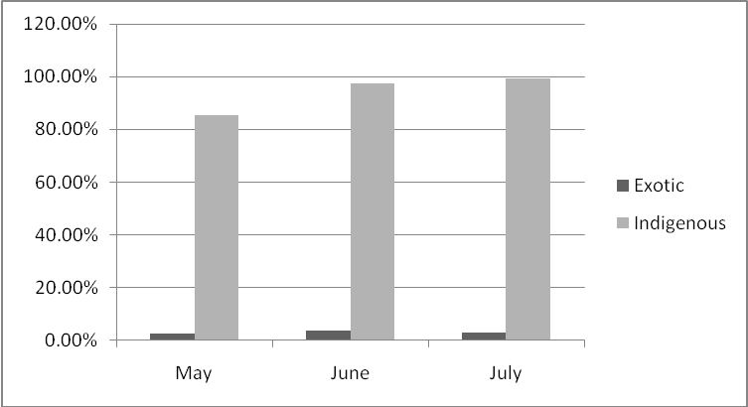
Figure 2: Monthly prevalence of Fasciola gigantica infection in Exotic(Ankole) and Indigenous (Nilotic) cattle during post mortem examination at Juba main S/House, May - July 2012.

4. Discussion

The significantly higher prevalence of Bovine fasciolosis in indigenous Nilotic than the exotic Ankole cattle breed might be attributed to lack of control strategy applied to fasciolosis for the past three decades besides inadequate veterinary services delivery system in South Sudan. This is exacerbated by the presence of permanent, extensive swamps in some areas and seasonal flooding of grazing land adjacent to swamps and rivers which collectively provide suitable habitats for snails in swampy areas. Moreover, humid, warm conditions in the main cattle-rearing areas of South Sudan are conducive for the survival of the aquatic snails that act as the intermediate hosts for F.gigantica. The significant low prevalence among the exotic Ankole cattle may be explained by de-worming regimens taken for the imported livestock in Uganda. Literature review indicated that the prevalence of fasciolosis in Uganda revealed 10% (Ozung et al., 2011).

The high prevalence of bovine fasciolosis comparable to previous works done in the Sudan might be due to agro-ecological and climatic differences. In Ethiopia, Kenya Tanzania and Nigeria reports showed prevalence of 39.6%, 8.6%, 16.3% and 31.7%, respectively (Kithuka et al.,2002; Ibrahim et al., 2010; Malleu et al., 2010 ; Ozung et al., 2011). In Malakal, Upper Nile State, South Sudan, the prevalence of liver flukes in cattle revealed 37.0% (Eisa, 1963), who detected fluke eggs in 15.4% of cases in 365 cattle. Pathological lesion of the affected livers causes considerable loss. This economic loss is substantially higher than the average loss due to fasciolosis in Ganawa slaughter house for 5 years which were 898,080 Sudanese Genieh (SDG) and 160 SDG at Al kadaru slaughter house(Yasen, 2012). Scores of partial condemned livers revealed 63.6% which are greater than totally condemned livers (31.4%) indicating a continuous environmental contamination of infected snails in the vicinity of Nilotic cattle. The mechanical majority of the cattle inspected during the study have been hailed from Uganda suggesting that F. gigantica is the only species affecting cattle in Uganda. Similarly all cattle inspected at Juba main slaughterhouse suffered from F.gigantica infection and none was infected with F.hepatica. This may explain the exclusion of the latter in the epidemiology of bovine fasciolosis in South Sudan.

5. Conclusion
Fasciolosis is an important parasitic disease causing considerable loss of revenue due to condemnation of affected livers at Juba main slaughter house. Establishment of an effective control programme with regular treatment at 12-13 week intervals with flukicides is effective against both mature and immature flukes. This will eventually reduce and mitigate the intensity of infection in a herd over time and subsequent environmental contamination. Prospects for sustainable development of livestock need snail control and that should be added to the package of trematodes control aiming at Fasciola and other fresh water snails in South Sudan. Further studies on the molecular aspects and epidemiology covering a wider area, capturing all seasons and involving large population of indigenous animals are needed for developing strategies for the control of fasciolosis in South Sudan.

Acknowledgements
We are indebted to A/Commissioner of Animal Resources and Fisheries, Juba County, CES and the University of Khartoum for allowing us to conduct sampling at Juba Slaughter House and publish this paper. Sincere acknowledgements are due to Undersecretary, Animal Resources and Fisheries Sector at the Ministry of Agriculture, Forestry, Tourism, Animal Resources, Fisheries, Cooperatives and Rural Development for financial support.

Corresponding Author
Dr. Amal Ahmed Mousa
E-mail: amal78ahmed@yahoo.com

References:
- Dechasa Terefe, Anteneh Wondimu, and Fekadm Gachen, (2012).Prevalence, Gross Pathological Lesions and Economic Losses of Bovine fasciolosis at Jimma Municipal abattoir Ethiopia. J Vet. Med. Anim. Hlth 4: 6-11.
- Atta El Manan, A.M., Bushara, H.O. and Majid, A.M (2001). Some Aspects of bovine Fasciolosis in Northern Gazira and Khartoum State.The Sud. J. Vet Res.,17:35-40.
- Karib, E.A. (1962). Fascioliasis in cattle and sheep in the Sudan. Bulletin de l'Office International des Epizooties, 58:337-346.
- Ibrahim, N., Wasihun, P. and Tolosa, T. (2010). Prevalence of Bovine Fasciolosis and Economic Importance Due to Liver Condemnation at Kombolcha Industrial Abattoir, Ethiopia. The Intern. J.Vet. Med. 8:21-26.
- Anon (2010). Monthly reports from States of South Sudan, Ministry of Animal Resources and Fisheries (MARF)- South Sudan.
- Ozung, P.O., Owai, P.U and Oni, K.O (2011). An assessment of the prevalence of fasciolosis of ruminants in Ikom abattoir of Cross River State, Nigeria. Cont. J.Vet Sci., 5:1-5.
- Kithuka, J.M., Maingi, N. Njeruh F.M. and Ombui, J.N.( 2002). The prevalence and economic importance of bovine fasciolosis in Kenya-an analysis of abattoir data. Ondersts- poort J. Vet. Res, 69:255-262.
- Malleu L.S.B, Nonga, H.E. and Karimuribo, E.D. (2010). A slaughter house survey of liver lesions in slaughtered cattle, sheep and goats at Arousha Tanzania Res. J. Vet Sci. 3:179 -188.
- Eisa, A.M.(1963).Incidence of parasites in bovine livers. Sud. J. Vet.Sci Anim. Husb.,4 (2) : 72-76.
- Yasen Alhindi. (2012). Monitoring and Assessment of losses from condemnation of organs infected with some parasites or larvae in slaughter houses in Khartoum State Sudan, MTAH Thesis Khartoum University.

10/22/2013

