Drought Monitoring over Egypt by using MODIS Land Surface Temperature and Normalized Difference Vegetation Index

Khalil1 A.A. ¹; M.M. Abdel-Wahab²; M. K. Hassanein¹; B.Ouldbdey ³; B. Katlan ³; and Y.H. Essa¹

¹Central Laboratory for Agricultural Climate (CLAC), Agricultural Research Center (ARC), Ministry of Agriculture and Land Reclamation (MALR), Egypt
² Faculty of science - Cairo University, Egypt
³ The Arab Center for the Studies of Arid Zones and Dry Lands (ACSAD)
Alaa_armka@yahoo.com

Abstract: Drought is a serious climatic condition that affects nearly on all climatic zones worldwide, with semi-arid regions being especially susceptible to drought conditions because of their low annual precipitation and sensitivity to climate changes. In the present work, we use the Vegetation Health Index (VHI) as drought indices to monitoring the drought over Egypt.The Moderate Resolution Imaging Spectrometer (MODIS) on the terra satellite has been used the normalized difference vegetation index (NDVI) and land surface temperature (LST) to calculate the Vegetation Condition Index (VCI) , Temperature Condition Index (TCI) and vegetation health index (VHI) over Egypt, for the seasons from 2000/2001 to 2010/2011. The time series of (VCI) and (TCI) show that; in certain years they were corresponded to each other, while in other years they were one counter the other and their resultant determined the occurrence and severity of drought, which is reflected in the Vegetation Health Index (VHI). The results show that; the effect of drought on vegetation varies noticeably between areas, a pattern that is determined mainly by the location of land-cover types. The drought frequency increased during the last four years. The agricultural seasons 2000/2001 and 2010/2011 were the highest agricultural area affected by high drought while the 2006/2007 was the lowest agricultural area affected by high drought.
[Khalil1 A.A.; M.M. Abdel-Wahab; M. K. Hassanein; B.Ouldbdey ; B. Katlan; and Y.H. Essa. Drought Monitoring over Egypt by using MODIS Land Surface Temperature and Normalized Difference Vegetation Index. Nat Sci 2013;11(11):116-122]. (ISSN: 1545-0740). http://www.sciencepub.net. 17

Keywords: drought, Vegetation MODIS, NDVI, VHI, VCI and TCI

Introduction
Drought is a slow-onset natural disaster, an insidious and creeping phenomenon which occurs in virtually all climatic regimes. Drought is also related to the timing and the effectiveness of the rains, thus, each drought year is unique in its climatic characteristics and impacts. And also Drought is a major nature hazard affecting large areas and millions of people every year. Drought can be described by three characteristics: intensity, duration and spatial coverage (Wilhite and Glantz 1985, American Meteorological Society 1997). Intensity refers to the degree of precipitation shortfall and is closely linked to duration in the determination of its impacts. To some extent, drought occurs with uncertainty at a micro-scale, and drought occurrence sites vary from time to time when studying spatial distributions of drought (Wang and Wei 1998). Meteorologically based drought monitoring refers to point-based analyses, which might include simple presentations of specific events relative to their long-term historical averages (often denoted as ‘normal’). The point-based drought indices have been used extensively for monitoring drought and for making operational water management decisions. Regional drought assessment is conventionally based on drought indices for the identification of drought characteristics, such as its intensity or severity, duration and its areal extent. Drought indices are mainly special combinations of indicators which are based mainly on meteorological and hydrological data. A complete analysis of drought indices is provided by Hayes (2004) and Wilhite (2005), give a comprehensive overview of the drought indices. Drought impacts are usually first apparent in agriculture. Agriculture production is closely linked to actual crop evapotranspiration, which is usually monitored by the water balance of the whole crop growing cycle. Therefore, a drought index, which closely describes temporal and spatial variations of crop water use status, is suitable for monitoring drought. Satellite remotely sensed data offer considerable advantages and should be an integral part of drought monitoring, especially for the temporal and spatial evolution of drought. Since 1981, Advanced Very High Resolution Radiometer (AVHRR) data collected from the National Oceanic and Atmospheric Administration (NOAA) series of satellites have been used to generate vegetation indices such as the Normalized Difference Vegetation Index (NDVI) and to retrieve Land Surface Temperature (LST). NDVI not only maps the presence of vegetation on a pixel basis, but also provides the density of vegetation within a pixel. LST is a good indicator of the energy balance at the Earth’s surface because it is one of the key parameters in the physics of land-surface processes on regional and global scales. AVHRR NDVI was applied successfully to classify land vegetation types (Menenti et al. 1993), and monitor vegetation growth conditions from excellent to stressed (Kogan 1990, Prince 1991). A successor to AVHRR is the MODIS (Moderate Resolution Imaging Spectroradiometer) instrument, an advanced narrowband- width sensor, from which composited reflectance data are made available at no cost every 8 days by NASA and USGS, through the Earth Resources Observation Systems (EROS) data center (Justice and Townshend 2002a). The MODIS remotely sensed data can be used to produce NDVI imagery at 250m resolution, and to retrieve LST at the global scale (Wan and Li 1997). NDVI and/or LST time series plots have been used to identify and monitor drought evolution (Kogan 1995, Chen et al. 1994, Lozano-Garcia et al. 1995, Liu and Kogan, 1996). Liu and Ferreira (1991) reported a good correlation between monthly total rainfall and monthly cumulative NDVI with a time lag of one month. The combination of NDVI and LST has provided better understanding of drought events with their close inter-relations with surface drought status. The objective of this study is to monitoring the agriculture drought over Egypt by using Vegetation Health Index (VHI) indices during the period from 2001 to 2011 for months from October to May.

The Study Area
Egypt lies primarily between latitudes 22° and 32°N, and longitudes 25° and 35°E, and the country’s maximum distances are 1,024 km from north to south, and 1,240 km from east to west. Egypt is boarded by the Mediterranean Sea to the north, by Sudan to the south, by the Red Sea, Palestine to the east, and by Libya to the west.
The total area of Egypt is 1,001,450 km2, with a land area of 995,450 km² and a coastline of 3,500 km on the Mediterranean and the Red Sea. The surface level extremes range from 133 m below sea level in the Western Desert to 2,629 m above sea level in Sinai Peninsula. The general climate of Egypt is dry, hot, and desertic, most of Egypt's rain falls in the winter months. South of Cairo, rainfall averages only around 2 to 5 mm per year and at intervals of many years. On a very thin strip of the northern coast the rainfall can be as high as 410 mm, mostly between October and April.

Data and Method
The 16-day composite NDVI product is based on MODIS Terra surface reflectance corrected for molecular scattering, ozone absorption and aerosols, and adjusted to nadir and standard Sun angles with the use of the Bidirectional Reflectance Distribution Function (BRDF) models (Van Leeuwen et al. 1999). The Land Surface Temperature (LST) product is generated from MODIS data every 8-day including geolocation, calibrated radiance, cloud masking, atmospheric temperature and water vapour (Wan and Li 1997).
Tucker (1979) used NDVI as an index of vegetation health and density (Thenkabail and Gamage et al. 2004).
NDVI has been used to detect drought in various parts of the world in the recent decades.
Normalized difference vegetation index (NDVI), taking the ratio between the difference between the Near-Infrared Radiation (NIR) and Visible Red Radiation and their sum.

$NDVI =\frac{ (NIR – Red) }{(NIR + Red)}$ (1)
The Vegetation Condition Index (VCI), the Temperature Condition Index (TCI), and the Vegetation Health Index (VHI) have been developed further using the following equations as:
$VCIj=\frac{ \left(NDVIj – NDVI min\right)}{\left(NDVImax- NDVImin\right)}*100$ (2)
$CIj=\frac{ \left(LSTmax – LST\right)}{\left(LSTmax- LSTmin\right)}*100$ (3)
$VHI=0.5*VCI+0.5*TCI$ (4)

Where NDVI, NDVI_{min}, and NDVI_{max} are the monthly average of smoothed NDVI, its multiyear absolute minimum and its maximum respectively; LST, LST_{min}, and LST_{max} are similar values for temperature (Kogan, 2001). For the present study, NDVI and LST data for the months from October to May of 11 seasons from 2000/2001 to 2010/2011 have been used. Both indices characterize the status of crop development. The first index (VCI) is based on the relation between the actual value of NDVI and the values of NDVI that represent the best (NDVI_{max}) and the worst (NDVI_{min}) crop growing conditions for 11 seasons. The second index (TCI) represents the relation between the actual value of temperature and the temperature that occurred for the potential (LST_{min}) and stress (LST_{max}) crop conditions within the same period.

Results and Discussion
The Vegetation Healthy Index (VHI) as drought index has been calculated from October to May months for the seasons from 2000/2001 up to 2010/ 2011. The analysis illustrated the drought variability spatial distribution in time and space. The main drought classes are as follows: Extreme Drought (0-10%), High Drought (10-20 %), Moderate Drought (20-30%), Slight Drought (30-40%) and No Drought (> 40%). The distributions of eight months from October to May during the period from 2000/2001 to 2010/2011 have been shown in figure (1) for illustration. The effect of drought on December month among all studied seasons was very low except at 2004, where its effect was high compared by other years, while the effect of drought on May month was ranged from moderate to extreme drought during all seasons except at 2006 and 2011, where those effects were very low. Also it’s observed that, the effect of drought at 2010 was very high among all months while it was low effect at 2006.The extreme drought was most effect in the years 2001 during the months from January. to May, 2008 in November and from March to May, 2009 in October., January., February and April, and 2010 in October, November, January, February and April. The seasonal Vegetation Health Index (VHI) over Egypt during the seasons from 2000/2001 to 2010/2011 has been shown in figure (2) for illustration. The agricultural seasons 2003/2004, 2005/2006 and 2006/2007 were the best season compared by other seasons. The drought frequency increased during the last four years. The total agricultural area affected by drought during study period has been shown in figure (3) according to its classified. It has been found that, the season 2006/2007 has the highest agricultural area not affected by the drought while season2009/2010 has the lowest agricultural area not affected by the drought figure (3 A). The agricultural season 2004/2005 has the highest agricultural area affected by low drought while season 2009/2010 has the lowest agricultural area affected by low drought figure (3 B). The agricultural season 2008/2009 has the highest agricultural area affected by moderate drought while season 2000/2001 has the lowest agricultural area affected by moderate drought figure (3 C) and The agricultural seasons 2000/2001 and 2010/2011 have the highest agricultural area affected by high drought while season 2006/2007 has the lowest agricultural area affected by high drought figure (3 D). The results could summarized that Egypt should concentrate on the agriculture activity in the Nile valley and Delta by supplementary irrigation during the winter season to improve the crop productivity of this area (Yousif, 2011), to increase the food security in case of cultivating wheat, barley, feeders and etc. For strategic action, the supplementary irrigation could calculate annually depending on the potential cultivated area, the crop, climatic data (perception and ETo). This paper has demonstrated, in line with other studies (Wilhelmi and Wilhite, 2002; Wu and Wilhite, 2004), that the impact of vegetation on climate variability, including drought, can vary spatially. A similar behavior has been reported in the shrub and pasture-lands of the centre of the Ebro valley, areas that have undergone major human modifications. Even during years of normal rainfall, these vegetation communities have difficulties in developing their activity and in advancing towards more mature stages (Braun-Blanquet and Bolo´ s, 1957). Thus, during drought episodes, these communities suffer the effects of water shortages with even greater intensity. Differences in the correlation coefficient values have also been recorded within the same land-cover type as a function of the average NDVI and climatic aridity. The impact of climate variability and drought on vegetation activity is most marked in the most arid areas. In semi-arid regions, vegetation responds rapidly to spatio-temporal variations in soil moisture (Le Houerou, 1984; Bonifacio et al., 1993; Sannier and Taylor, 1998). In general, vegetation located on the limits of its environmental distribution is more vulnerable to climatic variability than that which is located in areas of adequate climate conditions for vegetation activity (Fritts, 1976).

Conclusion
The complexity of the drought phenomenon hinders our full understanding of their impact. This paper highlights the changes in the vegetation cover in Egypt from 2001 to 2011, the results had shown that; the effects of drought on vegetation can be highly diverse, varying with different factors including the month, land-cover type, vegetation characteristics and temperature conditions. The Vegetation Healthy Index (VHI) is one of the drought indices which are more widely used for monitoring drought. Results indicated that, monitoring drought by remote sensing technique, reflect the dynamic changes of the land coverage area. The Vegetation Healthy Index (VHI) has shown that; the agricultural seasons 2000/2001 and 2010/2011 had the highest agricultural area affected by high drought while the 2006/2007 had the lowest agricultural area affected by drought. Further studies on the drought monitoring by connecting the data from these satellite images could be compared with actual field survey. The use of such maps should improve drought management plans and play a large role in mitigating the impact of such episodes.

Acknowledgements
The present work would not have been possible without the help of The Arab Center for the Studies of Arid Zones and Dry Land (ACSAD) and German international Cooperation GIZ to our Lab, so we wish to record our deep thanks and gratitude.

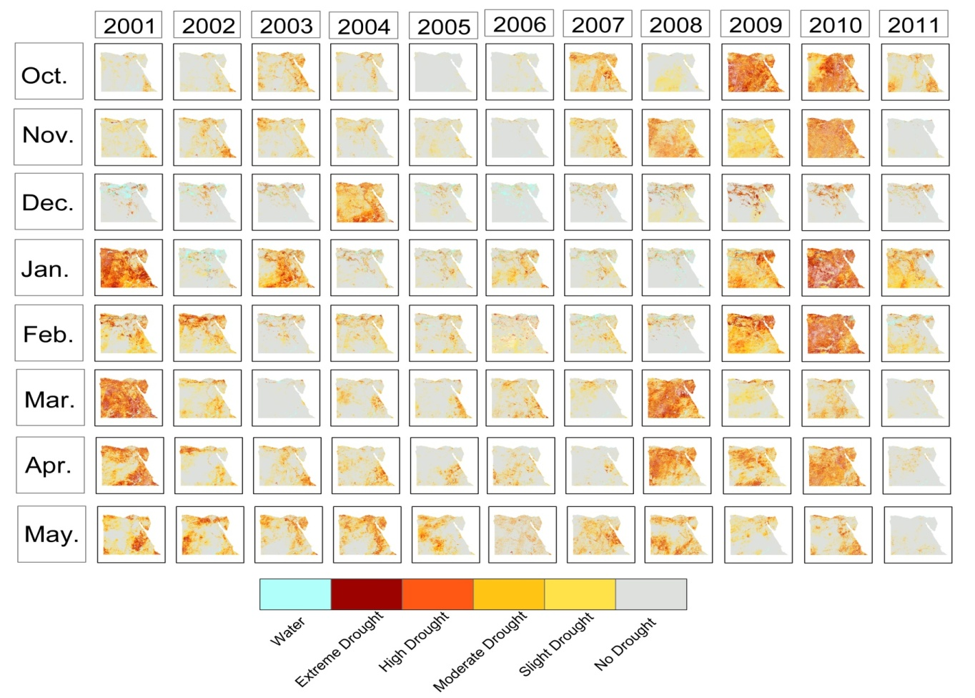
Fig. (1) Classified Vegetation Health Index over Egypt from 2000/2001 to 2010/2011 during months October-may (agricultural season)

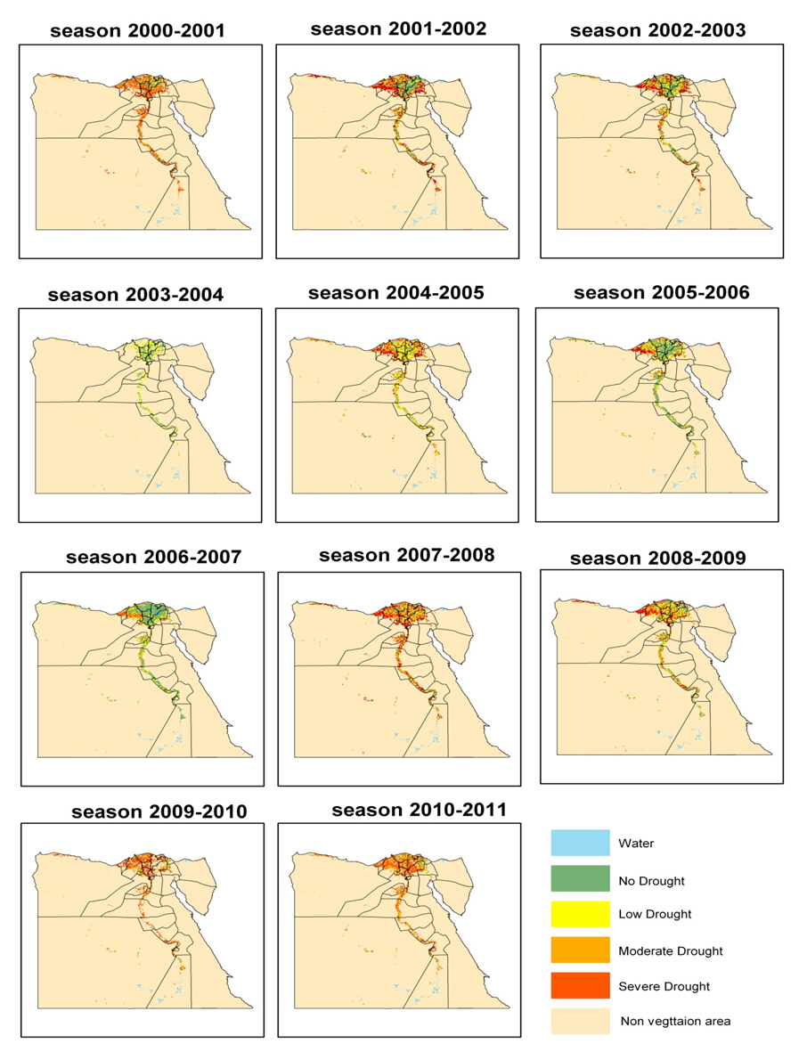
Fig. (2) Seasonal Vegetation Health Index (VHI) over Egypt during the period from 2001 to 2011

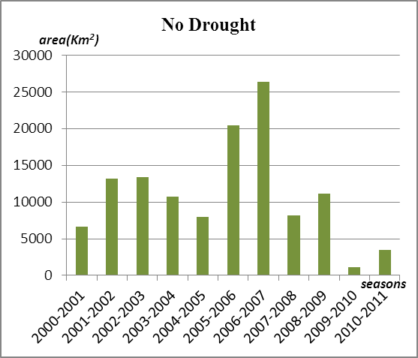  A | 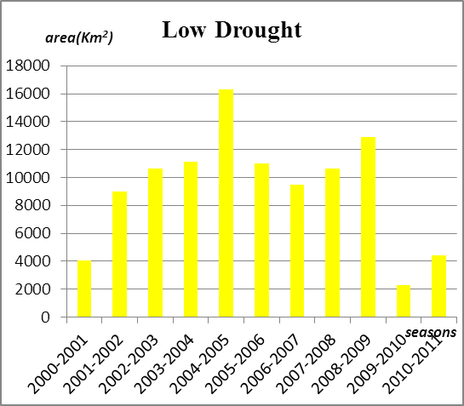  B
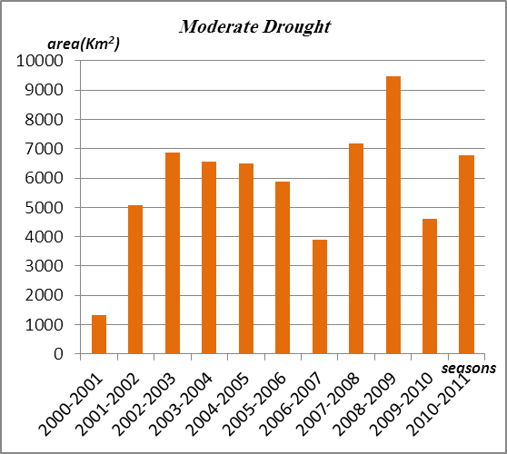  C | 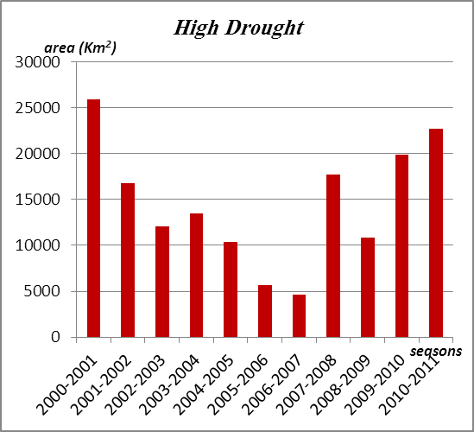  D
Fig. (3) The total area of different seasonal drought classes during the period from 2001 to 2011

References
- AMERICAN METEOROLOGICAL SOCIETY, 1997, Policy statement: meteorological droughts. Bulletin of the American Meteorological Society, 78, 847–849.
- Bonifacio, R., Dugdale, G., and Milford, J. R.: 1993, Sahelian rangeland production in relation to rainfall estimates from Meteosat, Int. J. Remote Sensing 14, 2695–2711.
- Braun-Blanquet, J. and Bolo´ s, O.: 1957, Les groupements vegetaux du bassin de l’Ebre, Anal. Estacio´n Exp. Aula Dei 5, 1–4.
- Chen, W.-Y., Xiao, Q.-G., and Sheng, Y.-W., 1994, Application of the anomaly vegetation index to monitoring heavy drought in 1992. China Remote Sensing of Environment, 9,106–112 (in Chinese).
- Fritts, H. C.: 1976, Tree Rings and Climate, Academic Press, Londres.
- Hayes, M.J. (2004). Drought indices, National Drought Mitigation Center, Nebraska, USA. http://drought.unl.edu/whatis/indices.htm
- Justice, C.; Townshend, J. 2002a. Special issue on the moderate resolution imaging spectroradiometer (MODIS): A new generation of land surface monitoring. Remote Sensing of Environment 83: 1–2.
- Kogan, F. N., 1990, Remote sensing of weather impacts on vegetation in non-homogeneous areas. International Journal of Remote Sensing, 11, 1405–1419.
- Kogan, F. N. 1995. Droughts of the late 1980s in the United States as derived from NOAA polar orbiting satellite data. Weather in the United States. Bulletin of American Meteorological Society 76: 655–668.
- Kogan, F. N.,2001 Operational space technology for global Vegetation Assessment. Bull. Amer. Meteor. Soc., 82(9), pp. 1949-1964.
- Le Houerou, H. N.: 1984, Rain use efficiency: a nifying concept in arid-land ecology, J. Arid Environ. 7, 1–12.
- Liu, W. T., and Ferreira, A., 1991, Monitoring crop production regions in the Sao Paulo State of Brazil using normalized difference vegetation index. Proceeding of the 24th International Symposium on Remote Sensing of Environment, Rio de Janeiro,27–31 May, vol. 2 (Chicago: ERIM), pp. 447–455.
- Liu, W. T., and Kogan, F. N., 1996, Monitoring regional drought using the Vegetation Condition Index. International Journal of Remote Sensing, 17, 2761–2782.
- Lozano-Garcia, D. F., Fernandez, R. N., GALLO, K. P., and JOHANNSEN, C. J., 1995, Monitoring the 1988 severe drought in Indiana, U.S.A. using AVHRR data. International Journal of Remote Sensing, 16, 1327–1340.
- Menenti, M., Azzali, S. A., Verhoef, W., and Van Swol, R., 1993, Mapping Recent Advances in Quantitative Remote Sensing 71 agroecological zones and time lag in vegetation growth by means of Fourier analysis of time series of NDVI images. Advances in Space Research, 13, 233–237.
- Nemani, R. R., Pierce, L. L., Running, S. W., and GOWARD, S. N., 1993, Developing satellite derived estimates of surface moisture status. Journal of Applied Meteorology, 28, 276–284.
- Prince, S. D., 1991, Satellite remote sensing of primary production: comparison of results for Sahelian grassland 1981–1988. International Journal of Remote Sensing, 12,1301–1312.
- Sannier, C. A. D. and Taylor, J. C.: 1998, Real-time vegetation monitoring with NOAAAVHRR in Southern Africa for wildlife management and food security assessment, Int. J.Remote Sensing 19, 621–639.
- Tucker, C. (1979). Red and photographic infrared linear combinations for monitoring vegetation. Remote Sensing of Environment, 8:127 – 150.
- Van Leeuwen, W. J. D., Huete, A. R., and Laing, T. W., 1999, MODIS vegetation index compositing approach: a prototype with AVHRR data. Remote Sensing of Environment, 69, 264–280.
- Wan, Z.-M., and Li, Z.-L., 1997, A physics-based algorithm for retrieving land surface emissivity and temperature from EOS/MODIS data. IEEE Transactions on Geoscience and Remote Sensing, 35, 980–996.
- Wang, P.-X., and WEI, Y.-M., 1998, Research, Demonstration and Extension of Sustainable Farming Systems for Rainfed Agriculture (UNDP-CPR/91/114 Project Final Report) (Xi’an, PR China: World Publishing Corporation).
- Wilhelmi, O. V., Hubbard, K. G., and Wilhite, D. A.: 2002, Spatial representation of
- agroclimatology in a study of agricultural drought, Int. J. Climatol. 22, 1399–1414.
- Wilhite, D. A., and GLANTZ, M. H., 1985, Understanding the drought phenomenon: the role of definitions. Water International, 10, 111–120.
- Wilhite, D. (2005). Drought and Water Crises. Science, Technology, and Management Issues. Taylor & Francis Group.
- Wu, H., Hubbard, K. G., and Wilhite, D. A.: 2004, An agricultural drought risk-assessment model for corn and soybeans, Int. J. Climatol. 24, 723–741.
- Yousif M. (2011). Exploitation of the Wasted Nile Water in the Mediterranean Sea. European Water 33: 29-32.

10/2/2013

