The Application of Geophysical Methods in Foundation Failure Investigation a Case Study of Metro Hostel, Camp Area, Abeokuta, South Western Nigeria.

^{1*}Coker, J.O., ²Makinde, V., ²Mustapha, A.O. and ³Adesodun, J.K.

¹Department of Physical Science, Lagos State Polytechnic, Ikorodu
²Department of Physics, Federal University of Agriculture, Abeokuta
³Department of Soil Science and Land Management, Federal University of Agriculture, Abeokuta
jocoker20@gmail.com; victor_makindeii@yahoo.com;
amidumustapha@gmail.com; adesodunjk@funaab.edu.ng
*Corresponding Author

Abstract: This study was carried out to assess the causes(s) of the foundation failure of the Metro Hostel Building opposite Mechanic Village, Camp Area, Abeokuta, Nigeria, using combined geophysical techniques which comprises of Vertical electrical sounding (VES) and Seismic Refraction methods. The major affected structure is a two storey building leaning and having severe foundation based cracks. The PASI – Earth (16 GLN) resistivity meter was used for resistivity data collection and ABEM Terraloc MK -6 Seismograph for velocity data collection. The result of the vertical electrical sounding gives a maximum of three sequences: topsoil, weathered layer (clayey sand/sandy clay) and fractured rock/fresh basement with a maximum value of 10.38 m depth to the basement. The result was complemented and corroborated by seismic refraction method which also gives three main velocity layers with the second layer velocity ranges from 680 and 950 m/s with thickness value ranging from 6.80 – 8.27 m and a total depth -to-bedrock of 10.27 m. The presence of clayey materials identified in the study area posed a threat to three buildings erected. It is concluded from the study that the building structure failed due to incompetent clay layer and improper foundation design on some part of the building which is pronounced by the observed tilting and cracks.
[Coker, J.O., Makinde, V., Mustapha, A.O. and Adesodun, J.K. The Application of Geophysical Methods in Foundation Failure Investigation a Case Study of Metro Hostel, Camp Area, Abeokuta, South Western Nigeria. Nat Sci 2013;11(11):103-109]. (ISSN: 1545-0740). http://www.sciencepub.net/nature. 15

Keywords: Clayey materials, Foundation failure, Seismic Refraction method, Vertical Electrical Sounding.

1. Introduction
Geophysical data is an important parameter in contributing to the design and construction of Civil Engineering structures such as buildings, roads and dams. Hence, the major considerations in the design of such structures are the pre-construction investigation of the subsoil at the proposed location in order to ascertain the fitness of the host earth materials.
The geophysical methods that suit such investigations are the electrical resistivity, gravity and seismic refraction (Olorunfemi and Meshida, 1987; Olorunfemi et al, 2005; Akintorinwa and Adeusi, 2009; Fatobal et al, 2010; Oyedele et al, 2012 and Coker et al, 2013). The electrical resistivity method is the most commonly used method out of all the geophysical method as it combines speed, accuracy and cost-effectiveness in the localization of faults, fractures, vertical rock contacts, buried metallic pipes and seepage paths.
In this work a combined geophysical method was used that is, electrical resistivity method integrated with seismic refraction method so as to improve the quality of the results. Seismic refraction methods have been extensively used in petroleum, mineral and engineering investigations and to some extent for hydrologic applications during the past 30 years. Recent advances in equipment, sound sources and computer interpretation techniques make seismic refraction methods highly effective and economical for obtaining data for shallow investigations. This method used a surface technique that can image the subsurface profile in two dimensional (2D) perspectives and reduced the ground damageability thus creating a sustainable environment during the mapping stages. (Abidin et al, 2013).
According to Clayton et al; (1995), although the method requires a ground contact, it remains minimal and damage to the site will normally be negligible. On the basis of this, an integrated method approach was used to investigate the causes(s) of the foundation failure of the buildings in the premises of Metro hostel at Camp area, Abeokuta, South western Nigeria.

2. Study area, Physiographic and Geologic Setting
The study area is located along Abeokuta-Ibadan express way at Camp area, opposite Mechanic village, Abeokuta. The study area (figure 1) lies between longitude 3⁰43’35’’ and 3⁰43’38’’E and latitude 7⁰18’57’’ and 7⁰18’60’’N.
The topography is relatively plain and bounded by a perennial tributary of a swampy area to the southern part of the premises.
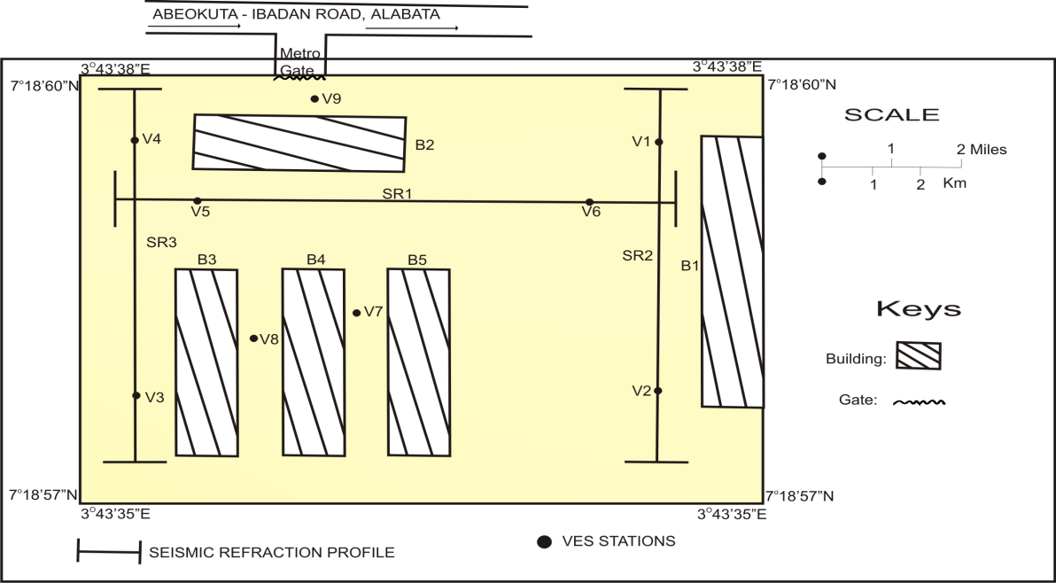
Figure 1: Data Acquisition Map of the Study Area Showing Vertical Electrical Sounding (VES) points and Seismic Refraction Traverses.

The geology of Ogun State comprises sedimentary and basement complex rocks, which underlie the remaining surface area of the state. It also consists of intercalations of argillaceous sediment. The rock is soft and friable but in some places cement by ferruginous and siliceous materials (Badmus and Olatinsu, 2009). The sedimentary rock of Ogun State consists of Abeokuta formation lying directly above the basement complex (figure 2). This in turn is overlain by Ewekoro Oshosun and Ilaro formations, which are all overlain by the coastal plain sands (Benin formation).
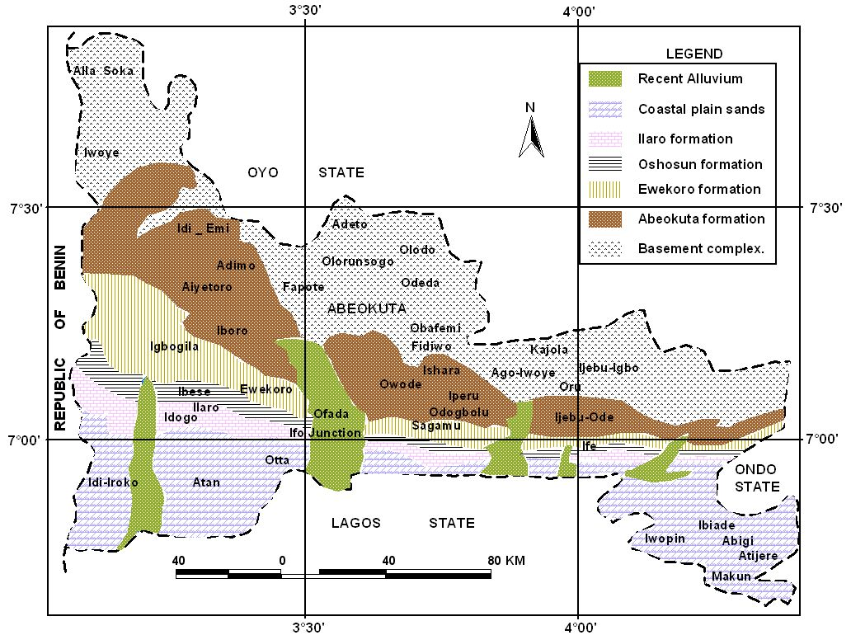
Figure 2: The geological map of Ogun State.

3. Methodology
The methods used involved data acquisition which usually carried out on the field and data processing done in the laboratory or outside the field arena.

Data Acquisition and Processing using Schlumberger Array
In this work the Schlumberger array was employed because it requires less man- power and it is less sensitive to the effects of near surface lateral inhomogeneities than the Wenner arrangement (Roy and Apparao, 1971; Jones, 1985). These advantages bring about a realistic quantitative interpretation of field data obtained.
A rod is hammered into the ground when a site is located, which serves as the mid point from which AB/2 spacing can be measured in both directions by means of measuring tape with respect to the required spacing from 1m to 100m.
The two current (C₁, C₂) and two potential (P₁, P₂) electrodes are now driven down into the ground at the desired spacing as indicated along the measuring tape. The rechargeable 12V battery is connected to a PASI-Earth (16GLN) resistivity meter; also the current and potential electrodes are connected to the Terrameter with the four short cables by their clips to connect the positive and the negative terminals i.e. C₁, C₂ and P₁, P₂ on the terrameter to the two potentials reels and current cables.
AB/2 was measured in both directions from 1.0m to 100m using the base station as the midpoint. Similarly MN/2 was also measured on both sides with values varying from 0.25m to 5m. The number of cycles of averaging desired is then set on the terrameter and the current is turned down to the least ampere value i.e. 0.5 Amps, this passed through the current electrodes into the ground while terrameter is turned on to measures electrical resistance R i.e. the first reading after the measure button has been depressed. Depending on the number of cycles set (say 3), at the end of the third beep the last value of resistance is recorded. After each reading, the current electrodes are moved to a pre-calculated position or electrode spacing before subsequent reading, the potential electrodes are also moved from time to time.
For each electrode combination for which a sounding was made and reading of resistance R of the volume of earth material within the electrical space of the electrode configuration was obtained, a configuration factor G was calculated using equation 1. The product of G and R was then made to obtain the apparent resistivity of the said earth material. This was subsequently done on all the point data obtained for each VES station to give the set of apparent resistivity values.

Data Acquisition and Processing using Seismic Refraction Method
Seismic refraction method is one of the most effective geological techniques for defining hard rock aquifer, for determine depth-to-bedrock, competence of bedrock, depth to the water table, or depth to other seismic velocity boundaries (North West Geophysical Associates Inc, 2002).
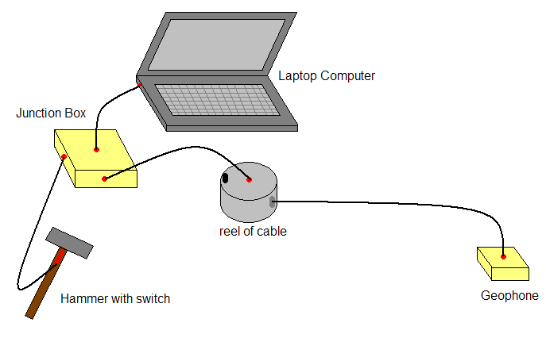
Figure 4: Separate components of the seismic design

To carry out a seismic refraction survey using the designed equipment (Source, Detector and Recorder) above in figure 4, follow these steps: first a survey line needs to be set out. The hammer plate placed at one end. Plug the sledge hammer connector (Source) into the correct socket on the junction box. Plug the output of the junction box into the line in socket on the laptop using the stereo cable. Place the geophone at the smallest separation from the source and secure to the ground using the tent pegs. Connect the reel to a 24 channel of 28Hz vertical geophone (Detector) and the reel to the geophone socket of the junction box. Turn the laptop on and open the goldwave program and create a new file. Turn on the junction box, checking the LED is illuminated.
Now press record on the goldwave program – ABEM Terraloc MK-6 Seismograph (Recorder) and hit the plate with the hammer. After the plate has been struck press stop on the goldwave program and the data collected will have been recorded. You may want to hit the hammer more than once and an average of the first arrival travel times can be taken. Save the file with a name that relates to the geophone position and then move the geophone, open a new file and repeat until data is collected for the whole survey line.The first arrival time data in each geophone is then plotted in the graphic of relationship between the geophone numbers versus the first arrival time of P-waves for each shooting point. It should be a plot with two straight line sections, the first from the direct wave and the second from the refracted wave. From the graph, the curve of time arrival of each geophone is then picked in order to generate the intercept time graph.
In the picking analysis, the knowledge of the seismic waves propagations are needed in order to differ the arrival waves from the refracted P-wave and the other seismic waves such as Rayleigh waves and S-waves. The final process is calculating the velocity of P-waves and the thickness of each layer in the site The final result interpretation is displayed using the software program called Pickwin (Pick First Breaks or Dispersion Curves) and Plotrefa (Refraction Analysis, Version 2.73).

4. Results and Discussions
The result of the VES has a maximum three layered type curves. The curve types identified within the study area include H and A type with the H as the predominant curve type. The typical curve types are as shown in figures 5 and 6. Table 1 shows the summary of the VES interpretation.

Discussion on Vertical Electrical Sounding (VES) Results
Beneath VES 1 to 9, Table 1 interpreted in this location, the lithology consists of maximum of three layers: topsoil, weathered layer (clayey sand/sandy clay) and fractured rock/fresh basement.
The topsoil of the lithology has a relatively low resistivity between the range 177 and 356 ohm-m and thickness range of 2.37 to 3.5m, the low resistivity values of the topsoil is attributed to the location found in the swampy area.
The weathered layer ranges from clayey sand and sandy clay of an incompetent materials with a thin thickness of range 4.30 and 7.42m and resistivity of values 147 and 385 ohm-m respectively. The last layer is underlain by fractured basement and fresh basement of resistivity 806-1624 ohm-m with a range of depth to basement values between 6.67 and 10.38m. It should be noted that major parts of the area consist of sandy clay and clayey sand at shallow depths which pose a serious threat to structural work constructed in the area especially on the fractured rock. The buildings (3 numbers of 2 storey’s) in that location was found tilted and sinking with many major cracks which resulted to the abandoning of the buildings.

Table 1: Summary of the VES Interpretation Results
1  H | 1 | 177.44 | 2.58 | 2.58 | Top soil
 | 2 | 372.29 | 5.40 | 7.98 | clayey sand
 | 3 | 1624.11 | - | - | fresh Basement
2  H | 1 | 318.37 | 3.54 | 3.54 | Top soil
 | 2 | 166.42 | 6.20 | 9.74 | sandy clay
 | 3 | 858.63 | - | - | fractured rock
3.  A | 1 | 193.92 | 2.37 | 2.37 | Top soil
 | 2 | 385.00 | 4.30 | 6.67 | clayey sand
 | 3 | 806.25 | - | - | fractured rock
4  H | 1 | 324.80 | 3.25 | 3.25 | Top soil
 | 2 | 158.00 | 6.11 | 9.36 | sandy clay
 | 3 | 1578.11 | - | - | fresh Basement
5  H | 1 | 356.42 | 2.80 | 2.80 | Top soil
 | 2 | 169.31 | 5.71 | 8.51 | sandy clay
 | 3 | 1000.65 | - | - | fresh Basement
6  H | 1 | 310.64 | 3.28 | 3.28 | Top soil
 | 2 | 147.25 | 7.01 | 10.29 | sandy clay
 | 3 | 908.90 | - | - | fractured rock
7.  A | 1 | 207.31 | 2.61 | 2.61 | Top soil
 | 2 | 332.6 | 5.94 | 8.55 | clayey sand
 | 3 | 1008.82 | - | - | fresh Basement
8  H | 1 | 276.45 | 2.96 | 2.96 | Top soil
 | 2 | 182.92 | 7.42 | 10.38 | sandy clay
 | 3 | 875.24 | - | - | fractured rock
9  H | 1 | 289.45 | 2.83 | 2.83 | Top soil
 | 2 | 157.32 | 6.50 | 9.33 | Sandy clay
 | 3 | 831.96 | - | - | Fractured rock

Table 2: Summary of the Seismic Refraction Interpretation Results
Layer | P-wave ms⁻¹ | Aver-age Thick-ness (m) | Depth (m) | Lithology
1  2  3 | 320  750  1450 | 2.00  8.27  ------- | 10.27 | Soil  Weathered  Saturated Sand and Gravel
1  2  3 | 330  680  1500 | 2.30  7.44  -------- | 9.74 | Soil  Weathered  Sandstone
1  2  3 | 390  950  1500 | 2.55  6.80  ------- | 9.35 | Soil  Clay  Sandstone

Table 3: Typical primary velocity (Vp) of some of the earth materials
Material / Author | P-wave velocity (m/s)
Soil (Sheriff, 1991 and Reynolds, 1997) | 100 to 500
Dry sand and gravel (Sheriff, 1991 and Reynolds, 1997) | 450 to 950
Saturated sand and gravel (Sheriff, 1991 and Reynolds, 1997) | 1,250 to 1,850
Clay (Sheriff, 1991 and Reynolds, 1997) | 900 to 2,700
Sandstone (Mc Carthy, 2007; Sheriff, 1991 and Reynolds, 1997) | 1,500 to 4,000
Shale (Mc Carthy, 2007; Sheriff, 1991 and Reynolds, 1997) | 1,200 to 4,300
Igneous Rock / Hard Rock (Sheriff, 1991 and Reynolds, 1997) | 4,500 to 6,000
Weathered, fractured, or Partly decomposed (Peck et al,1974 and Lee, 2002) | 610 to 3048

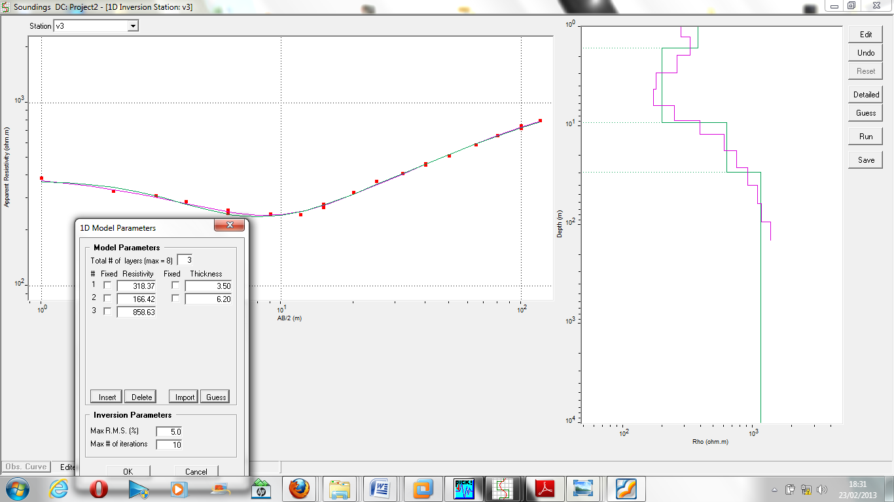
Figure 5: Typical H-Type Sounding Curve

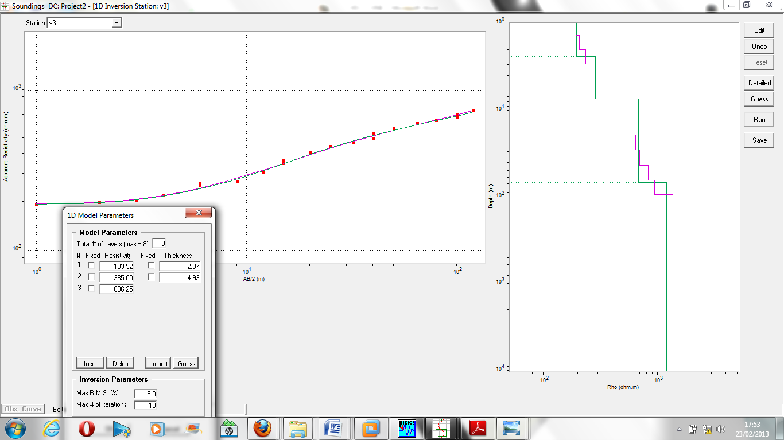
Figure 6: Typical A-Type Sounding Curve

Discussion on Seismic Refraction Method
Seismic refraction method has been extensively used in petroleum, mineral and engineering investigations and to some extent for hydrologic applications, during the past 30 years (Haeni, 1986 and Joshua et al, 2004).
In this research, seismic refraction method was used to corroborate other geophysical methods called Vertical electrical sounding (VES).
Results from profile 1 to 3 (Table 2) gives three major layer of velocity representing three types of geomaterial with different characteristics (figures 7 to 9). The first layer was identified as unconsolidated material of residual soil with some pore/voids within the layer. The topsoil velocity ranged from 320 – 390m/s with a thickness ranging from 2.00 – 2.55m compared with the thickness of (2.37-3.50m) recorded in electrical resistivity method. Thus both results reliably indicate that this topsoil is very thin.
The Secord layer has velocity and resistivity values in the range 680-950m/s and 147-385 Ohm-m respectively. Thus, a low velocity values was identified in this intermediate layer and a fractured/fault is suspected. Both geophysical methods corroborated give an incompetent weathered layer with clayey materials in profile 3 or partly decomposed as interpreted in profiles 1 and 2 according to some authors (Mc Carthy, 2007; Peck et al, 1974; Lee, 2002; Sheriff, 1991 and Reynolds, 1997) in standard textbooks as shown in table 3.

Figure 7: Inverted Seismic Layer for Traverse 1

Figure 8: Inverted Seismic Layer for Traverse 2

According to Dearman et al, (1995), major new fractures may form or be extended, incipient fractures may lose tensile strength and the discontinuities rock wall may weaken, leading to reduce shear strength and stiffness. Lee (2002) says the intense rainfall will raise groundwater level rapidly condition to the ground surface and this would result in a sudden increase in pore pressure which would reduce the shearing resistance of geomaterial and finally lead to a failure. The third layer had a velocity ranging from 1450 – 1500m/s with a maximum depth of 10.27m to the bedrock and was in agreement with 10.38m recorded in electrical survey.

Figure 9: Inverted Seismic Layer for Traverse 3

5. Conclusions
Geophysical investigation involving Vertical Electrical Sounding (VES) and Seismic refraction methods was carried out in the premises of Metro hostel to assess the cause(s) of the foundation failure of the buildings. The geoelectric sections reveal three distinct subsurface layers for both electrical resistivity survey and seismic refraction methods which include the topsoil, the weathered layer and the bedrock.
The topsoil has Seismic P-wave velocity in the range 320 to 390m/s and electrical resistivity from 177 to 356 ohm-m with thickness ranging between 2.00 and 3.50m for both. The second layer is interpreted as the weathered layer with an incompetent clayey material which threatens the buildings sitting on top of the weakened host material pronounced as cracks, leaning and sinking of the buildings.
The third layer resistivity ranges between806 and 1624 ohm-m interpreted as fractured rock/fresh basement with a shallow depth of value 10.38m to the bedrock corroborated with the seismic refraction method of layer velocity ranges from 1450 and 1500m/s with value 10.27m depth- to- bedrock.
In the light of these results, it becomes clear that the failure of the foundations of the buildings at Metro hostel are due to differential settlement of the suspected incompetent (weak) clay material on which it was located. It is suggested that reinforcement, concrete packing and buttress pillars should be done around the buildings especially in areas with more pronounced subsidence to avoid total collapse. It is thus concluded that the combination of the two methods has reduced the ambiguity inherent in using a single geophysical techniques.

Acknowledgments:
We hereby acknowledged the authority of the Federal University of Agriculture, Abeokuta for the permission granted to us and the field crew to carry out the investigation within the School premises.

Corresponding Author:
Coker Joseph Olakunle
Department of Physical Sciences
Lagos State Polytechnic,
Ikorodu,, Lagos State, Nigeria
E-mail: jocoker20@gmail.com

References
- Abidin, M.H.Z., Saad, R., Ahmad, F., Wijeyesekera, D.C., Mataral, J. and Baharuddin in M.F.T.. Mapping of geotechnical data using seismic refraction studies Caspian J. of Applied Sciences Research 2013; 2(AICCE’12 and 1212).
- Akintorinwa, O.J., and Adeusi, F..Integration of Geophysical and Geotechnical Investigations for a Proposed Lecture Room Complex at the Federal University of Technology, Akure, SW, Nigeria. Jour. Of Applied Sciences 2009; 2(3), pp 241-254
- Badmus, B.S and Olatinsu, O.B. Geoelectric mapping and characterization of limestone deposits of Ewekoro formation, South-western Nigeria: J. of Geology and Mining Research 2009; Vol. 1 (1) pp. 008 – 018
- Clayton, C.R.I; Mathews, M.C; and Simons, N.E. Site Investigation, 2nd Ed. Blackwell Science 1995; Oxford
- Coker, J.O., Makinde, V., Mustapha, A.O. and Adesodun, J.K. Electrical Resistivity Imaging for Foundation Failure Investigation at Remo Secondary School, Sagamu, South-- Western Nigeria. International Science Investigation Journal 3013; Vol. 2 (4): 40-50
- Dearman, W; Price, D; Martin, R; Pinches, G; and Fookes, P.G. The Description and Classification of Weathered Rocks for engineering purposes. The Quarterly Journal of Engineering Geology 1995; 212
- Fatoba, J.O., Alo, J.O and Fakeye, A. A. Geoelectric Imaging for Foundation Failure Investigation at Olabisi Onabanjo University Minicampus, Ago-Iwoye, Southwestern Nigeria. Jour. of Applied Sciences Research 2010; 6 (12): 2192-2198
- Haeni, F.P. Application of Seismic Refraction Methods in Groundwater Modeling Studies in New England. Jour. Of Geophysics 1986;Vol.51, No.2, pp 236-249
- Jones, M.T. The weathered zone aquifers of the basement complex area of Africa. Quarterly Journal of Engineering Geology 1985; 18, pp 35-36.
- Joshua, E.O., Oladunjoye, M.A., and Bayewu, O.O. Mapping overburden Structure using Combined Seismic Refraction and Electrical Resistivity Methods: A case study of Omi-Adio and its environs, Southwestern Nigeria. Africa Geosciences Review2004; Vol.11, No.4, pp 281-291
- Lee, T.S. Shallow Failure in Slope Stability and Stabilization Methods, 2nd Ed. John Wiley & Sons, Inc 2002; New York
- Mc Carthy, D.F. Essentials of soil mechanics and foundations. Basic Geotechnics 2007; 7th Edition. Pearson Int. Edition, New Jersery.
- North West Geophysical Associates Inc. Geofisica International 2002; 50-4: 401-409
- Olorunfemi, M.O. and Meshida, E.A.. Engineering Geophysics and Its Application in Engineering Site Investigation (Case study of Ile-Ife area). The Nigeria Engineer 1987; 22(2): 57-66
- Olorunfemi, M.O., Ojo, J.S., Idornigie, A.I., and Oyetoran, W.E. Geophysical Investigation of Structural Failure of a Factory Site in Asaba area, Southern Nigeria. Jour. Of Mining and Geology 2005; Vol.41 (1), pp 111-121
- Oyedele, K.F; Oladele, S. and Onoh, C.. Geo-Assessment of subsurface conditions in Magodo Brook Estate, Lagos, Nigeria. Int. J. of Advanced Scientific and Technical research 2012; issue 2, vol.4, pp 731-741
- Peck, R.B; Hanson, W.E. and Thornburn, T.H. Foundation Engineering 1974; Wiley, New York
- Reynolds, J.M. An introduction to Applied and Environmental Geophysics1997; Chichester, England, Wiley, p 796
- Roy, A. and Apparao, A. Depth of Investigation in Direct Current Methods. Geophysics 1974;36:943-959
- Sheriff, R.E. Encyclopaedic Dictionary of Exploration geophysics, 3rd Ed. Tulsa, Okla, Society of Exploration Geophysics 1991; P 376

10/9/2013

