Change of physico-chimical proprieties of some local oils during frying

Ahcene Boureghda^{1,} Samir Benayache ¹ and Fadila Benayache¹.

¹Unité de recherche: Valorisation de resource naturelle et molecules bioactives,et analyse physic- chimique Faculty of Science, Department of Chemistry, University Constantine-1, ALGERIA
E-mail: boureghdacene@hotmail.com

Abstract: Virgin olive oil (stored for 18 months) and Sunflower oil (stored for 3 months) were used for repeated deep – fat frying potato fillet (French fries) for two weeks consecutive at 160 – 180 °C and the frying time was set for eight (8) minutes and then allowed to cool for five hours at ambient temperature.This study was performed to assess the quality local oils using physico – chemical methods for analysis, it was also conducted to compare and correlate oil quality parameters as: the Peroxide value(PV), Fry fatty acid value (FFA), Iodine value (IV), Saponification values (SV), Density(D) and Refractive index(RI). The heating thermo gram showed that all quality parameters were significantly changed as frying time advanced.
[Boureghda A, Benay ache S, Benayache F. Change of physic-chimical proprieties of some local oils During frying. Nat Sci 2013;11(11):88-91]. (ISSN: 1545-0740). http://www.sciencepub.net. 12

Keywords: Vergin olive oil, Sunflower, Deep fat frying, Indices values.

Introduction:
Frying is one of the most popular proc-eedings for food preparation worldwide. Hence, the use and abuse of frying oils have become of great concern, especially since compounds originated at high temperature are suspicious to impair the nutritional value of fats(Amany et al, 2008)]. Indeed, well several years, controls are performed to ensure the quality of frying oil to preserve the consumers of adverse health effects as a result of the formation of degradation products (Skrokki, 1995).
Some Nutritionists go far as to advocate virilually excluding fried products in an efforts to promote healthy eating (Sebedio and Grandgirand, 1987). Numerous types of edible oils are used in frying; however, repeated use of frying oils produces undesirable constituents that may pose health hazards (Croon and al, 1986). During frying, a number of reactions occur in the frying oil causing oxidation and hydrolytic degradation of the oil. Heating in the presence of air causes partial convertibly of fats and oils to volatile chain scission products, non volatile oxidized derivatives and dimeric, polymeric substances (Knoth, 2009),. The free radical formed by fatty acids react with oxygen to generate peroxides that enter into a multitude of reaction producing numerous products, such as aldehydes, ketones, acids and polymerized fats(Ahmed, 1996) Heat, water, air and the presence of contamination materials together with duration of frying cause these degradative reactions. The main cause of oil degradation are oxidation, thermal treatment, and oil food interaction at high temperature (Gertz, 2OOO)
Oxidative and chemicals changes in frying fats during use are characterized by a decrease in the total unsaturations of the fat with increase in free fatty acids, foaming, color andviscosity (Aladeduneye and Przbylski, 2009) The main aim of this study was to evaluated some effect important chemical and physical changes of the selected vegetable oils during deep fat frying of Potato fillet (French fries) using physico-chemical methods in order to evaluate the quality of frying oils.

Material and methods:
Our choice is based on olive oil in the costal region of El Milia (Algeria), known for its hot and humid climate in summer and cold in winter. The harvest is done traditionally and sunflower oil locally-produced was taken from supermarket, the main properties of this oil are: Refined Sunflower 100%, rich in vitamin E, without cholesterol, temperature maximum 170°C and reused 10 times. They are destined th mixture of glacial acetic acid and chloroform(2 :3) reacted with saturated potassium iodide, and titrated with standard Na₂S₂O₃.For measuring free fatty acids, samples of oils/fat were neutralized with ethanol, using phenolphthalein indicator and titrated with NaOH.The Iodine value(g/100g) determines the degree of unsaturations was found by mixing the samples with CCl4, Wijis solution, potassium iodide and distilled water, and titrated with 0.01 Na₂S₂O₃ using starch as indicator. The saponification value is the number of milligrams of potassium hydroxide or sodium hydroxide required to saponify 1g of fat under these conditions.

Results:
All results determined are shown in tables 1 and 2.The results show an increase in all the measured parameters with increased frying time excepting iodine value and saponifition index. The extent of oxidation of the sample as mesureted by POV increased from 1.6 to 3.6 meq/ Kg for (OO), then decreased after thirth and fifth frying operation. This could be explained by the fact of these oils were resistant to oxidation up to a point of the heating (White et al, 2005). The graph in Figure 4 shows the shape of the variation of the index of peroxide depending on number of fries for each oil type, we find that the heating of the oil Causes the increase of the index of peroxide at the beginning of cooking to a maximum value (6.75 for the fifth frying cooking oil in SFO and 18.5 to thirth frying cooking in olive oil. Then there is a decrease. However, FFA of these tow oils were almost same behavior heating but FSO had the low measurement as Figure 1 and table 1 shown The increase of the acidity can be explained by the thermo-oxidation of oil, this increase, is due to the liberation of fatty acids by hydrolysis which is a change which undergoes the oil during the repeated frying (Stevenson et al, 2004).The iodine values and sapon-ifications for each controlled sample show a decreasing trend for both the oils, as shown in Fig 2 and 3 respectively and table. 1. Similar results has been reported in soybean, corn and crude rape seed oils (Chu, 2004).

Table 1: Parameters Values
N^{bre} of frying | Before frying | 1 | 2 | 3
POV(SFO,OO) | (1.6, 9) | (2.1, 10.7) | (3.45, 13) | (4.2, 18.5)
FFA(SFO,OO) | (0.06, 0.21) | (0.09,0.21 | (0.14, 0.22) | (0..18, 0.24)
IV(SFO, OO) | (130,83.12) | (84.38,78.04 | (59, 59) | (39.97,39.97)
SV(SFO,OO) | (193.54,108.03) | (178.11,150.31 | (172.50,150.31) | (168.30, 112.02)

Table. 1 (continued)
N^{bre} of frying | 4 | 5 | 6 | 7
POV(SFO,OO) | (5.56, 15.56) | (6.75, 12.02) | 6.25 (SFO) | 5.8 (SFO)
FFA(SFO,OO) | (0.21,0.26) | (0.24, 0.33) | 0.25 (SFO | 0.29(SFO)
IV(SFO, OO) | (27.28,27.28) | (20.93, 17.76) | 14.59 (SFO | 12(SFO)
SV(SFO,OO) | (140.25,98.70) | (126.22, 42.07) | 126.92(SFO | 112.20 (SFO)

The density and refractive index were determined for each oil sample, before and after thermal treatment.the physical parameters were determined by picnometer method for density and the refractive index was determined with an Abbe refractometer ATGO 3T type, the results are presented in table2.

Table 2: Density and refractive index
N^{bre} of frying | Before frying | 1 | 2 | 3
IR(SFO, OO) | (1.464,1.463) | (1.465,1.466 | (1.465,1.468) | (1.466, 1.469)
D(SFO,OO) | (0.916,0.908) | (0.916,0.909) | (0.917,0.910) | (0.917,0.912)

Table. 2: (Continued
N^{bre} of fries | 4 | 5 | 6 | 7
Ir (SFO,OO) | (1.466, 1.472 | (1.466,1.475) | (1.468,SFO) | 1.469 (SFO)
D(SFO, OO) | (0.918,0.915) | (0.919,0.916) | 0.919(SFO) | 0.920(SFO)

The refractive index of the vegetable oils is increasing during thermal treatment. Biggest influence on the refractive index was observed at the Olive oil seems less stable against thermal treatment. This result was confirmed recently (Nita et al, 2010). As we can see from table 2 the density of oils has small variations around the initial value, this indicating that the thermal treatment does not affect sensible the density as a result of relatively short period of thermal treatment.

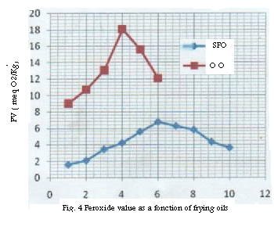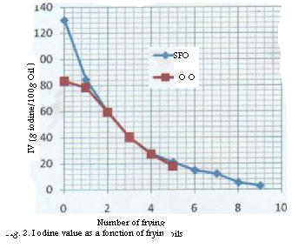
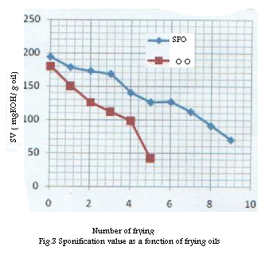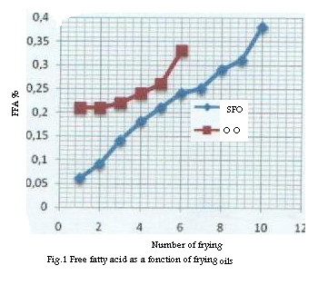
Illustration curves

Discussions :
During repeated frying foods, there can be observed a normally degradation in the vegetal oils, because of these degradation reactions, a number of physical and chemicals changes occurs in frying oils including increase in density(D), refractive index(RI), free fatty acid content (FFA), peroxide value(PV) and decrease in saponification value (SV) and iodine value(IV). If the frying process is continued, these materials will undergo further degradation and finally the oil will not be appropriate for frying The physico-chemical parameters of olive oil showed a lower quality of olive oil compared to sunflower oil. The analysis showed that the acidity in olive oil for example reaches a value higher than the Algerian norm (0.3%) in the fifth frying, while in the case of Sunflower oil up to eighth in condition better than normal kitchens. Although some recent studies have shown the contrary(Choe and Min, 2007). This is due to olive oil contains more oleic acid and less linoleic acid and lenolenic acid than other 9vegetable oils, that is, monounsaturated than polyunsaturated fatty acids. It was found also that cooler regions will yielded oils with higher oleic acid than warmer climate. That is, a cool region olive oil may be more monounsaturated in content than a warmer region oil.
Our statement that the differences in measurements in determining the quality of the oils was mainly due to the method of obtaining oil from the harvest until the arrival at the mill, which are some factors that affect the quality of oils may vary from region to region and even in the same area. We advised the consumer to pay attention to the labels package mentioning the number of fry that depends on the working conditions of each oil.. Althougnt some further analysis are necessary to complete this work by other fried foods, cooking with other oils, a sensory analysis that will establish criteria for foods, cooking with other oils, a sensory analysis that will establish criteria for characterizing the flavor of oil and complementary analysis such as:Colour, Viscosity, HPLC, FTIR and MIR.

Acknowledgements:
We acknowledge Institut de la Nutrition et des Technologie Agro-alimentaires (I.N.A.T.A.A,) University Mentouri Constantine- Algeria, for providing research facilities

Corresponding Author:
Dr. Boureghda Ahcene Department of Chemistry, University Constantine – 1 Algeria
E-mail: boureghdacene@hotmail.com

Abbreviations: OO: Olive Oil, SFO: Sunflower Oil PV: Peroxide Value, IV: Iodine Value SV: Saponification Value, FFA: Free Fatty Acid D: Density, RI Refractive Index. MIR: Medium infrared, FTIR: Fourier transform infrared spectroscopy HPLC: Hignt performens liquid chromatography

References
1 Amany, M. M. Basuny, Shaker, M. Arafat,
Essam and Mohamed. Bitter-ness, natural
Antioxidant and quality Indices of virgin
oil. J. Biol. Chem Environ. Sci., 3; 2008,
433-436
2 Skrokki, A.. Test used for examining the
quality of frying Fat Sciencetechnology, 97,
384-3386
3 Sebedio, J.L., Grandgirard, A., Septier, C.
Prevost, J. Etat d’alteration de quelques
huiles de friture prelevees en restauration.
Revue Francaise des Corps Gras, 1987, 34,
15–18
4 Croon, L.B., Rogstad,A.,Leth, T. & Kiu
tamo, T. (1986). A comparative study
of Analytical methods for quality eval
-uation of frying fat. Fette Seifen Ans-
trichmittel,88, 87–91.
5 Knoth G, Steidly KR, A Comparison of
Used Cooking Oils: AVery Heterogeneous
Feedstoch for Biodiesel,Bioresource Tech-
nology, 2009,100 (23), pp. 5796 -5801
6 Gertz C. Chemical and Physical Parametrs
as Quality Indicators of used Frying Fats,
Euro Lipid Science Technology 102, 2000,
pp, 566-572
7 T. Ahmed, A. Settar, S. A. Nagra and M.
A. Sheikh, pak. J. Parmacy Punjab Univ-
ersity, 19969 (2), 51
8 Aladedunye FA, Przbylski R, Protecting
Oil During Frying: A Comparative Study,
Eur J Lipid Sci Tech 111, 2009, p. 893
9 White. P. J et Miller. L. A, “Possibilités et
Lumites des Controles de la pureté des
huiles alimentaires fluids”. Revue Français
des corps gras, 2000 ; 8(65):pp. 1334-1338
10 S. G. Stevenson, V. Jenser and M. Eskin,
JOACS.,1964, 61, 1102.
11 Y. H. Chu, and S. Luo, JOACS., 1994, 71.
897
12 Nita, A. Neagu, S. Geacai, A. Dumetru
and A. Sterpu, Ovidusuniversity,Annal of
chemistry, Vol 21, No.1, 2010
13 Choe E, Min DB, Chemistry of Deep Fat
Frying Oil, Journal of Food Science 72,
2007, pp. 78-86.

10/5/2013

