Effect of Probiotic Fermented Soy Milk and Gamma Radiation on Nitrosourea-Induced Mammary Carcinogenesis

Omayma, A.Ragab¹;El-sonbaty, S. M.²; Aziza, S. A.¹ andAboelftouh, A. E.¹

¹Biochemistry department, Faculty of Veterinary Medicine, Benha University.
²Microbiologydepartment, National Centre of Radiation Research and Technology, Atomic Energy Authority, Cairo, Egypt.
Sawsansonbaty@yahoo.com

Abstract: Background and aim of the work: Antioxidants can reduce damage produced by low doses of radiation on living cells. This study was designed to investigate the effects of fermented soy milk (FSM) and low dose of gamma radiation on carcinogenic effect of N-methyl-N-nitrosourea (MNU). Material and methods: Female rats were divided into 8 groups: group (1): control, group (2): injected with MNU, group (3): whole body exposed to low dose of gamma radiation (0.5 Gy), group (4): given FSM orally, group(5): given FSM and MNU, group (6): received MNU and exposed to gamma radiation,, group (7): given FSM, MNU and exposed to gamma radiation. Results: Fermented soy milk exerted significant, ameliorative effect on glutathione peroxidase, superoxide dismutase and catalase activities, lipid peroxidation and TNF-α levelin rats injected with MNU. Combined treatment of FSM and low dose of gamma radiation markedly elevated GSH level, ameliorated MNU effect on cell cycle phases Go/1, S, G2/M and induce apoptosis via activation of caspase-3.Conclusion: FSM consumption with exposure to low doses of gamma radiation reduced carcinogenesis and oxidative stress effects induced by MNU in the mammary tissues.
[Omayma, A. Ragab; El-sonbaty, S. M.; Aziza, S. A. and Aboelftouh, A. E. Effect of Probiotic Fermented Soy Milk and Gamma Radiation on Nitrosourea-Induced Mammary Carcinogenesis Nat Sci 2013;11(11):35-42]. (ISSN: 1545-0740). http://www.sciencepub.net/nature. 7

Key words: fermented soy, N-methyl-N-nitrosourea, mammary gland, cell cycle, TNF- α, gamma radiation, antioxidant state.

1. Introduction:
Breast cancer is the most frequently diagnosed cancer and the leading cause of cancer death in female worldwide. The significance of nutrition in protecting living organisms from the toxic effects of environmental carcinogens has gained increasing attention due to less toxicity and high efficacy against various diseases. The intake of soy and soy-based products is associated with a lower risk of several types of cancers, including breast cancer. There are many functional ingredients contained in soy foods such as soy protein, isoflavones, saponins, phytic acid, phytosterol, and phenolic acid. The chemopreventive effects of soybean and soy containing food products may be related to genistiein, daidzein and glycitein(1).
Human have always been exposed to various natural sources of ionizing radiation emitted by the isotopes present in the earth’s crust, air, water and biosphere, and also originating from the outer space. In some parts of the globe the level of this natural background radiation is significantly higher than the world average with no adverse health effects. Today, people can be additionally exposed to “man-made” radiation delivered at high doses (e.g., during radiotherapy and radiation accidents as well as after detonations of nuclear weapons) or low doses (e.g., during production and distribution of radioactive materials and use of radiation sources for industrial and medical purposes). The low-level environmental and occupational exposures are much more common and distributed over much larger populations than the high-level exposures(2).
Soybean fermentation by a system of Lactobacillus and yeast consists of a mixture of soybean extracts and the secondary metabolites of these microorganisms. In addition fermentation increased the bioactive isoflavoneaglycone than its unfermented counterpart. It has been used in clinical trials to prevent cancer and cardiovascular disease progression due to its antioxidant activity (3), antimutagenic effect also for the reduction of chemotherapy side effects (4).
The lactic acid bacteria have cancer chemopreventive properties and act through diverse mechanisms, including alteration of the intestinal microflora, enhancement of the host’s immune response, and antioxidative and antiproliferative activities(5). Some reports also claim that soymilk fermented with probiotic bacteria has some advantages: a reduced content of oligosaccharides, enhanced antioxidant activities, and improved flavor and sensory characteristics (6,7). There is evidence suggesting that combining several probiotic bacteria will achieve stronger effects than single-strain probiotics (8).
Fermentation of Soy products using different types of microorganisms changes chemical components of soy and increase the soluble nitrogen compounds such as riboflavin, niacin, pantothenic acid, biotin, folic acid and nicotinic acid(9,10).
This work aim is to investigate the protective role of FMS and low dose of gamma radiation in reducing tumor incidence and progress induced byN-methyl-N-nitrosourea (MNU).
2.Material and method:
Animals
Rats used in this study were Virgin female Sprague-Dawley at 42 days of age, with body weight of 130-150g. Rats were purchased from the Egyptian Holding Company for Biological Products and Vaccines (Cairo, Egypt). Animals were housed under standard conditions of light and temperature and allowed free access to standard pellet diet and tap water. Animals were randomly divided into eight groups (n=8).
Fermented soy milk (FSM)
Soy milk was purchased from Soy factor, food technology institute Agricultural Research Center, Giza, Egypt. The fermented soy was prepared using microorganisms: Lactobacillus acidophilus, Lactobacillus bulgaricus, Streptococcus lactis, Bifidobacteria (11).FSM was diluted with distilled water to 2% and administrated orally at dose equivalent to 0.2 ml/kg body wt daily.
Gamma radiation
Irradiation of rats was carried out using a Canadian Gamma cell-40(137 Cs) at the National Center for Radiation Research and Technology (NCRRT), Cairo, Egypt. Rats whole body were exposed to gamma rays and received a dose rate of 0.461Gy/minute, calculated according to the Dosimeter department in the NCRRT.
Experimental design and sample collection
The N-methyl-N-nitrosurea (MNU) (Sigma–Aldrich, Diesenhofen, Germany) was injected intraperitoneally (I/P) twice (50 mg/kg/body weight each), between postnatal days 10 and 30.
Female rats were divided into 8 groups at the beginning of the experiment: group (1): served as negative control and orally received saline, group (2): Rats were injected with MNU, group (3): Animals were exposed to whole body gamma radiation (0.5 Gy), group (4): Rats were given FSM orally via gastric tube (20ml/kg), group(5): rats were given FSM and injected with MNU, group (6): Rats were received FSM (20ml/kg) and exposed to (0.5 Gy) gamma radiation, group(7):Rats were injected with MNU and exposed to (0.5 Gy) gamma radiation, group (8): Rats were given FSM, injected with MNU and exposed to gamma radiation (0.5Gy). At the end of the experiment (13 weeks) animals were anesthetized and sacrificed, Heparinized blood samples were collected from the heart. And mammary glands tissues were dissected.
Evaluation of tumor necrosis factor- alpha (TNF-α)
TNF-alpha concentration in rat mammary gland was measured using the "Assay Max Rat TNF-alpha ELISA kit of murine monoclonal antibody". (ASSAYPRO, 41 Triad South Drive St. Charles, MO 63394, USA).
Evaluation of apoptosis and cell cycle analysis by flow cytometry
Flow cytometric analysis was performed for cell cycle analysis and evaluation of apoptosis. Mammary glands were cut into small pieces and fixed in 70% ethanol in phosphate buffer saline for 1 h on ice, incubated with 50 μg/ml RNase A at 37ºC overnight, stained with 50 μg/ml propidium iodide and subjected to flow cytometric analysis using FACS Calibur. Cells were then analyzed for green (FITC, indicating DNA fragmentation detection) and (PI, allowing DNA quantification) red fluorescence by flow cytometry using a Becton Dickinson® FAC Star Plus flow cytometer. Apoptotic cells were identified in a DNA histogram as a sub-G1 hypodiploid population were obtained with a computer program for Dean and Jett mathematical analysis(12).
Antioxidant parameters
Lipid peroxides content was determined using 1,1,3,3‐tetraethoxypropane as a standard, (13). GSH contentdetermination was according to, (14). Glutathione peroxidase determination was according to, (15) and Catalase activity was estimated following the method of, (16).
Pathological study:
Rats mammary gland tissues were fixed in 10% neutral formalin buffer, and then embedded in paraffin wax. Specimens were dehydrated through graded alcohol, cleared in xylene and embedded in paraffin. Sections of 5µm-thickness were cut and stained with Heamatoxylin and eosin (H&E), (17).
Statistical analysis:
Experimental data were analyzed using one way analysis of variance (ANOVA) using SPSS (statistical package for social sciences, 1999; ver.10.0), and the significance among the samples was compared at P≤0.05. Results were represented as mean ±SD (n =8).
3. Results
In the present study, MNU intoxication induced significant biochemical alterations in the blood, causing a significant increase in the GSH content and GPx and CAT activities compared to that of control. Oral administration of fermented soy milk(FSM) after MNU injection, caused significant reduction in antioxidant enzymes GPx and CAT compared to MNU treated group. Whole body irradiation with low dose of gamma radiation (0.5 Gy) markedly ameliorated GPx, and CAT while increased SOD activities with significant increase in GSH level compared to MNU. Combined treatment of both FSM and gamma radiation to MNU treated group significantly increased GPx, SOD and GSH compared to MNU and significantly reduced CAT, Table (1).

Table I: The effect of fermented soy milk and and / or γ-irradiation on glutathione peroxidase, superoxide dismutase, catalase activities and glutathione (GSH) level in the blood.
GSH (mg/dl) | Catalase (U/L) | SOD (U/ml) | GPx (mU/mL) | Groups
5.0 ± 0.6 | 644 ± 77.3 | 24.3 ± 2.9 | 6.4 ±0.78 | Control
5.8 ± 0.7 | 595± 71.2^{b} | 22.7 ± 2.7 | 2.3 ±0.2^{ab} | FSM
4.9 ± 0.6^{b} | 507 ± 60.4^{ab} | 21.1 ± 2.5 | 2.1 ±0.2^{ab} | Radiation(Rad)
6.6 ± 0.8ª | 732 ± 87.4 | 19.5± 2.3ª | 9.9 ± 0.8ª | MNU
8.9±1.08^{ab} | 477 ± 56.9^{ab} | 32.0 ± 3.8^{ab} | 5.0 ± 0.6^{ab} | MNU+Rad
6.5 ± 0.79ª | 461 ± 55.1^{ab} | 20.6± 2.5 | 4.7 ±0.5^{ab} | MNU+FSM
10.3±1.24^{ab} | 311 ± 37.2^{ab} | 27.9 ± 3.4^{b} | 8.1 ± 0.16^{ab} | MNU+Rad+FSM
ª significant compared to control, ^{b} significant compared to MNU.

3.2. Effect on lipid peroxidation and tumor necrosis factor alpha
Oral administration of FSM to MNU treated groups caused a significant increase in TNF-α, which was ameliorated via exposure to gamma radiation or FSM. Treatment with FSM accompanied with exposure to low dose of gamma irradiation markedly reduced TNF-α levels compared to control, fig.1.
Lipid peroxidation was significantly increased by MNU or gamma radiation. On the other hand, FSM significantly reduced MDA level caused by MNU, fig.2.
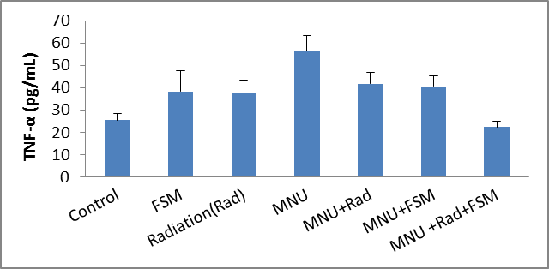
Fig (1): Effect of fermented soy milk and low dose of gamma radiation on TNF-α

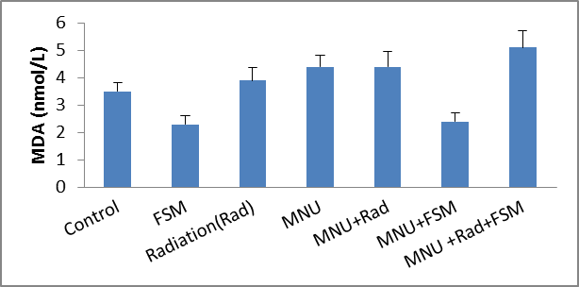
Fig (2): Effect of fermented soy milk and low dose of gamma radiation on lipid peroxidation.

Effect on cell cycle
Cell cycle analysis of mammary gland via flow cytometry clearly shows that, FSM treatment caused significant alterations in cell cycle analysis as it caused cell cycle arrest at Go/1 appeared in increased cell population at Go/1 with significant decrease in cell population at S and G2/M phases compared to control. Rats of MNU group treated with FSM and gamma irradiation showed, amelioration in cell percentage of Go/1, S and G2/M phases compared to control and tumor groups.

Table II: The effect of fermented soy milk and or γ-irradiation on cell cycle analysis in the mammary gland tissue.
G2/M% | S% | Go/G1% | Groups
5.6±0.7 | 37.2±4.4 | 15.2±1.8 | Control
2.04±0.3^{ab} | 14.3±1.7^{ab} | 37.8±4.5^{ac} | FSM
0.38±0.1ª | 2.7±0.3ª | 13.7±1.6^{b} | Radiation(Rad)
9.1±1.1^{ab} | 18±2.2^{ab} | 72.8±8.7^{ab} | MNU
0.42±0.04ª | 0.98±0.1ª | 4.3±0.5^{ab} | MNU+Rad
0.59±0.1ª | 3.2±0.4ª | 33.7±4.0ª | MNU+FSM
1.35±0.2^{ab} | 7.5±0.1^{ab} | 14.7±1.7^{b} | MNU+Rad+FSM

*Legends as in table 1

Effect on caspase-3 and apoptosis
Apoptosis and caspase-3 analysis by flow cytometry results in fig.3. shows the inducing effect of FSM and gamma radiation on apoptosis along via caspase-3 mechanism. Combined treatment with FSM and gamma radiation markedly enhanced apoptotic cell number and caspase-3 mechanism.

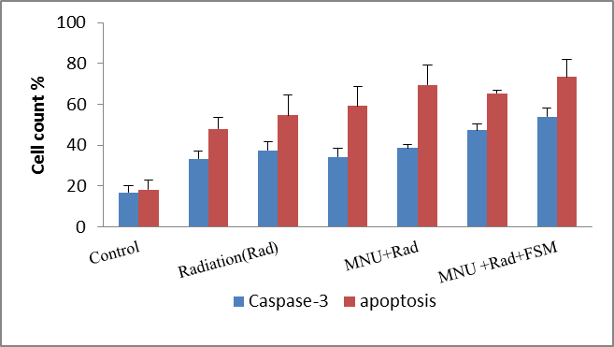
Fig (3): Effect of fermented soy milk and low dose gamma radiation on of caspase-3 and apoptotic cell count %.

Histopathological study
Histopathological study by light microscope of female rat mammary glands showed several marked changes with different treatments (Fig.4). Mammary gland in the control group was distinguished with lactiferous duct and acini embedded in adipose tissue. Oral administration of FSM revealed normal histological structure, also, mammary gland of irradiated rats with or without FSM administration showed healthy histological structure with no structure alterations. Rats treated with MNU showed anaplastic hyperchromatic lining epithelium with lose of basement membrane (carcinoma). MNU group received FSM showed hyperplasia in lactiferous duct with polyformation and cystic dilation, while treatment with FSM for 15 days before MNU injection markedly ameliorated MNU effect. Female rats treated first with FSM and exposed to gamma radiation then injected with MNU showed normal histological structure.

4. Discussion
In a continuing effort to improve cancer therapy, it was found that ultra-low doses of radiation are capable of enhancing the efficacy of chemotherapy. The clinical results of this combined treatment approach have proven to be so effective, it is now frequently employed for advanced abdominal and head and neck cancers. Combined chemotherapy and radiotherapy regimens have become the standard approach because they allow one to reduce toxicity while maintaining high overall efficacy, since antioxidants can reduce damage produced by both low and high doses of radiation.antioxidant treatment before and after radiation exposure are essential for a maximal reduction in radiation damage. Prevention of immediate radiation-induced genotoxicity requires that an antioxidant be present at the time of irradiation (18).
Fermentation consists of modifying food by microorganisms(bacteria, molds, and yeasts) that grow and reproduce andconsume part of the substrate and enrich it with the products of their metabolism. It is an ancient technology that remains oneof the most practical methods for preserving foods and enhancingtheir nutritional qualities (19,20). Fermented soymilk, unlike fermented milk or yogurt drinks, contains nolactose or cholesterol and have the health benefitsfrom both soy itself and the fermentation(21).
In the present study, MNU in female rats caused significant changes in antioxidant parameters: increase in GSH level accompanied with significant decrease in GPx, CAT and SOD activities, this effects were ameliorated with administration of FSM or combined treatment of FSM +radiation exposure. oxidative stress caused by MNU increased free radicals production result in significant increase in lipid peroxidation (22). Antioxidant enzymes are capable of eliminating reactive oxygen species and lipid peroxidation products, thereby protecting cells and tissues from oxidative damage. Superoxide dismutases convert superoxide radicals to molecular oxygen and H₂O₂, and catalase decomposes H₂O₂ to molecular oxygen and water. FSM administration was able to normalize SOD and GPx activities which reduced in the tumor tissue(23) in MNU groups due to the presence of soy isoflavonsaponin and lactobacillus sp. which exerts potent antioxidant activity and free radical scavenging capability exerting its activity viaseveral anti-oxidative mechanisms: catalase, glutathione-system-related compounds and Mn-SOD, decreasing the risk of ROS accumulation also degrade the superoxide anion and hydrogen peroxide (24,25). N-methyl-N-nitrosoureatransforms mouse mammary epithelial cells to proneoplastic and neoplastic states in rat, however, malignant tumors appeared earlier and at a faster rate than the benign tumors (26).
Fermented soy and low dose of gamma radiation enhanced GSH levels, which protect vital organs from damage via free radicals through free-radical scavenging, restoration of the damaged molecules by hydrogen donation, reduction of peroxides, and maintenance of protein thiols in the reduced state (27). It was reported that, Soy(1) and exposure to low dose irradiation (0.5 Gy) significantly enhanced GSH content within 24 hrs post-irradiation(28). The presence of 3-hydroxyanthranilic acid (3-HAA) a by-product of soy fermentation in FSM and Lactobacillus markedly combat oxidative stress and reduced lipid oxaridationin vivo(29). Lactobacillus,attenuate proliferation (30) and reduce NOlevels (31).
Exposure to low doses of ionizing radiation may stimulate cellular detoxification and repair mechanisms leading to reduction of the DNA damage even below the spontaneous level and decreasing the probability of neoplastic transformation (32,33), such exposures may also enhance immune reactions of the organism and attenuate harmful effects of higher doses of radiation (34,35),significantly delayed the tumor growth, enhanced GSH content in the spleen within 24 hrs post-irradiation (28).

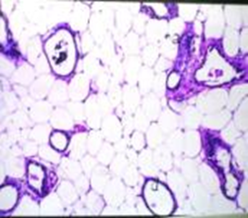  A | 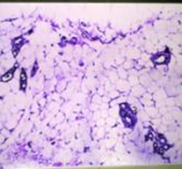  B | 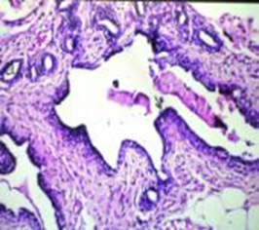  C
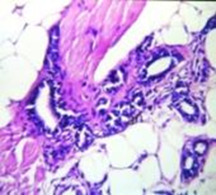  D | 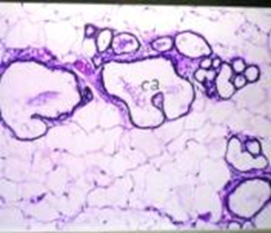  E | F
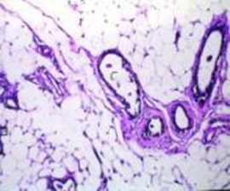
G
Fig.(4): Light microscopic photos of rats mammary gland showing: (a) In control group histological structure of the lactiferous duct (d) and acini (a) embedded in adipose tissue. (b) In FSM treated group: no ultrastructural changes in the structure of the lactiferous duct (d) and acini (a). (c) In irradiated group: no ultrastructural changes in the structure of the lactiferous duct (d) and acini (a). (d) In MNU group: showing anaplastic hyperchromatic lining epithelium of the acini (a) with lose of basement membrane (carcinoma). (e) In FSM+ irradiation group: showing normal histological structure of lactiferous duct (d) and acini (a). (f) In MNU+FSM group; showing mild systicdialation of the intact duct and acini. (g) In MNU+FSM+Radiation: showing normal histological structure of the duct (d) and acini (a).

The inhibition of cytokine production or function serves as a key mechanism in the control of inflammation(36). In this study, FSM ameliorated the elevation in TNFα caused by MNU, may referred to the presence of genistein which reduce the production of TNF-α, IL-6, IL-1 via its effect on nitric oxide and COX-2 gene expression(37,38). The components of lactic acid bacteria or bifidobacterium cells and peptides formed during the fermentation have been reported to affect the production of cytokines (39,40).
Cell cycle analysis of female rat mammary tissue via flow cytometry showed disturbance in cell cycle in MNU group observed in all phases with accumulation of cell count at G1, this disturbance was significantly ameliorated by FSMtreatment and combined treatment of FSM and gamma radiation decreasing MNU effect on cell cycle and apoptotic cell count compared to the control.
The presence of isoflavone, particularly genistein in soy, exerts its antioxidant effects to protect cells against reactive oxygen species by scavenging free radicals and reducing the expression of stress-response related genes. Genistein is a tyrosine kinase inhibitor, induce apoptosis in different types of cancers including breast cancers through both NF-κB dependent and independent pathways. It activatescaspases, apoptosis and inhibits DNA-binding activity of NF-κB in various cancer cells. Furthermore, its pre-treatment abrogated the activation of NF-κB stimulated by H₂O₂or TNF-α(41). Although soy extract induced higher percentage of cells undergoing apoptosis than genistein or daidzein(42). Accompanied treatment of FSM and low dose of radiation induce more inhibitory effect on tumor cell, since low dose of gamma radiation also able to delaye tumor growth in Ehrlich solid tumor bearing mice (28).
The histological observations indicate that FSM accompanied with low dose of gamma radiation has great efficiency as anti-inflammatory and antitumor treatment against MNU carcinogenesis. The ameliorative effects of FSM upon the structural alterations could be explained by the role of FSM in regulating vital cellular functions, including cell proliferation and differentiation and its potent antioxidant activity and free radical scavenging capability.
MNU has an impact on the expression of regulatory genes triggering apoptosis and directly development toxicity followed by accumulation of mutations either in somatic cells or blood cells(43). The proposed antiproliferative effects of FSM reflect the primary protective action on damaged cells. Induction of apoptosis may be considered in case of failure of reparative mechanisms lead to cell death and is also important for protection of the entire organism.
This study demonstrates that soy antioxidants and microbial components accompanied with low dose of gamma radiation can reduce the harmful mutagenic and oxidative stress effect of MNU in inducing mammary tumors.

References
- Khan SA, Chatterton RT, Michel N, Bryk M, Lee O, Ivancic D, Heinz R, Zalles CM, Helenowski IB, Jovanovic BD, Franke AA, Bosland MC, Wang J, Hansen NM, Bethke KP, Dew A, Coomes M, Bergan RC (2012). Soy isoflavone supplementation for breast cancer risk reduction: a randomized phase II trial. Cancer Prev Res (Phila).5(2):309-319.
- Nowosielska E M, Cheda A, Wrembel-Wargocka J, Janiak M K. (2012). Effect of low doses of low –let radiation on the innate antitumor reactions in radioresistant and radiosensitive mice. Dose-Response. 10:500-515.
- Wang YC, Yu RC, Chou CC. (2006). Antioxidative activities of soymilk fermented with lactic acid bacteria and bifidobacteria. Food Microbiol.23:128–135.
- Chin Y, Tsui K, Chen M, Wang C, Yang C, Lin Y.(2012). Bactericidal Activity of Soymilk Fermentation Brothby In Vitro and Animal Models. J Med Food. 15 (6); 520–526.
- Kim JE, Hur HJ, Lee KW, Lee HJ.(2007). Anti-inflammatory effects of recombinant arginine deiminase originating from Lactococcuslactis ssp. lactis ATCC 7962. J Microbiol Biotechnol. 17: 1491–1497.
- Wang YC, Yu RC, Chou CC. (2006). Antioxidative activities of soymilk fermented with lactic acid bacteria and bifidobacteria. Food Microbiol.23:128–135.
- Wang YC, Yu RC, Yang HY, Chou CC.(2003). Sugar and acid contents in soymilk fermented with lactic acid bacteria alone or simultaneously with bifidobacteria. Food Microbiol. 20: 333–338.
- Chun J, Woo JJ, Kim JS, Lim J, Park CS, Kwon DY, Choi I, Kim JH. (2008). Hydrolysis of isoflavoneglucosides in soymilk fermented with single or mixed cultures of Lactobacillus paraplantarum KM, Weissella sp. 33, and Enterococcus faecium 35 isolated from humans. J Microbiol Biotechnol.18:573–578.
- Anderson R L, Wolf W J. (1995). Compositional changes in trypsin inhibitors, phytic acid, saponins and isoflavones related to soybean processing. J. Nutr. 125: 581S-588S.
- Wang C, Wixon R.(1999). Phytochemicals in soybeans-Their potential health benefits, Inform.10:315-320.
- Chang WH, Liu JJ, Chen CH, Huang TS, Lu FJ. (2002). Growth inhibition and induction of apoptosis in MCF-7 breast cancer cells by fermented soy milk. Nutr Cancer.43(2):214-26.
- Dean PN, Jett JH. (1974). Brief note: mathematical analysis of DNA distributions derived from flow microfluorometry. J Cell Biol. 60: 523.
- Yoshioka T, Kawada K, Shimada T, Mori M. (1979). Lipid peroxidation in maternal and cord blood and protective mechanism against activated oxygen toxicity in the blood. Am J Obstet Gynecol. 135: 372.
- Beutler E, Duron O, Kelly BM. (1963). Improved method of the determination of blood glutathione. J. Lab & Clin Med. 61: 882.
- Paglia DE, Valentine WN.(1967). Studies on the quantitative and qualitative characterization of erythrocyteglutathione peroxidase. J Lab Clin Med. 70: 158.
- Sinha AK.(1972). Colorimetric assay of catalase. Anal Biochem.47: 389.
- Bancroft J D, Gamble M. (2008). Theory and Practice of Histological Techniques.6th Ed., Churchill Livingstone, Elsevier, China.
- Okunieff P, Chen Y, Maguire D, Huser A. (2008). Molecular markers of radiation –related normal tissue toxicity. Cancer Metastasis Rev. 27: 363-374.
- Reddy N R, Salunkhe D K. (1989). Fermentation. In “Handbook of World Food Legumes: Nutritional Chemistry, Processing Technology and Utilization”, CRC Press, Inc.: Boca Ratón, FL,;Vol. III.
- Deshpande S S, Salunkhe D K, Oyewole O B, Azam-Ali S, Battcock M, Bressani R. (2000). Fermented Grain Legumes, Seeds and Nuts. A Global PerspectiVe; Food and Agriculture Organization of the United Nations: Rome, Italy.
- Lin C, Tsai Z, Cheng I, Lin S. (2005). Effects of fermented soy milk on the liver lipids underoxidative stress. World J Gastroenterol. 11(46):7355-7358.
- Garcia-Solis P, Alfaro Y, Anguiano B, Delgado G, Guzman RC, Nandi S, Diaz-Munoz M, Vazquez/Martinez O, Aceves C.(2005). Inhibition of N-methyl-N-nitrosourea induced mammary carcinogenesis by molecular iodine(I2) but not by iodide (I-) treatment Evidence that I2 prevents cancer promotion. Mol Cell Endocrinol. 236 49–57.
- Chen YC, Sugiyama Y, Abe N, Kuruto-Niwa R, Nozawa R, Hirota A. (2005). DPPH radical-scavenging compounds from Dou-chi, a soybean fermented food. Biosci Biotechnol Biochem. 69:999-1006.
- Liu C,PanT.(2010). In Vitro Effects of Lactic Acid Bacteria on Cancer Cell Viability and Antioxidant Activity. J. Food Drug Analysis. 18: 77-86.
- Zhou N, Zhang JX, Fan MT, Wang J Guo G, Wei XY. (2012). Antibiotic resistance of lactic acid bacteria isolated from Chinese yogurts. J. Dairy Science 95, 4775–4783.
- Macejova D, Brtko J.(2001). Chemically induced carcinogenesis: a comparison of l-methyl-l-nitrosourea,6,12-dimethylbenzanthracene, diethylnitroso-amine and azoxymethan models. Endocr Regul. 35(1):53-59.
- Lewis-Wambi J. S., Kim H. R., Wambi C., Patel R., Pyle J. R., Klein-Szanto A. J., and Jordan V. C. (2008). Buthioninesulfoximine sensitizes antihormone-resistant human breast cancer cells to estrogen-induced apoptosis Breast Cancer Res. 10(6): R104.
- Kojima S. (2006). Induction of glutathione and activation of immune functions by low-dose, whole-body irradiation with gamma-rays]. Yakugaku Zasshi. 126(10):849-857.
- Zhou S, Zhang R. Xu Y, Bi T. (2012).Antioxidant and Immunity Activities of Fufang Kushen Injection Liquid. Molecules. 17: 6481-6490.
- Ramesh V, Rajesh R, Kumar RB, Singh. K, Kaushik J, Mann B. (2012): Comparative evaluation of selected strains of lactobacilli for the development of antioxidant activity in milk. Dairy Science & Technology. 92: 179-188.
- Fernanda L K, Danielle C G M, Lívia C AR, Marisa C PP, Graciela FV, Lucas LC, Elizeu AR Iracilda ZC. (2012). A soy-based product fermented by Enterococcus faecium and Lactobacillus helveticus inhibits the development of murine breast adenocarcinoma. Food Chem Toxicol. 50: 4144–4148.
- Redpath JL, Elmore E. (2007). Radiation-induced neoplastic transformation in vitro, hormesis and risk assessment. Dose-Response. 5:123-130.Feinendegen L, Hahnfeldt P, Schadt EE, Stumpf M, Voit EO.(2008). Systems biology and its potential role in radiobiology. Radiat Environ Biophys. 47:5–23.
- Safwat A. (2000): The role of low-dose total body irradiation in treatment of non-Hodgkin’s lymphoma: a new look at an old method. RadiotherOncol. 56:1-6.
- Safwat A, Bayoumy Y, El-Sharkawy N, Shaaban K, Mansour O, Kamel A. (2003).The potential palliative role and possible immune modulatory effects of low-dose total body irradiation in relapsed or chemo-resistant non-Hodgkin’s lymphoma. RadiotherOncol. 69:33-36.
- Shapira L, Soskolne W A, Houri Y, Barak V, Halabi A, Stabholz A. (1996). Protection against endotoxic shock and lipopolysaccharide-induced local inflammation by tetracycline: Correlation with inhibition of cytokine secretion. Infect. Immun. 64: 825-828.
- Murakami A, Matsumoto K, Koshimizu K, Ohigashi, H. (2003). Effects of selected food factors with chemopreventive properties on combined lipopolysaccharide- and interferon-γ-induced IB degradation in RAW 264.7 macrophages. Cancer Lett. 195: 17-25.
- VeghI, Enriquez de Salamanca R.(2007). Prolactin,TNF alpha and nitric oxide expression in nitrose-N-methylurea induced mammary tumours. J Carcinogenesis. 6:18-26.
- Masotti AI, Buckley N, Champagne CP, Green-Johnson J. (2011). Immunomodulatory bioactivity of soy and milk ferments on monocyte andmacrophage models.Food Research International. 44: 2475–2481.
- Vaˇskovaa J, Kassayovab M, Vaˇskoa L. (2011). Potential role of melatonin in DNA damage caused by nitrosourea-inducedmammary carcinogenesis Acta Histochemica. 113: 423–427.
- Li Y, Kong D, BaoB, Ahmad A, Sarkar FH. (2011). Induction of Cancer Cell Death by Isoflavone: The Role of Multiple Signaling Pathways.Nutrients. 3: 877-896.
- Hsu A, Bray TM, Helferich WG, Doerge DR, Ho E. (2010). Differential effects of whole soy extract and soy isoflavones on apoptosis in prostate cancer cells.ExpBiol Med (Maywood). 235(1):90-97.
- Budán F, Varjas T, Nowrasteh G, Varga Z, Boncz I, Cseh J, Prantner I, Antal T, Pázsit E, Gőbel G, Bauer M,Gracza T, Perjési P, Ember IG. (2008). Early Modification of c-myc, Ha-rasand p53 Expressions by N-Methyl-N-nitrosourea.In vivo.22: 793-798.

10/2/2013

