Effect of Storage Period on Microbiological Quality of Whole and Low-fat Pasteurized Cow Milk

Ebtehal Abdulaziz AlTamim

Nutrition & Food Science Department, Home Economics College, Princess Noura Bint Abdulrahman University, Riyadh, Saudi Arabia
Nody_lovetheall@hotmail.com

Abstract: This study was conducted to determine the effect of storage period on whole and low-fat pasteurized cow milk. Milk samples packaged in plastic containers were collected from four factories and stored in temperature 4°C for 1, 3 and 8 days of production. The samples were analyzed chemically for Acidity as lactic acid% & pH, and microbiologically for bacterial counts, yeasts & mold counts, coliform counts, Staphylococcus aureus and salmonella. The significant difference was conducted at (p≤0.05).The results showed that acidity of milk increased in all whole-fat milk samples during 3rd & 8th day of storage comparing to 1st day. Sample (2-A) was the highest value of acidity with mean and standard deviation (0.14±0.035), the lowest value for pH (6.70±0.012), and the highest value for bacterial counts (6.0 × 104). Also, the results showed that the acidity increase in all low-fat milk samples during 3rd & 8th day of storage comparing to 1st day. Sample (3-B) was the highest (0.14±0.035) in acidity, lowest pH (6.68±0.017), and more bacterial counts (7.0 × 107). Yeast & mold counts in some milk samples was less than < 10 and Zero in others. Coliform counts, Staphylococcus aureus and salmonella were Zero in all samples. This study suggests that storage period has a strong influence on the quality of whole and low-fat pasteurized milk, and it is recommended to consume milk on the 1st day of storage.
[Ebtehal Abdulaziz AlTamim. Effect of Storage Period on Microbiological Quality of Whole and Low-fat Pasteurized Cow Milk. Nat Sci 2013;11(11):29-34]. (ISSN: 1545-0740). http://www.sciencepub.net/nature. 6

Keywords: Cow Milk, Pasteurization

1. Introduction
Milk is a white liquid with high nutrition value for human & animals growth. The people awareness of milk importance raises its consumption and encourages dairy companies to expand production that change consuming method of this product (Buzzola et al., 2001; Sheet, 2010; Looper, 2012).
Saudi Arabia achieved self-sufficiency in raw milk production by five main companies producing 85% of total milk production (AlSuhaibani and AlJnobi, 2004).
Milk quality is affected by many factors like cow hygiene, environment, milking techniques, packaging, transportation and storage’s period & temperature (Rizwan et al., 2011; Batool et al., 2012). Many preserving techniques apply on milk to extent its shelf-life including pasteurization and cooling storage to reduce bacterial (European Commission, 2006).
Researchers studied effect of commercial-scale, high-temperature, short-time pasteurization at 73°C on viability of Mycobacterium paratuberculosis in naturally infected cow’s milk. They found that this process was no more effective at killing Mycobacterium paratuberculosis bacteria if they are present in raw milk in sufficient numbers. Dairy industry needs to keep this subject under review, because Mycobacterium paratuberculosis causes Johne’s disease in cattle and that the bacteria may pass into the human food chain via cows’ milk. Also the bacteria may or may not cause or contribute to Crohn’s disease in humans, even though it has been reported that. Mycobacterium paratuberculosis has been detected more commonly in patients with Crohn’s disease than in the general population (<1.0%) (Grant et al., 2002; Food safety authority of Ireland, 2000). But Millar et al. (1996) and Keswani and Frank (1998) insisted that extending the pasteurization process for more than 25 second was effective to kill this bacteria.
Rouvinen (2010),and Savescu et al. ( 2009) mentioned that storage practices and periods of raw milk and processed milk products had important role in bacterial growth, and some bacterial community is able to thrive in cold conditions. Also, a study of the effect of frozen storage on the survival of probiotic microorganisms found in traditional and commercial Kefir concluded that the traditionally produced kefir was shown to have significantly (P<0.05) higher counts of bacteria and yeast at each sampling (O’Brien, 2012).
Therefore, the aim of this study is analyzing to study the effect of different storage periods on the acidity, pH, and bacterial counts on the pasteurized whole and low-fat milk.

2. Materials and Methods
Pasteurized whole and low-fat milk samples packaged in 2 Liter plastic containers were collected from four factories in Riyadh city. They were stored in temperature 4°C for 1, 3 and 8 days of production. Samples 1- 4 A for whole fat milk, 1 -4 B for low fat milk.
The samples were analyzed chemically and microbiologically as the following:

Chemically:
Acidity:
Acidity value was estimated according to AOAC (2005) as Lactic acid % by weight, and calculated as the following:
1 mL 0.1N NaOH = 0.0090g lactic acid

pH:
pH was determined according to AOAC(2005) by Digital pH meter to read the concentration of titratable hydrogen ions in milk samples.

Microbiologically:
Bacterial counts:
Bacterial counts was estimated according to AOAC (2005) by colony counts of bacterial culture plates of dry medium incubated at 32°C.

Yeast & Mold:
Yeast & Mold was estimated according to AOAC (2005) by dry rehydrated film (PetrifilmTM Method).

Coliform:
Coliform counts was determined according to AOAC (2005) using Petri film Coliform Count Plates® incubating 24±2hrs at 32±1°C.

Staphylococcus aureus:
The presence of Staphylococcus aureus was detected in milk samples according to (Wehr & Frank ,2004) which depends on incubation at 35 ±2ºC for 30 to 48 hours.

Salmonella:
Detection of Salmonella based on incubation at 35±2ºC (Wehr&Frank ,2004).

Statistical Analysis:
All study results were subject to statistical Analysis of Variance (ANOVA) of SAS (SAS, 1998) to study the significant differences at p≤0.05 among the milk samples, storage periods, data charts and different comparing.

3. Results and Discussion
Figures (1, 2) below shows the storage periods effect on the acidity level of whole and low-fat pasteurized cow milk. Measuring milk acidity is an important test used to determine milk quality physically, chemically and microbiologically (Batool et al., 2012). Acidity is an important factor for microorganisms growth and survival in food (UNIFEM, 1995). The results in this study show the increase of milk acidity in 3rd & 8th day of storage comparing to the 1st day. The high-acidity level for the Whole-fat milk was Sample (2-A) with mean and standard deviation (0.13±0.035) & (0.14±0.035), respectively. For the Low-fat milk, sample (3-B) has the high-acidity level with (0.13±0.035) and (0.13±0.035), respectively. The high-acidity during storage periods support what AlKanhal et al. ( 1994) and Looper (2012) mentioned about the significant effect of storage time and temperature on Acidity level and consequently on milk quality. Also, a study conducted on chemical & physical quality of soya milk stored in different temperatures showed the increase of acidity-level according to the storage periods. The statistical significance was large (P<0.05) in soya milk acidity during storage in room temperature and refrigerating (Odu and Egbo, 2012). Pesta et al. (2007) studied the effects of storage conditions on 20 raw milk samples which were stored at 20-25°C, and 20 at 2-8°C, for 168 hours, the pH was lowered by an average of 1.19 units, which indicate an acidification process such as bacterial spoilage.
pH value is an important indicator to test milk quality (Goff, 2009). Some studies mentioned that knowledge of the initial pH prior to heating alone was not sufficient for predicating the changes that occurred during heating and storage (Chandrapala et al., 2010). Figures(3,4) shows the increase in pH level in 3rd & 8th day of storage comparing to the 1st day. In regards of Whole-Fat milk, sample (2-A) was the lowest pH level with mean and standard deviation (6.75±0.017) & (6.72±0.035), respectively. Sample (3-B) was the lowest pH level in Low-Fat milk with (6.72±0.035) for 3rd day & (6.70±0.012) for the 8th day of storage. This decrease was mentioned by (Hassan et al., 2009) that pH level decreases as long as the storage period. Also, The results show a reverse correlation between acidity level and pH in milk, when acidity level increases pH level decreases. This correlation was discussed in some studies that found the pH of milk powders stored at room temperature decreased, and milk powder that has deteriorated extensively as a result of poor storage conditions, appears to have an unpleasant, acidic taste (Farkye et al., 2001).
Table (1) shows the compares between mean bacterial counts and storage periods in whole-fat l milk. It shows all samples' increase of bacterial counts during 3rd & 8th Day of storage comparing to 1st Day. The highest mean bacterial counts was sample (2-A) (1.9×103) CFU/g (Colony-Forming Units per gram). Also it was the highest in 3rd & 8th Day (2.9×103) & (6.0×104) CFU/g, respectively. For Yeast & mold counts, some samples contained less than < 10, and this was mentioned by Agarwal et al. (2012) that yeast and molds were detected in the samples of unpasteurized as well as pasteurized milk. 3and4 A samples have zero of Yeast & molds. In all milk samples have no E. coli, Staphylococcus aureus and Salmonella were detected. Also, this increase of bacterial counts during storage was studied by AlRakabi et al. (2010) who mentioned that bacterial counts after milk drying process during storage was high. This high level was significant at P≤ 0.05, with maximum increase after (90) days of storage (150 × 102) & (110 × 103) CFU/g at 5°C & 25°C, respectively. El-Prince & Korashy ( 2003) studied the bacterial counts at (1.3 × 102) CFU/g in some baby formula powders. Mycobacterium avium subspecies paratuberculosis cultured from 244 bottles and cartons of commercially pasteurized cow's milk obtained at random from retail outlets throughout the Czech Republic were investigated by Ayele et al. (2005). They cleared that the dynamic changes in the bacterial population in milk samples before and after 24-h conservation at 4°C were monitored, and a considerable evolution of bacterial populations occurred during conservation.
Table (2) shows the comparison of mean bacterial counts and storage periods in low-fat milk. The bacterial counts increase in all samples during 3rd & 8th Day of storage comparing to 1st Day. The highest mean bacterial counts was sample (3-B) in 1st, 3rd & 8th day of storage by (3.6×103), (2.2 ×105) & (7.0 × 107) CFU/g, respectively. In this study there is a correlation between microbiological quality of milk and its level of Acidity & pH, which agreement with AOAC, (2005) who mentioned that as long storage period as the increase in the acidity and bacterial counts in milk. Clare et al.(2005) concluded that when the storage period was long the acidity and bacterial counts increased, but pH decreased. Some bacteria like Streptococcus causes milk to curdle and become acidic taste by decreasing pH level (North, 1918). A study by Alkanhal et al.(1996) discussed the impact of year seasons on raw milk quality, since pH increased and bacterial counts decreased in winter samples comparing to summer ones.
In regards of yeast & mold, coliform counts, Staphylococcus aureus and salmonella, none of the milk samples contain any type of these microorganisms. AlRakabi et al.( 2010) mentioned that these type of bacteria did not contaminate milk powder samples stored for (30/60/90) days. But, other study showed cow milk storage at 4°C for 10 hours leaded to increase the acidity level, their contents of bacterial counts and Yeast & Mold during storage periods (Eid, 2009).

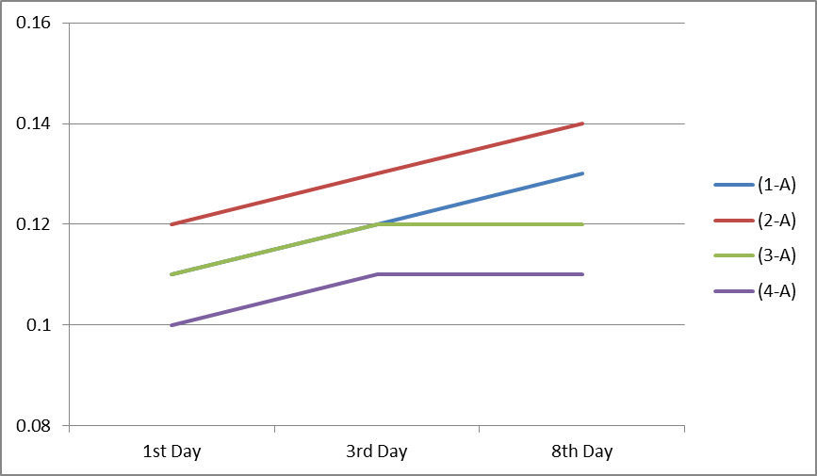
Fig (1): The effect of storage periods on total acidity level of Whole - Fat Milk Samples

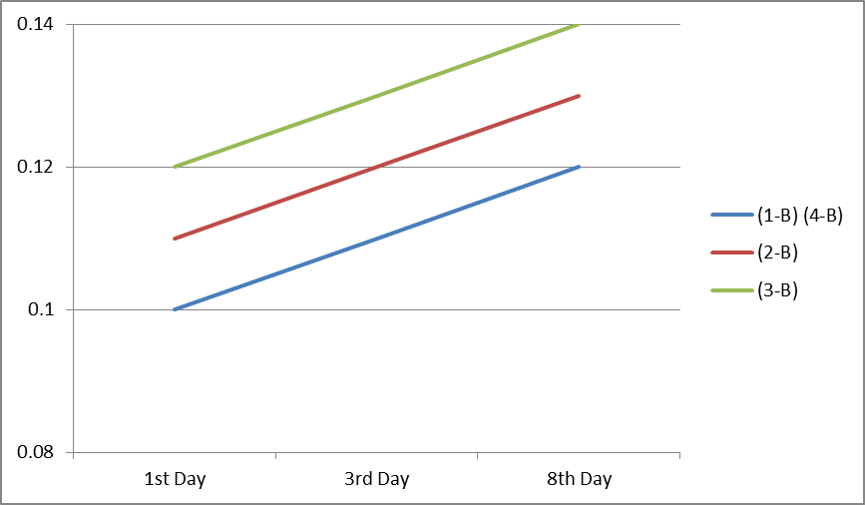
Fig (2): The effect of storage periods on total acidity level of Low - Fat Milk Samples

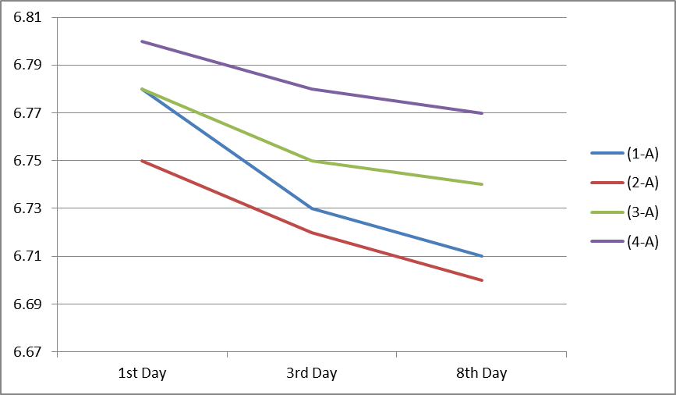
Fig (3): The effect of storage periods on pH level of Whole - Fat Milk Samples

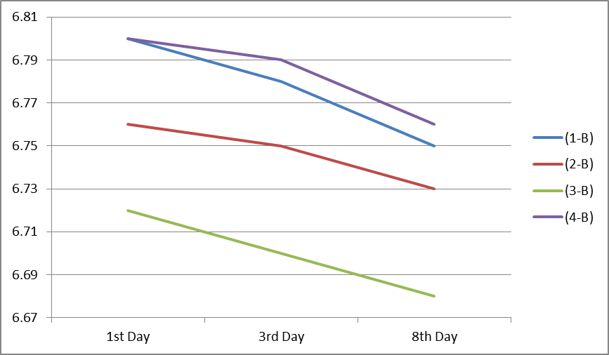
Fig (4): The effect of storage periods on pH level of Low - Fat Milk Samples

Table (1): Comparison of Mean Bacterial Counts and Storage Periods in Whole-Fat Milk*
Samples | Storage Period | Bacterial Counts | Yeast & Mold | Coliforms / Staphylococcus Aureus / Salmonella
(1-A) | 1st Day | <10 | <10 | -
 | 3rd Day | 3.4×102 | <10 | -
 | 8th Day | 6.4×102 | <10 | -
(2-A) | 1st Day | 1.9×103 | <10 | -
 | 3rd Day | 2.9×103 | <10 | -
 | 8th Day | 6.0×104 | <10 | -
(3-A) | 1st Day | <10 | <10 | -
 | 3rd Day | 2.2×103 | - | -
 | 8th Day | 3.5×103 | - | -
(4-A) | 1st Day | <10 | - | -
 | 3rd Day | <10 | - | -
 | 8th Day | 2.5×102 | - | -
*Mean ± Standard deviation

Table (2): Comparison of Mean Bacterial Counts and Storage Periods in Low-Fat Milk*
Samples | Storage Period | Bacterial Counts | Yeast & Mold | Coliforms / Staphylococcus aureus / Salmonella
(1-B) | 1st Day | 1.3×102 | - | -
 | 3rd Day | 1.1×103 | - | -
 | 8th Day | 6.4×103 | - | -
(2-B) | 1st Day | 2.6×103 | - | -
 | 3rd Day | 3.2×104 | - | -
 | 8th Day | 3.0×105 | - | -
(3-B) | 1st Day | 3.6×103 | - | -
 | 3rd Day | 2.2×105 | - | -
 | 8th Day | 7.0×107 | - | -
(4-B) | 1st Day | 1.3×102 | - | -
 | 3rd Day | 1.0×103 | - | -
 | 8th Day | 3.2×103 | - | -
*Mean ± Standard deviation

Conclusion
Cow milk is a fast damage product. This stdy concludes that storage period has a significant impact on full and low fat milk's microbiological quality. When pH decreases the acidity & bacterial counts increase as long as the storage period since production, which limits shelf life of milk.

References
- Agarwal, A.; Awasthi, V. ; Dua, A.; Ganguly, S.; Garg, V. and Marwaha, S. (2012). Microbiological profile of milk: Impact of household practices. Indian Journal of Public Health, Vol.56 (1) 88:94.
- ALkanhal, H; Abu-Lehia, I and & AlSaleh, A. (1994). Changes in the quality of fresh and recombined ultra-high temperature treated milk during storage. Int. Dairy Journal. 4: 221-236.
- AlKanhal, H; Abu Tarboush, H.; Hamad, A.and AlSharawi,M.(1996) Quality of raw milk produced in Saudi Arabia. King Saud University Journal, Agriculture science. 8(2) 2110223.
- AlRakabi, A.; Mahmood, I. and AlTamimi, A. (2010). The Capacity of Maillard reactions to extend the storage periods of dried cow milk. AlBasrah Reserah Journal. Vol. 36 (5): 59-64.
- AlSuhaibani, S and AlJnobi, A. (2004). Agricultural production in Custodian of two holy mosques Era. Ministry of higher education, King Saud University, Riyadh.
- American Public Health Association (APHA). (1978). Standards Methods for the Examination of Dairy Products. 14th Ed. Marth (ed). Washington DC. USA
- AOAC (2005). Official Methods of Analysis, 16th Ed. Association of official Analytical Chemists. USA.
- Ayele, W.; Svastova, P.; Roubal, P.; Bartos, M. and Pavlik, I. (2005). Mycobacterium avium subspecies paratuberculosis cultured from locally and commercially pasteurized cow's milk in the Czech Republic. Applied and Environmental Microbiology. 71(3):1210-1214.
- Batool, S.; Rauf, N.; Tahir, S. and Razia Kalsoom. (2012). Microbial and Physico-chemical contamination in the wheat flour of the twin cities of Pakistan. Internet Journal of Food Safety, Vol.(14):75-82.
- Buzzola, F.; Quelle, L.; Gomez, M.; Catalano, M.; Steele-Moore, L,; Berg, D.; Gentilini, E.; Denamiel, G. and Sordelli,D. (2001). Genotypic analysis of Staphylococcus aureus from milk of dairy cows with mastitis in Argentina. Epidemiology and Infection Journal. 126(3):445-52.
- Chandrapala,J.; McKinnon,I.; Augustin,M. and Udabage,P.(2010) The influence of milk composition on pH and calcium activity measured in situ during heat treatment of reconstituted skim milk.Journal of Dairy Research. 77(3):257-64.
- Clare, D; Bang, W.; Gartwright,G.; Drake, M.; Coronel, P. and Simunovic, J. (2005). Comparison of sensory, microbiological and biochemical parameters of microwave verses indirect UHT fluid skim milk during storage. Journal of Dairy Science. 88 (12): 4172-4182.
- Dechser, B. (1996). Dairy Parathion: Food cycle technology source book.
- Eid, M. (2009). Effect of some process on dairy products characters. Master thesis, Dairy Department, AlMansoura University. Egypt.
- El-Prince,E. and Korashy, E. (2003). Microbiological quality of some dried milk-based infant foods in Assiut City, Assiut Veterinary Medical Journal, Vol. 49(97): 190-203.
- European Commission (2006). Milk and milk products in the European union, Office for official publications of the European communities. Belgium. pp:27
- Food Safety Authority of Ireland. (2000). Mycobacterium paratuberculosis does it contribute to Crohn’s disease. Microbiology Sub-committee . Dublin. Ireland.
- Farkye, N.; Smith, K. and Schonrock, T. (2001). An overview of changes in the characteristics, functionality and nutritional value of skim milk powder (SMP) during storage. USA. U.S. Dairy Export Council.
- Goff, D. (2009). Dairy Science and Technology. Dairy education series. University of Guelph. Canada.
- Grant, I.; Hitchings, E.; McCartney, A.; Fiona, F. and Rowe, M. (2002). Effect of Commercial-Scale High-Temperature, Short-Time Pasteurization on the Viability of Mycobacterium paratuberculosis in Naturally Infected Cows' Milk. Applied and Environmental Microbiology. Vol. 68 (2): 602-607.
- Hassan, A; Amjad, I and Mahmod, S. (2009). Microbiological and physicochemical analysis of different UHT milk available in a local market. Asian Journal of food and agro-industry. Vol 2 (3), 434-447.
- Keswani, J. and Frank, J. (1998). Thermal inactivation of mycobacterium paratberculosis in milk. Journal of Food Protection. Vol. 61(8): 974-978.
- Looper, M. (2012). Factors affecting milk composition of lactating cows. Division of Agriculture, University of Arkansas System. pp: 6
- Michel, V. (2012). Raw milk microbial quality: Effect on dairy product quality. Institut Technique du Lait et des Produits Laitiers. French-Chinese Seminary. France
- Millar, D.; Ford, J.; Sanderson, J.; Withey, S.; Tizard, M.; Doran, T. and Hermon-Taylor, J. (1996). IS900 PCR to detect mycobacterium paratberculosis in retail supplies of whole pasteurized cows' milk in England & Wales. Applied and Environmental Microbiology. Vol. 62(9): 3445-3452.
- North, C. (1918). Farmers' Clean Milk Book. University of California. John Wiley & son Inc.
- O’Brien, K. (2012). The effect of frozen storage on the survival of probiotic microorganisms found in traditional and commercial kefir, Master thesis, Department of animal sciences, Louisiana State University. pp:60
- Odu, N. and Egbo, N. (2012). Assessment of the Effect of Different Preservatives on the Physico-chemical Quality of Soy milk Stored at Different Temperatures. Nature & Science. Vol. 10 (8), p77.
- Pesta, M; Williams, P; Zampa, N; Garry, E and Ouattara, G. (2007). The effects of Raw Milk storage conditions on freezing point, pH and Impedance. Advanced instruments Inc. Tow Technology Way. USA.
- Rizwan,M.; Pervez,A. and Khan,J. (2011). Bacterial quality of raw and packed milk. Canadian Journal on Scientific and Industrial Research Vol. 2 (2): 86-94.
- Rouvinen,V.(2010). Changes in bacterial population and antimicrobial resistance during cold storage of conventional and organic raw milk. Master's thesis. Department of Food and Environmental Sciences. University of Helsinki.
- SAS Institute Inc. (1998) Statistical Analysis System User’s Guide (Vol. I and II. Version 6) Cary, NC: SAS Institute.
- Savescu, P.; Dunoiu, A. and Stan, I. (2009). Study regarding the changes of cow milk redox potential and pH follow the addition of specific microorganisms. Universitatea de Ştiinţe Agricole şi Medicină Veterinară Iaşi. Romania. Lucrări Ştiinţifice. Vol. 52: 621-627.
- Sheet, O. (2010). Isolation of Staphylococcus aureus from ruminant's milk and their resistence to antibiotics in Ninevah governorate. Iraqi Journal of Veterinary Science. Vol. 24 (2): 109-114.
- UNIFEM. (1995). Storage: Food Cycle Technology Source book. UNIFEM: women's fund at the United Nations.
- Wehr,H. and Frank,J. (2004).Standard Methods for the Examination of Dairy Products. American Public Health Association APHA. 17th Ed.

10/3/2013

