Thermo-Sensitive Flowering Behaviour of Cajanus cajanifolius (Haines) Maesen-A Threatened Wild Relative of Cajanus cajan

Kanak Sahai¹, Krishna Kumar Rawat²

CSIR-National Botanical Research Institute, Rana Pratap Marg, Lucknow, Uttar Pradesh 226001, India
¹sahaikanak@rediffmail.com, ²drkkrawat@rediffmail.com

Abstract: Impact of high temperature on the flowering behaviour of Cajanus cajanifolius (Haines) Maesen (Fabaceae), a wild relative of Cajanus cajan has been studied. Considerable effects on pollen viability, stigma receptivity, flowering, fruiting and reproductive phenology have been noticed. The study revealed tremendous flower bud fall as soon as the temperature reached above the 30ºC during flowering. High temperature stress had also reduced duration of reproductive events.
[Sahai K, Rawat KK. Thermo-Sensitive Flowering Behaviour of Cajanus cajanifolius (Haines) Maesen-A Threatened Wild Relative of Cajanus cajan Nat Sci 2013;11(11):21-25]. (ISSN: 1545-0740). http://www.sciencepub.net/nature. 4

Keywords: heat stress; flower abortion; pollen viability; reproductive phenology; stigma receptivity

1. Introduction
The wild relatives of crops are a vital source of genetic diversity that can be used to develop the ability of plants to cope with or to adapt climate change. Reproduction plays an important role in adaptation and succession of plant life. The temperature highly regulates onset of flowering, fruiting, its duration and reproductive outputs. However, due to continuous rise in temperature, the survival of wild relatives of crops is itself under threat as heat stress severely effects their growth, reproductive phenology and yield. Heat stress due to high ambient temperatures is a growing threat to crops worldwide (Hall, 2001, Wahid et al., 2007). Continuous increase in mean temperature can disturb the growth of various plants specially crops, by altering their phenology, resulting in early maturity (Porter, 2005). Sometimes, in many crop plants early maturation is closely correlated with smaller yield production and losses under high temperatures (Adams et al., 2001a). However, plants exhibit a variety of response to high temperature. Such abiotic stress frequently limits the growth and productivity. The effectiveness of high temperature in reducing fruit production during hot summer has been studied by some earlier workers with the best example in Tomato (Lycopersicon esculentum Mill.) where fruit set is somewhat affected at day/night temperatures above 26/20 ºC and severely affected above 35/26 ºC (Barry and Raffiq-uddin, 1988). However, plant responses for heat stress vary species to species and among various phenological stages. Even a short period of heat stress can increase bud and flower abortion (Wahid et al., 2007). Though flower drop is essentially as a result of lack of fertilization, can be influenced by number of factors including reduced gamete viability (Iwahori and Takahashi, 1964; Iwahori, 1965, 1966) and lesser number of pollen (Abdalla and Verkrek, 1968). Hence, bud drop and failure of pollination can lead to drastic loss of yield. Elongation of pollen tube into style may also be affected by high temperature which can disturb normal fertilization process (Smith, 1935; Smith and Cochran, 1935; Iwahori and Takahashi, 1964; Iwahori, 1967). Similarly stigma receptivity may also get affected due to considerable increase in temperature (Charles and Harris, 1972). In different crops the time taken up to fruit ripening varies and is probably affected by the varying temperature (Adams et al., 2001b). In addition, high temperature can also inhibit the ripening process (Lurie et al., 1966) as well as the rate of fruit growth (Adams et al., 2001a).
Pulse legumes are particularly sensitive to heat stress at the bloom stage; only a few days of exposures to high temperatures (30-35ºC) can cause heavy yield losses through flower drop or pod abortion (Siddique et al., 1999). Considering the above findings, the present study was carried out to determine the effect of rising temperature on the reproductive phenology of threatened (Ramanandan and Singh, 1997; Reddy et al., 2006) Cajanus cajanifolius.
Among the wild relatives, Cajanus cajanifolius (Fabaceae), is the most probable progenitor of Cajanus cajan (Van der Maesen, 1986, 1990; Nadimpalli et al., 1992) and it is speculated that C. cajan may have evolved through a series of gene mutations in C. cajanifolius (Pundir and Singh, 1985). However, C. cajanifolius has been proved as a valuable species as it has not only shown resistance against pod fly (Sithanathan et al., 1980) and Alternaria leaf spot disease (Singh et al., 1984) but also exhibits a protein content more than 30% (Singh and Jambunathan, 1980) and had been used in hybridization programme to develop resistant characters (Pundir and Singh, 1987).

2. Material and Methods
The seeds of Cajanus cajanifolius with accession no. 15632 were procured from International Crops Research Institute for the Semi Arid Tropics, Patancheru, Hyderabad (ICRISAT), India. Plants raised from them at experimental plot of National Botanical Research Institute, Lucknow ( India) and maintained in two different conditions. A group of five plants were kept in pots inside a net house while another group of five plants were transplanted in the soil- bed outside the net house. Fifty inflorescences from five plants with 539-549 flowering units were tagged randomly. The maximum and minimum temperature was recorded daily during the study. Various events of reproductive phenology including floral bud initiation, flowering peaks, bud and flower abortion, pod initiation, pod maturity and seed set were studied in detail. Maximum and minimum temperature of respective duration was also recorded on the daily basis. Floral buds of 1 day prior to open, 2 days prior to open, about to open and freshly opened flowers were collected for pollen viability and stigma receptivity through Benzidine test (Galen et al., 1985).

3. Results
3.1 Pollen Viability and Stigma Receptivity:
Pollen viability ranged 10-50% in different stages of floral buds and open flowers at 30ºC-35ºC (Table 1). Similarly stigmas of the same were receptive with gradual loss. However, the floral units of the same stages lost pollen viability as well as stigma receptivity when the temperature increased beyond 35ºC (Table 1).

Table 1. Status of Pollen viability and Stigma receptivity of Cajanus cajanifolius at 30 ºC - 40 ºC temperature

Sl no. | Floral stage during analysis | Temperature range  (30ºC-35º C) |  | Temperature range  (35ºC-40º C)
 |  | Pollen viability  (%) | Stigma receptivity | Pollen viability  (%) | Stigma receptivity
1. | Bud (-2 days to germination) | 35-50% | NIL | 10-20% | NIL
2. | Bud (-1day) | 30-40% | Receptive | NIL | NIL
3. | Bud (0 days) open) | 10-30% | Receptive | NIL | NIL
4. | Open flower | 10-20% | Receptive | NIL | NIL
Since, Cajanus cajanifolius showed two different flowering phases in one season, four flowering phases i.e. two of each season were monitored in detail during 2009-2010 and 2011-2012.

3.2 First Phase (2009-2010):
First phase of flowering started from 26th October 2009 with the opening of first flower and lasted with fruit maturation on 27th January 2010 thus took a total of 94 days. During the starting of flowering the maximum and minimum temperature was 31ºC and 13ºC respectively while it was 26.2ºC and 8.8ºC respectively at the end of flowering. However, peak flowering was noticed between 2nd and 4th weeks of November when maximum and minimum temperature ranged between 26.8ºC to 31ºC and 10.6ºC to14.4ºC respectively. Maximum i.e. 68% bud and flower drop was recorded during last week of October to 2nd week of November 2009, when the minimum and maximum temperature ranged between 13.0ºC to 15.6 ºC and 30.4ºC to 31.6ºC respectively. Pod initiation started in the 4th week of October and took about 61 days for maturation. During this period maximum and minimum temperature ranged between 23.0ºC to 31.0ºC and 5.0ºC to13.0ºC respectively (Figure 1).

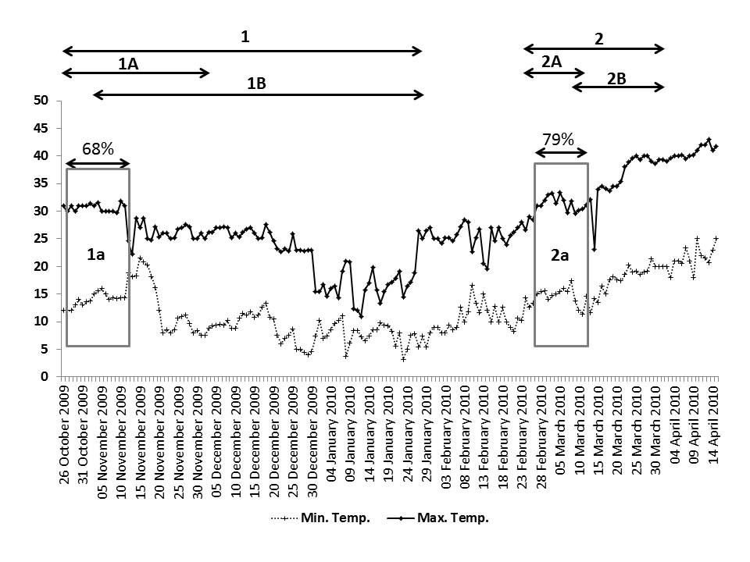
Figure 1. Figure showing fall in flowering units against the fluctuating temperature (Min. and Max.) during 2009-2010. 1. First phase, 1A. Flowering period, 1B. Fruiting and seed set period, 1a. Fall in flowering units at 30-35 ºC. 2. Second phase of flowering, 2A. Flowering period, 2B. Fruiting and seed set period, 2a. Fall in flowering units at 30-35 ºC.

3.3 Second Phase (2009-2010):
The second phase of flowering was started from 28th Feb when maximum and minimum temperature was 31ºC and 15.4ºC respectively. Flowering ended on 11th March when temperature was 30.4ºC (max.) and 11.4ºC (min.). Thus the complete flowering period took 12 days with a peak flowering period from 6th March (32ºC max., 16ºC min.) to 9th March (29.6ºC max., 13.8ºC min.). Pod initiation was started from 9th March and took 22 days for maturation. It was less than half of the first phase of flowering, which was 61 days (Figure 1). Thus the complete duration of reproductive phenology of second phase of flowering was of 34 days. Interestingly most of the buds, which initiated healthy gradually shriveled, died and finally abscised. Thus the total drop was calculated as 97% (Figure 1). Such abscission of floral buds continued over the flowering period simultaneously with the initiation of new buds. During the abscission the maximum temperature was also above the 30ºC like the first phase of flowering.

3.4 First Phase (2011-2012):
Flowering started from 3rd Nov. 2011 at 28ºC maximum and 15ºC minimum temperature and lasted up to 8th January 2012 at 18ºC maximum and 11ºC minimum temperature, thus took 67 days. However, peak flowering period exhibited between 2nd week of November and 3rd week of December at the temperature range-13ºC to 30ºC maximum and 4ºC to 18ºC minimum. A maximum i.e., 53.06% floral bud/flower drop was observed between 2nd and 3rd week of November when maximum and minimum temperature ranged 28ºC to 30ºC and 12ºC to 16ºC respectively (Figure 2). Pod initiation started from last week of November and took about 55 days for maturation. Thus total day’s counts for flowering to fruit maturation were 73 days. During this period the maximum and minimum temperature ranged between 13ºC to 28ºC and 2ºC to 14ºC respectively (Figure 2).

3.5 Second Phase (2011-2012):
Flowering started from 17th February at 30ºC maximum 14ºC minimum temperature and ended up to 21st March at 32ºC maximum 17ºC minimum temperature with a peak flowering period from last week of February to 2nd week of March. The range of temperature during this period was 25ºC to 32ºC maximum and 7ºC to 16ºC minimum. A maximum i.e., 98.16% bud/ flower drop was recorded during 3rd week to 4th week of March when maximum and minimum temperature ranged 32ºC to 36ºC and 15ºC to 19ºC respectively. Pod initiation on remaining flowers was started from 2nd week of March and took about 20 days to be fully matured. During this period the maximum and minimum temperature ranged between 25ºC to 37ºC and 7ºC to 19ºC respectively. Thus the total duration from flowering to fruit maturation was scored as 33 days, which was 40 days less than the first phase.

According to the daily observations made on the drop of flowering units and their synchronous relation with rising temperature, though the drop in flowering units was a regular process during the entire flowering period of both phases, the maximum number of drops i.e., 48 and 82 units were recorded on the day when the temperature was 30ºC max. /13ºC min. and 36ºC max. /16ºC min. respectively. Similarly, minimum drop i.e., 3 and 1 flowering units were observed on that day when the temperature was 13ºC max., 5ºC min and 25ºC max., 8ºC min. in first and second phase respectively (Figure 2).

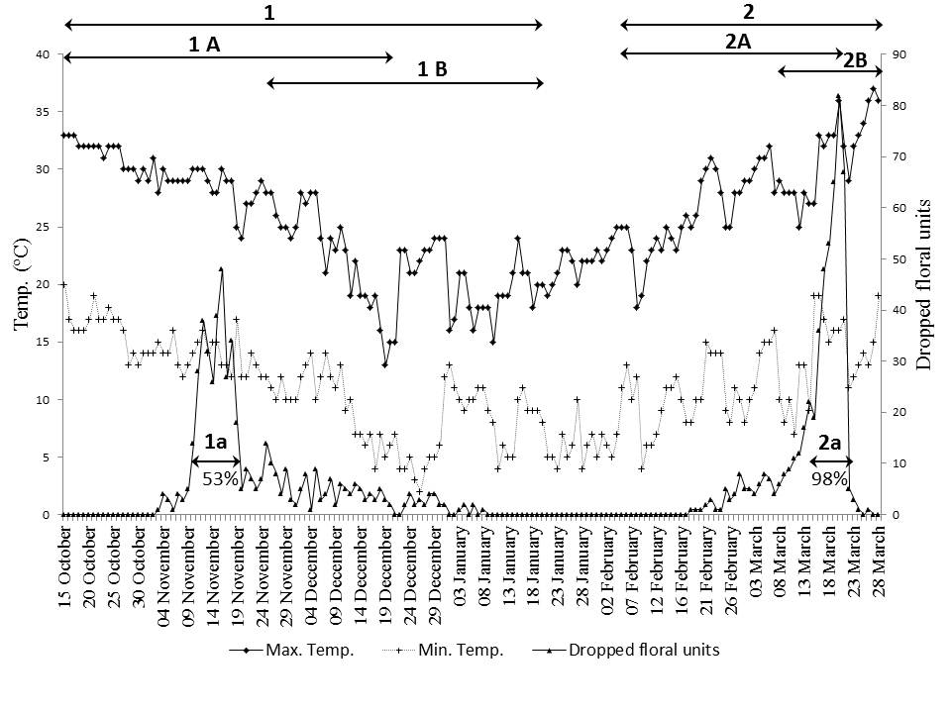
Figure 2. Figure showing fall in flowering units against the daily temperature (Min. and Max.) during 2011-2012. 1. First phase of flowering, 1A. Flowering period, 1B. Fruiting and seed set period 1a. Fall in flowering units between 28-30 ºC. 2. Second phase of flowering, 2A. Flowering period, 2B. Fruiting and seed set period. 2a. Fall of flowering units at 32-36 ºC.

4. Discussions
Plant reproduction is highly vulnerable to temperature especially when the extremes coincide with flower initiation or during reproductive events. However, in accordance to many other reports (Konsens et al., 1991; Reddy et al., 1992; Guilioni et al., 1997; Siddique et al., 1999; Sato et al., 2006) a short duration of high temperature i.e., above 30ºC could significantly increase the frequency of floral bud/flower or pod abortion and caused heavy yield losses in Cajanus cajanifolius. Though different reproductive phenological stages differ within sensitivity to high temperature, it is most deleterious during flower initiation. In the first phase of both the years, the bud abortion was observed when the maximum temperature crossed the limit of 30ºC. However, in the second phase of flowering of the same years, the maximum temperature was always above the level of 30ºC just from the beginning of flowering phase, hence the bud abortion continued till the end of the flowering simultaneously with the development of new buds. Most of the young buds gradually shriveled in this process, resulting in considerable loss of flowers. Similar types of results were also reported in wheat plant, where temperature raised above 30ºC during floret formation caused complete sterility (Owen, 1971; Saini and Aspinall, 1982). A slight rise and fall of temperature even for a short duration can affect plants vegetative as well as reproductive life cycle and many other physiological processes (Singla et al., 1997) as revealed by the present study. Flowering and fruiting stage of any plant species is highly vulnerable to temperature stress though the degree of stress may vary species to species. Though, high temperature is most deleterious when flower start to initiate, different reproductive events differ within its sensitivity. Due to wide fluctuation in temperature, crops are becoming a high risk crop mainly in northern plains. Both abrupt rise and fall in atmospheric temperature lead to flower drop, abortion of pod and poor seed set. Among pulses, Cajanus is very sensitive to abrupt fluctuation of temperature leading to massive bud/flower drop as observed in the study. In addition, rising temperature may also lead to alter reproductive phenology as it reduced the duration of different reproductive events. The total duration of bud initiation to pod maturity got reduced up to 1/3 of the duration of first phase, i.e., from 94 days to 32 days. The peak flowering period was also reduced to four days in comparison to 10 days of first phase and the effective pod maturation phase drastically reduced to 31 days in comparison to 61 days of first phase. Due to abrupt and constantly high temperature plant may become physiologically stressed and imbalanced in the biochemical constituents, which can damage pollination, fertilization and seed production process. The study also revealed that not only the rise of maximum temperature responsible for the drop of flowering units but abrupt fall in minimum temperature had also enhanced the number of drops. In addition, during the first year (2009-2010) of study, the flowering remained suspended from last week of January to second week of February, when the maximum and minimum temperature ranged 22ºC to 28ºC and 5ºC to 16ºC respectively. Similarly in 2011-2012, flowering was also absent from 3rd week of January to 1st week of February when the maximum and minimum temperature ranged 19ºC to 25ºC and 4ºC to 13ºC respectively.
According to the detailed study of both the flowering phases of two consecutive years i.e. 2009-10 and 2011-12 it was concluded that a few days exposure to the temperature beyond 30ºC or 35ºC during reproductive event is a threat to reproductive output consequently survival of Cajanus cajanifolius. Further studies will definitely not only help to understand the necessary requisites for adapting the changing environment but will also provide some lead to the breeders to develop better varieties for maximum yield even under stress during climate change.

Acknowledgements:
We thank Director, CSIR-National Botanical Research Institute, Lucknow (India), for providing necessary facilities. We also thank International Crop Research Institute for the Semi Arid Tropics (ICRISAT), Patancheru, Hyderabad (India) for providing seeds of the plant species.

Corresponding Author:
Dr. Kanak Sahai
Seed Biology Lab.
CSIR-National Botanical Research Institute
Rana Pratap Marg, Lucknow, Uttar Pradesh 226001, India
E-mail: sahaikanak@rediffmail.com

References
- Abdalla AA, Verkrek K. Growth, flowering and fruit set of the tomato at high temperature. Netherlands Journal of Agricultural Science 1968; 16: 71-6.
- Adams SR, Cockshull KE, Cave CRJ. Effect of temperature on the growth and development of tomato fruits. Annals of Botany 2001a; 88: 869-77.
- Adams SR, Valdes VM, Cave CRJ, Fenlon JS. The impact of changing light level and fruit load on the pattern of tomato yields. Journal of Horticultural Science and Biotechnology 2001b; 76: 368-73.
- Berry SZ, Rafiq-Uddin M. Effect of high temperature on fruit set in tomato cultivars and selected germplasm. Horticultural Science 1988; 23: 606-8.
- Charles WB, Harris RE. 1972: Tomato fruit set at high and low temperatures. Canadian Journal of Plant Science 1972; 52: 497-506.
- Galen C, Plowright RC, Thompson JB. Floral biology and regulation of seed set and seed size in the lily, Clintonia borealis. American Journal of Botany 1985; 72: 1522-44.
- Guilioni L, Wery J, Tardieu F. Heat stress-induced abortion of buds and flowers in Pea: Is sensitivity linked to organ age or to relations between reproductive organs?. Annals of Botany 1997; 80: 159-68.
- Hall AE. Crop Responses to Environment. CRC Press, Boca Raton, Florida. 2001.
- Iwahori S, Takahashi K. High temperature injuries in tomato. III. Effects of high temperature on flower buds and flowers of different stages of development. Journal of the Japanese Society for Horticultural Science 1964; 33: 67-74
- Iwahori S. High temperature injuries in tomatoes. IV. Development of normal flower buds and morphological abnormalities of flower buds treated with high temperature. Journal of the Japanese Society for Horticultural Science 1965; 34: 33-41.
- Iwahori S. High temperature injuries in tomato. V. Fertilization and development of embryo with special reference of the abnormalities caused by high temperature. Journal of the Japanese Society for Horticultural Science 1966; 35: 379-86.
- Iwahori S. Auxin of tomato fruit at different stages of its development with special reference to high temperature injuries. Plant Cell Physiology 1967; 8: 15-22.
- Konsens I, Ofir M, Kigel J. The effect of temperature on the production and pod-set patterns and abscission of flowers and pods in snap bean (Phaseolus vulgaris L.). Annals of Botany 1991; 67: 391-9.
- Lurie S, Handros A, Fallik E, Shapira R. Reversible inhibition of tomato fruit gene expression at high temperature. Plant Physiology 1966; 110: 1207-14.
- Nadimpalli BG, Jarret RL, Pathak SC, Kochert G. Phylogenetic relationships of Pigeonpea (Cajanus cajan) based on nuclear restriction fragment length polymorphism. Genome 1992; 36: 216-23.
- Owen PC. Responses of semi-dwarf wheat to temperatures representing a tropical dry season. II. Extreme temperatures. Experimental Agriculture 1971; 7: 43-7.
- Porter JR. Rising temperatures are likely to reduce crop yields. Nature 2005; 436: 174.
- Pundir RPS, Singh RB. Biosystematics relationships among Cajanus, Atylosia and Rhynchosia species. Theoretical and Applied Genetics 1985; 69: 531-4.
- Pundir RPS, Singh RB. Possibility of genetic improvement of Pigeonpea [Cajanus cajan (L.) Millsp.] utilizing wild gene sources. Euphytica 1987; 36: 33-7.
- Ramanandan A, Singh L. Pigeonpea. In: Fuecillo D, Sears L, Stapleton P, eds. Biodiversity in trust: Conservation and use of plant genetic resources in CGIAR centres. Cambridge University Press. 1997:156-67.
- Reddi CS, Reddy KN, Pattanaik C, Raju VS. Ethnobotanical observation on some endemic plants of Eastern ghats, India. Ethnobotanical leaflets 2006; 10: 82-91
- Reddy KR, Hodges HF, Reddy VR. Temperature effect on Cotton fruit retention. Agronomy Journal 1992; 84: 26-30
- Saini HS, Aspinall D. Abnormal sporogenesis in wheat (Triticum aestivum L.) induced by short periods of high temperature. Annals of Botany 1982; 49: 835-46.
- Sato S, Kamiyama M, Iwata T, Makita N, Furukawa H, Ikeda H. Moderate increase of mean daily temperature adversely affects fruit set of Lycopersicon esculentum by disrupting specific physiological process in male reproductive development. Annals of Botany 2006; 97(5): 731-8.
- Siddique KHM, Loss SP, Regan KL, Jettner RL. Adaptation and seed yield of cool season grain legumes in Mediterranean environments of south-western Australia. Australian Journal of Agricultural Research 1999; 50: 375-87.
- Singh U, Jambunathan R. Pigeonpea grain quality investigated at ICRISAT. International Pigeonpea Newsletter 1980; 1: 38-9.
- Singh UP, Charhan VB, Reddy PR. Field screening of Pigeonpea and Atylosia for resistance to Alternaria tenuissima. International Pigeonpea Newsletter 1984; 3: 38-9.
- Singla SL, Pareek A, Grover A. High Temperature. In: Prasad MNV, ed. Plant Ecophysiology. John Wiley and Sons Inc, New York. 1997: 101-26.
- Sithanathan S, Lateef SS, Reed W. Pod fly susceptibility in Pigeonpea: some aspects of oviposition preference. Proceedings of the International workshop on Pigeonpea, Patancheru, India. December 15-19, 1980: 329-35.
- Smith O, Cochran HL. Effect of temperature on pollen germination and tube growth in the tomato. Cornell University Agricultural Experiment Station Memoir 1935; 175: 1-11.
- Smith O. Pollination and life history studies of the tomato Lycopersicon esculentum Mill. Cornell University Agricultural Experiment Station Memoir 1935; 184: 1-16.
- Van der Maesen LJG. Cajanus DC and Atylosia W. & A. (Leguminosae): A revision of all taxa closely related to the pigeonpea, with notes on other related genera within the subtribe Cajaninae. Wageningen Agricultural University, The Netherlands. 1986.
- Van der Maesen LJG. Pigeon pea: Origin, history, evolution, and taxonomy. In: Nene YL, Hall SD, Sheila VK, eds. The Pigeon pea. CAB International, Wallingford, Oxon, UK. 1990: 15-46.
- Wahid A, Gelani S, Ashraf M, Foolad MR. Heat tolerance in plants: An overview. Environmental and Experimental Botany 2007; 61: 199-223.

7/1/2013

