Changes in Morpho-Physiology of Jatropha curcas grown under different water regimes

Neha Tiwari, Mamta Purohit, Gunjan Sharma, A.R. Nautiyal

High Altitude Plant Physiology Research Centre, Post Box No.- 14, HNB Garhwal University, Srinagar, Garhwal- 246174, Uttarakhand, India
neha.tiwari7@gmail.com

Abstract: Jatropha curcas, a drought resistant perennial species has come into prominence as an important biodiesel crop. The investigation was aimed at studying the extent to which Jatropha curcas seedlings can resist water stress. During the experimentation, the response of J. curcas to water stress in terms of growth attributes, photosynthesis, fluorescence characters and leaf and soil water potential was studied. All the growth attributes showed drastic reduction in stressed plants in comparison to control plants. A significant reduction in fresh and dry biomass was observed with increasing water stress level. Minimum leaf and soil water potential was shown by stressed plants as compared to daily watered plants. When compared to control plants, photosynthesis decreased in water stressed plants and Fv/Fm, a parameter of PSІІ efficiency was maximum in control plants as compared to stressed plants.
[Tiwari N, Purohit M, Sharma G, Nautiyal, AR. Changes in Morpho-Physiology of Jatropha curcas grown under different water regimes. Nat Sci 2013;11(9):76-83]. (ISSN: 1545-0740). http://www.sciencepub.net/nature. 11

Key words: Water stress; Growth attributes; Photosynthesis; J. curcas

1. Introduction
Water is one of the major and essential abiotic components that regulate plant growth and development and its deficiency alters the morphological, physiological and biochemical properties of plants. Decreasing the external water potential by only -0.1 MPa or less results in a perceptible decrease in cellular growth (which is irreversible cell enlargement). The quantity and quality of plant growth depend on cell division enlargement, and differentiation and all of these events are affected by water stress (Cabuslay et al., 2002, Correia et al., 2001). The Severe water stress may result in the arrest of photosynthesis, disturbance of metabolism and finally the death of plant (Jaleel et al., 2008c). When the water status in a leaf falls below a threshold value, stomata respond by closing with consequent reduction in CO₂ assimilation as well as transpiration. Stomatal closure decreases the carbon dioxide influx which limits photosynthesis and supports photoinhibition under high irradiance. Non-stomatal photosynthesis limitation has been attributed to the reduced carboxylation efficiency (Jia and Gray, 2004), reduction in ribulose 1-5, biphosphate regeneration, reduced amount of functional Rubisco (Kanechi et al., 1995) and decrease in electron transport chain activities. Water stress caused negative effect on seedlings of Mediterranean water saver Pinus halepensis and water spenders Quercus coccifera and Q. ilex., As a result stomatal conductance, CO₂ assimilation and transpiration rate reduced (Baquedano and Castillo, 2006). Similarly Mokhatar et al. (2011) evaluated effect of different water regimes on Hevea brasiliensis and concluded that Hevea brasiliensis cannot withstand water stress at nursery stage and replanting in dry areas.
Jatropha curcas L., a drought resistant perennial shrub or small tree is one of the most promising sources of bio-fuel today. It is known to grow in drier sites but can grow under a wide range of rainfall regimes from 250 to 1200mm per annum (Katwal and Soni, 2003). In low rainfall areas and in prolonged dry spell periods, the plant sheds its leaves to counter drought. However, its tolerance to water stress at the seedling stage is not known. Therefore the objective of present study was to analyze the response of J. curcas to water-deficit at seedling stage in respect of the growth behaviour and photosynthesis.

2. Material and Methods
J. curcas seeds were sown in seedling Styrofoam trays in mid March and after 15 days of their radical emergence, the seedlings were transferred to large plastic pots of 33cm diameter and 35cm height (approx capacity- 25 kg of soil, containing equal proportion of garden soil, sand and farmyard manure) and kept in a glass house.
The study was conducted in randomized block design with five replications. In each pot five seedlings were planted and for each treatment five pots were used. After 3 weeks of planting in pots (allowing seedlings to establish), the plants were subjected to water stress treatment. Before subjecting the plants to water stress treatment, mean leaf number per plant, leaf area and shoot length were recorded randomly. Three levels of water stress were given i.e. daily watering (control), watering after two days (2-D) and watering after five days (5-D). Watering of every pot was done with 1000ml of water. Before the initiation of experiment, water holding capacity of soil (Goel and Trivedi, 1992) was determined, which was 25%. The plants were maintained in these water regimes for two months and subsequently observations were made on their growth, bioproductivity (capacity to produce biomass) and photosynthesis.
For growth measurements five plants from each water regime were randomly selected and their shoot length, number of leaves and leaf area were determined at fortnightly intervals. After 60 days, these plants were uprooted, washed thoroughly, blotted dry and the shoot length, root length, shoot thickness, number of leaves and leaf area were determined. Subsequently the root, shoot and leaves were separated and their fresh weight, dry weight and water content were determined. For dry weight determination, the plants were dried in an electric oven at 80⁰ C for 48 hours (Evans, 1972). Leaf area was measured with portable leaf area meter (model Li 3000, Li COR, USA). Stem thickness was measured with the help of digital vernier calliper. Before the harvest, plants from all the treatments were studied to observe the changes in physiological parameters under stress condition. Leaf and soil water potential measurements of control and stressed plants were done using the WP4 Dew point Potentiometer. Gas exchange characteristics were measured using Li-COR photosynthetic system (Li-6400 portable photosynthetic system). To measure the chlorophyll fluorescence parameters in different treatments Plant Efficiency Analyzer PEA (Hansatech Ltd. U.K) was used.
The data were statistically analyzed using mean and standard deviation. ANOVA was applied to test the variations and least significant difference (Lsd at 5% level) was also determined to compare treatment mean. Simple correlation (Karl Pearson's) matrix between water regimes and morpho-physiological parameters were also prepared.

3. Results and Discussion
The results clearly indicated that all the aspects of plant growth and productivity were adversely affected by water stress. As shown in table 1, growth measurements recorded during the termination of experiment (after 60 days), were at best in daily watered plants while these were least in plants with five days watering cycle. Figure 1 shows the effect of water stress on shoot length, leaf number and leaf area from the date of initiation of stress upto 60 days. The growth of the plant was significantly inhibited under water stress condition. Data obtained that there was an inverse relationship between increasing level of water stress and the number of leaves and leaf area from all the treatments. The leaf number and leaf area were recorded maximum in daily watered plants (19±2.59 and 155.25±8.16 cm² respectively) and minimum in plants with five days watering cycle (11±2.30 and 55.72±6.85 cm² respectively). The first sign of water shortage in the field usually is a restriction in foliage growth (Fischer and Hagan, 1965, Jordan et al., 1975), attributable to the high sensitivity of expansive growth to water stress. The reduction in leaf growth may be due to the sensitivity of process of cellular growth to water stress, which is reduced long before photosynthesis and stomatal conductance (Hsiao, 1973). Similar results were recorded in soybean (Zhang et al., 2004) and Populus (Wullschleger et al., 2005), where water deficit stress mostly reduced leaf growth and in turn the leaf area. Hence, leaf area can be considered as an important parameter indicative of the level of stress.

Table 1. Effect of water stress on growth measurements of J. curcas after 60 days of stress treatment
 | Control | 2-D | 5-D | P value | LSD
Growth attributes
Leaf number | 19 | 13 | 11 | <0.001 | 3.01
Leaf area (cm²) | 155.25 | 77.54 | 55.72 | <0.001 | 9.92
Shoot length (cm) | 44.20 | 26.00 | 21.10 | <0.001 | 3.86
Root length (cm) | 25.00 | 19.60 | 14.60 | <0.001 | 3.77
Shoot thickness (cm) | 1.31 | 0.97 | 0.72 | <0.001 | 0.13

The shoot length and shoot diameter were also affected adversely by water stress conditions. The shoot length and shoot thickness was maximum in daily watered plants (44.2± 3.96 cm and 1.31±0.11cm respectively) while it was minimum in plants with five day watering cycle (21.10±1.14 and 0.72±0.09 respectively) and the differences among different water regimes were highly significant (P< 0.001). Similar results were obtained by Aref and Juhany (2005) and Abdalla and Khoshiban (2007).The process of cell division, cell enlargement and differentiation which together are responsible for cell growth and development, are very much sensitive to water stress because of their dependence upon turgor (Jones and Lazeby, 1988), and this sensitivity must have resulted in the decreased growth of water stressed plants. Moreover, apical meristem which is responsible for shoot growth, is very much sensitive to water stress (Husain and Aspinall, 1969). According to Abe and Nakai (1999) lowering of water potential during early phase of water stress, directly affects cell expansion, whereas in later stages rate of cambial cell division declines because of hormonal regulation.

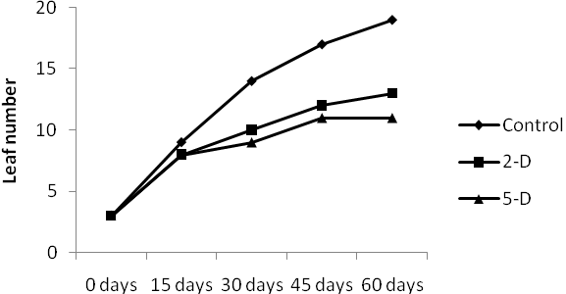
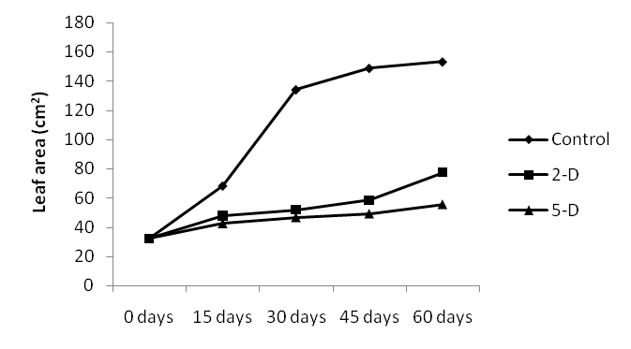
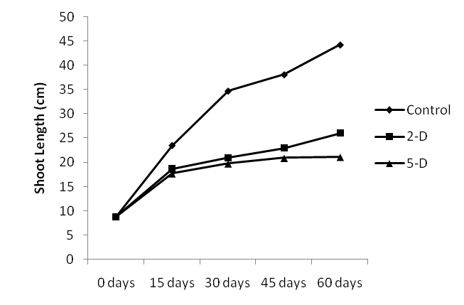
Figure 1. Changes in leaf number, leaf area and shoot length of J.curcas grown under different water regimes

Under limited supply of water plants usually develop extensive root system which prevent or postpone drought injury. But in the present study, increasing stress level also hindered root growth. However, the magnitude of reduction of root length was lower than that of shoot length. This means that the plant was able to maintain its internal root system to access soil water better. The results are in accordance with the results of Kuhns et al. (1985), Waring and Schlesinger (1985), Seiler and Cazell (1990), Pokhriyal et al. (1997), Kumari et al. (1999), where water stress caused decrease in root growth. The reduced extensibility of the root tip tissue due to hardening of the expanding cell walls might cause decline in root growth (Neumann et al. 1994). The maximum root length was recorded in daily watered plants i.e. 25.00±2.55 cm whereas minimum was recorded in plants with five day watering cycle 14.60±2.95 cm.

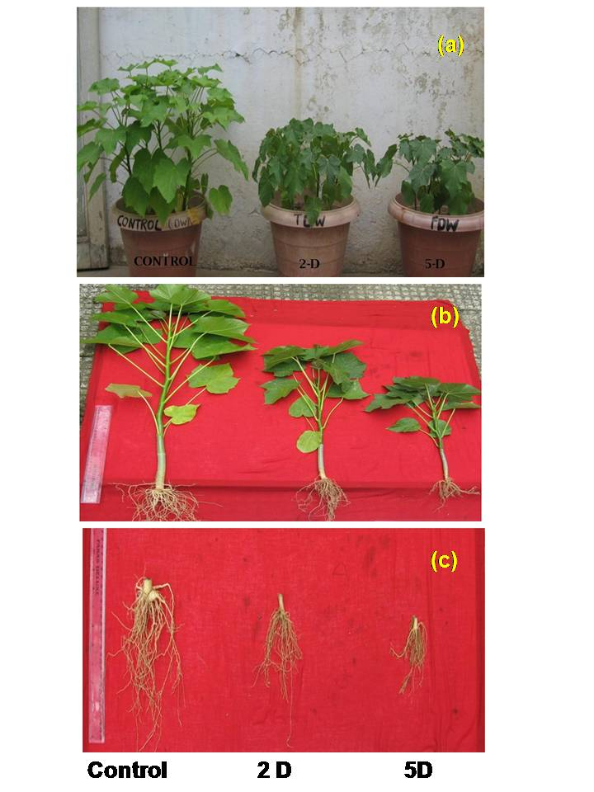

Plate 1. (a) J. curcas plants grown under different water regimes, (b) Changes in growth pattern under different water regimes, (c) Changes in root growth under different water regime

Water stress affects the soil moisture thus soil water potential and leaf water potential are also affected. Therefore, tissue water potential is the best parameter to measure water stress in studies of plant responses to water stress. Drought is a situation that lowers plant water potential and turgor to the extent that plants face difficulties in executing normal physiological functions. Water stress caused reduction in leaf water potential from -0.49 MPa in control plants to -1.95 MPa in 5-D plants. A similar trend was also recorded in case of soil water potential (Figure 2). Similar observations where water stressed plants showed lowest value of water potential have also been reported by Yadav et al. (2001) in wheat, Chartzoulakis et al.(2002) in two avocado cultivars, Klamkowski and Treder (2006) in strawberry. As the primary effect of dehydration on plants, the rapid lowering of leaf water potential is associated with relatively modest losses of water from the leaf tissue, which ultimately cause the loss of turgor. When soil water is inadequate for plant supply, the transpirational water loss reduces the water potential in the tissue. Under stress there is a reduction in turgor, leading to the narrowing of stomatal aperture and a progressive reduction in photosynthetic activity.
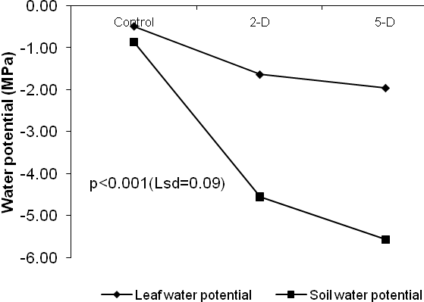
Figure 2. Effect of water stress on leaf and soil potential of J. curcas after 60 days of stress treatment

There was a reduction in whole plant fresh weight and dry weight with the increase in water stress level. Daily watered plants accumulated higher biomass than stressed plants. There was a significant difference (P<0.001) among the different water regimes in fresh and dry weight of plants (Figure 3). Decreased plant height, total fresh weight and dry weight of Trachyspermum ammi under increasing water stress level have also been reported by Azhar et al. (2011).Our results confirm the finding of Ghassemi-Golezani et al. (2008) who reported a decrease in fresh and dry biomass of Anethum graveolens under water stress condition. Since the growth is especially sensitive to water stress, this could have occurred due to impairment of cell division process: cell elongation and cell expansion (Hussain et al., 2008), as a result yields decreased noticeably even with moderate stress.

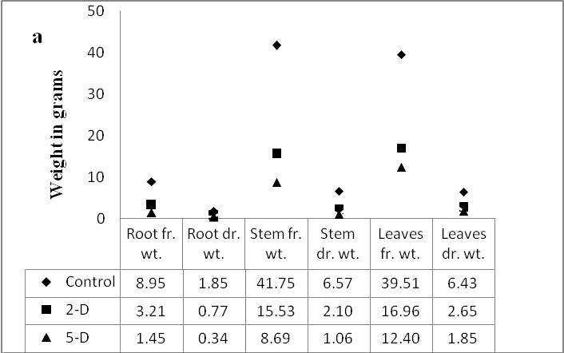
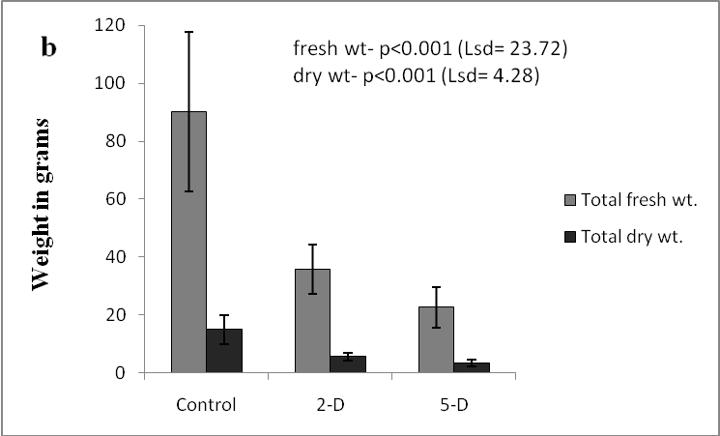
Figure 3. Effect of water regimes on (a) fresh weight and dry weight of root, stem and leaves and (b) total fresh weight and dry weight in J. curcas

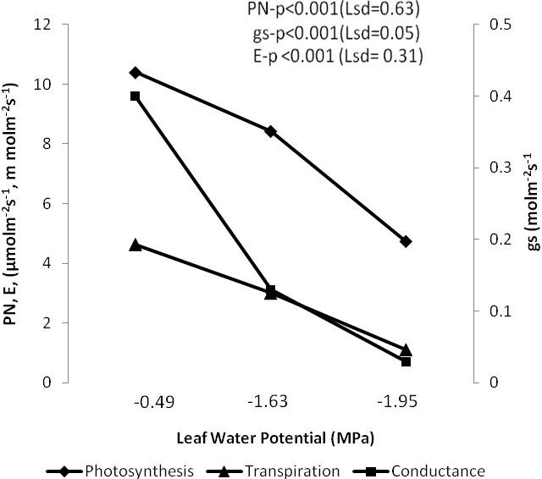
Figure 4. Variation in photosynthetic rate, conductance and transpiration with respect to variation in leaf water potential in J. curcas under different water regimes

A considerable decrease in rate of photosynthesis from 10.4 µmol m⁻² s⁻¹ in daily watered plants to 4.74 µmol m⁻² s⁻¹ in 5-D plants was recorded (Figure 4). Our results are in accordance with those of Klamkowski and Treder (2006), Yang et al. (2010) and Mokhatar et al. (2011), where photosynthesis had inverse relationship with increasing water stress. Decreased photosynthesis in water stressed plants could be due to closed stomata, decreased hill reaction or due to reduced leaves which are photosynthetically less efficient as also reported by Marani et al. (1985).
When plants are rapidly stressed stomata close very effectively and the depression of photosynthesis can be almost totally ascribed to isolation from external CO₂ supply. Boyer and Bowen (1970) reported convincing data indicating that even moderate stress on sunflower leaves inhibit the activity of Photosystem II in chloroplast fragments isolated from these leaves. The inhibition of Photosystem II in sunflower was well correlated with the inhibition of CO₂ assimilation by intact leaves for the range of leaf water potential from the beginning of to complete stomatal closure. Mohanty and Boyer (1976) found that the quantum yield of photosynthesis in intact leaves as well as Photosystem II activity in isolated chloroplast fragments were reduced by stressing the plants. These data indicate that basic aspects of light- harvesting and energy conversion were altered by stress. Like photosynthesis, transpiration and conductance rate were also higher in well watered plants than in stressed ones (Table 2). Statistical data indicated a significant effect of water stress on WUE (A/E). WUE was increased with increasing water stress level i.e. from 2.26 mmol/mol in control plants to 4.41mmol/mol in 5-D plants. Wie Hua et al. (2003) also reported an increase in WUE in Hippophae rhamnoides seedlings under drought conditions. According to Heitholt (1989) and Jensen (1976) moderate water stress could improve the WUE, but this improvement is at the cost of reduced growth. Transpiration depends upon opening and closing of guard cells. Decrease in rate of transpiration might have occurred due to lose of turgidity of guard cells under soil moisture deficit conditions causing stomatal closure. This limits the rate of CO₂ diffusion through stomates causing decline in the photosynthetic rate (Luvaha, 2005). The plants suffering with water stress are comparatively warmer than well watered plants because of reduced transpiration (Begg, 1980). Kirnak et al. (2001) reported that in egg plant water stress increased the leaf temperature upto 3-4⁰ C as compared to control plants. Similar was the case in the present study in which decrease in soil water also caused sequential decrease in the rate of transpiration which causes increase in leaf temperature.

Table 2. Effect of water stress on physiological parameters of J. curcas after 60 days of stress treatment
 | Control | 2-D | 5-D | P value | LSD
Physiological Parameters
Photosynthesis | 10.40 | 8.43 | 4.74 | <0.001 | 0.63
Conductance | 0.40 | 0.13 | 0.03 | <0.001 | 0.05
Transpiration | 4.63 | 3.01 | 1.12 | <0.001 | 0.31
Leaf Temperature | 29.89 | 31.76 | 34.00 | <0.001 | 0.30
Water Use Efficiency | 2.26 | 2.80 | 4.41 | <0.001 | 0.66

Among the different fluorescence parameters studied in J. curcas under different water regimes, the Fv/Fm, a parameter of PSІІ efficiency, in general was higher in well watered plants in comparison to stressed plants (Figure 5). Similar results were obtained by Jeyaramraja et al. (2003) who observed a clear reduction in Fv/Fm ratio with increasing soil moisture deficit, indicating a loss in the primary photochemical efficiency of the stressed leaves. The reduction of Fv/Fm must be due to the reduced efficiency of PSII apparatus and under water stress photosynthetic electron transport through PSII is inhibited (Chakir and Jenson, 1999). Hamidou et al. (2007) also reported a similar trend in cowpea and asserted that decrese in photochemical activity under water stress condition was mainly due to stomatal process.

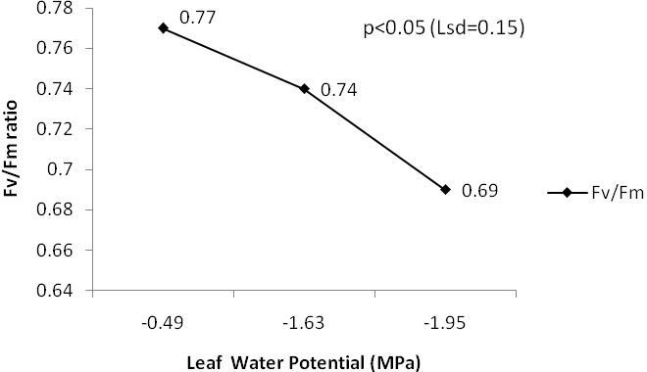
Figure 5. Changes in Fv/Fm ratio in daily watered plants (Ψ= -0.49 MPa), 2-D plants (Ψ= -1.63MPa) and 5-D plants (Ψ= -1.95 MPa)

Table 3. Correlation matrix among different parameters of J. curcas after 60 days of stress treatment
 | WR | PN | gs | E | Fv/Fm | LWP | SWP | LN | LA | SL | RL | ST
WR | 1
PN | -0.99*** | 1
Gs | -0.87** | 0.94*** | 1
E | -0.97*** | 0.99*** | 0.97*** | 1
Fv/Fm | -0.82** | 0.82** | 0.76* | 0.81** | 1
LWP | -0.83** | 0.91*** | 0.99*** | 0.94*** | 0.71* | 1
SWP | -0.83** | 0.91*** | 0.99*** | 0.94*** | 0.72* | 0.99*** | 1
LN | -0.70* | 0.77** | 0.84** | 0.80** | 0.72* | 0.81** | 0.84** | 1
LA | -0.85** | 0.92*** | 0.99*** | 0.95*** | 0.74* | 0.98*** | 0.98*** | 0.87** | 1
SL | -0.78** | 0.87** | 0.96*** | 0.90*** | 0.72* | 0.96*** | 0.97** | 0.92*** | 0.98*** | 1
RL | -0.89*** | 0.91*** | 0.85** | 0.90*** | 0.71* | 0.82** | 0.83** | 0.80** | 0.83** | 0.85** | 1
ST | -0.88*** | 0.92*** | 0.93*** | 0.93*** | 0.89*** | 0.90*** | 0.91*** | 0.88*** | 0.91*** | 0.93*** | 0.92*** | 1
Note: * = p<0.05, ** = p<0.01 ***=p<0.001 significance level, WR- water regime, PN-photosynthesis, gs-conductance, E-transpiration, LWP-leaf water potential, SWP-soil water potential, LN-leaf number, LA-leaf area, SL-shoot length, RL- root length, ST-shoot thickness

The correlation matrix among the various parameters studied was shown in table 3. The table clearly indicated that all the parameters were negatively correlated with the increasing level of water stress. However all the morpho-physiological parameters studied during the experimentation were highly and positively correlated among themselves. This showed that water stress slowed down all the morpho-physiological characters of J. curcas.
Although J. curcas is a drought tolerant plant but a close perusal of data obtained in present study indicated that imposition of even a mild water stress would lead to significant reduction in morpho-physiological attributes of J. curcas. This was evident from the differences between daily watered and water stressed plants that were of higher magnitude between 2-D and control plants than between the 2-D and 5-D plants. Such a response of a drought tolerant species to water stress could be an area of further research.

Acknowledgements:
We wish to acknowledge the help rendered by the faculty and technical staff of the HAPPRC, HNB Garhwal University, Srinagar, Uttarakhand, India

Corresponding Author:
Neha Tiwari
High Altitude Plant Physiology Research Centre
H.N.B. Garhwal University
Srinagar, Garhwal 246174, Uttarakhand, India
E-mail: neha.tiwari7@gmail.com

Author Details:
Neha Tiwari*, Mamta Purohit*, Gunjan Sharma*, A.R. Nautiyal*
Address: * High Altitude Plant Physiology Research Centre, Post Box No.- 14, HNB Garhwal University, Srinagar, Garhwal- 246174, Uttarakhand, India
E-mails: neha.tiwari7@gmail.com,
purohitmamta.6@gmail.com,
gnjnsharma86@gmail.com
arnautiyal@gmail.com

References
- Cabuslay GS, Ito O, Alejal AA. Physiological Evaluation of Response of Rice (Oryza sativa L.) to Water Deficit. Plant Sci. 2002; 63: 815-827.
- Correia MJ, Coelho D, David MM. Response to Seasonal Drought in Three Cultivars of Ceratonia siliqua, Leaf Growth and Water Relation. Tree Physiol. 2001; 21: 645-653.
- Jaleel CA, Manivannan P, Lakshmanan GMA, Gomathinayagam M, Panneerselvam R. Alterations in morphological parameters and photosynthetic pigment responses of Catharanthus roseus under soil water deficits. Colloids Surf. B: Biointerfaces. 2008c; 61: 298–303.
- Jia Y and Gray VM. Interrelationship between nitrogen supply and photosynthetic parameters Vicia faba L. Photosynthetica. 2004; 41(4): 605-610.
- Kanechi M, Kunitomo E, Inagaki N, Maekawa S. Water stress effect on ribulose1-5, biphosphate carboxylase and its relationship to photosynthesis in sunflower leaves. In: M. Mathis ed. Photosynthesis: from light to biosphere. Kluwer Academic Publisher, Dordrecht- Berlin-London. 1995; 4: 597-600.
- Baquedano F J and Castillo FJ. Comparative ecophysiological effects of drought on seedlings of the Mediterranean water- saver Pinus halepensis and water spenders Quercus coccifera and Quercus ilex. Trees- Struct. Funct. 2006; 20 (6): 689- 700.
- Mokhatar SJ, Daud NW, Zamri NM. Evaluation of different water regimes on Hevia brasiliensis grown on Haplic Ferralsol soil at nursery stage. Int. J. of Applied Sci. and Tech. 2011; 1(3): 28-33.
- Katwal RPS and Soni PL. Biofuels: an opportunity for socioeconomic development and cleaner environment. Indian For. 2003; 129: 939-949.
- Goel PK. and Trivedi RK. Chemical and Biological methods for water pollution, soil and plant analysis. Ist Ed., Published by Env. Publications, Post Box – 60, Karad. 1992.
- Evans GC. The Quantitative Analysis of Plant Growth. Blackwell Scientific publication, Oxford, 1972.
- Fischer RA and Hagan RM. Plant water relation, irrigation management and crop yield. Exp. Agric. 1965; 1: 161-177.
- Jordan WR, Brown KW, Thomas JC. Leaf age as a determinant in stomatal control of water loss from cotton during water stress. Plant Physiol. 1975; 56: 595-599.
- Hsiao TC. Plant responses to water stress. Annual Review of Plant Physiol. 1973; 24: 519- 570.
- Zhang M, Duan L, Zhai Z, Li J, Tian X, Wang B, He Z, Li Z. Effects of plant growth regulators on water deficit-induced yield loss in soybean. Proceedings of the 4th International Crop Science Congress, Brisbane, Australia. 2004.
- Wullschleger SD, Yin TM, DiFazio SP, Tschaplinski TJ, Gunter LE, Davis MF, Tuskan GA. Phenotypic variation in growth and biomass distribution for two advanced-generation pedigrees of hybrid poplar. Canadian J. For. Res. 2005; 35: 1779–178.
- Aref IM and Juhany ELI. Growth response of Acacia seyal, Acacia negrii and Acacia asak trees to water stress. J.of King Saud Univ, Agricultural Sciences. 2005; 17(2): 75-81.
- Abdalla MM and Khoshiban ENH. The Influence of Water Stress on Growth, Relative Water Content, Photosynthetic Pigments, Some Metabolic and Hormonal Contents of two Triticium aestivum cultivars. J. Appl. Sci. Res. 2007; 3(12): 2062-2074.
- Jones BM and Lazenby A. The grass crop, the physiological basis of production. Chapman and Hall, London. 1988: 226-240.
- Husain I and Aspinall D. Water stress and apical morphogenesis in barley. ANN. Bot. 1969; 33: 393-407.
- Abe H and Nakai T. Effect of the water status within a tree on tracheid morphogenesis in Cryptomeria japonica D.Don. Trees (Berl). 1999; 14:124–129.
- Kuhns MR, Garett HE, Tesky RO, Hinckly TM. Root growth of black walnut trees related to soil temperature, soil water potential and leaf water potential. For. Sci. 1985; 31:617-629.
- Waring RH and Schlesinger WH. Forest Ecosystems; Concepts and Management. Academic Press, Orlando, Florida. 1985.
- Seiler JR and Cazall BH. Influence of water stress on the physiology and growth of red spruce seedlings. Tree Physiol. 1990; 6: 69-77.
- Pokhriyal TC, Singh U, Chaukiyal SP. Effect of water stress treatments on growth parameters and nitrogenous activity of Acacia nilotica. Indian J. of Plant Physiol. 1997; 2(1): 72-74.
- Kumari Ranjitha BD, Settu A, Asha Ramadhas TK. Studies on some morpho-physiological characters in fenugreek (Trigonella) to moisture stress. Adv. Plant Sci. 1999; 12(1): 171-176.
- Neumann PM, Azaizen H, Leon D. Hardening of root cell walls: A growth inhibitory response to salinity stress. Plant Cell Envt. 1994; 17: 303-309.
- Yadav RS, Gayadin, Jaiswal AK. Morpho-physiological changes and variable yield of wheat under moisture stress conditions. Indian J. Plant Physiol. 2001; 6 (4): 390-394.
- Chartzoulakis K, Pataks A, Kofidis G, Bosabalidis A, Nastou A. Water stress affects leaf anatomy, gas exchange,water relations and growth of two avocado cultivars. Sci Horti. 2002; 95: 39-50.
- Klamkowski K and Treder W. Morphological and Physiological responses of Strawberry plants to water stress. Agric. Conspec. Sci. 2006; 71(4): 159-165.
- Azhar N, Hussain B, Ashraf MY, Abbasi KY. Water stress mediated changes in growth, physiological and secondary metabolites of Desi Ajwain (Trachyspermum ammi L.). Pak. J. Bot. 2011; 43: 15-19.
- Ghassemi-Golezani K, Andalibi B, Zehtab-Salmasi S, Saba J. Effects of water stress during vegetative and reproductive stages on seed yield and essential oil content of dill (Anethum graveolens L.). J. Food Agric. Environ. 2008; 6 (3-4): 282-284.
- Hussain M, Malik MA, Farooq M, Ashraf MY, Cheema MA. Improving drought tolerance by exogenous application of glycinebetaine and salicylic acid in sunflower. J. Agron. Crop Sci. 2008; 194: 193-199.
- Yang L, Han ZM, Yang LM, Han M. Effect of water stress on photosynthesis, biomass, and medicinal quality of Tribulus terrestri. J. Appl. Ecol. 2010; 21 (10): 2523-8.
- Marani A, Baker DN, Reddy VR, Mckinion JM. Effect of Water Stress on Canopy Senescence and Carbon Exchange Rates in Cotton. Crop Sci. 1985; 25: 798-802.
- Boyer JS and Bowen BL. Inhibition of oxygen evolution in chloroplast isolated from leaves with low water potential. Plant Physiol. 1970; 45: 612-615.
- Mohanty P and Boyer JC. Chloroplast response to low leaf water potential. IV. Quantum yield is reduced. Plant Physiol. 1976; 57:704-709. University, Kenya.
- Wei Hua G, Li Bo, Yong Mei H, Hai Xia Z, Xin Shi Z. Effect of Different water stresses on Eco- Physiological Characteristics of Hippophae rhamnoides seedlings. Acta Bot. Sin. 2003; 45 (10): 1238-1244.
- Heitholt JJ. Water Use Efficiency and dry matter distribution in nitrogen and water stressed winter wheat. Agron J.1989; 81: 464-469.
- Jensen ME. Water consumption by agricultural plant. In: Kozlowski T, ed. Water Deficit and Plant Growth. Academic Press, New York. 1976.
- Luvaha E. The effects of water deficit on the growth of mango (Mangifera indica) rootstock seedlings. M.Sc Thesis. Maseno University, Kenya. 2005.
- Begg JE. Morphological adaptations of leaves to water stress. In: NC. Turner and PJ. Kramer ed. Adaptations of plants to water and high temperature stress. Wiley and Sons, New York. 1980; 33-42.
- Kirnak H, Kaya C, Tas I, Higgs D. The influence of water deficit on vegetative growth, physiology, fruit yield and quality in eggplants. Bulg. J. Plant Physiol. 2001; 27 (3-4): 34-46.
- Jeyramraja PR, Jayakumar D, Pius PK, Raj Kumar R. Relation of altered protein expression with chlorophyll fluorescence in tea under water stress. Indian J. of Plant Physiol. (2003; 8: 214-218.
- Chakir S and Jensen M. How does Lobaria pulmoria regulate Photosystem II during progressive desiccation and osmotic water stress? A chlorophyll fluorescence study at room temperature and at 77 K. Physiol plant. 1999; 105: 257-265.
- Hamidou F, Zombre G, Braconnier S. Physiological and biochemical response of cowpea genotypes to water stress under glasshouse and field condition. J. Agron. Crop Sci. 2007; 193: 229-239.

7/26/2013

