Efficacy of Fractionated CO₂ Laser and Pulsed Dye Laser in Treatment of Keloids and Hypertrophic Scars

Bonan P.¹, Shokeir H.A.^{.2}, Emam H.M.³, Samy N.A.², Rabie A.A.³ and Abdelhamid M.F.³

¹Department of Dermatology II, University of Florence, Florence, Italy
²Department of Medical Laser Applications, Dermatology Unit, National Institute of Laser Enhanced Sciences, Cairo University, Egypt.
³Research Department of Dermatology and Venereology, National Research Center, Cairo, Egypt.
Rabie80@yahoo.com

Introduction: Keloids and hypertrophic scars are skin proliferative disorders with altered dermal matrix deposition. Although laser improves scars, a universal treatment protocol regarding laser type, dosage and number of sessions has not yet been established; in addition Laser indications and efficacy have not been fully defined. We studied the impact of laser therapies on keloids and hypertrophic scars. Methods: This study aimed to assess keloids and hypertrophic scars response to 6 sessions of combined pulsed dye laser and fractionated CO₂ laser (4 sessions of pulsed dye laser and 2 sessions of fractionated CO₂ laser). Pulsed Dye laser parameters were fluence: 6- 6.5 joules/cm², spot size: 10 millimeter and pulse duration: 0.5 millisecond. Fractionated CO₂ laser parameters were fluence: 15 Watts, spacing: 500 micrometer and dwell time: 0.7-1 millisecond. Scar textural pliability, pigmentation and vascularity were subjectively scored according to the modified Vancouver Scar Scale comparing readings before laser sessions and after the 2nd, 4th, 6th laser sessions and after follow up for 6 months. Collected data was analyzed with appropriate statistical tests. Hemoglobin, melanin and contour indices were objectively calculated. Results: Combined pulsed dye laser and fractionated CO₂ laser ameliorated (with highly statistically significance) modified Vancouver Scar Scale from 7.00±0.60 to 2.00±1.35 in keloids and from 7.13±0.99 to 1.63±0.74 in hypertrophic scars. Hemoglobin, melanin and contour indices showed amelioration with combined pulsed dye laser and fractionated CO₂ laser. Conclusion: When pulsed dye laser is associated with fractionated CO₂ laser in the treatment of keloids and hypertrophic scars, scar amelioration is achievable.
[Bonan P., Shokeir H.A., Emam H.M., Samy N.A., Rabie A. A and Abdelhamid M.F. Efficacy of Fractionated CO₂ Laser and Pulsed Dye Laser in Treatment of Keloids and Hypertrophic Scars. Nat Sci 2013;11(9):17-23]. (ISSN: 1545-0740). http://www.sciencepub.net. 4

Keywords: Fractionated CO₂ laser, Hypertrophic scars, Keloids, Microscopic treatment zones, modified Vancouver Scar Scale, Pulsed dye laser

1. Introduction
Cutaneous dermal injury eventuates in the inevitable formation of scar, which may be cosmetically acceptable or unacceptable. The reparative process involves inflammation, granulation tissue formation, and matrix remodeling resulting in variable degree of fibrosis. In some cases, exuberant fibrosis may produce disfiguring keloids and hypertrophic scars (Clark, 1993).
Keloids and hypertrophic scars have been notoriously difficult to eradicate with traditional treatments, including surgical excision, corticosteroids and continuous laser destruction, yielding either unsatisfactory results or high lesional recurrence rates (Alster and Handrick., 2000)
Over the past decade, advances in pulsed laser technology have enabled successful treatment of these lesions, giving millions of patients a new therapeutic option. Pulsed dye laser improves the textural quality, the appearance of scar erythema, also it affects the scar pliability, hypertrophy and symptoms of patient discomfort (Bouzari et al., 2007).
Fractionated CO₂ laser may represent the most popular ablative fractionated laser type. The recent development of ablative fractionated CO₂ technology represents a significant advance for scars treatment. Ablative fractionated laser in general are blamed to induce hyper pigmentation and prolong healing time when used for treatment of scars in the neck, chest and hands (Tierny and Hanke, 2009). However, Stebbins and Hanke in 2011 demonstrated that with appropriately conservative settings, ablative fractionated CO₂ laser can safely be used in off-face areas. This work aimed to study the effect of pulsed dye laser + fractionated CO₂ laser in treatment of keloids and hypertrophic scars.

2. Subjects and methods
Patient Population and setting
A total of 20 patients with keloids and hypertrophic scars underwent laser sessions, during the study period. Patients were seen, treated and followed up in Dermatology department at Salus Medical Center, Florence, Italy and National Institute of Laser Enhanced Sciences, Cairo University, Egypt. The scar duration ranged from 2 to 11 years. Demographic data collected include age, sex, location and scar duration. Outcome data include incidence of complications and number of procedures.
Study design
We conducted a prospective, before-after, study of all keloids and hypertrophic scar patients who underwent laser treatment of keloids and hypertrophic scars during a 24-month period. In this model, both keloids and hypertrophic scars were assessed before and after treatment, using modified Vancouver Scar Scale (Table 1) and a specialized camera (Cutaneous Multi Spectral Analyzator) that detects hemoglobin, melanin and contour. All patients with keloids and hypertrophic scars were treated, with no patients serving as negative, untreated, internal controls. Rather, post treatment patients were compared to pretreatment patients, to measure the effect of the intervention
.
Table 1: Modified Vancouver Scar Scale (Bowes et al, 2002).
Parameter | Rating | Description
Vascularity | 0, normal | Color closely resembles the color over the rest of one’s body.
 | 1, pink | A slight increase in local blood supply.
 | 2, red | A significant increase in local blood supply.
 | 3, purple | Excessive local blood supply.
Pigmentation | 0 | Hypopigmentation.
 | 1, normal | Color closely resembles the color over the rest of one’s body.
 | 2, | Hyperpigmentation.
Pliability | 0, normal | Normal pliability.
 | 1, supple | Flexible with minimal resistance.
 | 2, yielding | Giving way to pressure; offering moderate resistance.
 | 3, firm | Solid, inflexible unit, not easily moved, resistant to manual pressure.
 | 4, banding | Rope like tissue, does not limit the range of motion.
 | 5, contracture | Permanent shortening of scar, limit the range of motion.

Main Outcome Measures
For this study, we measured functional outcomes, as determined by a scar scale and a specialized camera. For subjective, provider-rated outcomes we used the modified Vancouver Scar Scale which is an easy-to-use method that provides measurement in 3 distinct categories: vascularity, pigmentation and pliability. For objective, patient-reported outcomes, we used Cutaneous MultiSpectral Analyzator that detects hemoglobin, melanin and contour indices. Range of scores for modified Vancouver Scar Scale varied from 0 to 10 with higher score associated with more morbidity.
Data Collection
Both the modified Vancouver Scar Scale and the Cutaneous MultiSpectral Analyzator were assessed immediately before the 1st session, after the 6th session and after 6 months follow up after 6th session. Modified Vancouver Scar Scale was determined by 2 blinded observers at the time of assessment, regarding the previous scale and type of therapy. Hemoglobin, melanin and contour indices were assessed using the Cutaneous Multi Spectral Analyzat or. Data regarding, laser type, laser setting, complications and follow up were recorded and housed in a separate, secure database.
Surgical Technique
All procedures were performed in a hospital based ambulatory surgery center. Patients underwent laser treatment with topical anesthesia only. Specific operative technique, including type of laser and range of settings, has been documented elsewhere, but overall treatment algorithm includes the following modalities:
- Vascular specific, 595-nm wavelength, pulsed dye laser photothermolysis to reduce hyperemia and improve pliability of the scar (Dermobeam 2000, DEKA, Calenzano, Italy). Typical settings include a fluence of 6-6.5 j/cm², spot size of 10 mm, pulse duration of 0.5 ms and 1 pass.
- Ablative, fractionated, 10,600 nm wavelength CO₂ laser resurfacing to correct abnormal texture, thickness, and stiffness of keloids and hypertrophic scars (SmartXide DOT; DEKA, Calenzano, Italy). Typical settings include energy per session measuring 15 Ws. Spacing was adjusted at 500 µm and dwell time at 0.7-1 ms. Only 1 pass is performed with the hand piece.
Laser treatment of keloids and hypertrophic scars begins no sooner than 2 years after injury and wound closure and continues every 4 to 6 weeks for 6 sessions (4 sessions with pulsed dye laser and 2 sessions with fractionated CO₂ laser). Wound care includes topical antibiotic ointment (fusidic acid) application twice daily for 7 days and return to work or school within 3 to 5 days after the procedure. Patients do not routinely receive preoperative antibiotic or antiviral prophylaxis, unless they are carriers of methicillin-resistant Staphylococcus aureus or have frequent outbreaks of oral herpes simplex. Post operative analgesia is accomplished with non steroidal anti inflammatory agents.
Statistical analysis
Data were analyzed using SPSS software package version 16.0 (SPSS/Windows Version 16.0, SPSS Inc., Chicago, IL, USA). Student T test, with statistical significance assigned to P values less than 0.05.

3. Results
Patient Demographics
From January 2010 to January 2012 we treated 20 patients with keloids and hypertrophic scars. The duration of keloids ranged from 2 to 9 years (4.62±2.32). The duration of hypertrophic scars ranged from 2 to 11 years (5.06±2.61). The sites involved in the keloids group patients, in order of frequency, were: the shoulder in 5 (41.6%), the neck in 3 (25%), the pre-sternal area in 3 (25%), the hand in 1 (8.4%). The sites involved in the hypertrophic scars group patients were: the forearm in 3 (37.5%), the neck in 2 (25%), the face in 2 (25%), the infra mammary area in 1 (12.5%). Mean age of keloids was 36.25±10.27 and mean age of hypertrophic scars was 41.25±7.88.
Outcome Measures
Over the course of the study modified Vancouver Scar Scale in keloids and hypertrophic scars decreased from 7.00±0.60 to 2.00±1.35 and from 7.13±0.99 to 1.63±0.74 respectively (Table 2 and 3). By analyzing the data of Cutaneous MultiSpectral Analyzator camera, the hemoglobin index of both keloids and hypertrophic scars reported a highly significant decrease from 47.58±15.93 to 7.61±4.47 and from 48.37±14.24 to 7.75±9.54 (p<0.01) respectively. Melanin index showed a highly significant decrease in both keloids and hypertrophic scars from 9.50±10 to 5.69±6.07 and from 14.81±8.82 to 8.45±5.03 (p<0.05) respectively. Contour showed a highly significant improvement in both keloids and hypertrophic scars (Figure 1 and 2).

Table 2: Modified Vancouver Scar Scale in keloid patients treated with combined pulsed dye laser and fractionated CO₂ laser.
 | 1  Before the 1st laser session | 2  After the 2nd laser session | 3  After the 4th laser session | 4  After the 6th laser session | 5  After 6 months follow up | P-value  1&5
Vascularity  mean±SD range | 2.50±0.52 | 1.83±0.39 | 1.00±0.43 | 0.42±0.51 | 0.42±0.51 | 0.000
Pigmentation mean±SD range | 1.42±0.51 | 1.42±0.51 | 1.25±0.62 | 0.92±0.67 | 0.92±0.67 | 0.007
Pliability mean±SD range | 3.08±0.51 | 2.25±0.75 | 1.50±0.52 | 0.67±0.78 | 0.67±0.78 | 0.000
Total score  mean±SD range | 7.00±0.60 | 5.50±0.80 | 3.75±0.87 | 2.00±1.35 | 2.00±1.35 | 0.000
Significant P value (<0.05) Highly significant P value (<0.01)

Table 3: Modified Vancouver Scar Scale in hypertrophic scar patients treated with combined pulsed dye laser and fractionated CO₂ laser.
 | 1  Before the 1st laser session | 2  After the 2nd laser session | 3  After the 4th laser session | 4  After the 6th laser session | 5  After 6 month follow up | P-value  1&5
Vascularity  mean±SD range | 2.50±0.53 | 1.63±0.58 | 1±0 | 0.25±0.46 | 0.25±0.46 | 0.000
Pigmentation mean±SD range | 1.63±0.52 | 1.50±0.53 | 1.50±0.53 | 1.13±0.64 | 1.13±0.64 | 0.033
Pliability mean±SD  range | 3.13±0.64 | 2.25±0.46 | 1.37±0.52 | 0.25±0.46 | 0.25±0.46 | 0.000
Total score  mean±SD range | 7.13±0.99 | 5.38±0.74 | 3.88±0.64 | 1.63±0.74 | 1.63±0.74 | 0.000
Significant P value (<0.05 Highly significant P value (<0.01)

Complications
Pulsed dye laser treatments were well tolerated. Subjects described the procedure as near painless. Immediately after treatment all subjects were noted to have purplish discoloration of the scar. No complications were noted during the course of the study. On the other hand, fractionated CO₂ laser was accompanied by post operative erythema which subsided from 3 to 6 days. Shedding of the scabs caused by fractionated CO₂ laser was seen during the 1st week after treatment and patients were reassured that this was a normal sign. We may attribute the absence of complications after the use of pulsed dye laser laser to the fair skin types of patients studied in this work (Fitzpatrick type II and III). Adequate pre and post treatment preparations of patients in the present study with sunscreens, topical retinoids, cold fomentations, and local antibiotics share in the fortunate absence of complications after both pulsed dye and fractionated CO₂ laser sessions. Histo-pathological specimens could not be harvested from patients in this study because they refused any surgical insult for fear of scar deterioration.

Figure 1: Hemoglobin (hb), melanin and contour of keloids pre, post 6 sessions of combined pulsed dye laser and fractionated CO₂ laser and after follow up of 6 months.
%

%

Figure 2: Hemoglobin (hb), melanin and contour of hypertrophic scars pre, post 6 sessions of combined pulsed dye laser and fractionated CO₂ laser and after follow up of 6 months.

Improvements of scar characters were evident in keloids and hypertrophic scars patients to variable levels. The recorded character improvement of the 2 different scar types varied according to the used laser modality (Figures 3-6).

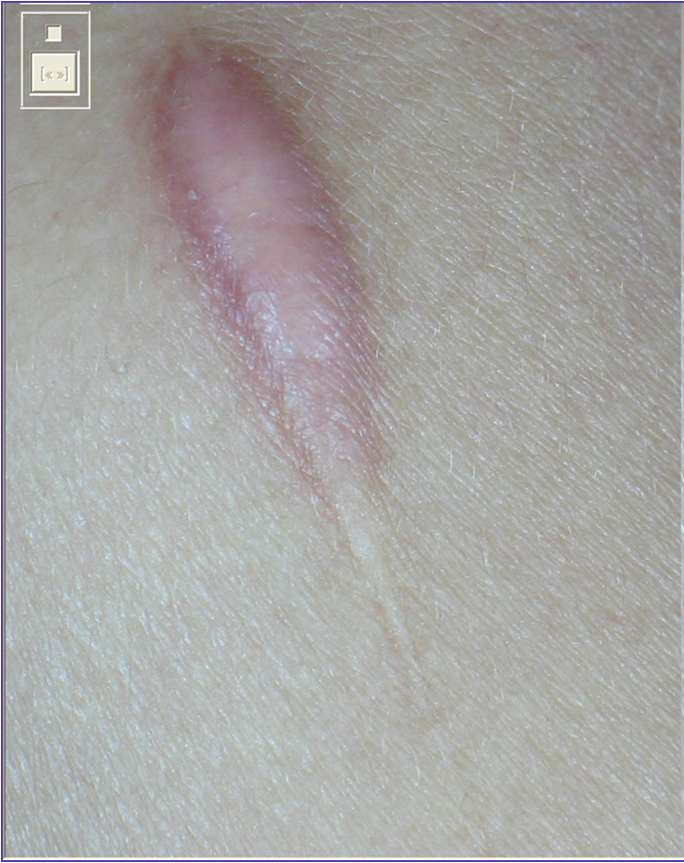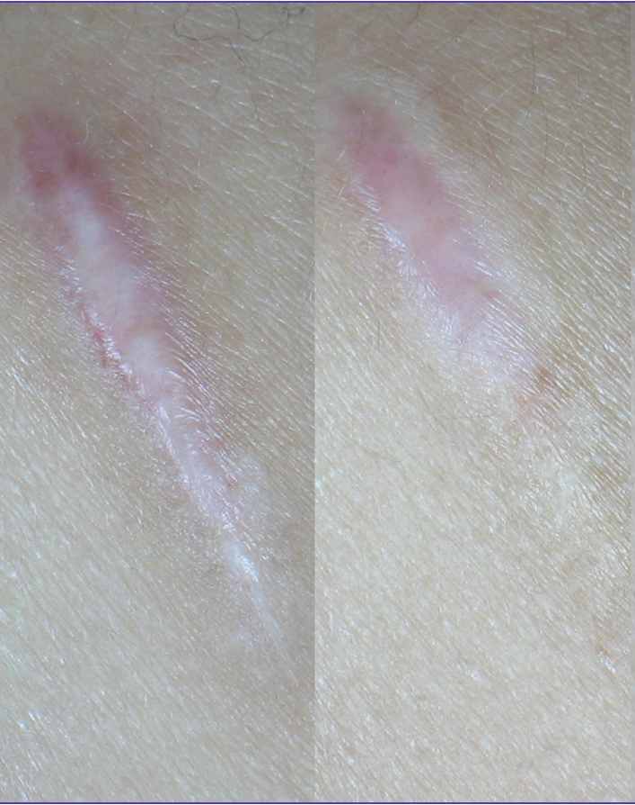
a
b
c
Figure 3: Left shoulder keloid before (a), after (b) 6 sessions of combined pulsed dye laser and fractionated CO₂ laser and after follow up of 6 months (c).
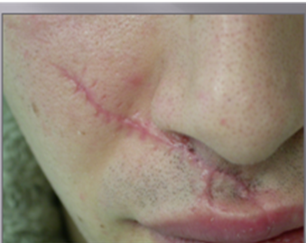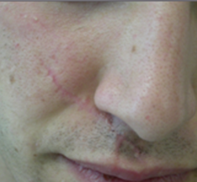
a
b
Figure 4: Right cheek and upper lip hypertrophic scar before (a) and after (b) 6 sessions of fractionated CO₂ laser.

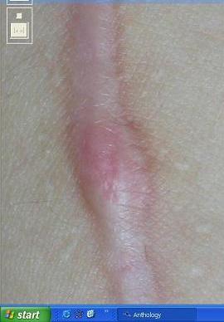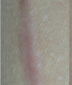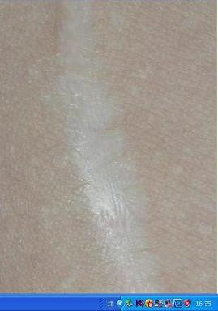
a
b
c
Figure 5: Right arm hypertrophic scar before (a), after (b) 6 sessions of combined pulsed dye laser and fractionated CO₂ laser and after follow up of 6 months (c).
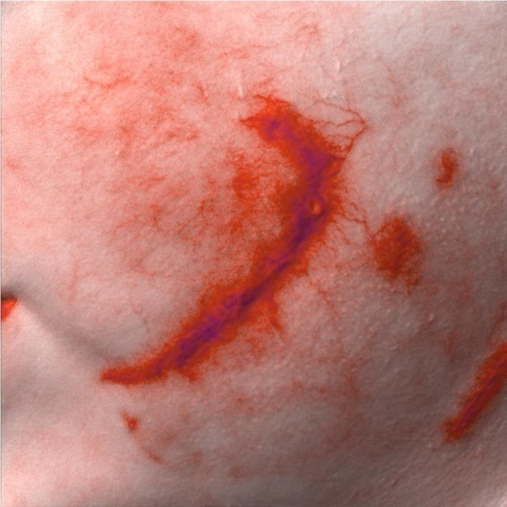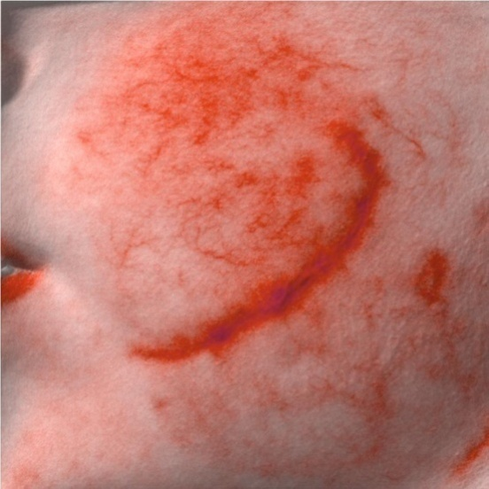
a
b
(Figure 6) Cutaneous MultiSpectral Analyzator image for left cheek hypertrophic scar before (a) and after (b) combined pulsed dye and fractionated CO₂ laser treatment showing a decrease in the hemoglobin amount.

3. Discussion
In this prospective, before-after cohort study assessing the effect of laser therapy on keloids and hypertrophic scars, we provide strong evidence that treatment with pulsed dye laser and fractionated CO₂ laser improves the objective and the subjective components of these scars, based on both the modified Vancouver Scar Scale and the Cutaneous MultiSpectral Analyzator. Within the 24 months of this study period, the modified Vancouver Scar Scale decreased significantly in both keloids and hypertrophic scars from 7.00±0.60 to 2.00±1.35 and from 7.13±0.99 to 1.63±0.74 respectively. Hemoglobin, melanin and contour indices decreased with a highly significant improvement. These results were achieved after 6 laser sessions (4 pulsed dye laser and 2 fractionated CO₂ laser sessions). We concluded that laser can be safely combined to treat keloids and hypertrophic scars and achieve nearby results of invasive surgical interference. Laser may not only complement traditional modalities of compression garments, silicone sheeting, deep massage and moisturizing agents, but these emerging technologies may also disrupt current algorithms and reset our expectations of what we can achieve, in restoring form of patients with keloids and hypertrophic scars.
In addition to improving the characteristics of keloids and hypertrophic scars, we note that laser treatments result in substantial gain in the physical components of keloids and hypertrophic scars. The improvement in keloids and hypertrophic scars continue with consecutive sessions. For this reason we recommend several sessions and guide our overall treatment plan based on the response of the patient to these laser treatments. Not only does laser therapy improve the physical aspects of keloids and hypertrophic scar, this approach may also eliminate the need for or decrease the magnitude of reconstructive surgery.
The study results showed that combined pulsed dye laser and fractionated CO₂ laser decreased total modified Vancouver Scar Scale in the keloids patients and hypertrophic scars patients from 7.00±0.60 to 2.00±1.35 and from 7.13±0.99 to 1.63 ±0.74 respectively. Martin and Collawn in 2013 combined both 7-session laser (pulsed dye laser and fractionated CO₂ laser) with triamcinolone acetonide (TAC) intra-lesional injections and reported a lighter purple color and a flatter appearance of treated keloids. In a study by Hultman et al, 2013 combined pulsed dye laser (3 to 5 sessions) and fractionated CO₂ laser (1 to 3 sessions) in treatment of burn hypertrophic scars. The interval between sessions was 6 weeks. They wrote that pulsed dye laser is useful for reducing the size and hyperemia and the fractionated CO₂ laser is useful for correcting the abnormal texture, thickness, and stiffness. Improvement in vascularity, pigmentation and pliability, was recorded. Changes in the burn hypertrophic scars were measured by the Vancouver Scar Scale that decreased from 11.3 to 5.5 after the last session. It does worth to mention here that despite the lower pulsed dye laser energy (6-6.5 vs 6-11 j/cm²) and the shorter pulse duration (0.5 vs 1.5 ms) delivered in the present study, the results were comparable.
Fractionated CO₂ laser seems to be an encouraging approach in treatment of keloids. The CO₂ laser decreases fibroblasts proliferation, increases basic fibroblast growth factor (bFGF) production (that reduces collagen synthesis) and inhibits transforming growth factor beta 1 (TGF-β1) secretion (that increases collagen synthesis) (Scrimali et al., 2012). Fractionated resurfacing may improve Hypertrophic scars through vaporization or coagulation of microscopic dermal columns and this in turn stimulates collagen production and remodeling (Hultman et al., 2012).
Pulsed dye laser affects blood vessels of keloids and hypertrophic scars through the concept of selective photothermolysis, in which the light energy emitted from pulsed dye laser, is absorbed by hemoglobin, generating heat and leading to coagulation necrosis (Liu et al., 2012). Vascular changes were also noted in pulsed dye laser irradiated tissue beginning with occlusion of the papillary vascular plexus and evolving to longitudinal rearrangement of blood vessels and cross-filling between vessels of adjacent territories (Lack and Rachel, 2004). Manuskiatti et al in 2001 reported a decrease in erythema after treating erythematous keloids segments with pulsed dye laser in laser parameters close to those used in the present study (5-7 j/cm² fluence, 0.45 msec pulse duration and 5 mm spot size). Vascularity improvement came significant in their results (p=0.03) after 5-6 sessions pulsed dye laser and came highly significant in the results of the present study (0.000) after 4 sessions Pulsed dye laser and 2 sessions fractionated CO₂ laser. Chan et al., (2004) showed a decrease in vascularity after treatment of linear erythematous hypertrophic scars with pulsed dye laser. Fractionated laser may cause microscopic thermal damage to the small blood vessel walls of the dermal vasculature under the effect of photothermolysis (Glaich et al., 2007). It does worth to mention here that we could not find published work justifiable for comparison with our study recording keloids vascularity changes after its irradiation with fractionated CO₂ laser.
In the present study after combined pulsed dye laser with fractionated CO₂ laser, improved hypertrophic scars colors: 4 red and 2 purple colored hypertrophic scars changed to normal and 2 purple hypertrophic scars changed to pink.
Pulsed dye laser 585nm targets melanin (Zelickson et al., 1999). Groover and Alster (2000) used pulsed dye laser 585 nm with fluence between 5-5.5 j/cm² with 10 mm spot size for 4 sessions. Improvement of hyper pigmentation was noticed. In the present study using pulsed dye laser and fractionated CO₂ laser 6 out of 10 hyperpigmented keloids and hypertrophic scars turned to normal color. The remaining 4 scars partially responded to the combined laser treatment showing new areas of normal color.
Alster and Handrick., (2000) reported that pulsed dye laser makes dermal collagen finer, more fibrillar, and less dense. They also claimed that ischemia from micro vascular destruction caused by laser, releases collagenase, leading to collagenolysis. They noted that dermal heat produced from blood vessels irradiated by laser can stimulate the collagen synthesis. Manuskiatti et al., (2007) used 595-nm pulsed dye laser at a fluence of 7 j/cm² and pulse duration of 0.45 ms in treatment of keloids. Patients were treated every 4 weeks for a total of 3 treatments. Improved scar softening and elasticity of segments were noticed. With the same 595-nm pulsed dye laser and very similar parameters for 4 laser sessions of pulsed dye laser and 2 sessions of fractionated CO₂ laser, the results in the present study showed significantly decreased keloids pliability from 3.08±0.52 to 0.67±0.78 and improved its contour from 2.38±0.63 to 0.71±0.29. Alster and Handrick (2000) noticed improved pliability and texture of hypertrophic scars treated with 585-nm pulsed dye laser with energy fluencies ranging from 5.5 to 7.5 j/cm² and 7-mm or 10 mm spot size. In the present study combining 595-nm pulsed dye laser with fractionated CO₂ laser showed a highly significant decrease in hypertrophic scars pliability from 3.12±0.64 to 0.25±0.46 and improved its contour from 2.01±0.68 to 0.30±0.10 (according to modified Vancouver Scar Scale).

Conclusion:
Combined pulsed dye laser and fractionated CO₂ laser is a new effective modality for treatment of both keloids and hypertrophic scars. In hypertrophic scars the combined fractionated CO₂ laser and pulsed dye laser is very good as we target both hemoglobin and collagen.

References
- Alster T.S. and Handrick C. (2000): Laser treatment of hypertrophic scars, keloids and striae. Semin. Cutan. Med. Surg.; 19(4):287–292.
- Bouzari N., Davis S.C. and Nouri K. (2007): Laser treatment of keloids and hypertrophic scars. Int. J. Dermatol.; 46(1):80–88.

Bowes L.E., Nouri K. and Berman B. (2002): Treatment of pigmented hypertrophic scars with the 585 nm pulsed dye laser and the 532 nm frequency–doubled Nd:YAG laser in the Q–switched and variable pulse modes: a comparative study. Dermatol. Surg.; 28:714–719.
- Chan H.H., Wong D.S., Ho W.S., Lam I.K., and Wei W. (2004): The use of pulsed dye laser for the prevention and treatment of hypertrophic scars in chinese persons. Dermatol. Surg.; 30:987–994.
- Clark RA. (1993): Biology of dermal wound repair. Dermatol Clin.; 11(4):647-66.
- Glaich A.S., Goldberg L.H., Dai T. and Friedman P. (2007): Fractional photothermolysis for the treatment of telangiectatic matting. a case report. J. Cosmet. Laser Ther.; 9:101–103.
- Groover and Alster (2000): Laser revision of scars and striae. Dermatol. Ther.; 13(1):50–59.
- Hultman C.S., Edkins R.E., Lee C.N., Calvert C.T. and Cairns B.A. (2012): Shine on: review of laser– and light–based therapies for the treatment of burn scars. Dermatol. Res. Pract.; (243651):19.
- Hultman C.S., Edkins R.E., Wu C., Calvert C.T. and Cairns B.A. (2013): Prospective, before–after cohort study to assess the efficacy of laser therapy on hypertrophic burn scars. Ann. Plast. Surg.; 70(5):521–526.
- Lack E.B. and Rachel J.D. (2004): Resolution of retracted scar after 585–nm pulse dye laser surgery. J. Cosmet. & Laser Ther.; 6:149–151.
- Liu A., Moy R.L., Ross E.V., Hamzavi I. and Ozog D.M. (2012): Pulsed dye laser and pulsed dye laser–mediated photodynamic therapy in the treatment of dermatologic disorders. Dermatol. Surg.; 38(3):351–366.
- Manuskiatti W., Fitzpatrick R.E and Goldman M.P. (2001): Energy density and numbers of treatment affect response of keloidal and hypertrophic sternotomy scars to the 585–nm flash lamp–pumped pulsed–dye laser. J. Am. Acad. Dermatol.; 45(4):557–565.
- Manuskiatti W., Wanitphakdeedecha R. and Fitzpatrick R. (2007): Effect of pulse width of a 595–nm flash lamp–pumped pulsed dye laser on the treatment response of keloidal and hypertrophic sternotomy scars. Dermatol. Surg.; 33:152–161.
- Martin M.S. and Collawn S.S. (2013): Combination treatment of CO₂ fractional laser, pulsed dye laser and triamcinolone acetoninde injection for refractory keloid scars on the upper back. J. Cosmet. Laser Ther. 2013 Mar 1. PMID: 23452175.
- Scrimali L., Lomeo G., Tamburino S., Catalani A. and Perrotta R. (2012): Laser CO₂ versus radiotherapy in treatment of keloid scars. J. Cosmet. Laser Ther.; 14:94–97.
- Stebbins W.G. and Hanke C.W. (2011): Ablative fractional CO₂ resurfacing for photoaging of the hands: pilot study of 10 patients. Dermatol. Ther.; 24(1):62–70.
- Tierney E.P. and Hanke C.W. (2009): Ablative fractionated CO₂ laser resurfacing for the neck: prospective study and review of the literature. J. Drugs Dermatol.; 8(8):723–731.
- Zelickson B.D., Kilmer S.L., Bernstein E., Chotzen V.A., Dock J., Mehregan D. and Coles C. (1999): Pulsed dye laser therapy for sun damaged skin. Lasers Surg. Med.; 25(3):229–236.

6/25/2013

