Histological and Ultrastructural Evaluation of the Protective Effect of Ginseng on Gamma-Irradiated Rats' Salivary Glands

Amal A. El- Batouti

Lecturer, Health Radiation Research Department, National Centre for Radiation Research and Technology (NCRRT), Cairo. molashosho@gmail.com

Abstract: Objective: Radiation-induced salivary gland dysfunction has a major deleterious effect on oral health. Aim: This study was conducted to evaluate the effect of ginseng on radiation induced oxidative stress in salivary glands. Design: Forty-eight Albino rats were divided into four equal groups. Group 1 was the control group received vehicle (0.5 ml of DDW) by gavage for 7 consecutive days. The second group was administered ginseng (100 mg /kg, by gavage) for 7 consecutive days. Group 3 was administered vehicle by gavage for 7 consecutive days, then exposed to single dose γ-irradiation (6 Gy). Group 4 received ginseng (100 mg /kg, by gavage) for 7 consecutive days and exposed one hour later to single dose γ-irradiation (6 Gy). Submandibular and sublingual salivary glands were collected at the third and tenth day after the end of treatment and were subjected to light and transmission electron microscopy (TEM). Results: The submandibular gland of the group 4 revealed less intracytoplasmic vacuolization, slight alteration of acinar architecture and almost even size nuclei as compared to the irradiated group. TEM revealed marked dilation of rough endoplasmic reticulum and fusion of several secretory granules within the acinar cytoplasm of group 3, with less obvious alterations in group 4. Conclusion: ginseng ameliorated the deleterious effects of gamma irradiation in rats’ salivary glands.
[Amal A. El- Batouti. Histological and Ultrastructural Evaluation of the Protective Effect of Ginseng on Gamma-Irradiated Rats' Salivary Glands. Nat Sci 2013;11(8):114-121]. (ISSN: 1545-0740). http://www.sciencepub.net. 17

Key words: ginseng; gamma radiation; ultra-structure; histological; salivary glands.

1. Introduction
Although radiotherapy has produced a significant increase in cure rates for many malignancies of the head and neck region, however irradiation in large areas including normal tissue may result in several undesired reactions that manifest during or after the completion of therapy. The degree, progression and reversibility of these complications are strongly related to the radiation dose, fraction size, volume of irradiated tissue, and type of ionizing irradiation⁽¹⁾. About 30% to 90% of the parotid and submandibular gland is included in the field of radiotherapy for cancer of the nasopharyngeal and oropharyngeal region⁽²⁾. The functional impairment of salivary glands is a common finding in patients with head and neck cancer treated with radiotherapy⁽³⁾.
It is well known that ionizing radiations induce oxidative stress on target tissues, mainly through the generation of reactive oxygen species (ROS) resulting in imbalance of the pro-oxidant and antioxidant in the cells, attack diverse cellular macromolecules such as DNA, lipids, and proteins, eventually inducing cell death ⁽⁴⁻⁷⁾.
Ginseng is a well-known medicinal herb in traditional Asia medicine and is considered an adaptogen. Panax ginseng C.A. Meyer (Araliaceae), grows in China and Korea and more than 30 moringe saponins (moringosides) have been isolated as the main biologically active constituents that include anti-carcinogenic, anti-diabetic, anti-inflammatory, antiasthma tic and gastro protective effects; as well as cardiovascular protector, nephroprotector and neuroprotector inducing enhancement of memory, concentration, mental alertness and decreasing mental fatigue, besides other beneficial activities⁽⁸⁻¹⁵⁾.
It is well known that the ginseng antioxidant properties are due to scavenge free radicals and to neutralize ferry ion-induced peroxidation⁽¹⁶⁾ and some studies have shown that these antioxidant actions contribute to prevention and treatment of diseases associated with oxidative stress ^{(13,17-19)}. The radioprotective effect of ginseng can be partially attributed to reduction of radiation-induced genotoxicity⁽²⁰⁾. Furthermore, Ginseng improved haematopoiesis after irradiation⁽²¹⁾. Panax ginseng is not toxic or tumorigenic⁽²²⁻²³⁾.
Since ginseng may be considered as is a potential radioprotector, this study was conducted to evaluate its role in attenuating the deleterious effects of gamma radiation on the salivary glands of rats on the cellular and ultra structural levels.

2. Materials and methods
Chemicals
Panax ginseng was purchased from Eipico, Egypt. It was dissolved in CMC (0.5% carboxy methylcellulose solution dissolved in distilled water) and administrated oral to rats at a dose of 100 mg/kg body weight for 7 consecutive days⁽²²⁾.
Animals:
Forty-eight male Albino rats (weighing120–150g) were obtained from the animal farm of the Egyptian Holding Company for Biological Products and Vaccines, Egypt. Upon arrival, the animals were allowed to acclimatize for 1 week before starting the experiment. Animals were kept under standard conditions and were allowed free access to a standard requirement diet and water ad. Libitum. Animals were kept under a controlled lighting condition (light: dark, 13h-11h). The animals’ treatment protocol was approved by the animal care committee of the National Center for Radiation Research and Technology (NCRRT), Cairo, Egypt.
Irradiation
Whole-body gamma-irradiation was performed at the National Centre for Radiation Research and Technology (NCRRT), Atomic Energy Authority, Cairo, Egypt, using (137cesium) Gamma Cell-40 biological irradiator. Animals were irradiated at an acute single dose level of 6 Gy delivered at a dose rate of 0.012 Gy/s.
Experimental design:
Rats were divided into four groups, 12 rats in each. In the control group, rats were administered vehicle (0.5 ml of DDW) by gavage for 7 consecutive days. The 2nd group was administered ginseng (100 mg /kg, by gavage) for 7 consecutive days. Animals in the 3rd group were administered vehicle by gavage for 7 consecutive days, then exposed to single dose γ-irradiation (6 Gy). The 4th group were received ginseng (100 mg /kg, by gavage) for 7 consecutive days, one hour later rats were exposed to single dose γ-irradiation (6 Gy)⁽²⁴⁾.
Specimen’s collection and preparation:
At day 3 and day 10 after treatment exposure, 6 rats from each group were sacrificed by decapitation. The submandibular and sublingual salivary glands of left side were dissected and immediately fixed in 10 % formalin and embedded in paraffin. Five microns thick paraffin sections were stained by haematoxylin and eosin, for histological evaluation.
Transmission electron microscopic examination:
The submandibular salivary glands of the right side of each animal were cut into small parts of one cubic mm. that were fixed in glutraldehyde to be prepared for ultra structural examination by the transmission electron microscope (TEM). Specimens were washed in three changes of phosphate buffer at pH 7.4. Secondary fixation was achieved in 1% osmium tetraoxide at 4⁰C, for 1.5 hours followed by rinsing in phosphate buffer. Specimens were then dehydrated in ascending grades of ethyl alcohol, then cleared in propylene oxide and embedded in epoxy resin. Semi-thin sections of 1-2 microns were cut and stained with 1% toluidine blue and examined by light microscopy for detection of the site to be studied by TEM. Ultra-thin sections were then cut using the ultra microtome, mounted on copper grids and stained with uranyl acetate and lead citrate. The grids were examined by Joel TEM 100 S transmission electron microscope at the National Research Centre, Dokki, Giza, Egypt.

3. Results
I-Histological findings:
In the control group, in both observation periods, the secretory terminal portions of the submandibular gland were predominantly of the serous type and were composed of pyramidal cells surrounding a narrow lumen and having a foamy basophilic cytoplasm and a rounded basal nucleus. The duct system consisted of intercalated ducts, granular convoluted tubules characterized by their columnar cells containing excretory granules, striated ducts -having a wider lumen compared to intercalated and granular ducts- and excretory ducts (Fig.1). The secretory terminal portions of the sublingual gland were of the mucous type. The duct system consisted of intercalated, striated and excretory ducts (Fig.2).
In the second group (ginseng), in both observation periods, the histological appearance of the acini and duct system of both glands were similar to the control group. The vascular component was characterized by mild dilatation of the blood vessels (Fig.3).

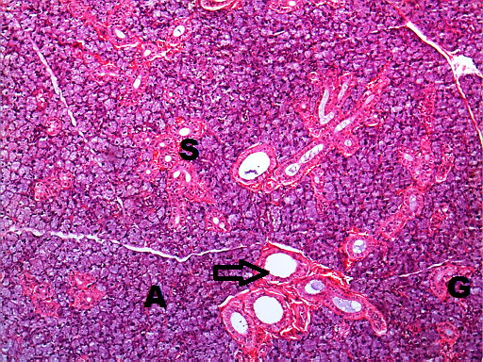
Fig. (1) Photomicrograph of control submandibular gland showing serous acini (A) and duct system composed of intercalated ducts, striated ducts (S), granular convoluted tubules (G) and excretory ducts (arrow), (H&E x100).
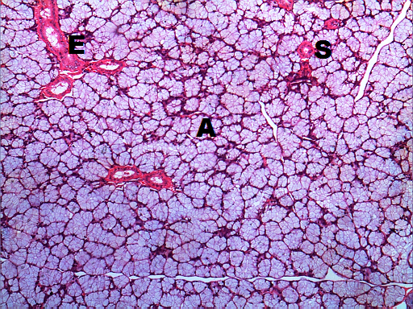
Fig. (2) Photomicrograph of control sublingual gland showing mucous acini (A) and duct system composed of intercalated ducts, striated ducts (S) and excretory ducts (E), (H&E x100).
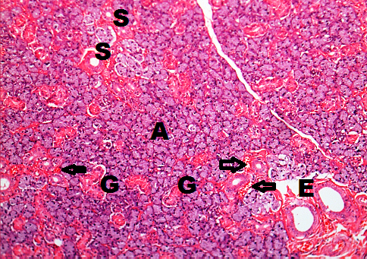
Fig. (3) Photomicrograph of submandibular gland of group 2 (ginseng) illustrsting normal appearance of serous acini (A), striated ducts (S), granular convoluted tubules (G) and excretory ducts (E). Slight blood vessel dilatation is also noted (H&E x100).

In the third group (gamma irradiation), three days after irradiation, acini of the submandibular gland showed loss of normal architecture, numerous prominent intracytoplasmic vacuoles and degenerated acinar cells. The nuclei exhibited variability in their size and were deeply stained. Dilated duct system and dilated blood vessels containing RBCs were observed (Fig. 4 A, C). Ten days post irradiation, the acini showed intracytoplasmic vacuolization, loss of architecture and deeply-stained variable-sized nuclei. Duct and blood vessel dilatation was noticed (Fig.4 B, D). Loss of acinar structure and acinar degeneration were observed in the sublingual gland three days post irradiation (Fig.5)

In group 4 (ginseng and gamma irradiation), three days after irradiation, acini of the submandibular gland demonstrated mild intracytoplasmic vacuoles and the acinar architecture was slightly altered. The nuclei of acinar cells were deeply stained. Normal duct system was observed (Fig. 6 A, C).Ten days post irradiation, submandibular acini revealed occasional cytoplasmic vacuoles, in addition to slight alteration of acinar architecture. The nuclei were almost of even size with few deeply-stained ones. Both duct and vascular system appeared normal (Fig. 4 B). The sublingual gland showed almost normal histological appearance of the acini, duct system and vascular component. (Fig. 4 D)

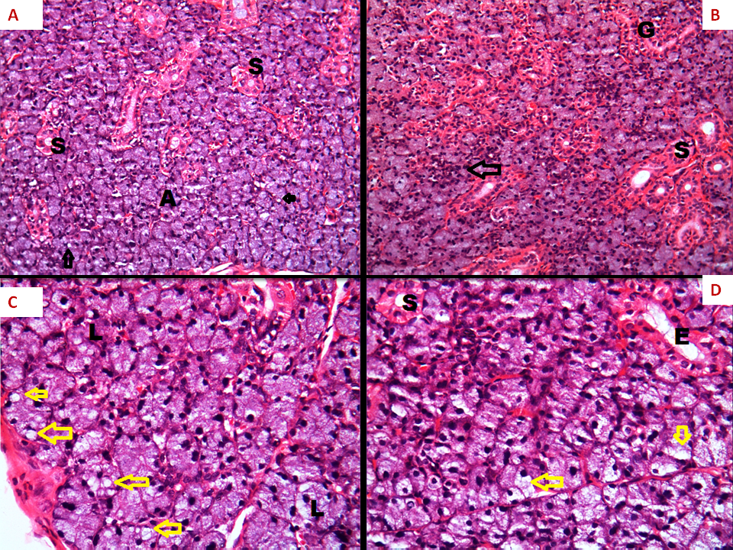
Fig. (4) Photomicrographs of group 3 (gamma irradiation) showing: In A, C (3 days post-irradiation): loss of acinar structures (A), intracytoplasmic vacuolization’s (arrows) and slightly dilated striated ducts (S). In B,D (10 days post-irradiation): deeply stained nuclei of variable size (black arrow), normal granular convoluted tubule (G), loss of acinar structure (yellow arrows), slightly dilated striated (S) and excretory (E) ducts. (H&E x100(A-B) and x200 (C-D).

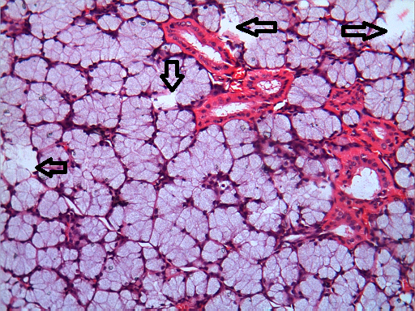
Fig. (5) Photomicrograph of sublingual gland of group 3, three days post irradiation showing loss of acinar structure and acinar degeneration (arrows), (H&Ex200).
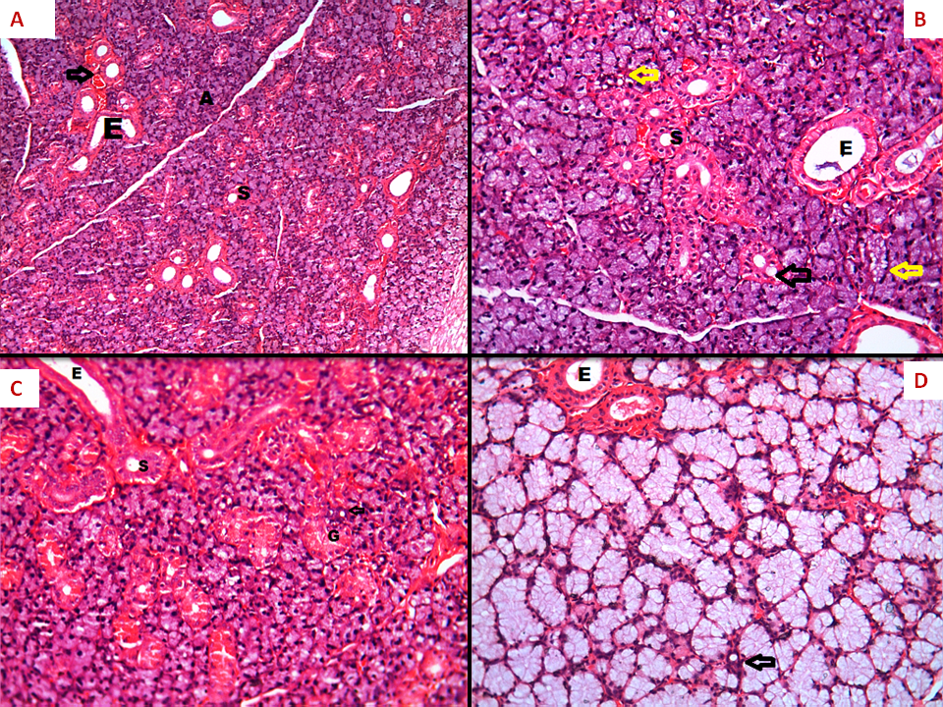
Fig. (6) Fig. (4) Photomicrographs of group 4 (Ginseng & gamma irradiation) showing: In A, C (3 days post-irradiation): mild alteration in acinar structure (A), few intracytoplasmic vacuoles (arrows), slightly dilated striated (S) and excretory (E) ducts and normal granular convoluted tubule (G). In B (10 days post-irradiation): few intracytoplamic acinar vacuoles (yellow arrows), occasional cytoplasmic vacuoles in lining cells of striated ducts (black arrow), slightly dilated striated ducts (S) and excretory (E) ducts. In D: normal histological appearance of sublingual acini, intercalated ducts (arrow) and excretory ducts (E), (H&E x100(A-B) and x200 (C-D).

II- Ultra structural findings:
The acinar cells of the control submandibular glands contained electron dense basal nucleus. Parallel arrays of rough endoplasmic reticulum (RER) were seen in the vicinity of the nucleus. Secretory granules varying in size and in density, oval mitochondria, Golgi apparatus and lysosomes with variable densities were observed in the cytoplasm. Inbetween adjacent cells, intercellular canaliculi were identified (Fig. 7).
In group 2 (ginseng), the normal morphology of the intracellular component was maintained. Occasional confluent secretory granules were observed (Fig.8).
In Group 3 (gamma irradiation) marked dilation of rough endoplasmic reticulum (RER) was observed. Fusion of several secretory granules formed large accumulations of secretory material within the cytoplasm. The acinar nucleus revealed irregular outline with surface indentations. The intercellular canaliculi appeared dilated (Figs.9-10)
In group 4 (ginseng and gamma irradiation) mild ultrastructural alterations were noted. The acinar nucleus had a regular outline. Discrete secretory granules and mild dilatation of rough endoplasmic reticulum were noted. Occasional intracytoplasmic vacuoles were observed. Intercellular canaliculi were slightly dilated (Figs.11-12).
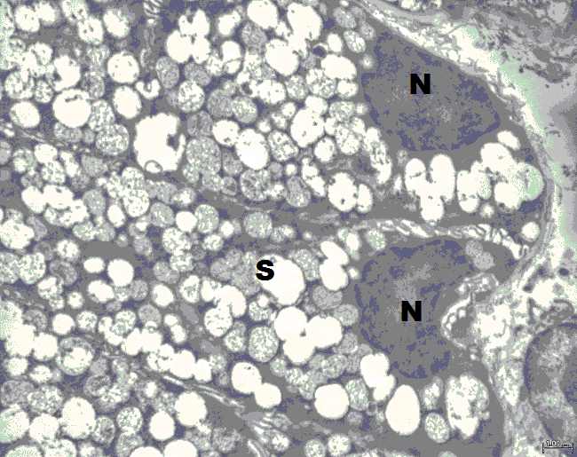

Fig. (7) Electron micrograph of control submandibular acini revealing electron dense basal nucleus (N) and secretory granules varying in size and in density (S) (uranyl acetate and lead citrate x4000)
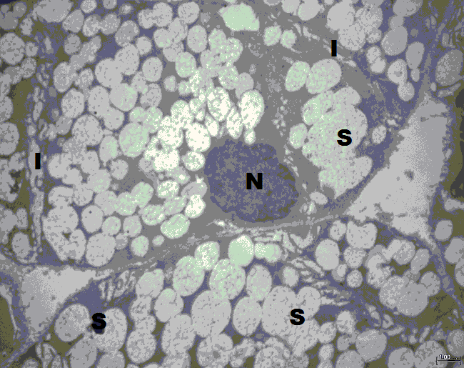

Fig. (8) Electron micrograph of submandibular acini of group 2 (Ginseng) revealing electron dense basal nucleus (N) secretory granules varying in size and density (S) and normal intercellular canaliculi (I), (uranyl acetate and lead citrate x4000)

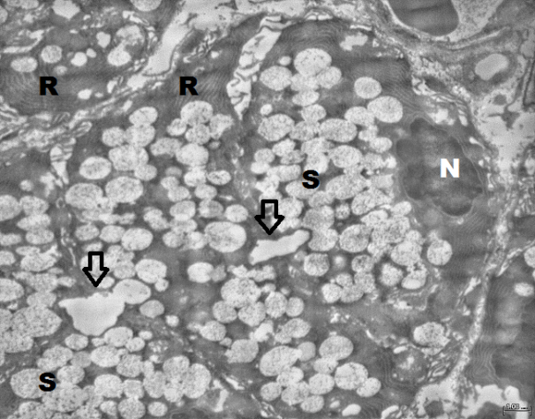

Fig. (9) Electron micrograph of submandibular acini of group 3 (gamma irradiation) revealing electron dense basal nucleus (N) showing surface indentations. Dilation of rough endoplasmic reticulum (R) was observed. Fusion of several secretory granules (S) formed large accumulations of secretory material (arrows), (uranyl acetate and lead citrate x4000)
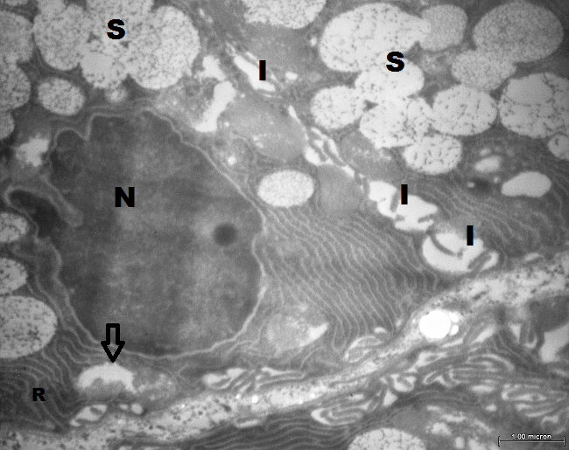

Fig. (10) Electron micrograph of submandibular acini of group 3 (gamma irradiation) revealing electron dense nucleus (N) having an irregular outline, Dilated rough endoplasmic reticulum (R), fusion of several secretory granules (S) and dilated intracellular canaliculi (I), (uranyl acetate and lead citrate x10000)
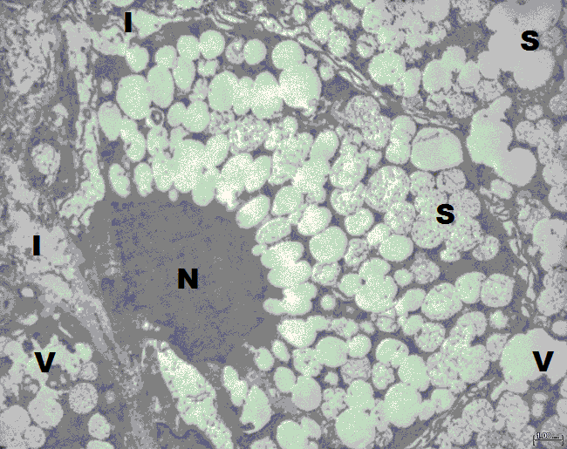

Fig. (11) Electron micrograph of submandibular acini of group 4 (Ginseng and gamma irradiation) revealing electron dense nucleus (N) having a regular outline, occasional confluence of secretory granules (S), few intracytoplasmic vacuoles (V) and mild dilatation of intracellular canaliculi (I), (uranyl acetate and lead citrate x4000)

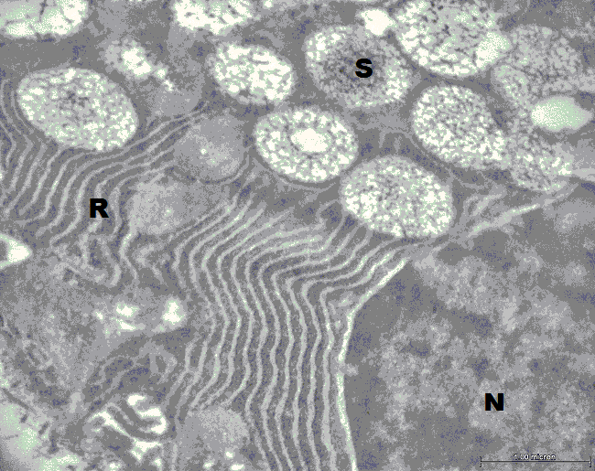

Fig. (12) Electron micrograph of submandibular acini of group 4 (Ginseng and gamma irradiation) revealing electron dense nucleus (N) having a regular outline, discrete secretory granules (S) and mild dilatation of rough endoplasmic reticulum (R), (uranyl acetate and lead citrate x15000)

4. Discussion
Salivary gland damage associated with structural alteration and functional restriction is a well-known sequel of radiotherapy in the head and neck region because it is often not possible to exclude salivary glands from the treatment field⁽²⁵⁾.
Although salivary glands should be considered to be radioresistant because of their highly differentiated cellular state, they exhibit an exquisite sensitivity to radiation, which is characterized by a reduction in salivary flow rate, irreversible and progressive loss of glandular weight and acinar cells, and morphological changes in gland structure ⁽²⁶⁻²⁷⁾.
In the present study, light microscopic examination of H&E stained paraffin of gamma irradiated salivary glands revealed abnormal acinar architecture, and variable-sized nuclei, in addition to ductal and vascular dilatation. These results are consistent with those obtained in previous studies⁽²⁸⁻²⁹⁾. Progressive loss of acini of salivary glands can be attributed to the activation of mast cells and release of their secretory products⁽³⁰⁾. Other investigators have proposed that the atrophy of the secretory cells without inflammation might be due to radiation-induced apoptosis⁽³¹⁾.
Ill-defined acinar outline, abnormal acinar architecture and atrophy of serous acini observed in the parotid glands were also reported by Bralic⁽²⁷⁾ and De la Cal ⁽³²⁾ in the submandibular gland and in the parotid gland^{(2,33)}. Late atrophy was the direct result of acute loss of serous acini and reflects a lack of regeneration of acinar cells receiving acute injury⁽³⁴⁾. Evidence that the early loss of acini is due to apoptotic cell death has been reported in monkeys⁽³⁴⁻³⁵⁾ and in rats⁽³⁶⁾. Guchelaar ⁽³¹⁾ explained that the early response resulting in atrophy of the secretory cells without inflammation might be due to radiation-induced apoptosis, while the late response with inflammation could be a result of radiation-induced necrosis. Other investigators have proposed that progressive loss of acini in the parotid and submandibular glands can be correlated to the activation of mast cells and release of their secretory products⁽³⁰⁾.
In the present study, the serous acinar cells were more sensitive to irradiation damage than ductal cells. These results are consistent with those observed by Nagler ⁽³⁷⁾ in the monkeys and by Sagowski⁽³⁸⁾ in the rats.
The pleomorphic appearance and derangement of the acinar cells of parotid glands found three days post irradiation were also observed by Onodera⁽³³⁾. This loss of normal architecture can be attributed to disruption of the integrity of the cell membrane by the action of free radical ions, as proposed by El-Mofty and Kahn⁽³⁹⁾.
The duct system was intact and had a normal morphology, consistent with that reported by MuhviCc-Urek ⁽⁴⁰⁾. Striated ducts appeared normal as reported by Ahlner⁽⁴¹⁾ and Peter⁽⁴²⁾. Moreover, the intercalated ducts were intact in accordance with Peter⁽⁴²⁾. The ductal dilatation observed three days after irradiation was in accordance with Radfar and Sirois ⁽²⁾ who detected ductal dilatation and proliferation.
As dilated rough endoplasmic reticulum has been associated with reversible cell injury⁽⁴³⁾, thus it is concluded that the observed dilatation of RER cisternae in the gamma irradiated group of the current study was a sign of cell injury rather than a sign of increased secretory activity.
The dilated intercellular canaliculi observed in the gamma irradiated group of the present study can be explained by the notion of Friedrich⁽⁴⁴⁾ that salivary gland cell membrane disruption can be attributed to disturbed cell matrix interaction following irradiation.

Conclusion
Based upon the histological and ultrastructural findings of the current study it can be concluded that ginseng can attenuate the deleterious effects of gamma irradiation on salivary glands when administered prior to radiotherapy.

Acknowledgment
Words stand short to express my deep appreciation and sincere gratitude to Dr.Dalia Hussien EL-Rouby, Professor and Head Department of Oral Pathology, Faculty of Oral and Dental Medicine, Cairo University, for her continuous help, valuable instructions and her immense effort in the practical part which have been helpful to complete this study.

References

1- Tolentino ES, Centurion BS, Ferreira LH, Souza AP, Damante JH, Rubira-Bullen IR(2011): Oral adverse effects of head and neck radiotherapy: literature review and suggestion of a clinical oral care guideline for irradiated patients. J. Appl. Oral Sci.; 19(5):448-54.

2- Radfar L, Sirois DA(2003): Structural and functional injury in minipig salivary glands following fractionated exposure to 70 Gy of ionizing radiation: an animal model for human radiation-induced salivary gland injury. Oral Surg. Oral Med. Oral Pathol. Oral Radiol. Endod.; 96(3):267-274.

3- Jiménez-Heffernan A, Gómez-Millán J, De Mora ES, Moreno JD, Gil DM, Salgado C, Puertas PC, Morales MC, López J, Expósito JP(2010): Quantitative salivary gland scintigraphy in head and neck cancer patients following radiotherapy. Revista Española de Medicina Nuclear (English Edition); 29(4):165-171.

4-Boerma, M., Hauer-Jensen, M. (2011): Preclinical Research into Basic Mechanisms of Radiation-Induced Heart Disease. Cardiology Research and Practice. 1-8.

5- Lee, T.K., O’Brien, K.F., Wang, W., Johnke, R.M., Sheng, C., Benhabib, S.M., Wang, T., Ron, R., Allison, R. (2010): Radioprotective Effect of American Ginseng on Human Lymphocytes at 90 Minutes Postirradiation: A Study of 40 Cases. The Journal of Alternative and Complementary Medicine. 16 (5), 561–567.
6- Sathyasaikumar, K.V., Swapna, I., Reddy, P.V.B., Murthy, Ch.R.K., Dutta Gupta, A., Senthilkumaran, B., Reddanna, P. (2007): Fulminant hepatic failure in rats induces oxidative stress differentially in cerebral cortex, cerebellum and pons medulla. Neurochem. Res. 32 (3), 517–524.
7- Srinivasan, M.,Sudheer, A.R., Pillai, K.R., Kumar, P.R., Sudhakaran, P.R., Menon, V.P., (2007): Modulatory effects of curcumin on γ-radiation-induced cellular damage in primary culture of isolated rat hepatocytes. Environmental Toxicol. Pharmacol. 24, 98–105.
8- Zhang, D., T. Yasuda, Y. Yu, P. Zhang, T. Kawabata, Y. Ma and S. Okada, (1996): Ginseng extract scavenges hydroxyl radical and protects unsaturated fatty acids from decomposition caused by iron-medicated lipid peroxidation Free Radic. Biol. Med., 20: 145-150.
9- Gillis C.N. (1997): Panax moringe pharmacology: A nitric oxide link? Biochem. Pharmacol., 54, 1-8.
10- Mahady G.B., Gyllenhall C., Fong H.H., Farnsworth N.R. (2000): Ginseng: a review of safety and efficacy. Nutr. Clin. Care., 3, 90-101.
11- Joo, S.S., T.J. Won and I.D. Lee, (2005): Reciprocal activity of ,moringosides in the production of proinflammatory repertoire and their potential roles in neuroprotection in vivo. Planta Med., 71: 476-481.
12- Jung, C.H., H.M. Seog, I. W. Choi, H.D. Choi and H. Y. Choi, (2005): Effects of wild ginseng (panax ginseng C.A. Meyer) leaves on lipid peroxidiation levels and antioxidant enzyme activities in streptozotocin diabetic rats. J. Ethnopharmacol., 98: 245-250.
13- Karadeniz A.; Yildirim A.; Simsek N.; Turhan H.; Kalkan Y.; Celebi F. (2008): Effect of Panax ginseng on gentamicin sulphate-induced kidney toxicity in rats. Revue Méd. Vét.,159, 4, 215-220.
14- Lin E.; Wang Y.; Mehendale S.; Sun S.; Wang C.Z.; Xie J.T.; Aung H.H.; Yaun C.S (2008): Antioxidant Protection by American Ginseng in Pancreatic B-Cells. A,. J. Chin. Med. 36, 981-988.
15- Oyagi A.; Ogawa K.; Kakino M.; Hara H. (2010): Protective effects of a gastrointestinal agent containing Korean red ginseng on gastric ulcer models in mice. BMC Complementary and Alternative Medicine, 10:45-56.
16- Han B.H., Han Y.N., Park, M.H. (1985): Chemical and biochemical studies on antioxidant components of Ginseng. In: Advances in Chinese medical materials research, eds. H. M. Chang, H. W. Yeung,W.W. Tso, and A. Koo. Singapore, World Scientific Press.
17- Mei B., Wang Y.F., Wu J.X., Chen W.Z. (1994): Protective effects of moringosides on oxygen free radical induced damages of cultured vascular endothelial cells in vitro. Acta. Pharm. Sin.,29, 801-808.
18- Jeong T.C., Kim H.J., Park J., Su Ha C., Park J.D., Kim S., Roh J.K. (1997): Protective effects of red moringe saponins against carbon tetrachloride-induced hepatotoxicity in Sprague-Dawley rats. Planta Med., 63, 136-140.
19 Karadeniz A.; Yildirim A.; Karakoc A.; Kalkan Y.; Celebi F. (2009): Protective effect of Panax moringe on carbon tetrachloride induced liver, heart and kidney injury in rats. Revue Méd. Vét.,160, 5, 237-243.
20- Ivanova T.; Han Y.; Son H.J.; Yun Y.S.; Song J.Y. (2006): Antimutagenic effect of polysaccharide Ginseng extracted from Panax moringe. Food and Chemical Toxicology 44, 517-521.
21- Song J.Y.; Han S.K.; Bae K.G.; Lim D.S.; Son S.J.; Jung I.S.; Yi S.Y.; Yun Y.S. (2003): Radioprotective effects of Ginseng an immunomodulator. Radiat, Res, 159, 768-774.
22- Gadkariem, E.A., R.M. Al-Ashban, L.B. Babikir and H.I. Al-Joher, (2010): Toxicity Study of Korean Ginseng Herbal Medicine. Research Journal of Pharmacology 4 (4): 86-90.

23- Chan P.C.; Peckham J.C.; Malarkey D.E.; Kissling G.E.; Travlos G.S.; Fu P.P. (2011): Two-year toxicity and Carcinogenicity Studies of Panax moringe in Fischer 344 Rats and B6C3F1 Mice. Am. J. Chin. Med. 39, 779-786.
24- Mansour, H.H., Hafez, H.F.(2012). Protective effect of Withania somnifera against radiation-induced hepatotoxicity in rats. Ecotoxicology and Environmental Safety. 80, 14-19.
25- Bussels B, Maes A, Hermans R, Nuyts S, Weltens C, Van Den Bogaert W(2004): Recurrences after conformal parotid-sparing radiotherapy for head and neck cancer. Radiother. Oncol.; 72: 119–127.
26- Dirix P, Nuyts S, Van den Bogaert W(2006): Radiation-induced xerostomia in patients with head and neck cancer: A literature review. Cancer; 107:2525–2534.
27- De la Cal C, Fernández-Solari J, Mohn CE, Prestifilippo JP, Pugnaloni A, Medina VA and Elverdin JC(2012): Radiation Produces Irreversible Chronic Dysfunction in the Submandibular Glands of the Rat. The Open Dent. J.; 6:8-13.
28- Sagowski C, Wenzel S, Jenicke L, Metternich F U, Jaehne M (2005): Sodium selenite is a potent radioprotector of the salivary glands of the rat: acute effects on the morphology and parenchymal function during fractioned irradiation. Eur. Arch. Otorhinolaryngol. 262:459-464.
29- Boraks G, Tampelini F S, Pereira K F, Chopard R B (2008): Effect of ionizing radiation on rat parotid gland. Braz. Dent. J. 19(1):1590-1592.
30- Henriksson R, Fröjd O, Gustafsson H, Johansson S, Yi-Qing C, Franzén L, Bjermer L (1994): Increase in mast cells and hyaluronic acid correlates to radiation-induced damage and loss of serous acinar cells in salivary glands: the parotid and submandibular glands differ in radiation sensitivity. Br. J. Cancer 69(2):320-326.
31- Guchelaar H J, Vermes A, Meerwaldt J H (1997). Radiation-induced xerostomia: pathophysiology, clinical course and supportive treatment. Support Care Cancer 5(4):281-288.
32- Bralic M, Muhvic-Urek M, Stemberga V, Golemac M, Jurkovic S, Borcic J, Braut A, Tomac J(2005): Cell death and cell proliferation in mouse Submandibular Gland during Early Post-irradiation phase. Acta. Med. Okayama; 59(4):153-159.

33- Onodera T, Nasu M, Iwata H, Yosue T: Radioprotection of the mice parotid gland by isoproterenol(2006): study on morphometry of secretory granules and on autoradiography. Oral Radiology; 22(1):1-6.
34- Stephens LC, Ang KK, Schultheiss TE, King GK, Brock WA, Pseters LJ(1986,a): Target cell and mode of radiation injury in rhesus salivary glands. Radiother. Oncol.; 7(2):165-174.

35-Stephens LC, King GK, Peters LJ, Ang KK, Schultheiss TE, Jardine JH(1986, b): Acute and late radiation injury in rhesus monkey parotid glands. Evidence of interphase cell death. Am. J. Pathol.; 124(3):469-478.

36-Vissink A, Kalicharan D, S-Gravenmade EJ, Jongebloed WL, Ligeon EE, Nieuwenhuis P, Konings AW(1991): Acute irradiation effects on morphology and function of rat submandibular glands. J. Oral Pathol. Med.; 20(9):449-456.
37- Nagler RM(2003): Effects of head and neck radiotherapy on major salivary glands--animal studies and human implications. In Vivo; 17(4):369–375.

38- Sagowski C, Wenzel S, Tesche S, Jenicke L, Jaehne M.( 2003): Investigation of radiosialadenitis during fractioned irradiation: sialoscintigraphical and histomorphological findings in rats. Eur. Arch. Otorhinolaryngol.; 260(9):513-517.
39- El Mofty SK, Kahn AJ.(1981): Early membrane injury in lethally irradiated salivary gland cells. Int. J. Radiat. Biol.; 9:55–62.
40- Muhvic-Urek M, Bralic M and Curic S(2006): Imbalance between apoptosis and proliferation causes late radiation damage of salivary gland in mouse. Physiol. Res.; 55:89–95.

41-Ahlner BH, Hagelqvist E, Lind MG(1994): Influence on rabbit submandibular gland injury by stimulation or inhibition of gland function during irradiation. Histology and morphometry after 15 gray. Ann. Otol. Rhinol. Laryngol.; 103(2):125-134.
42- Peter B, Van Waarde MA, Vissink A, Gravenmade EJ, Konings AW(1994): Radiation-induced cell proliferation in the parotid and submandibular glands of the rat. Radiat. Res.; 140(2):257-265.
43- Kumar V, Cotran RD, Robbins SL (1992): Basic Pathology. 5th edition.WB saunders company. Philadelphia, pp 3-23
44- Friedrich RE, Bartel-Friedrich S, Lautenschlager C, Holzhausen H J, Moll R(2000): Dose response relations of collagen IV expression in irradiated submandibular gland of the rat. Mund. Kiefer Gesichtschir.; 4(2):125-130.

6/22/2013

