A Histological and Immunohistochemical study on the effect of mobile phone radiation on the hipocampus of adult and newborn albino rats

Amal A. Afeefy¹ Amina M.A.Tolba² and Omayma K. Afifi³

Anatomy Department, Faculty of Medicine, Alazhar University Egypt ^{1, 2}
Histology Department, Faculty of Medicine, Tanta University, Egypt; Tiaf University KSA ³
Amal.afeefy73@yahoo.com

Abstract: Background: The effect of mobile phone radiation (electromagnetic field; EMFs) on the human health is a subject of recent interest and study, as a result of the enormous increase in its usage throughout the world. Concerns have been expressed about the possible interactions of this radiation with the human organism and, in particular, the brain. Aim of the work: studying the histological and immunohistochemical changes in the hippocampus after prenatal and postnatal mobile exposure and also in adult albino rats. Material and Methods: Twenty adult and thirty 4-week aged offspring male and female albino rats were divided into; group I (4-week aged control), group II (offspring exposed prenatally for 3 weeks and postnatal for 4 weeks); group III (adult control): and group IV (adult exposed for 12 weeks). EMFs exposure occurred from centrally placed mobile among the cages of animals and the mobile phone ringed for120 min/day. Results: examination of both limbs of the dentate gyrus of mobile-exposed animals revealed degenerative changes in some nerve cells especially in the granule layer. These changes were in the form of deeply stained nuclei, or intranuclear vacuolation in some granule cells. The dark cells which were wedged between the granule cells in control groups were absent, while the granule cells itself were apparently increased with decreasing in their diameter. The pyramidal cells in the CA3 region of the hippocampus proper were widely separated with loss of their normal arrangement. Most of them became irregular in shape, are surrounded with pericellular haloes and showed intranuclear vacuoles. There was a loss of the dark cells which were seen among the pyramidal cells in the control sections. As regards GFAP immunohistochemical results, a positive reaction in the form of thin regular brown fibers was present in the astrocytes of the dentate gyrus and the hippocampus proper of both control groups. After mobile exposure, there was an apparent increase in their intensity and became irregular, thickened and twisted. Conclusion: it could be concluded that the electromagnetic radiations emitted from mobile phone induced histological and immunohistochemical changes in the hippocampus of adult and young rats. These results might reflect the well-known affection in the memory, cognitive function and in the neural activity in CNS.
[Amal A. Afeefy, Amina M.A.Tolba and Omayma K. Afifi. A Histological and Immunohistochemical study on the effect of mobile phone radiation on the hipocampus of adult and newborn albino rats. Nat Sci 2013;11(8):98-113]. (ISSN: 1545-0740). http://www.sciencepub.net. 16

Keywords: Mobile phone, Rats, Hippocampus, L/M, GFAP.

1. Introduction:
The widespread use of cellular phones raises the question of their possible adverse biological effects, especially on the central nervous system. The mobile phones use the electromagnetic radiation in the microwave range. Many authors examined the effect of electromagnetic fields (EMFs) emitted by cellular phones on the neuronal activity of CNS, energy metabolism, neurotransmitter balance, blood–brain barrier permeability, cognitive function, sleep, and various brain diseases including brain tumors. It was reported that short-term memory loss or other cognitive effects may be associated with the use of mobile telephones ^{1,2}.
The hippocampus is a major brain component belonging to the limbic system. It is the part that control important behavioral and cognitive functions, including spatial learning and working memory ^{3,4}. It has an important role in the formation of new memories about the experienced events, places and stimuli. It was considered one of the sensitive targets for the effects of radiofrequency exposure particularly the dentate gyrus (DG) and hippocampus proper which are subregions crucial in memory and cognitive functions ^{5,6,7}.
The hippocampus is a medial temporal allocortex that folded itself into S-shape scroll along the floor of the lateral ventricle. It is one of the hippocampal formation which comprises subiculum, the hippocampus proper and the dentate gyrus. The hippocampus is also known as ammon`s horn and it is divided into cornu ammonis (CA) zones. The principle cells of the subiculum and hippocampus proper are the pyramidal cells while those of the DG are the granule cells. It should be mentioned that in general discussion related to memory, it is customary to use the term “hippocampus” as synonymous for hippocampus formation ^{8,9}.
The effects of EMFs emitted by mobile phones on the CNS have become a particular focus of concern owing to its close proximity to the brain ^{10,11,12}.
The neuroglial cells in CNS contain prominent bundles of intermediate filament composed of glial fibrillary acidic protein (GFAP).This protein is expressed by numerous cell types especially the astrocytes which are the largest neuroglia. It was early discovered by Eng et al., in 1971 during an analysis of multiple sclerosisplaques, and subsequently, it is considered a marker for both clinical and basic studies. It is necessary for many critical roles in the CNS as astrocyte-neuron interactions, cell-cell communication and adjusting the filament network during mitosis. GFAP has also been shown to be important in repair after CNS injury^{13, 14, 15}.
Although many studies suggested that the cellular phones change the functional activity of CNS especially the memory and cognitive function, there has been few works at the histological level either in adult or during development. So, the present work aimed to study the histological and immunohistochemical changes which might result from mobile exposure on the hippocampus of the offspring rats after prenatal and postnatal exposure and also in adult albino rats.
2. Material & Methods
Animals:
The present study was carried out on twenty healthy albino rats, 15 (females) and 5 (males) weighing from 270 to 300 grams each, in addition to 30 of their offspring. Female rats were separated from males for two weeks before the beginning of the experiment. Then, every three female rats were kept overnight in a cage with a single male in a ratio of 3:1. Next morning, the vaginal smear was made which showed that ten female rats have positive smear (1st day of pregnancy).Then, each pregnant rat was kept in a separate cage until delivery and their offspring were kept with their mothers for feeding. All animals were kept in clean properly ventilated cages under similar conditions and had free access to laboratory food and water throughout the experiment. They conducted according to the guidelines of the Animal Care and Use Committee of National Research Center, Egypt. The animals were divided into four main groups:
Group (1): consisted of 15 offspring animals that were kept in the animal house away from any source of EMFs to be used as control four-week old rats.
Group (2): included 15 offspring rats that were exposed prenatal (3weeks) and postnatal (4 weeks), to EMFs emitted from mobile phone.
Group (3): consisted of 10 rats those were kept away from any source of EMFs to be used as control adult animal (the 5 male rats and the 5 non-exposed pregnant rats).
Group (4): included 10 adult rats that were exposed to EMFs emitted from mobile phone for 12 weeks (5 pregnant rats and the 5 non-pregnant rats).
Exposure technique:
Animals of group 2 and 4 were exposed to EMFs emitted from mobile phone (Nokia N-75). Half of the pregnant rats were exposed to EMFs emitted from mobile phone from the first day of pregnancy until delivery (3 weeks). Then, the exposure was continued after delivery for their offspring for another 4 weeks. The adult rats of group 4 exposed to EMFs for 12 weeks. During EMFs exposure the cages are arranged in a circular manner and the mobile phone was placed in the center. The mobile phone ringed for 120 min/day for the whole period of the experiment. This was done by ringing 6 times/30 min. The time of ring was 50 seconds with 10 seconds interval between each two successive rings ^{16, 17, 18}.
At appropriate time, the animals were anesthetized using ether inhalation and perfused with 4% paraformaldehyde in 0.1 M sodium phosphate buffer containing 2.5% glutaraldehyde solution. Then, they were decapitated by a curved sharp scissor and their brains were removed by dissecting the skull bones from behind forwards with a blunt forceps starting from the vertebral canal to the frontal bone. The brains were kept in formalin for twenty four hours and then, each brain was divided sagittal into right and left hemispheres using a sharp blade.
For Histological study:
The brain specimens (right & left hemispheres) were fixed in 10% buffered neutral formalin for 24 hours and processed for paraffin sections. They dehydrated, cleared in xylol, were impregnated, embedded, and sectioning in a sagittal plane 5-8 micrometers. After that they were mounted on slides and stained with haematoxylin and eosin ¹⁹.
For GFAP immunohistochemical study:
Four µm paraffin sections were used for GFAP immune-staining activity with Streptavidin-biotin immunoperoxidase technique. The sections were placed on pretreated organosilane slides, deparaffinized and rehydrated. The endogenous peroxidase activity was blocked by using 0.05% H2O2 in absolute methanol for 30 min, followed by three washes in phosphate buffer saline (PBS). Antigen retrieval was performed by heating in citrate buffer (pH6) in microwave (4 minutes at high pressure then 4 at low pressure). Non-specific binding of the primary antibody was prevented by pre-incubation in 1-5% normal bovine serum albumen dissolved in PBS, for 30 minutes at 37oC. Then the sections were incubated with optimally diluted GFAP mouse monoclonal antibody (Dako N-series Ready; 1^{ry} antibody). Then, the slides were rinsed in PBS and the secondary antibody (horse antimouse) was applied to it. After that, the immunostaining was amplified and completed by Hoarseradish Peroxidase complex (Dako REALTMEn Vision TM/HRP, Mouse ENV) for 30 minutes. Sections were developed and visualized using 3,3 diaminobenzidine (DAB Chromogen). Sections were counterstained with Mayer׳s haematoxylin, dehydrated, cleared in xylene and over slipped with Permount. To check the specificity of the immunostaining, the negative control was performed using the PBS instead of primary antibody. The Sections were examined under by Olympus light microscope, equipped with a digital photo-micrographic camera system and the reactions were considered positive if there was dark brown cytoplasmic staining¹⁹.
3. Results
Group 1 (control rats four weeks old)
Microscopic examination of H&E. stained sections of all specimens in this group was similar and revealed the normal histological structure specific for the hippocampus. Each one showed the two main interlocking parts of hippocampus which are the dentate gyrus and the hippocampus proper. The dentate gyrus was differentiated into three parts; supra-pyramidal limb, infra-pyramidal limb, and the crest which is the meeting point of two limbs. The area between the two limbs is called hilus (Fig. 1a). The hippocampus proper appeared as a C-shaped structure and differentiated into three regions; CA1, CA2 and CA3. The CA1 region was located superior to the supra-pyramidal limb, while CA3 region was partially enclosed between the two limbs of the dentate gyrus. A part of CA3 region present just outside the hilus of the dentate gyrus (Figs. 1a & 1b).
Both limbs of the dentate gyrus and CA3 area were chosen to be studied in this research. Examination of limbs of dentate gyrus showed that it was consisted of three layers, merged with each other and not highly demarcated, molecular, granular and the polymorphic layers. These layers were apparent in the supra-pyramidal limb (Figs. 1c & 1d); and in the infra-pyramidal limb (Figs. 1e & 1f).
The molecular layer which is the outermost one was a relatively cell-free layer. It contained few neuroglial cells as astrocytes and oligodendrocytes in addition to blood vessels (Fig. 1c&1e). The granular layer constituted the principal layer of the dentate gyrus and lied deep to the molecular one. It had the greatest cell density in the dentate gyrus and was formed of dense columns of granule cells (Figs. 1c &1d). The granule cells appeared large rounded with open face rounded nuclei and prominent nucleoli. The nuclei were large, occupied most of the cells and were surrounded with thin cytoplasm. It was noticed that few small, dark eosinophilic cells variable in shape and size are present in the sub-granular zone and wedged among the granule cells (Figs. 1d &1f).
The molecular and the granular layers of both supra-pyramidal and infra-pyramidal limbs formed an inverted V-shaped area containing the polymorphic layers of both limbs (the hilus). The polymorphic layer contained various types of cells including pyramidal cells, astrocytes, and other neuroglial cells in addition to blood vessels. The pink stained background region between neuronal and neuroglial cell bodies in all layers is called the neuropil and was consisted of neuronal and glial cell processes (Fig. 1c&1e).
Microscopic examination of CA3 showed that it was formed also of three layers; molecular, pyramidal and the polymorphic layer, but, the pyramidal layer represented the principal cell layer in this area (Figs. 2a, 2b).
The pyramidal layer was formed mainly of pyramidal neurons whose cell bodies appeared triangular in shape and had large, rounded, vesicular nuclei with prominent nucleoli. There were many dark eosinophilic cells with different shape among the pyramidal neurons. Both the outermost molecular layer and the innermost polymorphic layer were relatively cell-free layers. They contained sparse neuclei of the neuroglial cells in addition to blood vessels on a pink neuropil background (Figs. 2a&2b).
As regards the immunohistochemical results, it was found that the hippocampus sections of this group showed a positive GFAP immunoreaction either in the dentate gyrus (sura-pyramidal, infra-pyramidal and hilus regions) or in the CA3 region of the hippocampus proper. The reaction was noticed in the form of thin and regular brown fibers in the star-shaped astrocytes (Figs. 2c, 2d,2e&2f).
Group2: (prenatal & postnatal exposed rats four weeks old)
Compared with the control specimens, the animals of this group, which was exposed prenatal and postnatal to electromagnetic field emitted by mobile phone, revealed the same general picture of the hippocampi (Fig.3a). The layer arrangement in both limbs of dentate gyrus was more or less as in the control group, but they showed variable degree of cellular degeneration (Figs. 3c &3d, 3e &3f).
Examination of the granular layer of the dentate gyrus in both suprapyramidal and infrapyramidal limbs showed an apparent increase in the number in addition to a decrease in diameter of the granule cells (Figs. 3c & 3e) comparing with their control group (1c&1e).These cells had features of degeneration in the form of deeply stained nuclei in some cells, partial decrease of the nuclear basophilia with intranuclear vacuolation in other cells, and gosts of cells in few of them. A decrease in the nuclear cytoplasmic ratio and wide spaces between them were observed in most of cells. The dark cells which were noticed and wedged between the granule cells in control group were absent (Figs. 3d &3f).
The hippocampus proper showed the same general architecture of the control group (Fig. 4a), while microscopic examination of the pyramidal cells in the CA3 region showed variable degrees of degeneration. Most of the cells became irregular in shape with decreased in the nuclear cytoplasmic ratio. The majority of cells had different shape and size and showed intranuclear vacuoles which may be single or coalease with each others. Some cells showed disruption of their nuclear wall. There was also a loss of the dark cells which were seen among the pyramidal cells in the control sections (Figs. 4a, 4b, 2a &2b).
As regards the immunohistochemical results, examination of the hippocampi of the same group showed an apparent increase in the amount and intensity of GFAP immuno-reactive astrocytes. The glial fibers were twisted with an irregular course and had more intensely staining (Figs. 4c, 4d, 4e&4f) as compared to the control group (Figs. 2c, 2d, 2e &2f).
Group3: (control adult rats)
The microscopic examination of all adult control rats` hippocampi was similar and showed the well-known normal picture of hippocampus. The dentate gyrus was differentiated into three parts; supra-pyramidal limb, infra-pyramidal limb and crest (Figs. 5a & 5b). Microscopically, each limb is consisted of molecular, granular and the polymorphic layers. The molecular layer contained few small astrocyte, other neuroglial cells and blood vessels while the granular layer which is the principal layer, was formed of dense columns of granule cells (Figs. 5c & 5e). The granule cells appeared rounded, and had large rounded vesicular nuclei with prominent nucleoli. Few dark cells were wedged between the granule cells and seen also in the sub-granular zone (Figs., 5d&5f). The polymorphic layer contained various types of cells including pyramidal cells, astrocyte, other neuroglial cells, and blood vessels (Figs. 5c &5e). It was noticed that the microscopic structure of all layers are more or less similar to the corresponding layers in the four-week control group.
Examination of the C-shaped hippocampus proper showed that, it was differentiated into the same regions and had the same cells and same layer arrangements of the four-week control group (Figs. 5a &5b).
Examination of CA3 region showed that it was formed of three layers; molecular, pyramidal and the polymorphic layers (Fig. 6a). The pyramidal layer was the main one and it consisted of regularly arranged pyramidal cells, each had triangular cell body and large rounded, vesicular nuclei with prominent nucleoli. Dark cells were detected between the pyramidal cells (Figs. 6a & 6b).
Concerning the GFAP immunoreactivity, it was detected that the hippocampi of the adult control rats showed +ve immunreaction in the form of brown staining in the star-shaped astrocytes. Thin brown fibers were observed and had a regular course either in the dentate gyrus parts or in the hippocampus proper (Figs. 6c, 6d, 6e, 6f).
Group 4: (exposed adult rats)
The microscopic examination of the adult rat’s hippocampi exposed to electromagnetic field emitted by mobile phone showed the same architecture and regions of the control group (Figs. 7a&7b). Both the suprapyramidal and infrapyramidal limbs microscopically consisted of the same layers in the control group; molecular, granular and polymorphic (Fig. 7c). The granular layer in the suprapyramidal limb showed an apparent increase in the number of the granule cells with decreasing in their diameter, comparing with its corresponding control group. There was a marked decrease and sometimes absence of the dark cells which were previously observed in the sub-granular zone and between the granule cells in the control sections (Figs.7c, 7d, 5c &5d). The infra-pyramidal limb of the dentate gyrus showed also an apparent increase in the number of the granule cells with decreasing in their size. Some of them have deeply stained nuclei and surrounded with vacuolated area, others have faint nuclei and few of them have ill defined cell boundaries and appeared as ghosts. Most of the pyramidal cells in the polymorphic layer have deeply stained nuclei surrounded with vacuolated area (Figs. 7e & 7f).
Examination of the hippocampus proper showed that it was similar to control group in differentiation into three regions CA1, CA2 and CA3 (Figs. 7a &7b). On examination of CA3 region, it was formed of three layers; molecular, pyramidal and the polymorphic layer Figs.. 8a). The pyramidal layer which is the main layer lost their normal arrangement and most of their cells were widely separated from each other as compared to the control group. Most of the pyramidal cells in this layer lost their triangular shape and are surrounded with pericellular haloes. These cells showed a decrease in the nuclear-cytoplasmic ratio and few of them had intranuclear vacuolation. The dark stained cells which were observed in the control animals were absent in the pyramidal layer (Figs. 8a, 8b, 6a &6b).
Regarding the GFAP immunoreactivity, animals of this group showed an apparent increase in the number of GFAP immunoreactive astrocytes and glial fibers. These fibers were appeared twisted with an irregular course and were thickened with increase in their staining intensity (Fig8c,8d, 8e&8f) comparing with its control group (Figs. 6c, 6d, 6e & 6f).

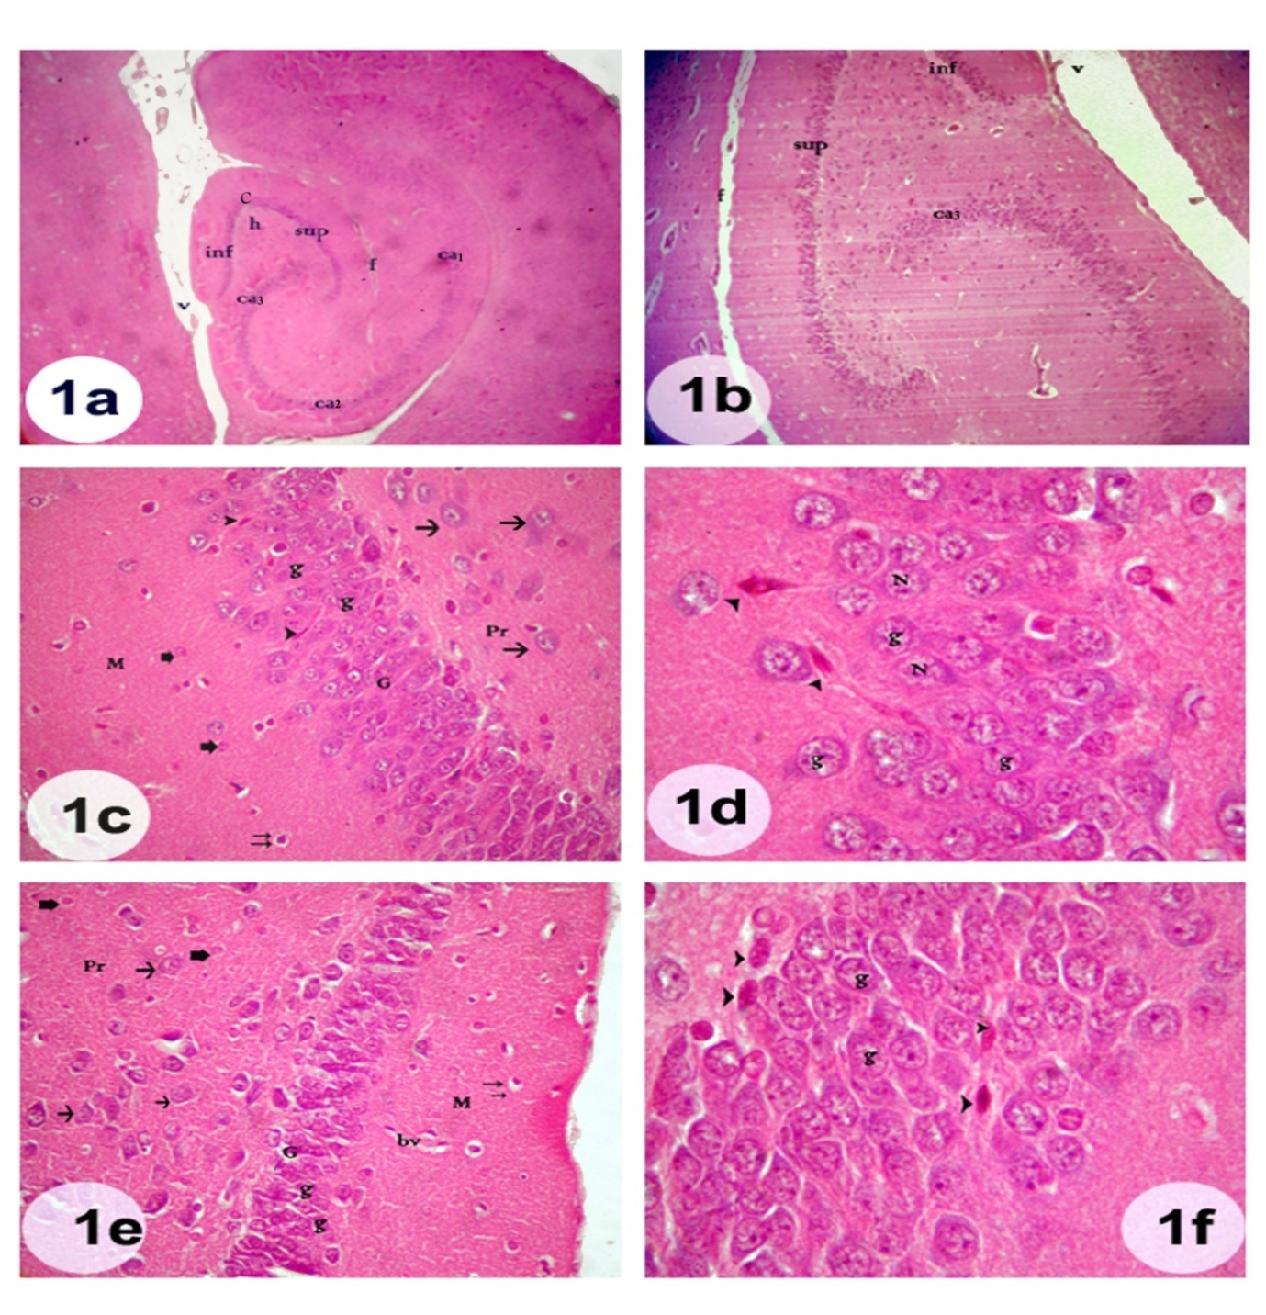
Plate (1): Photomicrographs of a section in a four weeks old control rat hippocampus: showing the dentate gyrus and the hippocampus proper. (Figs. 1a &1 b): the dentate gyrus is formed of; a supra-pyramidal limb (sup), an infra-pyramidal limb (inf) hilus (h) and crest (c). The hippocampus proper is formed of three regions CA1, CA2 and CA3.The CA₃ region of the hippocampus proper is partly enclosed between the two limbs of the dentate gyrus. Notice the presence of ventricle (v) and fissure (f) {Hx&E; 1a X40 and 1b X100}. (Fig. 1c): showing the three layers of supra-pyramidal limb of the dentate gyrus; molecular (M), granular (G) and the polymorphic layer (Pr). The polymorphic layer contains pyramidal cells (arrow). The molecular layer contains astrocytes (two arrows) and neuroglia (thick arrow). Notice presence of the granule cells in granular layer (g). Notice also presence of few small different shaped dark cells (arrow head) in the sub granular zone and wedged between the granule cells {Hx&E X400}. (Fig. 1d): higher magnification of the granular layer, showing the rounded granule cells (g) with vesicular nucleus (N) and few different shaped dark eosinophilic cells (arrow head) in the sub-granular zone and wedged between the granule cells {Hx&E X1000}. Fig. (1e): showing the infra-pyramidal limb of the dentate gyrus. The granule cells (g) are arranged in dense columns in the granular layer (G). The polymorphic layer (Pr) shows Pyramidal cells (arrow). Both polymorphic layer & molecular layer contain astrocytes (two arrows) and neuroglial cells (thick arrow) and blood vessels (bv) {Hx&E X400}. Fig. (1f): higher magnification of the granular layer, showing the granule cells (g) arranged in dense columns, each appears rounded with vesicular nuclei. Notice large amount of different shaped dark cells (arrow head) in the sub-granular zone, and wedged between the granule cells {Hx&E X1000}

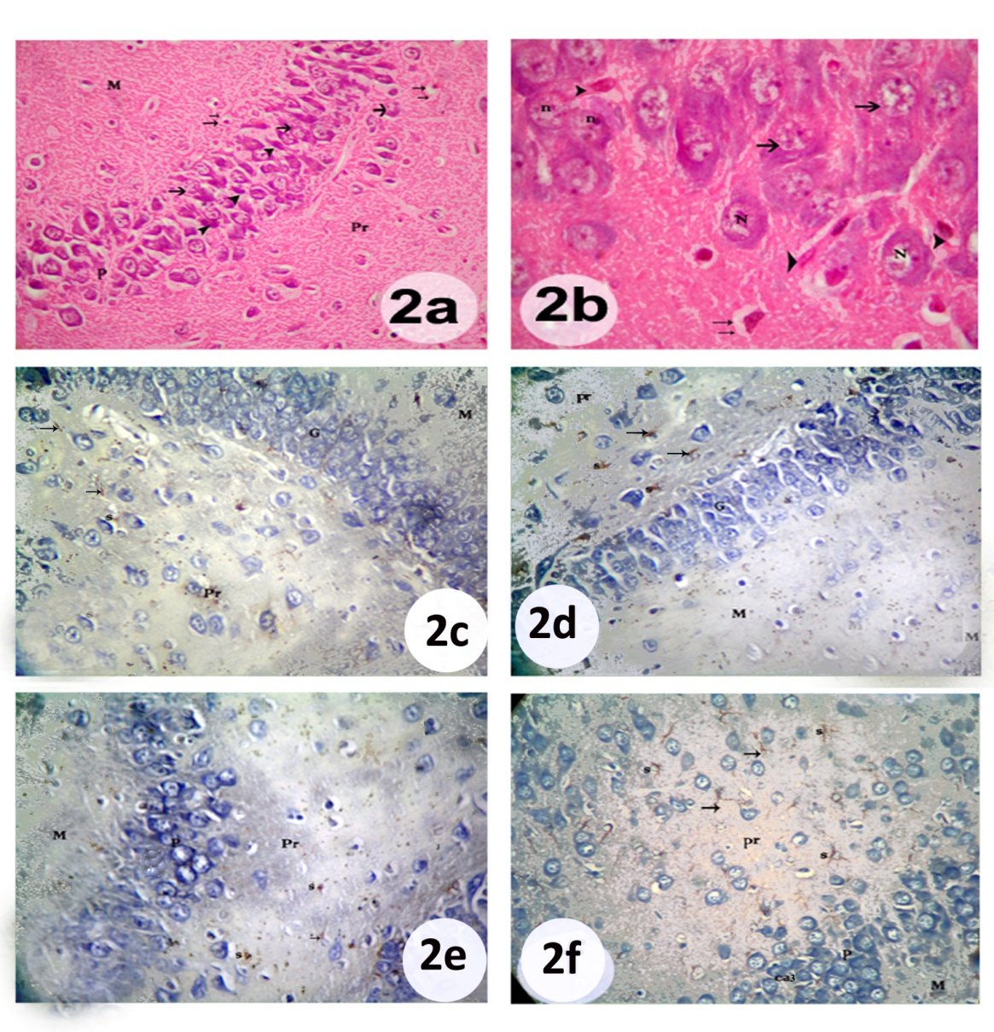
Plate 2: Photomicrographs of a section in a four weeks old control rat hippocampus. Fig. (2a): showing the CA₃ region of the hippocampus proper which is formed of three layers; molecular layer (M), pyramidal layer (P) containing pyramidal cells (arrow) and polymorphic layer (Pr). Notice the presence of large amount of dark cells (arrow head) between pyramidal cells and astrocytes (two arrows) {Hx&E X400}. Fig. (2b): higher magnification of the pyramidal layer, showing the pyramidal cells (arrow) of CA₃ region of the hippocampus proper. They have triangular cell bodies, with large vesicular nucleus (N) and prominent nucleolus(n). Notice presence large of amount of dark eosinophilic cells (arrow head) between the pyramidal ones &presence of astrocyt (two arrows) {Hx&E X1000}. Fig. (2c): showing the molecular layer (M), the granular layer (G) and the polymorphic layer (Pr) of the supra-pyramidal limb of the dentate gyrus. Note the GFAP immuno-reactive astrocytes (s) appearing as star-shaped cells. The fibers are thin and have a regular feature (arrow). Fig. (2d): showing the molecular layer (M), the granular layer (G) and the polymorphic layer (Pr) of the infra-pyramidal limb of the dentate gyrus. Note the GFAP immuno-reactive astrocytes (s) appearing as star-shaped cells. The fibers were thin and had a regular feature (arrow). Fig. (2e): showing the molecular layer (M), the granular layer (G) and the polymorphic layer (Pr) andCA3 region of the hippocampus proper. Notice the astrocytes (s). The fibers are thin and have a regular feature (arrow). Fig. (2f): showing the hilus region of the dentate gyrus. Notice presence of the molecular layer (M), the pyramidal layer (G) and the polymorphic layer (Pr) of CA3 region and presence of astrocytes (s). The fibers are thin and have a regular feature (arrow) {GFAP x 400}.

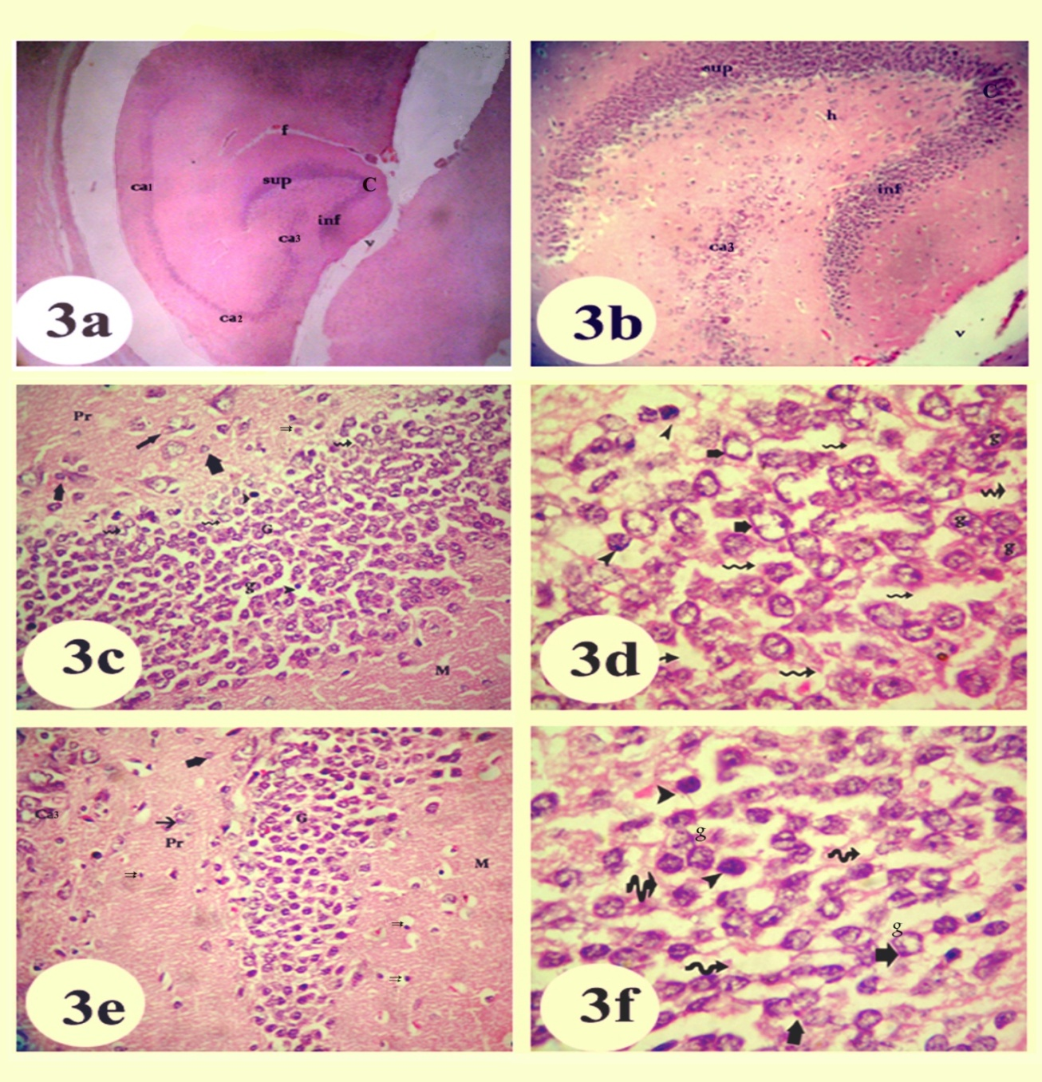
Plate 3: Photomicrographs of a section in a four weeks old rat hippocampus exposed prenatal and postnatal to electromagnetic field emitted by mobile phone. Fig. (3a): showing the dentate gyrus and the hippocampus proper. The dentate gyrus is formed of: supra-pyramidal limb (sup), infra-pyramidal limb (inf). The hippocampus proper is formed of three regions: CA₁, CA₂ and CA₃. Notice presence of fissure (f), creast(c) &ventricle (v) {Hx&E X40}. Fig. (3b): A higher magnification of the previous figure showing the supra-pyramidal limb (sup) the infra-pyramidal limb (inf) of the dentate gyrus and hilus (h) lies between them. Note part of CA₃ region (ca3) is enclosed between the two limbs {Hx&E X100}. Fig. (3c): showing the supra-pyramidal limb of the dentate gyrus which it is formed of three layers, molecular layer (M), granular layer (G) and the polymorphic layer (Pr). There is an apparent increased in the number of the granule cells(g) and decrease in their size as compared to the control group. Few dark basophilic cells (arrow head) are observed between the granule cells. Notice presence of pyramidal cells (arrow), astrocyte cells (two arrows), and other neuroglial cells (thick arrow).Notice also a wide spaces between the cells (spiral arrow) {Hx&E X400}. Fig. (3d): higher magnification of granular layer showing the suprapyrmidal limb of the dentate gyrus. Few of the granule cells (g) have deeply stained nuclei (arrow head), while others show loss of their nucleoli (thick arrow). Notice a wide spaces between the cells (spiral arrow) {Hx&E X1000}. Fig. (3e): showing the infra-pyramidal limb of the dentate gyrus. It is formed of three layers: The molecular layer (M), the granular layer (G) and the polymorphic layer (Pr). There is an apparent increase in the number of the granule cells and decrease in their size as compared to the control group. Notice the polymorphic layer contain pyramidal cells (arrow). Both polymorphic layer & molecular layer contain large amount of astrocyte cells (two arrow).Notice also presence of other neuoglial cells (thick arrow) and a part of CA3 (ca3). {Hx&E X400). Fig. (3f): A higher magnification of infra-pyramidal limb of dentate gyrus, showing Most of granule cells (g) are small in size, few of them showed deeply stained nuclei (arrow head), others showed loss of their nuclei &appeared as ghost (thick arrow). Notice a wide spaces between the cells (spiral arrow) {Hx&E X1000}.
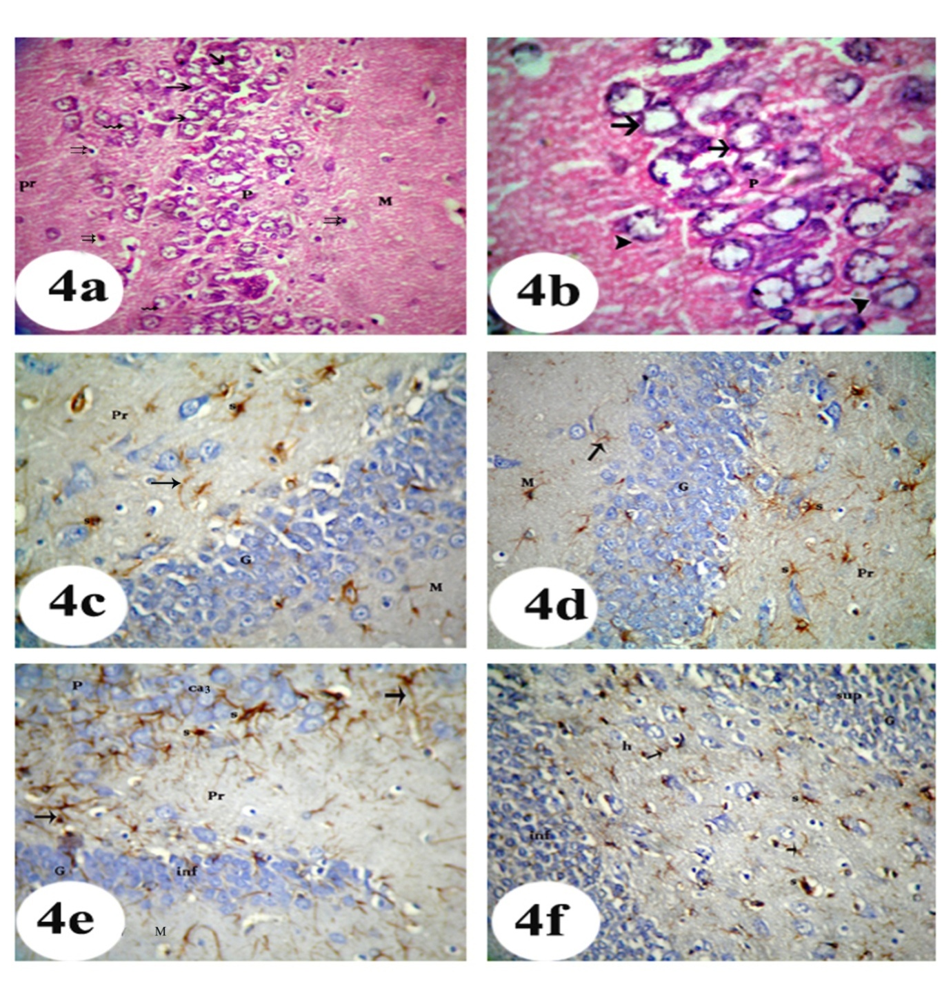
Plate 4: Photomicrographs of a section in a four weeks old rat hippocampus prenatal and postnatal exposed to electromagnetic field emitted by mobile phone. Fig. (4a): showing the three layers of the CA₃ region of hippocampus proper; molecular (M), pyramidal (P) & polymorphic layer (Pr). Some pyramidal cells appear irregular in shape, most of them loss their nuclei (arrow) and others have eccentric nuclei (spiral arrow). Notice, presence of astrocytes ( two arrows) {Hx&E X400}. Fig. (4b): A higher magnification of pyramidal layer in the CA₃ region of the hippocampus proper showing, most of the pyramidal cells loss of their nucleoli (arrow) and others show decreased nuclear cytoplasmic ratio (arrow head) {Hx&E X1000}. Fig. (4c): showing molecular (M), granular (G) and polymorphic layers (Pr) of the supra-pyramidal limb of the dentate gyrus. There is an apparent increase in the number of GFAP immuno-reactive astrocytes (s) and the glial fibers appear twisted, thickened and had intensely staining (arrow) as compared to the control group {GFAP x 400}. Fig. (4d): showing the molecular layer (M), the granular layer (G) and the polymorphic layer (Pr) of the infrapra-pyramidal limb of the dentate gyrus. There is an apparent increase in the number of GFAP immuno-reactive astrocytes (s), the glial fibers appear twisted and have thickened and intensely stained (arrow) as compared to the control group GFAP x 400. Fig. (4e): showing the pyramidal layer (P) and the polymorphic layer (Pr) of the Ca3. There is an apparent increase in the number of GFAP immuno-reactive astrocytes (s), the glial fibers appear twisted and have thickened and intensely stained (arrow) as compared to the control group. Notice the molecular layer (M) &granular layer (G) of infarapyramidal limb of dentate gyrus are present {GFAP x 400}. Fig. (4f): showing the hilus of dentate gyrus. There is an apparent increase in the number of GFAP immuno-reactive astrocytes (s), the glial fibers appear twisted and have thickened and intensely stained (arrow). Notice presence of the granular layer (G) of infarapyramidal limb (inf) & suprapyramidal(sup) limb of dentate gyrus {GFAP x 400}.
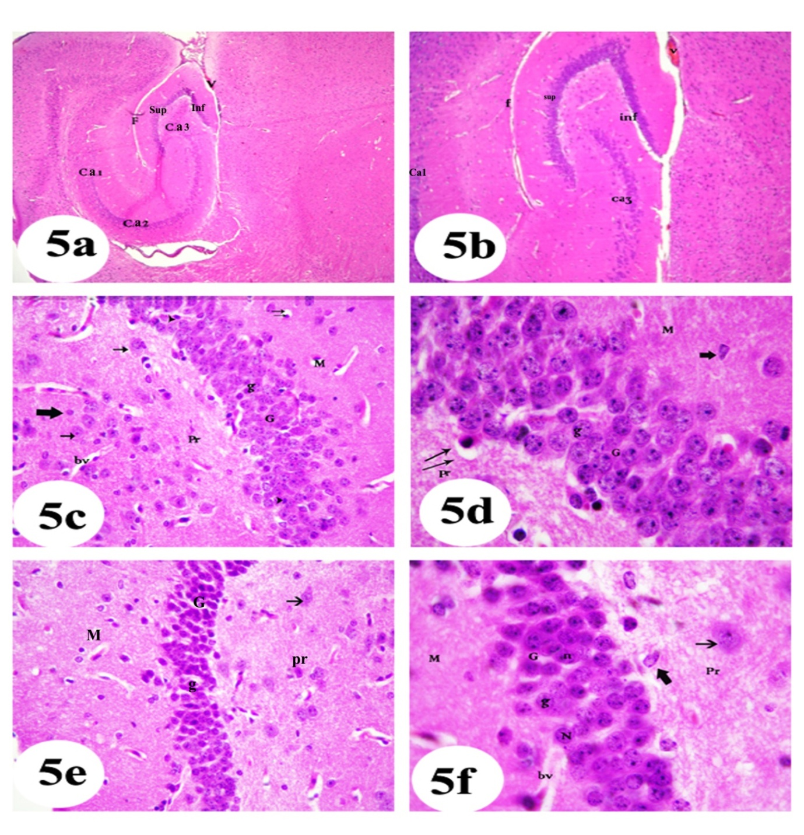
Plate (5): Photomicrographs of a section in an adult control rat hippocampus showing dentate gyrus, hippocampus proper, hippocampal fissure (F), and a ventricle (V). (Fig. 5a and 5b): showing supra-pyramidal limb (sup) and infra-pyramidal limb (inf) of the dentate gyrus in addition to CA1, CA2 and CA3 of the hippocampus proper. Notice a part of CA3 between the two limbs of the dentate gyrus{Hx&E; 5a X40, 5b X100}. (Fig.5c) showing the supra-pyramidal limb of dentate gyrus forms of molecular layer (M), granular layer (G) contains granule cells (g) and polymorphic layer (Pr) contains pyramidal cells (arrow). Notice presence of blood vessels (bv), astrocyt cells (double arrows) & other neuroroglial cells (thick arrow). Eosinophilic dark cells (arrows head) are wedged between the granule cells and in the sub-granular zone {Hx&E X400}. (Fig. 5d) higher magnification of suprapyramidal limb showing large rounded granule cellswith vesicular nucleus (g) and other neuroglial cell (thick arrow) Notice presence of astrocyte (two arrow){Hx&E X1000}. Fig. (5e): showing the infra-pyramidal limb of the dentate gyrus whuch is formed of molecular layer (M), granular layer (G) which contains granule cells (g) and polymorphic layer (Pr). The polymorphic layer contains pyramidal cells (arrow){ Hx&E X1400}. Fig.(5f): higher magnification of pervious figure showing the granule cells(g) with large rounded, vesicular nucleus (N) and prominent nucleoli (n). The Polymorphic layer (Pr) contains pyramidal cells (arrow). Notice presence of neuroglial cell (thick arrow) and blood vessels (bv) {Hx&E, X 1000}.

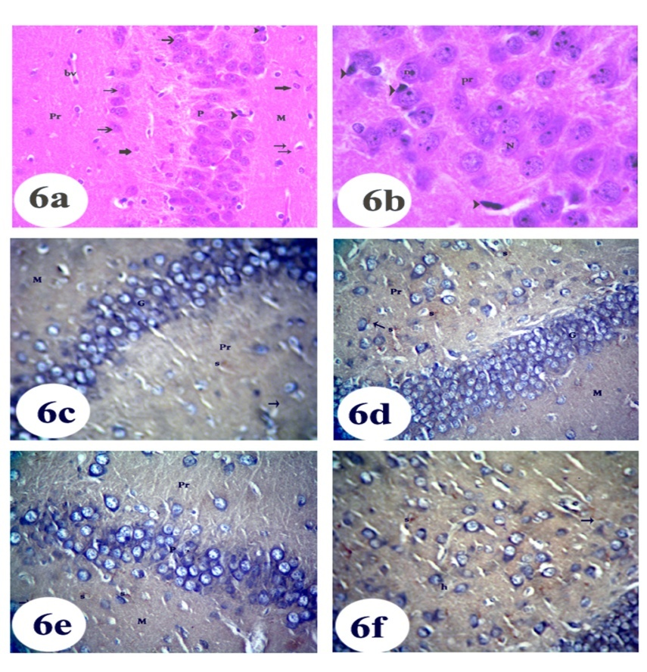
Plate 6: Photomicrographs of a section in adult control rat hippocampus, Fig. (6a): showing CA₃ region of the hippocampus proper which is formed of three layers; molecular (M), polymorphic (Pr) and pyramidal layer (P) that contains pyramidal cells (arrow). Notice presence of astrocyte cells (two arrows), neuroglial cell (thick arrow) and dark cells in between the pyramidal ones (arrow head) {Hx&E X400}. Fig. (6b): higher magnification of pyramidal layer showing the pyramidal cells of CA₃ region that have large vesicular nuclei (N) and prominent nucleoli (n). Notice presence of dark cells in between the pyramidal one (arrow head) {Hx &E X1000}. Fig. (6c): showing the molecular layer (M), the granular layer (G) and the polymorphic layer (Pr) of the supra-pyramidal limb of the dentate gyrus. The GFAP immuno-reaction appears as brown staining in star-shaped astrocytes (s) and as thin with a regular feature (arrow) in the fibers {GFAP x 400}. Fig. (6d): showing molecular layer (M), granular layer (G) and polymorphic layer (Pr) of the infra-pyramidal limb of the dentate gyrus. Note the GFAP immuno-reactive astrocytes (s) appearing as star-shaped cells. The fibers were thin and have a regular feature (arrow) {GFAP x 400}. Fig. (6e): showing faint GFAP immuno-reaction in the star-shaped astrocytes (s) in the CA3 region of the hippocampus proper which is formed of 3 layers molecular (M), pyramidal (P) and polymorphic (Pr) {GFAP x 400}. Fig. (6f): showing the hilus (h) region of the dentate gyrus with +ve GFAP reaction in the star-shaped astrocyte (s). The fibers were thin and have a regular feature (arrow) {GFAP x 400}.
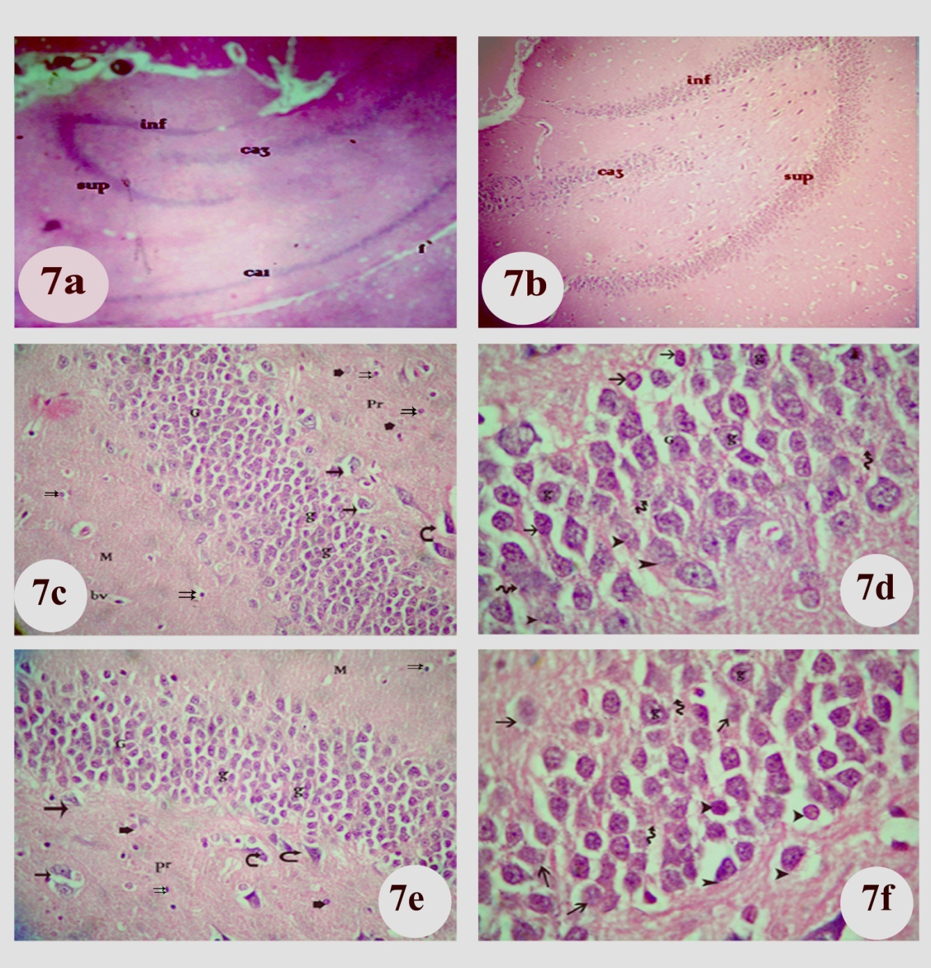
Plate 7: Photomicrographs of a section in an adult rat hippocampus, exposed to electromagnetic field emitted by mobile phone Fig. (7a): showing the supra-pyramidal (sup) and infra-pyramidal limb (inf) of the dentate gyrus and the CA1 and CA3 regions of the hippocampus proper. Notice presence of the hippocampal fissure (F){H&EX 40}. Fig. (7b): A higher magnification of the previous figure showing CA₃ region(ca3) enclosed between the supra-pyramidal limb (sup), and the infra-pyramidal limb (inf) of the dentate gyrus {H&E100}. Fig. (7c): showing the three layers of the supra-pyramidal limb of the dentate gyrus; molecular (M), granular (G) and polymorphic layers (Pr). There is an apparent increase in the number of the granule cells (g) and decrease in their size as compared to its control group. The polymorphic layer contains pyramidal cells surrounded with vacuolated areas (arrow) and some of them have deeply stained nuclei (curved arrow). Notice presence of blood vessels (bv), large amount of astrocyte (two arrows) and other neuroglial cells (thick arrow) {Hx&E X400}. Fig. (7d): A higher magnification of the granular layer (G) in suprapyrmidal limb of the dentate gyrus showing most of the granule cells (g) has ill defined cell boundaries with faint nuclei and appear as ghosts (spiral arrow). Some of them has deeply stained nuclei (arrow), few of them has faint nuclei (arrow head). Notice absence the dark cells in the sub-granular zone and in between the granule cells {Hx&E X1000}. Fig. (7e): showing the molecular layer (M), the granular layer (G) and the polymorphic layer (Pr) of the infra-pyramidal limb of the dentate gyrus. There is an apparent increase in the number of the granule cells (g) and decrease in their size as compared to its control group. The polymorphic layer contains pyramidal cells (arrow), most of them have deeply stained nuclei surrounded with vacuolated area (curved arrow). Notice presence of astrocyte cells (two arrows) and other neuroglial cells (thick arrow) {Hx&E X400}. Fig. (7f): A higher magnification of the previous figure showing the granule cells (g). Some of them has a deeply stained nuclei surrounded with vacuolated area (arrow head), others have faint nuclei (arrow) and few of them have ill defined cell boundaries and appeared as ghosts (spiral arrow). Notice absence of the dark cells in the sub-granular zone and in between the granule cells {Hx&E X1000}.

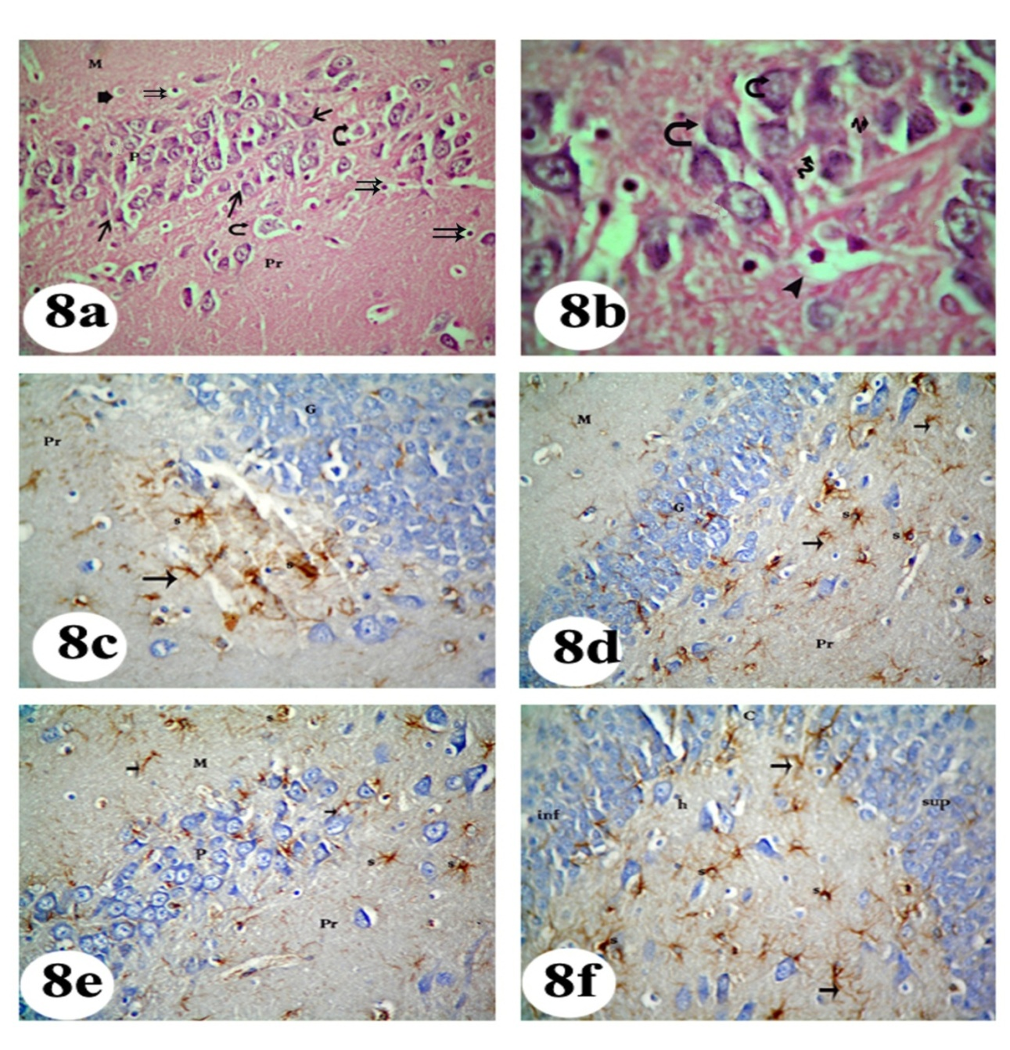
Plate 8: Photomicrographs of a section in adult rat hippocampus exposed to electromagnetic field emitted by mobile phone. Fig. (8a): showing the three layer of the CA₃ region of hippocampus proper; molecular (M).pyramidal (P) and polymorphic layer(Pr). Some of Pyramidal cells appeared irregular in shape with faint nuclei (arrow) others surrounded with vacuolated area (curved arrow). Notice presence of astrocytes ( two arrows) & other neuroglial cells (thick arrow) and absence of dark cells between the pyramidal ones {Hx&E X400}. Fig. (8b): Higher magnification of the CA₃ region of the hippocampus proper. Most of pyramidal cells appeared irregular in shape with faint nuclei surrounded with vacuolated area (curved arrows) and some of them have ill defined boundaries (spiral arrow). Notice presence of astrocyts ( two arrows) and absence of dark cells between the pyramidal ones {Hx&E X1000}. Fig. (8c): showing the granular layer (G) and the polymorphic layer (Pr) of the supra-pyramidal limb of the dentate gyrus. There is an apparent increase in the number of GFAP immuno-reactive astrocytes (s), and glial fibers. These fibers appear twisted and have thickened and intensely stained (arrow) comparing with its control group. Fig. (8d): showing the molecular layer (M), granular layer (G) and the polymorphic layer (Pr) of the infra-pyramidal limb of the dentate gyrus. There is an apparent increase in the number of GFAP immuno-reactive astrocytes (s) and glial fibers which appear twisted, thickened and intensely staining (arrow) comparing with the control group. Fig. (8e): showing the CA3 region of the hippocampus proper which formed of molecular layer (M), pyramidal layer (P) & polymorphic (Pr) layer. There is an apparent increase in the number of GFAP immuno-reactive astrocytes (s) and glial fibers. These fibers appear twisted, thickened and intensely stained (arrow) comparing with its control group. {GFAP x 400}. Fig. (8f): showing the hilus (h) of dentate gyrus with an apparent increase in the number of GFAP immuno-reactive astrocytes (s) and the glial fibers which appear twisted thickened and intensely stained (arrow). Notice presence of suprapyramidal limb (sup), infrapyramidal limb (inf) &crest (c) {GFAP x 400}.

4. Discussion:
The widespread use of wireless mobile communication has raised concerns of adverse effect to the brain owing to the proximity during use to the electromagnetic field (EMF) emitted by mobile phones. Many findings pointed to the potential risks of mobile phones on the CNS function, in addition to modification of the brain response during memory tasks and cognitive function ^{20, 21, 22}.
The hippocampus is considered one of the sensitive targets for the effects of radiofrequency exposure and the dentate gyrus and hippocampus proper; subregions were chosen in this work as they are particularly responsible for cognitive function such as learning and memory ⁶. Although numerous studies have been carried out in the epidemiology, cellular biology, and toxicology research fields, the potential adverse effects of EMF exposure on the human CNS are still controversial ²³.
During this work it was observed that the control animals either in the four-week old or adult group showed some small, dark cells in the sub-granular zone, and also wedged between the granule cells in suprapyramidal and infrapyramidal limbs as well as between the pyramidal cells in the CA3 region. These cells were previously described by Song et al., ²⁴ as neural stem cells that are present both in developing nervous system and in the adult nervous system of all mammals, including human. In addition, many authors observed the presence of stem cells with astrocytic properties in two locations in the brain; sub-ventricular and the sub-granular zones of the dentate gyrus of the hippocampus ^{25, 26, 27}.
However, immature neuron had been described by others as a cell with scarcity of cytoplasm and patchy chromatin aggregates in its nucleus Cummings et al., ²⁸. The localization of these immature neurons in the subgranular zone was coincided with the finding of other investigators who reported that the dentate granule cell is one of the nervous tissues that maintain mitotic activity in the adulthood. In addition, the new neurons continue to be generated throughout life originating from stem cells located in this area that ultimately differentiate into mature granule neurons ²⁹.
In this study, the number of these dark cells was apparently decreased in some sections while they completely disappeared in others after exposure to electromagnetic waves (EMW) emitted from mobile phone in the treated groups. This might be due to their differentiation into granule cells, in order to compensate for their loss, caused by exposure to electromagnetic field. This might account for an apparent increase in the number of granule cells compared to the control groups. This was in parallel with Zhu et al., ³⁰ who suggested that the intermittent hypoxia promoted proliferation of the endogenous neuro-progenitors leading to more newborn neurons in the hippocampus of adult rat. On contrast, this disagreed with the findings of Odaci et al., ³¹ who reported that exposure to radiofrequency radiation inhibited the formation and differentiation of neural stem cells during embryonic development in rats. They also detected that prenatal exposure to electromagnetic fields could affect the development of the granule cells of dentate gyrus in the rat hippocampus, which might lead to cell loss.
In the present work, microscopic examination of hippocamppi and both limbs of the dentate gyrus of exposed groups (prenatal, postnatal and in adult group) showed an apparent increase in the number of the granule cells with decreasing in their diameter. These cells had features of degeneration in the form of deeply stained nuclei, partial decrease of the nuclear basophilia with intranuclear vacuolation, a decrease in the nuclear cytoplasmic ratio and wide intercellular spaces. The pyramidal cells in the CA3 region in the treated groups also showed variable degrees of degeneration. Most of the cells became irregular in shape with decreased in the nuclear cytoplasmic ratio. The majority of cells had different shape and size and showed intranuclear vacuoles and some cells showed disruption of their nuclear wall. Similar results were suggested by Salford et al., ³², who detected neuronal damage in the cerebral cortex, hippocampus and basal ganglia following exposure to mobile phone. The damaged neurons appeared shrunken and darkly stained, with loss of their internal structure. Also, some of them showed cytoplasmic vacuoles, indicating an active pathological process. They also reported presence of black and shrunken nerve cells among the big pale pyramidal ones of the hippocampus proper. In addition, Odaci et al., ³¹ found a cell loss in CA3 as a result of chronic prenatal exposure to EMFs, while Orhan et.al., ³³ found that 900 MHz electromagnetic field exposure affects qualitative and quantitative features of hippocampal pyramidal cells in the adult female rat. After that, Narayanan et al., ² reported that the radio frequency radiation exposure has significantly induced marked morphological changes in the CA3 region of the hippocampus of the mobile phone-exposed in wistar rats.
These results are in agreement with many authors who found many adverse effects of mobile phone use on the human brain and brain related tissues, such as cerebellum and hippocampus ^{12, 34, 35}. These possible side effects of EMFs emitted by cellular phones on human meningeal tissue, brain, and nervous system have aroused considerable interest among both the scientific community and the general public ³⁶.
These results could be explained in four-aged animals by De Salles et al., ³⁷ who observe that the specific absorption rate produced by mobile phones in the heads of children is about sixty percent higher than that for adults.
Regarding the increase in the number of granule cell, it was explained by suggestion of Liu et al., ³⁸ who explained that the neuronal death within the hippocampus provided a stimulus for increased dentate neurogenesis. Additionally, if one considers the hippocampus a processing unit, adding neurons here might be more equivalent to an increase in working memory ⁵.
Experimental studies have shown that the radio-frequency electromagnetic radiation (RF-EMR) emitted from the mobile phones can affect and degenerate the brain in various ways. The exact mechanism responsible for this degeneration has to be investigated; perhaps the mechanism is through reactive oxygen species. The mobile phones caused oxidative damage biochemically by increasing the levels of Malondialdehyde (MDA), carbonyl groups, Xanthine oxidase (XO) activity, and decreasing CAT activity; and that treatment with melatonin significantly prevented oxidative damage in the brain³⁹. So, pharmacological enhancement of hippocampal neurogenesis was reported to be a therapeutic approach for improvement of cognition in learning and memory disorders ^{40.}
The mechanism of degeneration in the cells of hippocampus after exposure to electromagnetic waves attributed also to the changes in the permeability of the BBB^{41, 42}. They found that exposure to continuous radio-frequency radiation at the microwave range led to significant increase in the permeability of the BBB, with leakage of albumin into the surrounding brain tissue. They added that the BBB acted as a shield, protecting the brain against many harmful substances, and its disruption might account for the damage of pyramidal neurons occurring in the granule cells in both limbs of dentate gyrus and in the CA3 region in the hippocampus.
In the present study, there was an increase in the number of astrocytes in the all treated group which approved by GFAP. It showed an apparent increase in the amount and intensity of GFAP immuno-reactive astrocytes. The glial fibers were twisted with an irregular course and had more intensely staining. The glial cells were reported to be sensitive to EMW and a numeric increase in astrocytes was more pronounced in the hippocampus than in the frontal cortex⁴³. Some special astrocytes were suggested by some investigators to provide a unique neurogenic niche and have the capability to promote proliferation and neuronal fate determination⁴⁴. Moreover, it was stated that in response to central nervous system injury astrocytes become reactive and increase their expression of the intermediate filament proteins glial fibrillary acidic protein (GFAP) ⁴⁵. This finding could be explained by previous researchers who suggested that the increase of astrocytes may provide more nourishment required by the injured neurons. Other investigators described a population of small cells which are derived from the astrocytes and probably function as a transient precursor in the formation of new neurons^{46, 47}.
In conclusion, the well-known memory and cognitive affection after EMR exposure may be due to severe degenerative changes in the hippocampus. It is recommended to reduce the call time and limit the use of mobile phones either in young or adult age.

References

Hossmann K and Hermann D, Effects of electromagnetic radiation of mobile phones on the central nervous system, 2003; Bioelectromagnetics 24:49–62.
- Narayanan S, Kumar R, Potu B, Nayak S, Bhat, P, and Mailankot M, Effect of radio-frequency electromagnetic radiations (RF-EMR) on passive avoidance behaviour and hippocampal morphology in Wistar rats. 2010; Med Sci,115(2): 91-96
- Lemaire V, Koehl M, Le Moal, M, Abrous, D, Prenatal stress produces learning deficits associated with an inhibition of neurogenesis in the hippocampus. 2000; Proc. Natl. Acad. Sci.U. S. A. 97: 11032–37.
- Eyre M, Richter-Levin G, Avital A, Stewart M, Morphological changes in hippocampal dentate gyrus synapses following spatial learning in rats are transient. 2003;Eur J Neurosci. May, 17(9):1973-80.
- Kempermann G, Why new neurons? Possible functions for adult hippocampal neurogenesis. 2002; Neurosci. Feb 1; 22(3):635-38.
- Tashiro A, Makino H and Gage F, Experience specific functional modification of the dentate gyrus through adult neurogenesis: A critical period during an immature stage. 2007; Neurosci; 27(12):3252-59.
- Van Elzakker M, Fevurty R, Breindel T and Spencer, R, Environmental novelty is associated with a selective increase in Foss expression in the outlet elements of the hippocampal formation and peripheral cortex 2008; Learning and Memory; 15(12): 899-908.
- Andersen P, Soleng A and Raastad M: The hippocampal lamella hypothesis revisited. 2000; Brain Res. Dec 15; 886(1-2):165-71.
- Fitz-Gerald MJ and Folan-curran J: Clinical Neuroanatomy and related neuroscience. 4th edition, WB Saunders, 2002 ; p.241-253
- Mausset, A, de Seze, R, Montpeyroux, F, Privat, A, Effects of radiofrequency exposure on the GAB Aergic system in the ratcerebellum: clues from semi-quantitative immunohistochemistry. 2001; Brain Res. 912, 33–46.
- Dubreuil D, Jay T, Edeline, J, Does head-only exposure to GSM 900-MHz electromagnetic fields affect the performance of rats in spatial learning tasks, Behav,2002; Brain Res. 129, 203–10.
- Dubreuil D, Jay T, Edeline, J (): Head-only exposure to GSM900-MHz electromagnetic fields does not alter rat's memory in spatial and non-spatial tasks, Behav, 2003; Brain Res. 145, 51–61.
- Eng L and Ghirnikar R, GFAP and astrogiosis. 1994; Brain Pathol. 4:229-37.
- McLendon R and Bigner D, Immunohistochemistry of the glial fibrillary acidic protein: basic and applied considerations. 1994;Brain Pathol. 4:221-28.
- Ross HM and Pawlina W, Histology, a Text and Atlas with correlated cell and molecular biology, 5th edition, Lippincott Company 2011p.301-310.
- Besset A, Espa F, Dauvilliers Y, Billiard M and Deseze R, No effect on cognitive function from daily mobile phone use. 2005 Bioelectromag; 26(2):102-8
- Djeridane Y, Touitou Y, and Deseze R, Influence of electromagnetic field emitted by GSM-900 cellular tephones on the circadian patterns of gonadal, adrenal and pituitary hormones in men. 2008; Radiate. Res; 169(3):337-43.
- Araffa M, Farhoud H, Radwan A, Effect of Electromagnatic field on the testis of albino rat. 2009, Thesis submitted in fulfillment of M.D. degree, P.27
- Bancroft J D and Gamble M, Theory and practice of Histological Techniques. 5th ed. Churchill Livingstone, 2002, p. 109-136.
- Eliyahu I, Luria R, Hareuveny R, Margaliot R. Meiran N, and Shani G, Effects of radiofrequency radiation emitted by cellular telephones on the cognitive functions of humans. 2006; Bioelectromagnetics, 27(2): 119–26.
- Esen F, and Esen H, Effect of electromagnetic fields emitted by cellular phones on the latency of evoked electrodermal activity. 2006;Int J Neurosci. Mar; 116(3):321-9.
- Maskey D, Kim H, Kim H, and Kim M, Calcium-binding proteins and GFAP immunoreactivity alterations in murine hippocampus after 1 month of exposure to 835 MHz radiofrequency at SAR values of 1.6 and 4.0 W/kg. 2012;Neurosci Lett. 506(2):292-6
- Hietanen M, Establishing the health risks of exposure to radiofrequency fields requires. 2006; multidisciplinary research. 32, 169–170.
- Song H, Stevens C and Gage F, Neural stem cells from adult hippocampus develop essential properties of functional CNS neurons. 2002;Nat Neurosci. May;5(5):438-45.
- Seri B, Garcia Verdugo J, McEwen B and Alvarez Buylla A, Astrocytes give rise to new neurons in the adult mammalian hippocampus. 2001. Neurosci. Sep 15;21(18):7153-60
- Faiz M, Acarin L, Castellano B and Gonzalez, B, Proliferation dynamics of germinative zone cells in the intact and excitotoxically lesioned postnatal rat brain. 2005;BMC Neurosci.; 6: 26
- Oomen C, Girardi C and Cahyadi R,Opposite effects of early maternal deprivation on neurogenesis in male versus female rats. 2009 PLoS ONE'S; 4(1): e3675.
- Cummings B, Uchida N, Tamaki S, Salazar D, Hooshm and M., ummers R et al, Human neural stem cells differentiate and promote locomotor recovery in spinal cord-injured mice. 2005; Proc. Natl. Acad.Sci.U.S.A. 27;102(39):14069-74.
- Saito S, Matoba R, Ueno N, Matsubara K and Kato K, Comparison of gene expression profiling during postnatal development of mouse dentate gyrus and cerebellum. 2002;Physiol. Genomics Feb 28;8(2):131-37.
- Zhu X, Yan H, Zhang T, Qu H, Qiu, X, Chen L, et al, Intermittent hypoxia promotes hippocampal neurogenesis and produces anti-depressant like effects in adult rats. 2010. Neurosci.; 30(38): 12653-66
- Odaci E, Bas O and Kaplan S, Effects of prenatal exposure to a 900 MHz electromagnetic field on the dentate gyrus of rats: A stereological and histopathological study. 2008; Brain Res.: 1238: 224-9.
- Salford L, Brun A, Eberhardt J, Malmgren L and Presson B, Nerve cell damage in mammalian brain after exposure to microwaves from GSM mobile phones. 2003; Environmental Health Perspectives; 111(7): 881-83.
- Orhan B, Ersan O, Suleyman K, Niyazi A, Kagan U, Serdar C,Morphological changes in hippocampal dentate gyrussynapses following spatial learning in rats are transient,2009.; Eur. J. Neurosci. 17, 1973–80
- Mausset-Bonnefont, A, Hirbec H, Bonnefont, X, Privat A, Vignon J, de Seze R: Acute exposure to GSM 900-MHz electromagnetic fields induces glial reactivity and biochemical modifications in the rat 2004;brain. Neurobiol. Dis. 17, 445–454.
- Söderqvist F, Carlberg M, Hardell L,Use of wireless telephones and self-reported health symptoms: a population-based study among Swedish adolescents aged15–19 years. 2008; Environ. Health. 7:18
- Lahkola A, Salminen T, Raitanen J, Heinävaara S, Schoemaker M, Christensen H, et al, Meningioma and mobile phone use—a collaborative case-control study in five North European countries. 2008; Int. Epidemiol. 37, 1304–13.
- De Salles A, Bulla Gand Rodriguez C, Electromagnetic absorption in the head of adults and children due to mobile phone operation close to the head. Electromag.2006;Biol. Med.; 25(4): 349-60.
- Liu J, Solway K, Messing R. and Sharp F, Increased neurogenesis in the dentate gyrus after transient global ischemia in gerbils. 1998; Neurosci. Oct 1;18(19):7768-78
- Sokolovic D, Djindjic B, Nikolic J, Bjelakovic G, Pavlovic D, Kocic G,: Melatonin reduces oxidative stress induced by chronic exposure of microwave radiation from mobile phones in rat brain. 2008; Radiat Res (Tokyo);49:579–86
- Chohan M, Li B, Blanchard J, Tung Y, Heaney A, Rabe A, Iqbal K et al: Enhancement of dentate gyrus neurogenesis, dendritic and synaptic plasticity and memory by a neurotrophic peptide. 2009;Neurobiol Aging 1;16(19):7868-78
- Sirave, B and Seyhan, N, Blood-brain-barrier disruption by continuous wave radiofrequency radiation. Electromagn. 2009;Biol. Med.; 28(2): 215-22.
- Stam, R. Electromagnetic fields and the blood-brain-barrier. 2010Brain Res. Rev.; 65(1): 80-97
- Amenta F, Bronzetti E, Sabbatini M and Vega J, Astrocyte changes in aging cerebral cortex and hippocampus: A quantitative immunohistochemical study. 1998; Microsc. Res. Tech. Oct 1; 43(1):29-33.
- Lie D, Song H, Colamarino S, Ming Gand Gage F, Neurogenesis in the adult brain: New strategies for central nervous system diseases. 2004 Annu. Rev. Pharmacol. Toxicol.;44:399-21.
- Larsson Å, Wilhelmsson U, Pekna M and Pekny M, Increased cell proliferation and neurogenesis in the hippocampal dentate gyrus by GFAP in mice. 2004; Neurochem.Res. ; 29:2069-73.
- Seri B, Garcia Verdugo J, McEwen B and Alvarez Buylla A. Astrocytes give rise to new neurons in the adult mammalian hippocampus.. 2001; Neurosci. Sep 15;21(18):7153-60
- Wang X, Xu Y, Wang F, Tang L, Liu Z, and Li H et al: Aging-related changes of microglia and astrocytes in hypothalamus after intraperitoneal injection of hypertonic salinein rats. 2006; Technol. Med. Sci.; 26 (2):231-34.

6/12/2013

