The Occurrence and Modified Method for Phenotypic Identification of Ambler Group A and B Extended Spectrum β-Lactamases Production in Urino-Genital Gram Negative Bacterial Isolates from, Nigeria.

Christian Azubike Enwuru¹, Bamidele Iwalokun ¹, Nkechi Veronica Enwuru ², Oliver Ezechi ¹, NneomaIdika ¹, Afolabi Oluwadun ³

1. Nigerian Institute of Medical Research, Yaba, Lagos, Nigeria.
2. Faculty of pharmacy, University of Lagos, Idiaraba, Lagos, Nigeria.
3. College of Health Sciences, Dept. of Microbiology and Parasitology OOU, Sagamu, Ogun state, Nigeria.
enwuru@ymail.com

Abstract: Beta lactamase enzymes production in gram negative bacteria (GNB) grouped into four Ambler classe: A – D, remains a formidable threat to therapeutic interventions and impact negatively on the course and outcome of infections in patients worldwide. Routine β -lactamase screening is a standard for clinical bacteriology laboratories especially for gram negative pathogens of extra-intestinal origin medicated often with third and fourth generation cephalosporins. However, routine phenotypic screening methods (DDT and DDST) as recommended by CLSI for class A and B respectively have been found not sustainable in resource poor settings such as Nigeria, as a result of cost and cumbersomeness. This study was designed to study the occurrence and evaluate the performance of a modified DDT and DDST methods for phenotypic identification of Ambler class A and B - β-lactamase production in GNB for routine use in the clinical laboratories. A total of 63 consecutive non-repetitive gram-negative bacterial isolates from urino-genital specimens of men attending fertility clinic were studied. There were 10 different species of bacteria: with E. coli 23/63 (36.5%) and Enterobacter spp. 12/63 (19%) having the highest occurrence. Groups A and B β-Lactamases were screened with CLIS recommended phenotypic methods (DDT and DDST respectively) for Enterobacteriaceae and a modified agar plate (co-detection in a single lawn culture plate) and the results were compared. Of the 63 bacteria screened, 18 (29%) produced Ambler group A and 7 (11%) demonstrated hetero-resistant sub-population. Eleven (17.5%) were Ambler group B positive. One (1.5 %) strain showed hetero-resistant subpopulation and negative for Metallo β-Lactamase production. Out of the 18 group A and 11 group B ESBLs producing isolates by standard methods, 16 (89 %) and 10 (91%) were positive on the modified method respectively. The sensitivity and specificity were 88.9 % and 100% for group A and 91% and 100% for group B β-Lactamases, respectively. The positive predictive values of 100% were recorded for both. The highest co-production of both enzymes was amongst Serratia spp. 2/3. The result has demonstrated 29 % group A and 17.5 % group B ESBLs occurrence and that the modified method (less expensive, time saving and less cumbersome) is comparatively sensitive with the standard DDT and DDST methods recommended by CLSI and is equally recommended.
[Enwuru CA, Iwalokun B, Enwuru NV, Ezechi O, Idika N, Oluwadun A. The Occurrence and Modified Method for Phenotypic Identification of Ambler Group A and B Extended Spectrum β-Lactamase Production in Urino-Genital Gram Negative Bacterial Isolates from, Nigeria. Nat Sci 2013;11(8):48-53]. (ISSN: 1545-0740). http://www.sciencepub.net/nature. 8

Key words: Bacteria, Antibiotics, ESBLS, Occurrence, Modified, Screening.

- Introduction
It is a general phenomenon that infections of male urogenital tract are potentially correctable causes of male infertility (Weidner, 1999; WHO, 2000; Purvis, 1993). Urethritis and prostatitis, orchitis and epididymitis have been described as male accessory gland infections (WHO 2000). These infections may be caused by specific or facultative bacterial aetiology, particularly gram negative bacteria like E. coli (Naber, 2000). Treatment of these disease conditions are aimed at reduction or eradication of the microorganisms in the prostatic secretions and semen using antibiotics to prevent deleterious effects of inflammation on spermatogenesis and the consequent infertility. The use of antibiotics is greatly challenged by emergence of Multi Drug Resistance (MDR) and is a growing threat to public health (WHO, 2012). Routine studies provide important information about changes in microbial spectrum and trends in antibacterial resistance patterns (Ritu et al 2012). Studies on Beta Lactamases and location of the genes encoding the enzymes amongst gram negative organisms using molecular technology abound. From the late 1990s, MDR enterobacteriaceae producing ESBLs have emerged and is ever increasing within the communities and intensive care units of hospitals. Ever since their description, more than 200 different ESBLs have been identified, posing a significant risk to public health (Draw and Bonomo, 2010). Many genera of gram negative bacteria possess a naturally occurring chromosomal and plasmid mediated β-Lactamases. The enzymes were believed to have emanated mostly from penicillin binding proteins (PBP) evolved by selective pressure exerted by β - Lactam producing soil organisms found in the environment (Bradford, 2001). Production of β-lactamase is the major mechanism of resistance to β -Lactams, which are mostly, employed in the treatment of various infectious diseases (Drawz and Bonomo 2010). The β-lactamases breakdown the structure of β-Lactam rings of the antibiotics thereby rendering them ineffective. The first to be described in early 60’s was TEM-1 – a plasmid mediated β -Lactamase described in gram negative organisms (Bradford, 2001).
Ambler class A ESBLs (TEM, SHV, CTx-M and KPC) are serine carbapenemases known to hydrolyze and cause resistance to oxyimino-cephalosporines and Aztreonam, mostly amongst enterobacteriaceae (Rodrigues et al 2004) and Class B - metallo-β-Lactamases (IMP, VIM and SPM) are zinc (Zn²⁺) mediated. Both groups exhibit different mechanisms of hydrolytic effect on β-lactam drugs. Class C – (Amp C) and Class D – (OXA) have been severally reported (Bradford, 2001). The presence of these enzymes makes treatment with certain broad spectrum cephalosporines almost impossible, leading to high morbidity and sometimes mortality. Worst still, some enzymes have been associated with resistance to other non-betalactam antibiotics: aminoglycosides and chloroamphenicol.
In addition to ESBLs hydrolyzing pencillins, narrow and extended spectrum cephalosporines; further complication of the situation is resistance to β-lactam inhibitors which are on the increase and varies throughout the world. In 1993, a French study of 2,972. E. coli isolated from UTIs found 25 and 10 % of hospital and community isolates respectively showed amoxicillin/clavulate MICs of > 16/2 µg/ml. In USA, 24% of the 283 isolates were classified in 2004 as ampicillin/subactam resistant by disk diffusion, out of those, 83% were from community acquired infections (Drawz and Bonomo 2010). In Nigeria, apart from amoxicillin/clavulanate, the other 3 β-lactamase inhibitors (ticarcillin/clavulate, ampicillin/subalctam and pipercillin/tazobactam are not available. Early and prompt detection of bacterial agents with this threat when isolated from clinical specimens becomes apt; as this will influence the choice of antibacteria to be used for treatment (Pitout and Laupland, 2008). In view of this line of thinking, the Clinical Laboratory Standard Institute (CLSI) has recommended Double Disk Test (DDT) and Double Disk Synergy Test (DDST) for phenotypic identification of Ambler groups A and B respectively in our clinical bacteriology laboratory (CLSI M100-S14 2005).
However, there are myriad of challenges impeding this procedure as routine in bacteriology laboratory; ranging from operational challenges (cumbersomeness, turnaround time etc) to disagreement between results of methods generally and in particular the resource poor countries where high cost perception of diagnostic procedure is an issue. Most of modified screening methods tried, none was specifically targeted to saving of cost which is a majour constrain to resource poor countries. In Nigeria reasons for under detection or non- routine detection has been blamed on cost or sustainability. When therefore recent reports present increase in spread of β-lactamase producing bacterial aetiology in both nosocomial and community settings in Nigeria with poor and deleterious outcome (Aibinu, 2003;Yusha et al 2007; Iroha et al 2008; Eyitayo et al , 2009; Enwuru, et al, 2011) , the danger become more obvious.
Although there are reported cases of invitro sensitivity in Kirby Bouer disk diffusion method with concomitant invivo resistance (Ananthakrishnan et al 2000), which misleads the clinicians, nonetheless, the need is prime for routine phenotypic screening of ESBLs in bacteriology laboratories since oxyimino-cephalosporines and aztreonam are currently drugs of choice in management of majority of bacterial pathogens in Nigeria, this justified this study.
- Material and Methods
All gram negative organisms isolated from UTIs specimens were characterized and subjected to antibiogram, using standard techniques. Multi-Drug- Resistant (MDR) ones were used for the study. We considered an organism MDR if it was resistant to aminoglycoside, floroquinolone and a third generation cephalosporin tested (Ritu et al, 2012). Gram negative MDR organisms (with turbidity of 0.5 Mac-Farland standards) were further screened and those found resistant to any of: cefepime, cefprodoxime, ceftazidime, aztreonam, cefotaxime or ceftriaxone, were inoculated onto Mueller-Hinton agar (Oxoid) as recommended by CLSI M100-S14 (2005) document and Tryptic Soy Agar (TSA). EDTA (750µg) solution was prepared by dissolving 186.1g of disodium EDTA 2H₂O (Junsei Chemical, Tokyo, Japan) in 1 liter of sterile distilled water and adjusted to 8.0 pH by using 1MNaOH solution and was sterilized by autoclaving (Hemalatha et al, 2005). Two 10µg imipenem disks were placed 30 mm apart (edge to edge) on the plate, and 20µl of the 750µg EDTA were added onto one (Hemalathaet al, 2005). On the other hand the Ambler group A ESBL was screened by putting two currently available third generation cephalosporins-ceftazidime and ceftriaxone (CAZ and CTR 30µg disks) 36mm apart and a disk of Amoxicillin/clavulate (20/10µg) placed 15 mm edge to edge between them. Ceftazidime was employed because the complex moiety -2methyl and a carboxylic acid group confer extra stability to β -lactamase enzymes produced by gram negative bacteria. The extra stability to β -lactamases increases the activity of ceftazidime against otherwise resistant genera (CLIS M100-S14 2005). The enzymes were screened simultaneously on separate plates and combined on one lawn of bacterium plate for each organism. Incubation temperature was 25ºC for 18 to 24 hours. Standard organisms (E. coli ATCC 25922 and P. aeruginosa ATCC 27853) positive for ESBLS production were used to control the tests.
- RESULTS:
Of the 63 bacteria screened, 18 (29%) were pure ESBL Ambler group A positive (table 1, Plate 1) and 7 (11%) demonstrated hetero-resistant sub-population. Eleven (17.5%) were positive for Metallo β-lactamase (Zone diameter of ≥ 6mm difference between IMP and IMPEDTA disks) plate 2. One (1.5%) strain showed hetero-resistant subpopulation and negative for Metallo β-lactamase enzyme production

Table 1: Frequency of the bacterial isolates and the occurrence of B-lactamase enzymes
Isolate Total No (%) ESBLS Production
Group A (%)* Group B (%)*
E. coli 23(36.5) 9(39) 4(17.3)
Enterobacter 12 (19) 4(33) 1(8.3)
Pseud spp. 9(14.2) 1(11) 3(33.3)
Klebsieller spp. 6(9.5) 2(33) 0(00)
Salmonella spp. 3(4.8) 0(00) 1(33.3)
Serratia spp. 3(4.8) 2(67) 2(66.7)
Citrobacter 2(3.2) 0(00) 0(00)
Proteus spp. 2(3.2) 0(00) 0(00)
Edwardsiella 2(3.2) 0(00) 0(00)
Morganella 1(1.6) 0(00) 0(00)
Total 63(100%) 18 (29%) # 11(17.5)#
* = Percentage based on the ESBLs species positivity
# = percentage based on all ESBLs groups positivity

Chart 1: The prevalence and positive rates of the bacterial organisms studied
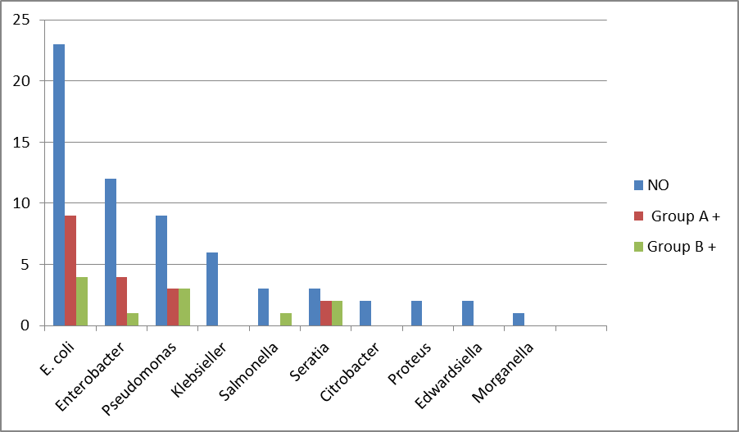
Out of the 18 positive group A and 11 positive group B isolates by exclusive single plate standard method, 16 (89%) and 10 (91%) were positive on the modified (Plate 3) method respectively.

Plate 1. Demonstrating ‘key hole’ appearance indicating Group A positive ESBLs production using single plate and single disks (CAZ 30µg{top}, AZT 30µg,{left} CTR 30µg{right} and Amoxicillin/clavulate 20/10µg ).
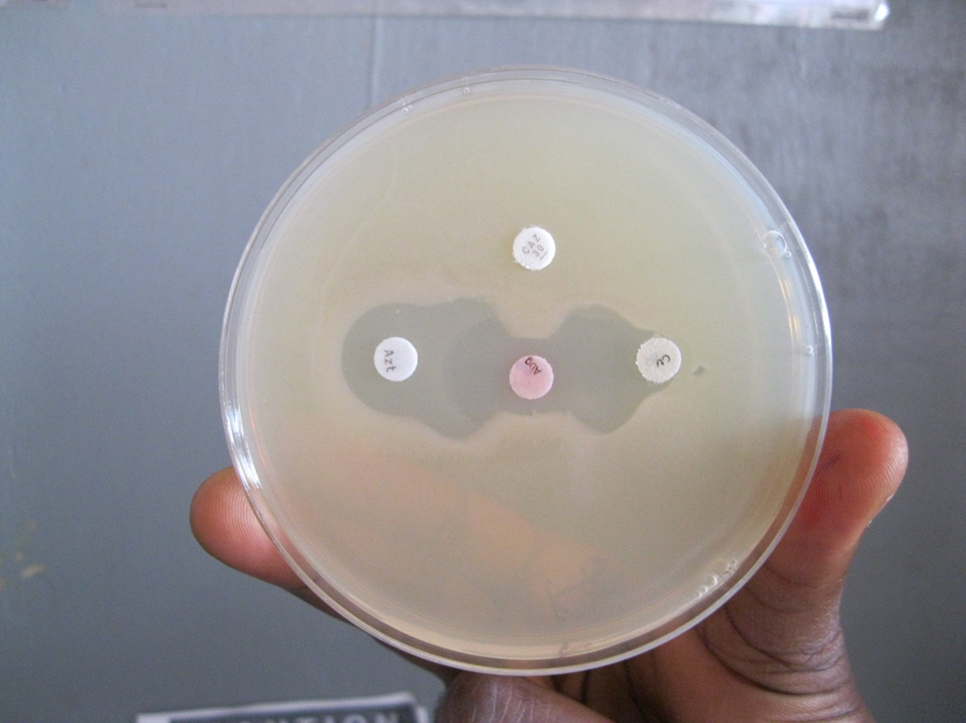
KEY:
CAZ = Ceftazidime
AZT = Aztreonam
CTR = Ceftriaxone
AUG = Amoxicillin/Clavulanic acid

Plate 2: Demonstrating ESBLs group A, non-production –a negative template (CAZ, AZT, CTR and AUG {Centre})
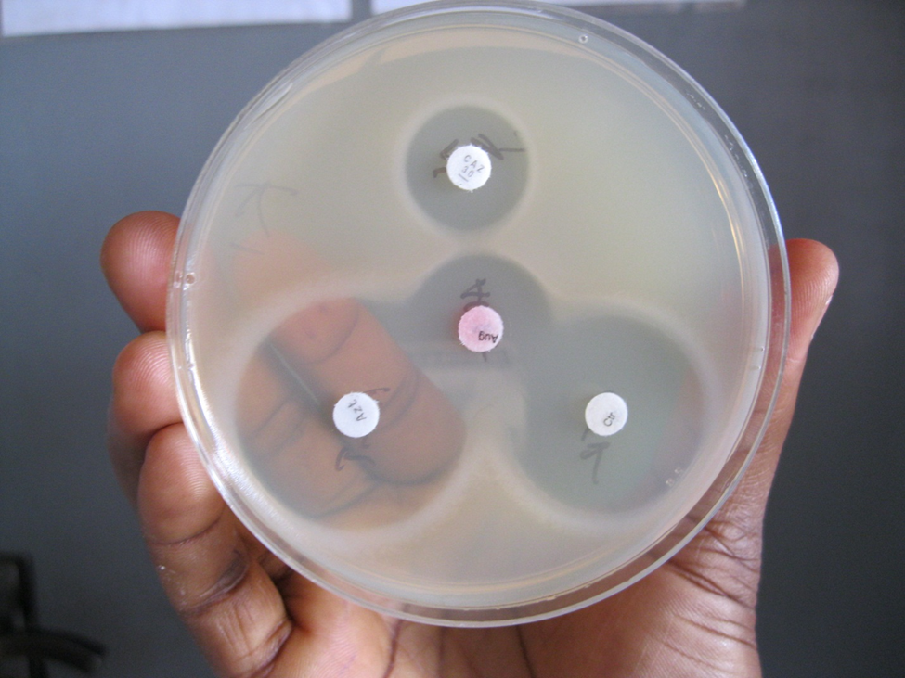
Plate 3. Demonstrating ESBLs group B –metallo-β-Lactamase production, using, CAZ, IMP and CAZEDTA and IMPEDTA in alternate positions. Notice increases in zones of inhibition which depicted EDTA inhibition of enzyme produced and positive result for -metallo β –lactamases
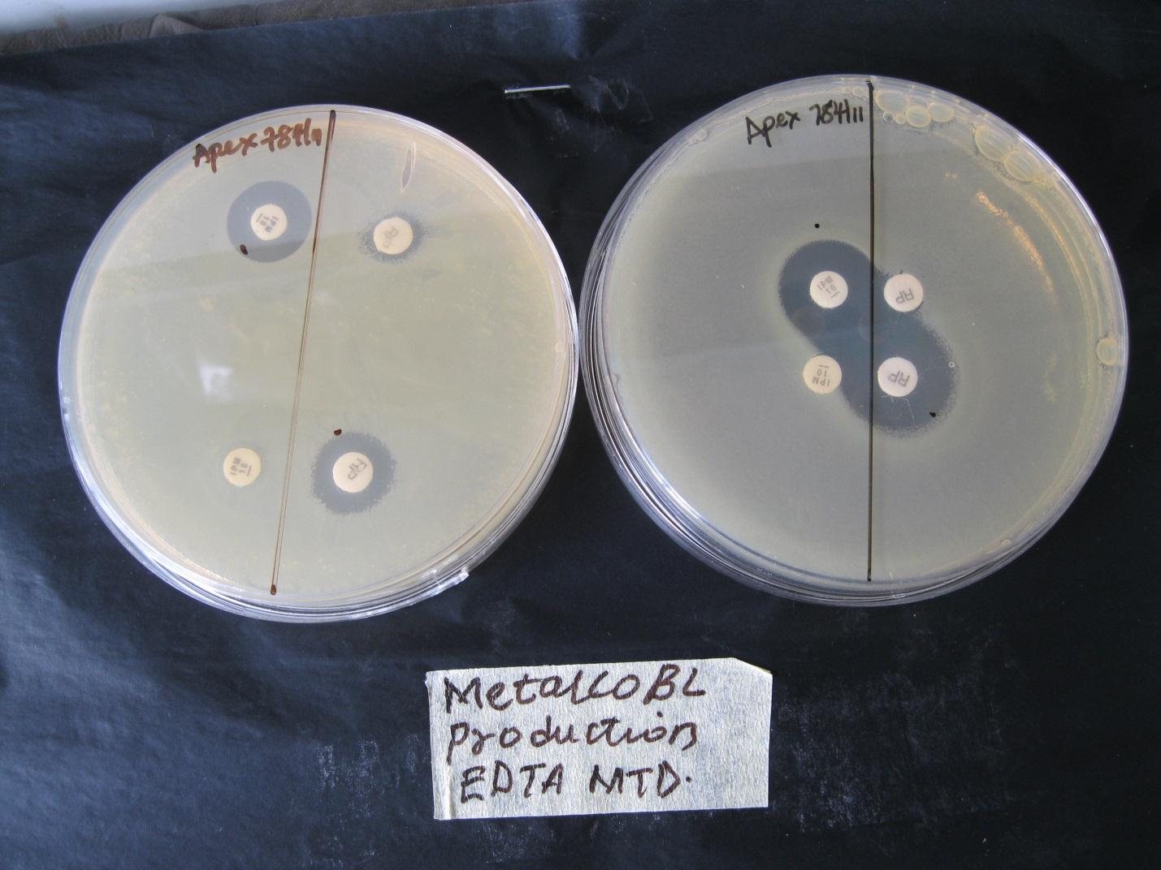
Key:
IMP = Imipenem
IMPEDTA = Imipenem impregnated with EDTA
CAZEDTA = Ceftazidime impregnated with EDTA

Plate 4: Demonstrating combined screening of Ambler group A and group B β-lactamases: plate (a) Left: positive plate for both, plate (b) center: group A ESBLs positive and group B negative and plate (c): on the right the use of plain disk (Top right) and disk impregnated with 20µl of 750µg EDTA (Lower left) to demonstrate EDTA effect: notice the distortion at the lower left. Also the effect of disk placement distance(15mm)on the positive plate compared with group A positive plate center(right) with shorter(10mm) disk placement
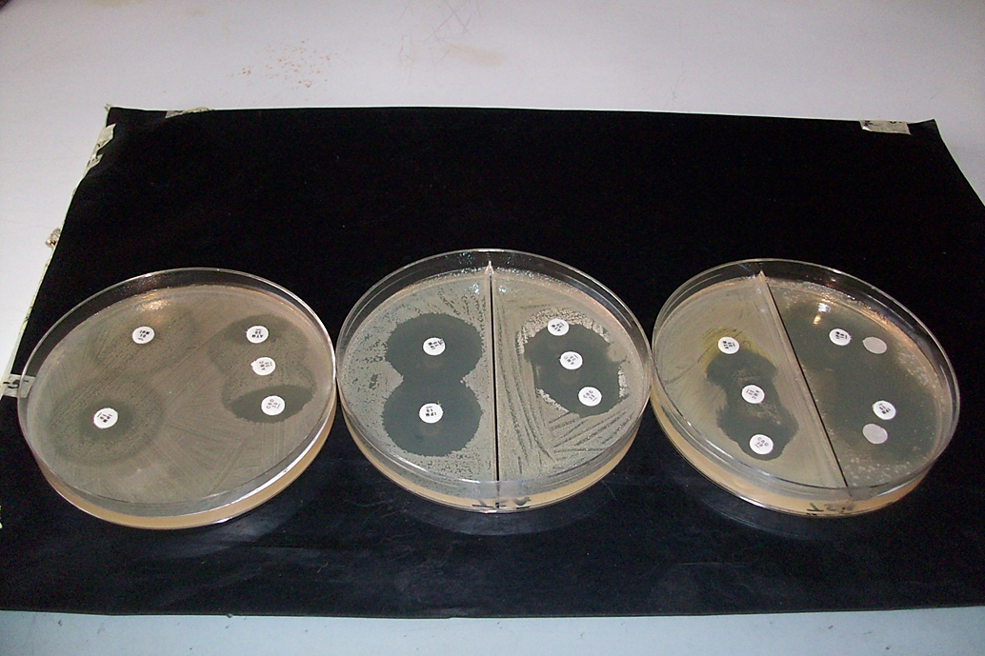
The sensitivity and specificity were 88.9 % and 100% for group A and 91% and 100% for group B -metallo β -lactamases, respectively. The positive predictive value of 100% was recorded for both. The TSA agar demonstrated clearer sensitivity pattern with less sub-population growth than the Muller Hinton agar (Plate 3)
- Discussion:
The increased prevalence of enterobacteriaceae and other bacteria producing β-lactamases, increased therapeutic failures and gene transfer dispositions create the greater need for laboratory testing methods (Bradford, 2001) one of the major bacterial resistance mechanisms is plasmid or chromosomal mediated β -lactamases production. Routine screening of the presence of these enzymes were recommended by CLIS document M100-S14 (2005). However, these methods are expensive and may not apply in clinical microbiology laboratories in resource poor settings; with concomitant rise in prevalence of β -lactamases producing bacterial resistance. In this study we report occurrence of 29 % Ambler group A and 17.5 % for group B - metallo β-lactamases respectively. Whereas in 2003, Aibinu et al reported prevalence rate of 20.3% for Ambler group A ESBLs in Enterobacter. These may not necessarily compare as Aibinu on worked single gram negative bacterium, whereas our study was on gram negative bacteria. Our report was lower than that of Eyitayo et al, (2009) who reported 32.8% prevalence rate from gram negative bacterial isolates from cancer patients in Lagos; although, the site of bacterial isolation may be of consequence. Recently, from Ibadan (same South West Nigeria) an alarming prevalence rate of 76.9% of ESBLs producers were reported of E. coli clinical isolates from wounds (Okesola et al, 2012). These suggest that the enzymes spread rapidly probably by clonal multiplicity or otherwise, that site of the infection is of importance in considering the occurrences of the enzymes, as well as variation within community and nosocomial isolates Enwuru et al, (2011) on Ambler group B. This probably explains the low rate in this report compared with some of the earlier ones, since most of the earlier reports were from hospital wards.
In other parts of the country, Yusha’U et al (2007) reported 2.25% for enterobacteriaceae in Kano and shapely in 2010, another report of 41.2% ESBLs pure production was reported with E. coli (28/47) and Proteus spp. (13/47) being the most frequent, this agrees with our report on the prevalence of E. coli and smacks the rapidity with which the enzymes spread. Also, in Ebony state 36.2% prevalence was reported, with 34.9% of such being isolated from urine (Iroha et al 2008) Klebsiella pneumonia was reported as the most prevalent. In one of our previous studies Metallo β-lactamase production prevalence rate of 23% was reported of E. coli and Klebsiella organisms from hospital and community sources (Enwuru et al, 2011). Reviewing research works, it appears either that scholars are not keen in studying Ambler class B –metallo β-lactamase production which is also as important as other classes of ESBLs as this class of enzyme hydrolyses carbarpenems or that they are frustrated by poor sensitivity of methods and probably high cost of molecular methods for validation. In other parts of the world, Aamerali et al 2003 reported 37.5% in Pakistan, France, 2.6% (Lavigne et al, 2004); Thailand 26% (Mayura et al 2004) and in India 53% (Rodrigues et al, 2004) and in 2007, India reported a frequency rate of 60.98% for ESBLs producers amongst E. coli and Klebsiella spp.; with highest producers amongst Enterobacter spp. as high as 70.9% (Shivaprakasha et al, 2007). Although there was no record of comprehensive surveillance reports from India and Nigeria, the available reports show higher prevalence of B-lactamase enzymes in India (highly populated) compared with Nigeria and Nigeria in turn higher than those from Europe: France (2.6%) and Netherlands <1% and American report of 0 - 25% (average 3 %) ESBLs production amongst enterobacteriaceae (Bradford, 2005).
At these reports we can possibly associate the enzymes spread with poor hygiene practice within hospitals and communities leading to spread from producers to non-producers -a phenomenon associated with plasmid transfer. Mobile patient population and transfer within wards and hospitals, poor enforcement of barrier precisions and lack of drug controls are other factors (Bradford, 2005; Drawz and Bonomo 2010). From our study, E. coli (chart 1) had the highest incidence rate for ESBLs, this agrees with the reports of Yusha’u et al, 2010 and Pseudomonas for metallo β-lactamase production. Although some previous reports implicated Enterobacteriaceae, Pseudomonas aeruginosa Hemophelious influenza, Neisseria gonorrhoeae (Bradford, 2001).
The DDST and DDT are standard methods for group A and metallo β-lactamases’ screening respectively. Our result of 88.9% sensitivity and 100% specificity for group A and sensitivity of 91% and specificity of 100% for group B –metallo βlactamases’ modified phenotypic screening were comparable with the recommended screening methods. The variation in the two methods CLSI break point and the modified method may be as a result of the fact that organisms with multiple β-lactamases production may have interfered with some of the test results. For instance Amp C production interferes with the detection of Class A ESBL (Hemalathaet al, 2007). However, the modified method is simple, saves both time and cost. Although, PCR, micro dilution, micro scan system and Vitek system methods are superior to it, they are quite expensive and require a level of expertise. Consequently, their application for routine diagnosis may not be feasible, particularly where resources are scarce. From this result we demonstrate that disks placed 15 mm edge to edge produced better discriminatory results, compared with 20mm recommended by (Picao et al, 2008).
According to these results the double disk synergy test in combination with enzyme hydrolysis test on the same plate were highly sensitive and specific for detection of Ambler class A and B B-lactamases. These enzymes were mainly found on E. coli, Klebsiella spp., Pseudomonas spp., Enterobacter and Serratia macscences. Essentially, these enzymes have been identified in other organisms such as Proteus spp., providncia spp. and quite a few Morganella morganii and Salmonella spp. (Bradford et al, 2001).
In recent times WHO reported that only 2 out of 130 laboratories in America surveyed specifically reported a positive study sample given to them as positive for ESBLs (Bradford, 2005). In Nigeria, routine screening for ESBLs is not quite common except for some research purposes.
In conclusion, the result has demonstrated that groups A and B β-lactamases could be screened on the same agar plate; especially plates with double chamber (plate 4). Also, TSA agar demonstrated more definitive results with minimal sub population growth; this method undoubtedly is cheaper for routine clinical bacteriology laboratories. This method has good positive predictive values.

Corresponding Author:
Enwuru C. A,
Public Health Department
Nigerian Institute of Medical Research,
P.M.B. 2013, Yaba, Lagos, Nigeria
E-mail: enwuru@ymail.com

REFERENCES
- WHO. Antimicrobial Resistance. Fact sheet, No 194 Review 2012; WWW.who.int/mediacentre/factsheets/fs194/en/
- Ritu N, Vivek MA, Shalini. Antibiotic impregnated tablets for screening ESBL and AmpC beta lactamases. IOSR Journal of Pharmacy 2012; 2(2) 207-209.
- Bradford PA. Extended spectrum B-lactamases in the 21st century:
Characterization, epidemiology and detection of this important resistance threat. Clin. Microbiol Rev. 2001; 14: 933 – 951.
- Drawz SM. and Bronomo RA. Three Decades of β-Lactamase Inhibitors. Clin. Microbiol Rev. 2010; 23 (1): 160-201.
- Rodrigues C, Joshi P, Jani SH. et al Detection of β-lactamase in nosocomial gram negative clinical isolates. Indian Journal of Medical Microbiology, 2004; 22 (4): 247 -250.
- Ananthakrishnan AN, Reba K, Kumar A, Badarinath S. Detection of Extended Spectrum B-lactamase producersamong surgical wound infection and burns patients in JIPMER. Indian Journal of Medical Microbiology , 2002; 18 (4) : 160 – 165
- Clinical Laboratory Standard Institute Performance Standard for antibacterial disk susceptibility testing. Approved Standard M100-S14, 15th ed. Clinical Laboratory Standard Institute, 2005; Wayne, Pa.
- Al-charrakh AH, Yousif SY, Al-Janabi SA. Occurrence and detection of Extended – Spectrum B-lactamases in Klebsiella isolates in Hilla, Iraq. African Journal of Biotechnology 2011;10 (4) : 657 – 665.
- Hemalatha V, Uma S, Vijaylakshmi K. Detection of metallobetalactamase producing Pseudomonas aeruginosa in hospitalized patients. Indian J Med Res 2005; 122: 148 -152.
- Aibinu I, Odugbemi T, MEE BJ. Extended Spectrum Beta-Lactamases in Isolates of Klebsiella spp. and Escherichia coli from Lagos, Nigeria. Nigerian Journal of Health and Biomedical Sciences, 2003; 2 (2): 53 – 60.
- Eyitayo OA, Ibukun EA, Oluwole AD, Afolabi OA, Aderemi TA, Olutoyin AA, Tolu OO. Occurrence of Beta-Lactamase Resistance among isolates from cancer patients in Lagos, Nigeria. Academia Arena, 2009; 1 (5). ISSN 1553 – 992x
- Yusha’U M, Olonitola SO, Aliyu BS. Prevalence of ESBLs among members of Enterobacteriaceae isolates obtained from Mohammed Abullahi Wase specialist hospital, Kano, Nigeria. International Journal of Pure and Applied Sciences, 2007; 1 (3): 42- 48.
- Iroha E, Amadi A., Agabus AC, Oji A. Susceptibility pattern of ESBLs producing klebsiela pneunmonia from clinical isolates. Journal of Microbiology, 2008; 5 (2): 34 – 39.
- Enwuru NV, Enwuru CA, Ogbonnia SO, Adepoju-Bello AA. Methallo Beta-Lactamase production by E. coli and Klebsiella spp. isolated from hospital and community subjects in Lagos, Nigeria. Nature and Science, 2011; 9 (11): 1- 5
- Okesola AO, Foaolade A. ESBLs production among clinical isolates of E. coli. International Research Journal of Microbiology (IRJM), 2012; (4) 140 – 143. ISSN: 2141 – 5463 3
- Aamer-Ali S, Fariha H, Safia A, Abdul HPrevalence of Extended spectrum B-lactamases in nosocomial and outpatients (Ambulatory). Pakistan Journal of Med. Science, 2003;9 (3) : 187- 191.
- Larigne JP, Bonnet R, Michux-Charachon S, Jourdan J, Caillon J, Sotto A. Post-antibiotic and post-B-lactamase inhibitor effects of ceftazidime plus sulbactam on expanded spectrum B-lactamase producing gram positive bacteria. Journal of Antimicrobial Chemotherapy, 2004
- Rodrigues C, Joshi P, Jani SH, et al Detection of B-Lactamases in nosocomial gram negative clinical isolates. Indian journal of Medical Microbiology.2004; 22 (4): 247 – 250.
- Shivaprakasha S, Radhakrishman K, Gireech AR, ShamsulKarim PM. Routine screening for ESBL production, a necessity of today. The Internet Journal of Microbiology, 2007; 3 (1). ISSN 1937 – 8289
- Yusha’U M, Aliyu HM, Kumurya AS, Suleiman K. Prevalence of ESBLs among Enterobacteriaceae in Murtala Mohammed Specialist Hospital, Kano, Nigeria. Bayaro Journal of Pure and Applied Science, 2010; 3 (1): 169 -172.
- Hemalatha V, Padma M, Uma S, Vinodh TM, Arunkumar AS. Detection of Amp C beta lactamases production in Escherichia coli and Klebsiella by an inhibitor based method. Indian Journal of Medical Research. 2007; 1-4 http://findarticles.com/p/articles/mi_qa3867/is_3_126/ai_n32051890/
- Picao RC, Andrade SS, Nicoletti GA, Campana NE, Moraes GC, Mendes RE, Gales AC. Methallo-B-Lactamase Detection: comparative evaluation of Double Disk Synergy versus Combined Disk Test for IMP-, GIM-, SIM-, SPM-, or VIM-producing Isolates. Journal of Clinical Microbiol. 2008;
- Weidner W, Krause W, Ludwig M. Relevance of male accessory gland infection for subsequent fertility with special focus on prostatitis. Hum Reprod Update, 1999; 5:421-432. http://www.ncbi.nlm.nih.gov:80/entrez/query.fcgi?cmd=Retrieve&db=PubMed&list_uids=10582781& dopt=Abstract
- World Health Organization WHO Manual for the Standardized Investigation, Diagnosis and Management of the Infertile Male. Cambridge University Press, 2000;ISBN: 9780521774741
- Purvis K, Christiansen E. Infection in the male reproductive tract impact, diagnosis and treatment in relation to male infertility. Int. Journal of Androl, 1993; 16:1-13. http://www.ncbi.nlm.nih.gov:80/entrez/query.fcgi?cmd=Retrieve&db=PubMed&list_uids=8468091&dopt=Abstract.

6/14/2013

